**MF 803 Homework 3**  
Due: Wednesday, October 2nd, by 6:30pm

**Xinyu Guo**

[**xyguo@bu.edu**](mailto:xyguo@bu.edu)

**U03375769**

**1. Volatility Experiments**

1. **Data Downloading**

Download historical data of SPY and VIX index. The time range is from 2005-01-01 to 2019-09-01. Head of factor data is shown as follows:

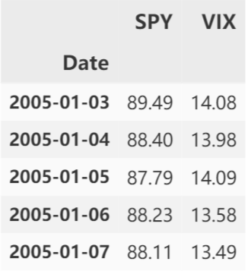

1. **Autocorrelation Test**

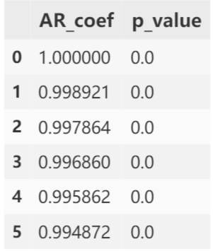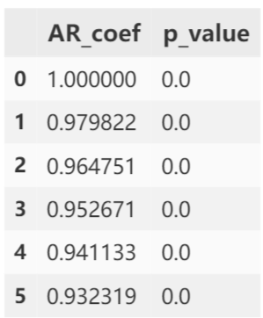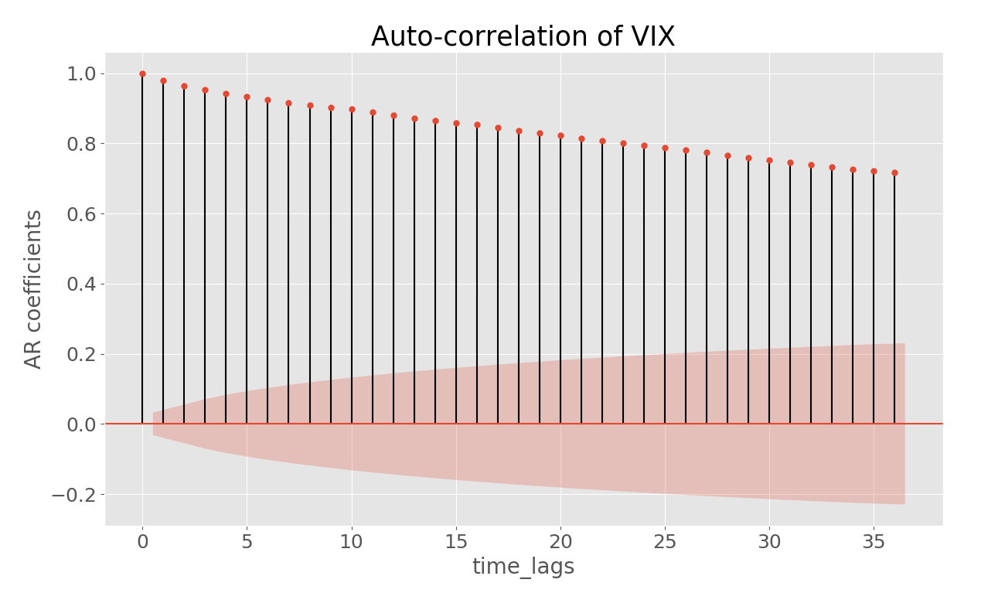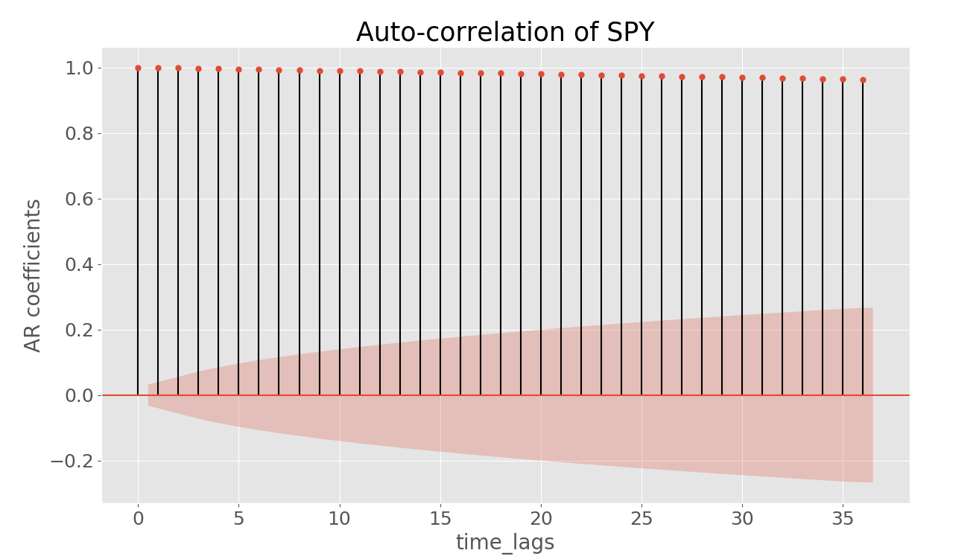

AR test result of SPY:

AR test result of VIX:

From the tables and figures above, we could see that both series present a clear indication of auto-correlation, in which their auto-correlation coefficients approach 1 closely and their p values are all zero. Specifically, there is a more intense auto-correlation in SPY than VIX. That is because SPY is built up by lots of publicly traded assets on the market, thus possibly having a less clear property of mean reversion than VIX.

1. **Correlation of SPY and implied volatility**

Daily correlation of SPY and its implied volatility is -0.4, and the monthly correlation is -0.42. Both represent a significant negative correlation. This is a bad phenomeon for using BSM to price the options because BSM has one essential assumption that the the implied volatility should be constant, which clearly does not corresponds to our result.

1. **Rolling 90-day Correlation of SPY and implied volatility**

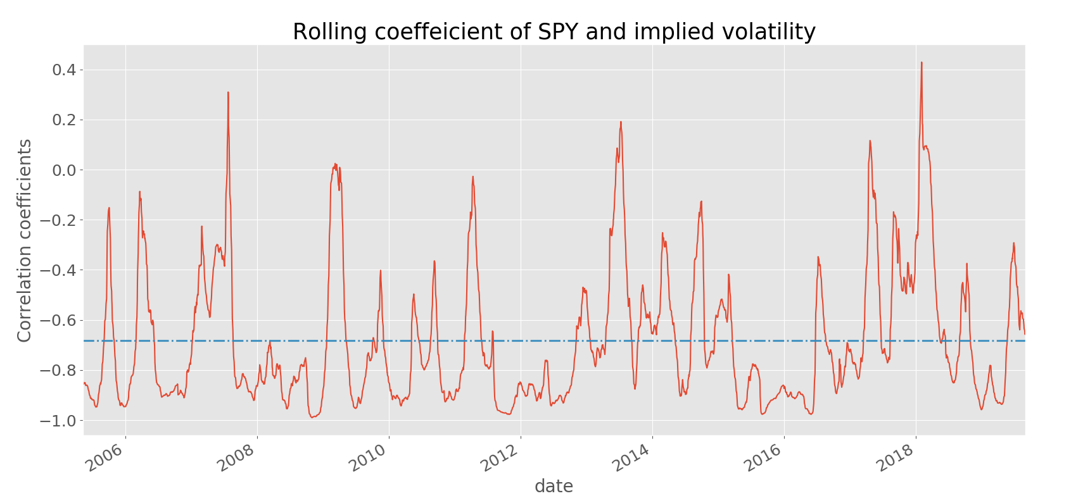

# From the figure above, we could see that the rolling correlation coefficients has a very huge volatility. Its long-term average is nearly -0.7. Specifically, in 2008 and 2018, the correlations deviated most from the long-term average.

1. **Premium of Volatility**

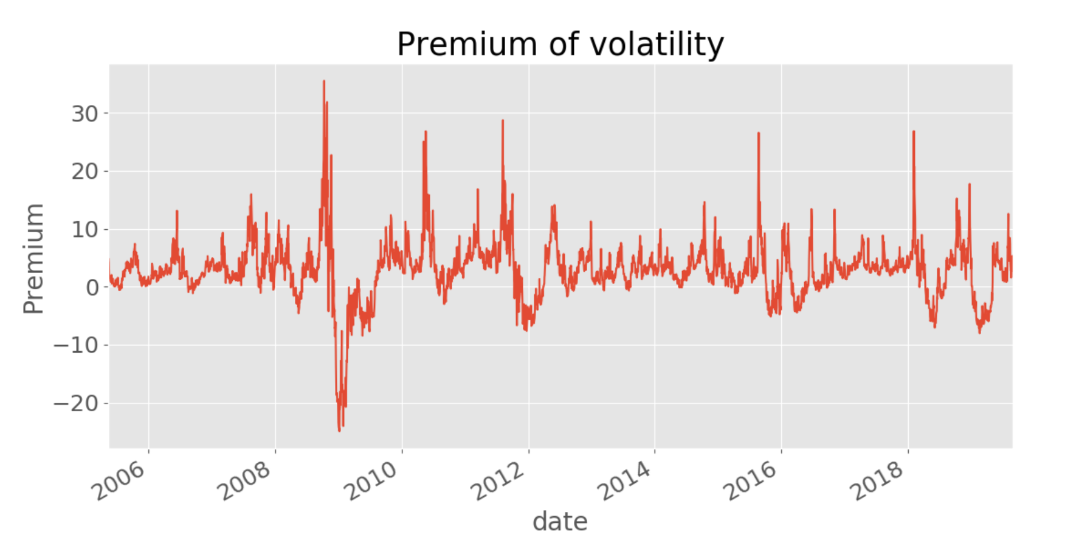

From the figure above, we could see that the premium is mostly positive. It peaked in 2008, then immediately reached -20, its bottom of all periods, shortly after the crisis. That is mainly because after the slump, the volatility calculated by real historical data varied greatly, while implied volatility had already been reflected during crisis. So the realized volatility became far greater than implied volatility.

1. **Straddle portfolio construction**

Head of the straddle portfolio is shown as below:

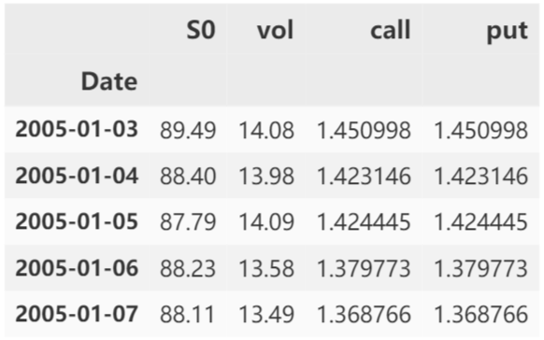

1. **Payoff of Straddles**

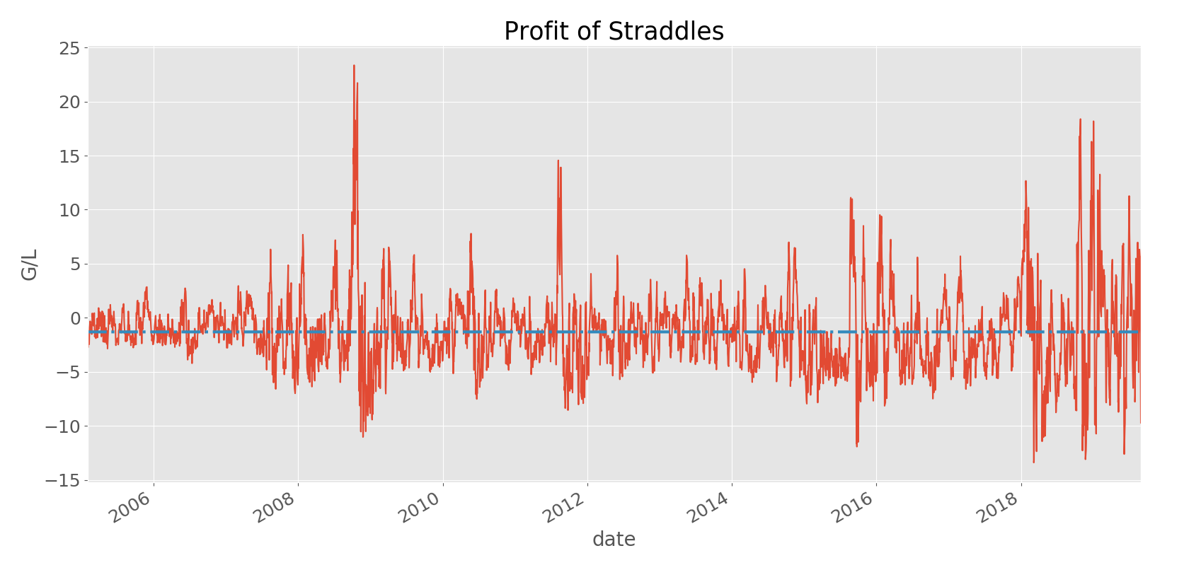

Average P/L of these straddles is: -1.3

1. **P/L of straddles & volatility premium**

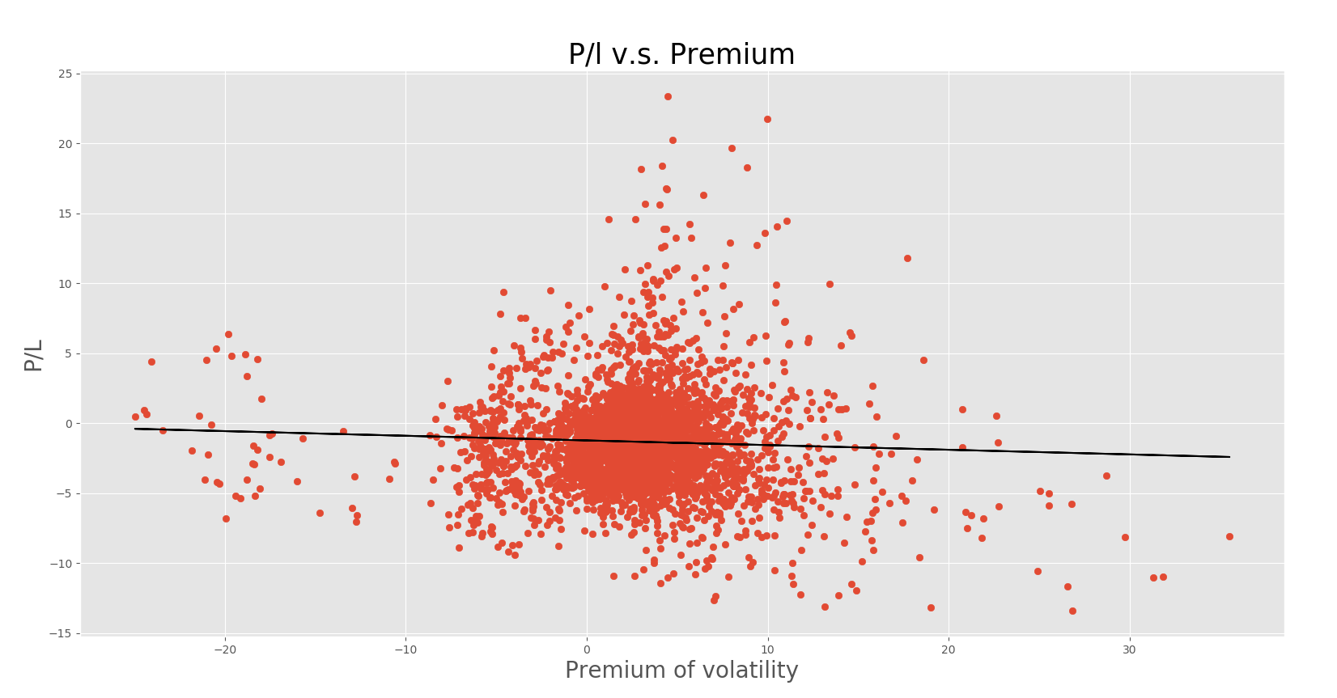

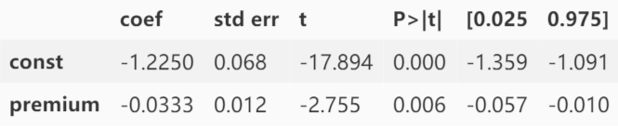

From the plot, we can see a slightly negative relationship between P/L and the premium of volatility. And the regression result also that the coefficient of premium is less than 0. This is probably because the p/l of options depends on the realized volatility of the asset price (SPY). The higher the volatility, the higher profits straddles would make. So this is reflected by a negative relationship between profit and the premium of volatility, which would decrease as the realized volatility rises.