**MF 803 Homework 5**  
Due: Wednesday, October 30th, by 6:30pm

**Xinyu Guo**

[**xyguo@bu.edu**](mailto:xyguo@bu.edu)

**U03375769**

**1. Yield Curve**

**(a) – (c) Forward Rates**

The calculated forward rates for the entire curve are:

|  |  |
| --- | --- |
| **Maturity** | **Forward Rates(%)** |
| 1 | 2.82377 |
| 2 | 3.25646 |
| 3 | 3.23817 |
| 4 | 3.17624 |
| 5 | 3.15105 |
| 7 | 3.19647 |
| 10 | 3.29530 |
| 30 | 3.23239 |

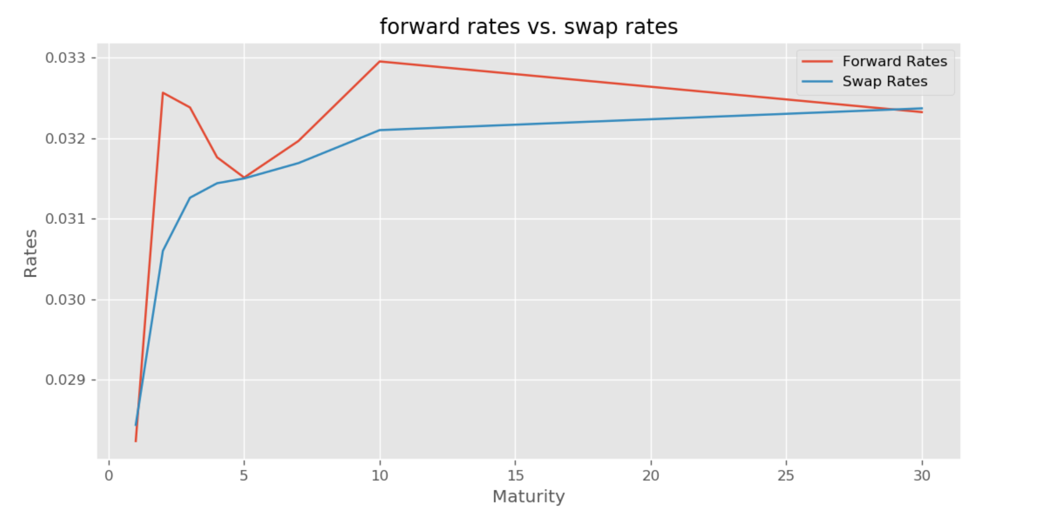

From the plot, we could see that the forward rates are mostly higher than the swap rates. The premium between forward rates and swap rates is generally due to the market’s expectation of risk of rising interest rate in the future.

**(d) Breakeven swap rate of a 15Y swap**

Breakeven swap rate of a 15Y swap is: 3.2237%

**(e) Zero Rates and discount factors**

|  |  |  |
| --- | --- | --- |
|  | Discount Factor | Zero Rates |
| 0.5 | 0.985980 | 0.028438 |
| 1.0 | 0.972157 | 0.028438 |
| 1.5 | 0.956456 | 0.029901 |
| 2.0 | 0.941009 | 0.030633 |
| 2.5 | 0.925896 | 0.031036 |
| … | … | … |
| 28.0 | 0.406133 | 0.032442 |
| 28.5 | 0.399622 | 0.032444 |
| 29.0 | 0.393215 | 0.032447 |
| 29.5 | 0.386911 | 0.032449 |
| 30.0 | 0.380708 | 0.032451 |

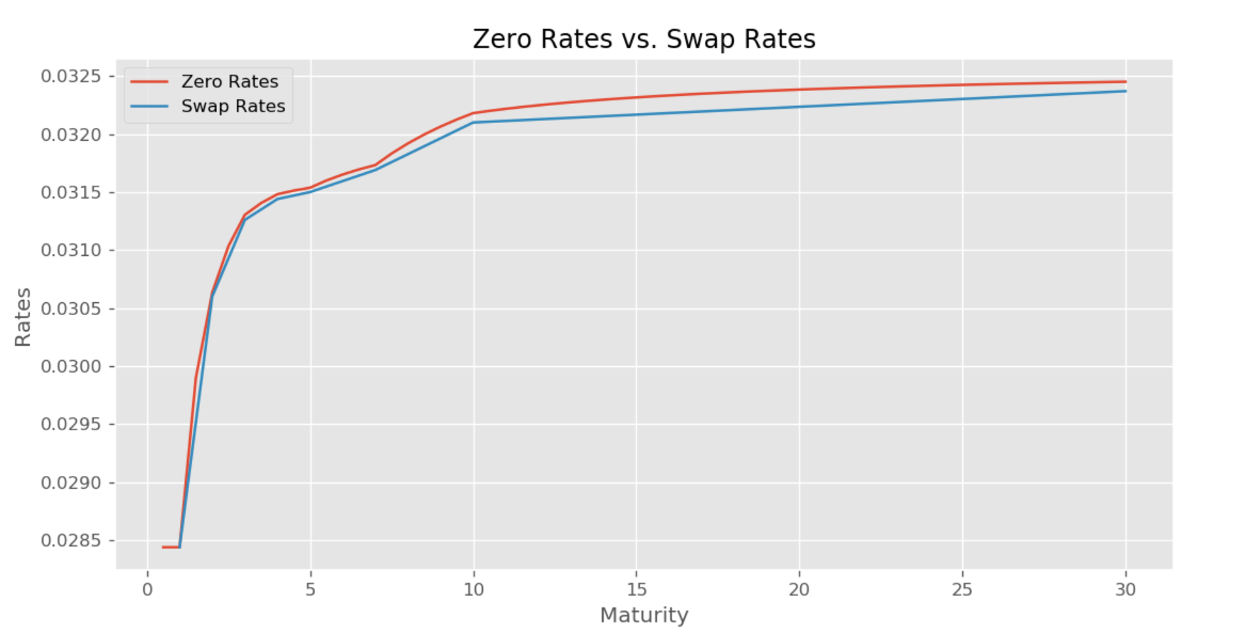

From the plot above, we can see that zero rates are also slightly higher than swap rates, since zero rates are calculated through the weighted sum of forward rates.

**(f) Upshift of forward rates**

|  |  |  |  |
| --- | --- | --- | --- |
|  | **Old Swap (%)** | **New Swap (%)** | **difference (bp)** |
| **1** | 2.8438 | 3.860559 | 101.675878 |
| **2** | 3.0600 | 4.078946 | 101.894578 |
| **3** | 3.1260 | 4.145596 | 101.959556 |
| **4** | 3.1440 | 4.163621 | 101.962146 |
| **5** | 3.1500 | 4.169517 | 101.951681 |
| **7** | 3.1690 | 4.188785 | 101.978457 |
| **10** | 3.2100 | 4.231159 | 102.115870 |
| **30** | 3.2370 | 4.258494 | 102.149390 |

From the table, we could see that the difference between old swap rate and new calculated swap rate is nearly 100 bp, but still has a little slight difference.

**(g) – (h) Bearish steepener to the swap rates**

|  |  |
| --- | --- |
| **Maturity** | **Forward Rates(%)** |
| 1 | 2.82377 |
| 2 | 3.25646 |
| 3 | 3.23817 |
| 4 | 3.38312 |
| 5 | 3.46353 |
| 7 | 3.48299 |
| 10 | 3.81713 |
| 30 | 3.93932 |

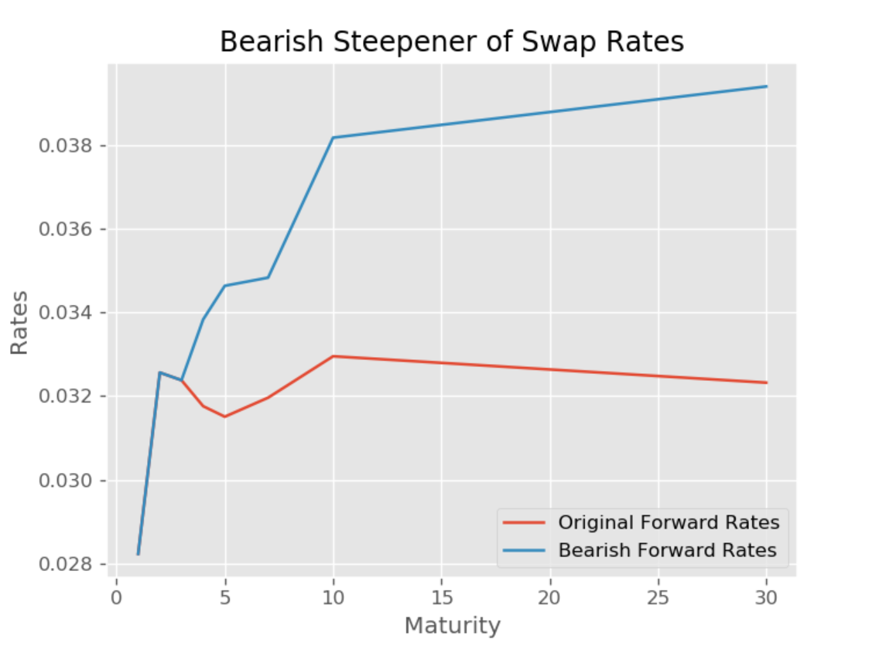

The new forward rates are same as original forward rates at beginning, but they diverge from year 4. And the bearish forward rates become steeper from then on.

**(i) – (j) Bull steepener to the swap rates**

|  |  |
| --- | --- |
| **Maturity** | **Forward Rates(%)** |
| 1 | 2.33017 |
| 2 | 3.26376 |
| 3 | 3.29705 |
| 4 | 3.23536 |
| 5 | 3.33155 |
| 7 | 3.33475 |
| 10 | 3.29571 |
| 30 | 3.23245 |

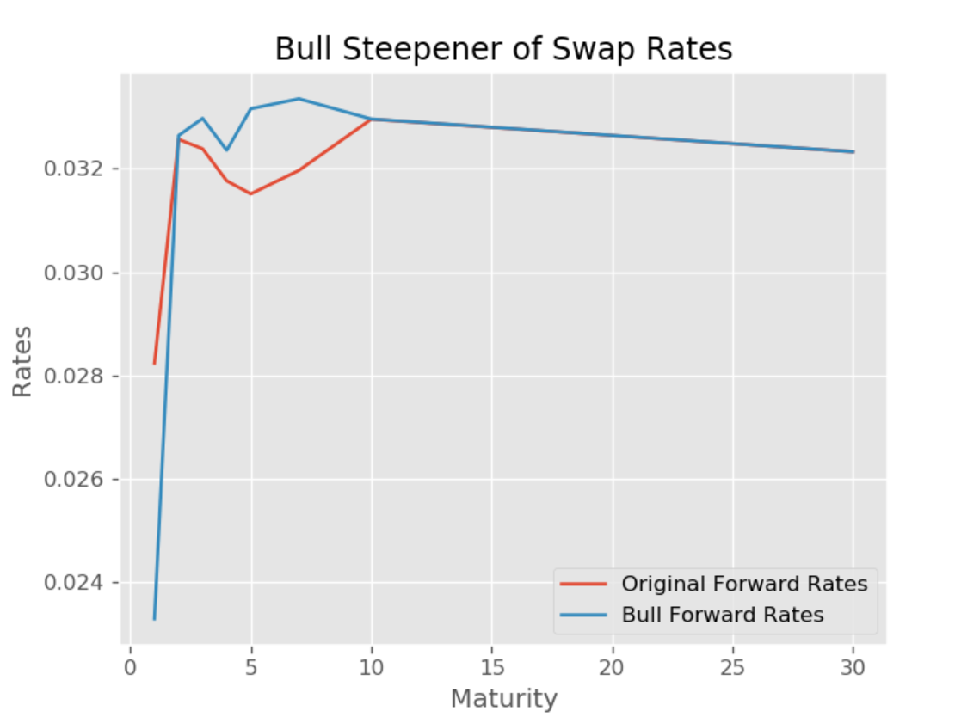

The new forward rates are not same as original forward rates at beginning, and then converge to the original swap rates as maturity increases.