**MF 803 Homework 6**  
Due: Wednesday, December 11th, by 6:30pm

**Xinyu Guo**

[**xyguo@bu.edu**](mailto:xyguo@bu.edu)

**U03375769**

**1. Covariance Matrix Decomposition**

**(a) Download historical price data of ETFs**

The head and tail of the price dataframe is as followed:

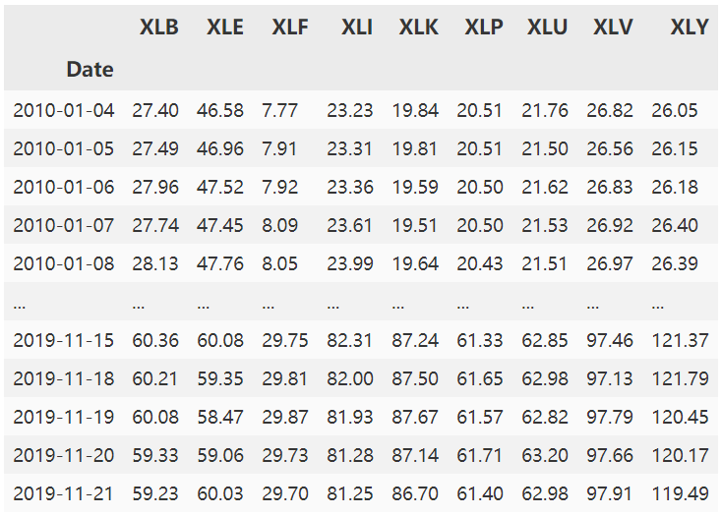

**(b) Covariance matrix**

The Covariance matrix is as followed:

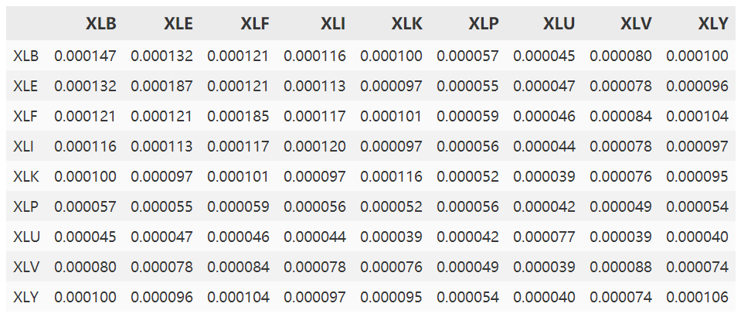

**(c) Eigenvalue decomposition**

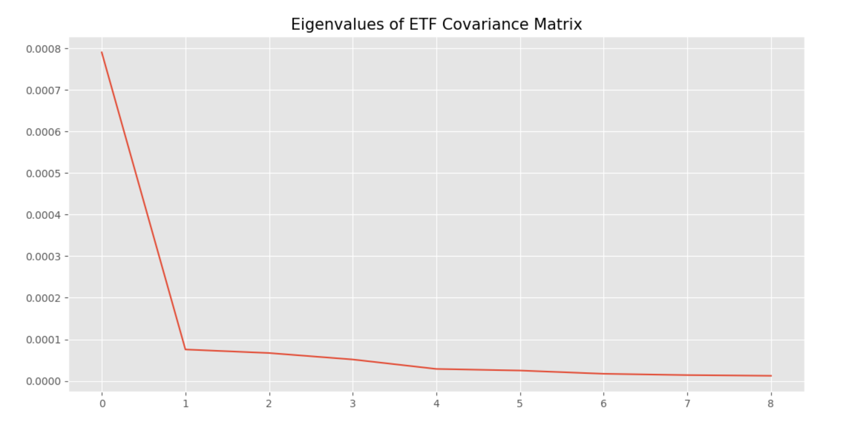

As we can see from the plot above, all of the eigenvalues are positive. None of them is negative or zero. We can see there are 2 eigenvalues that are significantly different from 0.

Since a covariance matrix is positive semi-definite, all of its eigenvalues should be expected to be positive.

**(d) Random Covariance Matrix**

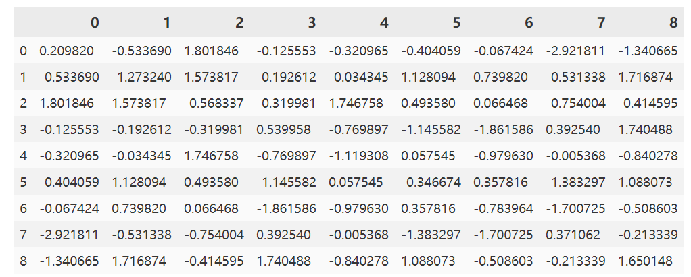

The random covariance matrix is generated as above. Since this is a covariance matrix, it must be symmetric.

**(e) Eigenvalue decomposition of Random Covariance Matrix**

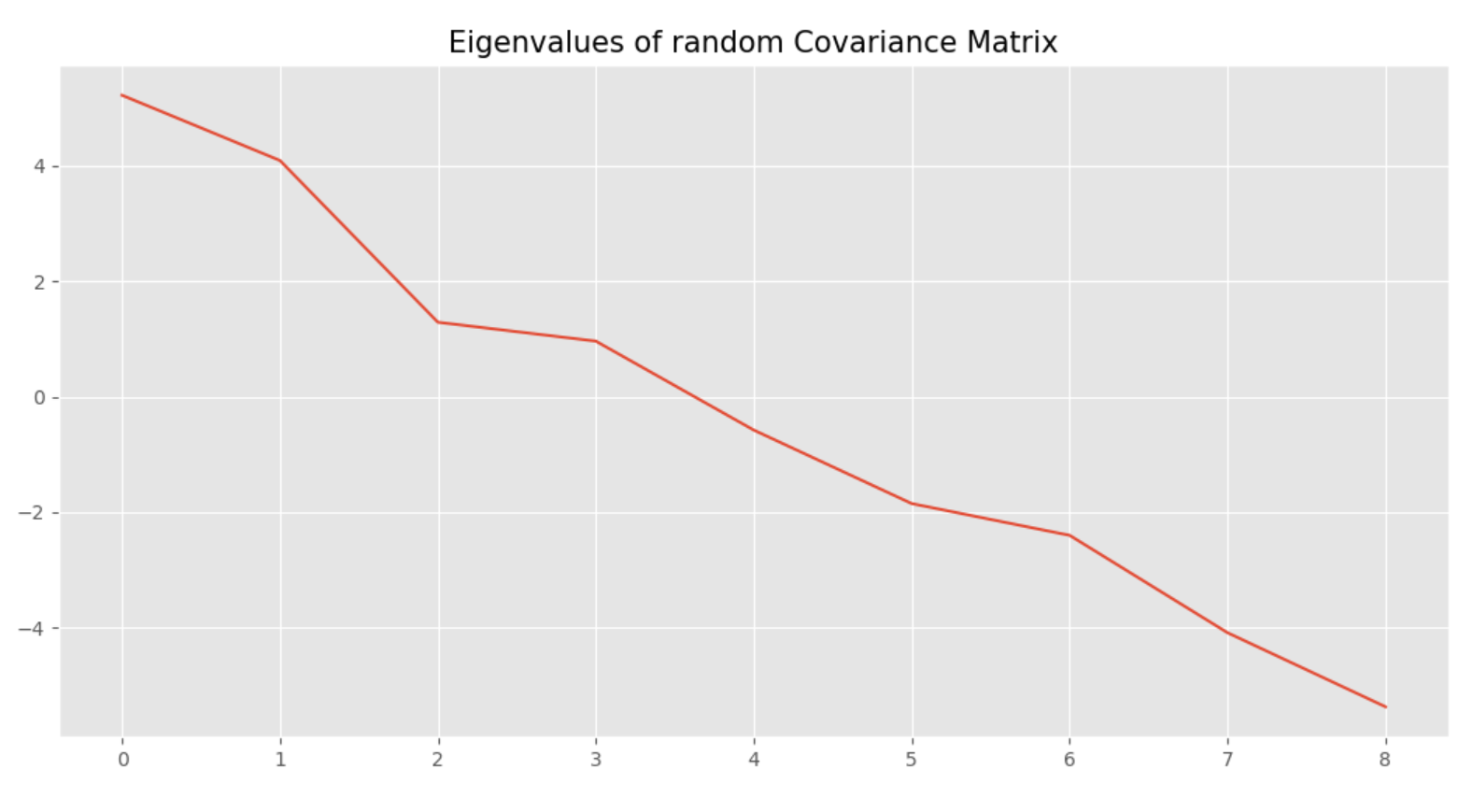

The eigenvalues of random covariance matrix is plotted as above. 44% of eigenvalues are positive. 55% of eigenvalues are negative. 0% of eigenvalues are zero. Since the data is generated randomly, we can find negative eigenvalues, which is not the same case as the real covariance matrix.

**2. Portfolio Optimization**

**(a) Annualized returns of ETFs**



**(b) Unconstrained mean-variance optimal portfolio**



**(c) Stability of portfolio weights**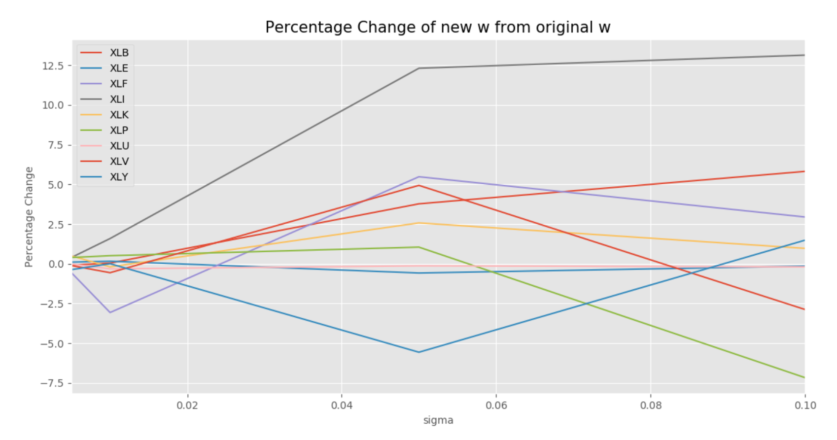Here, I use the percentage change of the new weights from original weights to measure the instability of the weights. As we can see from the plot above, the weights become more instable as sigma become larger.

**(e) Regularized covariance matrix when δ =1**

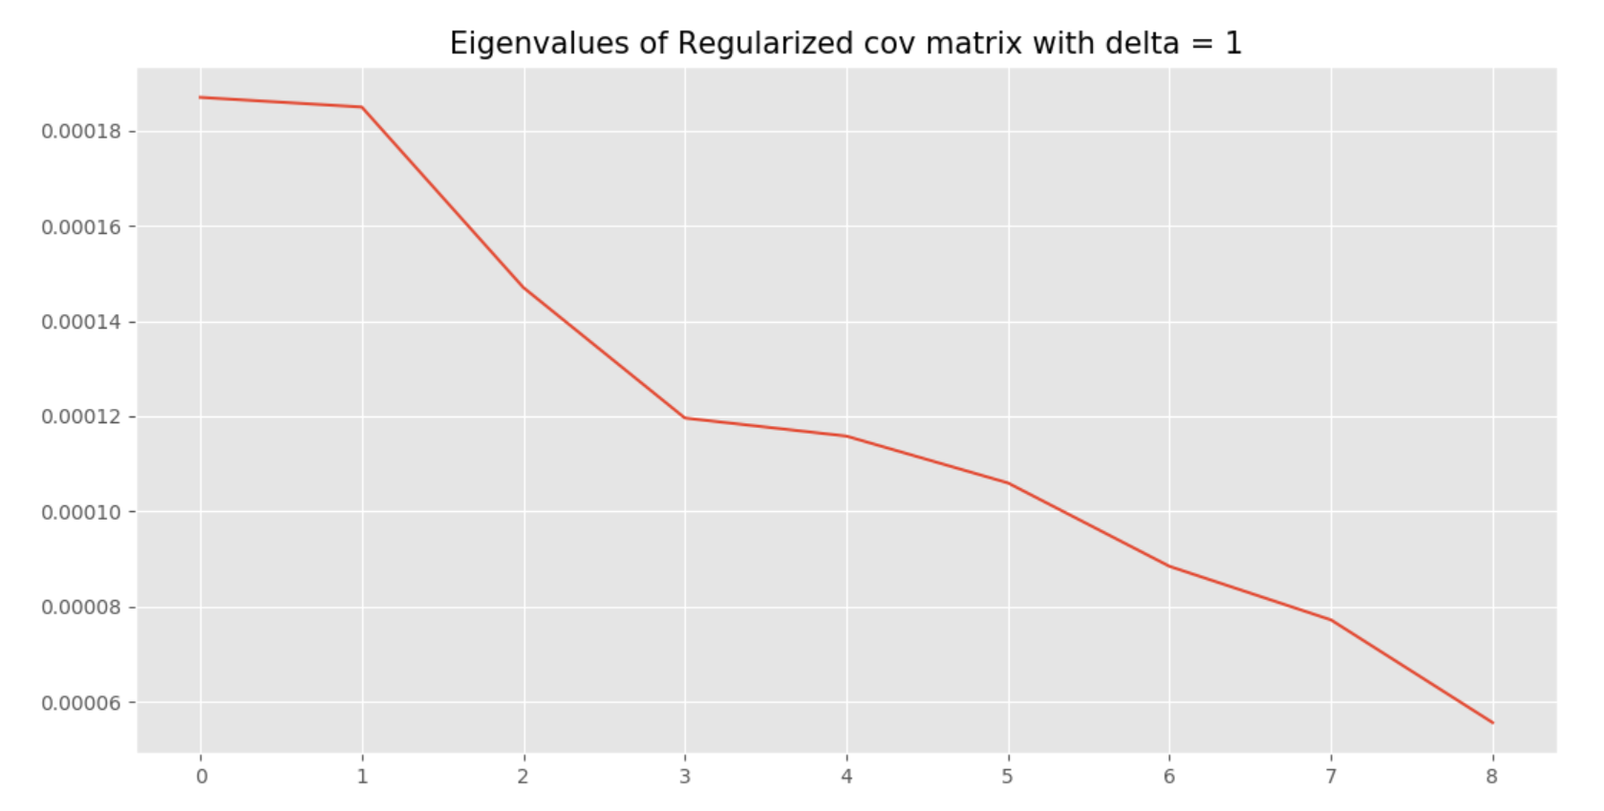

As we can see form the plot above, all the eigenvalues are positive. The rank of the matrix is 9 (full rank).

**(f) Regularized covariance matrixes with different δs**

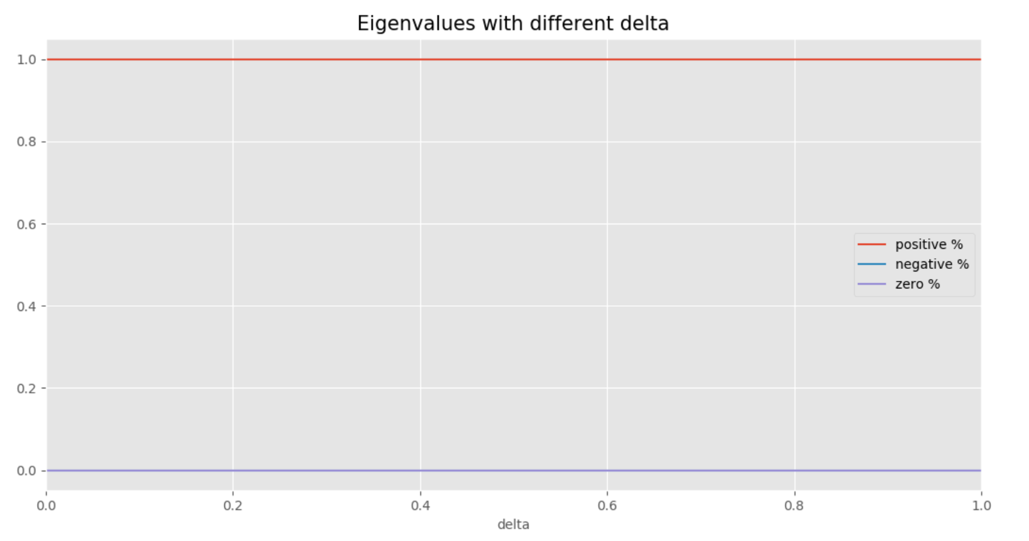We can see that all the eigenvalues are positive no matter what value delta is, since the matrixes are positive-definite.

**(g) Stability of portfolio weights with different parameters**

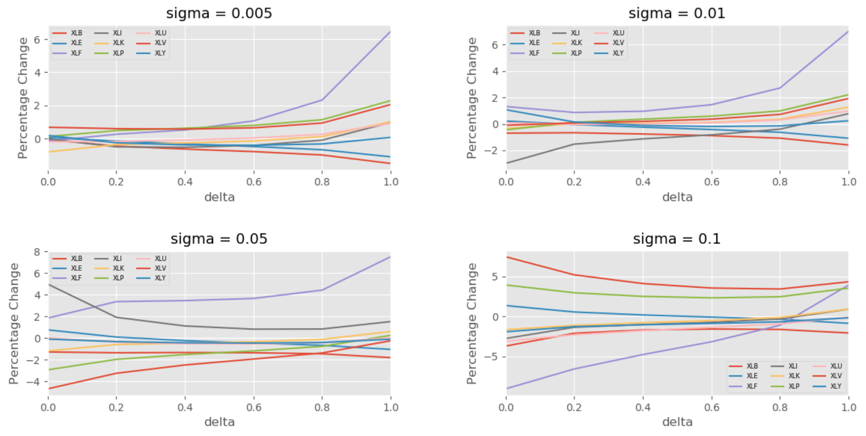

From the plots above, we can see that the percentage change of portfolio weights become much less stable as sigma becomes larger. Also, when sigma is held constant, there is also a clear tendency that weights become less stable as delta becomes larger.