**MF 796 Assignment 1**

**Xinyu Guo**

[**xyguo@bu.edu**](mailto:xyguo@bu.edu)

**U03375769**

1. **Areas of interest:** trading, machine learning, simulation methods, risk management.
2. This course emphasizes the application of various computational methods widely used in quantitative finance besides just theories. This would also be great help for our improvement in programming ability.
3. **Python:** Proficient

**R, SQL:** Familiar

**C++:** Matlab, learned

1. That is mainly because, when gamma is positive, theta tends to be negative.

The portfolio declines in value if there is no change in S, but increases in value if there is a large positive or negative change in S. When gamma is negative, theta tends to be positive and the reverse is true: the portfolio increases in value if there is no change in S but decreases in value if there is a large positive or negative change in S. As the absolute value of gamma increases, the sensitivity of the value of the portfolio to S increases.

1. **Option Pricing**
2. **St:** price of underlying asset at time t

**r:** risk-free rate; also characterizing the drift term

**sigma:** volatility of underlying asset

**beta:** When beta is greater than 1, the model presents leverage effect, where the volatility of a stock increases as its price falls

1. Price through simulation is: 10.95

Below is the simulated paths of CEV model.

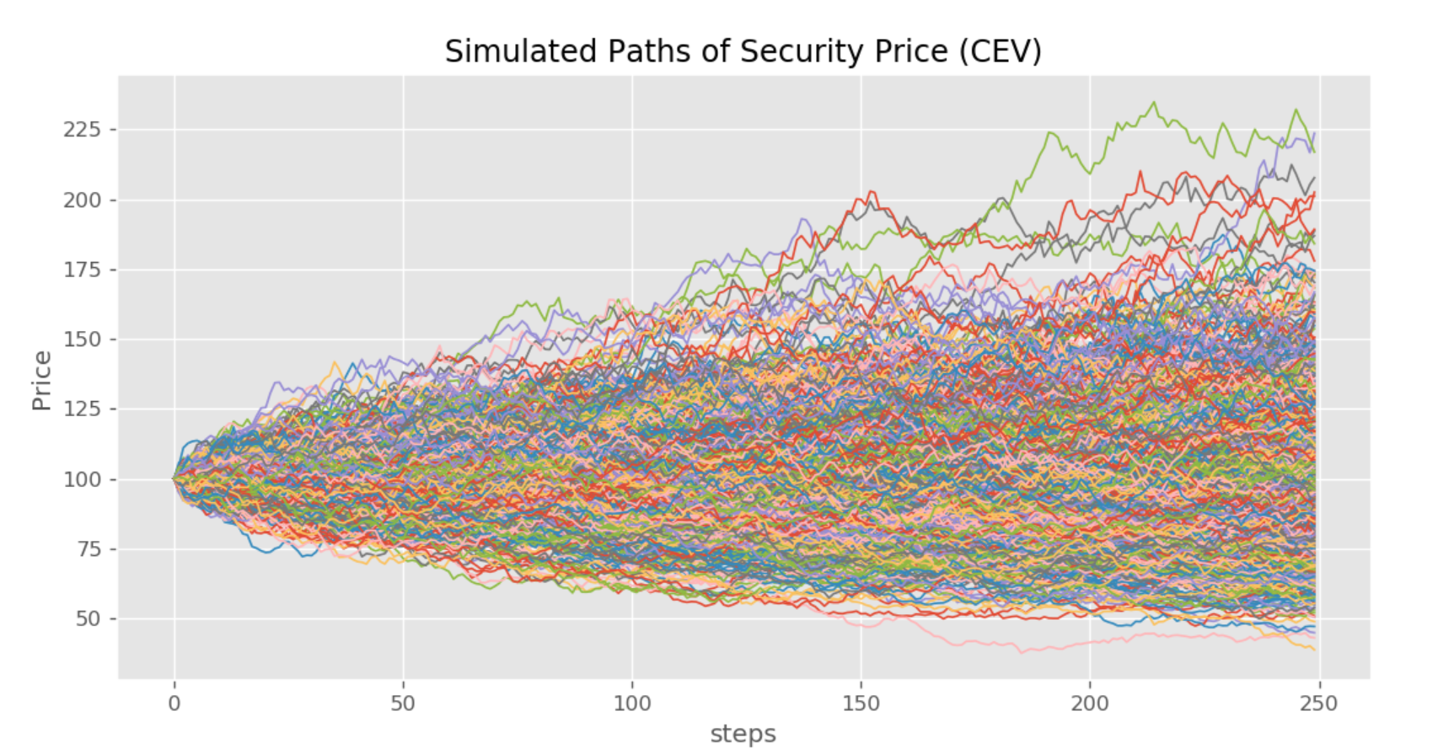

1. Price through BSM is: 9.95. This price is quite close to the price calculated by simulation. Theoretically, these two prices can’t be exactly identical due to the randomness in simulation, but they should be very close.
2. Delta is: 0.55
3. Need to short 0.55 shares of stocks.
4. Payoff of Delta Neutral portfolio is: 10.16. This payoff is very close to the price calculated by BSM earlier. That means the total P&L of the portfolio is closely to 0 after taking into account the cost of buying the call.

After calculation, when the price of underlying asset at maturity is greater than 122.11 or small than 81.9, the portfolio would make money. Otherwise it would lose money. Thus, we can conclude that the portfolio would make money if the call is deep in-the-money or deep out-of-money.

1. When beta is 0.5, payoff of Delta Neutral portfolio is: 1.02. The payoff becomes lower. That is because lower beta decreases the volatility of the asset price. So there would be less chance that the option would be deep-in-the money or deep out-of-money at maturity.
2. When sigma is 0.4, new delta is 0.58, payoff of Delta Neutral portfolio is: 16.14. The increase of volatility drives the increase of option value. On the other side, increase of volatility make it more likely to have deep in-the-money or deep out-of-money option at maturity.