**MF 796 Assignment 2**

**Xinyu Guo**

[**xyguo@bu.edu**](mailto:xyguo@bu.edu)

**U03375769**

**Problem 1**

1. Price of Call calculated by BSM is: 0.0188
2. The absolute error of each method is shown as follows:

|  |  |  |  |
| --- | --- | --- | --- |
| **N** | **Left** | **Middle** | **Gaussian** |
| 5 | 0.0033 | 0.0016 | 0.0 |
| 10 | 0.0008 | 0.0004 | 0.0 |
| 50 | 0.0000 | 0.0000 | 0.0 |
| 100 | 0.0000 | 0.0000 | 0.0 |

1. The rate of convergence of different methods:

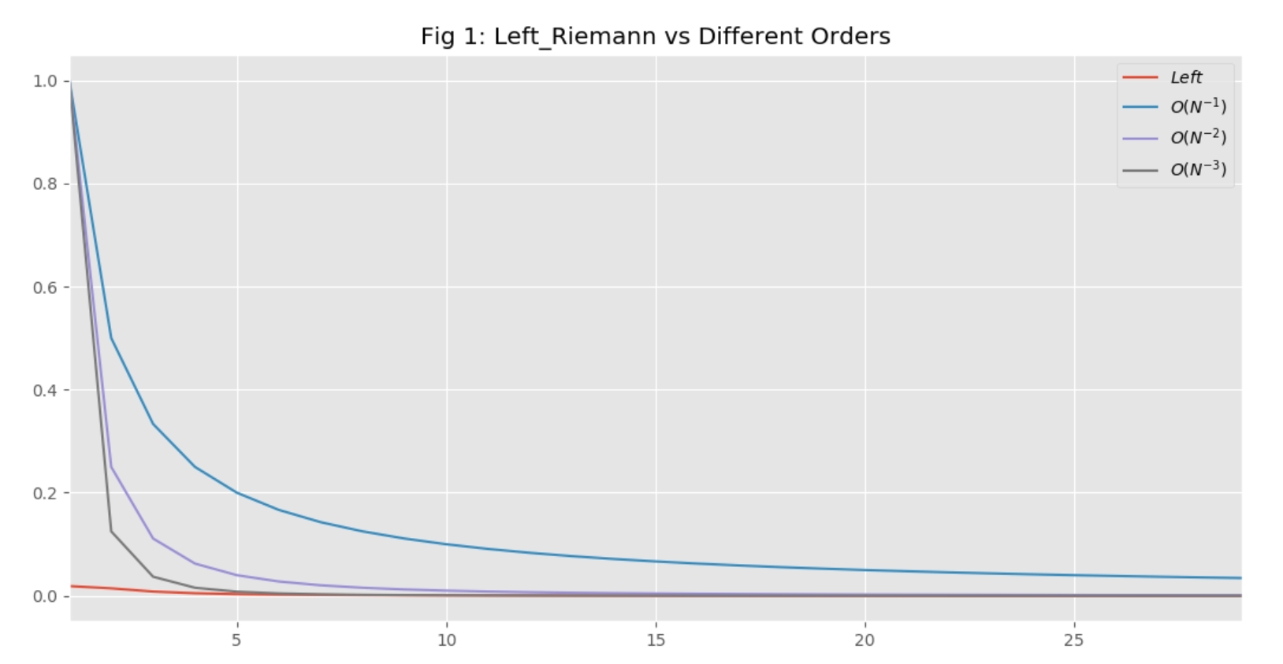

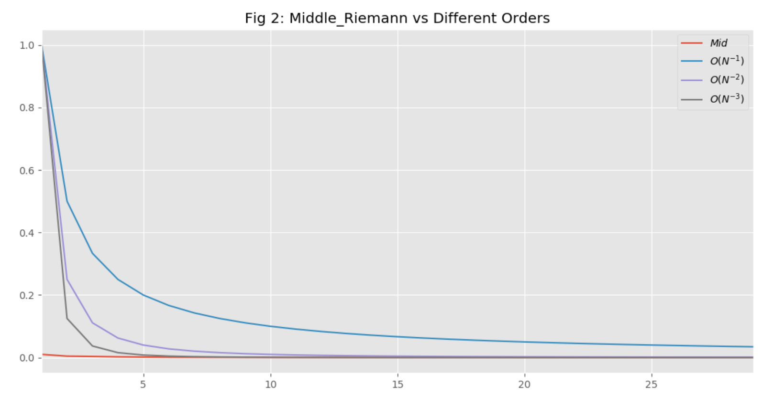

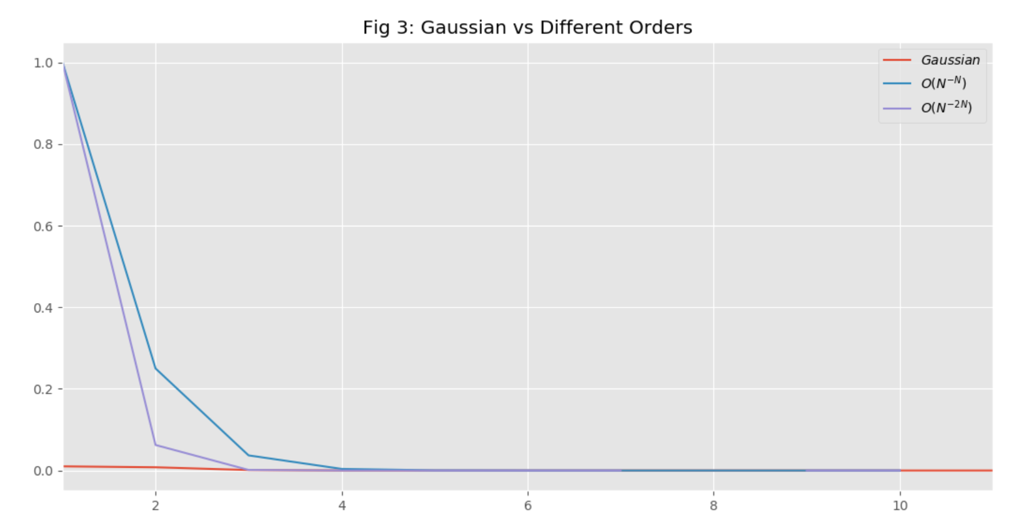

As we can see from the three figures above, the convergence rate of Midpoint error is between N^-2 and N^-3. And the Gaussian method is smaller than N^-2N.

1. Personally, I mostly like the Gaussian Method because it is very easy to implement in practice and has an extraordinary performance in approximating the integrals compared to other methods. But we still need to be careful of the variable transformation when applying this method.

**Problem 2**

1. For the current stock price, I used the close price of SPY500 on January 31th as S0, which is 321.73. Since r is 0, we could assume the mean of St is still S0. The price of Vanilla Option is 0.0522.
2. The price of contingent option is 0.02826.
3. When rho is 0.8, Contingent Option Price is : 0.0395

When rho is 0.5, Contingent Option Price is : 0.0490

When rho is 0.2, Contingent Option Price is : 0.0516

1. Yes. The correlation indeed matters. When correlation becomes greater, the price of contingent option becomes smaller. That is because both the prices in 6 months and 1 year would become higher or lower than 365 when the correlation increases. Both cases would decrease the value of the option.
2. When K2 is 360, Contingent Option Price is : 0.0136

When K2 is 350, Contingent Option Price is : 0.0004

When K2 is 340, Contingent Option Price is : 5.8545e-7

1. Yes. The strike price of the option expiring in 6 months also matters. When K2 increases, the option price increases too. That is because the price is more likely to be lower than the threshold when the strike price becomes bigger.
2. When K2 becomes infinity, and correlation is 0, the price of contingent option would be the same as vanilla option.