Exam the relationship Number of Visitors per Trip and Number of Trips Taken.

Exam variable with Scatter Plots

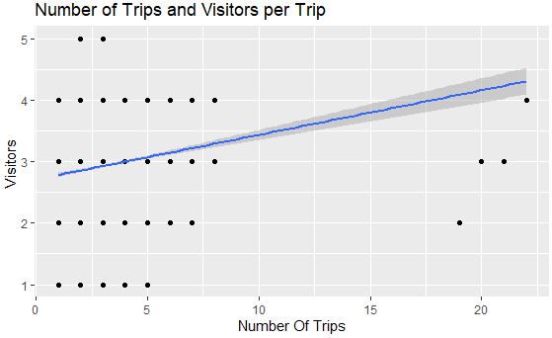

Observation:

* Number of Trips and Number of Visitors per Trips have a positive correlation.
* The majority of customers take under 10 trip with any group size.
* Groups of 2 to 4 make the most trips.
* People travel alone and group of 5 make 5 more less trip.

Pearson’s product-moment correlation:

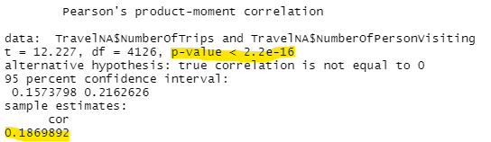

* p-value < 2.2e-16 indicate this is a significant correlation.
* r correlation coefficient is 0.1869892 indicates the correlation between Number of Trips and Visitors per Trip is a weak positive correlation.
* Our calculation result affirms our Scatter Plots.