COLLEGE WEBSITE

A Report submitted to the Department of

Computer Science & Engineering

**By**

G. Yashwanth (20kb1a0544) D. Yogish Reddy (20kb1a0537)

J. Siddarda Gowtham (20kb1a0547)

K. Sathish Babu (21kb5a0506) D. Siva Raghava (20kb1a0536)



DEPARTMENT OF COMPUTER SCIENCE & ENGINEERING

N.B.K.R. INSTITUTE OF SCIENCE & TECHNOLOGY

(AUTONOMOUS)

VIDYANAGAR- 524 413, TIRUPATHI DIST, AP



Website: [www.nbkrist.org](http://www.nbkrist.org/)  Ph: 08624-228 247

Mail: ist@nbkrist.org Fax: 08524-228 257

**N.B.K.R INSTITUTE OF SCIENCE & TECHNOLOGY**

(Autonomous)

(Approved by AICTE: Accredited by NBA: Affiliated to JNTUA, Ananthapuramu)

An ISO 9001-2000 Certified Institution

Vidyanagar -524 413, Tirupati District, Andhra Pradesh, India

BONAFIDE CERTIFICATE

This is to certify the report work entitled “COLLEGE WEBSITE” is the bonafide work done by J. Siddarda Gowtham (20KB1A0547), G. Yashwanth (20KB1A0544), D. Siva Raghava (20KB1A0536), K. Sathish Babu (21KB5A0506) & D. Yogish Reddy (20KB1A0537). The report is submitted to the department of COMPUTER SCIENCE & ENGINEERING, N.B.K.R Institute of science & Technology, Vidyanagar.

Internal Examiner External Examiner

**INDEX**

**S.NO TOPICS PAGE NO**

1. INTRODUCTION 4

1. MODULES 6

* 1. HOME PAGE 6

* 1. ABOUT PAGE 14

* 1. ADMISSION PAGE 22

* 1. PLACEMENTS PAGE 32

* 1. OVERVIEW PAGE 42

* 1. PORTAL PAGE 51

* 1. CONTACT US PAGE 52

1. BACKEND 62

1. CONCLUSION 74

5 REFERENCE 74

# 1. INTRODUCTION

The main purpose of College Website is to design, publish and to maintain a website for our college, which consists of all the information regarding College like infra structure, admission, academics, placements, about, contacts, etc**.**



**Fig 1: College Website**

Today all the work at the time of admission of the students is done manually by link and paper, which is very, slow and consuming much efforts and time. It is required to Design of Computerized Management System, to speed up and make it easy to use system. It reduces the manpower needed to perform the entire admission and administration task by reducing the paper works needed. The main goal of the system is to automate the process carried out in the organization with improved performance and realize the vision of complete paperless work.

### SCOPE

It is more efficient and convenient for the colleges. It reduces the man power needed to perform the entire administration task by reducing the paper works needed. if all the work is done by the computer there will be no chance of errors and moreover storing and retrieving of the information is easy, so work can be done speedily and in time.

### ADVANTAGES

* Easy to navigate
* Providing all the comprehensive information about the college
* Flash items are provided wherever necessary
* All the nostalgic images are provided in the gallery

**GLOSSARY**

|  |  |
| --- | --- |
| **TERM** | **DEFINITION** |
| HTML | Hypertext markup language |
| My SQL | My SQL |
| CSS | Cascading style sheet |
| PHP | Program hypertext preprocessor |

# 2. MODULES

## 2.1 HOME PAGE:

It is a basic page which provide complete access of different portals and gives a basic info of the college and achievements, events, campus life etc....

<!DOCTYPE html>

<head>

<title>

N.B.K.R INSTITUTE OF SCIENCE AND TECHNOLOGY

</title>

<link rel="stylesheet" href="Css\back.css">

<link rel="stylesheet" href="Css\footer.css">

<meta charset="utf-8">

<meta name="viewport" content="width=device-width, initial-scale=1">

</head>

<body>

<div class="logos">

<div id="nbkr">

<img src="Images\NBKRIST-logo.jpg" alt="nbkrlogo" width="400" height="150">

</div>

<div id="naac">

<img src="Images\naac2021logo.jpg" alt="naaclogo" height="100" width="100">

</div>

<div id="ugc">

<img src="Images\img1.jpg" alt="ugc" height="120" width="100">

</div>

<div id="aicte">

<img src="Images\AICTE.jpg" alt="aicte" height="95" width="95"> </div>

<div id="grade">

<img src="Images\img2.jpg" alt="grade" height="100" width="100">

</div>

<div id="nba">

<img src="Images\img4.jpg" alt="nba" width="100" height="100">

</div>

<div id="res">

<img src="Images\img5.jpg" alt="research" width="100" height="100">

</div>

</div>

<div class="navbar">

<div class="dropdown">

<button class="dropbtn"><a href="home.html" style="color:white;">Home</a>

</button>

</div>

<div class="dropdown">

<button class="dropbtn"><a href="about.html" style="color:white;">About</a>

</button>

</div>

<div class="dropdown">

</button class="dropbtn">

<button class="dropbtn">Academics

<div class="dropdown-content">

<a href="ug.html">B.Tech</a>

<a href="#">M.Tech</a>

</div>

</button>

</div>

<div class="dropdown">

<button class="dropbtn"><a href="admission.html"

style="color:white;">Admissions</a>

</button>

</div>

<div class="dropdown">

<button class="dropbtn"><a href="placements.html" style="color:white;">Placements</a>

</button>

</div>

<div class="dropdown">

<button class="dropbtn"><a href="overview.html" style="color: white;">Overview</a>

</button>

</div>

<div class="dropdown">

<button class="dropbtn">Portal

<div class="dropdown-content">

<a href="parentslogin.html">Parent</a>

<a href="facultylogin.html">Faculty</a>

</div>

</button>

</div>

<div class="dropdown">

<button class="dropbtn"><a href="contactus.html" style="color:white;">Contact us</a>

</button>

</div>

</div>

<div>

<div class="col1">

<p><img src="Images\achievements.png"></p>

</div>

<div class="col11">

<p><img src="Images\events.png"></p>

</div>

<div class="col12">

<img src="Images\campuslife.png">

</div>

</div>

<div class="achivements">

<div id="slideshow">

<div class="slide-wrapper">

<div class="slide">

<p class="slide-number">

<img src="Images\img 3.jpg" width="623px" height="418">

</p>

</div>

<div class="slide">

<p class="slide-number">

<img src="Images\img 4.jpg" width="623" height="418">

</p> </div>

<div class="slide">

<p class="slide-number">

<img src="Images\img 2.jpg" width="623" height="418">

</p>

</div>

<div class="slide">

<p class="slide-number">

<img src="Images\img 1.jpg" width="623" height="418">

</p>

</div> </div>

</div>

</div>

<div class="events">

<div id="slideshow">

<div class="slide-wrapper">

<div class="slide">

<p class="slide-number">

<img src="Images\sports.png" width="633" height="434">

</p>

</div>

<div class="slide">

<p class="slide-number">

<img src="Images\techvyuha.png" width="623" height="418">

</p> </div>

<div class="slide">

<p class="slide-number">

<img src="Images\parigrah.png" width="623" height="418">

</p>

</div>

<div class="slide">

<p class="slide-number">

<img src="Images\workshop.png" width="620" height="420">

</p>

</div>

</div>

</div>

</div>

<div class="campuslife">

<div id="slideshow">

<div class="slide-wrapper">

<! -- Define each of the slides and write the content -->

<div class="slide">

<h1 class="slide-number">

<img src="Images\campus1.jpg" width="623px" height="418">

</h1>

</div>

<div class="slide">

<h1 class="slide-number">

<img src="Images\campus 2.jpg" width="623" height="418">

</h1>

</div>

<div class="slide">

<h1 class="slide-number">

<img src="Images\campus3.jpg" width="623" height="418">

</h1>

</div>

<div class="slide">

<h1 class="slide-number">

<img src="Images\campus 4.jpg" width="623" height="418">

</h1>

</div>

</div>

</div>

</div>

<div class="footer">

<div class="ql ql1">

Professional Societies

<div class="qlc1 qlc">

<ul style="list-style-type:none">

<li><a href="https://www.ieee.org/" style="color:white">IEEE</a></li>

<li><a href="https://csi-india.org/" style="color:white">CSI</a></li>

<li><a href="http://www.isteonline.in/" style="color:white">ISTE</a></li>

</ul>

</div>

</div>

<div class="ql ql2">

Quick Links

<div class="qlc2 qlc">

<ul style="list-style-type:none">

<li>link 1</li>

<li>link 2</li>

<li>link 3</li>

<li>link 4</li>

</ul>

</div>

</div>

<div class="ql ql3">

Quick Links

<div class="qlc3 qlc">

<ul style="list-style-type:none">

<li>link 1</li>

<li>link 2</li>

<li>link 3</li>

<li>link 4</li>

</ul>

</div>

</div>

<div class="icons">

<img class="insta" src="Images\instagram.png" alt="instagram" width="25px" height="25px">

<img class="yout" src="Images\youtube.png" alt="youtube" width="25px" height="25px">

<img class="link" src="Images\linkedin.png" alt="linkedin" width="25px" height="25px">

</div>

<div class="copy">© Copyright N.B.K.R.I.S. T</div>

</div>

</body>



**Fig 2: Home page**

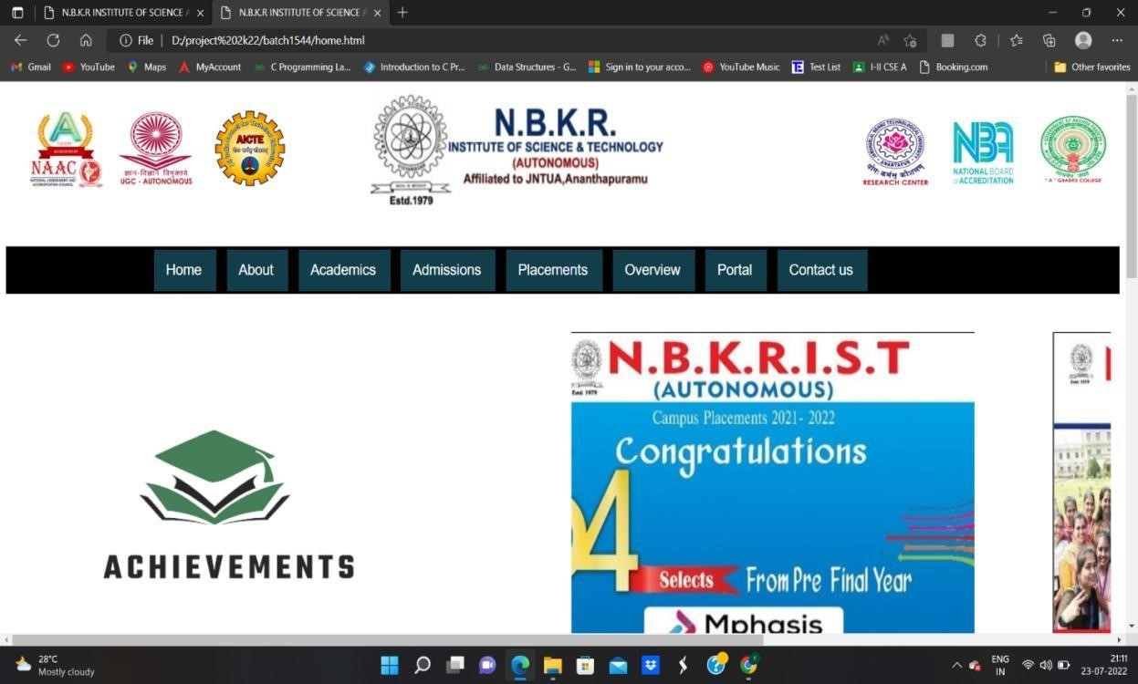

## 2.2 ABOUT:

This page gives the complete information about the college, director sir and Dr. I. gopalreddy sir

<!DOCTYPE html>

<html>

<head>

<title>

N.B.K.R INSTITUTE OF SCIENCE AND TECHNOLOGY

</title>

<link rel="stylesheet" href="Css\back.css">

<link rel="stylesheet" href="Css\about.css">

</head>

<body>

<div class="logos">

<div id="nbkr">

<img src="Images\NBKRIST-logo.jpg" alt="nbkrlogo" width="400" height="150">

</div>

<div id="naac">

<img src="Images\naac2021logo.jpg" alt="naaclogo" height="100" width="100">

</div>

<div id="ugc">

<img src="Images\img1.jpg" alt="ugc" height="120" width="100">

</div>

<div id="aicte">

<img src="Images\AICTE.jpg" alt="aicte" height="95" width="95">

</div>

<div id="grade">

<img src="Images\img2.jpg" alt="grade" height="100" width="100">

</div>

<div id="nba">

<img src="Images\img4.jpg" alt="nba" width="100" height="100">

</div>

<div id="res">

<img src="Images\img5.jpg" alt="research" width="100" height="100">

</div>

<! --<div id="qic">

<img src="img6.jpg" alt="qic" width="140" height="100">

</div>-->

</div>

<div class="navbar">

<div class="dropdown">

<button id="home" class="dropbtn"><a href=home.html style="color:

white;">Home</a></button>

</div>

<div class="dropdown">

<button class="dropbtn"><a href="about.html" style="color:white;">About</a>

</button>

</div>

<div class="dropdown">

</button class="dropbtn">

<button class="dropbtn">Academics

<div class="dropdown-content">

<a href="ug.html">B.tech</a>

<a href="#">M.tech</a>

</div>

</button>

</div>

<div class="dropdown">

<button class="dropbtn"><a href="admission.html" style="color:white;">Admissions</a>

</button>

</div>

<div class="dropdown">

<button class="dropbtn"><a href="placements.html" style="color:white;">Placements</a>

</button>

</div>

<div class="dropdown">

<button class="dropbtn"><a href="overview.html" style="color:white;">Overview</a>

</button>

</div>

<div class="dropdown">

<button class="dropbtn">Portal

<div class="dropdown-content">

<a href="parentslogin.html">Parent</a>

<a href="facultylogin.html">Faculty</a>

</div>

</button>

</div>

<div class="dropdown">

<button class="dropbtn"><a href="contactus.html" style="color:white;">Contact us</a>

</button>

</div>

</div>

<div id="block"><img align="right" src="Images\nb.jpeg" alt="Paris" top=5px width="470px" height="290px"></div>

<div><p>Established in 1979, NBKR Institute of Science & Technology is an Autonomous Institute affiliated to JNT University Anantapur. This Institute is reaccredited by NAAC (UGC) for the second cycle with "A" grade. All B.Tech. courses are accredited by National Board of Accreditation (NBA) under Tier 1. UGC awarded the status of "College with Potential for Excellence (CPE)" to our Institute.

The institute offers B.Tech. programs in Computer Science & Engineering, Electronics &

Communication Engineering, Electrical & Electronics Engineering, Mechanical Engineering,

Civil Engineering, and Information Technology. M. Tech. programs are offered in Power Systems,

Computer Science & Engineering, Digital Electronics & Communication Systems, Advanced Manufacturing Systems. The institute has an R&D Cell and recognized research centers of JNT University Ananthpuramu offering Ph.D. programs.

Guest lectures are regularly organized on latest trends by eminent industry experts, Entrepreneurs and HR managers.

The institute is spread across a lush green 184-acre campus that houses academic blocks, Boys and Girls hostels, Open air auditorium, sports complex, staff quarters etc. The Institute focuses on skill and professional development of the graduates through student run clubs, technical associations.

Professional chapters like IEEE, ISTE, IETE, CSI exist in our Institute.

Department laboratories and Computer Centre has state-of-the-art equipment to fulfil the needs of the researchers, students, and faculty. The central library is well-stocked with books, journals, magazines, and newspapers. It subscribes thousands of e-journals, e-books. The e-resources can be accessed through the campus network.

There are adequate opportunities for co-curricular and extra-curricular activities helping students gain overall skills. Industrial visits and relevant field visits expose the students to hands-on learning experience.

Industry Institute Partnership Cell (IIP Cell) caters the needs of the Institute and Industry by way of internships, consultancy. I Gopal Reddy, Founder Principal, Former Vice Chancellor, JNTU is the current chairperson. Dr Pokkuluri Kiran Sree is the former principal of the institute. Entrance of Admin,Electrical Engineering block V Vijaya Kumar Reddy is the director of the institute. Spread over 185 acres (75 ha), the college is a fully residential college and is located on the bank of river Swarnamukhi and is on the coastal line of Andhra Pradesh. The college was accredited by NBA four times. It is reaccredited by NAAC with A Grade. It was given Autonomous status by UGC, New Delhi from the Academic Year 2012–2013. There are four boy's hostels (Venus,

Jupiter, Mercury, and Neptune) and two girl's hostels and 72 residential quarters for the staff. </p> <p>The Institute is spread across a lush green 184-acre campus that houses academic blocks, Boys and Girls hostels, Open air auditorium, sports complex, staff quarters etc. The Institute focuses on skill and professional development of the graduates through student run clubs, technical associations. Professional chapters like IEEE, ISTE, IETE, CSI exist in our Institute. </p> </div>

<hr>

<h1></b>DIRECTOR</b></h1>

<div class="dir"><img align="right" src="Images\director.jpeg" width="300px" height="190px" ></div>

<div><p>Vijay Kumar (born 12 April 1962) is an Indian roboticist and UPS foundation professor in the School of Engineering & Applied Science with secondary <br>appointments in computer</p>

<p> and information science and electrical and systems engineering at the University of

Pennsylvania, and became the new Dean of Penn</p>

<p>B.Tech., Mechanical Engineering, Indian Institute of Technology, Kanpur, India, May 1983

M.Sc., Mechanical Engineering, Ohio State University, Columbus, Ohio, March 1988</p>

<p> Ph.D., Mechanical Engineering, Ohio State University, Columbus, Ohio, September

1987</p></div>

<hr>

<br>

<br>

<h2><b>Dr.I.GOPAL REDDY</b></h2>

<div><p> Dr.I.Gopal Reddy,Former Vice Chancellor, JNTU Chairman, NBKRIST.<br> <br>MESSAGE: It is an occasion to appreciate our entire faculty and students for launching college newsletter. I consider this wonderful opportunity, privilege and honor<br> to lead such progressive educational establishment. </p></div>

<div class="imp"><img align="right" src="Images\gopal.jpeg" top="10px" width="300px" height="190px" class="centre"></div>

</p>

<div class="footer">

<div class="ql ql1">

Professional Societies

<div class="qlc1 qlc">

<ul style="list-style-type:none">

<li><a href="https://www.ieee.org/" style="color:white">IEEE</a></li>

<li><a href="https://csi-india.org/" style="color:white">CSI</a></li>

<li><a href="http://www.isteonline.in/" style="color:white">ISTE</a></li>

</ul>

</div>

</div>

<div class="ql ql2">

Quick Links

<div class="qlc2 qlc">

<ul style="list-style-type:none">

<li>link 1</li>

<li>link 2</li>

<li>link 3</li>

<li>link 4</li>

</ul>

</div>

</div>

<div class="ql ql3">

Quick Links

<div class="qlc3 qlc">

<ul style="list-style-type:none">

<li>link 1</li>

<li>link 2</li>

<li>link 3</li>

<li>link 4</li>

</ul>

</div>

</div>

<div class="icons">

<img class="insta" src="Images\instagram.png" alt="instagram" width="25px" height="25px">

<img class="yout" src="Images\youtube.png" alt="youtube" width="25px" height="25px">

<img class="link" src="Images\linkedin.png" alt="linkedin" width="25px" height="25px"> </div>

<div class="copy">© Copyright N.B.K.R.I.S. T</div>

</div>

<

/body>



**Fig 3: About page**

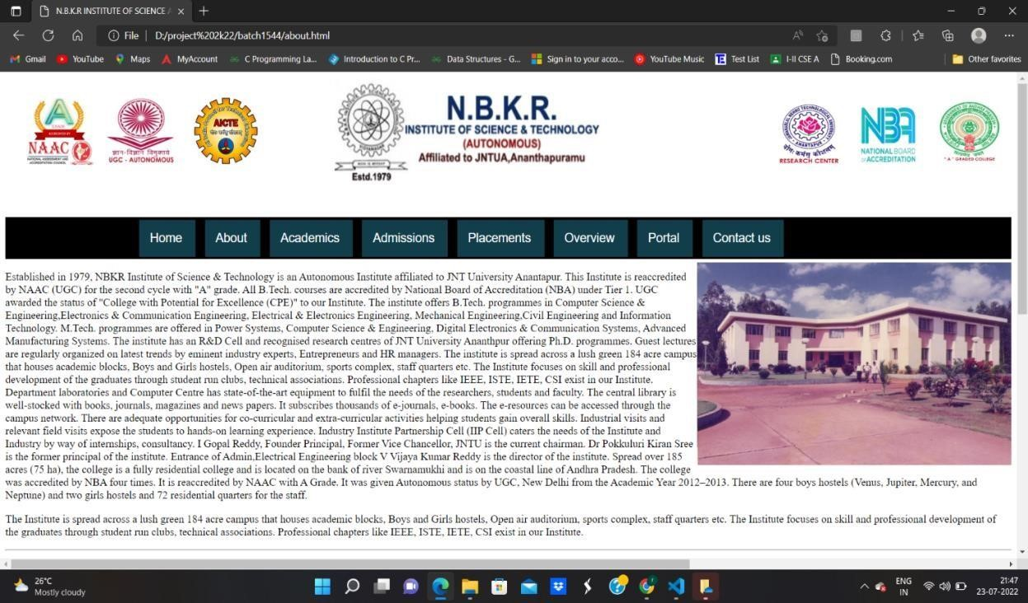

**2.3 ADMISSSIONS:**

This portal will give a complete detail of the fee's details, B. Tech, M. Tech, course’s and other bank details for the transactions.

<!DOCTYPE html>

<head>

<title>

N.B.K.R INSTITUTE OF SCIENCE AND TECHNOLOGY

</title>

<link rel="stylesheet" href="Css\back.css">

<link rel="stylesheet" href="Css\admission.css">

<link rel="stylesheet" href="Css\footer.css">

</head>

<body>

<div class="logos">

<div id="nbkr">

<img src="Images\NBKRIST-logo.jpg" alt="nbkrlogo" width="400" height="150">

</div>

<div id="naac">

<img src="Images\naac2021logo.jpg" alt="naaclogo" height="100" width="100">

</div>

<div id="ugc">

<img src="Images\img1.jpg" alt="ugc" height="120" width="100">

</div>

<div id="aicte">

<img src="Images\AICTE.jpg" alt="aicte" height="95" width="95">

</div>

<div id="grade">

<img src="Images\img2.jpg" alt="grade" height="100" width="100">

</div>

<div id="nba">

<img src="Images\img4.jpg" alt="nba" width="100" height="100">

</div>

<div id="res">

<img src="Images\img5.jpg" alt="research" width="100" height="100">

</div>

<!--<div id="qic">

<img src="img6.jpg" alt="qic" width="140" height="100">

</div>-->

</div>

<div class="navbar">

<div class="dropdown">

<button id="home" class="dropbtn"><a href="home.html" style="color:white;">Home</a>

</div>

<div class="dropdown">

<button class="dropbtn"><a href="about.html" style="color:white;">About</a>

</button>

</div>

<div class="dropdown">

</button class="dropbtn">

<button class="dropbtn">Academics

<div class="dropdown-content">

<a href="ug.html">B.tech</a>

<a href="#">M.tech</a>

</div>

</button>

</div>

<div class="dropdown">

|  |  |  |
| --- | --- | --- |
| <button  style="color:white;">Admission</a>  </button>  </div>  <div class="dropdown"> | class="dropbtn"><a | href="admissions.html" |
| <button | class="dropbtn"><a | href="placements.html" |
| style="color:white;">Placements</a> | |

</button>

</div>

<div class="dropdown">

<button class="dropbtn"><a href="overview.html" style="color:white;">Overview</a>

</button>

</div>

<div class="dropdown">

<button class="dropbtn">Portal

<div class="dropdown-content">

<a href="parentslogin.html">Parent</a>

<a href="facultylogin.html">Faculty</a>

</div>

</button>

</div>

<div class="dropdown">

<button class="dropbtn"><a href="contactus.html" style="color:white;">Contact us</a>

</button>

</div>

</div>

<h1>

<center><b>Admission Procedure</b></center></h1>

<br>

<hr>

<p>NBKR Institute of Science & Technology offers 4 year Undergraduate Programme in Engineering (B.Tech),2 year Postgraduate Programme in Engineering (M.Tech) and Doctoral Program in Engineering(PhD), The admission into the B.Tech courses except Category-B Seats is through a State-Level Entrance Test called "Engineering, Agriculture and Medical Common Entrance Test" (EAPCET) conducted by the Government of Andhra Pradesh.</p>

<br>

<p>70% seats are alloted by the Convenor, EAPCET and the Remaining 30%(Category-B)are filled by the apsche based on the Rank obtained in JEE Mains or EAPCET or Intermediate marks. Sanctioned Intake for the The College from the Academic Year 2021 - 2022 :: 960</p> <table width="100%">

<tr>

<th>Programmed by</th>

<th>Fee</th>

</tr>

<tr>

<td>B.tech</td>

<td>70000</td>

</tr>

<tr>

<td>M.tech</td>

<td>57000</td>

</tr>

</table>

<br>

<p>For further details please contact ::</p>

<br>

<table width="100%">

<tr>

<th>NAME</th>

<th>Responsabulity</th>

<th>number</th>

</tr>

<tr>

<td>Dr. C. Raveendra Reddy,

Professor & HOD</td>

<td>Dr. C. Raveendra Reddy,

Professor & HOD</td>

<td>

9441572755,9440765118,9440243010

</td>

</tr>

</table>

<br>

<h2><b>B.TECH</b></h2>

<table width="100%">

<tr>

<th>Branch</th>

<th>Intake seat</th>

</tr>

<tr>

<td>Civil Engineering</td>

<td>120</td>

</tr>

<tr>

<td>Mechanical Engineering</td>

<td>180</td>

</tr>

<tr>

<td>ELECTRICAL AND ELECTRONICS ENGINEERING</td>

<td>120</td>

</tr>

<tr>

<td>ELECTRONICS AND COMMUNICATION ENGINEERING</td>

<td>180</td>

</tr>

<tr>

<td>ARTIFICIAL INTELLIGENCE & DATA SCIENCE</td>

<td>120</td>

</tr>

<tr>

<td>COMPUTER SCIENCE AND ENGINEERING</td>

<td>180</td>

</tr>

<tr>

<td>INFORMATION AND TECHNOLOGY</td>

<td>60</td>

</tr>

</table>

<br>

<h2><b>M.TECH</b></h2>

<br>

<table width="100%">

<tr>

<th>Branch</th>

<th>Intake Seats</th>

</tr>

<tr>

<td>COMPUTER SCIENCE AND ENGINEERING(CSE)</td>

<td>18</td>

</tr>

<tr>

<td>DIGITAL ELECTRONICS AND COMMUNICATION SYSTEMS(ECE)</td> <td>18</td>

</tr>

<tr>

<td>POWER SYSTEMS(EEE)</td>

<td> 18</td>

</tr>

<tr>

<td>ADVANCED MANUFACTURING SYSTEMS(ME)</td>

<td>18</td>

</tr>

</table>

<h2>Bank Details for Payment</h2>

<h3>Union Bank of India:</h3>

<table width="100%">

<tr>

<th colspan="2">Union Bank of India,Vidyanagar Education Complex Branch(1160)</th>

</tr>

<tr>

<td>A/C No</td>

<td>116010011000353</td>

</tr>

<tr>

<td>Name</td>

<td>DIRECTOR NBKRIST</td>

</tr>

<tr>

<td>IFSC</td>

<td>UBIN0811602</td>

</tr>

</table>

<br>

<h3>State Bank of India</h3>

<table width="100%">

<tr>

<th colspan="2">State Bank of India:</th>

</tr>

<tr>

<td>A/C No</td>

<td>33362532008</td>

</tr>

<tr>

<td>Name</td>

<td>DIRECTOR NBKRIST</td>

</tr>

<tr>

<td>IFSC</td>

<td>SBIN0002811</td>

</tr>

</table>

<div class="footer">

<div class="ql ql1">

Professional Societies

<div class="qlc1 qlc">

<ul style="list-style-type:none">

<li><a href="https://www.ieee.org/" style="color:white">IEEE</a></li>

<li><a href="https://csi-india.org/" style="color:white">CSI</a></li>

<li><a href="http://www.isteonline.in/" style="color:white">ISTE</a></li>

</ul>

</div>

</div>

<div class="ql ql2">

Quick Links

<div class="qlc2 qlc">

<ul style="list-style-type:none">

<li>link 1</li>

<li>link 2</li>

<li>link 3</li>

<li>link 4</li>

</ul>

</div>

</div>

<div class="ql ql3">

Quick Links

<div class="qlc3 qlc">

<ul style="list-style-type:none">

<li>link 1</li>

<li>link 2</li>

<li>link 3</li>

<li>link 4</li>

</ul>

</div>

</div>

<div class="icons">

<img class="insta" src="Images\instagram.png" alt="instagram" width="25px" height="25px">

<img class="yout" src="Images\youtube.png" alt="youtube" width="25px" height="25px">

<img class="link" src="Images\linkedin.png" alt="linkedin" width="25px" height="25px"> </div>

<div class="copy">© Copyright N.B.K.R.I.S.T</div>

</div>

</body>

Fig 4: Admissions page

**2.4**

**PLACEMENTS**

:

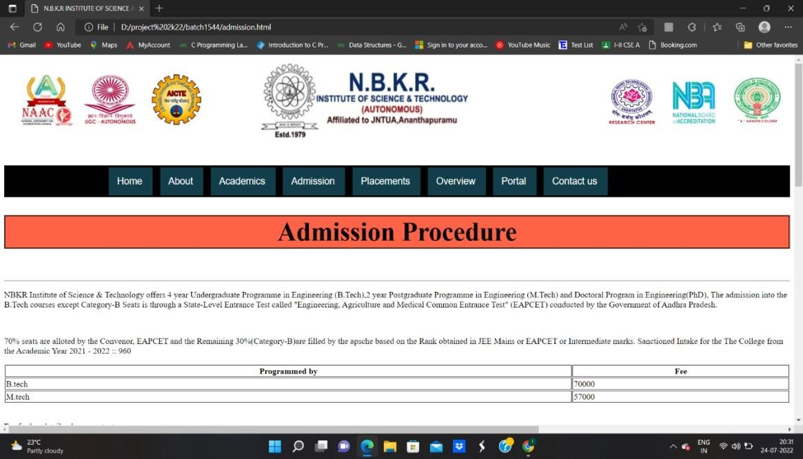

One faculty member from each Engineering Department is deputed as Training & Placement Office Coordinator to maintain the rapport between the department and the Training & Placement Cell. A separate wing is allotted to the Training & Placement cell.

Training Programs for GATE and Technical Training in C, Java & Python are being conducted regularly to the final and Pre-final students of all classes along with Campus Recruitment Training Programs to impart competitive skills, communication skills, mock Interviews and Group discussions techniques.

<!DOCTYPE html>

<head>

<title>

N.B.K.R INSTITUTE OF SCIENCE AND TECHNOLOGY

</title>

<link rel="stylesheet" href="Css\back.css">

<link rel="stylesheet" href="Css\footer.css">

<link rel="stylesheet" href="https://maxcdn.bootstrapcdn.com/fontawesome/4.7.0/css/fontawesome.min.css">

<meta charset="utf-8">

<meta name="viewport" content="width=device-width, initial-scale=1">

<link rel="stylesheet" href="Css\placements.css">

</head>

<body>

<div class="logos">

<div id="nbkr">

<img src="Images/NBKRIST-logo.jpg" alt="nbkrlogo" width="400" height="150">

</div>

<div id="naac">

<img src="Images/naac2021logo.jpg" alt="naaclogo" height="100" width="100">

</div>

<div id="ugc">

<img src="Images/img1.jpg" alt="ugc" height="120" width="100">

</div>

<div id="aicte">

<img src="Images/AICTE.jpg" alt="aicte" height="95" width="95">

</div>

<div id="grade">

<img src="Images/img2.jpg" alt="grade" height="100" width="100">

</div>

<div id="nba">

<img src="Images/img4.jpg" alt="nba" width="100" height="100">

</div>

<div id="res">

<img src="Images/img5.jpg" alt="research" width="100" height="100">

</div>

</div>

<div class="navbar">

<div class="dropdown">

<button class="dropbtn"><a href="home.html" style="color:white;">Home</a>

</button>

</div>

<div class="dropdown">

<button class="dropbtn"><a href="about.html" style="color:white;">About</a>

</button>

</div>

<div class="dropdown">

</button class="dropbtn">

<button class="dropbtn">Academics

<div class="dropdown-content"> <a href="ug.html">B.tech</a>

<a href="#">M.tech</a>

</div>

</button>

</div>

<div class="dropdown">

<button class="dropbtn"><a href="admission.html" style="color:white;">Admissions</a>

</button>

</div>

<div class="dropdown">

<button class="dropbtn"><a href="placements.html" style="color:white;">Placements</a>

</button>

</div>

<div class="dropdown">

<button class="dropbtn"><a href="overview.html" style="color:white;">Overview</a>

</button>

</div>

<div class="dropdown">

<button class="dropbtn">Portal

<div class="dropdown-content">

<a href="parentslogin.html">Parent</a>

<a href="facultylogin.html">Faculty</a>

</div>

</button>

</div>

<div class="dropdown">

<button class="dropbtn"><a href="contactus.html" style="color:white;">Contact us</a>

</button>

</div>

</div>

<div class="placements">

<table width="100%" border="2" cellspacing="0" cellpadding="0"> <tr class="heading">

<td><b><center><b><h3>Training & Placement Cell</h3></b></center>

</td>

</tr>

<tr>

<td height="100%" background="/images/content-bg-br_990.gif" align="left" valign="top" class="ContentM">

<p class="ContentM">

<h5>

<p>NBKR IST Training & Placement cell functions with an objective of creating ample career opportunities for students in reputed Corporate Companies. A separate Training & Placement Cell is existing in the college and one of the senior members is acting as head of the Training & Placement Cell and he is assisted by one experienced Placement Officer and five trainers. </p>

<h5>

<table width="100%" border="2">

<tr class="thead">

<td><b>SNO</b></td>

<td><b>Name</b></td>

<td><b>Position</b></td>

<td><b>Mobile.NO</b></td>

<td><b>E-Mail ID</b> </td>

</tr>

<!--

<tr>

<td>1</td>

<td>Mrs.B. Vasavi</td>

<td>Head, Training & Placement</td>

<td>9493238155</td>

<td>placement@nbkrist.org</td>

</tr>-->

<tr>

<td>1</td>

<td>Dr. N. Kishandar</td>

<td>Head,Training & Placement</td>

<td>8333801122</td>

<td>placement@nbkrist.org</td>

</tr>

<tr>

<td>2</td>

<td>Dr.Ch. Madhava reddy</td>

<td>Training & Placement Officer</td>

<td>9493915859</td>

<td>madhavac@gmail.com</td>

</tr>

<tr>

<td>3</td>

<td>Dr.Shaik Abzal</td>

<td>Aptitude Trainer</td>

<td>9401170916</td>

<td>abbuoct23@gmail.com</td>

</tr>

<tr>

<td>4</td>

<td>Mr.V.Bhuvana Kumar</td>

<td>CSE Department Co ordinator</td>

<td>9080150815</td>

<td>vbkumar1993@gmail.com</td>

</tr>

<tr>

<td>5</td>

<td>Mr.K.Kannaiah</td>

<td>ECE Department Co ordinator</td>

<td>8790231800</td>

<td>kannaiah.kanna9@gmail.com</td>

</tr>

<tr>

<td>6</td>

<td>Mr.T. Mabu Subhani</td>

<td>EEE Department Co ordinator</td>

<td>9703418727</td>

<td>subhanithota2001@gmail.com</td>

</tr>

<tr>

<td>7</td>

<td>K.Ramesh Kumar</td>

<td>MECH Department Co ordinator</td>

<td>9640200804</td>

<td>ramesh.bemi@gmail.com</td>

</tr>

<tr>

<td>8</td>

<td>V.Balaji</td>

<td>CIVIL Department Co ordinator</td>

<td>9985819935</td>

<td>vbalaji202@gmail.com</td>

</tr>

</table>

</h5>

</h5>

</p>

<p>One faculty member from each Engineering Department is deputed as Training & Placement Office Coordinator to maintain the rapport between the department and the Training & Placement Cell. A separate wing is allotted to the Training & Placement cell.

</p>

<p>Training Programs for GATE and Technical Training in C, Java & Python are being conducted regularly to the final and Pre-final students of all classes along with Campus Recruitment Training Programs to impart competitive skills, communication skills, mock Interviews and Group discussions techniques.</p>

<p>Around 30 companies from both software and core visit the college every year. The average salary during the present academic year is 3.05 Lakhs with highest being 6.00 Lakhs per annum.</p>

<h2>OBJECTIVES</h2>

<ol>

<li> To showcase NBKRIST as the placement destination for all the corporate companies.</li>

<li>To impart the technical and soft skill training programs to enhance the employability skills of the students.</li>

<li>To conduct more Industry-Institute-Interaction.</li>

<li>To keep self-targets for increasing the number of Companies to be visited ( previous Placement number).</li>

<li>To encourage students to participate in paper presentations, seminars, workshops and conferences.</li>

<li>Scheduling Campus Training programs from 1st year to prepare students to cater according to the corporate needs & requirements.</li>

<li>To invite corporate people to set up their “Centre of Excellence” in the college.</li>

</ol>

<h2>INDUSTRY INSTITUTE INTERACTIONS</h2>

<ol>

<li>Dassault Systems authorized Academic certification center.</li>

<li>Aveva certified as “Center of Excellence”.</li>

<li>APSSDC Certified as CMs skill Execellence center.</li>

<li>D-Link Academy as “Center of Excellence” for Networking.</li>

<li>HUAWEI as “Center of Excellence” for wireless Networking.</li>

<li>MOU with GTT on Soft Skill Training program.</li>

<li>MOU with PRIME MEDIAN for Japanese Skill Transfer program.</li>

<li>MOU with RED HAT Academy on Industry Academia interaction program.</li>

<li>MOU with APITA on Industry Academia interaction program.</li>

<li>Member Institute with ICT Academy.</li>

</ol>

<h2>INFRASTRUCTURE</h2>

<ol>

<li>Three Seminar Halls with LCD Projector and Public Audio System.</li>

<li>Interview & GD Cabins.</li>

<li>Computer Labs (with high-speed LAN) for conducting online exam.</li>

</ol>

</td>

</tr>

</table>

</div>

<div class="footer">

<div class="ql ql1">

Professional Societies

<div class="qlc1 qlc">

<ul style="list-style-type:none">

<li><a href="https://www.ieee.org/" style="color:white">IEEE</a></li>

<li><a href="https://csi-india.org/" style="color:white">CSI</a></li>

<li><a href="http://www.isteonline.in/" style="color:white">ISTE</a></li>

</ul>

</div>

</div>

<div class="ql ql2">

Quick Links

<div class="qlc2 qlc">

<ul style="list-style-type:none">

<li>link 1</li>

<li>link 2</li>

<li>link 3</li>

<li>link 4</li>

</ul>

</div>

</div>

<div class="ql ql3">

Quick Links

<div class="qlc3 qlc">

<ul style="list-style-type:none">

<li>link 1</li>

<li>link 2</li>

<li>link 3</li>

<li>link 4</li>

</ul>

</div> </div>

<div class="icons">

|  |  |  |  |
| --- | --- | --- | --- |
| <img class="insta" height="25px"> | src="Images\instagram.png" | alt="instagram" | width="25px" |
| <img class="yout" height="25px"> | src="Images\youtube.png" | alt="youtube" | width="25px" |
| <img class="link" height="25px">  </div> | src="Images\linkedin.png" | alt="linkedin" | width="25px" |
| <div class="copy">© | Copyright N.B.K.R.I.S.T</div> | |  |

</div> </body>

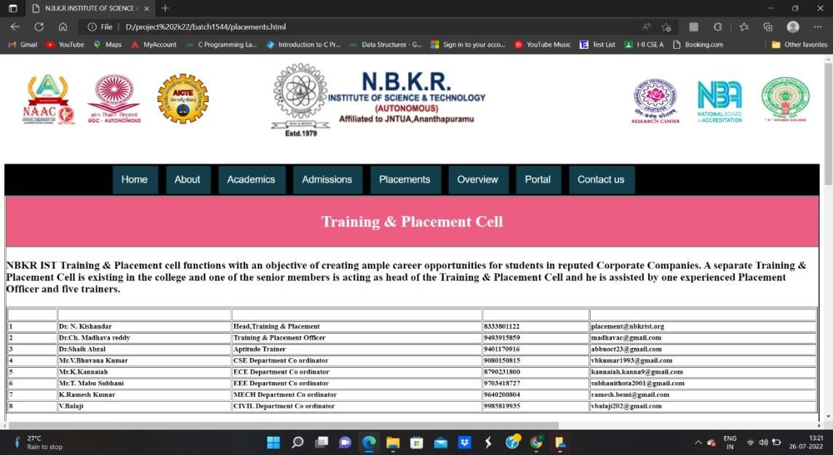

Fig 5: Placements page

**2.5 Over view:**

It gives a complete information about the college and address of the college and Accredited clubs and societies

<!DOCTYPE html>

<html lang="en">

<head>

<meta charset="UTF-8">

<meta http-equiv="X-UA-Compatible" content="IE=edge">

<meta name="viewport" content="width=device-width, initial-scale=1.0">

<link rel="stylesheet" href="Css\back.css">

<link rel="stylesheet" href="Css\overview.css">

<link rel="stylesheet" href="Css\overviewfoot.css">

<title>

N.B.K.R INSTITUTE OF SCIENCE AND TECHNOLOGY

</title>

</head>

<body>

<div class="logos">

<div id="nbkr">

<img src="Images\NBKRIST-logo.jpg" alt="nbkrlogo" width="400" height="150">

</div>

<div id="naac">

<img src="Images\naac2021logo.jpg" alt="naaclogo" height="100" width="100">

</div>

<div id="ugc">

<img src="Images\img1.jpg" alt="ugc" height="120" width="100"> </div>

<div id="aicte">

<img src="Images\AICTE.jpg" alt="aicte" height="95" width="95">

</div>

<div id="grade">

<img src="Images\img2.jpg" alt="grade" height="100" width="100">

</div>

<div id="nba">

<img src="Images\img4.jpg" alt="nba" width="100" height="100">

</div>

<div id="res">

<img src="Images\img5.jpg" alt="research" width="100" height="100">

</div>

</div>

<div class="navbar">

<div class="dropdown">

<button class="dropbtn"><a href="home.html" style="color:white;">Home</a>

</button>

</div>

<div class="dropdown">

<button class="dropbtn"><a href="about.html" style="color:white;">About</a>

</button>

</div>

<div class="dropdown">

</button class="dropbtn">

<button class="dropbtn">Academics

<div class="dropdown-content">

<a href="ug.html">B.Tech</a>

<a href="#">M.Tech</a>

</div>

</button>

</div>

<div class="dropdown">

<button class = “dropbtn”> < ahref= “admission.html” style=”color : white;”> Admissions</a>

</button>

</div>

<div class="dropdown">

<button class="dropbtn"><a href="placements.html" style="color:white;">Placements</a>

</button>

</div>

<div class="dropdown">

<button class="dropbtn"><a href="overview.html" style="color:white;">Overview</a>

</button>

</div>

<div class="dropdown">

<button class="dropbtn">Portal

<div class="dropdown-content">

<a href="parentslogin.html">Parent</a>

<a href="facultylogin.html">Faculty</a>

</div>

</button>

</div>

<div class="dropdown">

<button class="dropbtn"><a href="contactus.html" style="color:white;">Contact us</a>

</button>

</div>

</div>

<div class="overview">

<div class="about">

<center>

<h1>About</h1>

</center>

<p>

NBKR Institute of Science and Technology is a private autonomous institution established in the year 1979. It is also known as NBKRIST. The college is affiliated to Jawaharlal

Nehru Technological University, Anantapur. The National Assessment and Accreditation Council

(NAAC) has accredited the institute with an ‘A’ grade. It has been granted ‘College with Potential for Excellence (CPE)’ status by the University Grants Commission (UGC). The campus of NBKRIST is spread over an area of 184 acres and it has a total of 204 faculty members. As per the official website of the college, its mission is to develop effective learning skills enabling students to pick up critical thinking thus crafting them professionally fit and ethically strong.

</p>

<p>

The college offers B.Tech, M.Tech. and Ph.D courses. All the Bachelor of Technology (B.Tech) courses of the institute are accredited by the National Board of Accreditation (NBA). NBKRIST accepts AP EAMCET scores for admission to B.Tech courses. The college offers its courses in full-time mode. To provide industrial training to the students, the institute has collaborations with numerous corporations. The training and placement cell of NBKR Institute of Science and Technology offers a large number of placement and internship opportunities to the students. The campus of the institute has modern and upgraded facilities & infrastructure for students and faculty members.

</p>

</div>

<div class="loca">

<center><h1>Location</h1></center>

<ul><li>Our institution is located at Vidyanagar Kota, S.P.S.R, Andhra Pradesh.</li><li>The nearest airport to the college is Tirupati International Airport. It is located 82.5 km away from the campus.</li><li>With a

distance of 25.7 km, Pedapariya Railway Station is the nearest railway station to the

institute.</li><li>

Our institution is situated at a distance of 4.4 km away from the

Nayudupet Bus Stand.</li>

</ul>

</div>

<div class="acc">

<center><h1>Accreditions</h1></center>

<ul>

<li>NAAC has accredited the institute with an ‘A’ grade.</li><br>

<li>B.Tech courses are accredited by the NBA.</li>

</ul>

</div>

<div class="collab">

<center><h1>Collaborations</h1></center>

<ul>

<li>Prime Meiden</li><br>

<li>Huawei center of Excellence through Cognitel Training Services Pvt. Ltd.</li><br>

<li>Global Talent Track Private Limited</li><br>

<li>D-Link India Ltd.</li><br>

<li>Jupiter Control Systems</li><br>

<li>Electro Solar Solutions</li><br>

<li>Digital Shark Technology Pvt. Ltd.</li><br>

</ul>

</div>

<div class="clubs">

<center><h1>Clubs and Societies</h1></center>

<p>The institute has numerous clubs and societies for the students. NBKRIST clubs and societies provide students with the opportunity to show their talent. Furthermore, it allows students to follow their passion. Clubs and Societies at the campus organize various events at the campus. </p><br>

<ul>

<li>Networking Club</li><br>

<li>Data Science Club</li><br>

<li>Literary Club</li><br>

<li>Cultural Club</li><br>

<li>Language Club</li><br>

<li>Sports Club</li><br>

</ul>

</div>

<div></div>

</div>

<div class="footer">

<div class="ql ql1">

Professional Societies

<div class="qlc1 qlc">

<ul style="list-style-type:none">

<li><a href="https://www.ieee.org/" style="color:white">IEEE</a></li>

<li><a href="https://csi-india.org/" style="color:white">CSI</a></li>

<li><a href="http://www.isteonline.in/" style="color:white">ISTE</a></li>

</ul>

</div>

</div>

<div class="ql ql2">

Quick Links

<div class="qlc2 qlc">

<ul style="list-style-type:none">

<li>link 1</li>

<li>link 2</li>

<li>link 3</li>

<li>link 4</li>

</ul>

</div>

</div>

<div class="ql ql3">

Quick Links

<div class="qlc3 qlc">

<ul style="list-style-type:none">

<li>link 1</li>

<li>link 2</li>

<li>link 3</li>

<li>link 4</li>

</ul>

</div>

</div>

<div class="icons">

class="insta" src="Images\instagram.png" alt="instagram" width="25px"

<img

height="25px">

class="yout" src="Images\youtube.png" alt="youtube" width="25px"

<img

height="25px">

<img class="link" src="Images\linkedin.png" alt="linkedin" width="25px" height="25px">

</div>

<div class="copy">© Copyright N.B.K.R.I.S.T</div>

</div>

</body>

</html>

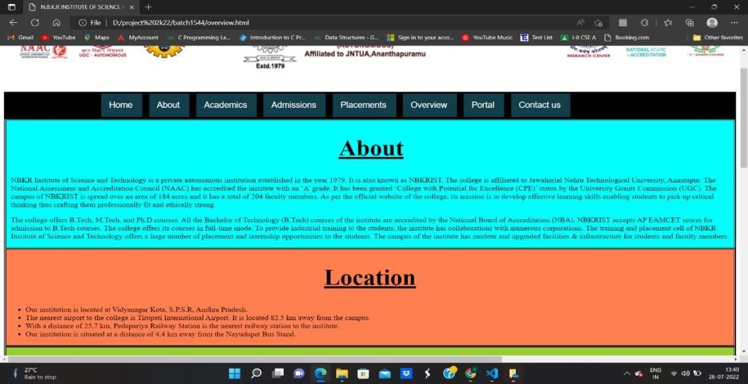

**Fig 6: Overview page**

## 2.6 Portal:

By entering the Roll number of the student, parent can access the details of their ward such as semester marks, mid marks, attendance, class incharge Name, contact.

<!DOCTYPE html>

<head>

<title>

N.B.K.R INSTITUTE OF SCIENCE AND TECHNOLOGY

</title>

<link rel="stylesheet" href="Css\parent.css">

<link rel="stylesheet" href="Css\style.css"> </head>

<body>

<div class="logos">

<div id="nbkr">

<img src="Images\NBKRIST-logo.jpg" alt="nbkrlogo" width="400" height="150">

</div>

<div id="naac">

<img src="Images\naac2021logo.jpg" alt="naaclogo" height="100" width="100">

</div>

<div id="ugc">

<img src="Images\img1.jpg" alt="ugc" height="120" width="100">

</div>

<div id="aicte">

<img src="Images\AICTE.jpg" alt="aicte" height="95" width="95">

</div>

<div id="grade">

<img src="Images\img2.jpg" alt="grade" height="100" width="100">

</div>

<div id="nba">

<img src="Images\img4.jpg" alt="nba" width="100" height="100">

</div>

<div id="res">

<img src="Images\img5.jpg" alt="research" width="100" height="100">

</div>

</div>

<div class="navbar">

<div class="dropdown">

<button id="home" class="dropbtn"><a href='home.html' style="color: white;">Home</a></button>

</div>

<div class="dropdown">

<button class="dropbtn"><a href="about.html" style="color:white;">About</a>

</button>

</div>

<div class="dropdown">

</button class="dropbtn">

<button class="dropbtn">Academics

<div class="dropdown-content">

<a href="ug.html">B.Tech</a>

<a href="#">M.Tech</a>

</div>

</button>

</div>

<div class="dropdown">

<button class="dropbtn"><a href="admission.html" style="color:white;">Admission</a>

</button>

</div>

<div class="dropdown">

<button class="dropbtn"><a href="placements.html" style="color:white;">Placements</a>

</button>

</div>

<div class="dropdown">

<button class="dropbtn"><a href="overview.html" style="color:white;">Overview</a>

</button>

</div>

<div class="dropdown">

<button class="dropbtn">Portal

<div class="dropdown-content">

<a href="parentslogin.html">Parent </a>

<a href="facultylogin.html">Faculty</a>

</div>

</button>

</div>

<div class="dropdown">

<button class="dropbtn"><a href="contactus.html" style="color:white;">Contact us</a>

</button>

</div>

</div>

<div class="center">

<img src="Images\lock.jpeg">

<form method="post">

<div class="txt_field">

<input type="text" required>

<span></span>

<label>Your wards roll number</label>

</div>

<div class="txt_field">

<input type="password" required>

<span></span>

<label>Your wards DOB</label>

</div>

<input type="submit" value="Login">

</form>

</div> </body>

</html>

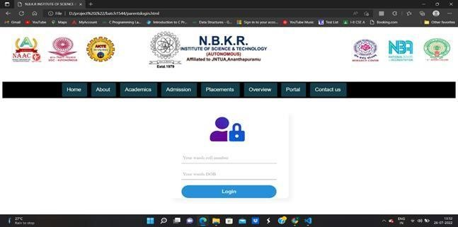

**Fig 7: portal page**

## 2.7 Contact us:

It provides a support and complete details about college and provide a contact numbers of our faculty for any queries.

<!DOCTYPE html>

<html>

<head>

<link href="Css\back.css" rel="stylesheet">

<link rel="stylesheet" href="Css\contactusfoot.css">

</head>

<body>

<div class="logos">

<div id="nbkr">

<img src="Images\NBKRIST-logo.jpg" alt="nbkrlogo" width="400" height="150">

</div>

<div id="naac">

<img src="Images\naac2021logo.jpg" alt="naaclogo" height="100" width="100">

</div>

<div id="ugc">

<img src="Images\img1.jpg" alt="ugc" height="120" width="100">

</div>

<div id="aicte">

<img src="Images\AICTE.jpg" alt="aicte" height="95" width="95">

</div>

<div id="grade">

<img src="Images\img2.jpg" alt="grade" height="100" width="100">

</div>

<div id="nba">

<img src="Images\img4.jpg" alt="nba" width="100" height="100">

</div>

<div id="res">

<img src="Images\img5.jpg" alt="research" width="100" height="100">

</div>

<!--<div id="qic">

<img src="img6.jpg" alt="qic" width="140" height="100">

</div>-->

</div>

<div class="navbar">

<div class="dropdown">

<button id="home" class="dropbtn"><a href="home.html" style="color:white;">Home</a>

</button>

</div>

<div class="dropdown">

<button class="dropbtn"><a href="about.html" style="color:white;">About</a>

</button>

</div>

<div class="dropdown">

</button class="dropbtn">

<button class="dropbtn">Academics

<div class="dropdown-content">

<a href="ug.html">B.tech</a>

<a href="#">M.tech</a>

</div>

</button>

</div>

<div class="dropdown">

<button class="dropbtn"><a href="admission.html" style="color:white;">Admissions</a>

</button>

</div>

<div class="dropdown">

<button class="dropbtn"><a href="placements.html" style="color:white;">Placements</a>

</button>

</div>

<div class="dropdown">

<button class="dropbtn"><a href="overview.html" style="color:white;">Overview</a>

</button>

</div>

<div class="dropdown">

<button class="dropbtn">Portal

<div class="dropdown-content">

<a href="parentslogin.html">Parent</a>

<a href="facultylogin.html">Faculty</a>

</div>

</button>

</div>

<div class="dropdown">

<button class="dropbtn"><a href="contactus.html" style="color:white;">Contact us</a>

</button>

</div>

</div>

<table width="100%" border="0" cellspacing="0" cellpadding="0">

<tr>

<td background="/images/content-title-heading_990.gif" height="46" class="Heading1">

<center>

<h3 style="background-color: rgb(237, 93, 129); color:#ffffff;text-align:center; font-size:150%;">Contact Us </h3>

</center>

</td>

</tr>

<tr>

<td height="640" background="/images/content-bg-br_990.gif" align="left" valign="top" class="ContentM">

<p class="ContentM">

<table width="100%" align="center" border="2">

<tr>

<td bgcolor="#3EAFD5 " align="center"><b style="color:#F8F9FA ; font-size:100%;font-family:verdana;">Admissions Incharge&HOD OF S&H </b> </td>

</tr>

<tr>

<td><b style=" font-size:100%;font-family:verdana;">Dr. C Raveendra

Reddy<br>Phone No :9441572755<br>Email:crreddy1966@gmail.com </td>

</tr>

<tr>

<td bgcolor="#3EAFD5 " align="center"><b style="color:#F8F9FA ; font-size:100%;font-family:verdana;">Student Academic Verifications</b> </td>

</tr>

<tr>

<td><b style=" font-size:100%;font-family:verdana;">Usual Response Time: 7 To 10 days<br>Phone No :08624-228247,08624-228547<br>Email:ist@nbkrist.org<br><font color="red">Note:Please do not call any HOD regarding student verifications.Only contact above phone numbers after 10 days of your request.</font>

</td>

</tr>

<tr>

<td bgcolor="#3EAFD5 " align="center"><b style="color:#F8F9FA ; font-size:100%;font-family:verdana;">HOD OF CIVIL ENGINEERING</b> </td>

</tr>

<tr>

<td><b style=" font-size:100%;font-family:verdana;">Dr. Durbha

Srinivas<br>Phone No :9494472625<br>Email:drdurbha@gmail.com </td>

</tr>

<tr>

<td bgcolor="#3EAFD5 " align="center"><b style="color:#F8F9FA ; font-size:100%;font-family:verdana;">HOD OF COMPUTER SCIENCE AND ENGINEERING,INFORMATION TECHNOLOGY and ARTIFICIAL INTELLIGENCE & DATA SCEIENCE</b> </td>

</tr>

<tr>

<td><b style=" font-size:100%;font-family:verdana;">Dr A Raja Sekhar

Reddy<br>Phone No :9441615716<br>Email:rajareddy4u@rediffmail.com</td>

</tr>

<tr>

<td bgcolor="#3EAFD5 " align="center"><b style="color:#F8F9FA ; font-size:100%;font-family:verdana;">HOD OF ELECTRONICS AND COMMUNICATION

ENGINEERING</b> </td>

</tr>

<tr>

<td><b style=" font-size:100%;font-family:verdana;">Dr. G Harinatha

Reddy<br>Phone No :9246422966<br>Email:reddyghr@gmail.com </td>

</tr>

<tr>

<td bgcolor="#3EAFD5 " align="center"><b style="color:#F8F9FA ; font-size:100%;font-family:verdana;">HOD OF ELECTRICAL AND ELECTRONICS

ENGINEERING</b> </td>

</tr>

<tr>

<td><b style=" font-size:100%;font-family:verdana;">Dr. S Suresh

Reddy<br>Phone No :94405 20130<br>Email:sanna_suresh@rediffmail.com </td>

</tr>

<tr>

<td bgcolor="#3EAFD5 " align="center"><b style="color:#F8F9FA ; font-size:100%;font-family:verdana;">HOD OF MECHANICAL ENGINEERING</b> </td>

</tr>

<tr>

<td><b style=" font-size:100%;font-family:verdana;">Dr.Ch R Vikram Kumar<br>Phone No :9490321975<br>Email:mehod@nbkrist.org </td>

</tr>

</table>

<div class="footer">

<div class="ql ql1">

Professional Societies

<div class="qlc1 qlc">

<ul style="list-style-type:none">

<li><a href="https://www.ieee.org/" style="color:white">IEEE</a></li>

<li><a href="https://csi-india.org/" style="color:white">CSI</a></li>

<li><a href="http://www.isteonline.in/" style="color:white">ISTE</a></li>

</ul>

</div>

</div>

<div class="ql ql2">

Quick Links

<div class="qlc2 qlc">

<ul style="list-style-type:none">

<li>link 1</li>

<li>link 2</li>

<li>link 3</li>

<li>link 4</li>

</ul>

</div>

</div>

<div class="ql ql3">

Quick Links

<div class="qlc3 qlc">

<ul style="list-style-type:none">

<li>link 1</li>

<li>link 2</li>

<li>link 3</li>

<li>link 4</li>

</ul>

</div>

</div>

<div class="icons">

<img class="insta" src="Images\instagram.png" alt="instagram" width="25px" height="25px">

<img class="yout" src="Images\youtube.png" alt="youtube" width="25px" height="25px">

<img class="link" src="Images\linkedin.png" alt="linkedin" width="25px" height="25px"> </div>

<div class="copy">© Copyright N.B.K.R.I.S.T</div>

</div>

</body>

</html>



**Fig 8:**



**Contact us page**

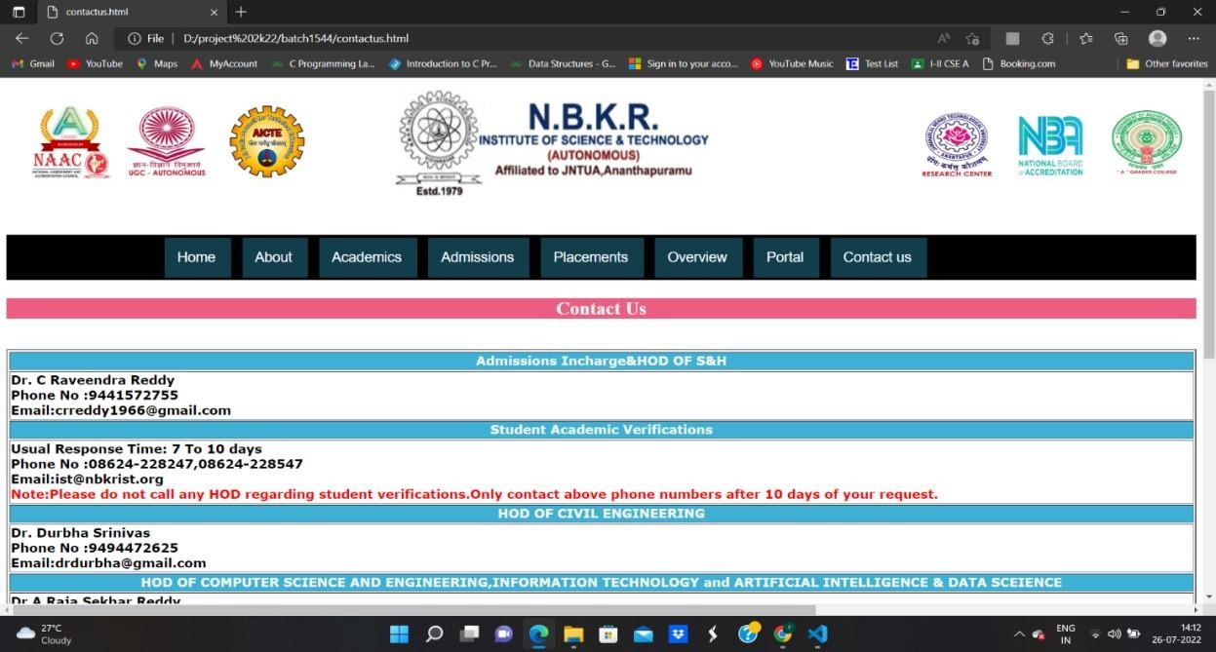

**3. Back End:**

In college management system the back end consists information about student details such as marks and attendance. Xampp server is used as the backend server and php is used as the backend language to connect with the front end. My SQL is used to store the specific details of user.

DATABASE NAME: Parent Portal

TABLES CREATED:13

Creation of Tables

ACADAMICS: -

Query: -create table academic (roll no varchar (30), grade 1 varchar (10), grade 2 varchar (20), grade 3 varchar (20)) INSERT: -

Insert into academics (‘roll no’, ‘grade 1’, ‘grade 2’, ‘grade 3’)

Values (‘20kb1a0536’, ‘7.55’, ‘8.12’, ‘NA’), (‘20kb1a0537’, ‘8.25’, ’7.02’,’NA’)

(‘20kb1a0544’, ‘9.0’, ‘8.9’, ‘NA’) (‘20kb1a0547’, ‘8.8’, ‘8.02’, ‘NA’) (‘20kb5a0506’, ‘8.5’,

‘8.5’,’NA’)

|  |  |  |  |
| --- | --- | --- | --- |
| Roll no | Grade 1 | Grade 2 | Grade 3 |
| 20kb1a0536 | 7.55 | 8.12 | NA |
| 20kb1a0537 | 8.25 | 7.02 | NA |
| 20kb1a0544 | 9 | 8.9 | NA |
| 20kb1a0547 | 8.8 | 8.02 | NA |
| 20kb5a0506 | 8.5 | 8.5 | NA |

MID-1-1-1: - Query: -create table academic (roll no varchar (30), English varchar (10), m 1 varchar (20), physics varchar (20), bee varchar (30), c varchar (30)) INSERT: -

Insert into MID-1-1-1(‘roll no’, ‘English’, ‘M-1’, ‘Bee’, ‘physics', ‘C’)

Values (‘20kb1a0536’, ‘30’, ‘31’, ‘32’, ‘33’, ‘34’), (20kb1a0537’, ‘35’, ‘36’, ‘37’, ‘38’, ‘39’),

(‘20kb1a0544’,’32’, ‘40’, ‘33’, ‘35’, ‘36’), (‘20kb1a0547’ ‘35’, ‘40’, ‘37’,’38’, ‘39’),

(‘21kb5a0506’,’31’,’28’,’30’,’32’,’35’)

|  |  |  |  |  |  |
| --- | --- | --- | --- | --- | --- |
| roll no | English | M-1 | Bee | physics | C |
| 20kb1a0536 | 30 | 31 | 33 | 32 | 34 |
| 20kb1a0537 | 35 | 36 | 38 | 37 | 39 |
| 20kb1a0544 | 32 | 40 | 35 | 33 | 36 |
| 20kb1a0547 | 35 | 40 | 38 | 37 | 39 |
| 21kb5a0506 | 31 | 28 | 32 | 30 | 35 |

MID 1-1-2: -

Query: -create table academic (roll no varchar (30), English varchar (10), m 1 varchar (20), physics varchar (20), bee varchar (30), c varchar (30)) INSERT: -

Insert into MID-1-1-2(‘roll no’, ‘English’, ‘M-1’, ‘Bee’, ‘physics', ‘C’)

Values (‘20kb1a0536’, ‘28’, ‘29’, ‘30’, ‘31’, ‘32’), (20kb1a0537’, ‘30’, ‘31’, ‘32’, ‘33’, ‘34’),

(‘20kb1a0544’,’28’, ‘27’, ‘29’, ‘30’, ‘31’), (‘20kb1a0547’ ‘31’, ‘32’, ‘33’,’34’, ‘35’), (‘21kb5a0506’,’35’,’34’,’33’,’34’,’32’)

|  |  |  |  |  |  |
| --- | --- | --- | --- | --- | --- |
| roll no | English | M-1 | Bee | physics | C |
| 20kb1a0536 | 28 | 29 | 30 | 31 | 32 |
| 20kb1a0537 | 30 | 31 | 32 | 33 | 34 |
| 20kb1a0544 | 28 | 27 | 29 | 30 | 31 |
| 20kb1a0547 | 31 | 32 | 33 | 34 | 35 |
| 21kb5a0506 | 35 | 34 | 33 | 34 | 32 |

MID 1-2-1: -

Query: -create table academic (roll no varchar (30), DS varchar(10), python varchar (20), m 2 varchar (20), chemistry varchar (30), uhv varchar (30))

INSERT: -

Insert into MID-1-2-1(‘roll no’, ‘DS’, ‘python’, ‘m 2’, ‘chemistry', ‘uhv’)

Values (‘20kb1a0536’, ‘40’, ‘38’, ‘36’, ‘34’, ‘32’), (20kb1a0537’, ‘33’, ‘34’, ‘35’, ‘36’, ‘37’),

(‘20kb1a0544’,’39’, ‘38’, ‘37’, ‘36’, ‘34’), (‘20kb1a0547’ ‘30’0, ‘35’, ‘35’,’33’, ‘32’),

(‘21kb5a0506’,’29’,’30’,’31’,’32’,’33’)

|  |  |  |  |  |  |
| --- | --- | --- | --- | --- | --- |
| roll no | DS | python | m-2 | chemistry | uhv |
| 20kb1a0536 | 40 | 38 | 36 | 34 | 32 |
| 20kb1a0537 | 33 | 34 | 35 | 36 | 37 |
| 20kb1a0544 | 39 | 38 | 37 | 36 | 34 |
| 20kb1a0547 | 30 | 35 | 35 | 33 | 32 |
| 21kb5a0506 | 29 | 30 | 33 | 32 | 33 |

MID 1-2-2: - Query: -create table academic (roll no varchar (30), DS varchar(10), python varchar (20), m 2 varchar (20), chemistry varchar (30), uhv varchar (30))

INSERT: -

Insert into MID-1-2-2(‘roll no’, ‘DS’, ‘python’, ‘m 2’, ‘chemistry', ‘uhv’)

Values (‘20kb1a0536’, ‘32’, ‘30’, ‘33’, ‘35’, ‘29’), (20kb1a0537’, ‘39’, ‘29’, ‘31’, ‘35’, ‘37’),

(‘20kb1a0544’,’29’, ‘36’, ‘33’, ‘32’, ‘29’), (‘20kb1a0547’ ‘40’, ‘38’, ‘33’,’32’, ‘29’),

(‘21kb5a0506’,’36’,’35’,’34’,’33’,’34’)

|  |  |  |  |  |  |
| --- | --- | --- | --- | --- | --- |
| roll no | DS | python | m-2 | chemistry | uhv |
| 20kb1a0536 | 32 | 30 | 33 | 35 | 29 |
| 20kb1a0537 | 39 | 29 | 31 | 35 | 37 |
| 20kb1a0544 | 29 | 35 | 37 | 38 | 29 |
| 20kb1a0547 | 40 | 38 | 33 | 32 | 29 |
| 21kb5a0506 | 36 | 35 | 34 | 33 | 34 |

MID 2-1-1

Query: -create table academic (roll no varchar (30), DLD varchar(10), CN varchar (20), DBMS varchar (20), NMPS varchar (30), es varchar (30))

INSERT: -

Insert into MID-2-1-1(‘roll no’, ‘DLD’, ‘CN’, ‘DBMS’, ‘NMPS', ‘ES’)

Values (‘20kb1a0536’, ‘33’, ‘34’, ‘35’, ‘36’, ‘37’), (20kb1a0537’, ‘38’, ‘39’, ‘40’, ‘31’, ‘32’),

(‘20kb1a0544’,’29’, ‘30’, ‘31’, ‘32’, ‘33’), (‘20kb1a0547’ ‘34’, ‘35’, ‘36’,’37’, ‘38’),

(‘21kb5a0506’,’33’,’32’,’31’,’29’,’31’)

|  |  |  |  |  |  |
| --- | --- | --- | --- | --- | --- |
| roll no | DLD | CN | DBMS | NMPS | ES |
| 20kb1a0536 | 33 | 34 | 35 | 36 | 37 |
| 20kb1a0537 | 38 | 39 | 40 | 31 | 32 |
| 20kb1a0544 | 29 | 30 | 31 | 32 | 33 |
| 20kb1a0547 | 34 | 35 | 36 | 37 | 38 |
| 21kb5a0506 | 33 | 32 | 31 | 29 | 31 |

MID 2-1-2

Query: -create table academic (roll no varchar (30), DLD varchar (10), CN varchar (20), DBMS varchar (20), NMPS varchar (30), es varchar (30))

INSERT: -

Insert into MID-2-1-2(‘roll no’, ‘DLD’, ‘CN’, ‘DBMS’, ‘NMPS', ‘ES’)

Values (‘20kb1a0536’, ‘40’, ‘39’, ‘38’, ‘37’, ‘36’), (20kb1a0537’, ‘32’, ‘33’, ‘34’, ‘35’, ‘36’),

(‘20kb1a0544’,’40’, ‘39’, ‘38’, ‘37’, ‘36’), (‘20kb1a0547’ ‘29’, ‘30’, ‘31’,’32’, ‘33’), (‘21kb5a0506’,’32’,’33’,’35’,’36’,’37’)

|  |  |  |  |  |  |
| --- | --- | --- | --- | --- | --- |
| roll no | DLD | CN | DBMS | NMPS | ES |
| 20kb1a0536 | 40 | 39 | 38 | 37 | 36 |
| 20kb1a0537 | 32 | 33 | 34 | 35 | 36 |
| 20kb1a0544 | 40 | 39 | 38 | 37 | 36 |
| 20kb1a0547 | 29 | 30 | 31 | 32 | 33 |
| 21kb5a0506 | 32 | 33 | 35 | 36 | 37 |

MID 2-2-1

Query: -create table academic (roll no varchar (30), mefa varchar (10), daa varchar (20), flat varchar (20), os varchar (30), se varchar (30))

INSERT: -

Insert into MID-2-1-2(‘roll no’, ‘mefa’, ‘daa’, ‘flat’, ‘os', ‘se’)

Values (‘20kb1a0536’, ‘32’, ‘34’, ‘33’, ‘35’, ‘37’), (20kb1a0537’, ‘35’, ‘36’, ‘37’, ‘38’, ‘39’),

(‘20kb1a0544’,’31’, ‘33’, ‘34’, ‘35’, ‘36’), (‘20kb1a0547’ ‘40’, ‘39’, ‘39’,’39’, ‘39’),

(‘21kb5a0506’,’31’,’35’,’35’,’36’,’37’)

|  |  |  |  |  |  |
| --- | --- | --- | --- | --- | --- |
| roll no | mefa | daa | flat | os | se |
| 20kb1a0536 | 32 | 34 | 33 | 35 | 37 |
| 20kb1a0537 | 35 | 36 | 37 | 38 | 39 |
| 20kb1a0544 | 31 | 33 | 34 | 35 | 36 |
| 20kb1a0547 | 40 | 39 | 39 | 39 | 39 |
| 21kb5a0506 | 31 | 35 | 35 | 36 | 37 |

INDEX: -

fr <?php

$got= $_POST['roll']; include_once

'connect.php';

$get=$got;

$select = mysqli_query($con, "SELECT `rollno` FROM `academic` WHERE `rollno` = '".$get."'") or exit(mysqli_error($con));

?>

<?php if(mysqli_num_rows($select)) : ?>

<script>alert('Student Record Found');</script>

<!DOCTYPE html>

<html lang="en">

<head>

<meta charset="UTF-8">

<meta http-equiv="X-UA-Compatible" content="IE=edge">

<meta name="viewport" content="width=device-width, initial-scale=1.0">

<title>php</title>

<style>

*{ padding: 0; margin: 0;

}

.p{

background-color: lightgrey; border-radius: 70px; padding: 11px; margin: 4px; textalign: center; border: 1px solid black; boxsizing: border-box; font-size: 33px; color: green;

} table{ margin: auto; padding : 5px; border: 2px solid black;

} th{ color: blue; }

th,td{ font-size: 25px; text-align : center; padding: 20px; margin: auto; border : 2px solid black;

}

</style>

</head>

<body>

<?php

$query = "select * from details where rollno= '$get' ;";

$query1="select * from academic where rollno= '$get';";

$query2="select * from bl where rollno= '$get';";

$query3="select * from mid221 where rollno='$get';";

$query4="select * from mid111 where rollno='$get';";

$query5="select * from mid112 where rollno='$get';";

$query6="select * from mid121 where rollno='$get';";

$query7="select * from mid122 where rollno='$get';";

$query8="select * from mid211 where rollno='$get';";

$query9="select * from mid212 where rollno='$get';";

$result = mysqli_query($con,$query);

$result1=mysqli_query($con,$query1);

$result2=mysqli_query($con,$query2);

$result3=mysqli_query($con,$query3);

$result4=mysqli_query($con,$query4);

$result5=mysqli_query($con,$query5);

$result6=mysqli_query($con,$query6);

$result7=mysqli_query($con,$query7);

$result8=mysqli_query($con,$query8);

$result9=mysqli_query($con,$query9);

$dis= mysqli_fetch_assoc($result);

$sem=mysqli_fetch_assoc($result1);

$bl=mysqli_fetch_assoc($result2);

$mid221=mysqli_fetch_assoc($result3);

$mid111=mysqli_fetch_assoc($result4);

$mid112=mysqli_fetch_assoc($result5);

$mid121=mysqli_fetch_assoc($result6);

$mid122=mysqli_fetch_assoc($result7);

$mid211=mysqli_fetch_assoc($result8); $mid212=mysqli_fetch_assoc($result9);

?>

<div class= 'p'> <?php echo 'Your ward '.

$dis['name'].' Sessional marks';

?>

</div>

<table>

<tr>

<th>Semister</th>

<th>Grade</th>

<th>backlogs</th>

</tr> <?php echo " <tr>"; echo "<td>1-1</td>"; echo "<td>".$sem['grade1']."</td>"; echo "<td>".$bl['bl1']."</td>"; echo "</tr>"; echo "<tr>"; echo "<td>1-2</td>"; echo "<td>".$sem['grade2']."</td>"; echo "<td>".$bl['bl2']."</td>"; echo "</tr>"; echo "<tr>"; echo "<td>2-1</td>"; echo "<td>".$sem['grade3']."</td>"; echo "<td>".$bl['bl3']."</td>"; echo "</tr>";

?>

</table><br>

<h1><center> Semister Wise Mid Marks</center></h1> <br>

<h2><center> 1-1</center></h2>

<br>

<table>

<tr>

<th>MID'S</th>

<th>ENGLISH</th>

<th>M1</th>

<th>PHYSICS</th>

<th>BEEE</th>

<th>C</th>

</tr> <?php echo "<tr>"; echo

"<td>1<td>"; echo "<td>".$mid111['english']."</td>"; echo "<td>".$mid111['m1']."</td>"; echo "<td>".$mid111['physics']."</td>"; echo "<td>".$mid111['beee']."</td>"; echo "<td>".$mid111['c']."</td>"; echo

"</tr>"; echo "<tr>"; echo

"<td>2</td>"; echo "<td>".$mid112['english']."</td>"; echo "<td>".$mid112['m1']."</td>"; echo "<td>".$mid112['physics']."</td>"; echo "<td>".$mid112['beee']."</td>"; echo "<td>".$mid112['c']."</td>"; echo

"</tr>";

?>

</table>

<br>

<h2><center>1-2</center></h2>

<br>

<table>

<tr>

<th>MID'S</th>

<th>DS</th>

<th>PYTHON</th>

<th>M2</th>

<th>CHEMISTRY</th>

<th>UHV</th>

</tr> <?php echo "<tr>"; echo

"<td>1<td>"; echo

"<td>".$mid121['ds']."</td>"; echo

"<td>".$mid121['python']."</td>"; echo

"<td>".$mid121['m2']."</td>"; echo "<td>".$mid121['chemistry']."</td>"; echo "<td>".$mid121['uhv']."</td>"; echo

"</tr>"; echo "<tr>"; echo

"<td>2</td>"; echo "<td>".$mid122['ds']."</td>"; echo "<td>".$mid122['python']."</td>"; echo "<td>".$mid122['m2']."</td>"; echo

"<td>".$mid122['chemistry']."</td>"; echo "<td>".$mid122['uhv']."</td>"; echo "</tr>";

?>

</table>

<br>

<h2><center>2-1</center></h2>

<br>

<table>

<tr>

<th>MID'S</th>

<th>DLD</th>

<th>CN</th>

<th>DBMS</th>

<th>NMPS</th>

<th>ES</th>

</tr> <?php echo "<tr>"; echo "<td>1<td>"; echo "<td>".$mid211['dld']."</td>"; echo

"<td>".$mid211['cn']."</td>"; echo "<td>".$mid211['dbms']."</td>"; echo "<td>".$mid211['nmps']."</td>"; echo "<td>".$mid211['es']."</td>"; echo "</tr>"; echo "<tr>"; echo

"<td>2</td>"; echo "<td>".$mid212['dld']."</td>"; echo "<td>".$mid212['cn']."</td>"; echo "<td>".$mid212['dbms']."</td>"; echo "<td>".$mid212['nmps']."</td>"; echo "<td>".$mid212['es']."</td>";

?>

</table>

<br>

<h2><center> Current Semister: 2-2</center></h2>

<table>

<tr>

<th>MID'S</th>

<th>MEFA</th>

<th>DAA</th>

<th>OS</th>

<th>SE</th>

<th>FLAT</th>

</tr>

<?php echo "<tr>"; echo

"<td>1</td>"; echo

"<td>".$mid221['mefa']."</td>"; echo "<td>".$mid221['daa']."</td>"; echo "<td>".$mid221['os']."</td>"; echo "<td>".$mid221['se']."</td>"; echo "<td>".$mid221['flat']."</td>"; echo "</tr>"; echo "<tr>"; echo "<td>2</th>"; echo "<td> NA </td>"; echo "<td> NA </td>"; echo "<td> NA </td>"; echo

"<td> NA </td>"; echo

"<td> NA </td>";

?>

</table>

</body>

</html>

<?php else: ?>

<script>alert('Student Record Not Found');document.location='portal.html'</script>

<?php endif; ?>

CONNECT: -

<?php

$host = "localhost:4306";

$user = "root";

$pass = "";

$dbname= "parentportal";

$con = mysqli_connect($host,$user,$pass,$dbname);

?>

**4. CONCLUSION:**

This application helps both the parents and the students to know more about the college like its infrastructure, academics, placements and many more. This application can be accessed through internet from anywhere.

**5. REFERENCE:**

* PHP book by Vasvani (TMH publications).

* Beginning PHP5 by WROX.

* [www.google.com](http://www.google.com/)

* [www.wikipedia.com](http://www.wikipedia.com/)

* [www.w3schools.com](http://www.w3schools.com/)

* Informatics practiced by Sumita Arora.