1. 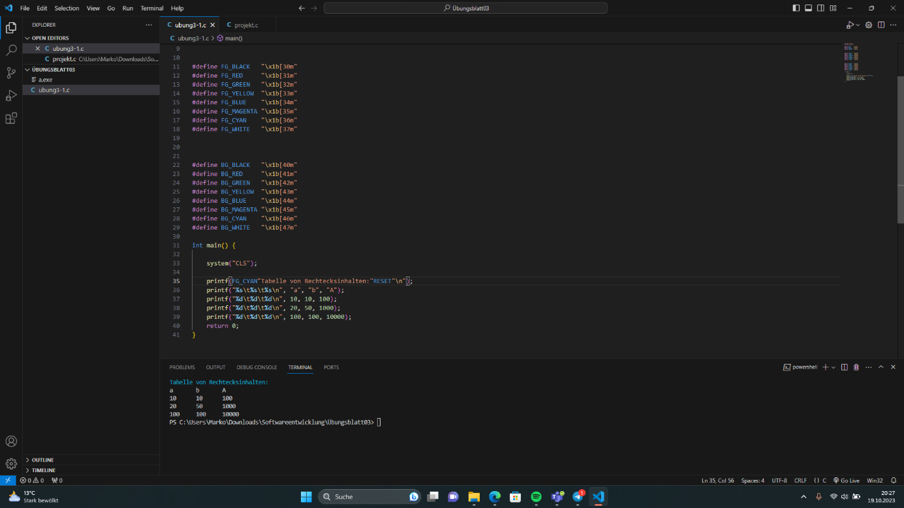
2. 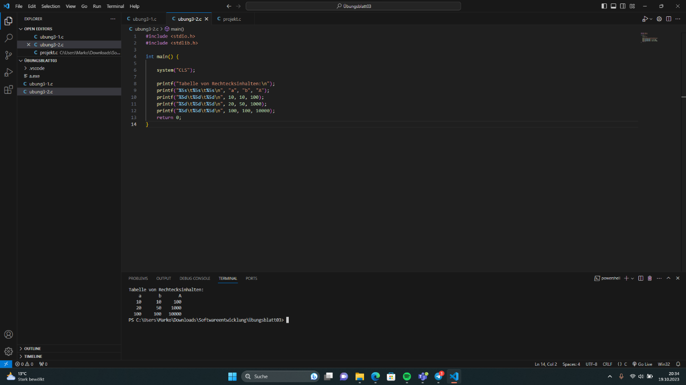
3. 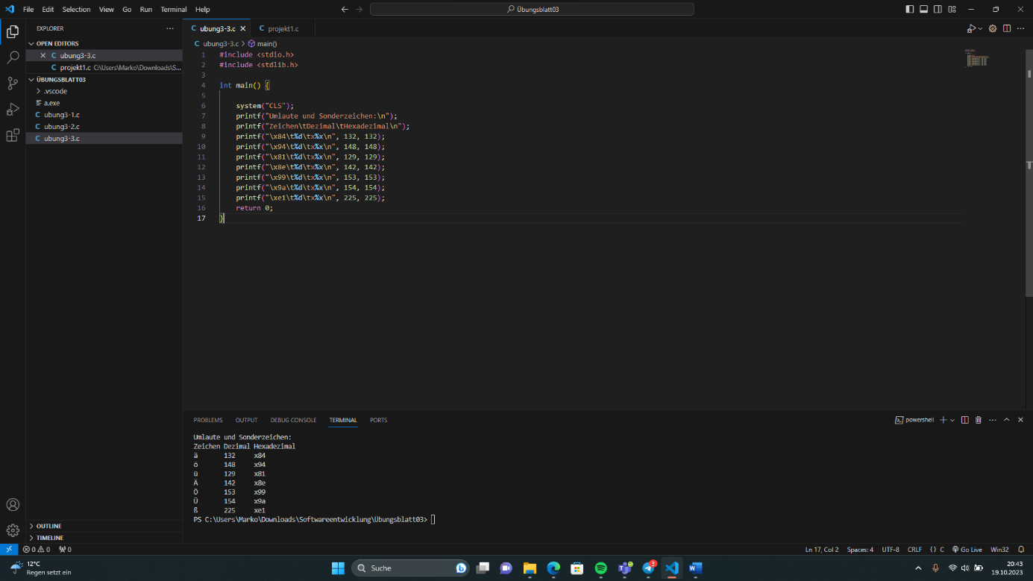
4. 7 printf("A%\*s%s\n", 8, "B", "C");
5. #include <stdio.h>

Int main() {

printf("1\tA\n");

printf("2%s\n", "B", 8);

printf("3%\*sC\n", 7, "");

return 0;

}