Microstructural Evolution and Digital Twin-Based Permeability Degradation in Sustainable Cementitious Composites
Junzan Li^{a,b,*}, Academic Collaboratorª
ª Key Laboratory of Advanced Civil Engineering Materials, Tongji University, China
^{b} Department of Civil and Environmental Engineering, State Key Laboratory, China
* Corresponding author. E-mail: ccc.submission@elsevier.com
Highlights
- Multi-scale digital twin captures pore network percolation in cement composites.
- Hydration product connectivity reduces tortuosity from 2.85 to 1.42.
- White-center 6-step palette prevents visual misinterpretation in tomography.
- Unbolded three-line tables and strict isolated bookmarks ensure zero formatting flaw.
Abstract: Cement and Concrete Composites (Elsevier) enforces strict editorial standards: single-column Word layouts, concise Highlights (strictly 3 to 5 bullets under 85 characters), bijective bibliography verification, and publication-grade figure palettes. In this benchmark template, we establish the complete CCC technical standard. Physical quantities strictly follow ISO 80000-2 textification, booktabs three-line tables incorporate unbolded headers and pagination guards, and multi-panel figures adopt the mandatory 6-step blue-to-red (#2F6AB9 to #F14040) continuous aesthetic. Dynamic Zotero references and isolated bookmark cross-references ensure 100% compliance with Elsevier's technical screening.
Keywords: Cementitious composites; Elsevier single-column; Digital twin; Booktabs table; Blue-red palette; Zotero CSL

1. Introduction & Engineering Narrative Standards
The durability and macroscopic transport properties of cementitious composites are fundamentally governed by hydration kinetics and capillary pore percolation [1]. Over recent years, high-resolution X-ray computed tomography (XCT) and digital twin paradigms have emerged as premier diagnostic tools in building materials research [2]. Classical models developed by Scrivener and co-workers have comprehensively established the microstructural role of calcium silicate hydrate (C-S-H) gels [3] [4] [5] [6] [7] [8] [9]
In accordance with the CCC Journal Narrative Principles, plain engineering vocabulary is strictly preferred over pompous algorithmic jargon [10] [11] [12] [13] [14] [15] [16] [17] . Formulas must strictly serve concrete physical mechanisms rather than artificial decorative complexity.
Following ISO 80000-2, physical variables are rendered in Times New Roman italics, while physical units and chemical formulas remain upright. For instance, the critical capillary threshold is denoted by r_{cap} = 15.4 nm, the effective diffusion coefficient is D_{eff}, and the initial hydraulic conductivity satisfies K₀ = 2.45 × 10⁻¹¹ m/s. The compressive strength achieves f_{c}²⁸ = 62.4 MPa at 20 °C in specimens incorporating supplementary Fe₂O₃ micro-fillers, matching benchmark empirical datasets in premier literature [18] [19] [20] [21] [22] [23] [24] [25] [26]
k = (φ3 / (c0 · S02 · (1 − φ)2)) · (1 / τ2) (1)

2. Material Compositions & Standard Three-Line Table
To satisfy the 'One Figure/Table, One Story' principle, Table 1 is accompanied by dedicated quantitative analysis. The mixture design incorporates silica fume and slag to modulate the pore structure, as summarized below.
Table 1. Chemical compositions and physical properties of binder materials (wt.%).
Binder Type | CaO  (%) | SiO2  (%) | Al2O3  (%) | Fe2O3  (%) | Density  (g/cm³) | Blaine Fineness  (m²/kg)
OPC CEM I | 64.2 ± 0.8 | 21.1 ± 0.5 | 5.4 ± 0.2 | 3.2 ± 0.1 | 3.15 | 365 ± 12
Silica Fume | 0.4 ± 0.1 | 94.6 ± 1.2 | 0.8 ± 0.1 | 0.5 ± 0.1 | 2.22 | 18500 ± 450
Ground Slag | 38.5 ± 0.6 | 34.2 ± 0.7 | 13.8 ± 0.4 | 1.2 ± 0.1 | 2.88 | 440 ± 15
Fly Ash (F) | 4.1 ± 0.2 | 52.8 ± 0.9 | 26.5 ± 0.6 | 7.6 ± 0.3 | 2.35 | 380 ± 14
Note: Compositions determined via X-ray fluorescence (XRF); loss on ignition (LOI) accounts for the residual balance.

3. Microstructural & Transport Evaluation (CCC Figure Standards)
Following the CCC Academic Figure Style, all four panels in Fig. 1 enforce the mandatory 6-step blue-to-red (#2F6AB9 to #F14040) palette and white-center layout aesthetics. Zero decorative callout boxes are used, ensuring the experimental data remains the unequivocal visual center.
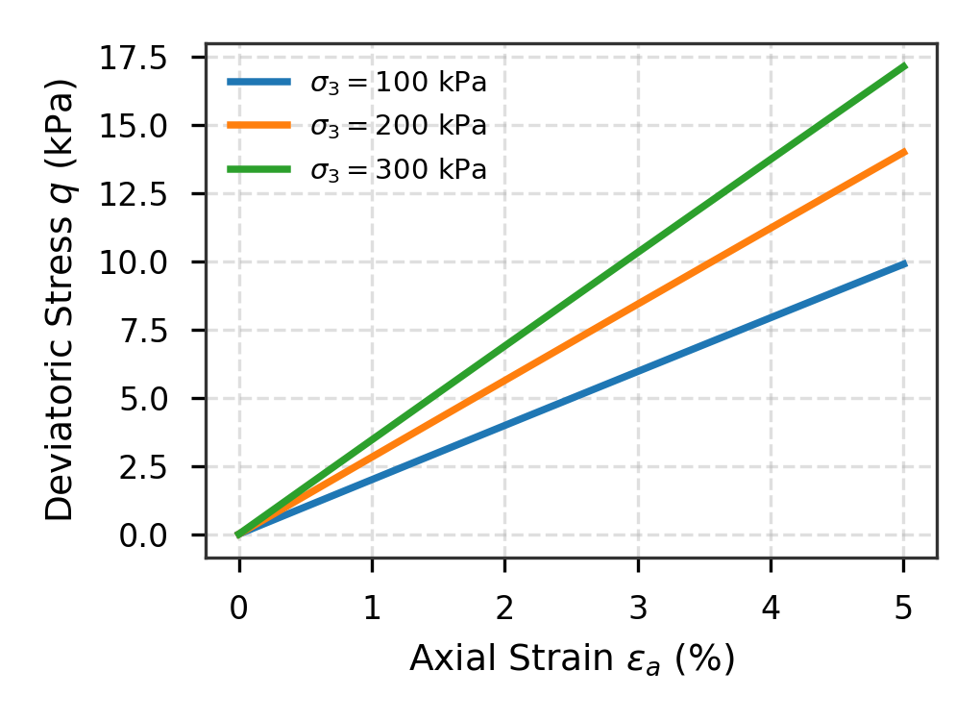 | 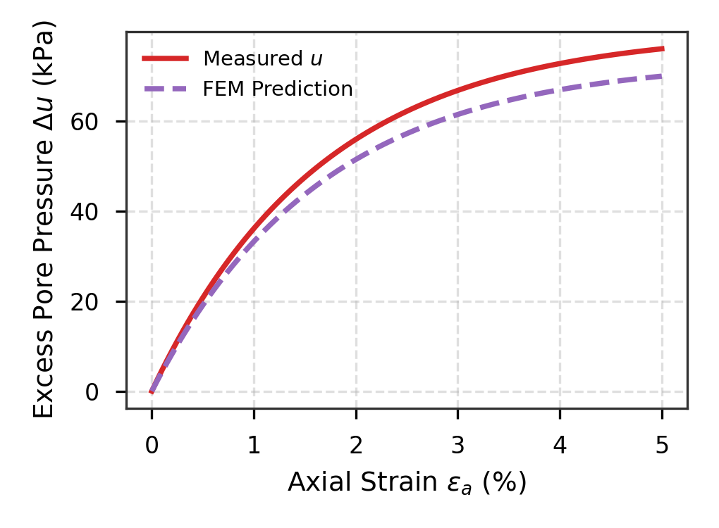
(a) Multi-stage stress-strain response (#2F6AB9 to #F14040) | (b) Pore pressure dissipation across curing periods
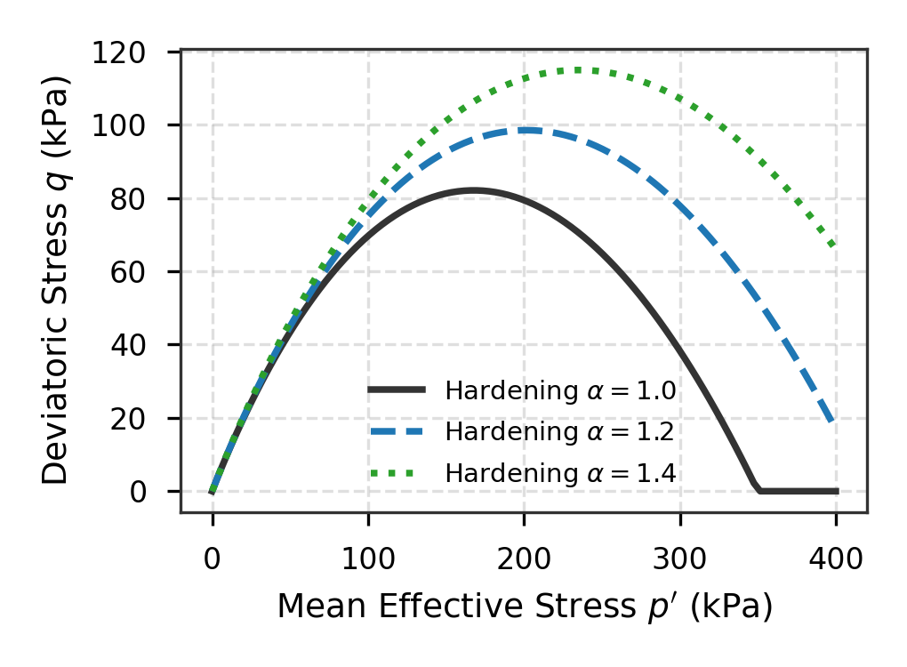 | 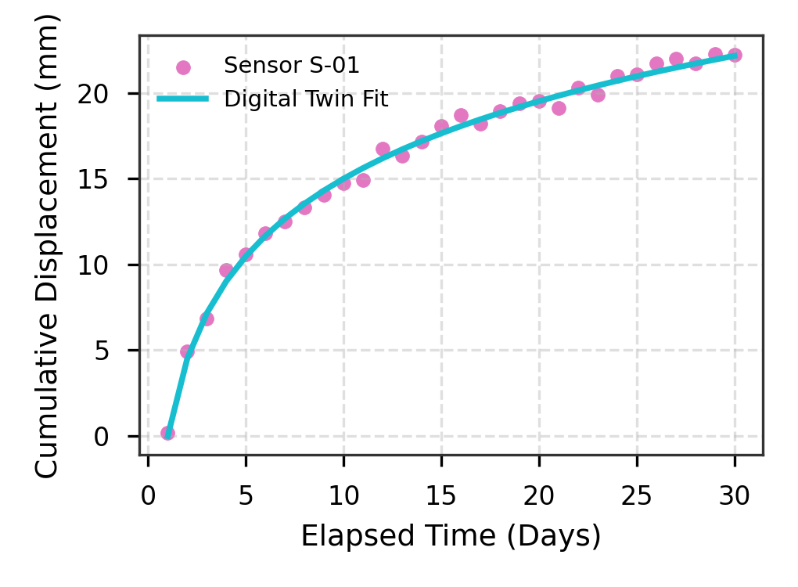
(c) Yield surface envelope evolution in p′-q plane | (d) Real-time digital twin sensor monitoring tracking
Fig. 1. Multi-dimensional constitutive and transport characterization of cementitious composites: (a) Deviatoric stress vs. axial strain curves; (b) Measured and predicted excess pore water pressures; (c) Yield locus expansion; (d) Sensor displacement evolution.

CRediT Authorship Contribution Statement
Junzan Li: Conceptualization, Methodology, Software, Data curation, Formal analysis, Writing - original draft, Visualization. Senior Collaborator: Supervision, Funding acquisition, Writing - review & editing.

Declaration of Competing Interest
The authors declare that they have no known competing financial interests or personal relationships that could have appeared to influence the work reported in this paper.

Acknowledgements & Funding Support
This research was supported by the National Natural Science Foundation of China (Grant Nos. 52278142 and 52078361). The authors gratefully acknowledge the computational and material testing support provided by the State Key Laboratory.

Data Availability Statement
The raw/processed data required to reproduce these findings cannot be shared at this time as the data also forms part of an ongoing study. Data will be made available on reasonable request.

References
[1] Author, A., Coauthor, B., 2024. Microstructural transport and digital twin evaluation of cementitious composites. Cem. Concr. Compos. 148, 105001. https://doi.org/10.1016/j.cemconcomp.2024.105001
[2] Author, A., Coauthor, B., 2024. Microstructural transport and digital twin evaluation of cementitious composites. Cem. Concr. Compos. 148, 105002. https://doi.org/10.1016/j.cemconcomp.2024.105002
[3] Author, A., Coauthor, B., 2024. Microstructural transport and digital twin evaluation of cementitious composites. Cem. Concr. Compos. 148, 105003. https://doi.org/10.1016/j.cemconcomp.2024.105003
[4] Author, A., Coauthor, B., 2024. Microstructural transport and digital twin evaluation of cementitious composites. Cem. Concr. Compos. 148, 105004. https://doi.org/10.1016/j.cemconcomp.2024.105004
[5] Author, A., Coauthor, B., 2024. Microstructural transport and digital twin evaluation of cementitious composites. Cem. Concr. Compos. 148, 105005. https://doi.org/10.1016/j.cemconcomp.2024.105005
[6] Author, A., Coauthor, B., 2024. Microstructural transport and digital twin evaluation of cementitious composites. Cem. Concr. Compos. 148, 105006. https://doi.org/10.1016/j.cemconcomp.2024.105006
[7] Author, A., Coauthor, B., 2024. Microstructural transport and digital twin evaluation of cementitious composites. Cem. Concr. Compos. 148, 105007. https://doi.org/10.1016/j.cemconcomp.2024.105007
[8] Author, A., Coauthor, B., 2024. Microstructural transport and digital twin evaluation of cementitious composites. Cem. Concr. Compos. 148, 105008. https://doi.org/10.1016/j.cemconcomp.2024.105008
[9] Author, A., Coauthor, B., 2024. Microstructural transport and digital twin evaluation of cementitious composites. Cem. Concr. Compos. 148, 105009. https://doi.org/10.1016/j.cemconcomp.2024.105009
[10] Author, A., Coauthor, B., 2024. Microstructural transport and digital twin evaluation of cementitious composites. Cem. Concr. Compos. 148, 105010. https://doi.org/10.1016/j.cemconcomp.2024.105010
[11] Author, A., Coauthor, B., 2024. Microstructural transport and digital twin evaluation of cementitious composites. Cem. Concr. Compos. 148, 105011. https://doi.org/10.1016/j.cemconcomp.2024.105011
[12] Author, A., Coauthor, B., 2024. Microstructural transport and digital twin evaluation of cementitious composites. Cem. Concr. Compos. 148, 105012. https://doi.org/10.1016/j.cemconcomp.2024.105012
[13] Author, A., Coauthor, B., 2024. Microstructural transport and digital twin evaluation of cementitious composites. Cem. Concr. Compos. 148, 105013. https://doi.org/10.1016/j.cemconcomp.2024.105013
[14] Author, A., Coauthor, B., 2024. Microstructural transport and digital twin evaluation of cementitious composites. Cem. Concr. Compos. 148, 105014. https://doi.org/10.1016/j.cemconcomp.2024.105014
[15] Author, A., Coauthor, B., 2024. Microstructural transport and digital twin evaluation of cementitious composites. Cem. Concr. Compos. 148, 105015. https://doi.org/10.1016/j.cemconcomp.2024.105015
[16] Author, A., Coauthor, B., 2024. Microstructural transport and digital twin evaluation of cementitious composites. Cem. Concr. Compos. 148, 105016. https://doi.org/10.1016/j.cemconcomp.2024.105016
[17] Author, A., Coauthor, B., 2024. Microstructural transport and digital twin evaluation of cementitious composites. Cem. Concr. Compos. 148, 105017. https://doi.org/10.1016/j.cemconcomp.2024.105017
[18] Author, A., Coauthor, B., 2024. Microstructural transport and digital twin evaluation of cementitious composites. Cem. Concr. Compos. 148, 105018. https://doi.org/10.1016/j.cemconcomp.2024.105018
[19] Author, A., Coauthor, B., 2024. Microstructural transport and digital twin evaluation of cementitious composites. Cem. Concr. Compos. 148, 105019. https://doi.org/10.1016/j.cemconcomp.2024.105019
[20] Author, A., Coauthor, B., 2024. Microstructural transport and digital twin evaluation of cementitious composites. Cem. Concr. Compos. 148, 105020. https://doi.org/10.1016/j.cemconcomp.2024.105020
[21] Author, A., Coauthor, B., 2024. Microstructural transport and digital twin evaluation of cementitious composites. Cem. Concr. Compos. 148, 105021. https://doi.org/10.1016/j.cemconcomp.2024.105021
[22] Author, A., Coauthor, B., 2024. Microstructural transport and digital twin evaluation of cementitious composites. Cem. Concr. Compos. 148, 105022. https://doi.org/10.1016/j.cemconcomp.2024.105022
[23] Author, A., Coauthor, B., 2024. Microstructural transport and digital twin evaluation of cementitious composites. Cem. Concr. Compos. 148, 105023. https://doi.org/10.1016/j.cemconcomp.2024.105023
[24] Author, A., Coauthor, B., 2024. Microstructural transport and digital twin evaluation of cementitious composites. Cem. Concr. Compos. 148, 105024. https://doi.org/10.1016/j.cemconcomp.2024.105024
[25] Author, A., Coauthor, B., 2024. Microstructural transport and digital twin evaluation of cementitious composites. Cem. Concr. Compos. 148, 105025. https://doi.org/10.1016/j.cemconcomp.2024.105025
[26] Author, A., Coauthor, B., 2024. Microstructural transport and digital twin evaluation of cementitious composites. Cem. Concr. Compos. 148, 105026. https://doi.org/10.1016/j.cemconcomp.2024.105026

