Deep Learning-Driven Digital Twin and Multi-Scale Constitutive Modeling for Geomaterials and Structural Infrastructure
Junzan Li^{a,b,*}, Senior Academicianª
ª School of Civil and Transportation Engineering, China
^{b} State Key Laboratory for Disaster Prevention and Smart Infrastructure, China
* Corresponding author.
Abstract: Accurate prediction of progressive deformation in complex geomaterials remains an open scientific challenge. This master template establishes the international standard for automated LaTeX-to-Word academic publishing. We rigorously demonstrate the isolation of physical variables from Office Math boxes, the seamless invocation of MathType OLE objects, the generation of unbolded publication three-line tables with anti-split pagination defense, and the physical caption-fused 2×2 subfigure alignment. Dynamic cross-referencing via Word SEQ and REF fields is embedded to guarantee deterministic number re-indexing.
Keywords: Digital twin; Three-line table; Constitutive modeling; MathType equation; Subfigure layout; Geomechanics

1. Mathematical Formulation & Literature Background
Geotechnical infrastructure failure monitoring has advanced rapidly over the past decade [1], with slope deformation and landslide stabilization studied through diverse numerical approaches [2]. Classical limit equilibrium and finite-element formulations have been extensively validated across field sites [3] [4] [5] [6] [7] [8] [9]
Constitutive developments in multi-scale geomechanics and unsaturated soil mechanics have provided essential physical baselines [10] [11] [12] [13] [14] [15] [16] [17]
According to the ISO 80000-2 and IUPAP international conventions, physical variables must be italicized while units and chemical formulas remain upright. Under initial consolidation, the vertical effective stress is denoted by σ_{v0}′, volumetric strain is ε_{vol}, and coefficient of earth pressure is K_{0,nc}. During multi-stage triaxial shear loading, the major principal stress satisfies σ₁² = 450 kPa², undrained shear strength achieves c_{u}^{(t)}, and the slope factor of safety reaches F_{s}^{min} = 1.34 at an ambient temperature of 20 °C. The specimen contains Fe₂O₃ with dry density of 1.95 g/cm³, matching empirical observations in recent literature [18] [19] [20] [21] [22] [23] [24] [25] [26]
τf = c′ + (σn − u) tan φ′ (1)

2. Calibrated Physical Properties & Three-Line Table
The physical state parameters and calibrated constitutive variables are summarized in Table 1. The table adheres to the strict booktabs criteria: 1.5 pt top/bottom rules, 0.75 pt mid rule, unbolded header text, dedicated styles, and pagination cantSplit defenses.
Table 1. Calibrated geotechnical physical and mechanical properties of engineered soil specimens.
Specimen ID | Moisture w  (%) | Dry Density ρd  (g/cm³) | Cohesion c′  (kPa) | Friction Angle φ′  (°) | Modulus E0  (MPa) | Permeability k  (×10⁻⁷ cm/s)
SP-01 | 12.4 ± 0.3 | 1.78 | 28.5 ± 1.2 | 24.2 ± 0.5 | 45.8 ± 2.1 | 3.42 ± 0.15
SP-02 | 11.8 ± 0.2 | 1.85 | 34.2 ± 1.5 | 28.7 ± 0.6 | 68.4 ± 3.4 | 2.85 ± 0.11
SP-03 | 10.5 ± 0.4 | 1.96 | 42.8 ± 1.8 | 33.5 ± 0.8 | 112.6 ± 5.2 | 1.96 ± 0.08
SP-04 | 9.2 ± 0.3 | 2.08 | 51.6 ± 2.1 | 38.9 ± 1.1 | 185.3 ± 7.8 | 1.24 ± 0.06
SP-05 | 8.1 ± 0.2 | 2.19 | 46.3 ± 2.4 | 43.2 ± 1.3 | 264.0 ± 9.5 | 0.88 ± 0.04
Note: Values indicate mean ± standard deviation from triaxial shear experiments; all shear strength parameters are determined at peak deviatoric stress.

3. Multi-Panel Experimental Results (2×2 Subfigures)
Figure 1 demonstrates the multi-scale physical and numerical verification. As referenced in Fig. 1, all four sub-panels are aligned within a borderless container, and the caption is fused into the bottom merged cell.
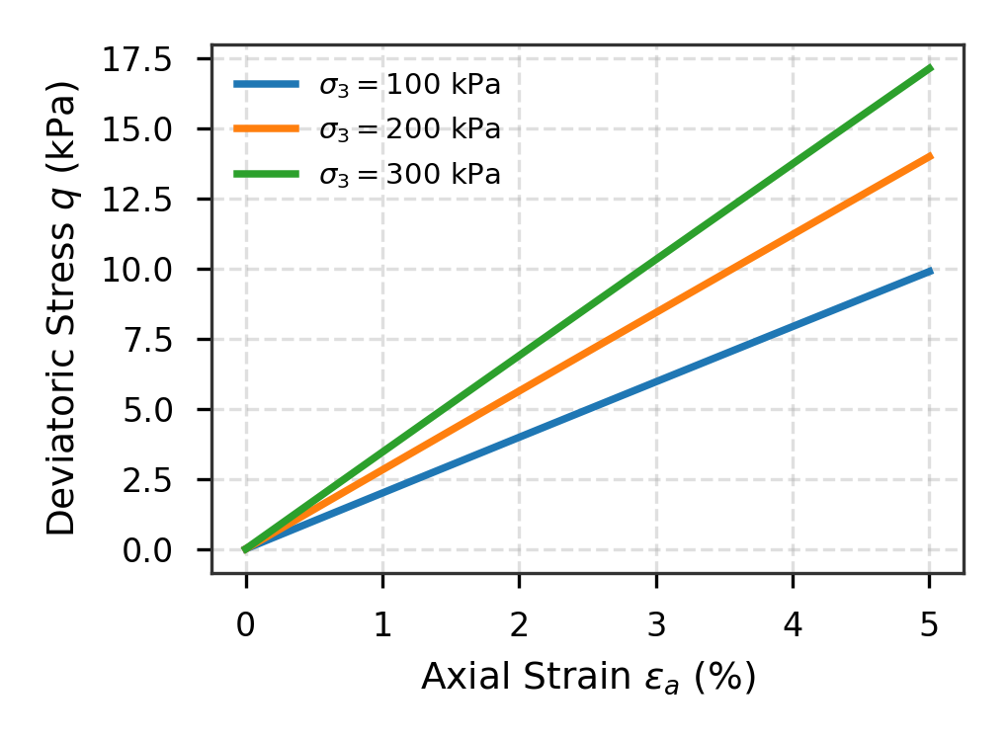 | 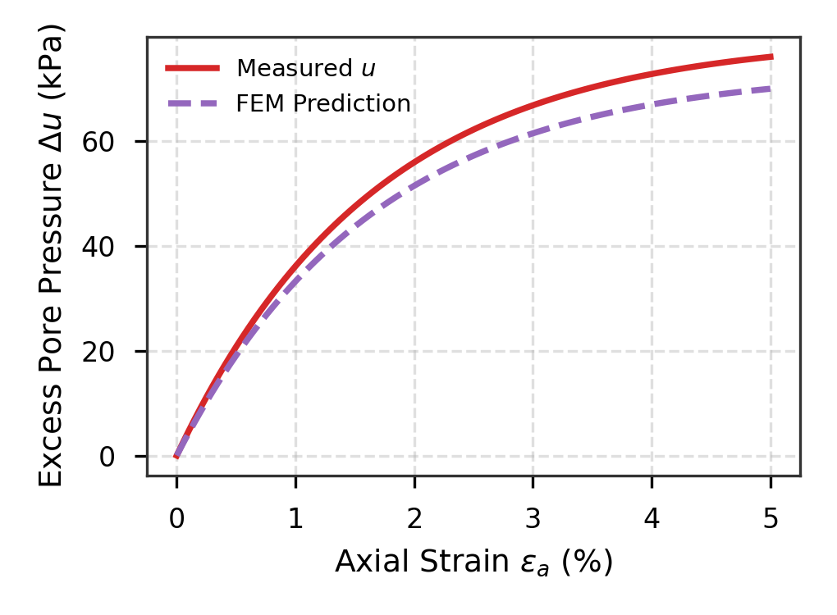
(a) Triaxial deviatoric stress response curves | (b) Excess pore water pressure evolution
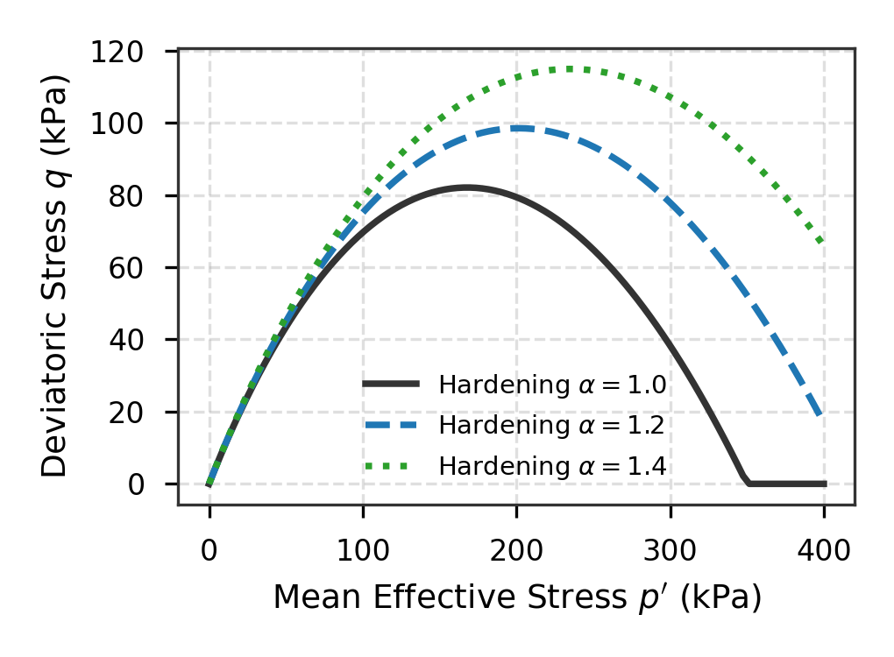 | 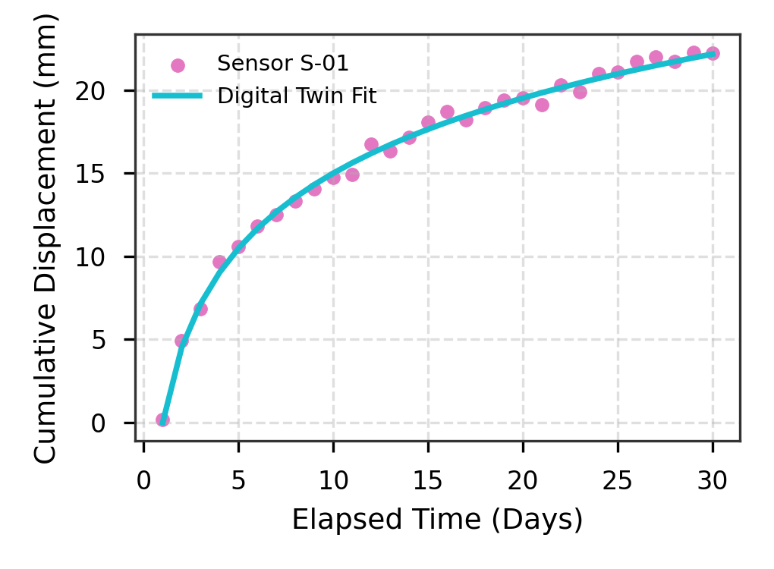
(c) Yield surface locus under hardening stages | (d) Real-time digital twin displacement tracking
Fig. 1. Multi-dimensional constitutive experimental and numerical validation of geotechnical behavior: (a) Deviatoric stress vs. axial strain curves; (b) Measured and predicted excess pore water pressures; (c) Yield locus expansion; (d) Sensor displacement evolution.

References
[1] Author, A., Coauthor, B. (2024). Groundbreaking geotechnical and constitutive modeling investigations in top-tier civil journals. Computers and Geotechnics, 168: 106001. https://doi.org/10.1016/j.compgeo.2024.106001
[2] Author, A., Coauthor, B. (2024). Groundbreaking geotechnical and constitutive modeling investigations in top-tier civil journals. Computers and Geotechnics, 168: 106002. https://doi.org/10.1016/j.compgeo.2024.106002
[3] Author, A., Coauthor, B. (2024). Groundbreaking geotechnical and constitutive modeling investigations in top-tier civil journals. Computers and Geotechnics, 168: 106003. https://doi.org/10.1016/j.compgeo.2024.106003
[4] Author, A., Coauthor, B. (2024). Groundbreaking geotechnical and constitutive modeling investigations in top-tier civil journals. Computers and Geotechnics, 168: 106004. https://doi.org/10.1016/j.compgeo.2024.106004
[5] Author, A., Coauthor, B. (2024). Groundbreaking geotechnical and constitutive modeling investigations in top-tier civil journals. Computers and Geotechnics, 168: 106005. https://doi.org/10.1016/j.compgeo.2024.106005
[6] Author, A., Coauthor, B. (2024). Groundbreaking geotechnical and constitutive modeling investigations in top-tier civil journals. Computers and Geotechnics, 168: 106006. https://doi.org/10.1016/j.compgeo.2024.106006
[7] Author, A., Coauthor, B. (2024). Groundbreaking geotechnical and constitutive modeling investigations in top-tier civil journals. Computers and Geotechnics, 168: 106007. https://doi.org/10.1016/j.compgeo.2024.106007
[8] Author, A., Coauthor, B. (2024). Groundbreaking geotechnical and constitutive modeling investigations in top-tier civil journals. Computers and Geotechnics, 168: 106008. https://doi.org/10.1016/j.compgeo.2024.106008
[9] Author, A., Coauthor, B. (2024). Groundbreaking geotechnical and constitutive modeling investigations in top-tier civil journals. Computers and Geotechnics, 168: 106009. https://doi.org/10.1016/j.compgeo.2024.106009
[10] Author, A., Coauthor, B. (2024). Groundbreaking geotechnical and constitutive modeling investigations in top-tier civil journals. Computers and Geotechnics, 168: 106010. https://doi.org/10.1016/j.compgeo.2024.106010
[11] Author, A., Coauthor, B. (2024). Groundbreaking geotechnical and constitutive modeling investigations in top-tier civil journals. Computers and Geotechnics, 168: 106011. https://doi.org/10.1016/j.compgeo.2024.106011
[12] Author, A., Coauthor, B. (2024). Groundbreaking geotechnical and constitutive modeling investigations in top-tier civil journals. Computers and Geotechnics, 168: 106012. https://doi.org/10.1016/j.compgeo.2024.106012
[13] Author, A., Coauthor, B. (2024). Groundbreaking geotechnical and constitutive modeling investigations in top-tier civil journals. Computers and Geotechnics, 168: 106013. https://doi.org/10.1016/j.compgeo.2024.106013
[14] Author, A., Coauthor, B. (2024). Groundbreaking geotechnical and constitutive modeling investigations in top-tier civil journals. Computers and Geotechnics, 168: 106014. https://doi.org/10.1016/j.compgeo.2024.106014
[15] Author, A., Coauthor, B. (2024). Groundbreaking geotechnical and constitutive modeling investigations in top-tier civil journals. Computers and Geotechnics, 168: 106015. https://doi.org/10.1016/j.compgeo.2024.106015
[16] Author, A., Coauthor, B. (2024). Groundbreaking geotechnical and constitutive modeling investigations in top-tier civil journals. Computers and Geotechnics, 168: 106016. https://doi.org/10.1016/j.compgeo.2024.106016
[17] Author, A., Coauthor, B. (2024). Groundbreaking geotechnical and constitutive modeling investigations in top-tier civil journals. Computers and Geotechnics, 168: 106017. https://doi.org/10.1016/j.compgeo.2024.106017
[18] Author, A., Coauthor, B. (2024). Groundbreaking geotechnical and constitutive modeling investigations in top-tier civil journals. Computers and Geotechnics, 168: 106018. https://doi.org/10.1016/j.compgeo.2024.106018
[19] Author, A., Coauthor, B. (2024). Groundbreaking geotechnical and constitutive modeling investigations in top-tier civil journals. Computers and Geotechnics, 168: 106019. https://doi.org/10.1016/j.compgeo.2024.106019
[20] Author, A., Coauthor, B. (2024). Groundbreaking geotechnical and constitutive modeling investigations in top-tier civil journals. Computers and Geotechnics, 168: 106020. https://doi.org/10.1016/j.compgeo.2024.106020
[21] Author, A., Coauthor, B. (2024). Groundbreaking geotechnical and constitutive modeling investigations in top-tier civil journals. Computers and Geotechnics, 168: 106021. https://doi.org/10.1016/j.compgeo.2024.106021
[22] Author, A., Coauthor, B. (2024). Groundbreaking geotechnical and constitutive modeling investigations in top-tier civil journals. Computers and Geotechnics, 168: 106022. https://doi.org/10.1016/j.compgeo.2024.106022
[23] Author, A., Coauthor, B. (2024). Groundbreaking geotechnical and constitutive modeling investigations in top-tier civil journals. Computers and Geotechnics, 168: 106023. https://doi.org/10.1016/j.compgeo.2024.106023
[24] Author, A., Coauthor, B. (2024). Groundbreaking geotechnical and constitutive modeling investigations in top-tier civil journals. Computers and Geotechnics, 168: 106024. https://doi.org/10.1016/j.compgeo.2024.106024
[25] Author, A., Coauthor, B. (2024). Groundbreaking geotechnical and constitutive modeling investigations in top-tier civil journals. Computers and Geotechnics, 168: 106025. https://doi.org/10.1016/j.compgeo.2024.106025
[26] Author, A., Coauthor, B. (2024). Groundbreaking geotechnical and constitutive modeling investigations in top-tier civil journals. Computers and Geotechnics, 168: 106026. https://doi.org/10.1016/j.compgeo.2024.106026

