Here is an introductory paragraph describing the experimental setup.
Following the 2x2 panel, here is an evaluation of the two primary mechanisms.
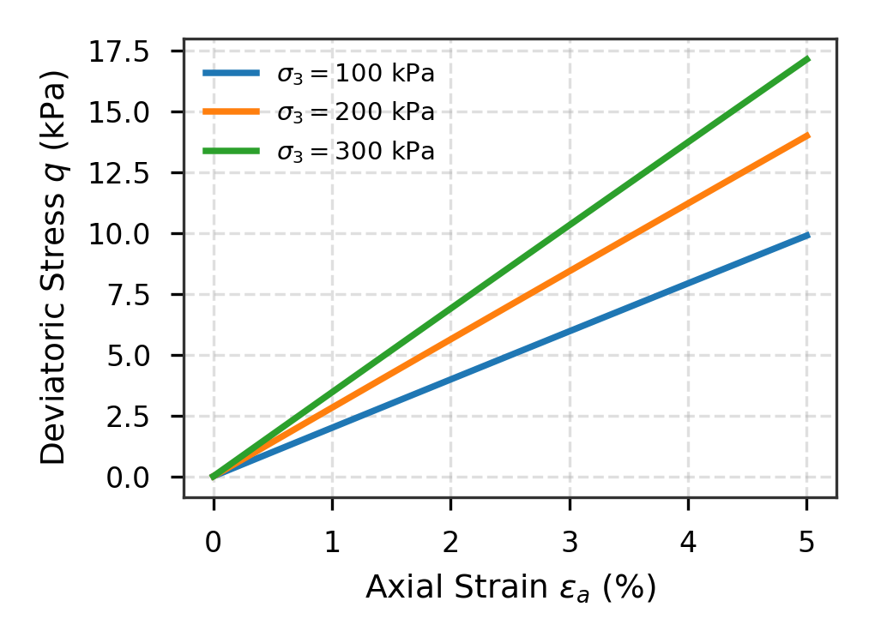 | 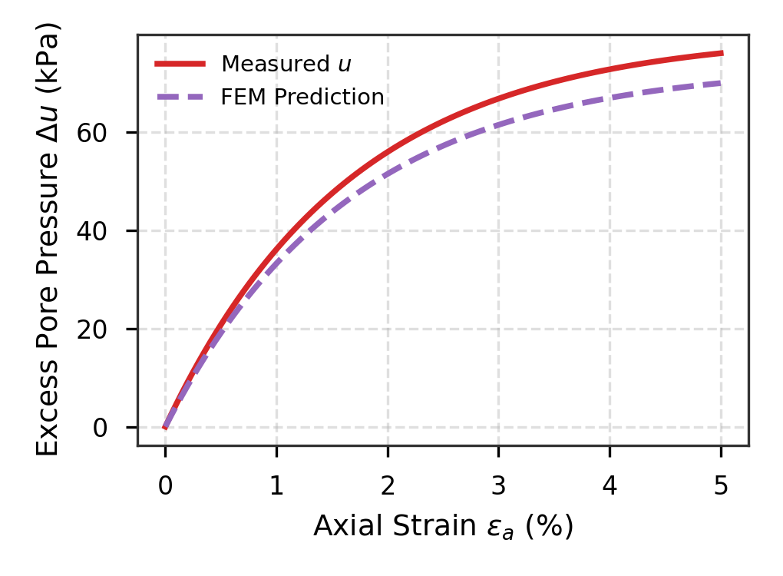
(a) Triaxial stress response | (b) Excess pore water dissipation
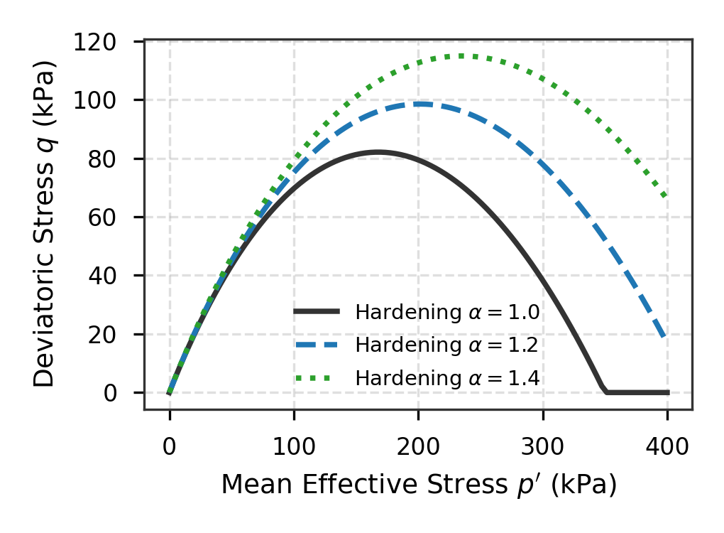 | 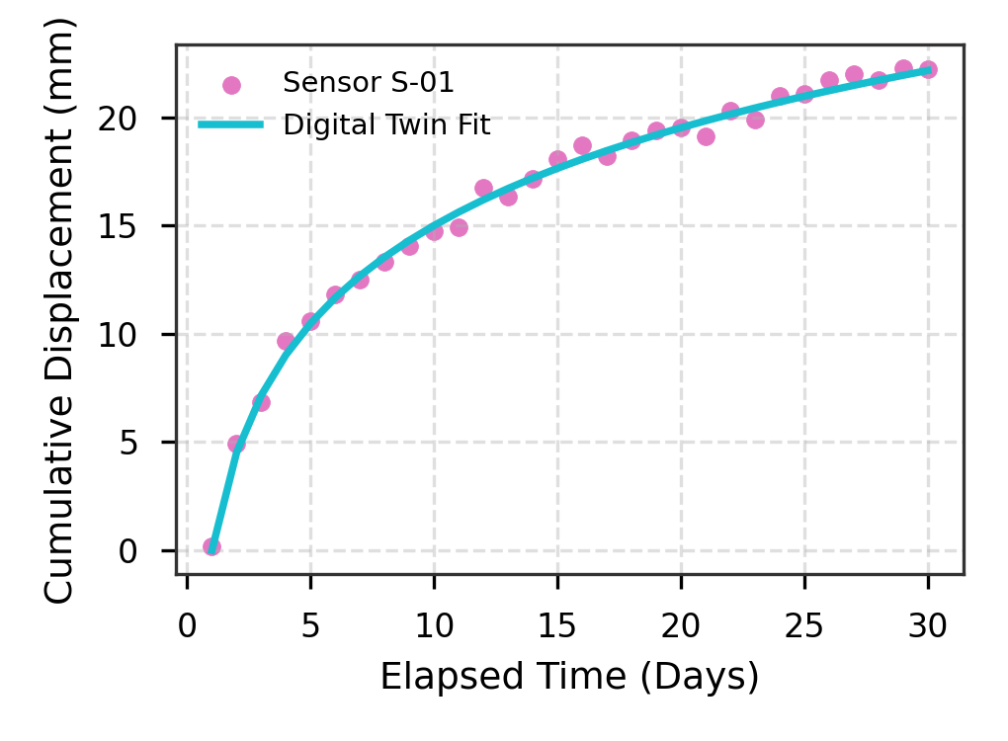
(c) Yield locus expansion | (d) Digital twin sensor monitoring
Fig. 1. Comprehensive mechanical and hydrological performance verification: (a) Stress-strain; (b) Pore pressure; (c) Yield locus; (d) Sensor tracking.
(a) Primary shear response | (b) Dissipation kinetics
Fig. 2. Direct comparison between shear and dissipation behaviors.

