Standard Subfigure Templates (Reference Ground Truth for AI & Converters)
1. Canonical 2x2 Subfigure Panel (4 Panels, GridSpan=2)
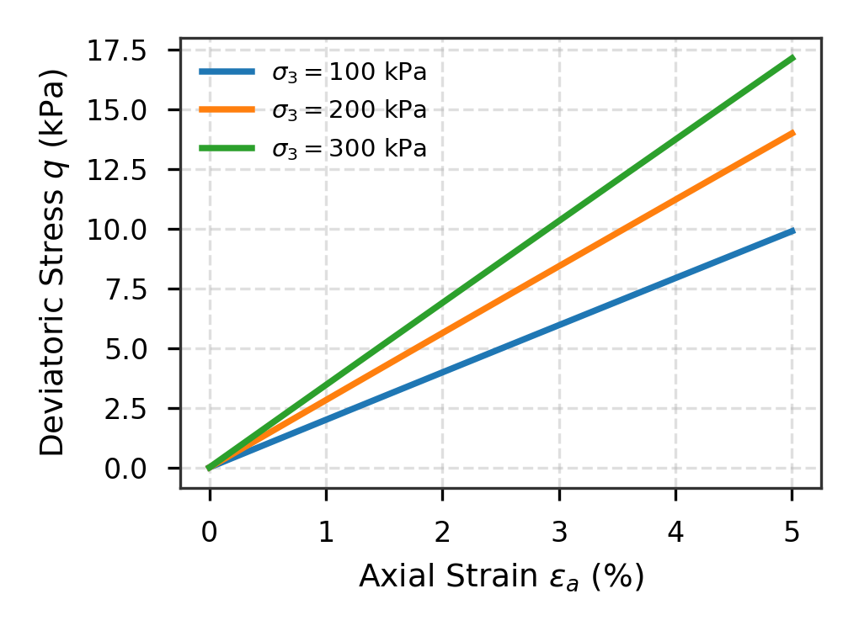 | 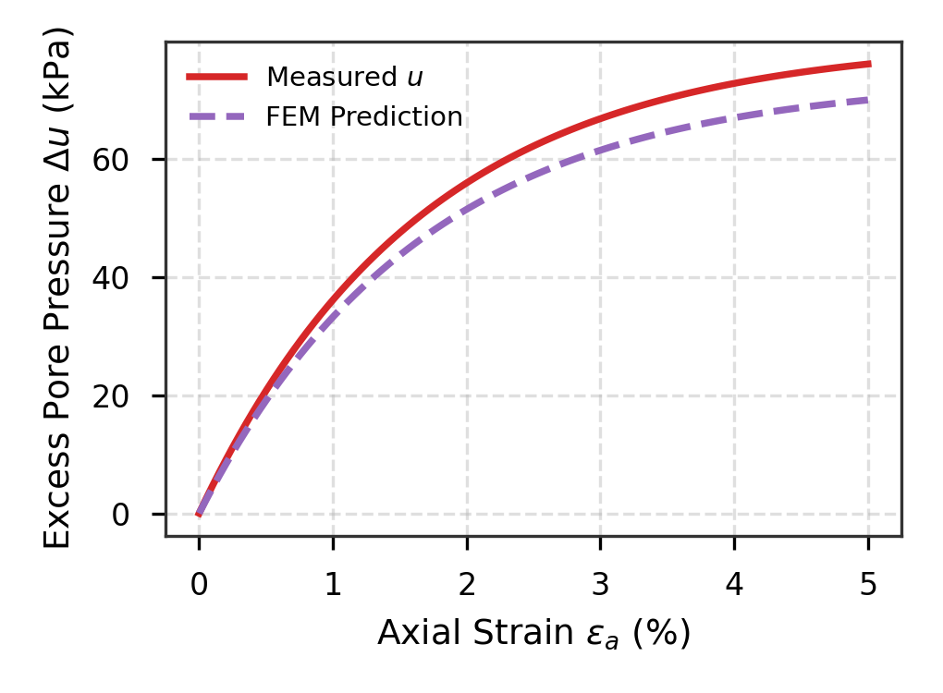
(a) Deviatoric stress versus axial strain curves | (b) Excess pore pressure dissipation response
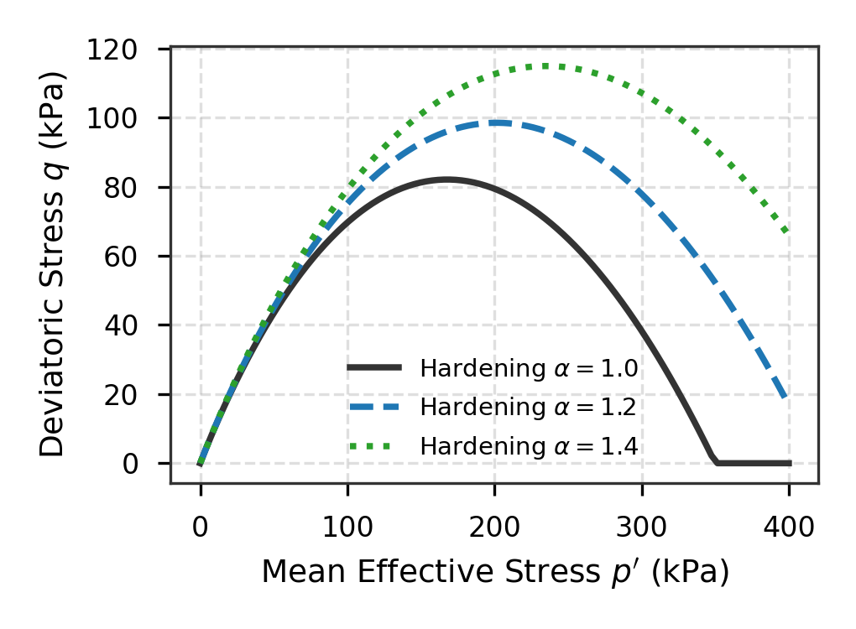 | 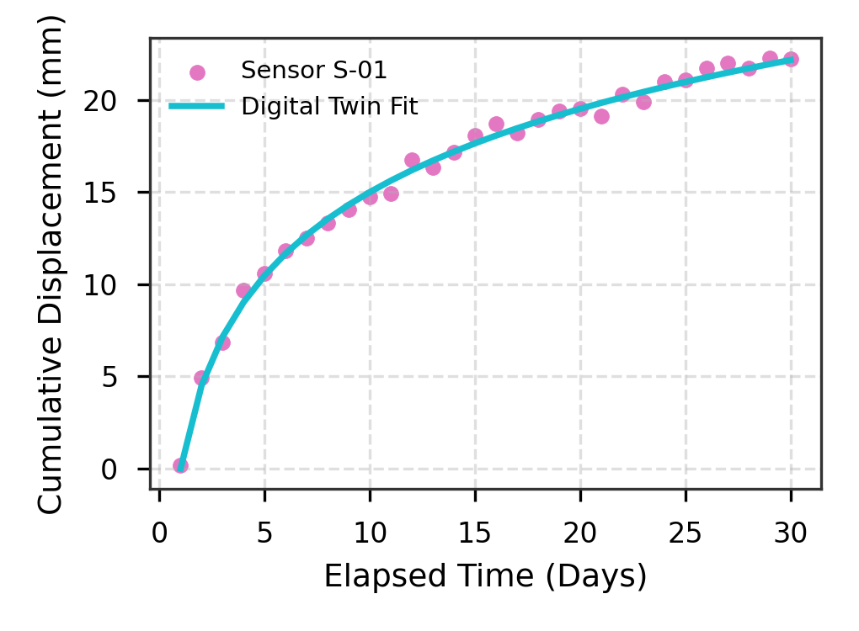
(c) Kinematic yield locus expansion in p′-q space | (d) Real-time sensor monitoring displacement tracking
Fig. 1. Multi-dimensional constitutive and transport validation: (a) Stress-strain; (b) Pore water pressure; (c) Yield locus; (d) Sensor tracking.
2. Canonical 1x2 Subfigure Panel (2 Panels Side-by-Side, GridSpan=2)
(a) Measured versus computed deviatoric stress response | (b) Normalized excess pore pressure dissipation trends
Fig. 2. Side-by-side comparison of constitutive behaviors: (a) Stress-strain; (b) Dissipation rates.

