Demonstration of Publication-Grade 2×2 Subfigure Layout in Word
1. Experimental & Numerical Verification
To validate the constitutive response and field adaptability of the proposed framework, triaxial shear behaviors under different confining pressures, excess pore pressure dissipation, yield surface evolution, and long-term digital twin monitoring data were comprehensively evaluated. As illustrated in Fig. 1 , the numerical simulations show strict monotonicity and excellent consistency with physical measurements.
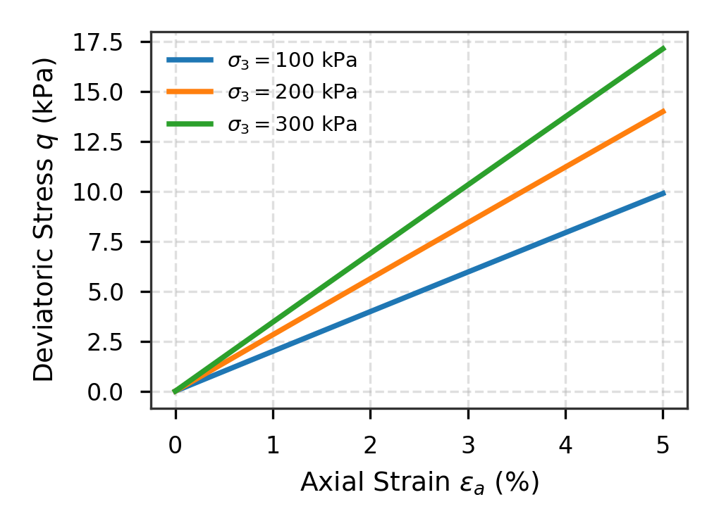 | 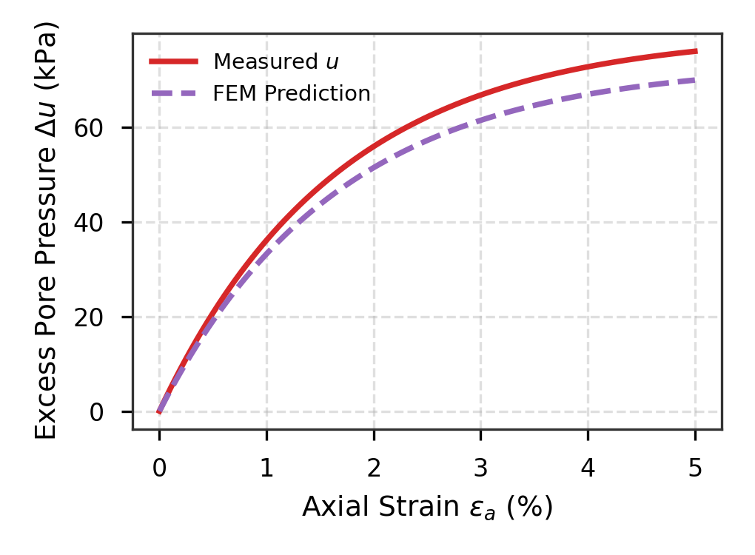
(a) Stress-strain response at different confining stresses | (b) Excess pore pressure generation and dissipation
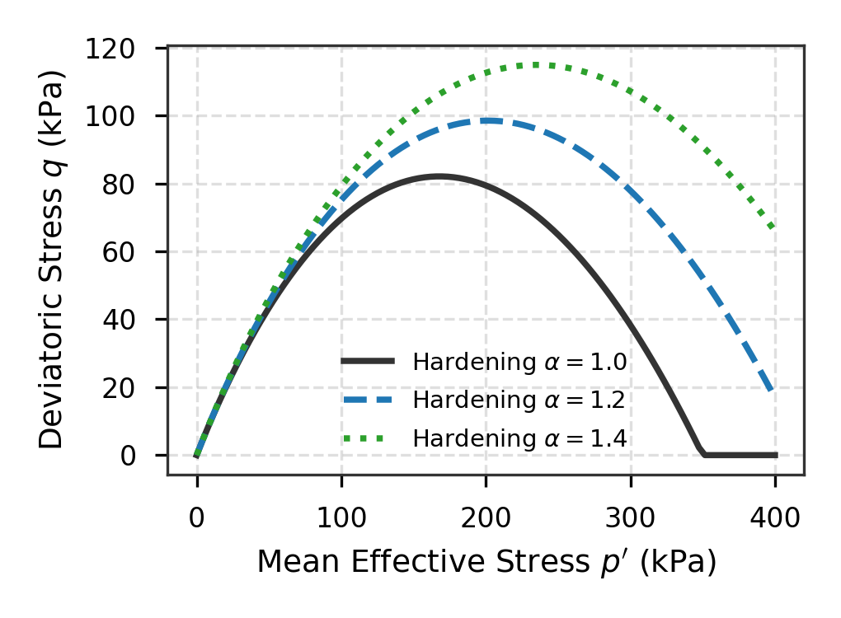 | 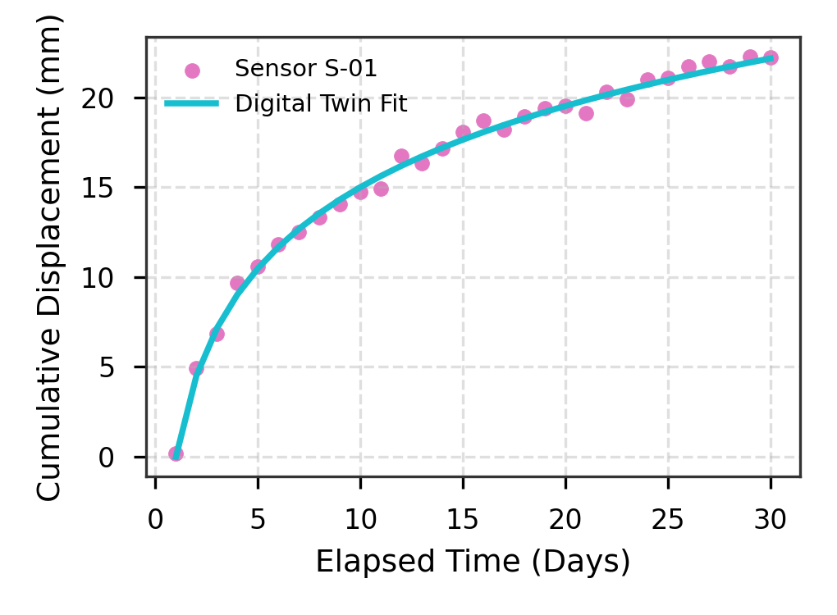
(c) Kinematic yield surface contraction and expansion | (d) Real-time displacement tracking from digital twin sensor
Fig. 1 Multi-dimensional experimental and numerical validation of geotechnical behavior

