WDD 130 – w03 Rafting site: planning document

Student name: Marvin

Course: WDD 130 – web development

Assignment: Week 03 – Rafting Site: Planning Documment

Date: 18th of July 2025

1. Site Logo

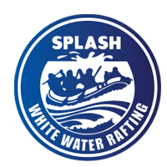Logo file Name: rafting-logo

1. color palette

palette URL: <https://coolors.co/palette/2f6690-3a7ca5-d9dcd6-16425b-81c3d7>

|  |  |  |
| --- | --- | --- |
| Label | Color Name | Hex Code |
| Primary Color | Deep Blue | #2F6690 |
| Secondary Color | River Blue | #3A7CA5 |
| Accent 1 Color | Light Gray | #D9DCD6 |
| Accent 2 Color | Sky Blue | #81C3D7 |

1. Typography

|  |  |  |
| --- | --- | --- |
| Font Type | Font Name | Link |
| Heading Font | Merriweather | https://fonts.google.com/share?selection.family=Heebo:wght@100..900|Merriweather:ital,opsz,wght@0,18..144,300..900;1,18..144,300..900|Roboto:ital,wght@0,100..900;1,100..900 |
| Text Font | roboto | https://fonts.google.com/share?selection.family=Heebo:wght@100..900|Merriweather:ital,opsz,wght@0,18..144,300..900;1,18..144,300..900|Roboto:ital,wght@0,100..900;1,100..900 |