(1) MPSoft Technologies Pvt. Ltd. is a fast growing IT industry and wants to implement a

function to calculate the monthly income generated from all projects from their N no of clients

like C1,C2,C3,C4….CN. The team wants to compare the time/steps required to execute this

function on various inputs and analyse the complexity of each combination. Also draw a

comparative chart. In each of the following functions N will be passed by user.

Design the algorithm for the same and implement using the programming language of your

choice. Make comparative analysis for various use cases &amp; input size.

1. To calculate the sum of 1 to N number using loop.

2. To calculate the sum of 1 to N number using the equation.

3. To calculate sum of 1 to N numbers using recursion.

Code:-

import time

import matplotlib.pyplot as plt

import sys

sys.setrecursionlimit(1000000)

def sum_using_loop(N):

    total = 0

    for i in range(1, N + 1):

        total += i

    return total

def sum_using_equation(N):

    return N * (N + 1) // 2

def sum_using_recursion(N):

    if N == 1:

        return 1

    return N + sum_using_recursion(N - 1)

def measure_time(func, N):

    start_time = time.time()

    try:

        func(N)

    except RecursionError:

        return float('inf')

    end_time = time.time()

    return end_time - start_time

input_sizes = [100, 1000, 5000, 10000, 20000, 50000,100000]

loop_times = []

equation_times = []

recursion_times = []

for size in input_sizes:

    loop_times.append(measure_time(sum_using_loop, size))

    equation_times.append(measure_time(sum_using_equation, size))

    recursion_times.append(measure_time(sum_using_recursion, size))

plt.figure(figsize=(12, 6))

plt.plot(input_sizes, loop_times, label='Loop', marker='s')

plt.plot(input_sizes, equation_times, label='Equation', marker='o')

plt.plot(input_sizes, recursion_times, label='Recursion', marker='*')

plt.xlabel('Input Size')

plt.ylabel('Execution Time')

plt.title('Comparison of timeing ')

plt.legend()

plt.grid(True)

plt.show()

Output:-

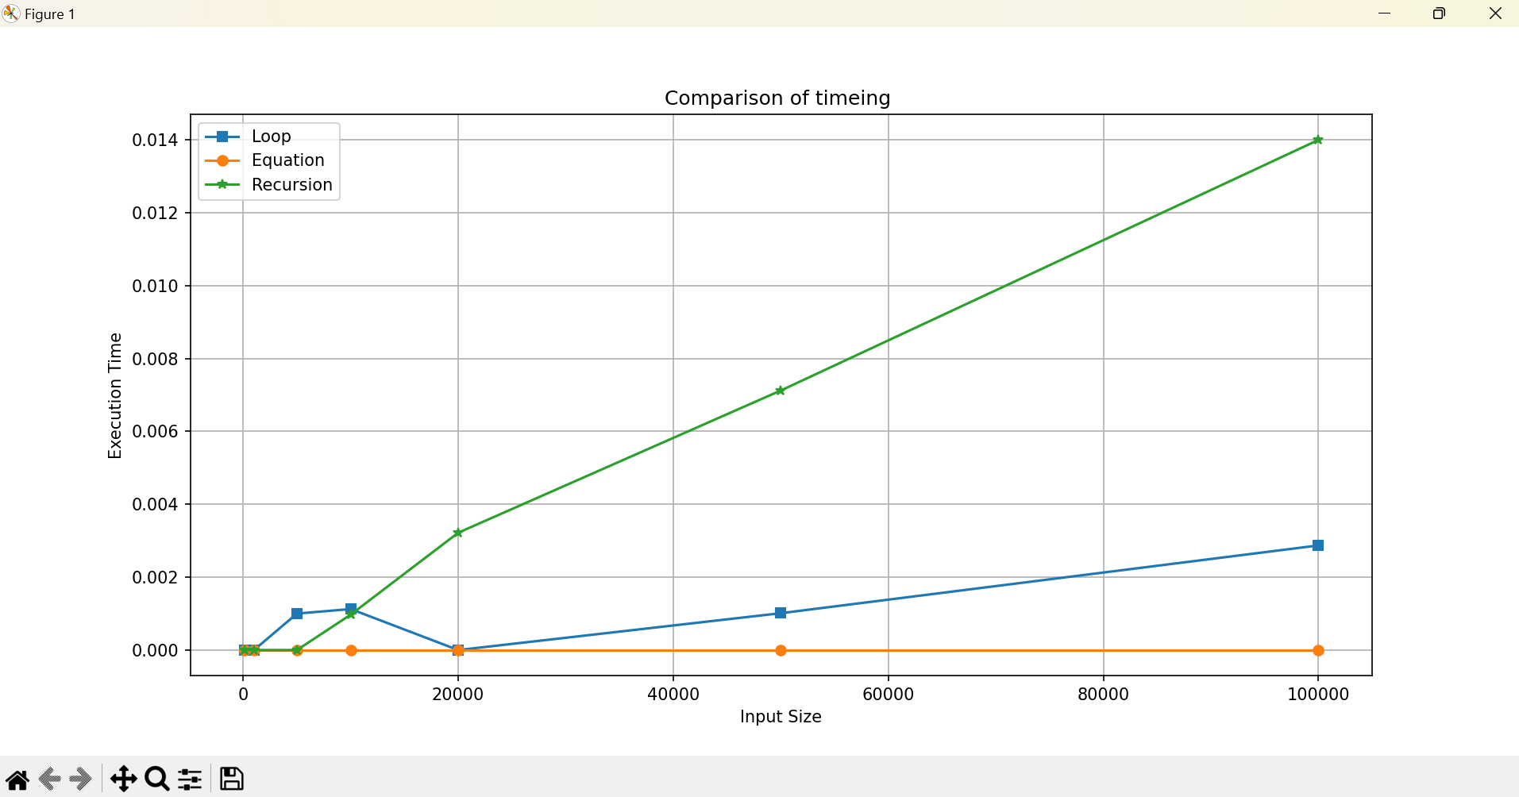

(2) Suppose a newly-born pair of rabbits, one male, one female, are put in a field. Rabbits are

able to mate at the age of one month so that at the end of its second month a female can produce another pair of rabbits. Suppose that our rabbits never die and that the female always produces one new pair (one male, one female) every month from the second month on. How many pairs will there be in one year? Apply appropriate algorithm/method to find out the above problem and also solve them using iteration and recursive method. Compare the performance of two methods by counting the number of steps executed on various inputs. Also draw a comparative chart. Design the algorithm for the same and implement using the programming language of your choice. Make comparative analysis for various use cases &amp; input size.

Code:-

import time

import matplotlib.pyplot as plt

def fibonacci_iterative(n):

    if n <= 1:

        return n

    a, b = 0, 1

    for _ in range(2, n + 1):

        a, b = b, a + b

    return b

def fibonacci_recursive(n):

    if n <= 1:

        return n

    return fibonacci_recursive(n - 1) + fibonacci_recursive(n - 2)

def measure_time(func, n):

    start_time = time.time()

    func(n)

    end_time = time.time()

    return end_time - start_time

input_sizes = [5, 10, 15, 20, 25, 30, 35]

iterative_times = []

recursive_times = []

for size in input_sizes:

    iterative_times.append(measure_time(fibonacci_iterative, size))

    recursive_times.append(measure_time(fibonacci_recursive, size))

n_months = 12

rabbit_pairs_iterative = fibonacci_iterative(n_months)

rabbit_pairs_recursive = fibonacci_recursive(n_months)

print(f"Number of rabbit pairs after {n_months} months (Iterative): {rabbit_pairs_iterative}")

print(f"Number of rabbit pairs after {n_months} months (Recursive): {rabbit_pairs_recursive}")

plt.figure(figsize=(12, 6))

plt.plot(input_sizes, iterative_times, label='Iterative', marker='s')

plt.plot(input_sizes, recursive_times, label='Recursive', marker='o')

plt.xlabel('Input Size')

plt.ylabel('Execution Time')

plt.title('Comparison of Fibonacci Calculation')

plt.legend()

plt.grid(True)

plt.show()

Output:-

