(1) There are 2 chefs, namely chef 1 and chef 2 in the MasterChef competition. The judge is

going to judge on the basis of 3 categories: presentation, taste and hygiene to prepare the dishes.

The marking is scaling from 1 to 100. The rating for chef 1 challenge is the triplet a = (a[0], a[1],

a[2]), and the rating for Chef 2 challenge is the triplet b = (b[0], b[1], b[2]), where 0 index is

presentation, 1 index is taste and 2 index is hygiene.

The task is to find their comparison points by comparing a[0] with b[0], a[1] with b[1], and a[2]

with b[2].

• If a[i] &gt; b[i], then Chef 1 is awarded 1 point.

• If a[i] &lt; b[i], then Chef 2 is awarded 1 point.

• If a[i] = b[i], then neither person receives a point.

Comparison points are the total points a person earned.

Given a and b, determine their respective comparison points.

Design the algorithm for the same and implement using the programming language of your

choice. Make comparative analysis for various use cases &amp; input size.

Sample Input 1

27 48 70

89 26 7

Sample Output 1

2 1

Explanation 1

Comparing the 0th elements, 27&lt;89 so Chef 2 receives a point.

Comparing the 1st and 2nd elements, 48&gt;26 and 70&gt;7 so Chef 1 receives two points.

The return array is [2,1].

CODE :-

* Python code:-
* from flask import Flask, request, render_template_string
* app = Flask(__name__)
* def compare_chefs(chef1, chef2):
* chef1_points, chef2_points = 0, 0
* for i in range(3):
* if chef1[i] > chef2[i]:
* chef1_points += 1

        elif chef1[i] < chef2[i]:

* chef2_points += 1
* return chef1_points, chef2_points
* @app.route('/', methods=['GET', 'POST'])
* def index():
* chef1_points, chef2_points = 0, 0
* if request.method == 'POST':
* try:
* chef1 = [int(request.form[f'chef1_{i}']) for i in range(1, 4)]
* chef2 = [int(request.form[f'chef2_{i}']) for i in range(1, 4)]
* chef1_points, chef2_points = compare_chefs(chef1, chef2)
* except ValueError:
* return "Invalid input. Please enter valid numbers."
* *# Read the HTML file and render it with points*
* with open('p1.html', 'r') as file:
* html_content = file.read()
* return render_template_string(html_content, chef1_points=chef1_points, chef2_points=chef2_points)
* if __name__ == "__main__":

    app.run(debug=True)

* HTML code:-
* <!DOCTYPE html>
* <html lang="en">
* <head>
* <meta charset="UTF-8">
* <meta name="viewport" content="width=device-width, initial-scale=1.0">
* <title>Chef Comparison</title>
* <style>
* body {
* font-family: Arial, sans-serif;
* text-align: center;
* margin-top: 50px;
* }
* .result {
* margin-top: 20px;
* }
* </style>
* </head>
* <body>
* <h1>Chef Comparison</h1>
* <form action="/" method="post">
* <h2>Enter scores for Chef 1 and Chef 2 </h2>
* <div>
* <h3>Chef 1 Scores:</h3>
* <input type="number" name="chef1_1" required>
* <input type="number" name="chef1_2" required>
* <input type="number" name="chef1_3" required>
* </div>
* <div>
* <h3>Chef 2 Scores:</h3>
* <input type="number" name="chef2_1" required>
* <input type="number" name="chef2_2" required>
* <input type="number" name="chef2_3" required>
* </div>
* <br>
* <input type="submit" value="Submit">
* `   </form>
* {% if chef1_points is not none and chef2_points is not none %}
* <div class="result">
* <h2>Results</h2>
* <p>Chef 1 Points: {{ chef1_points }}</p>
* <p>Chef 2 Points: {{ chef2_points }}</p>
* </div>
* {% endif %}
* </body>
* </html>
* Output:-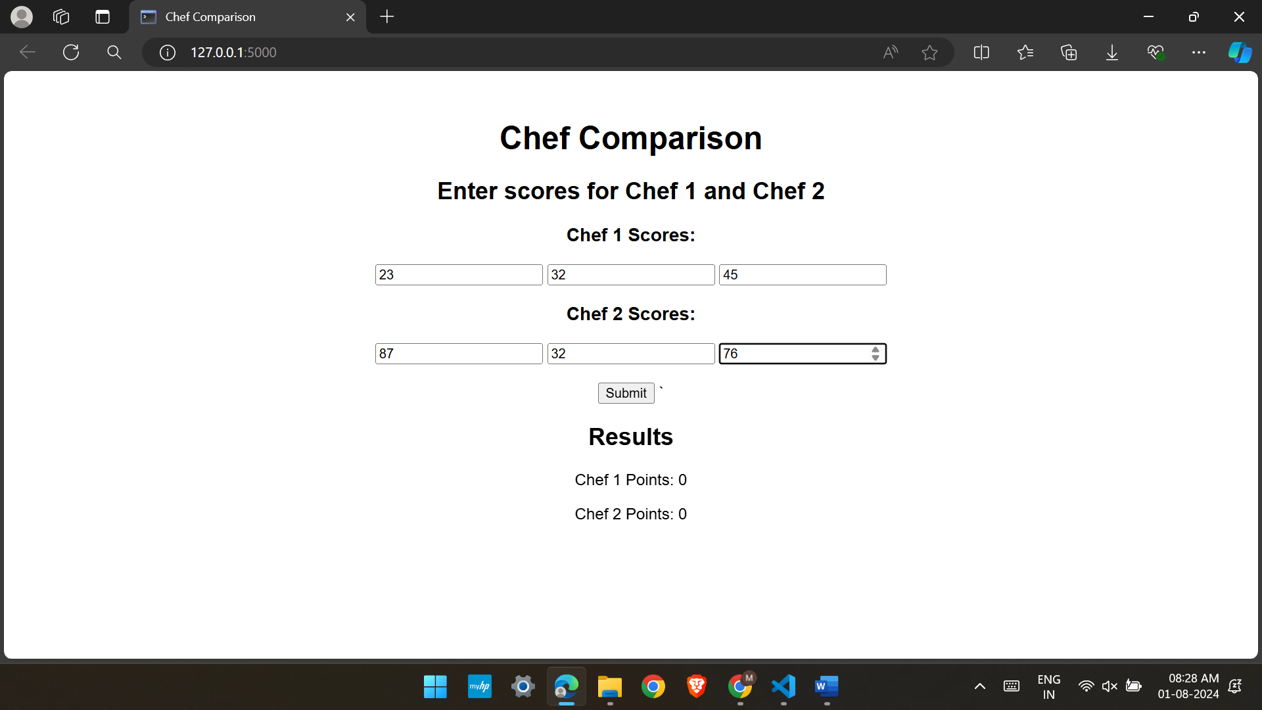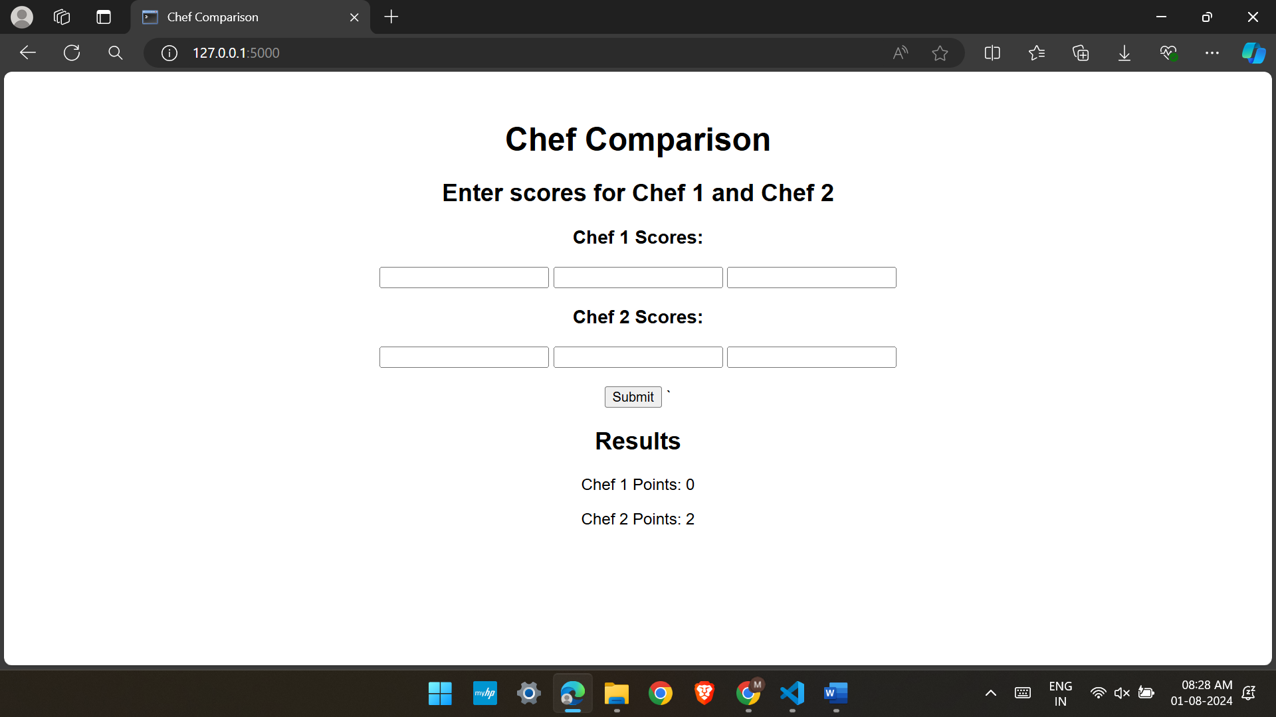
* TASK – 2 :-

(2) Let us suppose that you are having an array containing both positive and negative numbers.

Given the numbers you are supposed to find 2 such elements such that the sum of those numbers

is closest to zero.

Sample Input 1

15, 5, -20, 30, -45

Sample Output 1

15, -20

Explanation 1

In all the comparison, the sum of 15 and -20 is smallest amount among all other comparison.

Sample Input 2

15, 5, -20, 30, 25

Sample Output 2

15, -20 &amp; -20, 25

Explanation 2

In all the comparison, the sum of 15,-20 &amp; -20, 25

* Code:-
* Python code:-
* from flask import Flask, request, send_from_directory, render_template_string
* app = Flask(__name__)
* def find_closest_to_zero_pair(arr):
* closest_sum = float('inf')
* closest_pairs = []
* *# Generate all pairs manually*
* for i in range(len(arr)):
* for j in range(i + 1, len(arr)):
* pair_sum = arr[i] + arr[j]
* if abs(pair_sum) < abs(closest_sum):
* closest_sum = pair_sum
* closest_pairs = [(arr[i], arr[j])]
* elif abs(pair_sum) == abs(closest_sum):
* closest_pairs.append((arr[i], arr[j]))
* return closest_pairs
* @app.route('/', methods=['GET', 'POST'])
* def index():
* closest_pairs = []
* if request.method == 'POST':
* input_str = request.form['numbers']
* try:
* numbers = list(map(int, input_str.split(',')))
* closest_pairs = find_closest_to_zero_pair(numbers)
* except ValueError:
* closest_pairs = [('Error', 'Invalid input')]
* *# Render HTML directly from the file*
* return render_template_string(open('p2.html').read(), closest_pairs=closest_pairs)
* if __name__ == "__main__":
* app.run(debug=True)
* Html code:-
* <!DOCTYPE html>
* <html lang="en">
* <head>
* <meta charset="UTF-8">
* <meta name="viewport" content="width=device-width, initial-scale=1.0">
* <title>Closest Pair to Zero</title>
* <style>
* body {
* font-family: Arial, sans-serif;
* text-align: center;
* margin-top: 50px;
* }
* .form-container {
* margin-top: 20px;
* }
* .result {
* margin-top: 20px;
* }
* </style>
* </head>
* <body>
* <h1>Find Closest Pair to Zero</h1>
* <form action="/" method="post">
* <label for="numbers">Enter numbers separated by commas:</label><br>
* <input type="text" id="numbers" name="numbers" required><br><br>
* <input type="submit" value="Submit">
* </form>
* {% if closest_pairs %}
* <div class="result">
* <h2>Results</h2>
* <p>Closest Pairs to Zero Sum:</p>
* <p>
* {% if closest_pairs[0][0] == 'Error' %}
* {{ closest_pairs[0][1] }}
* {% else %}
* {% for p1, p2 in closest_pairs %}
* {{ p1 }}, {{ p2 }}{% if not *loop*.last %} & {% endif %}
* {% endfor %}
* {% endif %}
* </p>
* </div>
* {% endif %}
* </body>
* </html>

* Output:-

