**For the testing of the task I created a virtual host with the domain called: property.test/api**

**This is a CRUD Restfull API and to test the API I used POSTMAN.**

POST Method -> Inserting value into database and API returns LAT and LONG

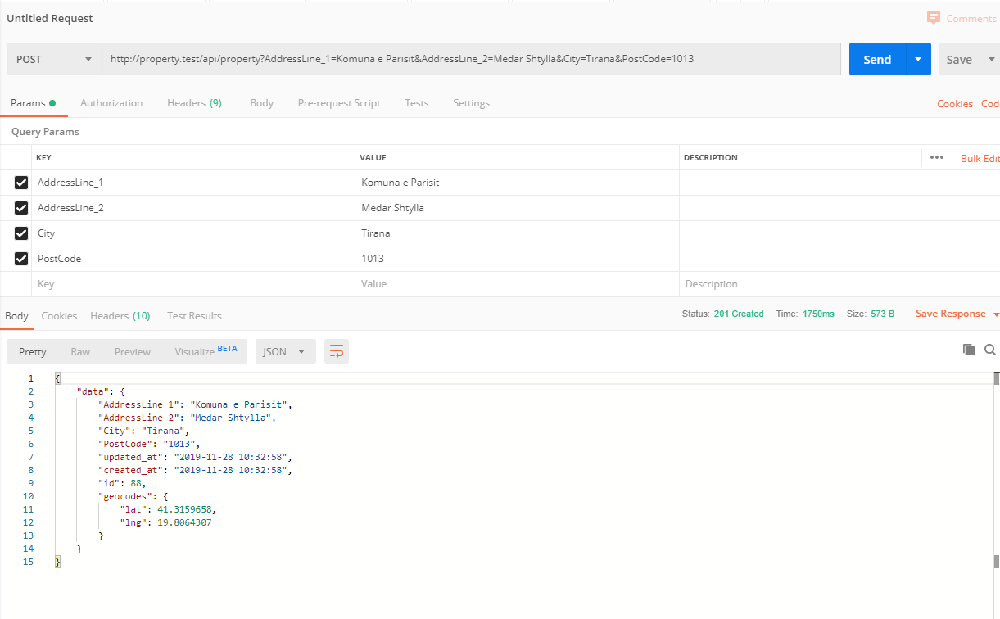

Method GET -> Returns all values from database and API also adds the values for LAT and LONG

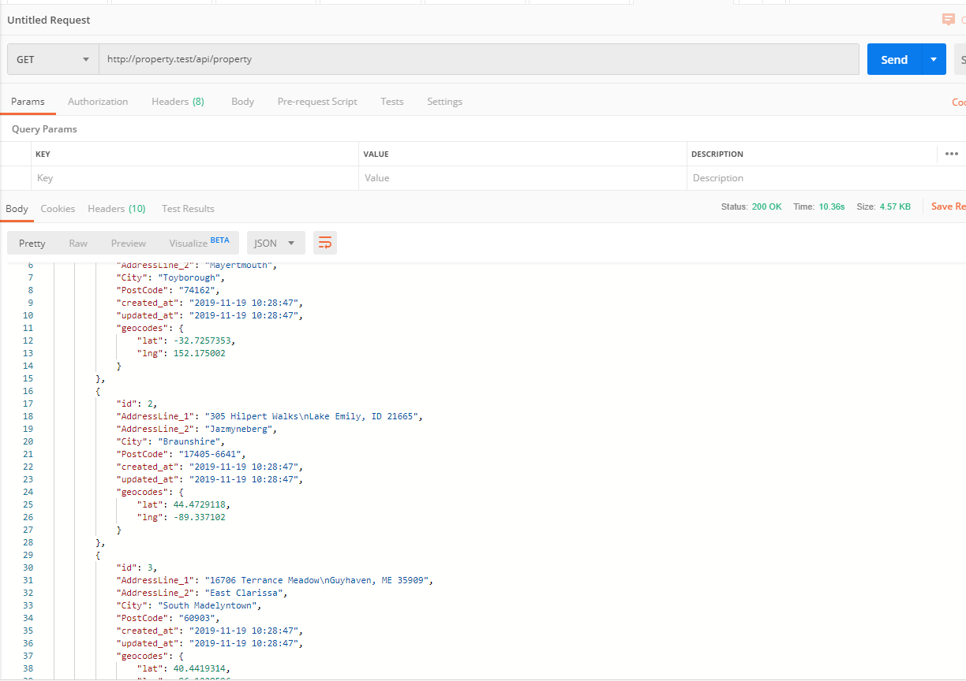

Method PUT -> Update value from database and API also returns LAT and LONG

