Republic of the Philippines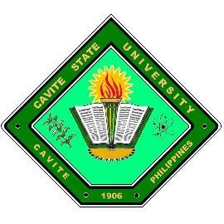

**CAVITE STATE UNIVERSITY**

CCAT Campus

Rosario, Cavite

*(046) 437-9505 /* 🖷*(046) 437-6659*

[cvsurosario@cvsu.edu.ph](mailto:cvsurosario@cvsu.edu.ph)

[www.cvsu-rosario.edu.p](http://www.cvsu-rosario.edu.p)h

**DEPARTMENT OF COMPUTER STUDIES**

**Trainee : FERNANDEZ, SHYLLE P.**

**Title : A NARRATIVE REPORT: TRAINING EXPERIENCES AT**

**CAVITE STATE UNIVERSITY - CCAT CAMPUS**

**TECHNOVATION BUILDING, RESEARCH & EXTENSION**

**APPROVED:**

**MARY GRACE D. SILVANO _**____ **JENNY DANE R. BASAYSAY, MBA** _____

Area Coordinator Date OJT Coordinator Date

**KARLO JOSE E. NABALIT** _____  **ARIEL G. SANTOS, EdD** _____

Department Chairperson Date Director, Instructions Date

**LAURO B. PASCUA, EdD** _____

Campus Administrator Date

Republic of the Philippines

**CAVITE STATE UNIVERSITY**

CCAT Campus

Rosario, Cavite

🕾 *(046) 437-9505 /* 🖷*(046) 437-6659*

[cvsurosario@cvsu.edu.ph](mailto:cvsurosario@cvsu.edu.ph)

[www.cvsu-rosario.edu.p](http://www.cvsu-rosario.edu.p)h

**DEPARTMENT OF COMPUTER STUDIES**

**On the Job Training (OJT) Narrative Report**

1. **Trainee Information**

**Name:** NOEL, MARVIN D.

**Course and Section:** BS Information Technology 402 A

**Complete Address:** Blk 1 Lot 6 Ph1 Hillsview Royale Timalan Balsahan Naic, Cavite

1. **Profile of the Company**

**Company Name**: Technovation Building, Research and Extension

**Physical Location**: Technovation Center, Cavite State University- CCAT

Campus, Tejeros Convention

**Website URL: https://www.facebook.com/CvSUCCATRE**

**Contact Information**: (046) 886 3597 / ccatre@cvsu.edu.ph

**The structure of the company:** Public

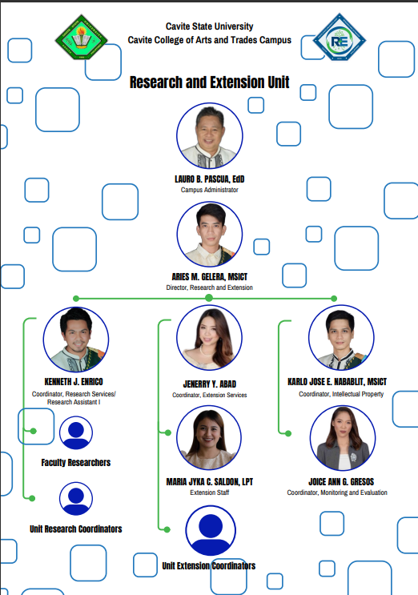

Organizational Chart

1. **Brief Description of the Company**

The Research & Extension Unit at the Cavite State University began with the conversion of Indang Rural High School into Don Severino Agricultural College in 1964. Since the Research Center has evolved to function as one of the trilogy roles of the University. To date, the University is the seat of the national research, development and extension for coffee and urban agriculture - a status bestowed by the Department of Agriculture Bureau of Agricultural Research (DA-BAR).

The position of campus administrator is presently held by Dr. Lauro B. Pascua. The Research Center (RC) exerted serious efforts towards streamlining the Research, Development and Extension Program by establishing a strong and effective research program aimed to generate innovative and viable technologies useful to farmers and other clients. This is done with the goal of improving their standard of living. The University’s research program focused on two major programs: Coffee Research, Development and Extension and Urban Agriculture Research, Development and Extension. These two major thrusts provide the framework for an organized research and extension. However, to accommodate the ever-increasing need for RD&E activities brought about by the development of the university into a comprehensive one, these thrusts have become more elaborated through the “Faculty and Students Research Capability Enhancement Program” that was approved by the University Board of Regents in 2004. Moreover, a MOU with Happy Earth Organization, a non-governmental organization, for RD&E activities on *Arenga pinnata* (kaong) was signed in 2004.

1. Mission

To engage in the improvement of the quality of life of farmers/fisherfolks, women, out-of-school youths, local government employees, and other clients through the conduct of relevant education and training; farm and 2 business advisory services; demonstration services; and information, communication, and technology services.

1. Vision

Alleviating the standard of living of the economically and socially disadvantaged sectors of society.

1. Product Services Description
   * + 1. Fund Support
       2. Literature and Plagiarism Check
       3. Consultation and Advising
       4. Faculty and Staff Development Programs
       5. Intellectual Property Assistance and Support
2. **Training Period**

The training period started from February 26, 2024 to May 31, 2024.

1. **Training Schedule**

Monday – Thursday, 7:00 AM – 6:00 PM

1. **Training Duties:**

|  |  |
| --- | --- |
| **Assigned Department** | **Weekly Work Assignment** |
| **Technovation Building**  **Research & Extension / CCT Tagaytay** | **Week 1 (Feb 26-29, 2024)**  The journal documents the writer's experience during my On-the-Job Training (OJT) at a research and extension office. On the first day, they engaged in meet and greet activities, familiarized themselves with the departments, and assisted in administrative tasks like making ID cards. On the second day, they conducted a community needs assessment in Tagaytay, helping survey employees and document responses to improve training programs. The third day involved working at the front desk, assisting visitors, and tabulating assessments using Excel. On the fourth day, they facilitated the signing of papers for an upcoming research bootcamp, coordinating with department chairs to gather signatures. |
| **Technovation Building**  **Research & Extension** | **Week 2 (March 4-6, 2024)**  During the second week, on March 4th, I engaged in various activities. I visited different departments to collect updates on the responsive research bootcamp participants list. I also obtained signatures from the GAD coordinator, Ms. Janet L. Rodriguez, and the campus administrator, Mr. Lauro B. Pascua. Additionally, I received guidance from Mr. Aries, the Director of Research and Extension, on scanning documents using an HP scanner. On March 5th, little was accomplished due to a morning meeting and subsequent departmental visits for updates on bootcamp participants. March 6th proved to be hectic as I managed campus communications and gathered updates on bootcamp participants, securing necessary signatures from professors and coordinators amidst their busy schedules. Despite the busyness, everything was successfully accomplished. |
| **Cvsu Hostel** | **Week 3 (March 11-14, 2024)**  Throughout days 8 to 11, the focus was on preparations and smooth execution of the Responsive Research Bootcamp. On March 11th, amidst the bustling activity in anticipation of the event, meticulous arrangements were made, including finalizing departmental lists, recording attendance, and creating backups of essential documents. As day one of the bootcamp dawned on March 12th, I took on the responsibility of registering participants and faculty, overcoming minor technical hiccups along the way. The subsequent days saw the event progress smoothly, with minor challenges in registration and certificate issuance being swiftly addressed. Despite imperfections, the overall atmosphere remained positive, culminating in a successful conclusion on March 14th, buoyed by the collaborative efforts of colleagues and even moments of lightheartedness during lunch. |
| **Technovation Building**  **Research & Extension** | **Week 4** **(March 18-21, 2024)**  During the fourth week of my OJT, I engaged in a variety of tasks and events. On March 18, I handled administrative duties such as signing certificates and organizing paperwork, followed by preparing for an upcoming event. The following day, March 19, I participated in event management, conducted a pre-assessment, and assisted throughout the event, meticulously documenting proceedings. On March 20, my responsibilities shifted to front desk duties and cleaning tasks, including certificate distribution and preparation for a conference the next day. Finally, on March 21, I documented speakers and events during the First Quarter conference, ensuring accurate records and capturing moments through photography. Despite the workload, I found satisfaction and happiness in my tasks. |
| **Technovation Building**  **Research & Extension** | **Week 5** **(March 25-27, 2024)**  During the fifth week of my on-the-job training (OJT), I began by distributing certificates that were pending from the previous week before delving into editing proceedings using Canva, a task that consumed the entirety of the afternoon. This was followed by photocopying attendance records and proposals to be included in the proceedings. The next day, we documented entries for the national women's month event and continued photocopying assessments for inclusion in the proceedings. I also prepared additional materials such as attendance records, evaluations, and proposals throughout the day. On the third day of the week, it was a half-day, primarily consisting of signing tasks with Sir Ariel. |
| **Technovation Building**  **Research & Extension** | **Week 6** **(April 1-4, 2024)**  During the sixth week of my on-the-job training (OJT), I primarily focused on managing proceedings and evaluating the GAD-Responsive Research Bootcamp and 1st Conference, which involved tabulating data, creating graphs, and ensuring accuracy in Excel and Word before printing. Continuation of this task on the following day included seeking feedback from Ma'am Jayka for revisions and additional document preparation. Another significant task involved sorting through archived papers from previous years, separating important documents such as theses without signatures and revised revisions from unnecessary ones, which were subsequently shredded. Additionally, inventory checks were conducted for office supplies and items, with efforts made to organize them efficiently, with further tasks planned for the next day, including another inventory check in the afternoon. |
| **Technovation Building**  **Research & Extension** | **Week 7th (April 8-11, 2024)**  During the 7th week of my on-the-job training, on April 8th, Monday, I spent the day sorting through papers in archive boxes, distinguishing between important documents and random ones such as old theses and proposals. After removing the unnecessary papers, I scanned proceedings from a boot camp and sent them to Sir Kenneth, then printed proceedings from Imagine Code on microbit and the first quarter of a conference for Sir Aries' review. Ma'am Jayka also tasked me with scanning the project proposal for Agapay. Moving on to April 11th, I focused on addressing Sir Aries' feedback on the proceedings, making necessary additions and deletions. Collaborating with Apple on Canva, we made edits, with him working on microbit content and myself on the conference materials. After printing and organizing the documents according to Sir Aries instructions, I assisted with additional scanning tasks assigned by Ma'am Jayka. |
| **Technovation Building**  **Research & Extension** | **Week 8th (April 15-18, 2024)**  During the 8th week of my On-the-Job Training, my experiences varied from administrative tasks to project coordination. On April 15th, the week started with me assisting Sir Aries in revising proceedings, incorporating his notes to ensure accuracy and completeness. After meticulously scanning each document, I forwarded them to Sir Kenneth for review. Additionally, I was tasked with preparing a fresh copy of the Imagine Code Creat Workshop material for JICA, aligning with our commitment to a voluntary workshop. The following day, April 16th, was relatively light, primarily involving the delivery of the revised proceedings to the DCS office. However, April 17th brought a flurry of activities. I collaborated with Sir Aries and other DTE teachers to sign travel orders, ensuring smooth logistics for upcoming engagements. Subsequently, I journeyed to ODI, where I facilitated further signings, ensuring the necessary paperwork was in order. Amidst these tasks, I dedicated time to organizing inventory pictures, systematically labeling them on Gdrive for easy reference. As the week progressed to April 18th, the pace slowed, with fewer urgent tasks in the RE department. This provided an opportunity to engage in reflective work, refining narratives and delving deeper into ongoing research initiatives, contributing to a productive and enriching week on OJT. |
| **Technovation Building**  **Research & Extension** | **Week 9th (April 22-27, 2024)**  During the 9th week of my On-the-Job Training, on April 22nd, I began by securing signatures from department chairpersons and visiting the Office of the Administrator at OCA to sign documents before returning per Ma'am Jenny's instruction to ODI for stamping papers for the midterm exam, completing my sole task for the day. On April 23rd, I obtained Sir Regie's signature for paperwork from Sir Aries and collected the document I had signed the previous day from OCA. Later, I fulfilled Sir Aries's request to print envelope labels before wrapping up with no further tasks. April 24th saw me gathering information from Ma'am Gresos for posting on the Research Extension page, with no further assignments due to limited RE activities. April 25th involved inventory management, where we surveyed offices and training rooms within the Techno building, as well as external locations like coffee shops, PPSS, clinic, HR, and TESDA, monitoring equipment borrowed by RE. Following this, I organized items from the RE office in Excel before concluding my day. Lastly, on April 27th, amidst preparations for RE's relocation to a new office, I focused on arranging and dismantling cabinets to facilitate the transition. |
| **Technovation Building**  **Research & Extension** | **Week 10th (April 29,30-May 2, 2024)**  Throughout the 10th week of my On-the-Job Training, the familiar rhythm of tasks continued, blending routine duties with the excitement of organizational transitions. On April 29th, I embarked on the day's activities by journeying to Tesda, where I liaised with Ma'am Lady to secure travel order details for an upcoming vacation. Following this, I seamlessly transitioned into another round of inventory management, a task carried over from the previous week, underscoring the importance of meticulous record-keeping and organizational efficiency. April 30th unfolded with a focus on inventory consolidation, as I diligently typed up a plethora of items utilized by RE, reflecting the breadth and depth of our operations. In the afternoon, the atmosphere buzzed with activity as we orchestrated the relocation of belongings to RE's new office space, where I played a pivotal role in organizing boxes and cabinets, ensuring a smooth transition amidst the hustle and bustle. As the week progressed into April 2nd, the inventory saga persisted, with my efforts concentrated on reconciling items from the RE office with the supply list, a testament to the meticulous attention to detail required in administrative roles. Later in the day, we once again rallied to move belongings to the new RE office, demonstrating resilience and adaptability in the face of organizational change. Throughout these endeavors, I remained steadfast in my commitment to executing tasks assigned to me with precision and dedication, embracing each challenge as an opportunity for growth and learning in the dynamic landscape of On-the-Job Training. |
| **Technovation Building**  **Research & Extension** | **Week 11th (May 6-9, 2024)**  During the 11th week of my on-the-job training, the students were asynchronous on Day 37, so I spent the day inventorying RE items not listed, and organizing them in Excel. Day 38 was similar, with little activity until the afternoon when we moved items as instructed. On Day 39, Sir Aries conducted another inventory, sorting RE equipment in inventory and outside, noting discrepancies. Day 40 involved repeating the inventory and documenting unnecessary items in Excel, followed by moving equipment to the new RE office and arranging furniture and cabinets. Finally, on Day 41, we focused on finalizing the new RE office setup and completing the move. |
| **Technovation Building**  **Research & Extension** | **Week 12th (May 13-16, 2024)**  During the 12th week of my on-the-job training, on Day 41, which was last Monday, we had limited activity at the RE office until around 5 o'clock when Sir Aries instructed us to dismantle and set up two desktops in the new office. On Day 42, my assignment from Sir Aries was to update the inventory and rearrange items for relocation, alongside attending a meeting to plan the bulletin design. Day 43 mainly revolved around moving belongings to the new RE office. |
| **Technovation Building**  **Research & Extension** | **Week 13th (May 20, 2024)**  All we did was move stuff to the new RE office. We spent the whole day carrying desks, chairs, computers, and other things from the old office to the new one. It was a simple but important task, making sure everything got safely relocated to the right place. |

1. **Significant accomplishments in performing your duties**

During his/her training at the Research Extension unit, she played a key role in make a proceeding, utilizing graphic design skills to contribute to the upcoming event that will take place. Collaborating with other department and teachers, colleagues that event Sir Aries Gelera Director of Research Extension thanked us for the three-day event that was completed with a good performance. Also, ma’am Jayka explain the responsibilities beyond basic organizational tasks, participating in designing materials, documenting proceedings, and engaging in meetings. Active involvement in event preparation and visitor assistance highlighted his/her adaptability and teamwork within the Research Extension unit. Overall, these accomplishments reflect his/her commitment to learning and positive contributions to the team during the training.

**Relevant Skills developed thru the OJT program**

* Teamwork and Hospitality
* Paper Work
* Adaptability
* Organizational Skills
* Communication

1. **Learning outcomes of the PRACTICUM**

* I learned to make a process of proceedings
* Learned to use modern technologies like scan, wireless printer
* Globally competitive and morally upright individuals with right attitude towards work
* Being calm helps you improve yourself, especially when you are overwhelmed with all the work

1. **Problems Encountered**

The following are the problems encountered by the student while at the On-The-Job Training Program:

* Sometimes interruption of connectivity of WIFI connection
* Challenges in adjust the process of signing papers
* Difficult to prepared due to consecutive event
* Struggle doing reports
* Delaying of work because of old version of printer

1. **Mentoring Process**

⮚ The mentor assisted guidance and explain of Research & Extension aspects.

⮚ The mentor instructed and gave the policy inside while training in Research & Extension.

⮚ The mentor gave assistance for those departments where located.

⮚ The mentor corrected and summarized the sentence while the task was being completed, and they also provided instructions.

⮚ After completing the task, the mentor asked for the copy of the project and gave another project proposal to perform.

1. **Limitations of the OJT program**

Although she utilized different designing tools, his/her goal is to learn more about Papers skilled. Preparation on events, making a program using a design or branding for events. To more specialized or advanced functions within the Research and Extension unit. This might hinder the depth of learning for individuals seeking a more comprehensive understanding of the field.

1. **Insights gained from the OJT program**

What I've learned in the research extension is very different from what is experienced in a real working world. It is very different from what is experienced in a real working world. It is a bit difficult at first because it is not a bad thing to ask questions about how to do it because we all go through that part. Sometimes we can also really test how to adapt to all the work, which will test his ability to handle a task that has been done. There are a variety of personalities in the workplace, but he/she learned that one needs to be able to adapt to them and build stronger relationships with them, especially those who are in positions above. You also need to be able to work with them because they are the ones that make the work easier. The knowledge gained and exercises conducted in the classroom are merely a rehearsal of how it would appear in a real-world situation rather than the actual work performed outside of the campus. She still has a lot of room for improvement. To get through each day, one needs to have confidence in oneself. Respect is necessary to maintain positive working relationships. She also gained knowledge about the operation of different campus facilities, particularly about the company they worked for. At last, the best moments one will ever have in the real world will eventually arise from a healthy work atmosphere, and those fantastic results.

**Photo Documentations**

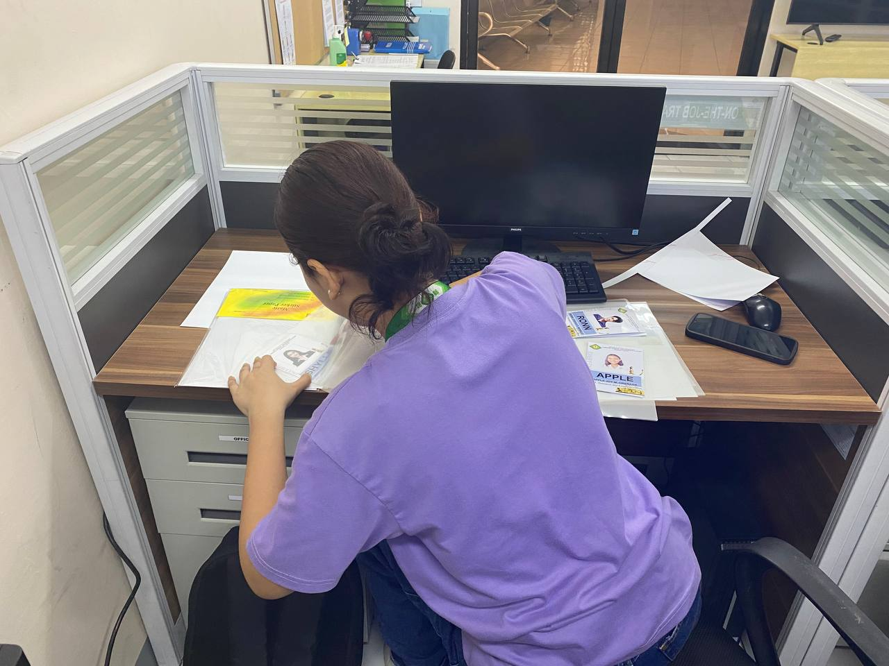

Picture 1. Laminating the OJT ID.



Picture 2. Assist Assessment on the Training in Tagaytay

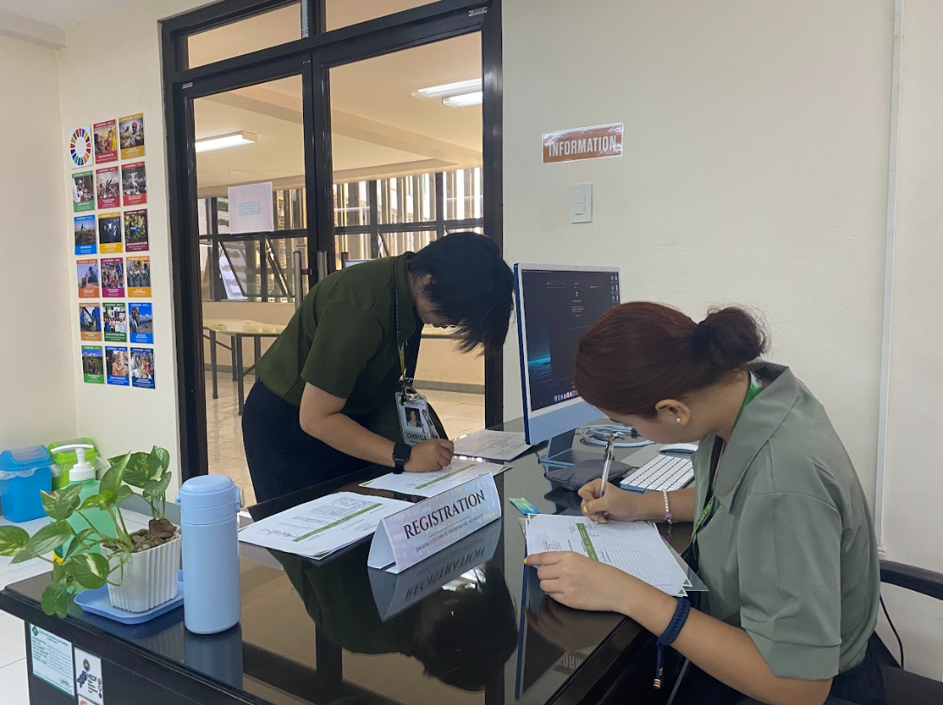

Picture 3. Assigning for Registration on Workshop

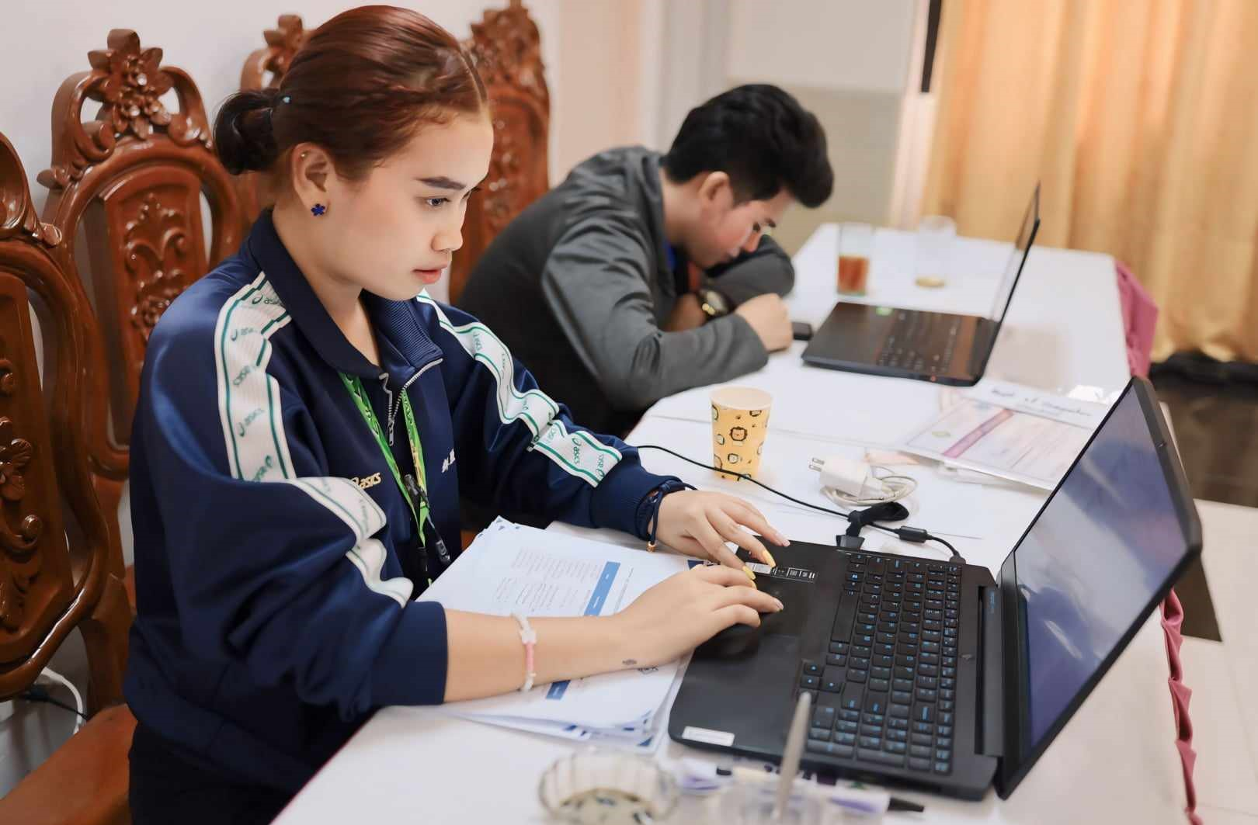

Picture 4. Make a List of Attendance for Research Bootcamp Day1

**XIV. Appendices**

* 1. **Resume**

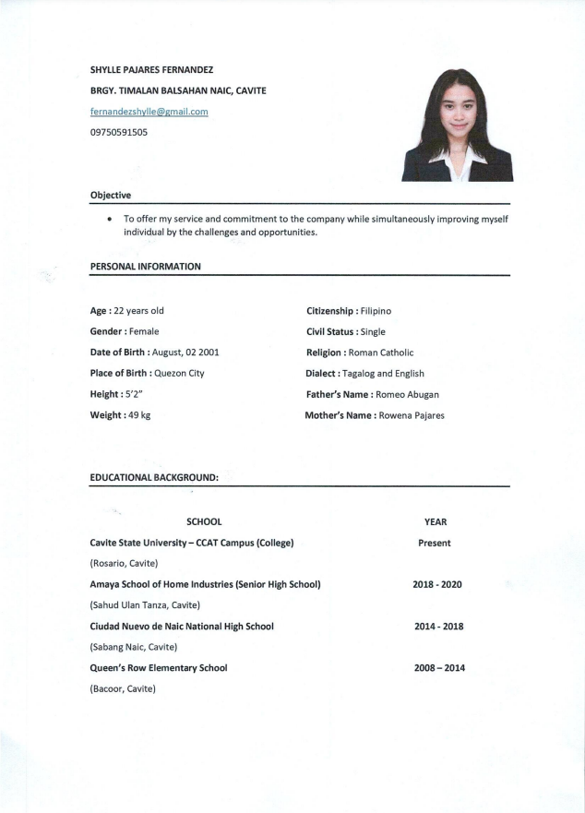

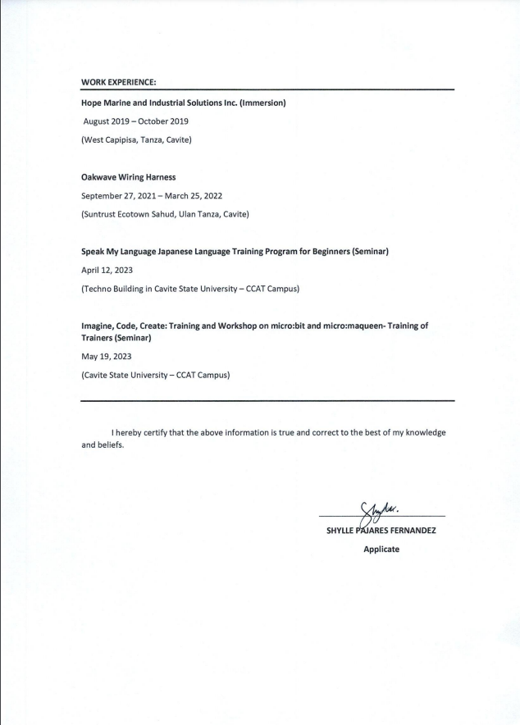

* 1. **Endorsement Letter**

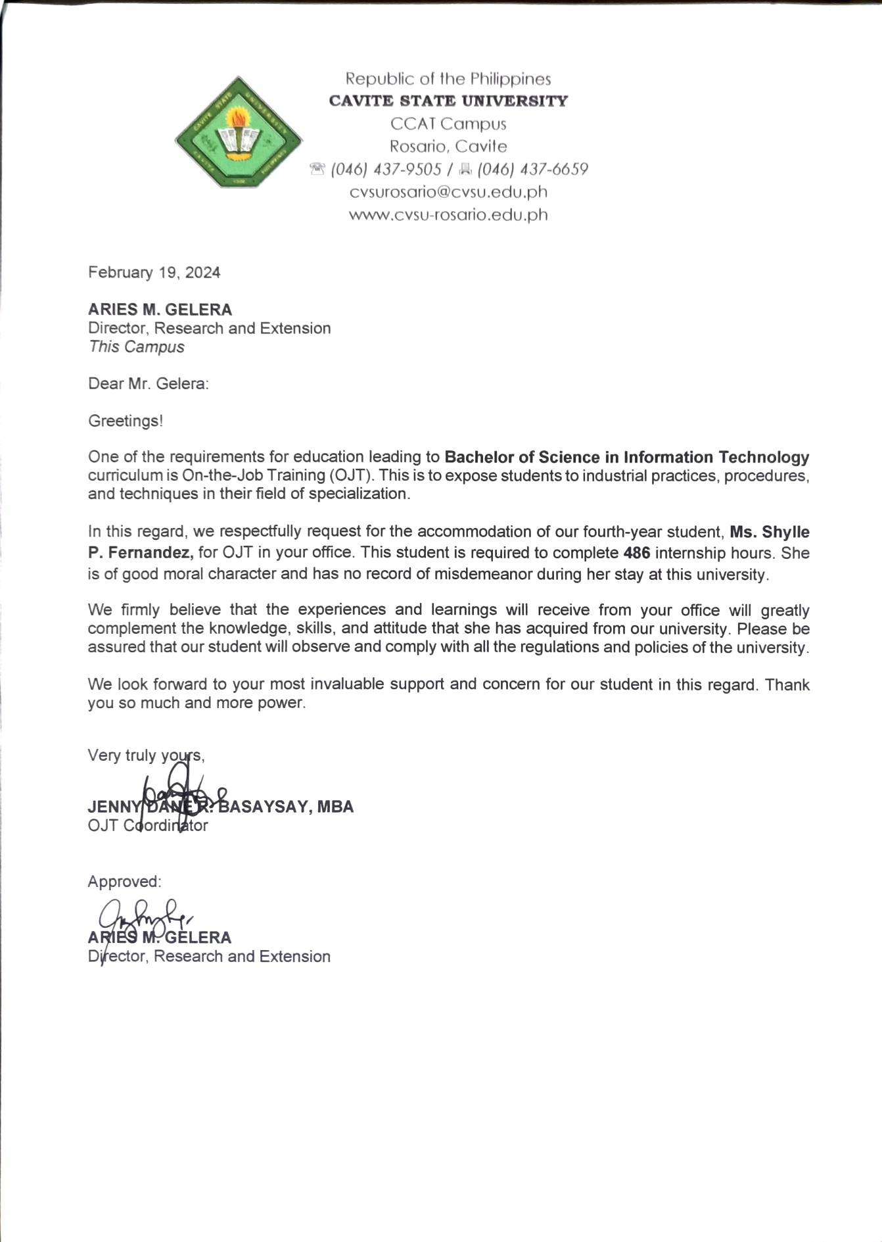

* 1. **Student Pledge**

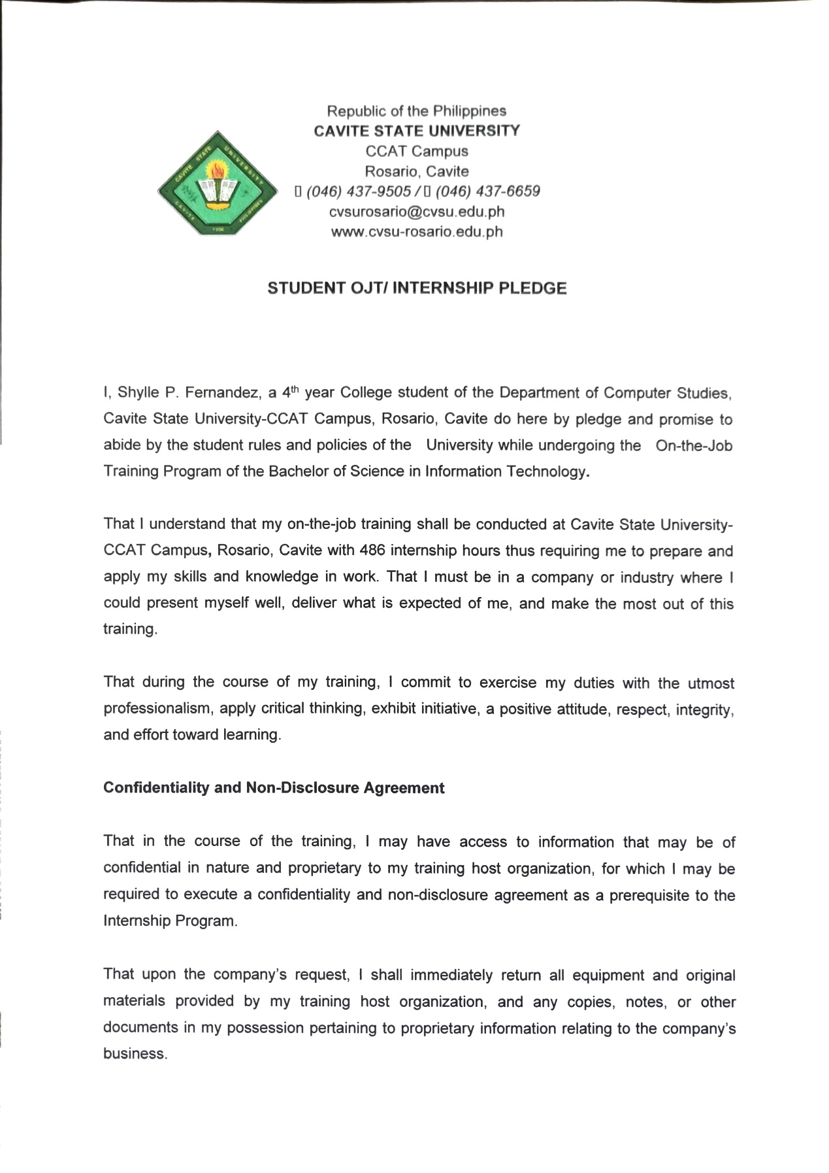

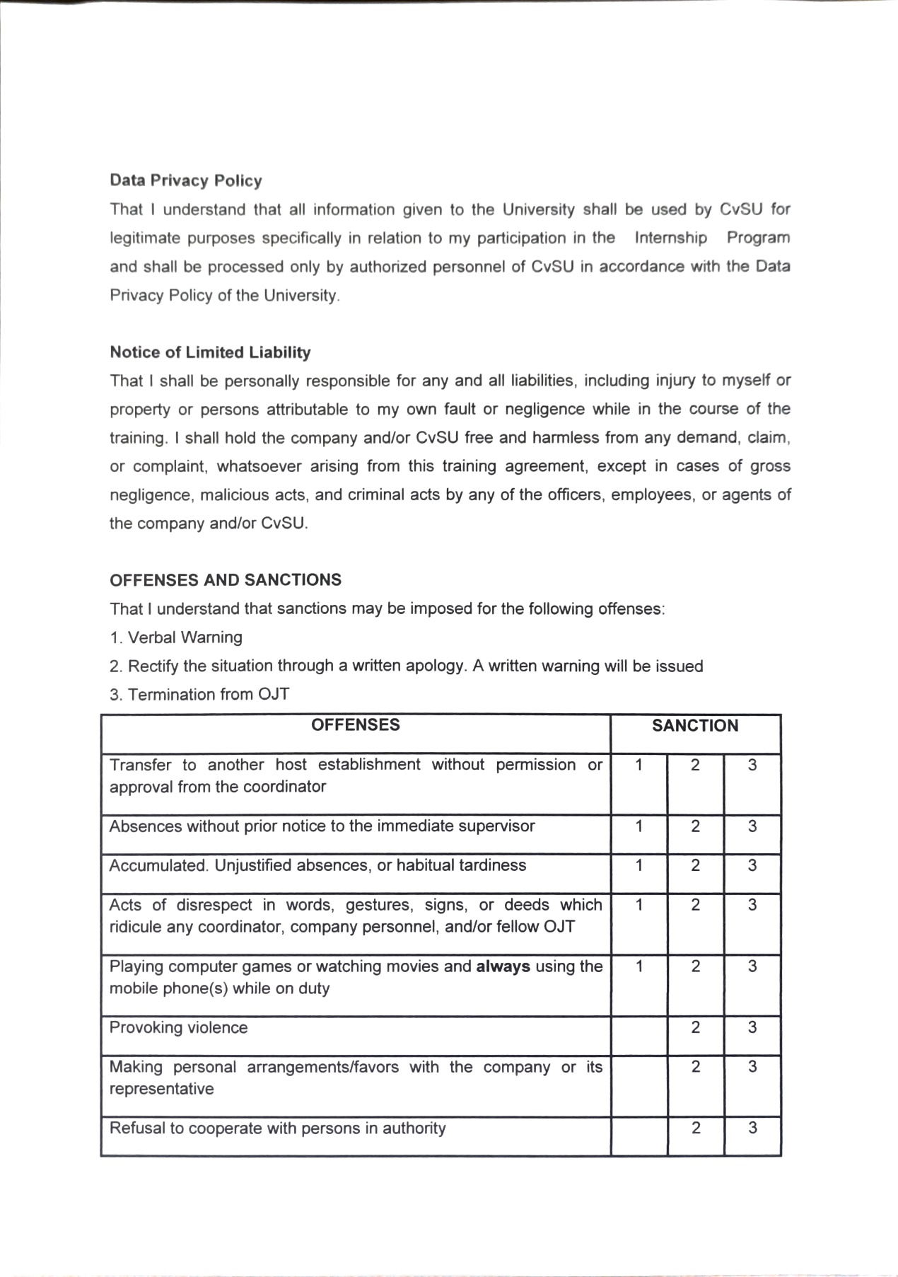

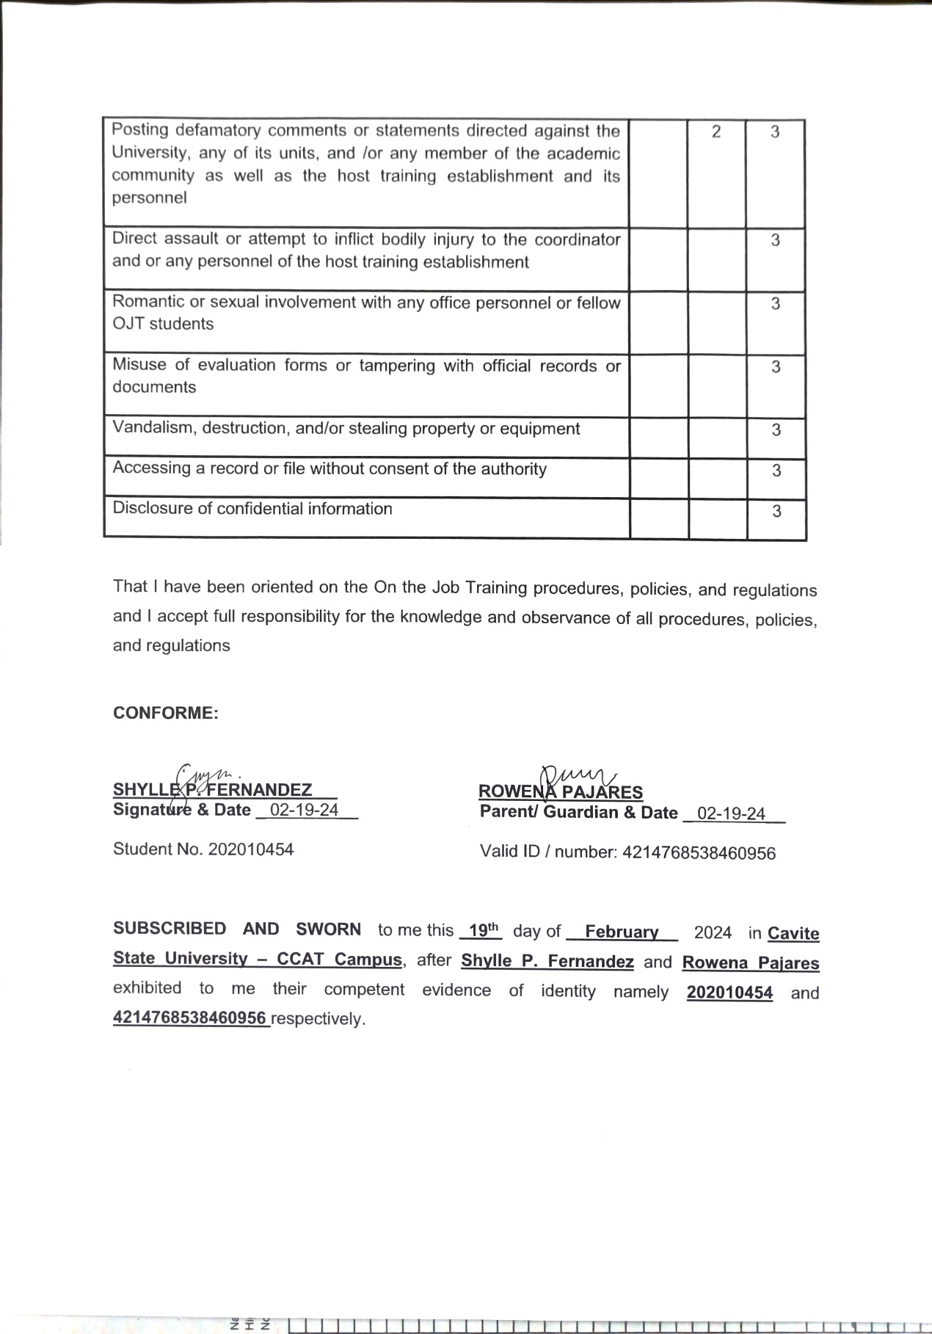

* 1. **Parents Consent**

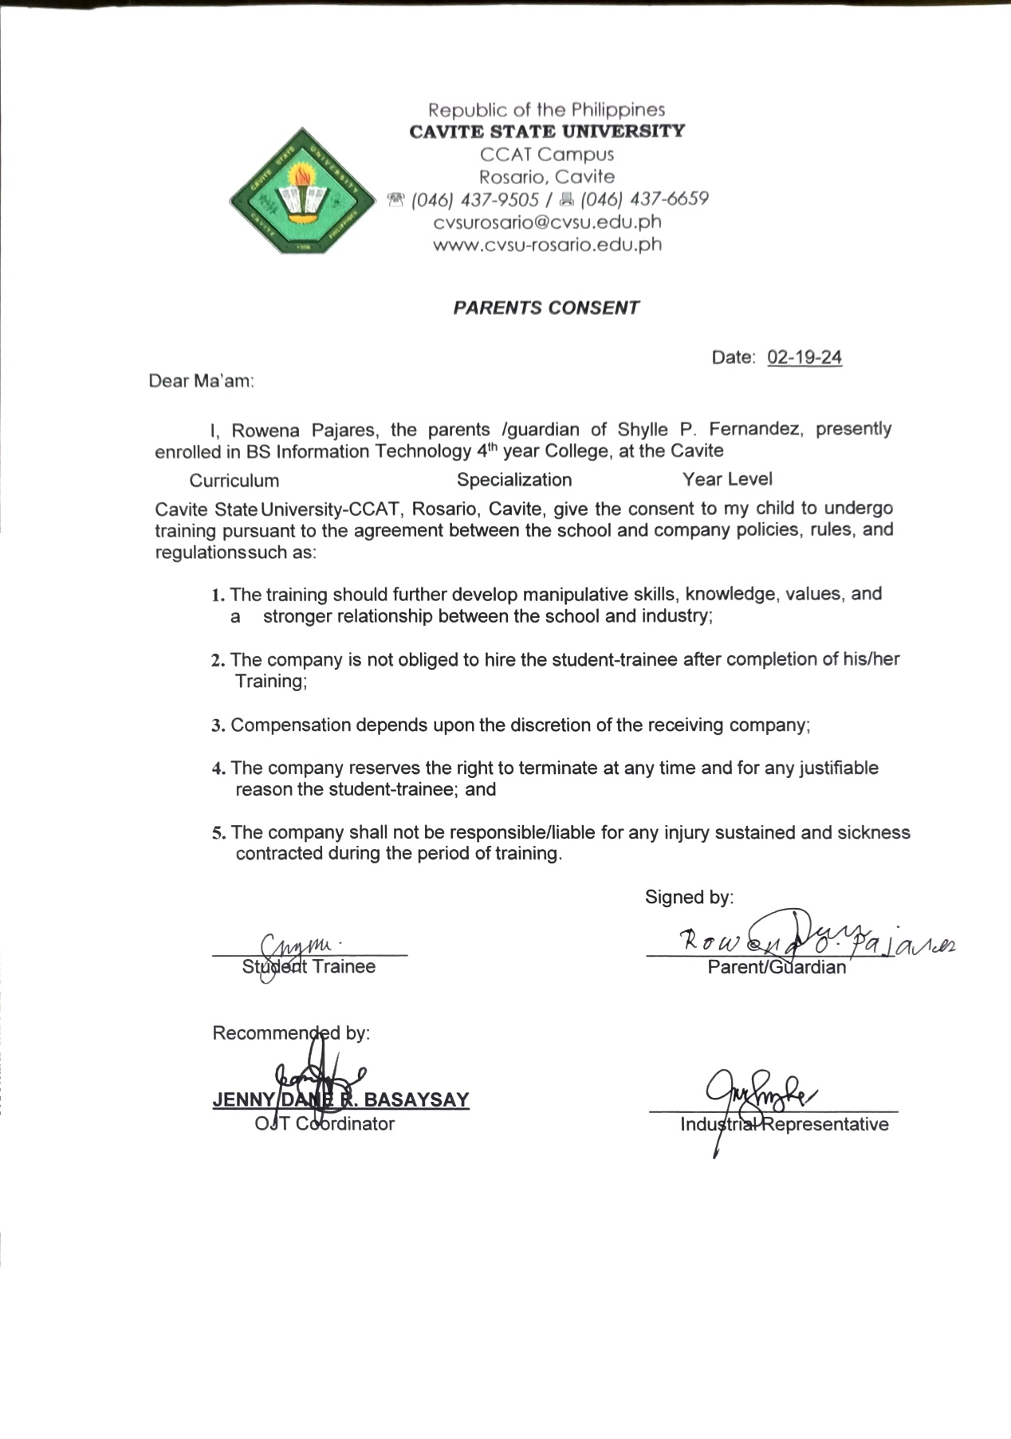

* 1. **Certificate of Completion**
  2. **Evaluation Form**

* 1. **Exit Form**