# Overview of Simulation Examples

## Lectures

### L2 – (Modified) Nodal Analysis

Deadline: Fri 12/10/2018

N:\Teaching\RWTH courses\Modeling and Simulation\06_MSP_WS20182019\04_examples\L2_circuit.emf

/ / / / /

### L3 – Resistive Companion

Deadline: 15/10/2018

N:\Teaching\RWTH courses\Modeling and Simulation\06_MSP_WS20182019\04_examples\L3_circuit.emf

/ / / / /

### L4 – Nonlinear Resistive Companion

Deadline: Fri 19/10/2018

N:\Teaching\RWTH courses\Modeling and Simulation\06_MSP_WS20182019\04_examples\L4_circuit.emf

/ / / /

### L8 - Decoupled Electromagnetic/Electromechanical Simulation

Deadline: Mon 19/11/2018

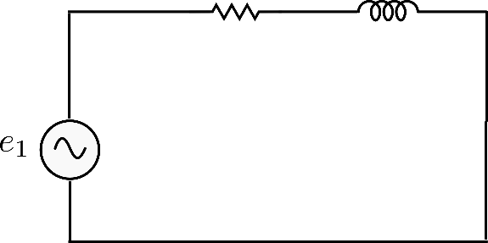

Comparison: EMT vs DP

## Exercises

### E3 - Resistive Companion and Dynamic Phasors

Deadline: Fri 30/11/2018

1)

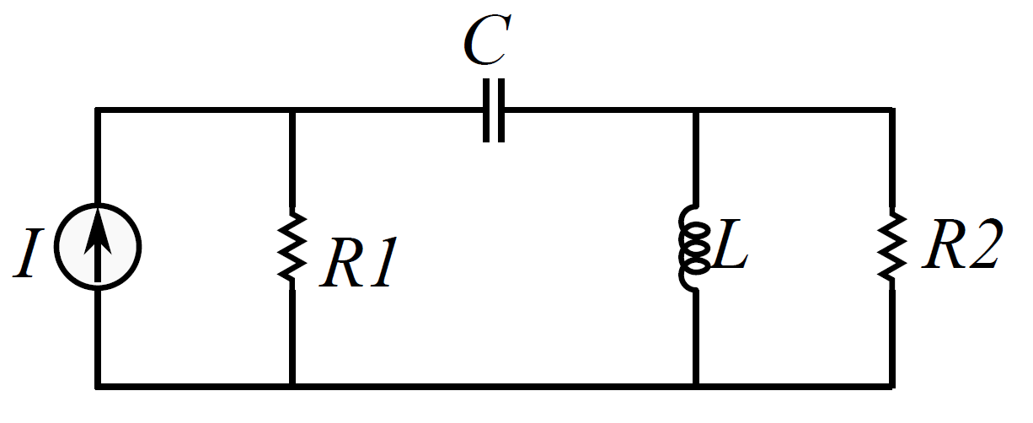

I = 10A / $R_{1} = 1$/ $R_{2} = 1$/ C = 1mF / L = 1mH / t = 1ms / $v_{c}(0) = 0$/ $I_{L}(0) = 0$

2)

Same as L4 Nonlinear Resistive Companion example