CSC312 Database Systems: Practical Assignment 2
Bit Knights Car Rental Database System
Design, implementation and querying of a relational database for a multi-branch car rental company in the Western Cape
by
The Bit Knights (Group 8)
Team member | Student number
Ntlahla Kalalo | 4497363
Vutshila Marvin Makhubela | 4335742
Constance Xoliwe Maluleke | 4350565
Andisiwe Mankayi | 4334941
Mthokozisi Junior Nkalanga | 4323080

Department of Computer Science, University of the Western Cape
Submission date: 13 October 2026
GitHub repository: https://github.com/<your-username>/BitKnights_CarRental

1.0 Introduction and Background
Car rental is a busy, data-heavy service industry. A rental company has to know at any moment which vehicles are on the road, which are free, who has booked what and for which dates, which staff member handled each booking and how much revenue every car and branch produces. When this information lives in paper forms or loose spreadsheets, the same customer is captured several times, cars are double-booked and managers cannot answer simple questions such as “which branch earns the most?” without hours of manual work. A relational database solves these problems by storing each fact once and linking facts together through keys [1], [2].

1.1 Business scenario
Bit Knights Car Rental is a (fictional) car rental company operating three branches in the Western Cape: Cape Town CBD, Cape Town International Airport and Stellenbosch. Each branch is registered as its own company record with its own address and telephone number. Every branch owns its own fleet of cars, ranging from budget hatchbacks such as the Renault Kwid to premium sedans such as the Mercedes-Benz C200, and each car has a fixed daily rate and a current status (available, rented or in maintenance).
Customers contact any branch to make a booking. A rental agent or branch manager captures the booking, recording the customer, the pick-up date and the return date. A single booking may include more than one car, for example a family travelling in two vehicles or a company renting a bakkie and a sedan together, and over time the same car appears on many different bookings. Every car placed on a booking is recorded as a rental line whose cost is the number of rental days multiplied by the car's daily rate. Customers must hold a valid driver's licence, and they may leave several contact details (cell phone numbers and e-mail addresses).
Motivation. Management currently cannot see fleet utilisation, branch revenue or staff performance at a glance. The database designed in this project gives Bit Knights a single, consistent source of truth that supports daily operations (what can be rented right now?) and management reporting (which customers are most loyal, which cars are idle, which agents generate the most revenue?). These questions are answered by the ten queries in Section 6.0.

1.2 Entities identified
Six entities were identified directly from the scenario, and a seventh (Customer_Contact) emerged during design to handle a multivalued attribute. Table 1 summarises them.
Table 1: Entities of the Bit Knights Car Rental database
Entity | Type | Description
COMPANY | Strong | A Bit Knights branch (CBD, Airport, Stellenbosch) that owns cars and employs staff.
EMPLOYEE | Strong | A staff member (rental agent or branch manager) who works for exactly one branch and captures bookings.
CUSTOMER | Strong | A licensed driver who makes bookings.
CUSTOMER_CONTACT | Weak | One contact detail (phone or e-mail) of a customer. Exists only for its customer; created to store the multivalued Customer_Contacts attribute.
CAR | Strong | A vehicle in a branch's fleet with registration, make, model, daily rate and status.
BOOKING | Strong | A reservation made by one customer, captured by one employee, for a pick-up and return date.
RENTAL | Bridge / composite | One car on one booking. Resolves the many-to-many relationship between BOOKING and CAR and stores the rental cost and status.

2.0 Business Rules
Business rules are short, precise statements of policy that describe how the organisation operates. They are the main source for identifying entities, relationships, connectivities and constraints [1]. The rules below were extracted from the scenario; the right-hand column shows how each rule was enforced in the database.
Table 2: Business rules and how they were implemented
ID | Business rule | Database implementation
BR1 | Each branch (company) employs one or many employees; each employee works for exactly one branch. | 1:M COMPANY–EMPLOYEE; Employee.Company_ID NOT NULL FK
BR2 | Each branch owns zero or many cars; each car belongs to exactly one branch. | 1:M COMPANY–CAR; Car.Company_ID NOT NULL FK
BR3 | A customer may make zero or many bookings; each booking is made by exactly one customer. | 1:M CUSTOMER–BOOKING; Booking.Customer_ID NOT NULL FK
BR4 | An employee may capture zero or many bookings; each booking is captured by exactly one employee. | 1:M EMPLOYEE–BOOKING; Booking.Employee_ID NOT NULL FK
BR5 | A booking may include one or more cars, and a car can appear on many bookings over time. | M:N BOOKING–CAR resolved by bridge entity RENTAL
BR6 | The same car may not be listed twice on the same booking. | UNIQUE (Booking_ID, Car_ID) on RENTAL
BR7 | Every customer must hold a driver's licence and no two customers may share a licence number. | Customer_License NOT NULL UNIQUE
BR8 | A customer may have several contact details (phones and e-mails). | Weak entity CUSTOMER_CONTACT with composite PK
BR9 | Every car has a unique registration number and a daily rate greater than zero. | Car_Registration UNIQUE; CHECK (Car_DailyRate > 0)
BR10 | A car is always Available, Rented or in Maintenance. | ENUM domain on Car_Status
BR11 | The return date may not be before the pick-up date. | CHECK (Return_Date >= Pick_Up_Date)
BR12 | A booking is Pending, Confirmed, Active, Completed or Cancelled; a rental line is Reserved, Active, Returned or Cancelled. | ENUM domains with defaults
BR13 | The cost of a rental line is the number of days × the car's daily rate, with a minimum charge of one day. | Derived attribute Rental_Cost, calculated by a BEFORE INSERT trigger
BR14 | Branches, cars, customers and employees with history may not be deleted, so that past bookings stay complete. | ON DELETE RESTRICT on all history foreign keys

2.1 How the rules guided the design
The rules were translated systematically. Nouns that need their own stored facts (branch, employee, customer, car, booking) became entities. Phrases such as “exactly one” and “zero or many” fixed the connectivity and optionality of each relationship, and therefore which table receives the foreign key and whether it may be NULL. BR5 revealed the many-to-many relationship that required the RENTAL bridge entity, and BR8 revealed the multivalued attribute that became the weak entity CUSTOMER_CONTACT. Rules about allowed values (BR9–BR12) became CHECK constraints, ENUM domains and UNIQUE indexes, so that the database itself, not only the application, rejects invalid data. BR13 produced the derived attribute and trigger, and BR14 determined the referential actions (RESTRICT versus CASCADE).

3.0 Entity–Relationship Design
The conceptual ERD (Figure 1) was drawn by the team in draw.io using Crow's Foot notation, which is the notation used in the course textbook [1] and is easy to read because it shows both connectivity (one or many) and optionality (mandatory or optional) at each end of a relationship. It models the six entities from the scenario and shows Customer_Contacts as an attribute of CUSTOMER, which is how the business describes it.
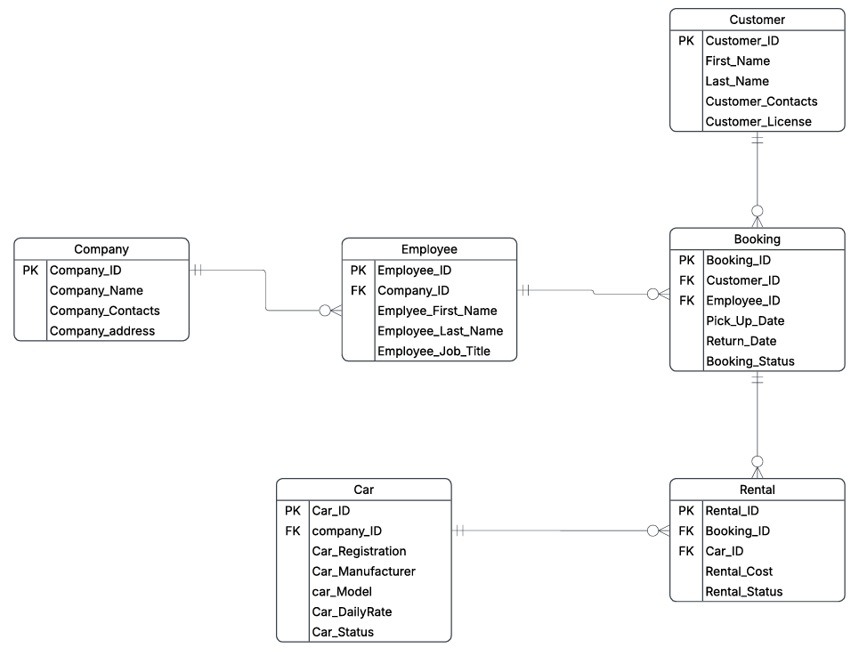
Figure 1: Conceptual ERD of the Bit Knights Car Rental database (Crow's Foot notation)
During logical design the multivalued attribute Customer_Contacts was moved into its own weak entity, CUSTOMER_CONTACT, and the RENTAL bridge entity received a UNIQUE (Booking_ID, Car_ID) constraint. Figure 2 shows the final logical ERD that matches the implemented MySQL schema exactly. It was redrawn from the SQL script with Graphviz so that the diagram and the code cannot drift apart (it is shown on the next page in landscape for legibility). Following the textbook convention [1], dashed lines are non-identifying (weak) relationships and the solid line is the identifying (strong) relationship.

Logical ERD of the implemented database
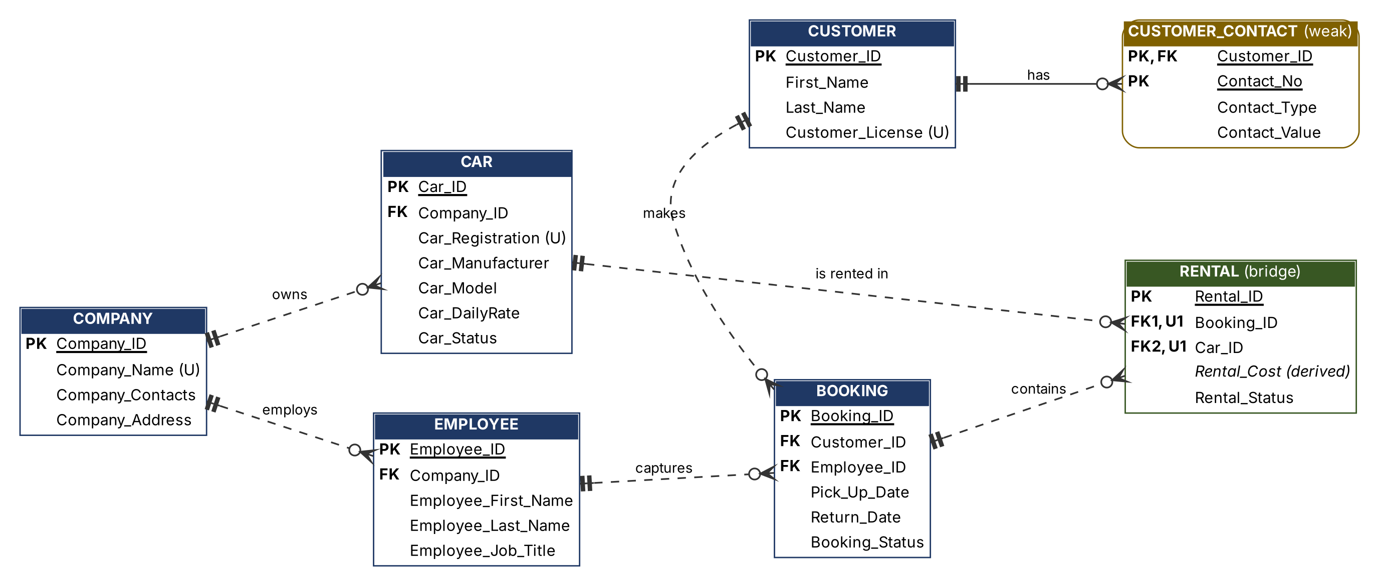
Figure 2: Logical ERD as implemented (PK = primary key, FK = foreign key, U = unique; dashed = weak/non-identifying, solid = strong/identifying)

3.1 Relationships, connectivities and cardinalities
Table 3: Relationships, connectivity and cardinality
Relationship | Connectivity | Cardinality (min, max) | Type | Meaning
COMPANY employs EMPLOYEE | 1:M | Company (1,1) – Employee (0,N) | Weak | A new branch may exist before staff are hired.
COMPANY owns CAR | 1:M | Company (1,1) – Car (0,N) | Weak | Every car belongs to one branch.
CUSTOMER makes BOOKING | 1:M | Customer (1,1) – Booking (0,N) | Weak | A registered customer need not have booked yet (e.g. Emma Roberts).
EMPLOYEE captures BOOKING | 1:M | Employee (1,1) – Booking (0,N) | Weak | Managers may capture no bookings.
CUSTOMER has CUSTOMER_CONTACT | 1:M | Customer (1,1) – Contact (0,N) | Strong | Contact’s PK contains Customer_ID.
BOOKING contains RENTAL | 1:M | Booking (1,1) – Rental (0,N) | Weak | Each rental line belongs to one booking.
CAR is rented in RENTAL | 1:M | Car (1,1) – Rental (0,N) | Weak | A new car has no rental history yet.
BOOKING – CAR (conceptual) | M:N | via RENTAL | — | Decomposed into the two 1:M relationships above.

3.2 Strong and weak entities and relationships
A strong (regular) entity can be identified by its own attributes, while a weak entity is existence-dependent on another entity and borrows part of its primary key from it [1]. COMPANY, EMPLOYEE, CUSTOMER, CAR and BOOKING are strong entities, each with its own surrogate key. CUSTOMER_CONTACT is a weak entity: a contact detail has no meaning without its customer, and its primary key (Customer_ID, Contact_No) contains the parent's key plus a partial key, Contact_No. The relationship CUSTOMER–CUSTOMER_CONTACT is therefore a strong (identifying) relationship, drawn with a solid line.
All other relationships are weak (non-identifying): the child table carries the parent's key only as a foreign key, not as part of its own primary key. For example, BOOKING is existence-dependent on CUSTOMER (Customer_ID is NOT NULL), but a booking is identified by its own Booking_ID. This shows that existence dependence and identification are different properties, a distinction the textbook stresses [1].

3.3 Decomposition of the many-to-many relationship
BR5 states that one booking may contain many cars and one car appears on many bookings over time. A relational table cannot store an M:N relationship directly, because either table would need a repeating list of foreign keys. The relationship was therefore decomposed into the bridge (composite) entity RENTAL, which has a 1:M relationship with BOOKING and a 1:M relationship with CAR [1], [6]. RENTAL also holds the attributes that belong to the combination of a booking and a car: the cost of that car for that booking and the status of that rental line.
Choice of primary key for the bridge entity. The natural primary key would be the composite (Booking_ID, Car_ID). We kept this pair as a candidate key by declaring it UNIQUE (constraint uq_rental_booking_car), which still prevents the same car from being listed twice on a booking (BR6). However, we chose a surrogate primary key, Rental_ID, for three reasons: (1) future tables such as damage reports or payments can reference one rental line through a single column; (2) joins and the Python code are simpler with one key column; and (3) if the business later allows the same car to be swapped out and back onto a booking, only the UNIQUE constraint has to change, not every foreign key. This combination of a surrogate PK and a UNIQUE composite candidate key is a common, recommended practice [1].

3.4 Nature of the attributes
Table 4 is the data dictionary for all attributes. It identifies primary and foreign keys and marks each attribute as mandatory (NOT NULL), unique, derived or multivalued, as required by the brief.
Table 4: Data dictionary: keys, constraints and nature of attributes
Table | Attribute | Data type | Key | Nature / constraint
COMPANY | Company_ID | INT  AUTO_INCREMENT | PK | Mandatory, unique surrogate key
 | Company_Name | VARCHAR(100) |  | Mandatory, unique
 | Company_Contacts | VARCHAR(20) |  | Mandatory; single-valued (one switchboard number)
 | Company_Address | VARCHAR(150) |  | Mandatory; composite attribute stored as one value
EMPLOYEE | Employee_ID | INT  AUTO_INCREMENT | PK | Mandatory, unique
 | Company_ID | INT | FK → Company | Mandatory
 | Employee_First_Name / Last_Name | VARCHAR(50) |  | Mandatory; simple parts of a composite name
 | Employee_Job_Title | VARCHAR(50) |  | Mandatory
CUSTOMER | Customer_ID | INT  AUTO_INCREMENT | PK | Mandatory, unique
 | First_Name / Last_Name | VARCHAR(50) |  | Mandatory; composite name split into simple attributes
 | Customer_License | VARCHAR(20) |  | Mandatory, unique (natural candidate key)
CUSTOMER_CONTACT | Customer_ID | INT | PK, FK → Customer | Mandatory; borrowed from the owner entity
 | Contact_No | TINYINT | PK (partial key) | Mandatory; 1, 2, … per customer
 | Contact_Type | ENUM('Phone',  'Email') |  | Mandatory, restricted domain
 | Contact_Value | VARCHAR(100) |  | Mandatory; one value of the multivalued Customer_Contacts
CAR | Car_ID | INT  AUTO_INCREMENT | PK | Mandatory, unique
 | Company_ID | INT | FK → Company | Mandatory
 | Car_Registration | VARCHAR(15) |  | Mandatory, unique (natural candidate key)
 | Car_Manufacturer / Car_Model | VARCHAR(50) |  | Mandatory
 | Car_DailyRate | DECIMAL(8,2) |  | Mandatory; CHECK > 0
 | Car_Status | ENUM |  | Mandatory; default 'Available'
BOOKING | Booking_ID | INT  AUTO_INCREMENT | PK | Mandatory, unique
 | Customer_ID / Employee_ID | INT | FK → Customer / Employee | Mandatory
 | Pick_Up_Date / Return_Date | DATE |  | Mandatory; CHECK Return_Date >= Pick_Up_Date
 | Booking_Status | ENUM |  | Mandatory; default 'Pending'
RENTAL | Rental_ID | INT  AUTO_INCREMENT | PK | Mandatory, unique surrogate key
 | Booking_ID, Car_ID | INT | FK; UNIQUE together | Mandatory; composite candidate key
 | Rental_Cost | DECIMAL(10,2) |  | Derived (days × rate), stored by trigger; CHECK >= 0
 | Rental_Status | ENUM |  | Mandatory; default 'Reserved'

Special attributes discussed:
- Multivalued attribute: Customer_Contacts. A customer can have several phone numbers and e-mail addresses. Storing them in one column (“082 555 1001; ayanda@…”) would break first normal form, and adding Phone1, Phone2, Email1 columns would create many NULLs and an arbitrary limit. The textbook’s recommended solution is a new entity [1], so each value is stored as one row in CUSTOMER_CONTACT. Contact_Type records whether the value is a phone or an e-mail, which is why one customer can have two phones (customer 6) or only an e-mail (customers 5 and 10).
- Derived attribute: Rental_Cost = MAX(Return_Date − Pick_Up_Date, 1) × Car_DailyRate. Derived attributes are normally calculated when needed, but storing them is justified when a historical value must be kept [1]. If a car's daily rate rises next year, past invoices must not change, so the cost is stored as a price snapshot and calculated automatically by the trigger trg_rental_cost_before_insert. Other derived values, such as Days_Booked and full names, are calculated only inside queries (Q2, Q5, Q6) and are not stored.
- Composite attributes: customer and employee names are split into first and last names so that we can sort by surname (Q2). Company_Address is also composite, but it is kept as one value because no business rule needs to search by suburb or postal code.
- Optional attributes: every column in the final design is NOT NULL. Optionality is handled through relationships instead: a customer without an e-mail simply has no e-mail row in CUSTOMER_CONTACT. This avoids NULLs and the three-valued logic problems they cause in queries [6].
- Unique attributes: Company_Name, Customer_License and Car_Registration are natural candidate keys and are enforced with UNIQUE indexes, while short integer surrogate keys are used as primary keys for efficient joins.
Software used. The conceptual ERD was drawn in draw.io because it supports Crow's Foot shapes and lets all team members edit the diagram. The database was built and inspected in MySQL Workbench 8.0 against a local MySQL 8.0.45 server, and the logical ERD (Figure 2) was generated with Graphviz directly from the final schema.

4.0 Relational Schema

4.1 Relational schema mapped from the ERD
Each strong entity maps to a table with its own primary key; each 1:M relationship is implemented by placing the primary key of the “1” side as a foreign key in the “M” side; the weak entity takes its owner’s key as part of its primary key; and the M:N relationship is implemented by the bridge table. In the notation below, underlined attributes form the primary key and italic attributes are foreign keys.
COMPANY (Company_ID, Company_Name, Company_Contacts, Company_Address)
EMPLOYEE (Employee_ID, Company_ID, Employee_First_Name, Employee_Last_Name, Employee_Job_Title)
CUSTOMER (Customer_ID, First_Name, Last_Name, Customer_License)
CUSTOMER_CONTACT (Customer_ID, Contact_No, Contact_Type, Contact_Value)
CAR (Car_ID, Company_ID, Car_Registration, Car_Manufacturer, Car_Model, Car_DailyRate, Car_Status)
BOOKING (Booking_ID, Customer_ID, Employee_ID, Pick_Up_Date, Return_Date, Booking_Status)
RENTAL (Rental_ID, Booking_ID, Car_ID, Rental_Cost, Rental_Status) UNIQUE (Booking_ID, Car_ID)
Foreign keys: Employee.Company_ID → Company; Car.Company_ID → Company; Customer_Contact.Customer_ID → Customer (ON DELETE CASCADE); Booking.Customer_ID → Customer; Booking.Employee_ID → Employee; Rental.Booking_ID → Booking; Rental.Car_ID → Car (all others ON DELETE RESTRICT, ON UPDATE CASCADE).

4.2 Normalisation
Normalisation is the process of evaluating and correcting table structures to minimise data redundancy and so reduce the update, insertion and deletion anomalies that redundancy causes [1], [2]. We started from the document that Bit Knights staff currently fill in by hand, the booking sheet, and normalised it step by step up to third normal form (3NF).
Step 0: Unnormalised form (UNF). One booking sheet holds the booking details, the customer with all of their contacts, the agent and branch, and a repeating group of cars. Table 5 shows two sheets taken from our sample data.
Table 5: Unnormalised booking sheets (repeating groups in the last two columns)
Booking_​ID | Customer | Customer contacts | Agent / branch | Dates | Cars on booking (repeating group)
1 | Ayanda Khumalo  WC7001245 | 082 555 1001  ayanda.khumalo@  example.co.za | Pieter van Wyk  Rental Agent  Cape Town CBD | 03–07 Aug 2026  Completed | Car 1, CA 123 456, Toyota Corolla, R450/day, CBD, R1 800, Returned
6 | Ruan du Plessis  WC7005693 | ruan.dp@  example.co.za | Liam Petersen  Rental Agent  Cape Town Airport | 12–19 Sep 2026  Completed | Car 6, CY 222 333, Kia Seltos, R620/day, Airport, R4 340, Returned  Car 7, CY 333 444, Toyota Hilux, R920/day, Airport, R6 440, Returned

The relation is unnormalised because it contains repeating groups: several cars per booking and several contact values per customer in a single cell.
Step 1: First normal form (1NF). To reach 1NF we (a) removed the multivalued customer contacts into their own relation CUSTOMER_CONTACT (Customer_ID, Contact_No, Contact_Type, Contact_Value), because flattening them would multiply every booking row by the number of contacts, and (b) flattened the car repeating group so that every row holds exactly one car on one booking. Each cell now holds a single atomic value, and the primary key is the composite (Booking_ID, Car_ID). Table 6 shows the flattened rows for the two sheets (selected columns only).
Table 6: 1NF relation RENTAL_FLAT (selected columns)
Booking_​ID | Car_​ID | Customer_​ID | First_​Name | Employee_​ID | Company_​ID | Pick_​Up_​Date | Car_​Model | Car_​DailyRate | Rental_​Cost
1 | 1 | 1 | Ayanda | 2 | 1 | 2026-08-03 | Corolla | 450.00 | 1800.00
6 | 6 | 5 | Ruan | 6 | 2 | 2026-09-12 | Seltos | 620.00 | 4340.00
6 | 7 | 5 | Ruan | 6 | 2 | 2026-09-12 | Hilux | 920.00 | 6440.00

The 1NF relation is RENTAL_FLAT (Booking_ID, Car_ID, Pick_Up_Date, Return_Date, Booking_Status, Customer_ID, First_Name, Last_Name, Customer_License, Employee_ID, Emp_First_Name, Emp_Last_Name, Emp_Job_Title, Company_ID, Company_Name, Company_Contacts, Company_Address, Car_Registration, Car_Manufacturer, Car_Model, Car_DailyRate, Car_Status, Car_Company_ID, Rental_Cost, Rental_Status). Its dependencies are drawn in the dependency diagram in Figure 3, presented in the same way as Figure 6.3 of the normalisation lecture slides [1], [11].
Even in 1NF the table still has serious anomalies. Ruan du Plessis’s name and booking dates are repeated for every car on his booking (update anomaly: changing his surname means updating several rows). A new car such as the Renault Kwid cannot be stored until it has been rented, because Booking_ID is part of the key and may not be NULL (insertion anomaly). Deleting Chloe Williams’s only booking (Booking 7) would also delete the only record of the BMW 3 Series (deletion anomaly).

Dependency diagram of the 1NF relation RENTAL_FLAT
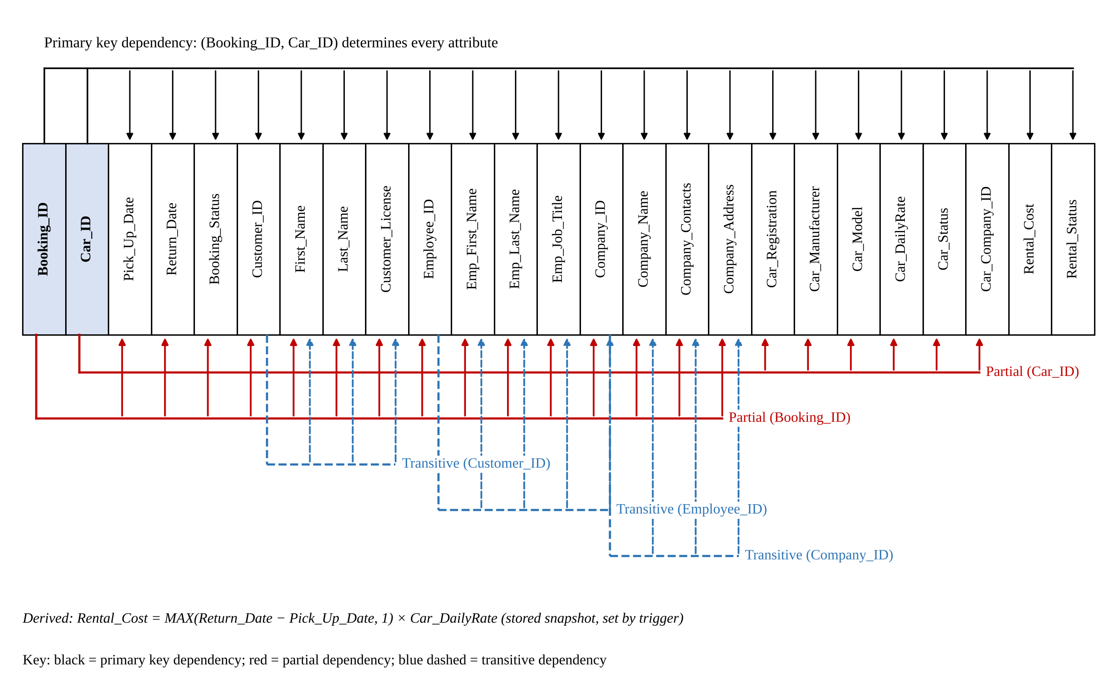

Figure 3: 1NF dependency diagram showing the primary key, partial and transitive dependencies (format of Figure 6.3 in [1], [11])
Table 7: Functional dependencies identified in RENTAL_FLAT

Dependency | Type | Problem
(Booking_ID, Car_ID) → Rental_Cost, Rental_Status | Full functional dependency | None: these facts truly describe one car on one booking.
Booking_ID → Pick_Up_Date, Return_Date, Booking_Status, Customer_ID, …, Company_Address | Partial dependency | Depends on only part of the key; violates 2NF.
Car_ID → Car_Registration, Car_Manufacturer, Car_Model, Car_DailyRate, Car_Status, Car_Company_ID | Partial dependency | Depends on only part of the key; violates 2NF.
Customer_ID → First_Name, Last_Name, Customer_License | Transitive dependency | Non-key attribute determines other non-key attributes; violates 3NF.
Employee_ID → Emp_First_Name, Emp_Last_Name, Emp_Job_Title, Company_ID | Transitive dependency | Violates 3NF.
Company_ID → Company_Name, Company_Contacts, Company_Address | Transitive dependency | Violates 3NF.

Step 2: Second normal form (2NF). A table is in 2NF when it is in 1NF and has no partial dependencies [1]. Each part of the composite key that determines other attributes became the key of a new table, and the attributes that depend on the whole key stayed behind:
- BOOKING_2NF (Booking_ID, Pick_Up_Date, Return_Date, Booking_Status, Customer_ID, First_Name, Last_Name, Customer_License, Employee_ID, Emp_First_Name, Emp_Last_Name, Emp_Job_Title, Company_ID, Company_Name, Company_Contacts, Company_Address)
- CAR (Car_ID, Car_Registration, Car_Manufacturer, Car_Model, Car_DailyRate, Car_Status, Company_ID)
- RENTAL (Booking_ID, Car_ID, Rental_Cost, Rental_Status)
- CUSTOMER_CONTACT (Customer_ID, Contact_No, Contact_Type, Contact_Value), unchanged from 1NF
CAR and RENTAL are already free of transitive dependencies. In CAR, Car_Registration also determines the other attributes, but this is not a 3NF violation because Car_Registration is itself a candidate key. BOOKING_2NF, however, still contains three transitive dependencies (through Customer_ID, Employee_ID and Company_ID), so customer, employee and branch details would still be repeated for every booking.
Step 3: Third normal form (3NF). A table is in 3NF when it is in 2NF and contains no transitive dependencies [1]. Each determinant of a transitive dependency became a new table, and a copy of it stayed behind as a foreign key:
- BOOKING (Booking_ID, Customer_ID, Employee_ID, Pick_Up_Date, Return_Date, Booking_Status)
- CUSTOMER (Customer_ID, First_Name, Last_Name, Customer_License)
- EMPLOYEE (Employee_ID, Company_ID, Employee_First_Name, Employee_Last_Name, Employee_Job_Title)
- COMPANY (Company_ID, Company_Name, Company_Contacts, Company_Address)
- CAR, RENTAL and CUSTOMER_CONTACT carried over from 2NF
The result is the seven tables of Section 4.1. In every table the only determinants are candidate keys, so the design also satisfies Boyce–Codd normal form (BCNF) [1], [6]. Two final implementation decisions were made after 3NF:
- Surrogate key for RENTAL. The 3NF key (Booking_ID, Car_ID) was replaced by Rental_ID as primary key and kept as a UNIQUE candidate key (see Section 3.3). This does not affect normal form because both are candidate keys.
- Controlled denormalisation of Rental_Cost. Strictly speaking Rental_Cost can be derived from Booking dates and the car's daily rate. We deliberately store it as a snapshot so that historical revenue does not change when prices change. The redundancy is controlled by the trigger, so users never type the value and it cannot be entered inconsistently (Test T15 in Section 8 confirms that every stored cost matches its formula).
Why normalisation matters for Bit Knights. Each fact is now stored once: a customer’s licence lives in exactly one row, a car can be added before its first rental, and deleting a booking can never delete a car or a customer. This keeps the data consistent, saves storage and makes the reports in Section 6 trustworthy [1], [2].

5.0 Database Implementation
The database was implemented in MySQL 8.0 with the InnoDB storage engine, which is required for foreign keys and transactions [3]. The character set utf8mb4 was chosen so that South African names with accents (e.g. “du Plessis”, “Botha”) and e-mail addresses are stored correctly. The implementation is split into three scripts so that it can be rebuilt from scratch at any time: 01_schema.sql (structure), 02_sample_data.sql (data) and 03_queries.sql (the ten queries).

5.1 CREATE TABLE statements (01_schema.sql)
DROP DATABASE IF EXISTS bit_knights_car_rental;
CREATE DATABASE bit_knights_car_rental CHARACTER SET utf8mb4 COLLATE utf8mb4_unicode_ci;
USE bit_knights_car_rental;

/* 1. COMPANY : a rental company or branch that owns cars and employs staff (strong entity) */
CREATE TABLE Company (
Company_ID INT AUTO_INCREMENT PRIMARY KEY,
Company_Name VARCHAR(100) NOT NULL UNIQUE,
Company_Contacts VARCHAR(20) NOT NULL,
Company_Address VARCHAR(150) NOT NULL
) ENGINE=InnoDB;

/* 2. EMPLOYEE : staff member working for exactly one company (strong entity) */
CREATE TABLE Employee (
Employee_ID INT AUTO_INCREMENT PRIMARY KEY,
Company_ID INT NOT NULL,
Employee_First_Name VARCHAR(50) NOT NULL,
Employee_Last_Name VARCHAR(50) NOT NULL,
Employee_Job_Title VARCHAR(50) NOT NULL,
CONSTRAINT fk_employee_company FOREIGN KEY (Company_ID)
REFERENCES Company (Company_ID) ON UPDATE CASCADE ON DELETE RESTRICT
) ENGINE=InnoDB;

/* 3. CUSTOMER : a person who rents cars (strong entity) */
CREATE TABLE Customer (
Customer_ID INT AUTO_INCREMENT PRIMARY KEY,
First_Name VARCHAR(50) NOT NULL,
Last_Name VARCHAR(50) NOT NULL,
Customer_License VARCHAR(20) NOT NULL UNIQUE
) ENGINE=InnoDB;

/* 4. CUSTOMER_CONTACT : holds the multivalued attribute Customer_Contacts (weak entity).
Partial key Contact_No together with Customer_ID forms the composite primary key. */
CREATE TABLE Customer_Contact (
Customer_ID INT NOT NULL,
Contact_No TINYINT NOT NULL,
Contact_Type ENUM('Phone','Email') NOT NULL,
Contact_Value VARCHAR(100) NOT NULL,
PRIMARY KEY (Customer_ID, Contact_No),
CONSTRAINT fk_contact_customer FOREIGN KEY (Customer_ID)
REFERENCES Customer (Customer_ID) ON UPDATE CASCADE ON DELETE CASCADE
) ENGINE=InnoDB;

/* 5. CAR : a vehicle owned by one company (strong entity) */
CREATE TABLE Car (
Car_ID INT AUTO_INCREMENT PRIMARY KEY,
Company_ID INT NOT NULL,
Car_Registration VARCHAR(15) NOT NULL UNIQUE,
Car_Manufacturer VARCHAR(50) NOT NULL,
Car_Model VARCHAR(50) NOT NULL,
Car_DailyRate DECIMAL(8,2) NOT NULL,
Car_Status ENUM('Available','Rented','Maintenance') NOT NULL DEFAULT 'Available',
CONSTRAINT chk_car_rate CHECK (Car_DailyRate > 0),
CONSTRAINT fk_car_company FOREIGN KEY (Company_ID)
REFERENCES Company (Company_ID) ON UPDATE CASCADE ON DELETE RESTRICT
) ENGINE=InnoDB;

/* 6. BOOKING : a reservation made by a customer and captured by an employee (strong entity) */
CREATE TABLE Booking (
Booking_ID INT AUTO_INCREMENT PRIMARY KEY,
Customer_ID INT NOT NULL,
Employee_ID INT NOT NULL,
Pick_Up_Date DATE NOT NULL,
Return_Date DATE NOT NULL,
Booking_Status ENUM('Pending','Confirmed','Active','Completed','Cancelled') NOT NULL DEFAULT 'Pending',
CONSTRAINT chk_booking_dates CHECK (Return_Date >= Pick_Up_Date),
CONSTRAINT fk_booking_customer FOREIGN KEY (Customer_ID)
REFERENCES Customer (Customer_ID) ON UPDATE CASCADE ON DELETE RESTRICT,
CONSTRAINT fk_booking_employee FOREIGN KEY (Employee_ID)
REFERENCES Employee (Employee_ID) ON UPDATE CASCADE ON DELETE RESTRICT
) ENGINE=InnoDB;

/* 7. RENTAL : bridge (composite) entity that resolves the many to many relationship
between Booking and Car. Rental_ID is a surrogate primary key and the pair
(Booking_ID, Car_ID) is kept UNIQUE so a car cannot be listed twice on one booking. */
CREATE TABLE Rental (
Rental_ID INT AUTO_INCREMENT PRIMARY KEY,
Booking_ID INT NOT NULL,
Car_ID INT NOT NULL,
Rental_Cost DECIMAL(10,2) NOT NULL DEFAULT 0.00,
Rental_Status ENUM('Reserved','Active','Returned','Cancelled') NOT NULL DEFAULT 'Reserved',
CONSTRAINT uq_rental_booking_car UNIQUE (Booking_ID, Car_ID),
CONSTRAINT chk_rental_cost CHECK (Rental_Cost >= 0),
CONSTRAINT fk_rental_booking FOREIGN KEY (Booking_ID)
REFERENCES Booking (Booking_ID) ON UPDATE CASCADE ON DELETE RESTRICT,
CONSTRAINT fk_rental_car FOREIGN KEY (Car_ID)
REFERENCES Car (Car_ID) ON UPDATE CASCADE ON DELETE RESTRICT
) ENGINE=InnoDB;

/* DERIVED ATTRIBUTE : Rental_Cost = number of rental days x daily rate (minimum one day).
The trigger calculates it automatically and stores it as a price snapshot, so later rate
changes do not rewrite history. */
CREATE TRIGGER trg_rental_cost_before_insert
BEFORE INSERT ON Rental
FOR EACH ROW
SET NEW.Rental_Cost =
(SELECT GREATEST(DATEDIFF(b.Return_Date, b.Pick_Up_Date), 1) * c.Car_DailyRate
FROM Booking b, Car c
WHERE b.Booking_ID = NEW.Booking_ID AND c.Car_ID = NEW.Car_ID);

/* Helpful indexes for the foreign keys used most in joins */
CREATE INDEX idx_booking_dates ON Booking (Pick_Up_Date, Return_Date);
CREATE INDEX idx_car_status ON Car (Car_Status);

Key points of the implementation: every foreign key is named (fk_…) so that error messages are readable; CHECK constraints, which MySQL enforces from version 8.0.16 [4], validate daily rates, costs and dates; ENUM columns restrict statuses to valid values; and two extra indexes support the date-range and status filters used by the queries. The trigger implements the derived attribute Rental_Cost. Its GREATEST(…, 1) guarantees that a same-day rental is charged as one day [5].

5.2 Sample data (02_sample_data.sql)
Realistic Western Cape data was loaded: 3 branches, 8 employees, 10 customers with 16 contact details, 12 cars, 14 bookings and 17 rental lines. The data was designed on purpose to exercise every query and constraint: there are multi-car bookings (3, 6 and 13), a cancelled booking (14), future bookings (11–13), a customer who has never booked (Emma Roberts), a car that has never been rented (Renault Kwid) and a car in maintenance (Toyota Hilux). An extract is shown below; the full script is in Appendix A and in the GitHub repository. Note that the INSERT into RENTAL does not supply Rental_Cost, because the trigger calculates it.
INSERT INTO Company (Company_Name, Company_Contacts, Company_Address) VALUES
('Bit Knights Cape Town CBD', '021 555 0101', '12 Strand Street, Cape Town, 8001'),
('Bit Knights Cape Town Airport', '021 555 0102', 'Airport Approach Road, Matroosfontein, 7490'),
('Bit Knights Stellenbosch', '021 555 0103', '45 Dorp Street, Stellenbosch, 7600');

INSERT INTO Customer_Contact (Customer_ID, Contact_No, Contact_Type, Contact_Value) VALUES
(1, 1, 'Phone', '082 555 1001'), (1, 2, 'Email', 'ayanda.khumalo@example.co.za'), ...

INSERT INTO Car (Company_ID, Car_Registration, Car_Manufacturer, Car_Model, Car_DailyRate, Car_Status) VALUES
(1, 'CA 123 456', 'Toyota', 'Corolla', 450.00, 'Available'), ...

INSERT INTO Booking (Customer_ID, Employee_ID, Pick_Up_Date, Return_Date, Booking_Status) VALUES
(1, 2, '2026-08-03', '2026-08-07', 'Completed'), ...

INSERT INTO Rental (Booking_ID, Car_ID, Rental_Status) VALUES -- Rental_Cost set by trigger
(1, 1, 'Returned'), (3, 5, 'Returned'), (3, 8, 'Returned'), ...

5.3 Tables after data insertion
The screenshots below were taken in MySQL Workbench after running both scripts (SELECT * FROM each table). They show that every table was created and populated as designed.
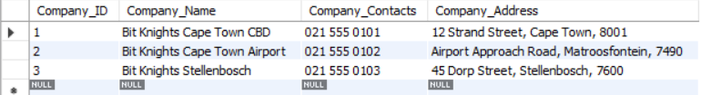
Figure 4: COMPANY table: three branches
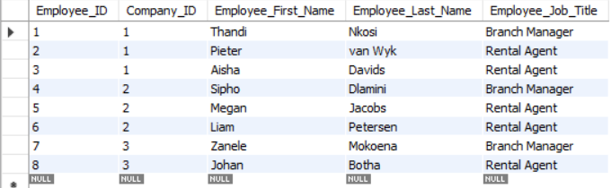
Figure 5: EMPLOYEE table: each employee linked to a branch through Company_ID
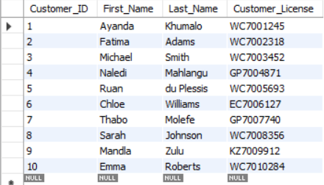
Figure 6: CUSTOMER table: unique driver's licence numbers
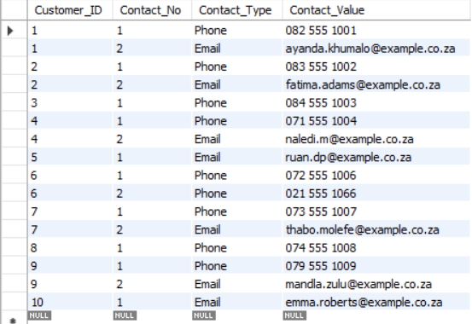
Figure 7: CUSTOMER_CONTACT table (weak entity): composite key (Customer_ID, Contact_No) storing the multivalued contacts
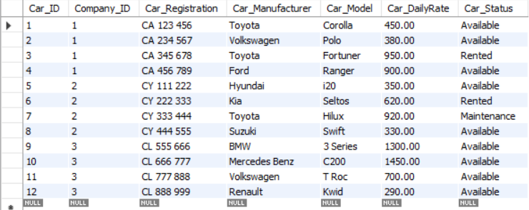
Figure 8: CAR table: fleet of 12 cars across three branches with status and daily rate
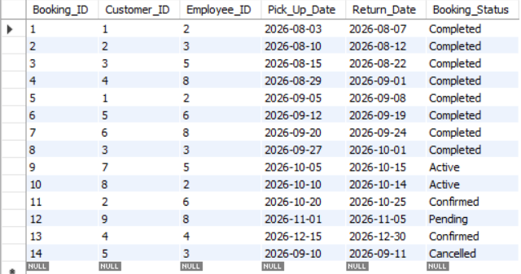
Figure 9: BOOKING table: 14 bookings with dates and status
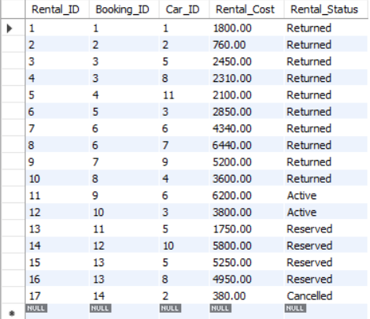
Figure 10: RENTAL bridge table: Rental_Cost values were calculated by the trigger (e.g. Booking 1: 4 days × R450 = R1 800)
The RENTAL screenshot confirms the trigger: for Rental 8 (Booking 6, Toyota Hilux, 12–19 September = 7 days) the stored cost is 7 × R920 = R6 440, exactly as calculated by hand.

6.0 SQL Queries
Ten queries were written: 2 simple, 4 medium and 4 complex, following the definitions in the assignment brief. Every query answers a real question that Bit Knights staff or management would ask. Table 8 summarises the SQL techniques each query demonstrates; the queries, their outputs (copied from the Python program’s run) and interpretations follow.
Table 8: Overview of the ten queries
Query | Level | Business question | Techniques demonstrated
Q1 | Simple | Which cars can be rented now, cheapest first? | WHERE, ORDER BY
Q2 | Simple | Who are our rental agents? | CONCAT, LIKE, ORDER BY
Q3 | Medium | Revenue per branch | INNER JOIN (3 tables), SUM, COUNT, AVG, GROUP BY, IN
Q4 | Medium | Premium cars above the fleet average | Subquery in WHERE and SELECT, AVG, ROUND
Q5 | Medium | Booking activity of every customer | LEFT JOIN, COUNT, MAX, CONCAT, GROUP BY
Q6 | Medium | Length and value of September bookings | JOIN, DATEDIFF, MONTHNAME, BETWEEN, SUM, COUNT
Q7 | Complex | Loyal high-value customers | 5-table JOIN, COUNT DISTINCT, SUM, HAVING with AND
Q8 | Complex | Employees above average revenue | 4-table JOIN, nested subquery with derived table in HAVING
Q9 | Complex | Idle or costly fleet to review | NOT IN subquery, JOIN, combined AND/OR conditions
Q10 | Complex | Multi-car or high-value bookings | 5-table JOIN, GROUP_CONCAT, COUNT, SUM, HAVING with OR

6.1 Q1 (Simple): Cars available for rent, cheapest first
Purpose and business context. When a customer phones in, the agent needs an instant list of cars that can be handed over now, with the cheapest options first so that budget-conscious customers are served quickly.
SELECT Car_ID, Car_Manufacturer, Car_Model, Car_Registration, Car_DailyRate
FROM Car
WHERE Car_Status = 'Available'
ORDER BY Car_DailyRate ASC;

Table 9: Output of Q1 (9 rows)
Car_​ID | Car_​Manufacturer | Car_​Model | Car_​Registration | Car_​DailyRate
12 | Renault | Kwid | CL 888 999 | 290.00
8 | Suzuki | Swift | CY 444 555 | 330.00
5 | Hyundai | i20 | CY 111 222 | 350.00
2 | Volkswagen | Polo | CA 234 567 | 380.00
1 | Toyota | Corolla | CA 123 456 | 450.00
11 | Volkswagen | T Roc | CL 777 888 | 700.00
4 | Ford | Ranger | CA 456 789 | 900.00
9 | BMW | 3 Series | CL 555 666 | 1300.00
10 | Mercedes Benz | C200 | CL 666 777 | 1450.00

Interpretation. Nine of the twelve cars are available. Prices range from R290 (Renault Kwid) to R1 450 (Mercedes-Benz C200). The Toyota Fortuner and Kia Seltos are excluded because they are rented, and the Toyota Hilux because it is in maintenance, which shows that the Car_Status domain is being used correctly.

6.2 Q2 (Simple): List of rental agents
Purpose and business context. Branch managers need a staff list of front-line agents (for rosters, training and performance reviews). CONCAT builds a readable full name and LIKE '%Agent%' selects the agents regardless of the exact title wording.
SELECT Employee_ID,
CONCAT(Employee_First_Name, ' ', Employee_Last_Name) AS Agent_Name,
Employee_Job_Title, Company_ID
FROM Employee
WHERE Employee_Job_Title LIKE '%Agent%'
ORDER BY Employee_Last_Name;

Table 10: Output of Q2 (5 rows)
Employee_​ID | Agent_​Name | Employee_​Job_​Title | Company_​ID
8 | Johan Botha | Rental Agent | 3
3 | Aisha Davids | Rental Agent | 1
5 | Megan Jacobs | Rental Agent | 2
6 | Liam Petersen | Rental Agent | 2
2 | Pieter van Wyk | Rental Agent | 1

Interpretation. Five of the eight employees are rental agents: two at the CBD branch (Company 1), two at the Airport (Company 2) and one at Stellenbosch (Company 3). The three branch managers are correctly excluded.

6.3 Q3 (Medium): Revenue performance per branch
Purpose and business context. Management wants to know which branch generates the most income, how many rentals each branch handled and the average value of a rental. Only rentals that produced income (Returned or Active) are counted, so reservations and cancellations do not inflate revenue.
SELECT co.Company_Name,
COUNT(r.Rental_ID) AS Total_Rentals,
SUM(r.Rental_Cost) AS Total_Revenue,
ROUND(AVG(r.Rental_Cost), 2) AS Average_Rental_Value
FROM Company co
INNER JOIN Car c ON c.Company_ID = co.Company_ID
INNER JOIN Rental r ON r.Car_ID = c.Car_ID
WHERE r.Rental_Status IN ('Returned', 'Active')
GROUP BY co.Company_ID, co.Company_Name
ORDER BY Total_Revenue DESC;

Table 11: Output of Q3 (3 rows)
Company_​Name | Total_​Rentals | Total_​Revenue | Average_​Rental_​Value
Bit Knights Cape Town Airport | 5 | 21740.00 | 4348.00
Bit Knights Cape Town CBD | 5 | 12810.00 | 2562.00
Bit Knights Stellenbosch | 2 | 7300.00 | 3650.00

Interpretation. The Airport branch is the strongest performer with R21 740 (52% of the R41 850 total), and it also has the highest average rental value (R4 348), which fits long trips by visitors flying into Cape Town. Stellenbosch owns the two most expensive cars but completed only two income-producing rentals, which suggests it should promote its premium fleet.

6.4 Q4 (Medium): Premium cars priced above the fleet average
Purpose and business context. Pricing and insurance decisions depend on knowing which cars are premium. The subquery calculates the fleet’s average daily rate (R720) and the outer query lists the cars above it and by how much.
SELECT Car_Manufacturer, Car_Model, Car_DailyRate,
ROUND(Car_DailyRate - (SELECT AVG(Car_DailyRate) FROM Car), 2) AS Above_Average_By
FROM Car
WHERE Car_DailyRate > (SELECT AVG(Car_DailyRate) FROM Car)
ORDER BY Car_DailyRate DESC;

Table 12: Output of Q4 (5 rows)
Car_​Manufacturer | Car_​Model | Car_​DailyRate | Above_​Average_​By
Mercedes Benz | C200 | 1450.00 | 730.00
BMW | 3 Series | 1300.00 | 580.00
Toyota | Fortuner | 950.00 | 230.00
Toyota | Hilux | 920.00 | 200.00
Ford | Ranger | 900.00 | 180.00

Interpretation. Five cars are priced above the R720 average. The two luxury sedans (C200 and BMW 3 Series) are R730 and R580 above average, while the three bakkies/SUVs are only R180 to R230 above. These cars need higher insurance cover and deposits, and they are the main revenue drivers.

6.5 Q5 (Medium): Booking activity for every customer
Purpose and business context. Marketing needs to see every registered customer, including those who have never booked, so it can target inactive customers. A LEFT JOIN keeps customers without bookings, COUNT gives the number of bookings and MAX the most recent pick-up.
SELECT CONCAT(cu.First_Name, ' ', cu.Last_Name) AS Customer_Name,
COUNT(b.Booking_ID) AS Total_Bookings,
MAX(b.Pick_Up_Date) AS Latest_Pick_Up
FROM Customer cu
LEFT JOIN Booking b ON b.Customer_ID = cu.Customer_ID
GROUP BY cu.Customer_ID, cu.First_Name, cu.Last_Name
ORDER BY Total_Bookings DESC, Customer_Name;

Table 13: Output of Q5 (10 rows)
Customer_​Name | Total_​Bookings | Latest_​Pick_​Up
Ayanda Khumalo | 2 | 2026-09-05
Fatima Adams | 2 | 2026-10-20
Michael Smith | 2 | 2026-09-27
Naledi Mahlangu | 2 | 2026-12-15
Ruan du Plessis | 2 | 2026-09-12
Chloe Williams | 1 | 2026-09-20
Mandla Zulu | 1 | 2026-11-01
Sarah Johnson | 1 | 2026-10-10
Thabo Molefe | 1 | 2026-10-05
Emma Roberts | 0 | NULL

Interpretation. Five customers are repeat customers with two bookings each. Emma Roberts has registered but never booked (count 0, NULL date), which an INNER JOIN would have hidden. She is an ideal target for a welcome discount. Naledi Mahlangu’s latest pick-up is in December, showing advance bookings for the holiday season.

6.6 Q6 (Medium): Length and value of bookings that started in September 2026
Purpose and business context. A monthly report shows how long customers rent for and how much each booking is worth. DATEDIFF calculates the rental length, MONTHNAME formats the month, BETWEEN filters the date range, and cancelled bookings/lines are excluded.
SELECT b.Booking_ID,
CONCAT(cu.First_Name, ' ', cu.Last_Name) AS Customer_Name,
MONTHNAME(b.Pick_Up_Date) AS Pick_Up_Month,
GREATEST(DATEDIFF(b.Return_Date, b.Pick_Up_Date), 1) AS Days_Booked,
COUNT(r.Rental_ID) AS Cars_On_Booking,
SUM(r.Rental_Cost) AS Booking_Total
FROM Booking b
JOIN Customer cu ON cu.Customer_ID = b.Customer_ID
JOIN Rental r ON r.Booking_ID = b.Booking_ID
WHERE b.Pick_Up_Date BETWEEN '2026-09-01' AND '2026-09-30'
AND b.Booking_Status <> 'Cancelled'
AND r.Rental_Status <> 'Cancelled'
GROUP BY b.Booking_ID, cu.First_Name, cu.Last_Name, b.Pick_Up_Date, b.Return_Date
ORDER BY b.Pick_Up_Date;

Table 14: Output of Q6 (4 rows)
Booking_​ID | Customer_​Name | Pick_​Up_​Month | Days_​Booked | Cars_​On_​Booking | Booking_​Total
5 | Ayanda Khumalo | September | 3 | 1 | 2850.00
6 | Ruan du Plessis | September | 7 | 2 | 10780.00
7 | Chloe Williams | September | 4 | 1 | 5200.00
8 | Michael Smith | September | 4 | 1 | 3600.00

Interpretation. Four valid bookings started in September, worth R22 430 in total. Booking 6 (Ruan du Plessis) was the largest: two cars for seven days, worth R10 780. The cancelled booking 14 (also in September) is correctly excluded.

6.7 Q7 (Complex): Loyal high-value customers
Purpose and business context. Bit Knights wants to reward loyal customers. A loyal customer is defined as someone with at least two completed bookings AND more than R4 000 spent. Five tables are joined so that we can also see how many different branches the customer used. The HAVING clause filters the groups after aggregation with two conditions combined by AND.
SELECT CONCAT(cu.First_Name, ' ', cu.Last_Name) AS Customer_Name,
COUNT(DISTINCT b.Booking_ID) AS Completed_Bookings,
COUNT(DISTINCT co.Company_ID) AS Branches_Used,
SUM(r.Rental_Cost) AS Total_Spent
FROM Customer cu
JOIN Booking b ON b.Customer_ID = cu.Customer_ID
JOIN Rental r ON r.Booking_ID = b.Booking_ID
JOIN Car c ON c.Car_ID = r.Car_ID
JOIN Company co ON co.Company_ID = c.Company_ID
WHERE b.Booking_Status = 'Completed'
AND r.Rental_Status = 'Returned'
GROUP BY cu.Customer_ID, cu.First_Name, cu.Last_Name
HAVING COUNT(DISTINCT b.Booking_ID) >= 2 AND SUM(r.Rental_Cost) > 4000
ORDER BY Total_Spent DESC;

Table 15: Output of Q7 (2 rows)
Customer_​Name | Completed_​Bookings | Branches_​Used | Total_​Spent
Michael Smith | 2 | 2 | 8360.00
Ayanda Khumalo | 2 | 1 | 4650.00

Interpretation. Only two customers qualify. Michael Smith (R8 360 across two branches) and Ayanda Khumalo (R4 650 at one branch) should receive loyalty benefits. Ruan du Plessis spent more in a single booking but has only one completed booking (his second was cancelled), so the AND condition correctly excludes him.

6.8 Q8 (Complex): Employees who generated more revenue than the average employee
Purpose and business context. This query supports performance reviews and incentives. The innermost query (derived table per_employee) totals revenue per employee; the middle query averages these totals (R8 370); and the outer query keeps only the employees whose revenue is above that average. This is a nested subquery inside a HAVING clause.
SELECT CONCAT(e.Employee_First_Name, ' ', e.Employee_Last_Name) AS Employee_Name,
co.Company_Name,
COUNT(DISTINCT b.Booking_ID) AS Bookings_Handled,
SUM(r.Rental_Cost) AS Revenue_Generated
FROM Employee e
JOIN Company co ON co.Company_ID = e.Company_ID
JOIN Booking b ON b.Employee_ID = e.Employee_ID
JOIN Rental r ON r.Booking_ID = b.Booking_ID
WHERE r.Rental_Status IN ('Returned', 'Active')
GROUP BY e.Employee_ID, e.Employee_First_Name, e.Employee_Last_Name, co.Company_Name
HAVING SUM(r.Rental_Cost) > (
SELECT AVG(emp_total)
FROM (SELECT SUM(r2.Rental_Cost) AS emp_total
FROM Booking b2
JOIN Rental r2 ON r2.Booking_ID = b2.Booking_ID
WHERE r2.Rental_Status IN ('Returned', 'Active')
GROUP BY b2.Employee_ID) AS per_employee)
ORDER BY Revenue_Generated DESC;

Table 16: Output of Q8 (3 rows)
Employee_​Name | Company_​Name | Bookings_​Handled | Revenue_​Generated
Megan Jacobs | Bit Knights Cape Town Airport | 2 | 10960.00
Liam Petersen | Bit Knights Cape Town Airport | 1 | 10780.00
Pieter van Wyk | Bit Knights Cape Town CBD | 3 | 8450.00

Interpretation. Three employees beat the R8 370 average: the two Airport agents (Megan Jacobs R10 960, Liam Petersen R10 780) and Pieter van Wyk at the CBD, who handled the most bookings (three). The result agrees with Q3, which showed the Airport as the top branch. Aisha Davids (R4 360) and Johan Botha (R7 300) are below average and may need sales support.

6.9 Q9 (Complex): Idle fleet that needs marketing or maintenance review
Purpose and business context. Idle cars cost money (insurance, licensing, depreciation). The query lists cars that have never been used on a valid rental (NOT IN subquery) OR that are in maintenance AND expensive (rate above R900), because those are costly to leave off the road.
SELECT c.Car_ID, co.Company_Name, c.Car_Manufacturer, c.Car_Model,
c.Car_Status, c.Car_DailyRate
FROM Car c
JOIN Company co ON co.Company_ID = c.Company_ID
WHERE c.Car_ID NOT IN (SELECT r.Car_ID
FROM Rental r
WHERE r.Rental_Status IN ('Returned', 'Active', 'Reserved'))
OR (c.Car_Status = 'Maintenance' AND c.Car_DailyRate > 900)
ORDER BY co.Company_Name, c.Car_DailyRate DESC;

Table 17: Output of Q9 (2 rows)
Car_​ID | Company_​Name | Car_​Manufacturer | Car_​Model | Car_​Status | Car_​DailyRate
7 | Bit Knights Cape Town Airport | Toyota | Hilux | Maintenance | 920.00
12 | Bit Knights Stellenbosch | Renault | Kwid | Available | 290.00

Interpretation. Two cars need attention: the Renault Kwid at Stellenbosch has never been rented, so it should be advertised or moved to a busier branch; the Toyota Hilux at the Airport has rental history but is in maintenance and costs R920 a day, so its repair should be prioritised. The Hilux appears only because of the OR condition, which demonstrates how the combined AND/OR logic works.

6.10 Q10 (Complex): Multi-car or high-value bookings with the cars listed together
Purpose and business context. Large bookings need extra attention (deposit, preparation of several cars, follow-up call). The query lists every booking that has more than one car OR is worth more than R5 000, joins five tables to show the customer and the agent, and uses GROUP_CONCAT to list all the booked cars in one readable cell.
SELECT b.Booking_ID,
CONCAT(cu.First_Name, ' ', cu.Last_Name) AS Customer_Name,
CONCAT(e.Employee_First_Name, ' ', e.Employee_Last_Name) AS Handled_By,
GROUP_CONCAT(CONCAT(c.Car_Manufacturer, ' ', c.Car_Model)
ORDER BY c.Car_DailyRate DESC SEPARATOR ', ') AS Cars_Booked,
COUNT(r.Rental_ID) AS Number_Of_Cars,
SUM(r.Rental_Cost) AS Booking_Total
FROM Booking b
JOIN Customer cu ON cu.Customer_ID = b.Customer_ID
JOIN Employee e ON e.Employee_ID = b.Employee_ID
JOIN Rental r ON r.Booking_ID = b.Booking_ID
JOIN Car c ON c.Car_ID = r.Car_ID
WHERE r.Rental_Status <> 'Cancelled'
GROUP BY b.Booking_ID, cu.First_Name, cu.Last_Name, e.Employee_First_Name, e.Employee_Last_Name
HAVING COUNT(r.Rental_ID) > 1 OR SUM(r.Rental_Cost) > 5000
ORDER BY Booking_Total DESC;

Table 18: Output of Q10 (6 rows)
Booking_​ID | Customer_​Name | Handled_​By | Cars_​Booked | Number_​Of_​Cars | Booking_​Total
6 | Ruan du Plessis | Liam Petersen | Toyota Hilux, Kia Seltos | 2 | 10780.00
13 | Naledi Mahlangu | Sipho Dlamini | Hyundai i20, Suzuki Swift | 2 | 10200.00
9 | Thabo Molefe | Megan Jacobs | Kia Seltos | 1 | 6200.00
12 | Mandla Zulu | Johan Botha | Mercedes Benz C200 | 1 | 5800.00
7 | Chloe Williams | Johan Botha | BMW 3 Series | 1 | 5200.00
3 | Michael Smith | Megan Jacobs | Hyundai i20, Suzuki Swift | 2 | 4760.00

Interpretation. Six bookings qualify. Bookings 6, 13 and 3 qualify because they include two cars (booking 3 is worth only R4 760 but is still included through the OR condition), while bookings 9, 12 and 7 are single-car bookings above R5 000. Booking 13 is an upcoming 15-day December booking worth R10 200, so the branch should prepare both cars in advance.

7.0 Application Script (Python)

7.1 Purpose of the script
The Python program car_rental_app.py connects to the MySQL database and shows that the database can be used from an application. It (1) can build the whole database from the SQL scripts with the --setup option, (2) runs all ten queries from Section 6.0 and prints the results as formatted tables, (3) demonstrates a parameterised query, and (4) demonstrates error handling by deliberately trying to insert an invalid booking. It uses the official mysql-connector-python driver [7] and python-dotenv [8] to read the connection details from a .env file, so that no password is hard-coded in the source code. As required, the team name, student numbers and file name are written in the header comment of the script.
An important design decision is that the script does not contain its own copy of the SQL. It reads the queries from 03_queries.sql, splitting the file on the “### Qn” markers. The queries in this report, in the SQL file and in the program are therefore guaranteed to be identical.

7.2 Database connection and query execution
CONFIG = {
"host": os.getenv("DB_HOST", "localhost"),
"port": int(os.getenv("DB_PORT", 3306)),
"user": os.getenv("DB_USER", "root"),
"password": os.getenv("DB_PASSWORD", ""),
}
DB_NAME = os.getenv("DB_NAME", "bit_knights_car_rental")

def run_all_queries(connection):
"""Run the 10 queries from 03_queries.sql."""
passed = 0
cursor = connection.cursor()
queries = load_queries()
for title, sql in queries:
print(f"\n=== {title} ===")
try:
cursor.execute(sql)
print_table([c[0] for c in cursor.description], cursor.fetchall())
passed += 1
except Error as err:
print(f" QUERY FAILED: {err}")
cursor.close()
print(f"\nSummary: {passed} of {len(queries)} queries executed successfully.")

connection = mysql.connector.connect(database=DB_NAME, **CONFIG)

The cursor’s description attribute supplies the column names, so print_table() can format the output of any query without knowing its columns in advance. Each query runs inside its own try/except block, so one failing query would be reported without stopping the others.

7.3 Parameterised query and error handling
cursor.execute(
"SELECT Car_Manufacturer, Car_Model, Car_DailyRate FROM Car "
"WHERE Car_Status = %s AND Car_DailyRate <= %s ORDER BY Car_DailyRate",
("Available", max_rate))

try:
cursor.execute(
"INSERT INTO Booking (Customer_ID, Employee_ID, Pick_Up_Date, Return_Date) "
"VALUES (%s, %s, %s, %s)",
(1, 2, date(2026, 11, 10), date(2026, 11, 5)))
connection.commit()
except Error as err:
connection.rollback()
print(f" Correctly rejected by MySQL: {err.msg}")

The %s placeholders send values separately from the SQL text, which prevents SQL injection, the most common attack on database applications [9]. The second block shows transaction handling: when MySQL rejects the booking because of the chk_booking_dates CHECK constraint, the program catches the error, rolls back and reports it instead of crashing.

7.4 How to run
pip install -r requirements.txt # mysql-connector-python, python-dotenv
copy .env.example .env # then type your MySQL password into .env
python car_rental_app.py --setup # first run: build + fill the database, run queries
python car_rental_app.py # later runs: only run the queries
python test_database.py # automated validation tests (Section 8)

7.5 Testing and validation of the script
The script was run on a Windows laptop with Python 3.10 and MySQL Server 8.0.45. Figure 11 shows the start of the run: the scripts are executed, the connection is confirmed and the first queries are printed. The run ends with “Summary: 10 of 10 queries executed successfully”, followed by the two demonstrations:
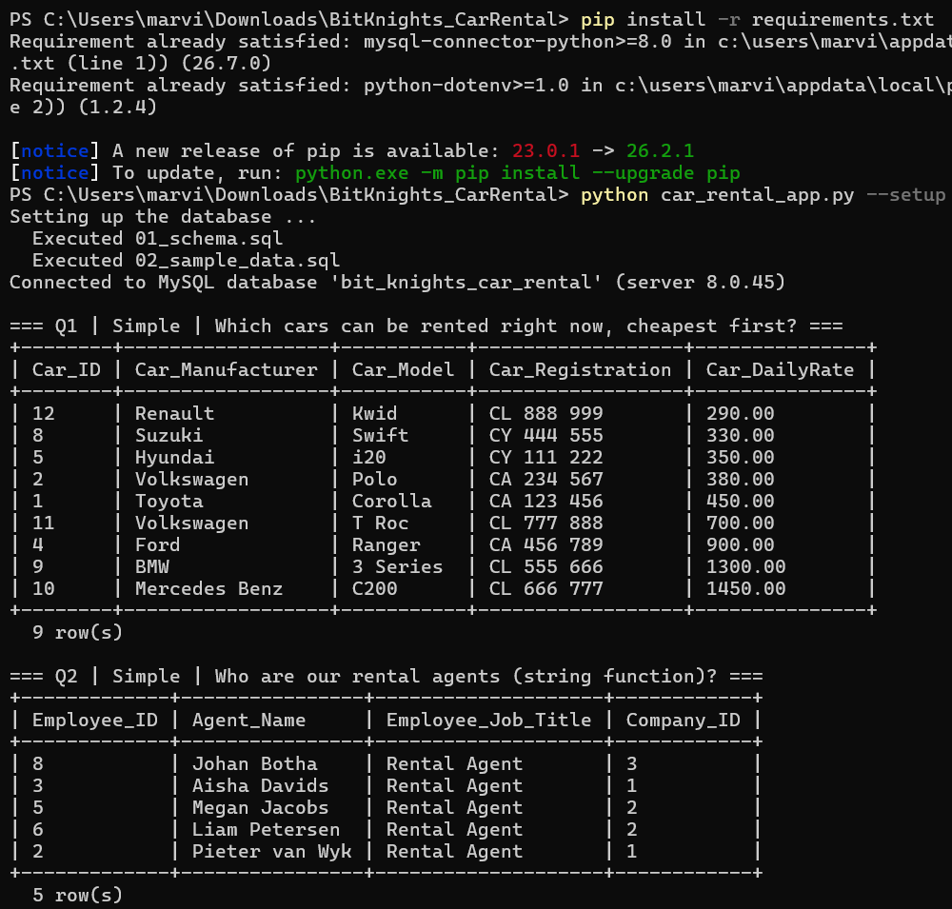
Figure 11: Running python car_rental_app.py --setup in Windows PowerShell
Summary: 10 of 10 queries executed successfully.

=== Extra demo | Available cars costing at most R500 per day ===
+------------------+-----------+---------------+
| Car_Manufacturer | Car_Model | Car_DailyRate |
+------------------+-----------+---------------+
| Renault | Kwid | 290.00 |
| Suzuki | Swift | 330.00 |
| Hyundai | i20 | 350.00 |
| Volkswagen | Polo | 380.00 |
| Toyota | Corolla | 450.00 |
+------------------+-----------+---------------+
5 row(s)

=== Extra demo | Constraint test (return date before pick up date) ===
Correctly rejected by MySQL: Check constraint 'chk_booking_dates' is violated.

Connection closed.

The script was validated in three ways: (1) the outputs printed on Windows (MySQL 8.0.45) were compared with an independent rebuild of the database from the same three scripts, and all ten results were identical; (2) key totals were recalculated by hand (Section 8.3); and (3) the script was run on a freshly built database with --setup to prove that the repository is self-contained.

8.0 Testing and Validation

8.1 Testing approach
Testing was done at three levels:
- Structural tests: after running 01_schema.sql, the tables, keys and constraints were checked in MySQL Workbench, and the row count of each table was compared with the number of rows inserted.
- Constraint (negative) tests: a separate automated script, test_database.py, deliberately tries to insert or change invalid data and checks that MySQL rejects it with the expected error code. Each test runs inside a transaction that is rolled back, so the sample data is never damaged and the tests can be repeated.
- Result verification: query outputs were checked against hand calculations and against each other (for example, the per-branch totals of Q3 must add up to the total revenue of all income-producing rentals).

8.2 Test results
Table 19: Automated validation tests (python test_database.py): 22 of 22 checks passed
ID | Test case | Expected / actual outcome | Result
T01 | Row count of all 7 tables after loading | 3, 8, 10, 16, 12, 14, 17 rows | Pass
T02 | Employee for non-existent branch (Company_ID 99) | Rejected: error 1452 (foreign key) | Pass
T03 | Rental for non-existent car (Car_ID 999) | Rejected: error 1048 (see note below) | Pass
T04 | Delete a branch that owns cars | Rejected: error 1451 (ON DELETE RESTRICT) | Pass
T05 | Duplicate car registration 'CA 123 456' | Rejected: error 1062 (UNIQUE) | Pass
T06 | Duplicate driver's licence | Rejected: error 1062 (UNIQUE) | Pass
T07 | Same car twice on one booking (bridge entity) | Rejected: error 1062 (uq_rental_booking_car) | Pass
T08 | Duplicate (Customer_ID, Contact_No) in weak entity | Rejected: error 1062 (PRIMARY) | Pass
T09 | Car with daily rate −R100 | Rejected: error 3819 (chk_car_rate) | Pass
T10 | Return date before pick-up date | Rejected: error 3819 (chk_booking_dates) | Pass
T11 | Car_Status = 'Stolen' (not in ENUM) | Rejected: error 1265 (strict mode) | Pass
T12 | Customer with NULL licence | Rejected: error 1048 (NOT NULL) | Pass
T13 | Trigger: 3 days × R290 | Rental_Cost = 870.00 | Pass
T14 | Trigger: same-day return | Charged one day: 290.00 | Pass
T15 | All 17 stored costs equal days × rate | 0 mismatches | Pass
T16 | Delete customer 10 (no bookings) | Contacts removed by ON DELETE CASCADE | Pass

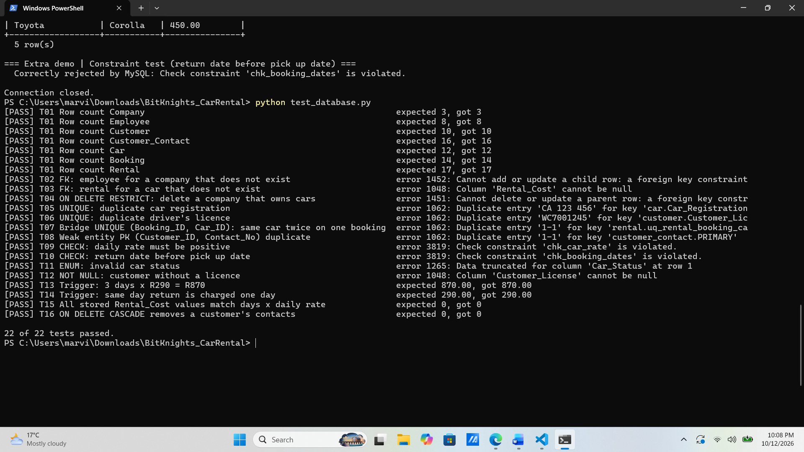
An interesting finding (T03). We expected inserting a rental for a non-existent car to fail with foreign key error 1452. Instead it failed with error 1048 (“Rental_Cost cannot be null”). The reason is the order in which MySQL processes a row: the BEFORE INSERT trigger runs first, finds no matching car, sets Rental_Cost to NULL, and the NOT NULL rule rejects the row before the foreign key is checked [5]. The invalid row is still rejected, so data integrity is safe, but this taught us that triggers change which error the user sees. The test was updated to accept either error.

8.3 Verification of query results by hand
- Q3: the twelve Returned/Active rental lines add up to R41 850, and the three branch totals (R21 740 + R12 810 + R7 300) give the same R41 850, so no rental was lost or counted twice by the joins.
- Q4: the twelve daily rates add up to R8 640, so the average is R8 640 / 12 = R720, which matches the Above_Average_By column (e.g. C200: R1 450 − R720 = R730).
- Q8: employee totals are R8 450, R4 360, R10 960, R10 780 and R7 300 (sum R41 850, the same figure as Q3). Their average is R8 370, so exactly three employees should be listed, and they are.
- Q5: the booking counts add up to 14, the number of rows in BOOKING, which proves that the LEFT JOIN neither dropped nor duplicated bookings.

8.4 Error handling
Errors are handled at two layers. In the database, constraints (PRIMARY KEY, FOREIGN KEY, UNIQUE, NOT NULL, CHECK, ENUM) reject invalid data no matter which program sends it. In the application, every database call is wrapped in try/except for mysql.connector.Error; failed inserts are rolled back; and if the connection itself fails, the program prints a helpful tip (“run --setup and check DB_USER and DB_PASSWORD”) and exits with a non-zero status code.

8.5 Limitations
- Double-booking is not prevented. The database does not stop the same car from being booked by two different bookings with overlapping dates. A BEFORE INSERT trigger on RENTAL that checks for overlapping date ranges would fix this.
- Car_Status is maintained manually. It is not updated automatically when a rental becomes Active or Returned, so it can become inconsistent with RENTAL. Triggers or a stored procedure for check-out/check-in would solve this.
- Rental_Cost is only calculated on INSERT. If a booking’s dates are changed later, the cost is not recalculated. This is intentional for price changes, but date changes should trigger a recalculation (a BEFORE UPDATE trigger on BOOKING).
- Cancelled lines keep a cost. Rental 17 (cancelled) still stores R380, so every revenue query must filter on status, as our queries do.
- Minimum-one rules are not enforced. The DDL cannot force a booking to have at least one car or a customer to have at least one contact; this must be enforced by the application.
- Small data set. With 12 cars and 14 bookings, performance was not tested at scale, although indexes were added for the most frequent filters.

9.0 Reflections and Discussion

9.1 Justification of design choices
- Surrogate integer keys (AUTO_INCREMENT) are short, never change and make joins fast, while natural keys (licence, registration, branch name) are still protected by UNIQUE constraints.
- Bridge entity with surrogate key plus UNIQUE pair gives the integrity of a composite key and the convenience of a single-column key (Section 3.3).
- ENUM instead of lookup tables for statuses: the lists are short and stable, so ENUM keeps the design simple. If Bit Knights needed to add statuses often, a STATUS lookup table would be better.
- RESTRICT versus CASCADE: history must never disappear, so deletes of branches, cars, customers and bookings are restricted; contact details have no value without their customer, so they cascade.
- Stored derived cost keeps historical revenue correct when prices change, and the trigger makes it impossible to type a wrong value.
- Separate SQL files read by Python keep a single source of truth for the queries.

9.2 Challenges
- Where to put contact details. Our first ERD treated Customer_Contacts as a simple attribute. When we saw that customers have several phones and e-mails, we had to decide between extra columns and a new entity. Researching weak entities [1] led us to CUSTOMER_CONTACT with a partial key.
- Choosing the bridge entity key. A composite key and a surrogate key each have advantages; we resolved this by using both (surrogate PK plus UNIQUE pair).
- Strict GROUP BY rules. MySQL 8 runs in ONLY_FULL_GROUP_BY mode by default [3], so every non-aggregated column in the SELECT list must also appear in GROUP BY. This is why Q5, Q7, Q8 and Q10 group by names as well as by IDs.
- Date arithmetic. DATEDIFF returns 0 for a same-day rental, which would make the cost R0. GREATEST(…, 1) solved this.
- Designing meaningful data. Queries only demonstrate something if the data contains the right cases, so the sample data was designed together with the queries (a never-rented car, a customer without bookings, a cancelled booking).

9.3 Lessons learned
We learned that most of the work in a database project happens before any SQL is written: clear business rules made the ERD almost automatic, and normalisation showed us exactly why each table exists. We also learned to let the database protect itself with constraints instead of trusting the application, and that testing must include deliberately wrong data, not only correct data. Finally, independent research in the MySQL Reference Manual [3], [4], [5] taught us features that were not covered in class, such as triggers, CHECK constraints and GROUP_CONCAT.

10.0 Conclusion
This project produced a complete, working database for Bit Knights Car Rental. Fourteen business rules were translated into an ERD with seven entities, including a weak entity for the multivalued contact details and a bridge entity that resolves the many-to-many relationship between bookings and cars. The design was normalised from an unnormalised booking sheet to 3NF (and BCNF) and implemented in MySQL 8 with primary, foreign, unique, NOT NULL and CHECK constraints and a trigger for the derived rental cost. All ten queries (2 simple, 4 medium, 4 complex) and the Python application ran successfully, and all 22 automated validation checks passed.
Beyond the technical result, the queries show the business value of the system: management can now see that the Airport branch earns more than half of the revenue, identify loyal customers and above-average staff, and spot idle or costly cars, all in seconds instead of hours. The same design could be extended with payments, damage reports and double-booking prevention to serve a real rental company.
GitHub repository: MarvinVutshila/BitKnights-CarRental-Database: CSC312 Database Practical Assignment 2 - Group 8

11.0 Declaration: Use of AI Tools

In line with the UWC policy on the ethical and responsible use of AI, we declare the following. The database design, business rules, SQL scripts, queries and Python program are the team's own work. We used two AI assistants during the project:

Gemini (Google) [10] used for independent research on MySQL syntax, help with writing and debugging SQL queries, and general study support while learning features not covered in class (such as triggers, CHECK constraints and GROUP_CONCAT).

Claude (Anthropic) [11] used to help structure and edit the written report, to check our query outputs and hand calculations, to redraw the logical ERD (Figure 2) and the dependency diagram (Figure 3) from our own schema, and to help write the automated test script test_database.py.

All AI-generated text, figures and code were reviewed, tested and corrected by the team. Every query and script was executed on our own MySQL 8.0.45 instance and the results were verified by hand (Section 8.3). We take full responsibility for the content of this submission.

Other sources consulted are the course textbook [1], the normalisation lecture slides [12], the MySQL and Connector/Python documentation [3]–[5], [7] and the W3Schools MySQL tutorial [13] recommended in the brief. They are cited in the text and listed in Section 13.0.12.0 Team Members’ Contribution
Table 20: Contribution of each team member

S/N | Name and Surname | Student Number | Key Contribution
1 | Ntlahla Kalalo | 4497363 | Wrote the introduction, background and business rules; compiled and edited the full report; formatted the document to the template (Times New Roman 12pt); wrote the reflections and conclusion.
2 | Vutshila Marvin Makhubela | 4335742 | Designed the conceptual and logical ERD; produced the relational schema and data dictionary; wrote the Python application script car_rental_app.py and set up the GitHub repository.
3 | Constance Xoliwe Maluleke | 4350565 | Performed the full normalisation from UNF to 3NF (dependency diagrams and denormalisation justification); designed and wrote the four complex queries (Q7–Q10).
4 | Andisiwe Mankayi | 4334941 | Designed and loaded the sample data (02_sample_data.sql); took the table screenshots for Section 5.3; helped write and test the four medium queries (Q3–Q6).
5 | Mthokozisi Junior Nkalanga | 4323080 | Implemented the MySQL schema with all constraints and the trigger; wrote the automated test script test_database.py; performed the testing and validation (Section 8) and the hand verification of query results.

S/N | Name and Surname | Student Number | Key Contribution
1 | Ntlahla Kalalo | 4497363 | Key contribution
2 | Vutshila Marvin Makhubela | 4335742 | Key contribution
3 | Constance Xoliwe Maluleke | 4350565 | Key contribution
4 | Andisiwe Mankayi | 4334941 | Key contribution
5 | Mthokozisi Junior Nkalanga | 4323080 | Key contribution

13.0 References
[1] C. Coronel and S. Morris, Database Systems: Design, Implementation, and Management, 13th ed. Boston, MA, USA: Cengage Learning, 2019.
[2] E. F. Codd, “A relational model of data for large shared data banks,” Commun. ACM, vol. 13, no. 6, pp. 377–387, Jun. 1970.
[3] Oracle Corporation, “MySQL 8.0 Reference Manual,” dev.mysql.com. Accessed: Oct. 12, 2026. [Online]. Available: https://dev.mysql.com/doc/refman/8.0/en/
[4] Oracle Corporation, “CHECK constraints,” in MySQL 8.0 Reference Manual. Accessed: Oct. 12, 2026. [Online]. Available: https://dev.mysql.com/doc/refman/8.0/en/create-table-check-constraints.html
[5] Oracle Corporation, “Trigger syntax and examples,” in MySQL 8.0 Reference Manual. Accessed: Oct. 12, 2026. [Online]. Available: https://dev.mysql.com/doc/refman/8.0/en/trigger-syntax.html
[6] R. Elmasri and S. B. Navathe, Fundamentals of Database Systems, 7th ed. Hoboken, NJ, USA: Pearson, 2016.
[7] Oracle Corporation, “MySQL Connector/Python Developer Guide,” dev.mysql.com. Accessed: Oct. 12, 2026. [Online]. Available: https://dev.mysql.com/doc/connector-python/en/
[8] S. Kumar, “python-dotenv,” PyPI. Accessed: Oct. 12, 2026. [Online]. Available: https://pypi.org/project/python-dotenv/
[9] OWASP Foundation, “SQL Injection Prevention Cheat Sheet,” OWASP Cheat Sheet Series. Accessed: Oct. 12, 2026. [Online]. Available: https://cheatsheetseries.owasp.org/cheatsheets/SQL_Injection_Prevention_Cheat_Sheet.html
[10] Anthropic, Claude [Large language model]. San Francisco, CA, USA: Anthropic, 2026. Accessed: Oct. 12, 2026. [Online]. Available: https://claude.ai
[11] Department of Computer Science, “Normalisation,” CSC312 Database Systems lecture slides, University of the Western Cape, Bellville, South Africa, 2026. [Online]. Available: iKamva.
[12] W3Schools, “MySQL tutorial,” w3schools.com. Accessed: Oct. 12, 2026. [Online]. Available: https://www.w3schools.com/mysql/mysql_sql.asp

14.0 Plagiarism Declaration
We are aware and understand that plagiarism is wrong and punishable according to the UWC policy. We, The Bit Knights (Group 8), confirm that this work is our own and that we have not plagiarised our work nor allowed anyone to copy our report or code.
Name and Surname | Student Number | Signature | Date
Ntlahla Kalalo | 4497363 |  | 13/10/2026
Vutshila Marvin Makhubela | 4335742 |  | 13/10/2026
Constance Xoliwe Maluleke | 4350565 |  | 13/10/2026
Andisiwe Mankayi | 4334941 |  | 13/10/2026
Mthokozisi Junior Nkalanga | 4323080 |  | 13/10/2026

Appendix A: Full sample data script (02_sample_data.sql)
USE bit_knights_car_rental;

INSERT INTO Company (Company_Name, Company_Contacts, Company_Address) VALUES
('Bit Knights Cape Town CBD', '021 555 0101', '12 Strand Street, Cape Town, 8001'),
('Bit Knights Cape Town Airport', '021 555 0102', 'Airport Approach Road, Matroosfontein, 7490'),
('Bit Knights Stellenbosch', '021 555 0103', '45 Dorp Street, Stellenbosch, 7600');

INSERT INTO Employee (Company_ID, Employee_First_Name, Employee_Last_Name, Employee_Job_Title) VALUES
(1, 'Thandi', 'Nkosi', 'Branch Manager'),
(1, 'Pieter', 'van Wyk', 'Rental Agent'),
(1, 'Aisha', 'Davids', 'Rental Agent'),
(2, 'Sipho', 'Dlamini', 'Branch Manager'),
(2, 'Megan', 'Jacobs', 'Rental Agent'),
(2, 'Liam', 'Petersen', 'Rental Agent'),
(3, 'Zanele', 'Mokoena', 'Branch Manager'),
(3, 'Johan', 'Botha', 'Rental Agent');

INSERT INTO Customer (First_Name, Last_Name, Customer_License) VALUES
('Ayanda', 'Khumalo', 'WC7001245'),
('Fatima', 'Adams', 'WC7002318'),
('Michael','Smith', 'WC7003452'),
('Naledi', 'Mahlangu', 'GP7004871'),
('Ruan', 'du Plessis', 'WC7005693'),
('Chloe', 'Williams', 'EC7006127'),
('Thabo', 'Molefe', 'GP7007740'),
('Sarah', 'Johnson', 'WC7008356'),
('Mandla', 'Zulu', 'KZ7009912'),
('Emma', 'Roberts', 'WC7010284');

INSERT INTO Customer_Contact (Customer_ID, Contact_No, Contact_Type, Contact_Value) VALUES
(1, 1, 'Phone', '082 555 1001'), (1, 2, 'Email', 'ayanda.khumalo@example.co.za'),
(2, 1, 'Phone', '083 555 1002'), (2, 2, 'Email', 'fatima.adams@example.co.za'),
(3, 1, 'Phone', '084 555 1003'),
(4, 1, 'Phone', '071 555 1004'), (4, 2, 'Email', 'naledi.m@example.co.za'),
(5, 1, 'Email', 'ruan.dp@example.co.za'),
(6, 1, 'Phone', '072 555 1006'), (6, 2, 'Phone', '021 555 1066'),
(7, 1, 'Phone', '073 555 1007'), (7, 2, 'Email', 'thabo.molefe@example.co.za'),
(8, 1, 'Phone', '074 555 1008'),
(9, 1, 'Phone', '079 555 1009'), (9, 2, 'Email', 'mandla.zulu@example.co.za'),
(10,1, 'Email', 'emma.roberts@example.co.za');

INSERT INTO Car (Company_ID, Car_Registration, Car_Manufacturer, Car_Model, Car_DailyRate, Car_Status) VALUES
(1, 'CA 123 456', 'Toyota', 'Corolla', 450.00, 'Available'),
(1, 'CA 234 567', 'Volkswagen', 'Polo', 380.00, 'Available'),
(1, 'CA 345 678', 'Toyota', 'Fortuner', 950.00, 'Rented'),
(1, 'CA 456 789', 'Ford', 'Ranger', 900.00, 'Available'),
(2, 'CY 111 222', 'Hyundai', 'i20', 350.00, 'Available'),
(2, 'CY 222 333', 'Kia', 'Seltos', 620.00, 'Rented'),
(2, 'CY 333 444', 'Toyota', 'Hilux', 920.00, 'Maintenance'),
(2, 'CY 444 555', 'Suzuki', 'Swift', 330.00, 'Available'),
(3, 'CL 555 666', 'BMW', '3 Series', 1300.00, 'Available'),
(3, 'CL 666 777', 'Mercedes Benz', 'C200', 1450.00, 'Available'),
(3, 'CL 777 888', 'Volkswagen', 'T Roc', 700.00, 'Available'),
(3, 'CL 888 999', 'Renault', 'Kwid', 290.00, 'Available');

INSERT INTO Booking (Customer_ID, Employee_ID, Pick_Up_Date, Return_Date, Booking_Status) VALUES
(1, 2, '2026-08-03', '2026-08-07', 'Completed'),
(2, 3, '2026-08-10', '2026-08-12', 'Completed'),
(3, 5, '2026-08-15', '2026-08-22', 'Completed'),
(4, 8, '2026-08-29', '2026-09-01', 'Completed'),
(1, 2, '2026-09-05', '2026-09-08', 'Completed'),
(5, 6, '2026-09-12', '2026-09-19', 'Completed'),
(6, 8, '2026-09-20', '2026-09-24', 'Completed'),
(3, 3, '2026-09-27', '2026-10-01', 'Completed'),
(7, 5, '2026-10-05', '2026-10-15', 'Active'),
(8, 2, '2026-10-10', '2026-10-14', 'Active'),
(2, 6, '2026-10-20', '2026-10-25', 'Confirmed'),
(9, 8, '2026-11-01', '2026-11-05', 'Pending'),
(4, 4, '2026-12-15', '2026-12-30', 'Confirmed'),
(5, 3, '2026-09-10', '2026-09-11', 'Cancelled');

INSERT INTO Rental (Booking_ID, Car_ID, Rental_Status) VALUES
(1, 1, 'Returned'),
(2, 2, 'Returned'),
(3, 5, 'Returned'),
(3, 8, 'Returned'),
(4, 11, 'Returned'),
(5, 3, 'Returned'),
(6, 6, 'Returned'),
(6, 7, 'Returned'),
(7, 9, 'Returned'),
(8, 4, 'Returned'),
(9, 6, 'Active'),
(10,3, 'Active'),
(11,5, 'Reserved'),
(12,10, 'Reserved'),
(13,5, 'Reserved'),
(13,8, 'Reserved'),
(14,2, 'Cancelled');

Appendix B: Full Python script (car_rental_app.py)
"""
Team Name : The Bit Knights (Group 8)
Course : CSC312 Database Practical Assignment 2
File name : car_rental_app.py
Team Members :
- Ntlahla Kalalo (4497363)
- Vutshila Marvin Makhubela (4335742)
- Constance Xoliwe Maluleke (4350565)
- Andisiwe Mankayi (4334941)
- Mthokozisi Junior Nkalanga (4323080)

Purpose
-------
Connects Python to the MySQL database "bit_knights_car_rental" and
1. (optional) builds the database from 01_schema.sql and 02_sample_data.sql,
2. runs all 10 business queries stored in 03_queries.sql and prints the results,
3. demonstrates a parameterised query and a constraint check with error handling.

Usage
-----
pip install -r requirements.txt
copy .env.example to .env and fill in your MySQL password
python car_rental_app.py --setup # first run: creates and fills the database
python car_rental_app.py # later runs: just executes the queries

Connection details are read from the .env file (DB_HOST, DB_PORT, DB_USER,
DB_PASSWORD, DB_NAME). If .env is missing, sensible defaults are used.
"""

import os
import re
import sys
from datetime import date
from pathlib import Path

import mysql.connector
from mysql.connector import Error
from dotenv import load_dotenv

BASE_DIR = Path(__file__).resolve().parent
load_dotenv(BASE_DIR / ".env")

# ============================================================================
# CONFIGURATION - LOCAL MYSQL INSTANCE (values come from .env)
# ============================================================================
CONFIG = {
"host": os.getenv("DB_HOST", "localhost"),
"port": int(os.getenv("DB_PORT", 3306)),
"user": os.getenv("DB_USER", "root"),
"password": os.getenv("DB_PASSWORD", ""),
}
DB_NAME = os.getenv("DB_NAME", "bit_knights_car_rental")
# ============================================================================

# ----------------------------------------------------------------------------
# Helper functions
# ----------------------------------------------------------------------------
def split_statements(sql_text):
"""Remove /* */ comments and split a SQL script into single statements."""
sql_text = re.sub(r"/\*.*?\*/", "", sql_text, flags=re.S)
return [s.strip() for s in sql_text.split(";") if s.strip()]

def run_script(connection, filename):
"""Execute every statement of a .sql file (used by --setup)."""
cursor = connection.cursor()
for statement in split_statements((BASE_DIR / filename).read_text(encoding="utf-8")):
cursor.execute(statement)
connection.commit()
cursor.close()
print(f" Executed {filename}")

def load_queries(filename="03_queries.sql"):
"""Read the queries file and return a list of (title, sql) pairs."""
text = (BASE_DIR / filename).read_text(encoding="utf-8")
text = re.sub(r"/\*.*?\*/", "", text, flags=re.S)
queries = []
for block in re.split(r"^### ", text, flags=re.M)[1:]:
title, sql = block.split("\n", 1)
queries.append((title.strip(), sql.strip().rstrip(";")))
return queries

def print_table(columns, rows):
"""Print rows as a neat text table."""
if not rows:
print(" (no rows returned)")
return
data = [[("NULL" if v is None else str(v)) for v in row] for row in rows]
widths = [max(len(str(c)), *(len(r[i]) for r in data)) for i, c in enumerate(columns)]
line = "+" + "+".join("-" * (w + 2) for w in widths) + "+"
print(line)
print("| " + " | ".join(str(c).ljust(w) for c, w in zip(columns, widths)) + " |")
print(line)
for r in data:
print("| " + " | ".join(v.ljust(w) for v, w in zip(r, widths)) + " |")
print(line)
print(f" {len(data)} row(s)")

# ----------------------------------------------------------------------------
# Main tasks
# ----------------------------------------------------------------------------
def setup_database():
"""Create the database, tables, trigger and sample data."""
print("Setting up the database ...")
connection = mysql.connector.connect(**CONFIG)
try:
run_script(connection, "01_schema.sql")
run_script(connection, "02_sample_data.sql")
finally:
connection.close()

def run_all_queries(connection):
"""Run the 10 queries from 03_queries.sql."""
passed = 0
cursor = connection.cursor()
queries = load_queries()
for title, sql in queries:
print(f"\n=== {title} ===")
try:
cursor.execute(sql)
print_table([c[0] for c in cursor.description], cursor.fetchall())
passed += 1
except Error as err:
print(f" QUERY FAILED: {err}")
cursor.close()
print(f"\nSummary: {passed} of {len(queries)} queries executed successfully.")

def demo_parameterised_query(connection, max_rate=500):
"""Parameterised query: protects against SQL injection."""
print(f"\n=== Extra demo | Available cars costing at most R{max_rate} per day ===")
cursor = connection.cursor()
cursor.execute(
"SELECT Car_Manufacturer, Car_Model, Car_DailyRate FROM Car "
"WHERE Car_Status = %s AND Car_DailyRate <= %s ORDER BY Car_DailyRate",
("Available", max_rate),
)
print_table([c[0] for c in cursor.description], cursor.fetchall())
cursor.close()

def demo_constraint_check(connection):
"""Shows error handling: the CHECK constraint rejects a return date before pick up."""
print("\n=== Extra demo | Constraint test (return date before pick up date) ===")
cursor = connection.cursor()
try:
cursor.execute(
"INSERT INTO Booking (Customer_ID, Employee_ID, Pick_Up_Date, Return_Date) "
"VALUES (%s, %s, %s, %s)",
(1, 2, date(2026, 11, 10), date(2026, 11, 5)),
)
connection.commit()
print(" Unexpected: the invalid booking was accepted.")
except Error as err:
connection.rollback()
print(f" Correctly rejected by MySQL: {err.msg}")
finally:
cursor.close()

def main():
try:
if "--setup" in sys.argv:
setup_database()
connection = mysql.connector.connect(database=DB_NAME, **CONFIG)
print(f"Connected to MySQL database '{DB_NAME}' (server {connection.server_info})")
try:
run_all_queries(connection)
demo_parameterised_query(connection)
demo_constraint_check(connection)
finally:
connection.close()
print("\nConnection closed.")
except Error as err:
print(f"Database error: {err}")
print("Tip: run 'python car_rental_app.py --setup' and check DB_USER and DB_PASSWORD.")
sys.exit(1)

if __name__ == "__main__":
main()

