**AYUDA: A MOBILE-BASED EMERGENCY TRACKING SYSTEM**

**FOR ZAMBOANGA CITY**

**Comparison Table of Related Systems**

|  |  |  |  |  |
| --- | --- | --- | --- | --- |
| Attributes | eSaklolo | Athena | CHITS | AYUDA |
| Route Planning Solution | ✘ | ✘ | ✘ | ✔ |
| Able to save records of incidents | ✘ | ✘ | ✔ | ✔ |
| Mobile Accessibility | ✔ | ✔ | ✘ | ✔ |
| Incident Reporting | ✔ | ✔ | ✔ | ✔ |
| Able to have a Resource Management | ✔ | ✔ | ✔ | ✔ |

*Table 1 . Comparison Table of Related System*

**Concept Map**

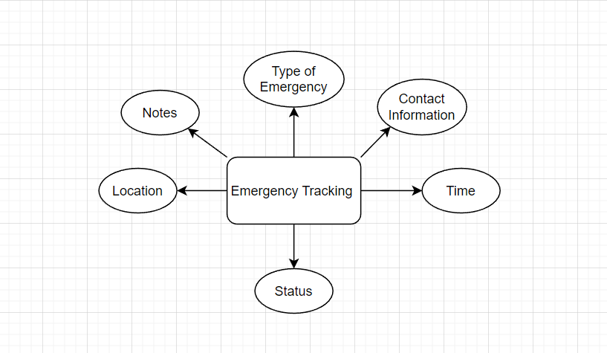

*Table . Concept Map*