**Demo #04 - Handin Template (Persona to Wireflow)**

* **Please “Make a copy” of this google doc file for yourself.**
* **Please name the file: *lastname_firstname_demo04.pdf (Individual Submission)***

**Part 1: Red Route:**

Pick a red route. Which one did you pick?

| Red Route: |
| --- |
|  |

**Part 2: User Story**

For the chosen red route, define a user story for each using the format below.

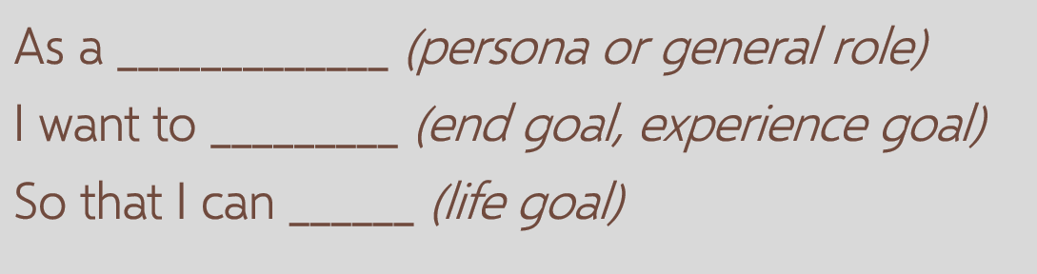

| User Story: |
| --- |
| As a ... |

**Part 3: Task Flow**

For the same User Story you have, create a core task flow. You don’t need to get fancy, just type each step in the table below.

Your task flow could have 4 steps or 10 steps. It depends on your user story. Add as many steps as needed.

| Step 1 |  |
| --- | --- |
| Step 2 |  |
| Step 3 |  |
| Step 4 |  |
| Step 5 |  |
| Step 6 |  |
| Step 7 |  |
| Step 8 |  |

**Part 4: Wireflow**

* Craft the mobile frame wireflow for the same task flow above. Simple and fast.
* Focus on the main interaction elements rather than make things beautiful.
* Use pen and paper!
* Put a screen capture or photo of your Wireflow below.
* Make sure that the details are clear and visible.

| *Paste the wireflow image here…* |
| --- |