

**User Manual**

**ACASYA** for WFC

Automatic Control and Analysis System Application for Wheel Fitted Component

September 11, 2020

Continental Automative SAS

1 Avenue Paul Ourliac

BP 83649

31036 TOULOUSE CEDEX 1



TABLE OF CONTENTS

I. ACASYA – FIRST STEPS 2

A. Installation 2

B. Welcome screen 4

C. Main screen 5

II. CREATION MODE 8

A. Test script creation 9

1. Create a new command 9

2. Commands details 11

a. SetA 11

b. SetP 11

c. SendLFD 11

d. StopLFD 12

e. SendLFCw 12

f. StopLFCw 12

g. LFPower 13

h. Label 13

3. Additional features 14

a. Modifying the table (step positions, load existing test) 14

b. Adding an extra end time to the test 14

4. Saving the Test script 15

B. Expected Results creation 16

1. Create a new check function 16

2. Check functions details 19

a. CheckTimingInterFrames 19

b. CheckTimingInterBursts 20

c. CheckFieldValue 21

d. CheckSTDEV 22

e. CheckNbBursts 23

f. CheckNbFramesInBurst 24

g. CheckCompareP 25

h. CheckCompareAcc 26

i. CheckNoRF 27

j. CheckTimingFirstRF 28

3. Additional features 29

a. Modifying the table (step positions, load existing test) 29

4. Saving the Expected Results script 29

C. Saving the Test Case 30

a. Test script worksheet 30

b. Test script worksheet 31

III. EXECUTION MODE 34

A. IHM 34

B. Executing a new sequence 35

1. Adding tests to your sequence 35

2. Starting the execution 35

C. Analyzing the results 36

1. Original scripts folder 36

2. Translated scripts folder 36

3. Test Case folders 37

a. Results folder 37

b. Check_Results.txt file 37

c. ErrorLog.txt 38

d. Logs files 38

e. Test Case files 38

4. Coverage Matrix with results synthesis 38

IV. RE-ANALYSE MODE 40

A. IHM 40

B. Starting an analysis 41

C. Analysis results 41

V. Security and monitoring 44

A. Electric Lock and Security Loop Blue button 44

B. Monitoring and status panel 45

VI. APPENDIX 48

A. Installation files 48

B. Check Results example 49

1. PASSED example 49

2. FAILED example 50

Chapter 1

ACASYA – First steps

# ACASYA – FIRST STEPS

**ACASYA for WFC** is the brand-new version of the software formerly called Wheel Unit Testing Tool 2.0. This new version has a brand-new design and new improved features. ACASYA allows you to automate the control and analysis of the LSE test bench. In other words, you have the possibility with this application to create your own Test Case scripts, execute them and get a synthesis of the test analysis.

## Installation

**Minimum system requirements:**

• OS: Windows 10

• Architecture: 32 or 64-Bit

• CPU: Dual-core CPU

• Memory: 4 GB RAM

• HD free space: 2 GB

• Screen resolution: 1280x1024 pixels display

• Software: Microsoft Office Excel – v. 1908 (build 11929.20934)

**Installation procedure:**



Double-clicking on will launch the installer. Follow then the instructions.

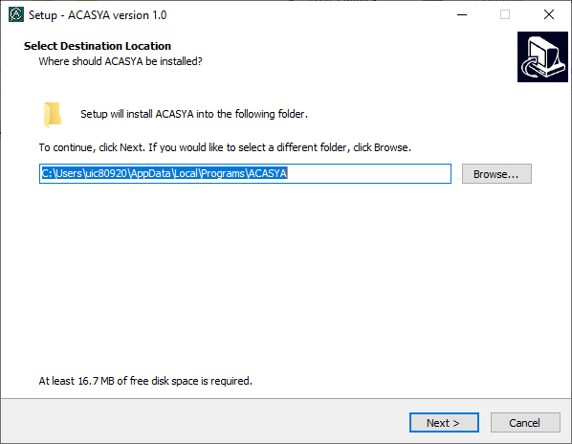

**Step 1:** Choose where to install ACASYA on your hard drive. The installation folder will contain all the necessary files for the proper using of ACASYA. See the list of installation files in the appendix.

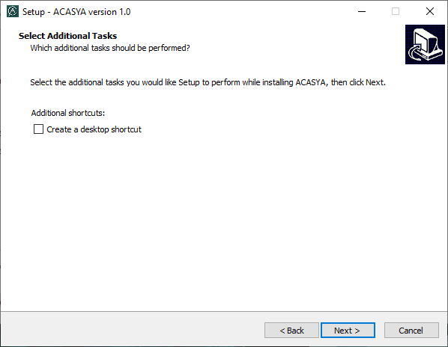

**Step 2:** The installer is able to add a shortcut on the desktop. Check the option if you need it.

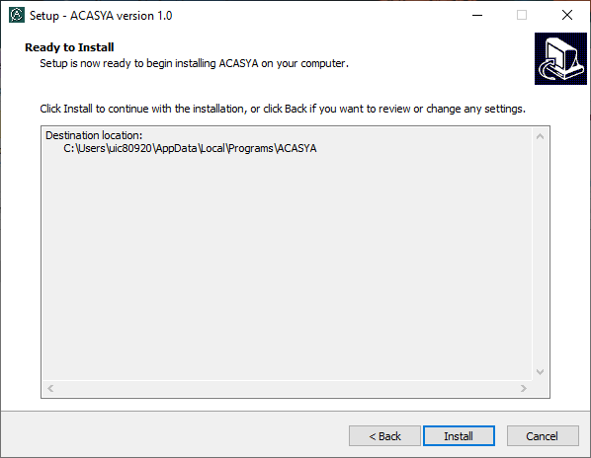

**Step 3:** ACASYA is now ready to be installed. Click on **Install** to launch the installation. The operation might take few seconds.

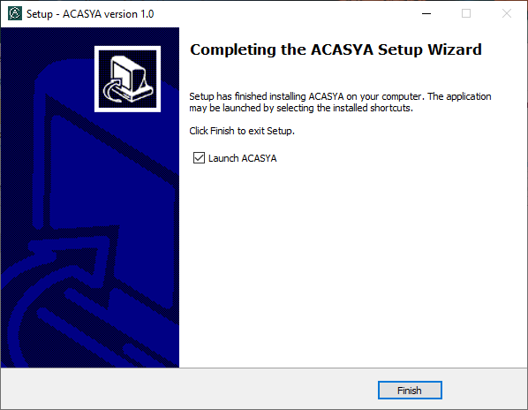

**Step 4:** The installer informs you when the installation is complete. Check **Launch ACASYA** to immediately launch ACASYA when you click on Finish. Otherwise, click on the ACASYA icon in the Start menu or on the Desktop.

Congratulations, you have now installed ACASYA!

## Welcome screen

Once ACASYA is launched, the Welcome screen is displayed, as shown in the Figure 1. This Welcome screen indicates the status of the LSE Test Bench and allows you to create a new project.

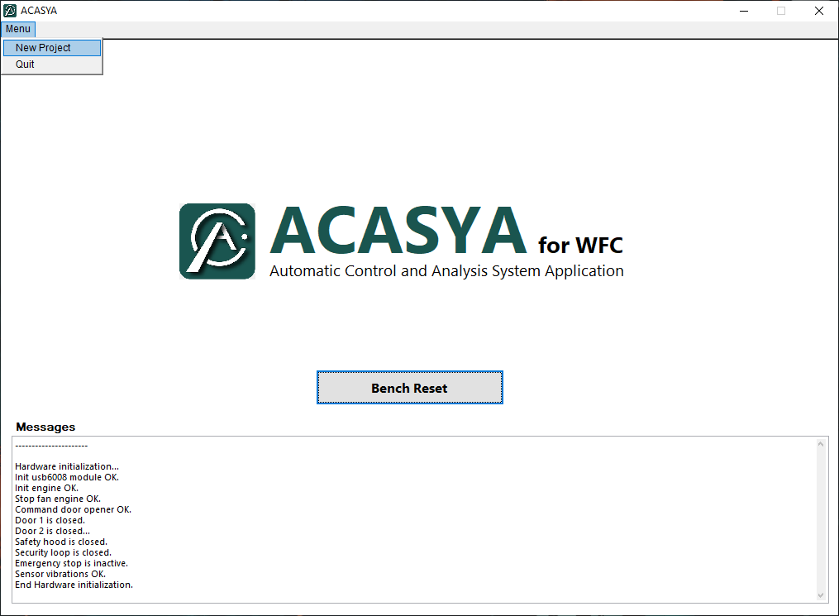

Figure 1. Welcome screen

To create a new project, click on the ***Menu*** tab, then click on ***New Project***.

## Main screen

After clicking on ***New Project***, the Main screen of ACASYA is displayed, as shown in the Figure 2. This window is organized as follows:

**(2)** **Configuration Files Panel**

**(3) WU IDs**

**Display**

**(1) Mode Selection Menu**

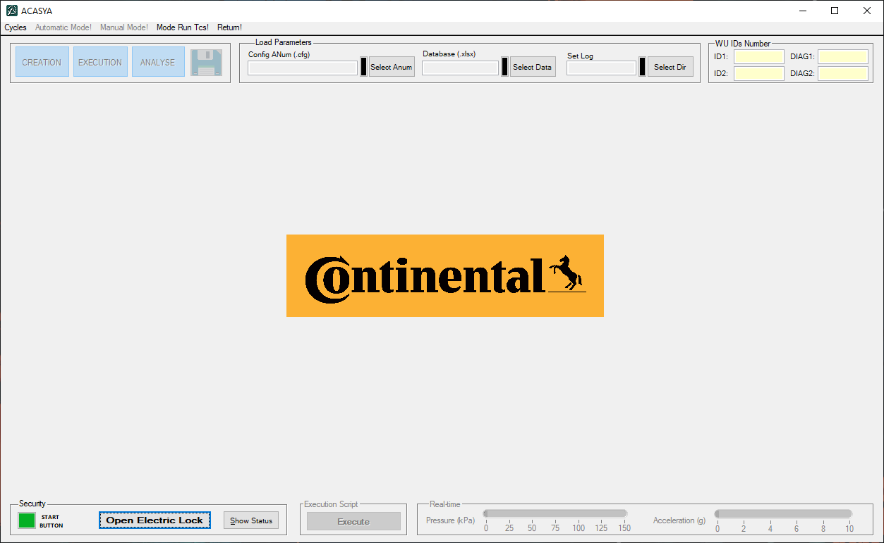

Figure 2. Main screen

**(4) Security Panel**

**(1) Mode Selection Menu:** gives access to the 3 modes (Creation, Execution and Re-Analyse).

**(2) Configuration Files Panel:** allows to load the configurations files and working folder.

**(3) WU IDs Display:** shows the WU ID numbers of the WFC defined in the Database.

**(4) Security Panel:** indicates security status and gives access to some security tool presented in the Security and monitoring chapter.

• Before creating or executing Test Case scripts, ACASYA must be configured imperatively. The user must load the configuration files and the working folder in the Configuration Files Panel presented above. There are three different elements to load[1]:

* ANum configuration file (.cfg file)
* Database configuration file (.xlsx file) - Project specifics parameters file
* Storage folder for logs - a directory which will be stocked the results of the tests.

• Once this step is completed, the ***Creation***, ***Execution*** and **Re-*Analyse*** buttons of the Mode Selection Menu are enabled and the WU IDs from the Database are loaded into the WU IDs Display, as presented in the Figure 3. Main window after configuration.

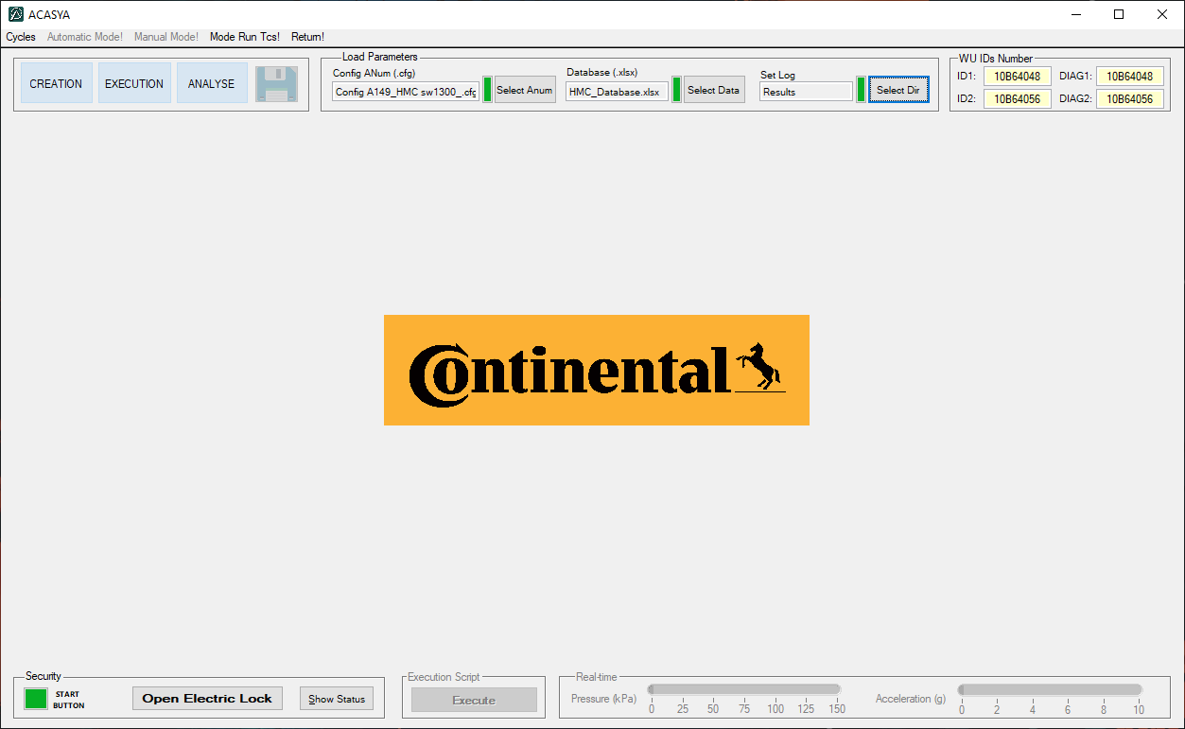

Figure 3. Main window after configuration

Chapter 2

Creation Mode

# CREATION MODE

In this mode you can create the Test Case, including the Test script and the Expected Results. The main window is splited in two parts: the one on the left side is dedicated to the creation of the Test script and the one on the right side is dedicated to the creation of the Expected Results.

**(3) Expected Results script creation table**

**(1) Test script**

**creation table**

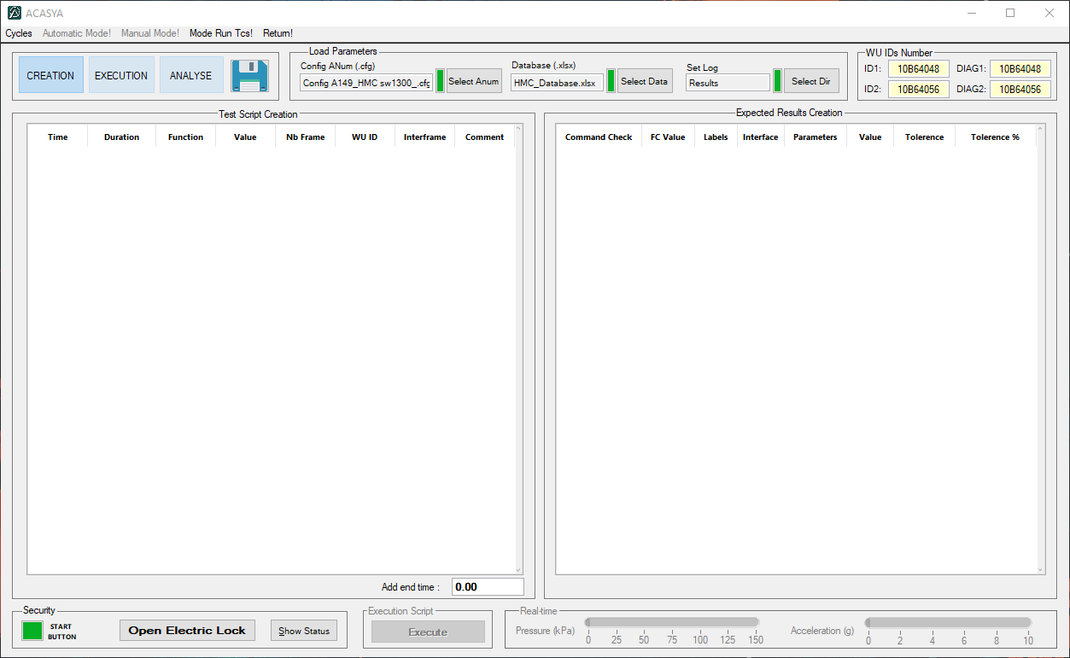

Figure 4. Creation Mode main window

**(2) Add end time**

**text box**

**(1) Test script creation table:** table to create the Test script (SetA, SetP, SendLFD…).

**(2) Expected Results script creation table:** table to create the Expected Results script (with check functions for the analysis).

**(3) Add end time text box:** text box to add some extra time to your Test script.

## Test script creation

Located at the left side of the window, this panel allows you to create the Test script. The Test script contains all the commands (set acceleration, set pressure, send LFD…) that will be executed by the bench during the test.

### Create a new command

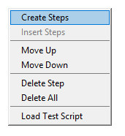A right click on the table gives you access to several features.

Click on ***Creates Steps*** to add a step to your table.

A new window titled “Script definition” appears, as presented above in the Figure 5.

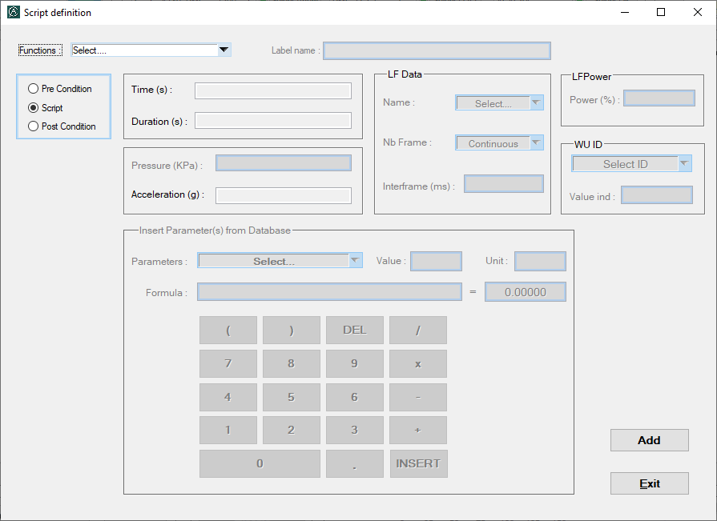

**1**

**5**

**4**

**3**

**2**

Figure 5. Script definition window

The window is divided as follow:

**(1) Function selection:** this contextual menu allows you to choose the command to be executed: (SetA, SetP, SendLFD, StopLFD, Label…). The various commands are detailed in the *Commands details* section.

**(2) Type of command:** this panel allows you to select the type of command. Three types are defined: - ***Pre condition*:** command to be executed before the test.

- ***Script*:** command to be executed during the test.

- ***Post condition*:** command to be executed after the test.

**(3) Parameters edition:** this panel allows you to configure all parameters linked with the command selected. The parameters are dimmed or not, according to the selected command. To enter a new parameter value, you must use the numeric keypad, presented in section 4.

**(4) Numeric keypad:** the numeric keypad, presented below in the Figure 6, allows you to enter the value of a parameter (Time, Duration, Pressure…).

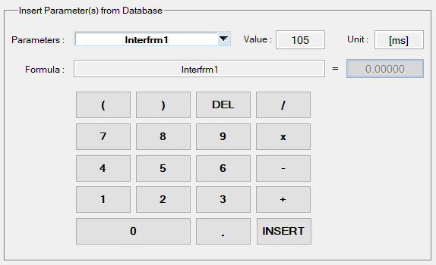

Figure 6. Numeric keypad for Test script Creation

The value can be a numeric value (e.g. “102”, “10”) or a formula using parameters from the Database. You can choose a specific parameter from the Database clicking on the contextual menu titled “**Parameters**” The unit and the value are displayed next to the parameter’s name.

To validate the parameter value, click on the **INSERT** button.

**(5) Add and Exit buttons:** once the command has been detailed, you can add it to the table using the button **Add**. A new line like this one is added to the table:



You can quit the “Script definition” window at any time with the button **Exit**.

### Commands details

As we have seen above, the Script definition window allows you to configure various commands. The Figures below detail some important information about commands.

#### SetA

|  |  |
| --- | --- |
| **Command** | **SetA** |
| **Interface** | Bench Test |
| **Mandatory parameters** | Time [s]  Duration [s]  Acceleration value [g] |
| **Description** | Sets the test bench acceleration to a given value.  Starts at time ***Time*** and produces a ramp from an initial acceleration value to the ***Acceleration value*** during ***Duration***seconds. |

#### SetP

|  |  |
| --- | --- |
| **Command** | **SetP** |
| **Interface** | Bench Test |
| **Mandatory parameters** | Time [s]  Duration [s]  Pressure value [kPa] |
| **Description** | Sets the test bench pressure to a given value.  Starts at time ***Time*** and produces a ramp from an initial pressure value to the ***Pressure value*** during ***Duration***seconds. |

#### SendLFD

|  |  |
| --- | --- |
| **Command** | **SendLFD** |
| **Interface** | ANum |
| **Mandatory parameters** | Time [s]  LF Data (Name, Nb Frame, Interframe)  LFPower [%]  WU ID |
| **Description** | Sends one or several ***LF Data*** frames to specific ***WU ID*(s)** with a signal strength  at ***LFPower*** %.  Starts at time ***Time*** and must be stopped with **StopLFD** command. |

#### StopLFD

|  |  |
| --- | --- |
| **Command** | **StopLFD** |
| **Interface** | ANum |
| **Mandatory parameters** | Time [s] |
| **Description** | Stops sending all LF Data frames at time ***Time****.* |

#### SendLFCw

|  |  |
| --- | --- |
| **Command** | **SendLFCw** |
| **Interface** | ANum |
| **Mandatory parameters** | Time [s]  LF Data (Name, Nb Frame, Interframe)  LFPower [%]  WU ID |
| **Description** | Sends one or several ***LF Carrier wave*** frames to specific ***WU ID*(s)** with a signal strength  at ***LFPower*** %.  Starts at time ***Time*** and must be stopped with **StopLFCw** command. |

#### StopLFCw

|  |  |
| --- | --- |
| **Command** | **StopLFCw** |
| **Interface** | ANum |
| **Mandatory parameters** | Time [s] |
| **Description** | Stops sending all LF Carrier wave frames at time ***Time****.* |

#### LFPower

|  |  |
| --- | --- |
| **Command** | **LFPower** |
| **Interface** | ANum |
| **Mandatory parameters** | Time [s]  LFPower [%] |
| **Description** | Sets the signal strength at ***LFPower*** % at time ***Time***. |

#### Label

|  |  |
| --- | --- |
| **Command** | **Label[2]** |
| **Interface** |  |
| **Mandatory parameters** | Time [s]  Label name |
| **Description** | Delimits the period of analysis.  E.g. From the ***Label 1***at ***Time 1*** to the ***Label 2*** at ***Time 2***. |

### Additional features

Once all the steps have been added, you get a table like the Figure 7, and several features are available.

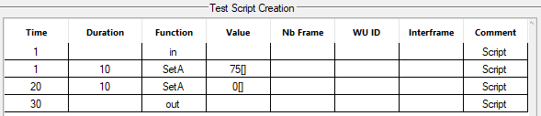

Figure 7. Example of a Test Script table

#### Modifying the table (step positions, load existing test)

As we have seen in the *Create a new command* part, a right click on the table gives you access to additional features:

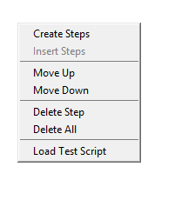

* *Move Up* and *Move Down*: change the position of the selected step[3].
* *Delete Step*: delete the selected step.
* *Delete All*: delete all steps of the table.
* *Load Test Script*: load the test script from an existing Test Case (.xlsx).

#### Adding an extra end time to the test

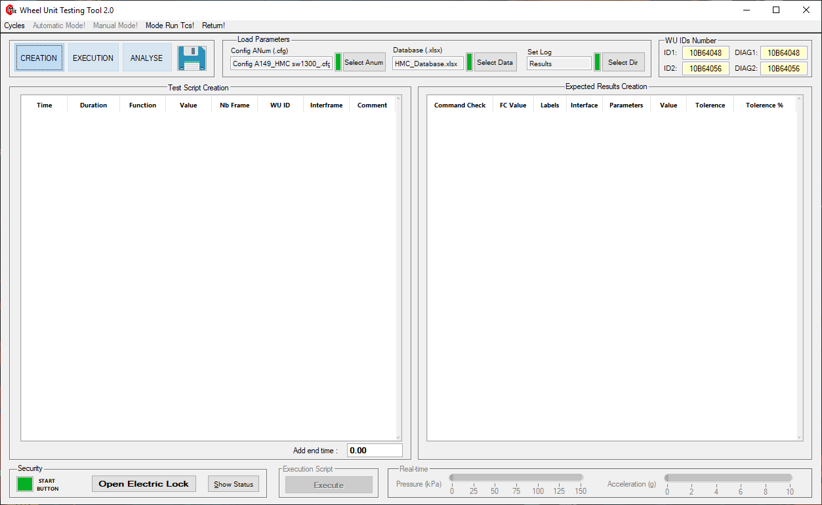Moreover, you can add some extra time to your test in the area shown below, because sometimes, the WFC continue to send some frames after the end of the test script.

The test will not end at the time indicated in this field, but at the total time of the script plus the extra time.

### Saving the Test script

Once the Test script is created, you can create the Expected Results script too or save only the Test script. In this case, the Expected Results section will be empty.

To save the Test script, check the Saving the Test Case section.

## Expected Results creation

Located at the right side of the window, this panel allows you to create the Expected Results script. The Expected Results script contains all the check functions (CheckNbBursts, CheckNoRF, CheckCompareAcc…) that will allow, once the execution is finished, to analyze the test and to give you the status PASSED or FAILED.

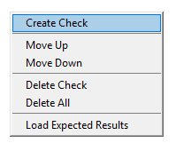

### Create a new check function

A right click on the table gives you access to several features.

Click on ***Create Check*** to add a Check function to your table.

A new window titled “Expected results” appears, as presented below in the Figure 8.

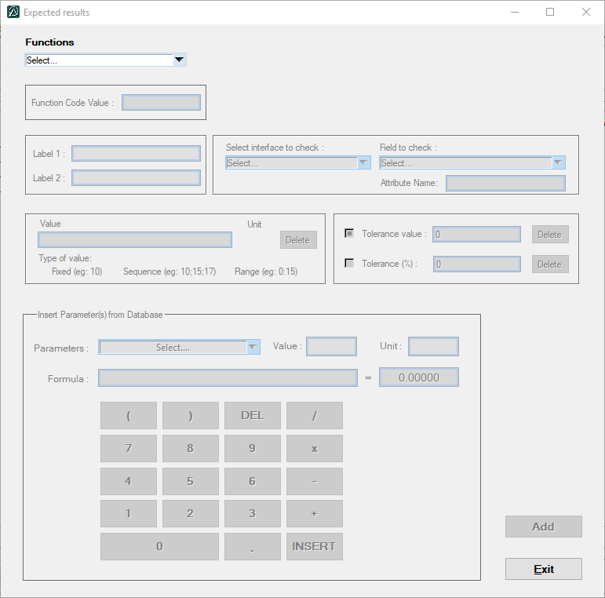

**5**

**4**

**7**

**3**

**2**

**1**

**6**

Figure 8. Expected Results window

The window is divided as follow:

**(1) Check functions selection:** this contextual menu allows you to choose the check function: (CheckTimingInterBursts, CheckTimingInterFrames, CheckFieldValue…). The various check functions are detailed in the *Check functions details* section.

**(2) Function Code Value:** this text field allows you to indicate the Function Code value. The received frames contain a number named Function Code, designating the mode in which the sensor is. By indicating the Function Code value in this text field, you will filter the frames received by keeping only the frames with this value. To enter a value, you need to use the numeric keypad presented below.

**(3) Labels:** this panel all allows you to indicate the two labels[4] between which the analysis will be done. The names of the labels must correspond to those defined in the Test script.

**(4) Interface and field to check:** this panel allows you to indicate the RF frame format (Standard_frm, Diag_frm ...) and the field to check.

The frames received during a test may have a different interface[5]. This “Interface to check” contextual menu is used to filter the frames received according to the chosen interface.

The “Field to check” contextual menu is used to check the existence of a parameter in the log file during the analysis. The parameter is specific to each interface.

***Note:*** *when you configure the CheckFieldValue function, this panel allows you to choose the parameter to check.*

**(5) Value and tolerances:** this panel allows you to indicate the expected value (timing, acceleration pressure, function code value…) and their its tolerance for the check function. The value depends of each check function.

To enter a value, you must click on the Value field and first choose the type of value (Single, Sequence or Range value) as presented here.

Then, you need to use the numeric keypad presented below.

To enter a tolerance[6] (value or percentage), you need to use the numeric keypad too.

The unit must be the same for the value and tolerance.

**(6)** **Numeric keypad:** the numeric keypad, shown below in the Figure 9, allows you to enter the value of your choice (Function Code Value, Value, Tolerances…).



Figure 9. Numeric keypad for Expected Results creation

The value can be a numeric value (e.g. “102”, “10”) or a formula using parameters from the Database. You can choose a specific parameter from the Database clicking on the contextual menu titled “**Parameters**” The unit and the value are displayed next to the parameter’s name.

To validate the parameter value, click on the **INSERT** button.

**(7) Add and Exit buttons:** once the check function has been detailed, you can add it to the table using the button **Add**. A new line like shown below is added to the table:



You can quit the “Expected results” window at any time with the button **Exit**.

### Check functions details

As we have seen above, the Expected results window allows you to configure various Check functions. The Figures below detail some important information.

#### CheckTimingInterFrames

### 

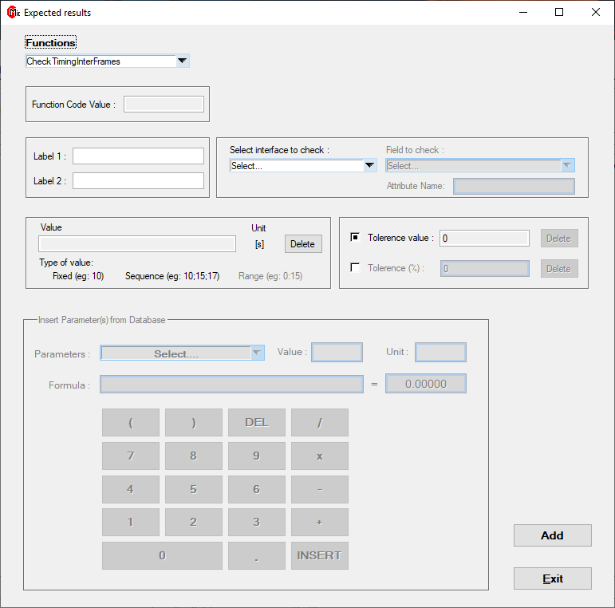

|  |  |  |
| --- | --- | --- |
| **Purpose** | | |
| This function allows to check the timing between two frames. | | |
| **Mandatory fields** | **Type of values** | **PASSED conditions** |
| Function Code value  Label 1 and Label 2  Interface  Field to check  Value  Tolerance (value or percentage) | Unit: [s]  Fixed  Range | Pre-conditions:   * Function Code   All the interframes between [**Value** +/- **Tolerance**]. |
| **Analysis** | | |
| First, the function filters the received frames keeping only those between the two labels and with an interface[7] and a FC value identical to those given as parameter.  Then, the function checks, for every burst[8], if all timings between frames belong to the interval defined by the value(s) given as parameter, plus/minus tolerance. | | |

#### CheckTimingInterBursts

### 

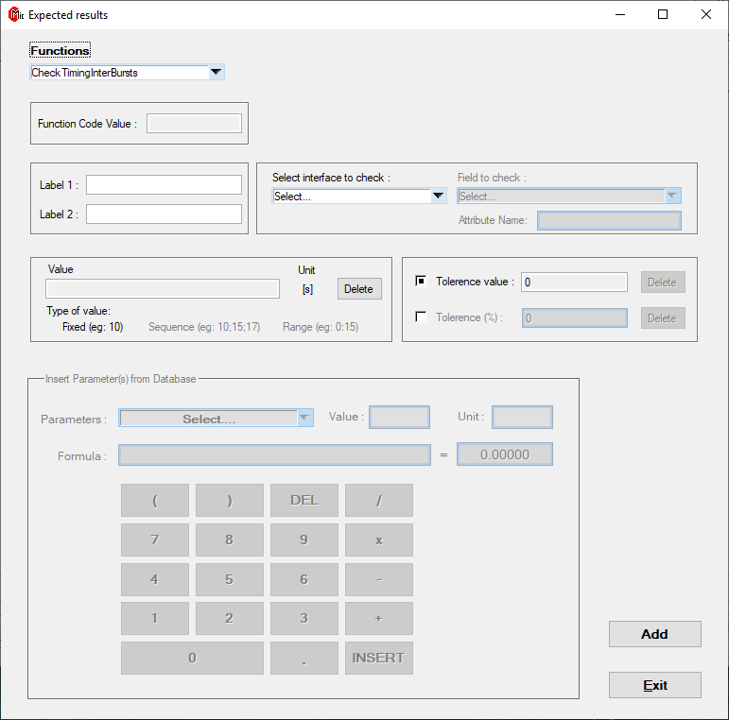

|  |  |  |
| --- | --- | --- |
| **Purpose** | | |
| This function allows to check the timing between two bursts. | | |
| **Mandatory fields** | **Type of values** | **PASSED conditions** |
| Function Code value  Label 1 and Label 2  Interface  Field to check  Value  Tolerance (value or percentage) | Unit: [s]  Fixed | Pre-conditions:   * Function Code   All the interbursts between [**Value** +/- **Tolerance**]. |
| **Analysis** | | |
| First, the function filters the received frames keeping only those between the two labels and with an interface[9] and a FC value identical to those given as parameter.  Then, the function checks if all timings between bursts[10] belong to the interval defined by the value(s) given as parameter, plus/minus tolerance. | | |

#### CheckFieldValue

### 

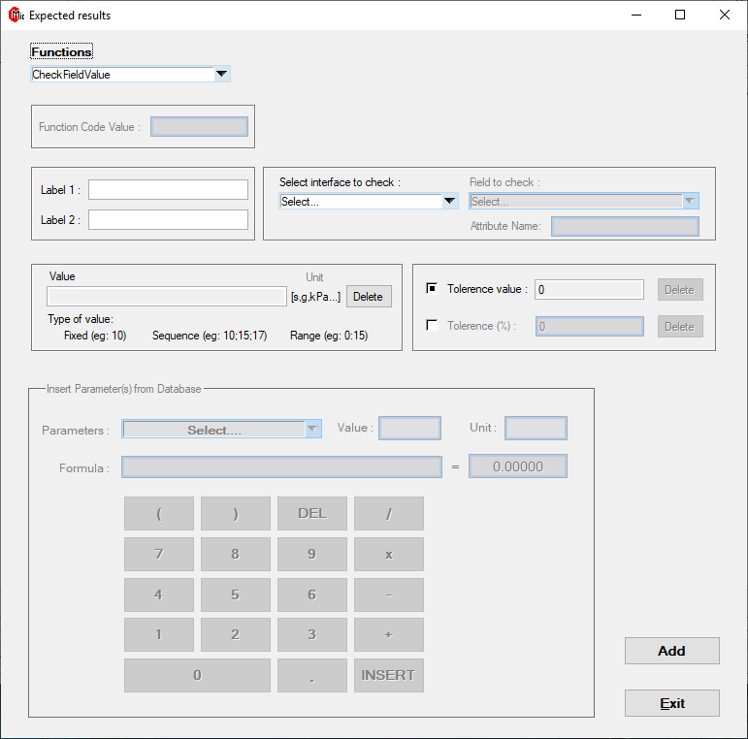

|  |  |  |
| --- | --- | --- |
| **Purpose** | | |
| This function allows to check the value of a specific field. | | |
| **Mandatory fields** | **Type of values** | **PASSED conditions** |
| Label 1 and Label 2  Interface  Field to check  Value  Tolerance (value or percentage) | Unit: [s, g, kPa…]  Fixed  Sequence  Range | All the field values between [**Value** +/- **Tolerance**]. |
| **Analysis** | | |
| First, the function filters the received frames keeping only those between the two labels.  Then, the function checks for all frames if the received value of the “Field to check” given as parameter belongs to the interval defined by the value(s) given as parameter, plus/minus tolerance. | | |

#### CheckSTDEV

### 

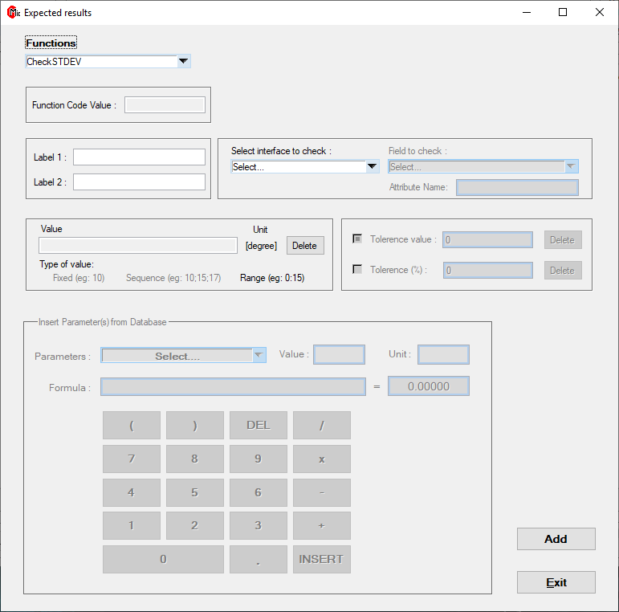

|  |  |  |
| --- | --- | --- |
| **Purpose** | | |
| This function allows to check the efficiency of the LSE feature. | | |
| **Mandatory fields** | **Type of values** | **PASSED conditions** |
| Function Code value  Label 1 and Label 2  Interface  Field to check  Value | Unit: [degree]  Range | Pre-conditions:   * Function Code * Number of populations   Standard deviation * 3 between [**Range value**]. |
| **Analysis** | | |
| First, the function filters the received frames keeping only those   * between the two labels * with an interface[11] and a FC value identical to those given as parameter * corresponding to the first frame[12] of the burst * with an *Angle_detection* field equal to 1.   Then, the function checks if the number of populationsis equal to the one expected[13] and checks if every population has a standard deviation multiply by three between the range given as parameter.  Finally, the function checks if the merged population[14] has a standard deviation multiply by three belongs to the interval defined by the range given as parameter. If the number of synchronized frames is below than 9, the standard deviation will be calculated but the status will be FAILED. | | |

#### CheckNbBursts

### 

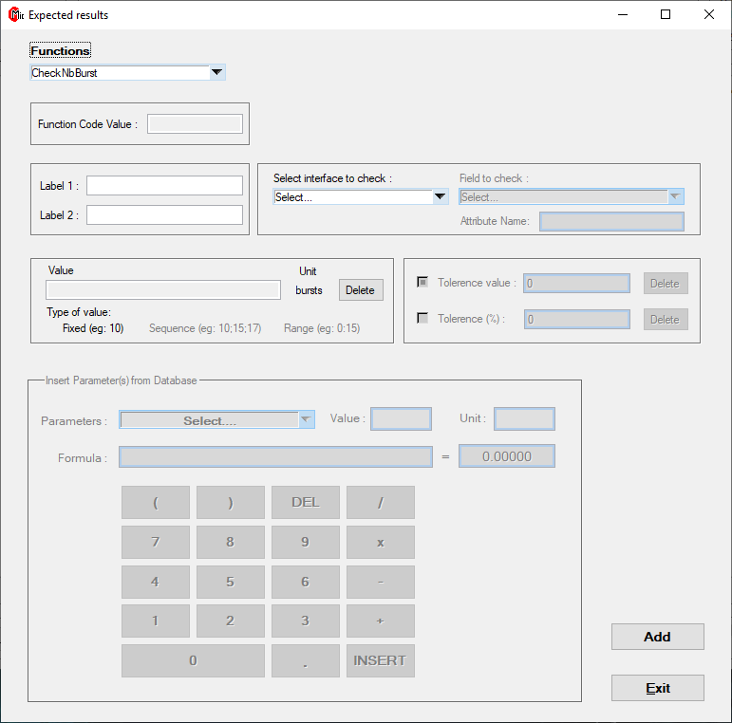

|  |  |  |
| --- | --- | --- |
| **Purpose** | | |
| This function allows to check the number of bursts sent during the test. | | |
| **Mandatory fields** | **Type of values** | **PASSED conditions** |
| Function Code value  Label 1 and Label 2  Interface  Field to check  Value | Unit: [number]  Fixed | Pre-conditions:   * Function Code   Number of bursts = **Value**. |
| **Analysis** | | |
| First, the function filters the received frames keeping only those   * between the two labels * with an interface[15] and a FC value identical to those given as parameter.   Then, the function counts the number of bursts[16] and compares the number with the value given as parameter. The number of bursts counted must be exactly equal to the value given as parameter. | | |

#### CheckNbFramesInBurst

### 

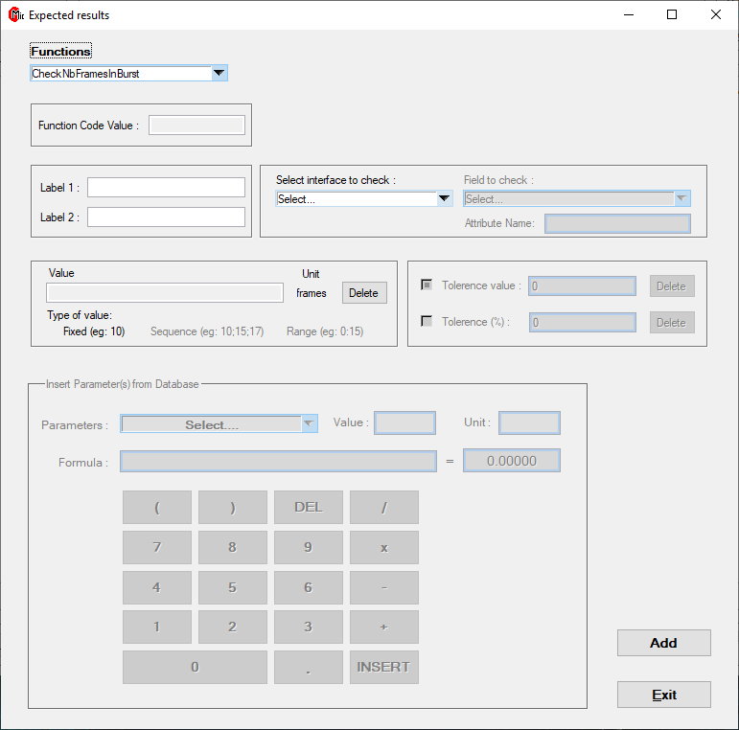

|  |  |  |
| --- | --- | --- |
| **Purpose** | | |
| This function allows to check the number of frames in the first burst sent. | | |
| **Mandatory fields** | **Type of values** | **PASSED conditions** |
| Function Code value  Label 1 and Label 2  Interface  Field to check  Value | Unit: [number]  Fixed | Pre-conditions:   * Function Code   Number of frames in first burst = **Value**. |
| **Analysis** | | |
| First, the function filters the received frames keeping only those   * between the two labels * with an interface[17] and a FC value identical to those given as parameter.   Then, the function counts the number of frames in the first burst[18] and compares the number with the value given as parameter. The number of frames counted must be exactly equal to the value given as parameter. | | |

#### CheckCompareP

### 

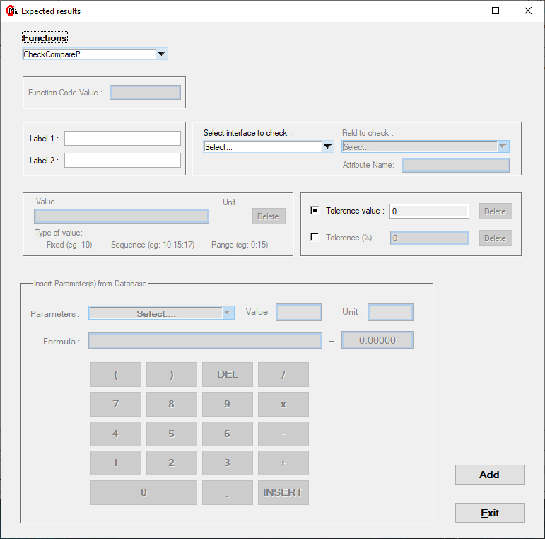

|  |  |  |
| --- | --- | --- |
| **Purpose** | | |
| This function allows to check the accuracy of the pressure values sent by the WFC. | | |
| **Mandatory fields** | **Type of values** | **PASSED conditions** |
| Label 1 and Label 2  Interface  Field to check  Tolerance (value or percentage) |  | All the pressure values between [**Value** +/- **Tolerance**]. |
| **Analysis** | | |
| First, the function filters the received frames keeping only those   * between the two labels * with an interface[19] identical to the one given as parameter.   Then, the function checks for every frame if the pressure value sent by the WFC[20] (from the *Pressure* field in log file) belongs to the interval defined by the reference pressure[21] value acquired by the bench plus/minus tolerance. | | |

#### CheckCompareAcc

### 

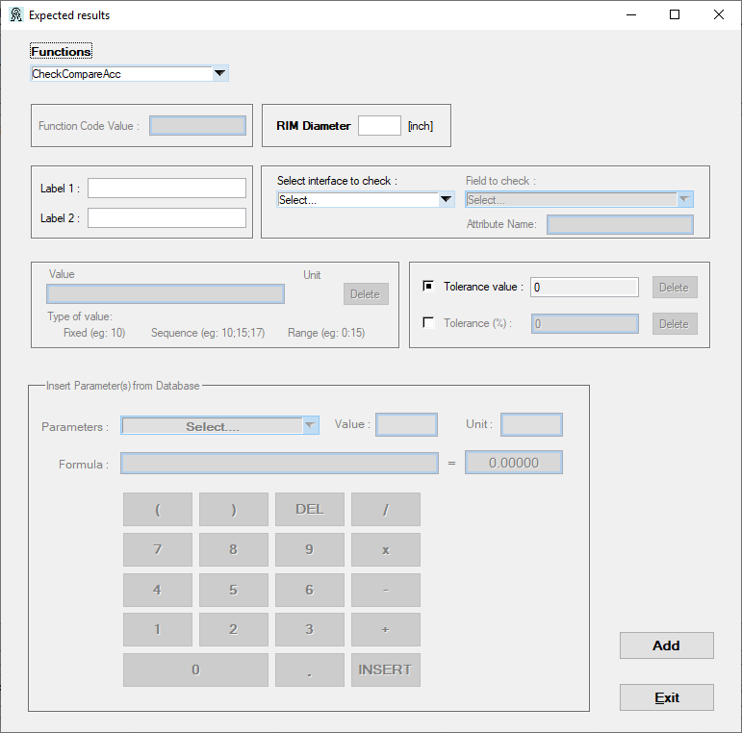

|  |  |  |
| --- | --- | --- |
| **Purpose** | | |
| This function allows to check the accuracy of the acceleration values captured and sent by the WFC. | | |
| **Mandatory fields** | **Type of values** | **PASSED conditions** |
| Label 1 and Label 2  Interface  Field to check  Tolerance (value or percentage)  RIM Diameter |  | All the acceleration values between [**Value** +/- **Tolerance**]. |
| **Analysis** | | |
| First, the function filters the received frames keeping only those   * between the two labels * with an interface[22] identical to the one given as parameter.   Then, the function checks for every frame if the acceleration value sent by the WFC[23] belongs to the interval defined by the reference acceleration[24] value acquired by the bench plus/minus tolerance. | | |

#### CheckNoRF

### 

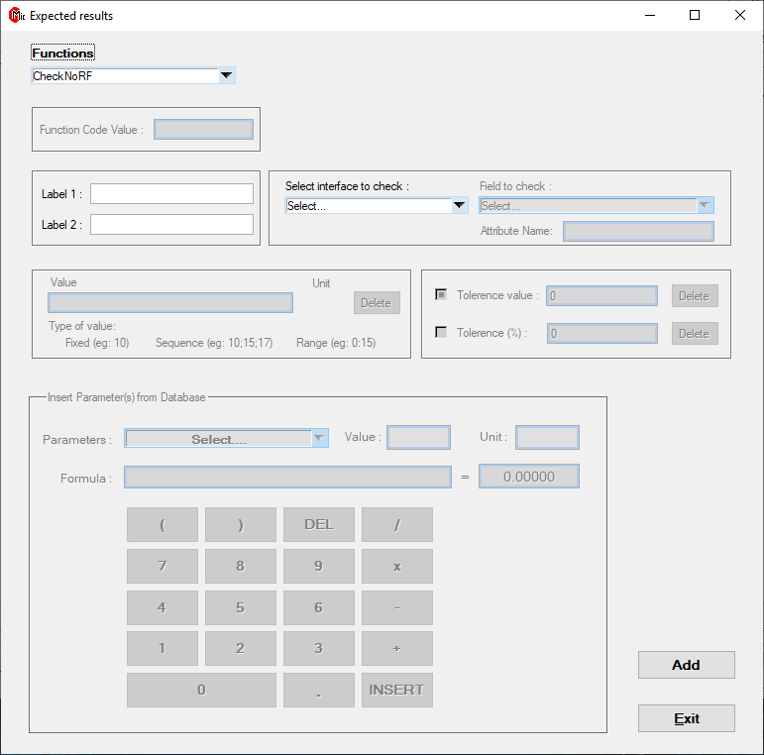

|  |  |  |
| --- | --- | --- |
| **Purpose** | | |
| This function allows to check the accuracy of the pressure values captured and sent by the WFC. | | |
| **Mandatory fields** | **Type of values** | **PASSED conditions** |
| Label 1 and Label 2  Interface  Field to check |  | No frame received between **Labels**. |
| **Analysis** | | |
| The function checks the absence of frame with the interface[25] given as parameter between labels.  Note: the function does not detect frames with an interface other than the one indicated as parameter. | | |

#### CheckTimingFirstRF

### 

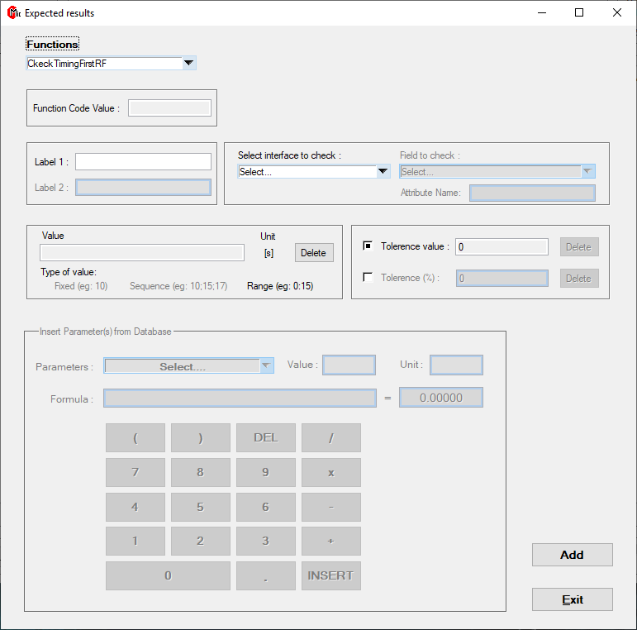

|  |  |  |
| --- | --- | --- |
| **Purpose** | | |
| This function allows to check the timing to receive the first RF. | | |
| **Mandatory fields** | **Type of values** | **PASSED conditions** |
| Function Code value  Label 1  Interface  Field to check  Value | Unit: [s]  Range | Pre-conditions:   * Function Code   Timing “Label 1 - first RF” +/- **Tolerance** between [**Range Value**] |
| **Analysis** | | |
| First, the function filters the received frames keeping only those with an interface[26] and a FC value identical to those given as parameter.  Then, the function checks if the timing between the Label 1 and the first RF belongs to the interval defined by the range given as parameter. | | |

### Additional features

Once all the steps have been added, you get a table like the Figure 10, and several features are available.

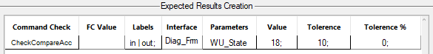

Figure 10. Example of a Test Script table

#### Modifying the table (step positions, load existing test)

As we have seen in the *Create a new check function* section, a right click on the table gives you access to additional features:

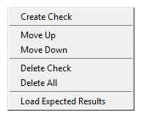

* *Move Up* and *Move Down*: changes the position of the check function[27].
* *Delete Step*: deletes the selected check function.
* *Delete All*: deletes all check functions of the table.
* *Load Expected Results*: loads the Expected Results script from an existing Test Case (.xlsx).

### Saving the Expected Results script

To save the Expected Results script, check the Saving the Test Case section.

## Saving the Test Case

As a reminder, the Test Case contains the Test script and the Expected Results script.

To save your Test Case, click on the **Save Button** located in the **Mode Selection panel** at the top of your window. Then, a new window allows you to choose where to save the Test Case file.

***Note:*** *you can save a Test Case with an empty Expected Results table.*

Saving the Test Case generates a **.xlsx file**, an **Excel table**. This Excel workbook contains two worksheets, one dedicated to the Test script and the other to Expected Results script.

#### Test script worksheet

The worksheet dedicated to the Test script is divided into 3 parts as shown below in the Figure 11:

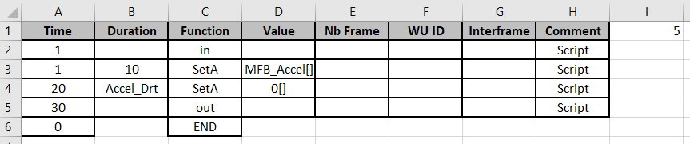

Figure 11. Test script saved in Excel

**Body of Test Script**

These lines contain all the commands of the test previously created. The parameters are still present and will be translated during the execution.

**End command**

This line is always located after the last command of the test. The END is a tag that indicates the end of the test script. The value in the *Time* column indicates the total execution time of the test. Initially, this value is at zero or at the value indicated in the Add end time field. The final value is updated during the execution (at the very beginning).

**Number of steps**

This cell contains the number of rows minus the header line. It is useful during the Test Case execution.

#### Test script worksheet

The worksheet dedicated to the Test script is divided into 2 parts as shown below in the Figure 12:

Figure 12. Expected Results script saved in Excel

**Body of Test Script**

These lines contain all the commands of the test previously created. The parameters are still present and will be translated during the execution.

**Number of steps**

This cell contains the number of rows. It is useful during the Test Case execution.

Chapter 3

Execution Mode

# EXECUTION MODE

## IHM

In this mode you can execute a sequence of tests previously created. The window is organized as follow:

**(4) Test in progress**

**(2) Sequence in progress**

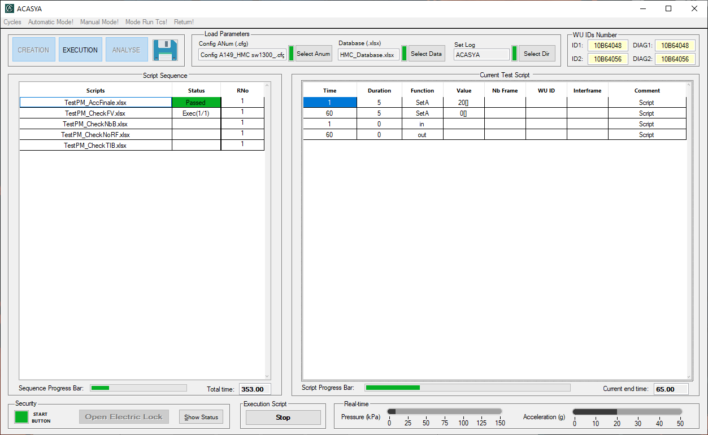

**Current Test table**

**Script Sequence table**

**(5) Test progress bar**

Figure 13. Main window

**(3) Sequence**

**progress bar**

**(1) Execute/Stop**

**button**

**(6) Real-time Pressure**

**and Acceleration**

**(1) Execute/Stop button:** button to start the test execution or to stop it at any time.

**(2) Sequence in progress:** table of the running sequence.

**(3) Sequence progress bar:** visual indicator to know the sequence progression.

**(4) Test in progress:** table of the running test script.

**(5) Test progress bar:** visual indicator to know the test progression.

**(6) Real-time Pressure and Acceleration:** visual indicator to know the Pressure and Acceleration values in real-time during the test execution.

## Executing a new sequence

### Adding tests to your sequence

A right click on the Script Sequence Table gives you access to several features.

Click on ***Add*** to add a Test Case to your table.

A new window appears and allows you to choose one or several Test Cases.

***Note:*** *right clicking on the* *Script Sequence Table* *allows you to delete tests or to load an existing sequence (previously saved).*

### Starting the execution

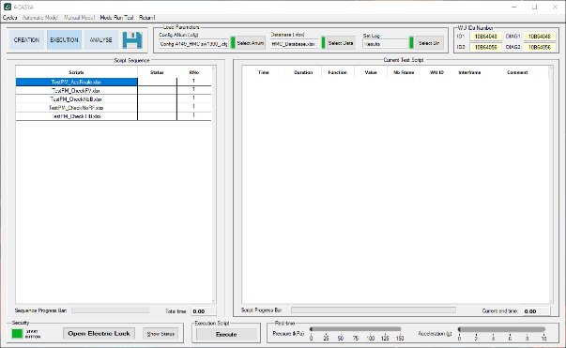

**Step 1:** Once the tests are loaded, you must save the sequence in a .txt file.

To save your sequence, click on the **Save Button** located in the **Mode Selection panel** at the top of your window. Then, a new window allows you to choose where to save the sequence.

***Note:*** *the application always checks if you have saved the sequence at the beginning of the execution.*



**Step 2:**  Now, you can start your sequence.

To start your sequence, click on the **Execution Button**located at the bottom of your window.

A picture of a timer should appear and indicates that the execution is running.

First of all, ACASYA starts to translate every test loaded. This first step allows to translate a Test Case with parameters into a Test Case[28] with only values.

Then, Test Case scripts are executed and displayed in the Current Test Table one by one until the last.

## Analyzing the results

During the execution, ACASYA creates a sequence folder where tests, configuration files and results are stored. The sequence folder is stamped with the date and time, as presented here:

Once the execution is complete, the sequence folder contains several files and subfolders as shown in the Figure 14:

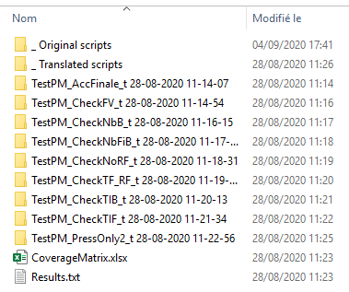

Coverage Matrix

with results synthesis

Translated scripts folder

Original scripts folder

Test Case folders

Figure 14. Sequence folder

### Original scripts folder

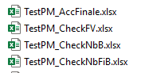

The **Original script folder** contains all the original Test Case scripts.

This folder allows you to easily access the scripts with the parameters.

### Translated scripts folder

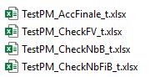The **Translated script folder** contains all the translated Test Case scripts.

As have seen above, ACASYA translates at the very beginning all Test Case scripts with parameters into Test Case scripts with only value. This folder allows you to easily access the scripts with values only.

### Test Case folders

The **Test Case folders** are very important folders because they contain the analysis results of each Test Case. There are as many folders as Test Case scripts.

A Test Case folder contains several elements as shown in the Figure 15:

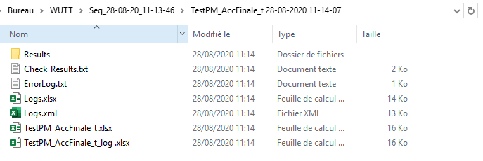

Original scripts folder

Figure 15. Test Case folder

*Original* scripts *folder*

Logs file

ErrogLog.txt file

Test Case files

#### Results folder

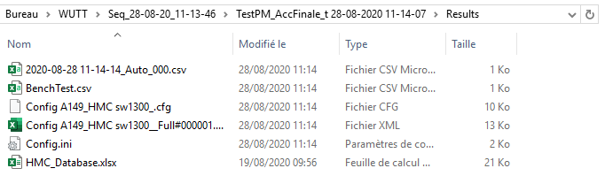

The Results folder contains several configuration files using by ACASYA during the execution such as the Database, the Config.ini file (with some environmental parameters), the ANum configuration, the original log file with received frames, etc.

#### Check_Results.txt file

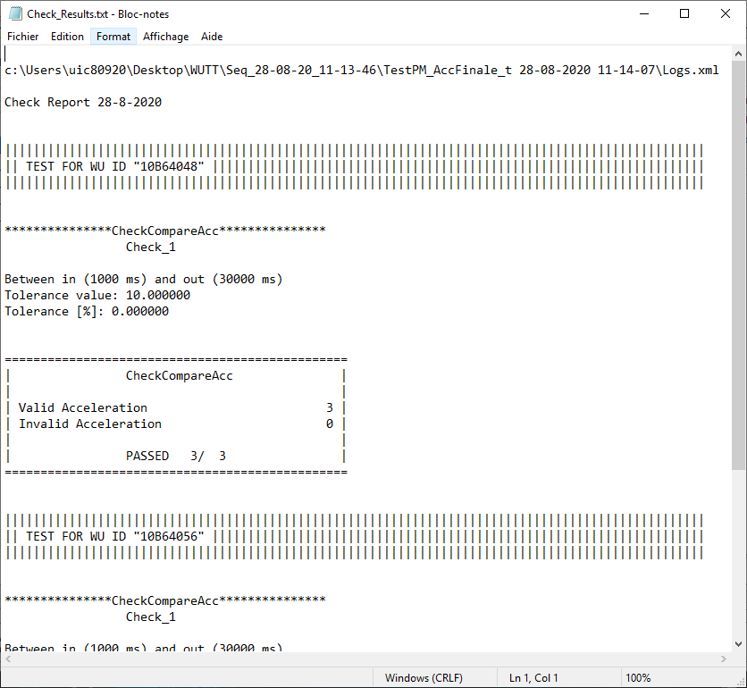The Check_Results.txt file is the most useful file of the Test Case folder. This text file contains the **analyse result** of the Test Case.

For each WFC, the text file indicates:

• the WU ID value and the Test Case name.

• the test parameters (labels, tolerances, FC value, etc.).

• the test conditions (expected value).

• rejected frames with wrong value.

• and whether the test is PASSED or FAILED.

You can find an example of a PASSED and FAILED Check_Results.txt in the Appendix.

Figure 16. CheckResults.txt

#### ErrorLog.txt

The ErrorLog text file specifies the status of the Application during and after performing each test. The Error Log text file contains some information such as:

• the Test Case name.

• the Configuration File Parameters and Reading Status: Successful or Failed.

• the Test Case decoding errors.

• the Test Case Commands after decoding.

• and the Test Case Reading Status: Successful or Failed.

#### Logs files

The Logs.xml file contains all the logs with frames received.

The Logs.xlsx file is the log processed by ACASYA during the analysis including labels.

**These files are very useful for understanding where the errors are coming from.**

#### Test Case files

These Test Case files is the Test Case scripts used and generated by ACASYA during the analyse.

### Coverage Matrix with results synthesis

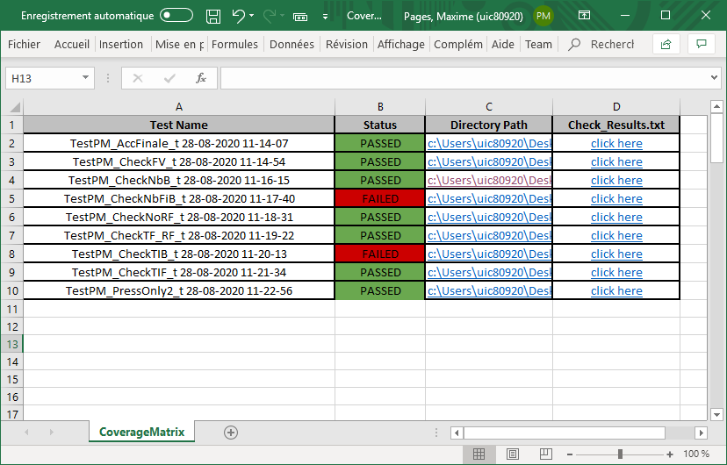The CoverageMatrix.xlsx is a very useful file to analyze your sequence. This Excel workbook allows you to quickly see which tests are passed or failed and to easily access to the Test Case folders and the CheckResults.txt files.

Figure 17. CoverageMatrix.xlsx

• Click on the hyperlinks of the “Directory Path” column to access to the Test Case folder.

• Click on the hyperlinks of the “Check_Results.txt” column to access to the Check_Results.txt file.

Chapter 4

Re-Analyse Mode

# RE-ANALYSE MODE

The Re-Analyse Mode is the last mode added to ACASYA in the last update. This very useful mode allows you to analyse Log file from a previously performed test. It is a perfect mode to save time when you don’t want to execute a test once again.

## IHM

The main window is divided as follow:

**(1) Files selection**

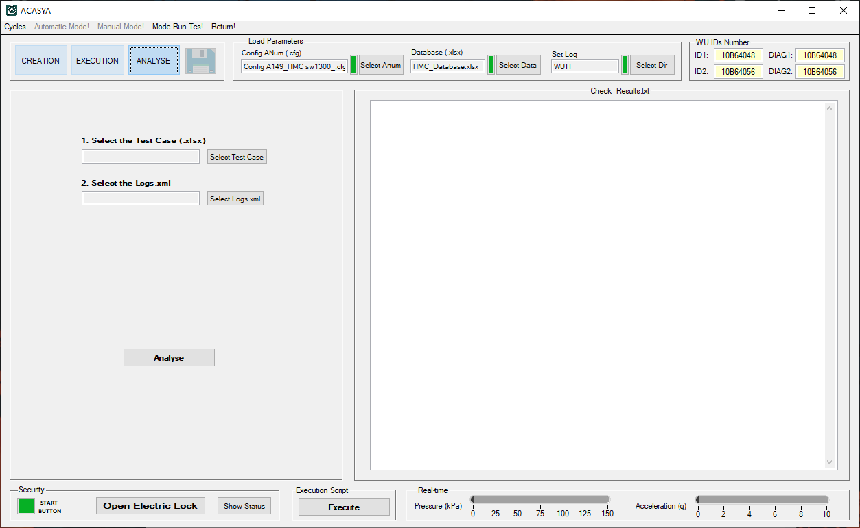

**Results panel**

Figure 18. Re-Analyse Mode main window

**(2) Analyse button**

**(1) Files selection:** panel to select the Test Case including the Expected Results script (with check functions) and the Logs.xml file.

**(2) Analyse button:** button to start the analyse

## Starting an analysis

To start an analysis, you need to indicate the Test Case including the Expected Results script (with check functions) and the Logs.xml file.

**Step 1:** Click on the *Select Test Case* button in the File Selection panel to choose the Test Case.

**Step 2:** Click on the *Select Logs.xml* button in the File Selection panel to choose the Logs.xml file.

**Step 3:** Once the Test Case and the Logs.xml file are loaded, click on the Analyse button to start the analysis.

A picture of a timer should appear, and the analysis may take few seconds.

## Analysis results

Once the analysis completed, ACASYA creates in your working folder a new Test Case folder. The Test Case folder is stamped with the date and time, as presented here:

The Test Case folder contains the Test Case script and the Check_Results.txt, identical to the one presented in the *Check_Results.txt file* section.

In addition, the Results panel displays the Check_Results.txt file created during the analyse and allows you to quickly verify whether the test is passed or failed.

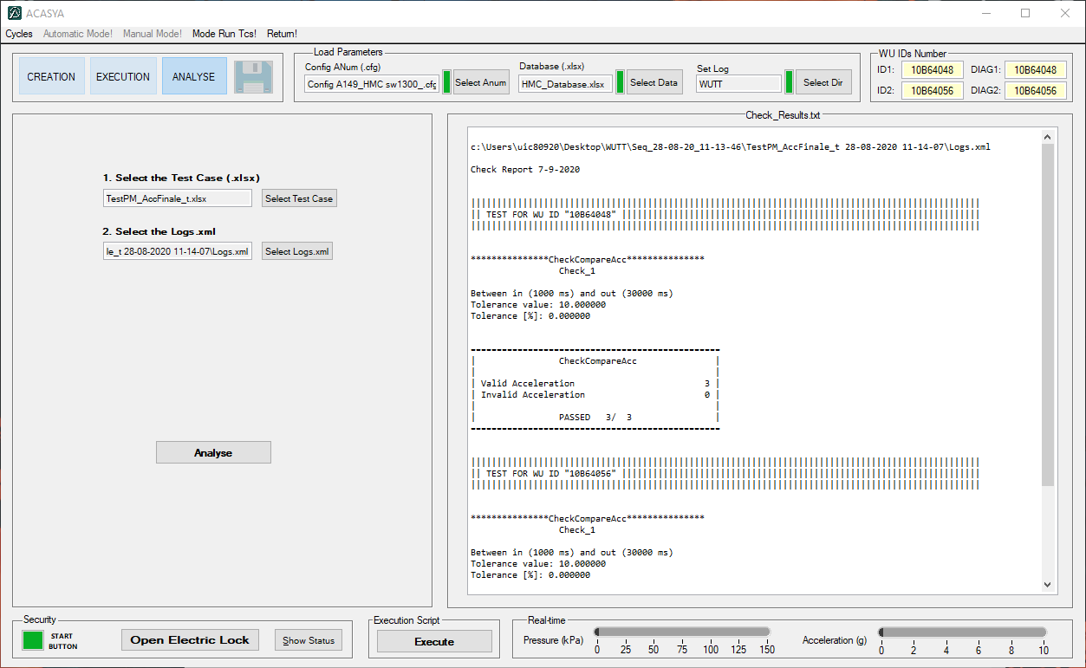

Figure 19. Analyse Results panel

Chapter 5

Security and Monitoring

# Security and monitoring

During tests, ACASYA sends pressure and acceleration commands to the LSE test bench. Some dangerous behavior for the user can occur: the pressure and acceleration values are too high, the safety doors are not closed...

To avoid any dangerous behavior, ACASYA was designed with some safety mechanisms.

## Electric Lock and Security Loop Blue button

If you want to have access to the WFCs, you need to open the Electric Locks clicking the **Open Electric Lock button**, presented below in the Figure 20:

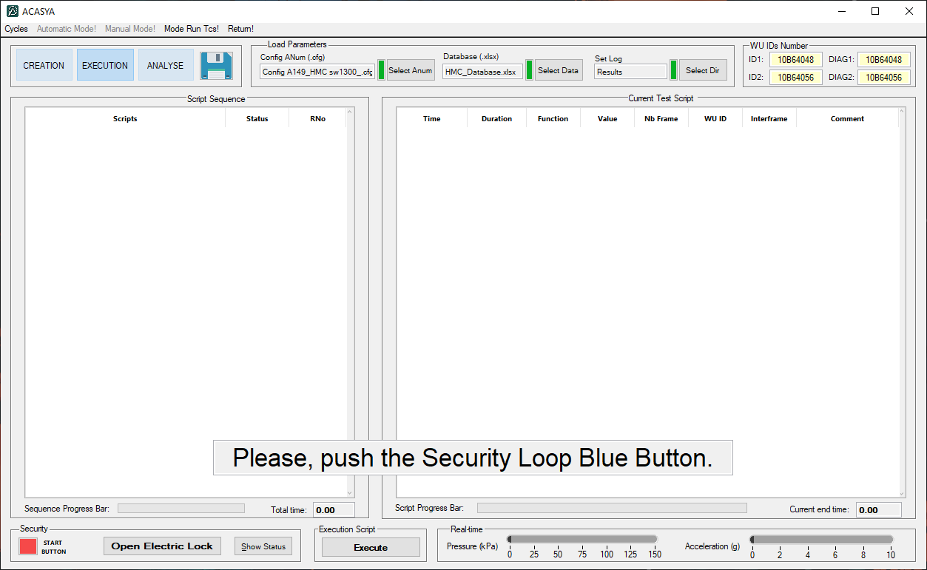

Figure 20. Electric lock and Security Loop Blue Button

Once the Electric Locks are closed, click again on the same button to validate the closing of the doors.

The message “*Please, push the Security Loop Blue Button*”, as shown above, now indicates to press the Blue button located near to the LSE test bench in order to interact with the bench safely.

## Monitoring and status panel

Figure 21. Status button position

Clicking on the **Show Status button** allows you to display the Status window, as presented in the Figure 22.

This window presented in the Figure 22. Status window shows the status of some elements of the bench and test equipment.

This monitoring window allows you to check the status of doors, security hood, security loop, emergency stop, USB6008 communication, etc.

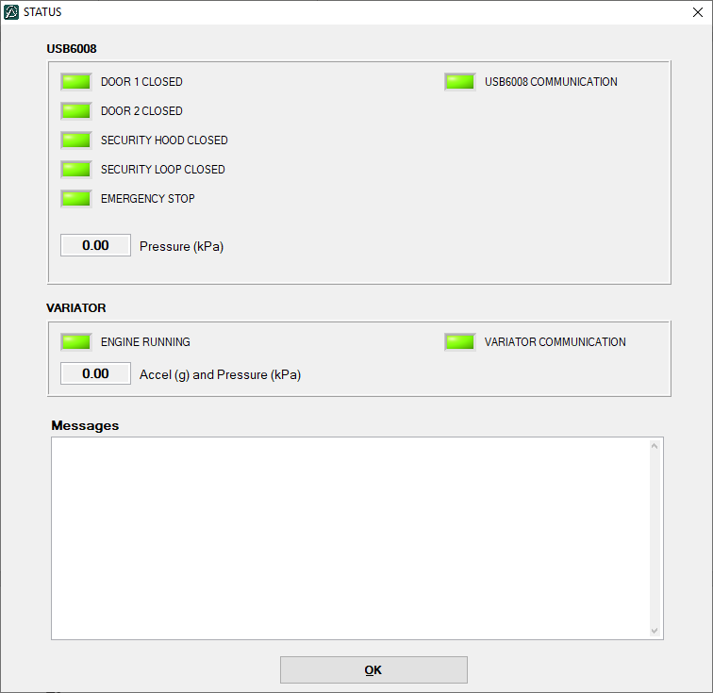

Figure 22. Status window

**APPENDIX**

# APPENDIX

## Installation files

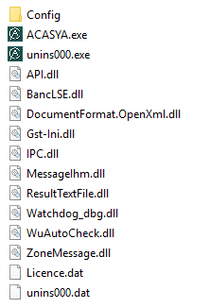

Figure 23. Installation files

## Check Results example

### PASSED example

c:\Users\uic80920\Desktop\WUTT\Seq_10-09-20_11-29-04\TestPM_AccFinale_t 10-09-2020 11-29-37\Logs.xml

Check Report 10-9-2020

|||||||||||||||||||||||||||||||||||||||||||||||||||||||||||||||||||||||||||||||

|| TEST FOR WU ID "10B64048"

|||||||||||||||||||||||||||||||||||||||||||||||||||||||||||||||||||||||||||||||

***************CheckCompareAcc***************

Check_1

Between in (1000 ms) and out (30000 ms)

Tolerance value: 10.000000

Tolerance [%]: 0.000000

================================================

| CheckCompareAcc |

| |

| Valid Acceleration 8 |

| Invalid Acceleration 0 |

| |

| PASSED 8/ 8 |

================================================

|||||||||||||||||||||||||||||||||||||||||||||||||||||||||||||||||||||||||||||||

|| TEST FOR WU ID "10B64056"

|||||||||||||||||||||||||||||||||||||||||||||||||||||||||||||||||||||||||||||||

***************CheckCompareAcc***************

Check_1

Between in (1000 ms) and out (30000 ms)

Tolerance value: 10.000000

Tolerance [%]: 0.000000

================================================

| CheckCompareAcc |

| |

| Valid Acceleration 8 |

| Invalid Acceleration 0 |

| |

| PASSED 8/ 8 |

================================================

### FAILED example

c:\Users\uic80920\Desktop\WUTT\Seq_10-09-20_11-29-04\TestPM_PressOnly2_t 10-09-2020 11-39-18\Logs.xml

Check Report 10-9-2020

|||||||||||||||||||||||||||||||||||||||||||||||||||||||||||||||||||||||||||||||

|| TEST FOR WU ID "10B64048"

|||||||||||||||||||||||||||||||||||||||||||||||||||||||||||||||||||||||||||||||

***************CheckCompareP***************

Check_1

Between in (1000 ms) and out (29000 ms)

Tolerance value: 10.000000

Tolerance [%]: 0.000000

The pressure 100.000000 is not between [101.890974,121.890974], (frames nb 14)

================================================

| CheckCompareP |

| |

| Valid Pressure 7 |

| Invalid Pressure 1 |

| |

| FAILED 1/ 8 |

================================================

|||||||||||||||||||||||||||||||||||||||||||||||||||||||||||||||||||||||||||||||

|| TEST FOR WU ID "10B64056"

|||||||||||||||||||||||||||||||||||||||||||||||||||||||||||||||||||||||||||||||

***************CheckCompareP***************

Check_1

Between in (1000 ms) and out (29000 ms)

Tolerance value: 10.000000

Tolerance [%]: 0.000000

================================================

| CheckCompareP |

| |

| Valid Pressure 4 |

| Invalid Pressure 0 |

| |

| PASSED 4/ 4 |

================================================

**ACASYA** for WFC

- User Manual -

Author: Maxime PAGES

September 2020



1. The loading order of files and folder is not important.
2. Label is not a function that will command the test bench or ANum. Labels are tags necessary to analyze the test.
3. Changing the position of the step does not affect the test execution order. Only the time indicated in the **Time** field is considered.
4. The CheckTimingFirstRF functions needs only one label (Label 1).
5. The interfaces are defined in the Database.
6. You can search for the exact value indicating a 0 value in the tolerance field.
7. The function checks if the “Field to check” linked to the Interface is an existing column in the log file.
8. Two frames belong to the same burst if their interframe timing is below the threshold time (*Interframe/Interburst Threshold* value stored in the Database).
9. The function checks if the “Field to check” linked to the Interface is an existing column in the log file.
10. Two frames do not belong to the same burst if their interframe timing is higher than the threshold time (*Interframe/Interburst Threshold* value stored in the Database).
11. The function checks if the “Field to check” linked to the Interface is an existing column in the log file.
12. The number of the first frame corresponds to the *Frame_number* field and must be equal to the *Frame_number* value stored in the Database.
13. The number of populations expected is stored in the Database (*Number of emission angles for LSE*)*.*
14. The n populations are plotted on a single area to check the orthogonality of the populations (using mod 360).
15. The function checks if the “Field to check” linked to the Interface is an existing column in the log file.
16. Two frames do not belong to the same burst if their interframe timing is higher than the threshold time (*Interframe/Interburst Threshold* value stored in the Database).
17. The function checks if the “Field to check” linked to the Interface is an existing column in the log file.
18. Two frames belong to the same burst if their interframe timing is below the threshold time (*Interframe/Interburst Threshold* value stored in the Database).
19. The function checks if the “Field to check” linked to the Interface is an existing column in the log file.
20. The pressure value captured by the sensor is stored in the *Pressure* field from the log file.
21. The reference pressure value is calculated by interpolation between two other known pressure values (from the bench) in order to guess the pressure value at the emission time of the frame.
22. The function checks if the “Field to check” linked to the Interface is an existing column in the log file.
23. The angular speed value captured by the WFC is stored in the *ASpeed* field from the log file and converted into acceleration (g) thanks to the RIM diameter given as parameter.
24. The reference pressure value is stored in the *Acceleration* field from the log file.
25. The function checks if the “Field to check” linked to the Interface is an existing column in the log file.
26. The function checks if the “Field to check” linked to the Interface is an existing column in the log file.
27. Changing the position of the step does not affect the test execution order. Only the time indicated in the **Time** field is considered.
28. The translated Test Case scripts are stored in a folder named “_ Translated scripts” inside the sequence folder.