THALES AVS Mérignac

[**www.thalesgroup.com**](http://www.thalesgroup.com)

|  |  |
| --- | --- |
| **Functional specification** | |
| **From: PANNETIER Marvyn** | **SITE, date: Bordeaux, december 2022** |
| **Ref.: V1.1** |  |
| **Information: Analog chain acquisition ASIC integration project.** | |

# Subject: Analog chain acquisition (nFCC/eFCC)

This document aims to fix the functional specification for the analog chain project. The document will evolve until a final version will be reach. The first goal is to determine which part will be change in ASIC to have an interesting project in terms of feasibility, performance, surface and cost.

Two solutions studied by THALES will be addressed in this document. The first one is a solution already approved and ready to be embedded in the eFCC project. The second is a solution still study currently, which aims to improve the current solution by adding multiplexing and other components.

# Functional diagrams



Figure 1: Solution eFCC



Figure 2: Solution with multiplexing

Figure 1&2 are the functional diagram of the two solutions mentioned earlier. Within the framework of this project, the integration will approximately the same for the both, except that the second solution will introduce a multiplexing stage to integrate in the ASIC.

At this point, the idea is to integrate at least the differential amplifier + the antialiasing filter + follower amplifier to solve impedance issues. The EMI filter could also be probably integrated as it seems not really hard to do.

Of course, here is a first iteration and the circuits, which will be integrated if it is possible, will probably change as the technology constraints become clearer with time.

# Specifications

Below is the first version of the specification, which contains the main points, underline during the first meeting about this subject.

|  |  |  |  |
| --- | --- | --- | --- |
| Parameters | Value | Units | State |
| Input signal voltage AC differential | 7.7 | VRMS |  |
| Input signal voltage DC | -10 to +10 | V |  |
| Common mode | From +/-3 up to +/-6 | V |  |
| Power supply | +/-16 | V |  |
| Accuracy (resolution) on position | 7e-4 | / |  |
| Input signal frequency | DC or 1853 to 5000 | Hz |  |
| ADC acquisition | 100 | KHz |  |
| Input impedance | 100 min (900-1000 if possible) | KΩ |  |
| Input differential capacitance | 3 | nF |  |
| Latency | 1.6 | ms |  |
| Temperature | -55 to 105 | °C |  |
| Short circuit resistance | 28 and 0 (ground) | V |  |

All these information come from the sensors specifications, which gave the input signal voltage and frequency. The others parameters like accuracy, latency…etc, are given by the specifications already fixed by THALES to respect the expectations and need of the final product.

Concerning the resolution, some detail can be helpful. The accuracy is a parameter fixed by THALES to be sure to receive the more representative signal possible. The position is measured, normalized and called X, it varies from -1 to 1 and the accuracy is fixed at ΔX = 7e-4. Depending on the sensor type, the ΔVmax accepted on the signal collected by the ADC at the end of the chain is not the same.

For a Variable differential transducer like the following:

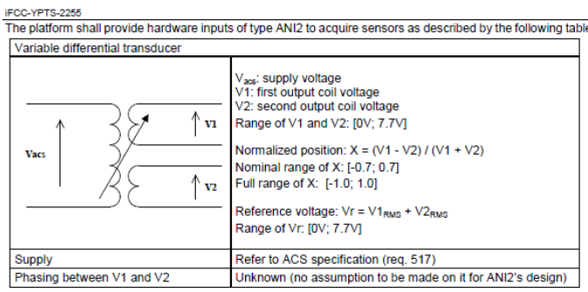

Figure 3: VDT sensor specifications

We can find the identify the case for what a perturbation on the signal will have the most influence. Below is a figure of the accepted error depending on the position of the sensor wanted by the client.



Figure 4: accepted static error depending of the position

Consequently, we can see that the point where the error have to be the lowest is at Mid-Stroke. From the figure 3 we can deduced that the position X is equal to zero for V1=V2. Now we can define the ratio adding the voltage perturbation:

$$ratio= \frac{V1+ΔV1-V2+ΔV2}{V1+ΔV1+V2+ΔV2}$$

We put ourselves at the point with less margin define above, so V1=V2 and we admit that ΔV1=ΔV2=ΔV so:

$$ratio= \frac{2ΔV}{2V1+2ΔV}$$

Now we want: $ratio<Err$ with Err = 7e-4



$\frac{2ΔV}{2V1+2ΔV}<Err$

$2ΔV*\left(1-Err\right)<2V1*Err$

$ΔV<\frac{V1*Err}{1-Err}$

$ΔVmax= \frac{V1*Err}{1-Err}$

If we take V1=5V*Rt with Rt the transformation ratio, never equal to 1 in the real life. For this file we will take Rt=0.9, so:

$ΔVmax= 3.152 mV$

VDT une seul bobine: erreur pas même calcul car pas défini de la même manière err=0.01*(1+X) au lieu de coeff*X

Def avant < a interpreter comme value – valueperturbe = error meme chose pour le premier xVDT mais value = 0 puisque placé a ce point exprès

Potar : Approximations dans les calculs et Vonc + Vc = Vc en approx

# Schematic details

The following figures are the schematic of the first solution for eFCC and allows having a first idea of what could be possibly integrated.

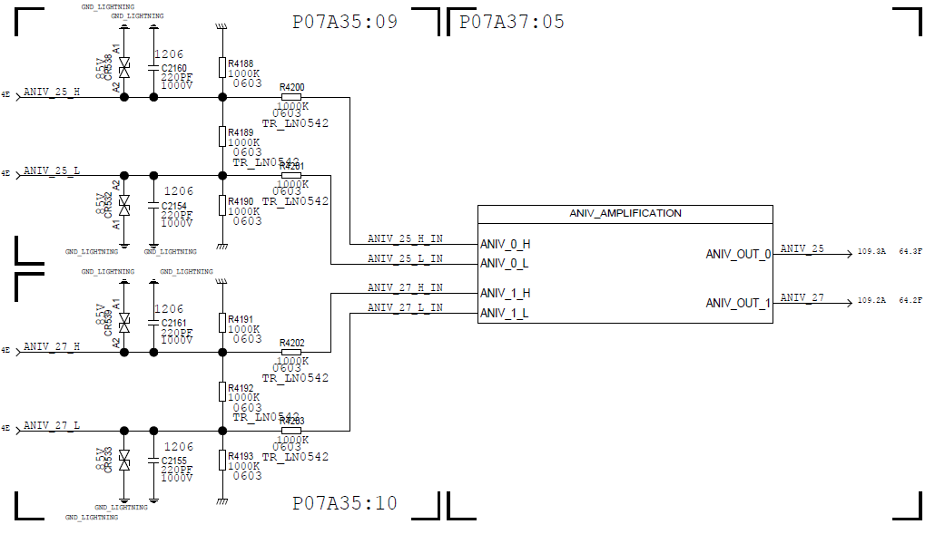

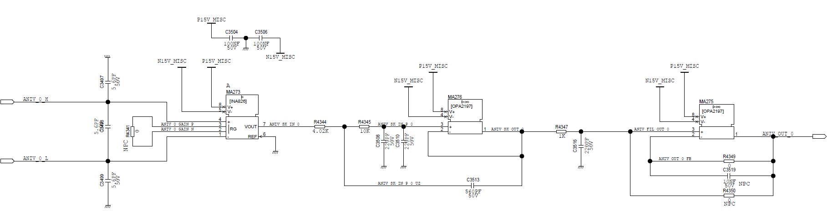

Figure 5: Schematics of the analog chain of the eFCC solution