Surface complexation of lithium and cobalt on dolomite in a sodium chloride brine: a carbonate-site model, capacity constraints, and the separation of sorption from mineralization
Marwa Elshebli¹, Javier Vilcáez¹, James Smay²
¹ Boone Pickens School of Geology, Oklahoma State University, Stillwater, OK 74078, USA ² School of Materials, Mechatronics & Manufacturing Engineering, Oklahoma State University, Tulsa, OK 74106, USA
Draft prepared from the single-ion batch data and the model workflow in the accompanying notebook (`LogK_LiCo_dolomite_carbonate_site_STEPWISE.ipynb`). All numbers in the Results were produced by that notebook; nothing is read from external files.

Abstract
Dolomite has been shown to recover Li⁺ and Co²⁺ from petroleum produced water, with Li⁺ removal governed mainly by sorption and Co²⁺ removal by coupled sorption and carbonate mineralization (Elshebli et al., 2025). Here the single-ion batch data (dolomite 60 g L⁻¹, 40 g L⁻¹ NaCl, 25 °C, six days) are interpreted with the three-site constant capacitance surface complexation model of Pokrovsky et al. (1999), in which metal cations bind the carbonate site, >CO₃H⁰ + Meᶻ⁺ ⇌ >CO₃Me⁽ᶻ⁻¹⁾⁺ + H⁺. A capacity test applied before any fitting shows that the high-recovery runs reported previously (≈70 mg L⁻¹ Co removed on 0.84 m² g⁻¹ dolomite) correspond to 1.7 to 2.4 times the crystallographic carbonate-site density and therefore cannot be adsorption, consistent with the zabuyelite and sphaerocobaltite detected by XRD. The present low-uptake data set lies inside the monolayer bound (Co 16 %, Li 72 % of carbonate sites), but the cobalt "pH 6" equilibrium point is supersaturated with sphaerocobaltite (SI = +0.93). Aqueous speciation at the measured equilibrium pH (7.05 to 8.26, not the nominal 2 and 6) shows 67 to 69 % of dissolved cobalt as free Co²⁺ and 27 % as CoCl⁺, and 90 % of lithium as free Li⁺. Neither constant proves determinable, and the two fail for different reasons, which is itself the result. For lithium the point-by-point constant is flat in pH (slope +0.02 per pH unit over five usable points spanning pH 4.3 to 8.3, internal spread 0.20), but lithium was dosed above the surface's capacity: the carbonate-site inventory can hold at most 3.2 % of the 20 mmol L⁻¹ present and the measured 2.3 % removal already fills 71 % of the surface, so the mass-action inversion is insensitive and the interval propagated from ±3 % analytical precision runs from −5.9 to +0.8. No central value is reported for lithium. Cobalt sits comfortably inside the monolayer bound (removal is 16 % of its site ceiling of 46.7 %), but its two usable points are both pre-equilibrium (day 2 and day 4 of the pH 6 batch); every day-6 point is excluded, one for sphaerocobaltite supersaturation (SI = +0.93) and three for being within analytical noise. Because uptake is still rising at the last sampling and log K increases monotonically with coverage, the measured coverage bounds the equilibrium coverage from below and the constant is therefore reported as a bound, log K(>CO₃Co⁺) ≥ −2.20, rather than as a central value; the ±1.16 is the random component from analytical precision alone and carries no information about the systematic offset from incomplete reaction. The two usable points span only 0.08 pH units, too narrow for the flat-line diagnostic. The constant taken from the aqueous–surface analogy of Van Cappellen et al. (1993) and Pokrovsky and Schott (2002), log K(>CO₃Co⁺) = −0.79, over-predicts the observed cobalt uptake by a factor of 3.5 to 7.4, so precipitation is not required to explain the removal measured in this low-uptake data set; the sorption prediction itself is too high. Ca/Mg competition and precipitation are both ruled out as causes by the data, leaving the borrowed constant, a reactive area of 13 to 29 % of BET (a three- to eight-fold reduction, against the 1.4-fold reduction Belova et al. explored), or incomplete equilibration. The time trend discriminates among these: the predicted sorption is flat to 11 % of its mean across the six days while the measured removal grows 2.3-fold, so the ratio closes monotonically from 7.4 to 3.5. A wrong constant, a reduced reactive area and sodium competition are all time-invariant scalings and would hold the ratio flat; a closing ratio is the signature of a system still approaching equilibrium. This does not exclude the other three, it only shows that none of them can be the whole explanation: any of them could still contribute a constant factor beneath the kinetics, and at 0.684 M sodium competition is the most likely to be doing so. The time axis is confounded with pH, which rises from 7.40 to 8.09 over the same interval, but the model closes that: its prediction is computed at each point's own measured pH assuming equilibrium, so the prediction is the pH effect with time removed, and it rises only 10 % against the 135 % rise measured. pH therefore accounts for at most 8 % of the observed increase. Crude extrapolation places the meeting point at two to three weeks, so the six-day experiment may simply have stopped too early. Incomplete equilibration in this sense covers two mechanisms that the time trend cannot separate, a slow approach to sorption equilibrium and recrystallization incorporating the cobalt into new lattice, and the extended run is designed to distinguish them (§3.5). Because the analogy value of −0.79 lies above the lower bound, it is not excluded by these data, and a single month-long batch held at fixed pH would settle whether the gap closes; the pH must be held near 7.18 rather than at the drifted value of 8.09, because at 8.09 the run sits above sphaerocobaltite saturation throughout and a closing ratio could equally mean precipitation, and alkalinity must be measured at each sampling because continued dolomite dissolution raises the saturation index in a way a fixed-pCO₂ calculation cannot see. Sorption cannot account for more than 41 % of the cobalt removed in the best previously reported run even if every carbonate site were occupied, which quantifies the coupled sorption–mineralization mechanism proposed earlier. The experimental design required for a genuinely transferable constant is specified.
Keywords: dolomite; surface complexation; constant capacitance model; lithium; cobalt; produced water; sphaerocobaltite; zabuyelite

1. Introduction
Lithium and cobalt are strategic metals whose recovery from saline produced water using low-cost carbonate minerals has attracted interest (Elshebli et al., 2025). Interpreting such uptake quantitatively requires a surface complexation model (SCM) that accounts for aqueous speciation, competition for surface sites, and the electrostatics of the mineral–water interface (Dzombak & Morel, 1990; Stumm & Morgan, 1996). For carbonate minerals the appropriate framework is the hydration-site model developed for calcite by Van Cappellen et al. (1993) and extended to magnesite and dolomite by Pokrovsky et al. (1999a, 1999b), in which three primary surface groups, >CO₃H⁰, >CaOH⁰ and >MgOH⁰, undergo protonation, deprotonation and complexation with the lattice ions and dissolved carbonate. In this model metal cations adsorb by forming >CO₃Me complexes on the deprotonated carbonate site, whereas anions and ligands bind the metal hydroxyl sites (Pokrovsky et al., 1999a). Belova et al. (2014) applied the same approach to nickel adsorption on calcite and chalk, determining the >CO₃Ni⁺ constant with FITEQL (Herbelin & Westall, 1999) and demonstrating the importance of preventing surface precipitation during the experiment.
An intrinsic stability constant describes a monolayer reaction at an interface. Where a large share of the metal has left solution as a discrete carbonate phase, a constant fitted to that removal is not an interfacial property but a lumped parameter that absorbs the solubility product, the carbonate supply from dolomite dissolution and the nucleation behaviour of the precipitate. The earlier study established that cobalt removal by dolomite is coupled sorption and mineralization and left the quantitative split as an open question (Elshebli et al., 2025). The purpose of this work is therefore twofold: to specify the carbonate-site SCM for lithium and cobalt on dolomite in brine, with every reaction, equation and parameter stated and sourced, and to determine what the existing data can and cannot constrain, using a capacity test and a saturation test before any fitting, and using the model in prediction mode to quantify the sorption–mineralization split.

2. Materials and methods

2.1 Dolomite and batch experiments
Dolomite from the Arbuckle Group (98 % dolomite by XRD) was ground and sieved; the single-ion batches used 6 g of dolomite per 100 mL of solution (60 g L⁻¹) in 40 g L⁻¹ NaCl at 25 °C, shaken at 150 rpm, with a nominal initial pH of 2 or 6 (Elshebli et al., 2025). Lithium (138.4 mg L⁻¹ from LiCl) or cobalt (80.5 mg L⁻¹ from CoCl₂·6H₂O) was added as the only trace metal. Aliquots were taken at 2, 4 and 6 days and analysed by ICP-OES for Li, Co, Ca and Mg; pH was recorded at each sampling. The specific surface area of the powder used here is 0.76 m² g⁻¹ (mean particle diameter 2.8 µm, density 2850 kg m⁻³), giving a surface concentration
S = 60 g L⁻¹ × 0.76 m² g⁻¹ = 45.6 m² L⁻¹. (1)
The value of 0.046 to 0.049 m² L⁻¹ quoted in the methods of Elshebli et al. (2025) is inconsistent with 0.84 m² g⁻¹ × 60 g L⁻¹ ≈ 50 m² L⁻¹ by a factor of 10³ and is most likely m² mL⁻¹; every surface normalization in an SCM divides by this quantity, so the corrected value is used throughout.

2.2 Experimental data
Table 1 gives the embedded data set. The measured pH at day 6 (7.05 to 8.26) differs from the nominal initial pH because dolomite dissolution buffers the suspension; the measured value is the one that enters the model.
Table 1. Single-ion batch data (dolomite 60 g L⁻¹, 40 g L⁻¹ NaCl, 25 °C).
Metal | Batch | Day | Ca (mg L⁻¹) | Mg (mg L⁻¹) | Metal (mg L⁻¹) | pH (measured) | Removal (%)
Co | pH 6 | 0 | 0.10 | 0.10 | 80.513 | 6.32 | 0
Co | pH 6 | 2 | 0.10 | 0.10 | 77.905 | 7.40 | 3.24
Co | pH 6 | 4 | 0.10 | 8.14 | 76.411 | 7.48 | 5.09
Co | pH 6 | 6 | 0.13 | 12.94 | 74.393 | 8.09 | 7.60
Co | pH 2 | 0 | 0.10 | 0.10 | 80.513 | 2.35 | 0
Co | pH 2 | 2 | 57.48 | 17.46 | 79.661 | 4.12 | 1.06
Co | pH 2 | 4 | 24.18 | 45.59 | 79.795 | 5.66 | 0.89
Co | pH 2 | 6 | 21.66 | 51.38 | 80.398 | 7.11 | 0.14
Li | pH 6 | 0 | 0.66 | 0.10 | 138.430 | 6.42 | 0
Li | pH 6 | 2 | 37.63 | 0.10 | 134.657 | 7.65 | 2.73
Li | pH 6 | 4 | 54.82 | 0.10 | 136.722 | 7.92 | 1.23
Li | pH 6 | 6 | 49.89 | 0.87 | 135.262 | 8.26 | 2.29
Li | pH 2 | 0 | 0.66 | 0.10 | 138.430 | 2.25 | 0
Li | pH 2 | 2 | 39.19 | 0.10 | 136.263 | 4.26 | 1.57
Li | pH 2 | 4 | 79.45 | 21.32 | 135.956 | 5.73 | 1.79
Li | pH 2 | 6 | 87.74 | 20.55 | 135.592 | 7.05 | 2.05

2.3 Aqueous speciation
Free-ion activities were computed at each data point from the measured pH, the measured total Ca and Mg, the NaCl medium and the measured total metal, at fixed atmospheric pCO₂ = 10⁻³·⁵ atm (open system, as in Pokrovsky et al., 1999a). Activity coefficients follow the Davies equation (Davies, 1962), valid to I ≈ 0.7 M,
log γᵢ = −A zᵢ² [ √I / (1 + √I) − 0.3 I ], A = 0.509 at 25 °C. (2)
The carbonate system is fixed by pH and pCO₂:
CO₂(g) ⇌ CO₂(aq), log K_H = −1.469; CO₂(aq) + H₂O ⇌ HCO₃⁻ + H⁺, log K = −6.345; CO₃²⁻ + H⁺ ⇌ HCO₃⁻, log K = 10.329 (3)
(Wolery, 1992). Aqueous complexes were written as formation reactions from the free ions with the constants in Table 2 (Smith & Martell, 2004; Wolery, 1992). For each cation X with analytical total T_X the mass balance
T_X = [X] + Σᵢ [Xᵢ-complex] (4)
was solved by fixed-point iteration together with the chloride balance and the ionic strength. Saturation indices were computed as SI = log(IAP/K_sp) with log K_sp = −17.09 for ordered dolomite (Parkhurst & Appelo, 2013), −9.98 for sphaerocobaltite CoCO₃ (Smith & Martell, 2004) and ≈ −2.5 for zabuyelite Li₂CO₃. The solid is dolomite, so calcite is not a starting phase of this system and is excluded from the reported tables and figures. Whether it could form is a separate question, since incongruent dolomite dissolution releases both calcium and carbonate, so the index was computed (log K_sp = −8.48; Plummer & Busenberg, 1982) and is reported in §3.2 rather than assumed away.
Table 2. Aqueous complexation reactions (formation from free ions, 25 °C, I = 0).
Reaction | log β | Reaction | log β
Ca²⁺ + Cl⁻ ⇌ CaCl⁺ | −0.70 | Co²⁺ + Cl⁻ ⇌ CoCl⁺ | 0.30
Ca²⁺ + CO₃²⁻ ⇌ CaCO₃⁰ | 3.22 | Co²⁺ + 2Cl⁻ ⇌ CoCl₂⁰ | −0.20
Ca²⁺ + H⁺ + CO₃²⁻ ⇌ CaHCO₃⁺ | 11.43 | Co²⁺ + CO₃²⁻ ⇌ CoCO₃⁰ | 4.23
Ca²⁺ + H₂O ⇌ CaOH⁺ + H⁺ | −12.70 | Co²⁺ + H⁺ + CO₃²⁻ ⇌ CoHCO₃⁺ | 12.20
Mg²⁺ + Cl⁻ ⇌ MgCl⁺ | −0.14 | Co²⁺ + H₂O ⇌ CoOH⁺ + H⁺ | −9.65
Mg²⁺ + CO₃²⁻ ⇌ MgCO₃⁰ | 2.98 | Co²⁺ + 2H₂O ⇌ Co(OH)₂⁰ + 2H⁺ | −18.80
Mg²⁺ + H⁺ + CO₃²⁻ ⇌ MgHCO₃⁺ | 11.40 | Li⁺ + Cl⁻ ⇌ LiCl⁰ | −0.50
Mg²⁺ + H₂O ⇌ MgOH⁺ + H⁺ | −11.79 | Li⁺ + H₂O ⇌ LiOH⁰ + H⁺ | −13.64
Na⁺ + Cl⁻ ⇌ NaCl⁰ | −0.78 | Li⁺ + CO₃²⁻ ⇌ LiCO₃⁻ | 0.90
Na⁺ + CO₃²⁻ ⇌ NaCO₃⁻ | 1.27
Na⁺ + H⁺ + CO₃²⁻ ⇌ NaHCO₃⁰ | 10.48
Na⁺ + H₂O ⇌ NaOH⁰ + H⁺ | −14.18

2.4 Surface complexation model
The dolomite surface is described by three primary hydration sites in the ratio 1 : 1 : 2, with site densities of 7 µmol m⁻² for >CaOH⁰, 7 µmol m⁻² for >MgOH⁰ and 14 µmol m⁻² for >CO₃H⁰ (Pokrovsky et al., 1999a). The total carbonate-site concentration in suspension is
S_T = 14 × 10⁻⁶ mol m⁻² × 45.6 m² L⁻¹ = 6.38 × 10⁻⁴ mol L⁻¹. (5)
The surface reactions and their intrinsic constants (Table 3) are those of Pokrovsky et al. (1999a, Table 3). Following the analogy between surface and solution complexation (Schindler & Stumm, 1987; Van Cappellen et al., 1993), metal cations bind the deprotonated carbonate site,
>CO₃H⁰ + Li⁺ ⇌ >CO₃Li⁰ + H⁺, K_Li (ΔZ = 0) (6a) >CO₃H⁰ + Co²⁺ ⇌ >CO₃Co⁺ + H⁺, K_Co (ΔZ = +1) (6b)
These are the two unknowns. Lithium forms a neutral surface species and therefore carries no Boltzmann term; cobalt forms a +1 species and does.
Table 3. Surface reactions and intrinsic constants (25 °C, I = 0) used as fixed parameters, transcribed from Table 3 of Pokrovsky et al. (1999a). Only the two dolomite columns are used; the calcite and magnesite columns are reproduced solely as a transcription record, since the dolomite values were read from the same table.
Reaction | Calcite | Magnesite | Dolomite, Ca site | Dolomite, Mg site
>CO₃H⁰ ⇌ >CO₃⁻ + H⁺ | −5.1 | −4.65 ± 0.15 | −4.8 ± 0.2 | −4.8 ± 0.2
>CO₃H⁰ + Me²⁺ ⇌ >CO₃Me⁺ + H⁺ | −1.7 | −2.2 ± 0.15 | −1.8 ± 0.2 | −2.0 ± 0.2
>MeOH⁰ ⇌ >MeO⁻ + H⁺ | −12 | −12 ± 1 | −12 ± 2 | −12 ± 2
>MeOH⁰ + H⁺ ⇌ >MeOH₂⁺ | 11.5 | 10.6 ± 0.15 | 11.5 ± 0.2 | 10.6 ± 0.2
>MeOH⁰ + CO₃²⁻ + 2H⁺ ⇌ >MeHCO₃⁰ + H₂O | −3.5 | −2.4 ± 0.5 | −4.0 ± 0.5 | −3.5 ± 0.5
>MeOH⁰ + CO₃²⁻ + H⁺ ⇌ >MeCO₃⁻ + H₂O | 17.1 | 14.4 ± 0.15 | 16.6 ± 0.2 | 15.4 ± 0.2
Site densities, Ca : Mg : CO₃ |  |  | 7 : 7 : 14 µmol m⁻² (assumed 1 : 1 : 2, "eight sites per nm²", §3.3)
Capacitance C = √I / α, α = 0.004 |  |  | 207 F m⁻² at I = 0.684 M (Pokrovsky et al., 1999a, §3.3)

The apparent and intrinsic constants are related through the Boltzmann factor (Pokrovsky et al., 1999a, Eq. 2; Gustafsson, 2014, Eq. 4.4),
K_int = K_app · exp(ΔZ F ψ₀ / RT), (7)
where ΔZ is the change in surface charge in the reaction, ψ₀ the surface potential, F the Faraday constant, R the gas constant and T the temperature. In concentration form a surface species of charge z carries the factor exp(−z F ψ₀/RT); for example
[>CO₃Ca⁺] = K_Ca [>CO₃H⁰] {Ca²⁺}/{H⁺} · exp(−F ψ₀/RT). (8)
The carbonate-site mass balance,
S_T = [>CO₃H⁰] + [>CO₃⁻] + [>CO₃Ca⁺] + [>CO₃Mg⁺] + [>CO₃Li⁰] + [>CO₃Co⁺], (9)
collapses to one equation in [>CO₃H⁰] because every other term is proportional to it. Calcium and magnesium are treated as competitors whose concentrations follow the measured solution chemistry at each point. The two metal hydroxyl sites are solved likewise because they carry surface charge. The net surface charge is computed from the charged surface species only (Charlet et al., 1990; Turner & Fein, 2006, Eq. 2.2.3),
σ = (F / S) Σᵢ zᵢ [iₛᵤᵣf] = (F/S) { [>CaOH₂⁺] + [>MgOH₂⁺] + [>CO₃Ca⁺] + [>CO₃Mg⁺] + [>CO₃Co⁺] − [>CO₃⁻] − [>CaO⁻] − [>MgO⁻] − [>CaCO₃⁻] − [>MgCO₃⁻] }, (10)
and related to the potential by the constant capacitance model (Pokrovsky et al., 1999a, Eqs. 3–4; Gustafsson, 2014, Eq. 4.11),
ψ₀ = σ / C, C = √I / α. (11)
Equations 9 to 11 are implicit and were solved by iteration on ψ₀ until it changed by less than 0.1 mV. A non-electrostatic model (ψ₀ = 0) was run in parallel. Note that Eq. 10 never contains dissolved Ca²⁺ or Mg²⁺: the mass-balance surface charge of Charlet et al. (1990) applied to a dissolving mineral carries the dissolution flux and, in the present titration data, reaches 1.7 mmol m⁻², sixty times the site density, so it cannot be used as a surface charge.

2.5 Surface coverage and its uncertainty
The measured coverage at each point is
Γ = (C₀ − C_eq) V / (m · SSA) (mol m⁻²), (12)
with V = 0.1 L, m = 6 g and SSA = 0.76 m² g⁻¹. Taking the ICP-OES precision as ±3 % on both C₀ and C_eq, the uncertainty of the difference is σ_Γ = √[(0.03 C₀)² + (0.03 C_eq)²] V/(m·SSA), which is large relative to Γ when removal is small; such points were down-weighted, not discarded. The same σ_Γ was propagated through the inversion of Eq. 13 by recomputing log K at Γ ± σ_Γ, which gives an asymmetric interval on each point-by-point constant. No solid-free blanks were available, so wall losses could not be subtracted.

2.6 Capacity and saturation criteria
Two tests precede any fitting. The capacity test compares Γ with the crystallographic site density: Γ/N_s > 1 is not reachable by adsorption. The saturation test requires SI < 0 for the metal carbonate at the point being fitted (Belova et al., 2014). Points were then graded on precision. Because Γ is the difference of two concentrations each measured to ±3 %, its relative error σ_Γ/Γ is the quantity that decides whether a point carries information about the constant. Two bars are used and both are stated: a point is fit-grade if σ_Γ/Γ < 30 %, meaning uptake is at least about three times the uncertainty in measuring it, and indicative if σ_Γ/Γ < 200 %; beyond that it is excluded. No point in this data set is fit-grade. Across the twelve sampled points the relative error runs from 54 % to 2968 % with a median of 220 %; the smallest is cobalt, pH 6 batch, day 6, and the two points that enter the cobalt arithmetic carry 129 % and 81 %. Every exclusion and every downgrade is listed with its reason.

2.7 Parameter estimation
Two procedures were used. Point by point, with Γ known, Eq. 6 is solved algebraically at each datum,
K_Co = ( [>CO₃Co⁺] {H⁺} ) / ( [>CO₃H⁰] {Co²⁺} ) · exp(F ψ₀ / RT), (13)
with [>CO₃Co⁺] = Γ·S and [>CO₃H⁰] from Eq. 9, giving one constant per point without an optimizer. Globally, the forward model predicts Γ for a trial log K and the weighted sum of squares over degrees of freedom,
WSOS/DF = Σᵢ [ (Γ_pred,ᵢ − Γ_meas,ᵢ) / σ_Γ,ᵢ ]² / (N − p), (14)
was minimized over all usable sampling days, not only day 6, so that the fit has degrees of freedom (Westall, 1982; Herbelin & Westall, 1999), as in the FITEQL treatment of Belova et al. (2014) with a dummy adsorbed component. The reported uncertainty is the largest of the least-squares standard error, the standard deviation of the usable point-by-point values, and the mean propagated half-width. The diagnostic of Step 6 is the plot of point-by-point log K against pH and against Γ: a constant independent of both is a transferable constant, drift with pH signals a wrong surface species or a missing coulombic term, and drift with loading signals surface precipitation.

2.8 Prediction mode and the mechanism split
For cobalt the constant was taken from the linear free-energy analogy between surface and aqueous carbonate complexes (Van Cappellen et al., 1993; Pokrovsky & Schott, 2002),
log K(>CO₃Co⁺) ≈ log K(>CO₃Ca⁺) + [log β(CoCO₃⁰) − log β(CaCO₃⁰)] = −1.8 + (4.23 − 3.22) = −0.79, (15)
and the model was run forward with all constants fixed to predict the sorbable cobalt at each time point. The difference between measured removal and predicted sorption, read together with SI(CoCO₃), is the mineralized fraction. Lithium, whose removal the earlier study attributed to sorption, was treated as the single adjustable parameter.

2.9 Verification of the speciation
The Davies equation is generally quoted as reliable to about 0.5 M and the brine is at 0.65 M. Two checks were made. First, the free-ion activities at one point (cobalt, pH 6 batch, day 6) were recomputed with the extended Debye–Hückel (B-dot) form used by EQ3/6 (Wolery, 1992); the two models differ by a factor of 0.80 in the free Co²⁺ activity, i.e. 0.10 log units in any constant, which is the floor on the accuracy of the result at this ionic strength whichever code computes it. Second, and more directly, the same three equilibrium points were solved independently by PHREEQC version 3 (Parkhurst & Appelo, 2013) through its Python bindings. Cobalt and lithium are absent from the shipped databases, so the formation constants used here were supplied to PHREEQC explicitly, and so were those for the calcium, magnesium and sodium complexes, since `phreeqc.dat` carries its own values for those and the calcium and magnesium activities feed the site balance directly. The thermodynamic data are therefore identical across every species that matters here, and the comparison isolates what remains: PHREEQC brings the WATEQ extended Debye–Hückel form with ion-size parameters rather than Davies, together with its own tableau and Newton solver. Every quantity the constants are computed from agrees to within the activity-model floor established above: 0.06 log units in the free-metal activity, 0.01 in the carbonate activity, 0.07 in the free calcium activity, 0.00 in the free magnesium activity and 0.07 in the saturation index of sphaerocobaltite. Two differences remain and are expected. Reported ionic strengths differ by 0.038 because PHREEQC works in molality on a kilogram-of-water basis and because the two activity models leave different fractions of the sodium chloride associated at this concentration. Free-ion fractions differ by up to nine percentage points because the WATEQ form distributes the same total metal differently between the free ion and its chloride pairs; the fraction is a reporting quantity, while the constants are inverted from the activity, and the activities agree. The equivalent Visual MINTEQ input is also printed for anyone repeating the check in that program (Gustafsson, 2014).
All calculations were performed in Python 3 (NumPy, SciPy, pandas, Matplotlib); the notebook reproduces every table and figure.

3. Results

3.1 Capacity test
Table 4. Surface coverage relative to the carbonate-site density.
Case | Removed (mg L⁻¹) | Area (m² L⁻¹) | Γ (µmol m⁻²) | Γ / 14 µmol m⁻² | Γ / 8.22 µmol m⁻²
This data, Co, pH 6 batch, day 6 | 6.12 | 45.6 | 2.28 | 0.16 | 0.28
This data, Li, pH 6 batch, day 6 | 3.17 | 45.6 | 10.0 | 0.72 | 1.22
Elshebli et al. (2025), Co, fine dolomite, pH 6, 25 °C | ≈70 | 50.4 | 23.6 | 1.68 | 2.87
Elshebli et al. (2025), Li, fine dolomite, 8.5 % of 138 mg L⁻¹ | 11.8 | 50.4 | 33.6 | 2.40 | 4.09

The high-recovery runs of the earlier study exceed the dolomite carbonate-site density by a factor of 1.7 to 2.4 even if every site were occupied by the metal alone. They therefore cannot be adsorption, in agreement with the 8 % zabuyelite and 4 % sphaerocobaltite found by XRD. The present low-uptake data set lies within the bound for cobalt (16 %) and at the margin for lithium (72 %).

3.2 Aqueous speciation and saturation
At the measured equilibrium pH, 67 to 69 % of dissolved cobalt is free Co²⁺, 27 % is CoCl⁺ and 3 % CoCl₂⁰; carbonate and hydroxide complexes are below 1.5 %. Lithium is 90 % free Li⁺ and 10 % LiCl⁰. Ionic strength is 0.65 to 0.66 M. The saturation index of sphaerocobaltite in the cobalt pH 6 batch rises from −0.42 (day 2) to −0.27 (day 4) to +0.93 at day 6; the pH 2 batch stays undersaturated (−6.96 to −0.98). Dolomite remains undersaturated at all points (SI ≤ −1.6) and Li₂CO₃ is far undersaturated (SI ≤ −6.4).
Calcite deserves a separate statement, because the solid used here is dolomite and calcite is therefore not a starting phase, but incongruent dissolution releases both calcium and carbonate and the index does not behave uniformly across the batches. Every cobalt point is undersaturated by 2.7 log units or more (−8.29 to −2.74), so calcite plays no part in the cobalt result and the bound of §3.4 is untouched by it. The lithium pH 6 batch is different: the index climbs −1.42, −0.71, −0.08 over days 2, 4 and 6, reaching saturation rather than moving away from it, and −0.08 lies inside the 0.10 log unit activity-model floor established in §2.9, so the model cannot resolve whether calcite is saturated at that point. Secondary calcite therefore cannot be excluded for that batch on this evidence. It would consume calcium rather than lithium, so it neither creates nor destroys lithium uptake, and the lithium constant is undetermined here for independent reasons; but it is the plausible solubility ceiling that the anomalous calcium of that batch (49.9 mg L⁻¹ against 0.87 mg L⁻¹ magnesium, §3.6) was approaching, and XRD on the recovered solid would settle it. Calcite is otherwise excluded from the reported tables and figures.

3.3 Coverage and site occupancy
Cobalt coverage at day 6 is 2.28 µmol m⁻² in the pH 6 batch (relative error 54 %) and 0.04 µmol m⁻² in the pH 2 batch (relative error > 1000 %, i.e. within noise). Lithium coverage is 9 to 10 µmol m⁻² in both batches (relative error ≈ 200 % at ±3 % ICP precision). Lithium is present at 20 mmol L⁻¹ and the carbonate-site inventory is 0.64 mmol L⁻¹, so the surface can hold at most 3.2 % of the lithium whatever the constant; the measured removal of 2.3 % is 71 % of that ceiling, and the site balance is close to saturation (free >CO₃H⁰ at 0.007 % of sites). At the equilibrium points the carbonate site is dominated by >CO₃⁻ (74 to 77 % in the cobalt batches, 21 to 25 % in the lithium batches), with >CO₃Ca⁺ at 0.1 to 8.7 %, >CO₃Mg⁺ at 0.1 to 18 %, and the metal complex at 16 % (Co, pH 6) and 64 to 72 % (Li). The surface potential is −0.1 to +8 mV and the Boltzmann factor 0.73 to 1.0.

3.4 Stability constants
Table 5. Point-by-point log K on the carbonate site (constant capacitance model). The interval is the constant recomputed at Γ ∓ σ_Γ. Points failing the capacity, saturation or noise criteria are marked and excluded from the fit.
Metal | Batch | Day | pH | Γ (µmol m⁻²) | rel. error (%) | SI(MeCO₃) | log K (CCM) | interval | log K (NEM) | used | reason for exclusion
Co | pH 6 | 2 | 7.40 | 0.97 | 129 | −0.41 | −2.35 | −5.41 to −1.91 | −2.37 | yes
Co | pH 6 | 4 | 7.48 | 1.53 | 81 | −0.27 | −2.07 | −2.87 to −1.73 | −2.13 | yes
Co | pH 6 | 6 | 8.09 | 2.28 | 54 | +0.93 | −1.89 | −2.30 to −1.63 | −1.89 | no | SI(CoCO₃) > 0
Co | pH 2 | 2 | 4.12 | 0.32 | 399 | −6.96 | −1.99 | −5.00 to −1.24 | −2.10 | no | within noise
Co | pH 2 | 4 | 5.66 | 0.27 | 474 | −3.88 | −2.67 | −5.68 to −1.85 | −2.76 | no | within noise
Co | pH 2 | 6 | 7.11 | 0.04 | 2970 | −0.98 | −3.51 | −6.51 to −1.96 | −3.59 | no | within noise
Li | pH 6 | 2 | 7.65 | 11.90 | 154 | −7.62 | −1.99 | −5.86 to +0.25 | −2.05 | yes
Li | pH 6 | 4 | 7.92 | 5.40 | 342 | −7.06 | −2.95 | −6.17 to +0.26 | −2.97 | no | within noise
Li | pH 6 | 6 | 8.26 | 10.00 | 183 | −6.40 | −2.38 | −5.93 to +0.23 | −2.38 | yes
Li | pH 2 | 2 | 4.26 | 6.85 | 269 | −14.40 | −2.24 | −5.53 to +0.78 | −2.26 | yes
Li | pH 2 | 4 | 5.73 | 7.82 | 235 | −11.50 | −2.52 | −5.88 to +0.38 | −2.55 | yes
Li | pH 2 | 6 | 7.05 | 8.97 | 205 | −8.82 | −2.39 | −5.84 to +0.36 | −2.41 | yes

Table 6. Reported constants (25 °C, I = 0.68 M NaCl), fitted on the usable points of Table 5. A central value is quoted only where the uncertainty is below 1.5 log units, a factor of about 30 either way; above that the interval is reported instead, because a central value carrying a wider interval than that is quoted without it. The threshold is a judgment call and is stated rather than left implicit. Cobalt is reported as a one-sided bound for the reason given in §3.4, so the ±1.16, a factor of 15 either way, is the random component only.
Reaction | n | Electrostatic (CCM) | Non-electrostatic | Internal spread | Propagated interval (±3 % ICP) | Basis
>CO₃H⁰ + Li⁺ ⇌ >CO₃Li⁰ + H⁺ | 5 | not determined (fit returns −2.33) | (−2.35) | 0.20 | −5.9 to +0.8 | site-limited: surface 71 % full, inversion insensitive; no central value reported
>CO₃H⁰ + Co²⁺ ⇌ >CO₃Co⁺ + H⁺ | 0 fit-grade (2 indicative) | not determined (fit returns −2.20) | (−2.24) | 0.20 | −5.4 to −1.7 | no point clears σ_Γ/Γ < 30 %; best is 54 %. Both indicative points are also pre-equilibrium, a second and independent limitation
>CO₃H⁰ + Co²⁺ ⇌ >CO₃Co⁺ + H⁺ (analogy) | – | −0.79 | −0.79 | – | – | predicted from Eq. 15

The lithium point-by-point values are flat in pH, with a slope of +0.02 per pH unit over the five usable points, which span pH 4.26 to 8.26; the electrostatic and non-electrostatic values agree to 0.04 log units, as expected at C = 207 F m⁻². That consistency is not accuracy. Because the surface is near saturation with lithium the inversion of Eq. 13 is insensitive, and propagating the ±3 % analytical error gives an interval from −5.9 to +0.8, nearly seven orders of magnitude, so no central value is reported. At ±1 % analytical precision the propagated half-width would fall to about 1.7 log units, but the site limitation remains; an isotherm at lower lithium concentration is what would constrain the constant.
Cobalt has no fit-grade point. Its best point, pH 6 day 6, carries a relative coverage error of 54 %, and that point is independently excluded for sphaerocobaltite supersaturation; the two points that enter the arithmetic, day 2 and day 4 of the pH 6 batch, carry 129 % and 81 %. log K(>CO₃Co⁺) is therefore not determined by these data. The weighted fit over the two indicative points returns −2.20 (CCM) and −2.24 (NEM) with a propagated interval of −5.4 to −1.7, and that number is reported here so the pattern can be read, not as a measurement. Two further limitations act on top of the precision one and are independent of it. Both indicative points are pre-equilibrium: removal is still rising at the last sampling (Figure 1), and log K increases monotonically with coverage, as scaling the day-4 uptake from 0.5 to 3 times confirms (log K −2.43, −2.23, −2.07, −1.84, −1.65, −1.34), so even with adequate precision the value would be a lower bound rather than a central one. And the three pH 2 points sit at 0.7 % removal, below the threshold at which the inversion becomes biased as well as imprecise: a Monte Carlo recovery test on synthetic data generated from a known constant returns +0.55 log units of bias at that uptake, because Γ is then dominated by noise that cannot go negative and the recovered constant is pushed upward (§3.7).
Because the constant is not determined, the analogy value of −0.79 is not excluded by these data; it lies inside the propagated interval of −5.4 to −1.7 and above the indicative value, which is consistent with the time-trend result of §3.5 that the system is still approaching equilibrium. Nothing in this data set can distinguish −0.79 from −2.2, and the extended run of §3.5 is what would.
The flat-line diagnostic cannot be applied to cobalt at all: the two usable points lie at pH 7.40 and 7.48, and a slope over a baseline of 0.08 pH units carries no information.
Two conventions in Table 6 follow Belova et al. (2014) and are worth stating. First, the non-electrostatic value is given alongside the electrostatic one because they argue that the non-electrostatic constant is a thermodynamic quantity while the constant-capacitance value is conditional on the electrostatic model; here the two differ by 0.04 log units, so nothing turns on the choice, but the thermodynamic value is the one to carry forward. Second, the quantity the literature actually compares is not the formation constant but the exchange constant,
log K_ex = log K(>CO₃Me) − log K(>CO₃Ca) (16)
which cancels the site-density convention and therefore transfers between studies that assumed different densities, as the formation constant does not. With log K(>CO₃Ca⁺) = −1.8 on dolomite, the cobalt bound gives log K_ex ≥ −0.44 on the non-electrostatic value and ≥ −0.40 on the constant-capacitance one. The nearest published comparisons are on calcite, since no measured exchange constant exists for a divalent trace metal on dolomite: Belova et al. (2014) report log K_ex = +0.58 for nickel and Zachara et al. (1991) +0.51 for the same system. These are analogues for a missing dolomite value, not statements about the solid used here. The cobalt bound sits about one log unit below both, which is what the incomplete-equilibration reading predicts and is a more informative comparison than the aqueous analogy alone, since it is a like-for-like comparison of measured exchange constants rather than of a measured value against an estimated one.

3.5 Prediction and mechanism split
With the constants of Table 3 and log K(>CO₃Co⁺) = −0.79, the forward model predicts that sorption alone would remove 24 to 27 % of the added cobalt in the pH 6 batch and 10 to 21 % in the pH 2 batch, whereas 3.2 to 7.6 % and 0.1 to 1.1 % were removed (Table 7). The signed residual (measured minus predicted) is negative at every point: the model puts 3.5 to 7.4 times more cobalt on the surface than left solution in the pH 6 batch, and far more where the measured removal is within noise. In this coarse, low-uptake system precipitation is therefore not required to explain the removal; the sorption prediction itself is too high by more than a factor of three. Three corrections could each close the gap: (a) the borrowed constant, the usable points giving an apparent value 1.4 log units weaker than the analogy; (b) a reactive area of 13 to 29 % of the BET area, which is a three- to eight-fold reduction, in the same direction as the adjustment Belova et al. (2014) explored but far larger than their 1.4-fold case; (c) incomplete equilibration, since removal is still rising at day 6; and (d) competition from sodium, which the present tableau does not contain. The last is the only candidate with published support on this mineral in this electrolyte. Brady et al. (1999) measured metal sorption on dolomite in NaCl solutions and found calcium and magnesium uptake diminished at 0.5 M NaCl, which they attributed to Na⁺ associating with the dolomite surface and to calcium and magnesium sorbing as hydrated, outer-sphere species. The brine here is 0.684 M, above their case, and the model carries no >CO₃Na⁰ species, so any sodium occupancy of the carbonate site is absent from the site balance and the model over-predicts by that amount. It also challenges the inner-sphere assumption the model inherits from Goldberg (1985).
These three are not equally plausible, and the time trend separates them (Figure 7c). Candidates (a) and (b) are time-invariant scalings: a constant that is too strong, or a reactive area below BET, depresses the measured coverage by the same factor at every sampling and would hold the ratio flat. Candidate (c) does not: if the system is still approaching equilibrium, the measured coverage climbs while the prediction stays put, and the ratio closes. In the pH 6 batch the predicted sorption is flat to 11 % of its mean (0.329, 0.326, 0.363 mmol L⁻¹) while the measured removal grows 2.3-fold (0.044, 0.070, 0.104 mmol L⁻¹), so the ratio falls monotonically: 7.44, 4.69, 3.50. That is the signature of (c). Two deliberately crude extrapolations, since three points cannot define a kinetic law, place the meeting point at day 22 by linear growth of the measured coverage and day 12 by log-linear decay of the ratio: weeks rather than days. The measured curve is still slightly accelerating rather than levelling off, which no simple approach-to-equilibrium law does, so both figures are indicative only.
The time axis is confounded with pH, which runs 7.40, 7.48, 8.09 across the same three samplings, so the rise could in principle be the affinity increasing as the solution buffers upward rather than an approach to equilibrium. The model closes that gap rather than merely flagging it. The predicted sorption is computed at each point's own measured pH assuming equilibrium, so the prediction is the pH effect with time removed: it rises 10 % from day 2 to day 6, against the 135 % rise measured. pH therefore accounts for at most 8 % of the observed increase, and unless the model's pH sensitivity is wrong by an order of magnitude it cannot produce the rise. Candidate (c) survives the confound. The pH 2 batch ratio runs the other way (9.4, 23, 148) because its measured removal collapses into analytical noise; those points are excluded on that basis and carry no trend.
This converts the list into a testable prediction. Extending one cobalt batch to a month would settle it, with three design points that follow from the analysis above. First, the pH must be held fixed, by buffer or periodic adjustment, because a run that lets it drift reproduces the same time-versus-pH ambiguity at longer timescale and forfeits the clean time axis. Second, it must be held low. Fixing the pH at the day-6 value of 8.09 would keep the bottle above sphaerocobaltite saturation for the entire month (SI = +0.93 at the day-6 residual cobalt, +0.97 at the full dose), and the ratio would then converge for either of two reasons, sorption reaching equilibrium or precipitate accumulating, which a solution-phase measurement cannot separate because the ratio is computed from solution concentrations alone. At the full 80.5 mg L⁻¹ dose the saturation index reaches zero at pH 7.60. Cobalt leaving solution lowers the index as the run proceeds, but it is not the only term that moves: dolomite continues to dissolve for a month and the carbonate it releases pushes the index back up, which the present calculation cannot see because it fixes carbonate from atmospheric pCO₂ (Eq. 5). Over six days that accumulation was modest; over thirty days it may outrun the cobalt depletion, and periodic pH titration on a mineral that buffers upward adds drift between adjustments. A target of pH 7.18, with a working window of 7.15 to 7.20, is therefore preferred to 7.35. It gives SI = −0.84 at the dose and −0.87 at day-6 depletion, so dissolved inorganic carbon would have to rise 6.9-fold before saturation is reached, against 3.2-fold at pH 7.35. The margin costs almost nothing in signal: the forward model predicts 23.5 % sorption at pH 7.35 and 23.4 % at pH 7.18, because the cobalt adsorption edge on this surface lies above pH 7.6 (Figure 2a) and below it the predicted coverage is nearly independent of pH, calcium and magnesium competition weakening with falling pH in step with the carbonate site's own deprotonation. The saturation index should also be recomputed at every sampling from measured alkalinity or dissolved inorganic carbon rather than from assumed atmospheric equilibrium, so that any approach to saturation is observed rather than assumed and appears in the same data set that carries the kinetics. The signal survives the lower target: the day-2 point sat at pH 7.40 with SI = −0.41 and gave 3.2 % removal, well above the ±3 % analytical precision. Lowering the cobalt dose would also drop the index, but a tenfold reduction pushes removal into the same analytical noise that already cost the pH 2 batch three points, so the pH route is preferred. Third, sampling at days 7, 10, 14, 21 and 28, rather than strictly weekly, brackets the day-12 extrapolation instead of stepping over it, with alkalinity taken alongside each aliquot. If the ratio converges on unity, the analogy constant of −0.79 was right and the six-day experiment stopped too early, which both validates the borrowed constant and dates the kinetics; if it plateaus near three, equilibrium has been reached and the residual gap belongs to the constant or the reactive area, which the isotherm and pH-edge design then separates.
Two further design points follow from published practice, and the second is what makes the run interpretable. Belova et al. (2014) equilibrated the mineral with the solution for about a week, filtered at 0.2 µm and used the filtrate without storage, so that only the metal was added to an already-equilibrated suspension. In the batches analysed here the dolomite and the metal went in together and dissolution ran alongside uptake, which is the common origin of the pH drift, the calcium and magnesium pattern that does not look congruent, and the carbonate accumulation the pH target above is designed to work around. Pre-equilibration removes the cause rather than managing the symptom and should be adopted.
The second point addresses an ambiguity in the time-trend argument itself. A ratio that closes is the signature of continued uptake after the fast step, but two mechanisms produce that: a slow approach to sorption equilibrium, or recrystallization of the carbonate surface that incorporates the trace cation into newly formed lattice. Belova et al. (2014) observed exactly this two-stage shape on calcite, attributed the slow stage to incorporation, and capped their experiments at 24 hours deliberately in order to stay inside the adsorption regime. Both mechanisms are time-dependent, so the flat-versus-closing test cannot separate them, and neither can XRD, because incorporation into an existing lattice produces no new phase. If incorporation is what is happening, a month-long run converges on the prediction for the wrong reason and the number extracted is not a sorption constant.
A desorption step separates them. The solid is filtered at day 28, resuspended in fresh metal-free brine at the same pH, and the cobalt returning to solution is measured. Substantial reversibility means the cobalt was held as a surface complex and the converging ratio means what it appears to mean; poor reversibility means incorporation, and the constant is then not extractable from a long run at all, which would make the 24-hour cap of Belova et al. (2014) the correct design instead. Cobalt is the favourable case for this test: Zachara et al. (1991) found the strongly hydrated divalent cations, zinc, cobalt and nickel, to be the most desorbable on calcite, and read this as evidence that they remain hydrated in a surface complex until recrystallization takes them in. The step costs one filtration and one further ICP analysis, and it converts an ambiguous convergence into a decisive one, which no amount of additional sampling can do.
Either outcome is informative, and the whole design costs one bottle, five samplings and one desorption step. XRD on the final solid remains worthwhile as a confirmation that nothing precipitated, but with the run held below saturation it is no longer what carries the interpretation, and it is not the check on incorporation.
Table 7. Cobalt: measured removal against the sorption predicted with the analogy constant.
Batch | Day | pH | SI(CoCO₃) | Measured removed (mmol L⁻¹) | Measured (%) | Predicted sorbed (mmol L⁻¹) | Predicted (%) | Residual, measured − predicted (mmol L⁻¹) | Predicted / measured
pH 6 | 2 | 7.40 | −0.42 | 0.044 | 3.2 | 0.329 | 24.1 | −0.285 | 7.4
pH 6 | 4 | 7.48 | −0.27 | 0.070 | 5.1 | 0.326 | 23.9 | −0.257 | 4.7
pH 6 | 6 | 8.09 | +0.93 | 0.104 | 7.6 | 0.363 | 26.6 | −0.259 | 3.5
pH 2 | 2 | 4.12 | −6.96 | 0.015 | 1.1 | 0.136 | 9.9 | −0.121 | 9.4
pH 2 | 4 | 5.66 | −3.88 | 0.012 | 0.9 | 0.281 | 20.5 | −0.268 | 23
pH 2 | 6 | 7.11 | −0.98 | 0.002 | 0.1 | 0.290 | 21.2 | −0.288 | 148

For the high-recovery runs of Elshebli et al. (2025), the absolute sorption ceiling at 50.4 m² L⁻¹ is 14 µmol m⁻² × 50.4 m² L⁻¹ = 0.71 mmol L⁻¹, against 1.19 mmol L⁻¹ of cobalt removed: at least 41 % of that removal is mineralization even if every carbonate site held cobalt, and a much larger share once protons, calcium and magnesium occupy their share of sites. The same arithmetic applies to lithium: the reported 8.5 % recovery is 2.4 times the carbonate-site ceiling (3.5 % at 0.84 m² g⁻¹), so the conclusion that lithium recovery is sorption-dominated needs to be revisited for the fine-particle runs, where zabuyelite reached 8 % of the solid.

3.6 A data check
The calcium and magnesium released by the same dolomite in the same brine are opposite by two orders of magnitude between the two pH 6 batches (Ca 0.13, Mg 12.9 mg L⁻¹ in the cobalt batch; Ca 49.9, Mg 0.87 mg L⁻¹ in the lithium batch). Congruent dissolution gives a molar Ca/Mg ratio near unity; the recorded values are 0.006 and 35. Because these ions are the competitors in Eq. 9, the raw ICP run should be checked before the values are relied on. The constants are, however, untouched by it: swapping Ca and Mg in the cobalt pH 6 day-6 point leaves the point-by-point value unchanged at −1.89 to two decimal places. The reason is worth stating because it is reassuring rather than suspicious. The two competitor constants differ by only 0.2 log units, so exchanging the two cations conserves the total competitor occupancy of the carbonate site and the site balance barely registers the change. The ICP anomaly therefore needs checking against the raw run for the dissolution story, since congruent dissolution of dolomite should give a molar Ca/Mg ratio near unity, but it does not threaten Table 6.

4. Discussion
The capacity test settles the question left open in the earlier study. Removal of 70 mg L⁻¹ of cobalt or 8.5 % of 138 mg L⁻¹ of lithium on 50 m² L⁻¹ of dolomite is one to three monolayers beyond what any surface complexation model can hold, so those recoveries are dominated by precipitation of sphaerocobaltite and zabuyelite, as the XRD already indicated. A constant fitted to such data would change with pH, temperature, loading and duration and would not be an interfacial property. The present single-ion data set is different: its uptake is small enough to sit inside the monolayer bound, and for lithium the point-by-point constant is independent of pH and of the electrostatic model, which is the behaviour a transferable constant should show. But lithium is site-limited rather than affinity-limited. At 20 mmol L⁻¹ against 0.64 mmol L⁻¹ of sites the surface is 71 % full, so the mass-action inversion is pinned and returns nearly the same value whatever it is fed; the internal consistency of 0.20 log units across five samples is a statement about the samples, not about the constant, and the propagated interval from −5.9 to +0.8 is the honest width. A central value is therefore not reported: a number carrying an interval that wide would be quoted without it the moment it appeared in a table. The constant is also conditional on the borrowed site density and competitor constants; Belova et al. (2014) reported ±0.45 to ±0.66 log units for nickel on calcite under far better controlled conditions.
For cobalt the analogy of Eq. 15 predicts a constant about one log unit stronger than that of calcium, consistent with the higher stability of CoCO₃⁰ over CaCO₃⁰. The observed uptake on the coarse dolomite is weaker than this prediction by a factor of 3.5 to 7.4. Because the constant is bounded from below rather than measured, the analogy value is not excluded by the data; the gap is diagnostic rather than a nuisance: it says that at least one link in the chain from constant to coverage is off by more than half an order of magnitude. The candidates are the borrowed constant itself (the usable points sit 1.4 log units below it, close to the calcium and magnesium values of −1.8 and −2.0), a reactive area of 13 to 29 % of the BET area (Belova et al., 2014, found that assuming 70 % of the BET area raised the fitted constant, the same move in the same direction), and incomplete equilibration on the coarse solid. Two explanations that would normally be offered are ruled out by the data themselves. Calcium and magnesium competition does not resolve it, because the two competitor constants are nearly equal and the swap test of §3.6 moves the constant by less than 0.01. Nor does precipitation, because the model predicts more sorption than the removal actually measured, so there is no excess removal to attribute to a second mechanism. The reactive-area explanation is quantitatively demanding: 13 to 29 % of BET is a three- to eight-fold reduction, where the case Belova et al. (2014) explored was a 1.4-fold reduction. Same direction, very different magnitude, and that gap is itself informative. Of the three, the time trend already favours incomplete equilibration: across the six days the prediction is flat while the measurement climbs, closing the ratio from 7.4 to 3.5, where a wrong constant or a reduced area would have held it flat (§3.5, Figure 7c). An isotherm at fixed pH separates (a) from (b); a month-long batch held below saturation tests (c) directly and is the cheaper experiment.
The two metals fail for different reasons, and the contrast is a clean result. Cobalt's site ceiling is 46.7 % of the added metal and the measured removal is 7.6 %, so cobalt sits comfortably inside the monolayer bound; its limits are analytical noise and incomplete equilibration, both addressed by longer runs and better precision. Lithium's ceiling is 3.2 % and the removal is 2.3 %, so the experiment was run above the surface's capacity; the fix there is a lower lithium concentration, not a longer run. Each metal points to a different experiment. The saturation history shows that the cobalt pH 6 batch crossed sphaerocobaltite saturation between day 4 and day 6, so the day 6 point is at the onset of precipitation and the earlier points, still undersaturated, give the cleaner estimate of sorption.
Three features of the experimental design limit what can be fitted irrespective of precipitation: two initial pH values rather than an edge, so the proton stoichiometry is not constrained; pH that drifts during the run, so each point is not an equilibrium at a defined pH; and a single initial concentration, so there is no isotherm and site density cannot be separated from binding constant even in principle. A genuinely transferable constant requires pre-equilibrating the dolomite with the brine until the pH is stable, filtering and using the solution without storage, adding metal at concentrations kept undersaturated with respect to CoCO₃ and Li₂CO₃ (micrograms per litre for cobalt), holding pH at six or more values across the uptake edge, varying the initial concentration at three or four levels at each pH, limiting contact to 24 h to stay in the fast adsorption regime, and running solid-free blanks at every condition (Belova et al., 2014).
Two limitations have direct precedent in that work and should be stated rather than passed over. No solid-free blanks were run here, so wall losses could not be subtracted; blanks at every condition are part of the standard procedure, and their absence matters most where measured removal is small, which is every point in this data set. More consequentially, the central finding of Belova et al. (2014) was that trace surface impurities, clay and polysaccharide at well under one percent by mass, raised the fitted nickel constant by roughly 0.7 log units relative to the pure mineral. The source study reports the composition of the dolomite used here twice, with different numbers: 98 % dolomite in the methods, against 94 % dolomite with 4 % quartz and 2 % ankerite by XRD. That discrepancy should be reconciled before the constant is quoted, because on Belova's evidence a few percent of non-dolomite surface is enough to move the result by more than the gap being argued about in §3.5. The defensible framing is that any constant reported here belongs to the Arbuckle powder as used, not to dolomite as a mineral, and a measured value for the non-dolomite fraction would be needed to say otherwise.

5. Conclusions
- The carbonate-site surface complexation model of Pokrovsky et al. (1999a), with metal cations on >CO₃⁻ and anions on >MeOH sites, is the appropriate framework for lithium and cobalt on dolomite; all reactions, equations and parameters are stated and sourced above.
- A capacity test must precede any fitting. The high-recovery runs of Elshebli et al. (2025) exceed the carbonate-site density by 1.7 to 2.4 times and are dominated by mineralization; at least 41 % of the best cobalt recovery is precipitation even at the sorption ceiling.
- Lithium behaves as a sorbing ion with a pH-independent constant, but log K(>CO₃Li⁰) is not determined by these data. The surface holds at most 3.2 % of the lithium present and is 71 % full at the measured removal, so the inversion is insensitive and the propagated interval runs from −5.9 to +0.8. The reported 8.5 % lithium recovery on fine dolomite is 2.4 times the sorption ceiling, so the earlier attribution of lithium recovery to sorption needs to be revisited for those runs.
- Cobalt has two usable points, both of them pre-equilibrium (day 2 and day 4 of the pH 6 batch); every day-6 point is excluded, one for supersaturation and three for analytical noise. Since uptake is still rising and log K increases monotonically with coverage, the constant is reported as a one-sided bound, log K(>CO₃Co⁺) ≥ −2.20, with ±1.16 as the random component only. The analogy value of −0.79 lies above the bound and is therefore not excluded. The two points span only 0.08 pH units, too narrow for the flat-line diagnostic. The aqueous–surface analogy, log K(>CO₃Co⁺) = −0.79, over-predicts the observed uptake 3.5 to 7.4 times; the borrowed constant, a reactive area of 13 to 29 % of BET, and incomplete equilibration are the candidate causes and are not separable with two pH values and one concentration.
- The cobalt discrepancy is diagnosed rather than merely listed. The predicted sorption is flat across the six days while the measured removal grows 2.3-fold, so the ratio closes from 7.4 to 3.5, which is the signature of incomplete equilibration and not of a wrong constant or a reduced reactive area, both of which are time-invariant. The pH rise over the same interval cannot account for it: the model's own prediction, which contains the pH dependence, moves only 10 % against the measured 135 %. Extending one batch to a month at fixed pH near 7.18, which keeps the whole run undersaturated with sphaerocobaltite by a margin of nearly one log unit, sampling at days 7, 10, 14, 21 and 28, and recomputing the saturation index from measured alkalinity rather than from assumed atmospheric equilibrium, is the test. It becomes decisive only with a desorption step at the end, because a closing ratio is equally the signature of surface recrystallization incorporating the cobalt into new lattice, the slow stage that led Belova et al. (2014) to cap their own runs at 24 hours, and no amount of extra sampling or XRD can tell the two apart. Pre-equilibrating the solid with the brine before the metal is added, as they did, removes the drift that made the six-day data ambiguous in the first place.
- Neither constant is pinned down, and the two failures are distinct: cobalt is limited by analytical noise and incomplete equilibration inside the monolayer bound, lithium by an experiment run above the surface's capacity. Each points to a different fix in the next experiment.
- The published surface concentration of 0.046 to 0.049 m² L⁻¹ should be corrected to ≈ 50 m² L⁻¹ (m² mL⁻¹ in the original), and the two reported compositions of the solid, 98 % dolomite in the methods against 94 % dolomite with 4 % quartz and 2 % ankerite by XRD, should be reconciled. The latter is not bookkeeping: Belova et al. (2014) found that impurities well under one percent by mass shifted the fitted constant by about 0.7 log units, so a few percent of non-dolomite surface is enough to move the result by more than the discrepancy under discussion in §3.5. Until it is settled, any constant reported here belongs to the Arbuckle powder as used rather than to dolomite as a mineral.
7a. The quantity that transfers between studies is the exchange constant, log K_ex = log K(>CO₃Me) − log K(>CO₃Ca), which cancels the site-density convention. The cobalt bound corresponds to log K_ex ≥ −0.44, about one log unit below the +0.58 of Belova et al. (2014) and the +0.51 of Zachara et al. (1991) for nickel on calcite, which is the direction incomplete equilibration predicts.
- The hand-coded speciation was verified against PHREEQC version 3 at three equilibrium points, with the formation constants for the metals and for the calcium, magnesium and sodium complexes all supplied so that only the activity model and the solver differ; the two agree to 0.06 log units in free-metal activity, 0.07 in free calcium activity and 0.07 in saturation index. With the activity-model floor at this ionic strength at 0.10 log units and the EDL parameter α shifting the constants by less than 0.01, neither the code nor the model parameters limit the result: the data do. The Ca/Mg release pattern in the two pH 6 batches is inconsistent with congruent dissolution and should be checked against the raw ICP run, although it does not change the constants.
- The experimental design for a transferable constant is specified and is a matter of weeks rather than months.

Figures
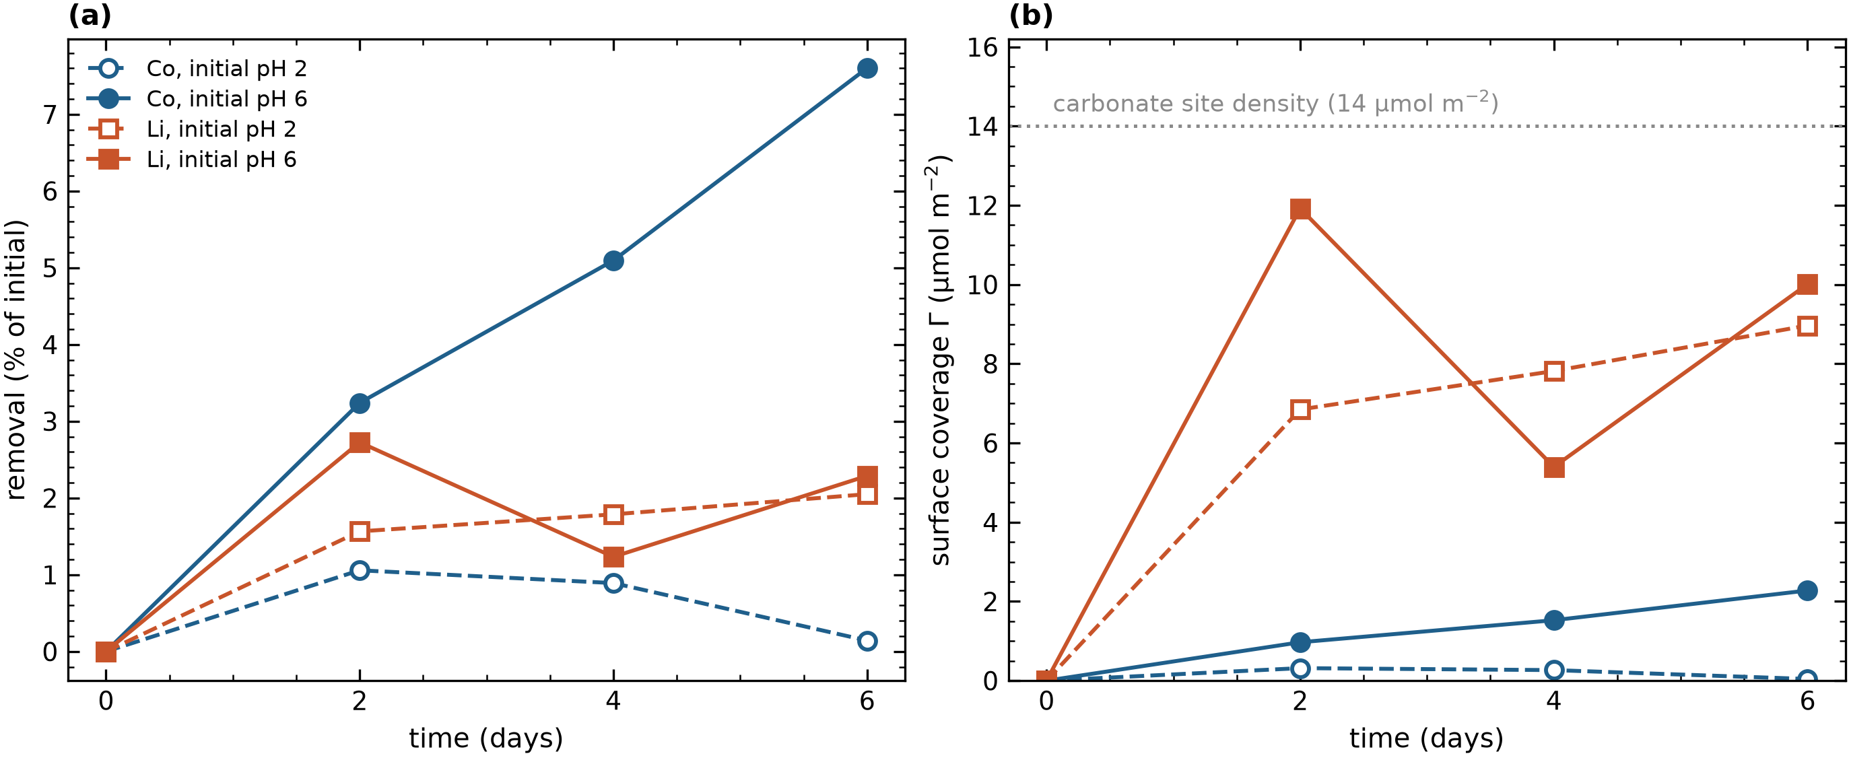
Figure 1. Kinetics of Li⁺ and Co²⁺ uptake by dolomite (60 g L⁻¹, 40 g L⁻¹ NaCl, 25 °C). (a) Removal as a percentage of the initial concentration; (b) surface coverage Γ from Eq. 12, with the carbonate-site density of 14 µmol m⁻² shown. Filled symbols, batches with initial pH 6; open symbols, initial pH 2. Cobalt removal in the pH 6 batch is still rising at day 6; lithium reaches 64 to 72 % of the site density by day 2.
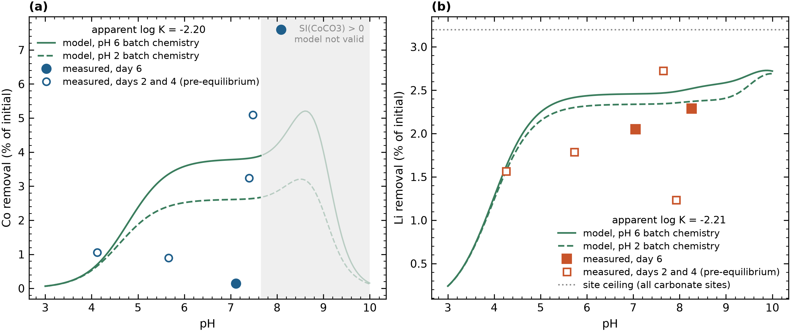
Figure 2. Adsorption edges. (a) Cobalt and (b) lithium removal against pH. Filled symbols are the day-6 points, open symbols the day-2 and day-4 samples plotted at their measured pH. Model curves are the forward prediction with the apparent constant of Table 6 and each batch's day-6 Ca and Mg (solid, pH 6 batch chemistry; dashed, pH 2 batch chemistry). The dotted line in (b) is the site ceiling: the removal if every carbonate site held lithium.
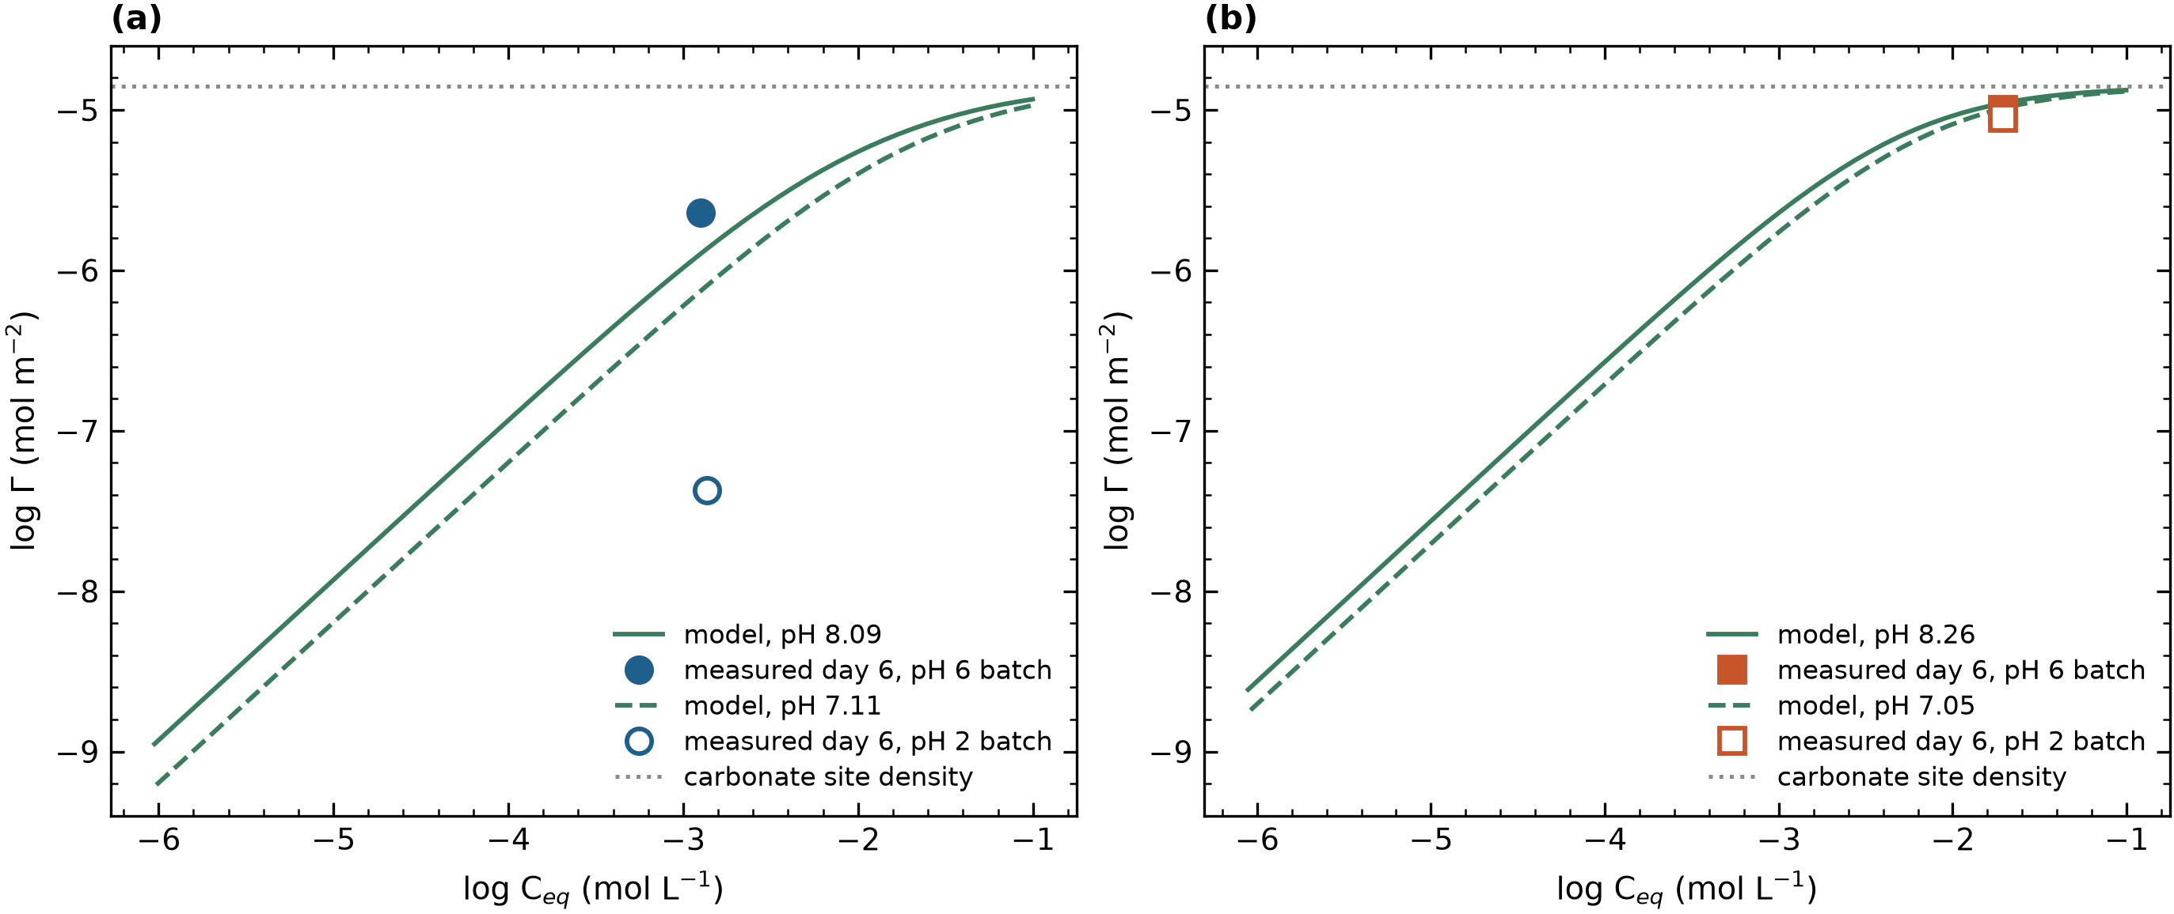
Figures 3 and 4. Isotherms, log Γ against log C_eq, for (a) cobalt and (b) lithium. Lines are the forward model at the day-6 pH of each batch with the initial concentration varied; symbols are the single measured point of each batch. The unit-slope region is low-coverage adsorption; the flattening toward the dotted line is site saturation. Lithium sits on the saturation shoulder.
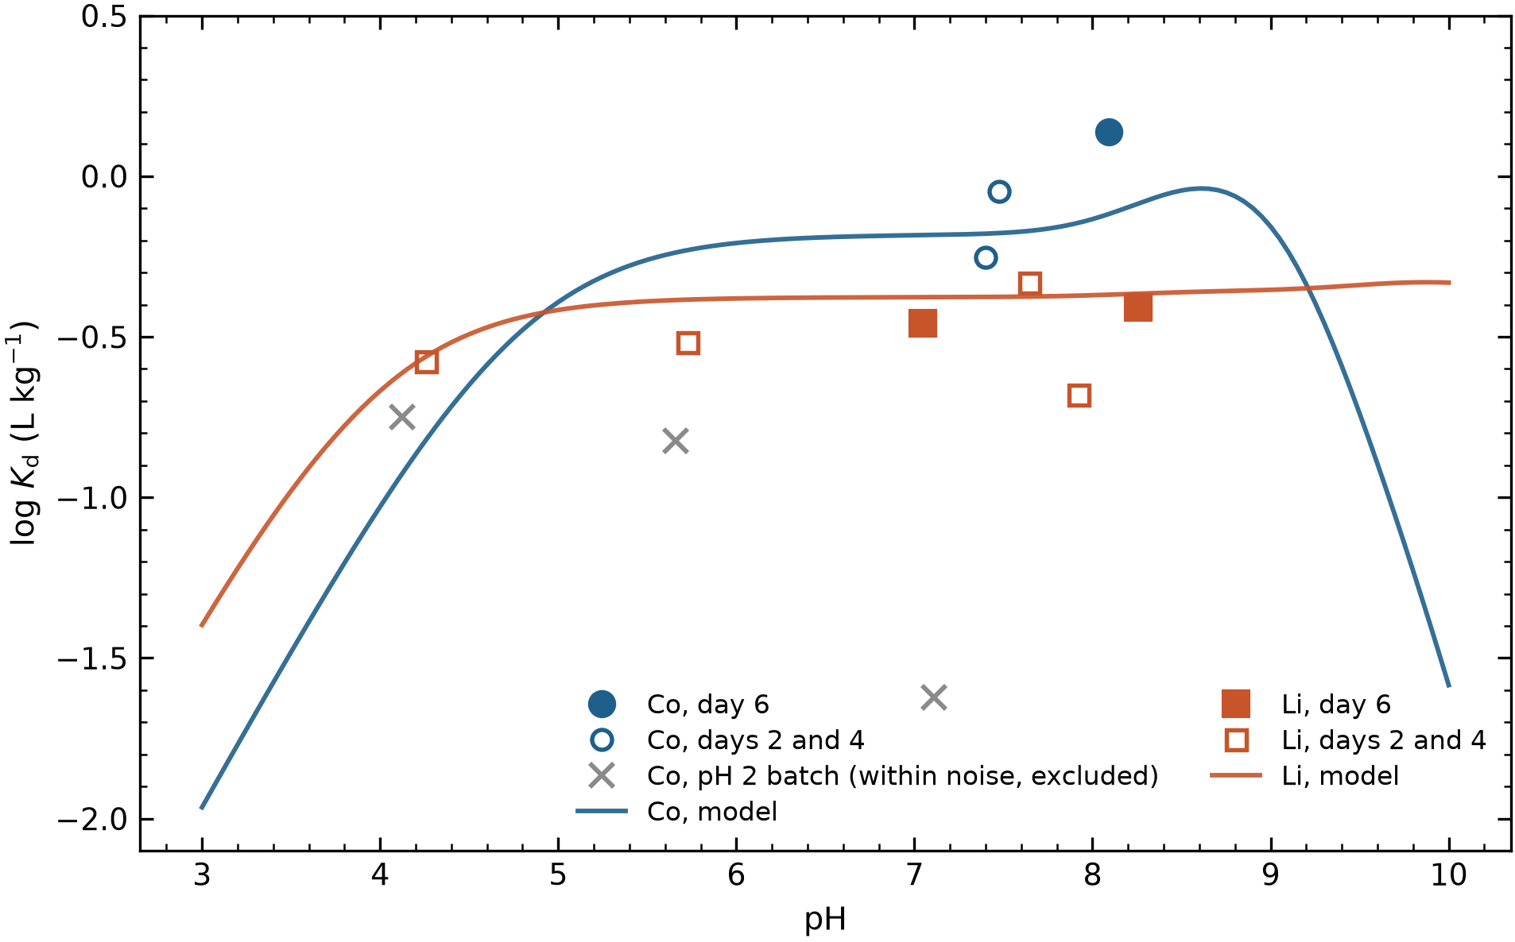
Figure 5. Distribution coefficient, log K_d against pH, with the model curves at the pH 6 batch chemistry. The cobalt pH 2 batch points are within analytical noise and are marked as excluded.
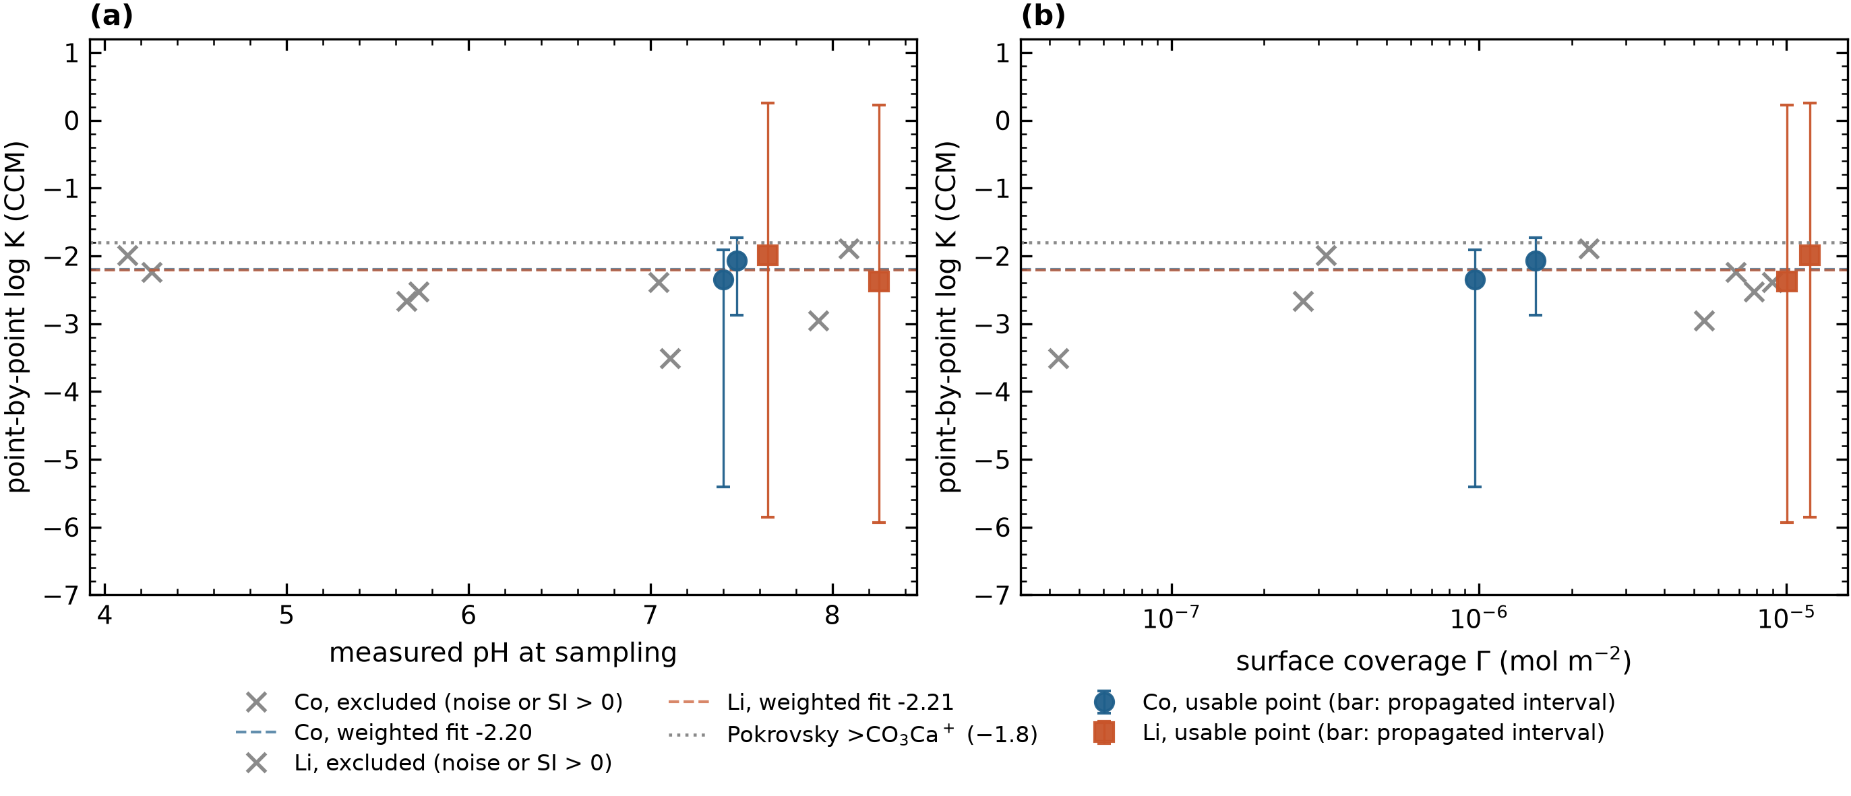
Figure 6. The flat-line diagnostic: point-by-point log K on the carbonate site against (a) measured pH and (b) surface coverage. Filled symbols are the usable points with the interval obtained by recomputing log K at Γ ∓ σ_Γ (±3 % ICP precision); crosses are the points excluded for being within noise or above sphaerocobaltite saturation. Dashed lines are the weighted fits of Table 6; the dotted line is Pokrovsky et al.'s >CO₃Ca⁺ constant. Lithium is flat in pH (slope +0.02 per pH unit) but its interval is wide because the surface is near saturation. Cobalt's two usable points lie 0.08 pH units apart, so no slope is computed for it.
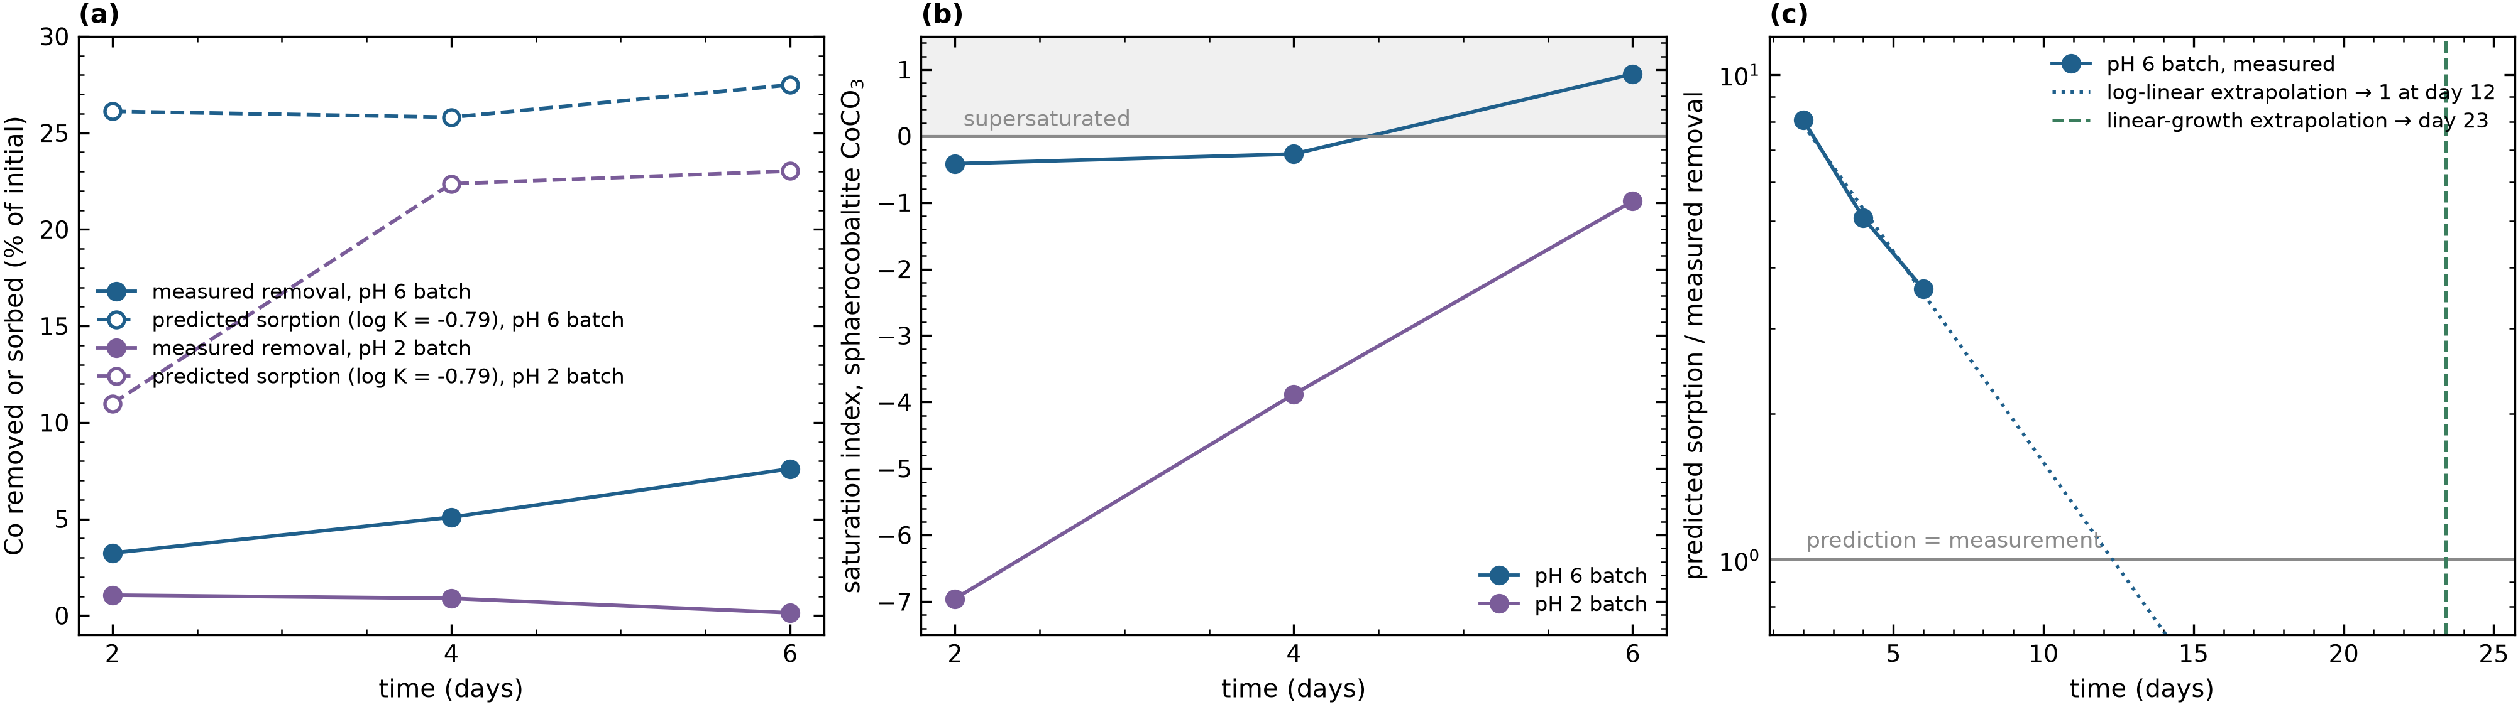
Figure 7. Cobalt: (a) measured removal (solid) against the sorption predicted with the analogy constant log K = −0.79 (open symbols, dashed), for the two batches; (b) saturation index of sphaerocobaltite at the same points, with the supersaturated region shaded; (c) the ratio of predicted sorption to measured removal in the pH 6 batch, on a log scale, with the two extrapolations to unity. The prediction lies above the measurement at every point (Table 7), but the ratio closes monotonically as the measurement climbs toward a prediction that is essentially flat, which is the signature of incomplete equilibration rather than of a wrong constant or a reduced reactive area. The pH rise over the same interval does not account for it: the model prediction, which contains the pH dependence, moves 10 % against the measured 135 %.
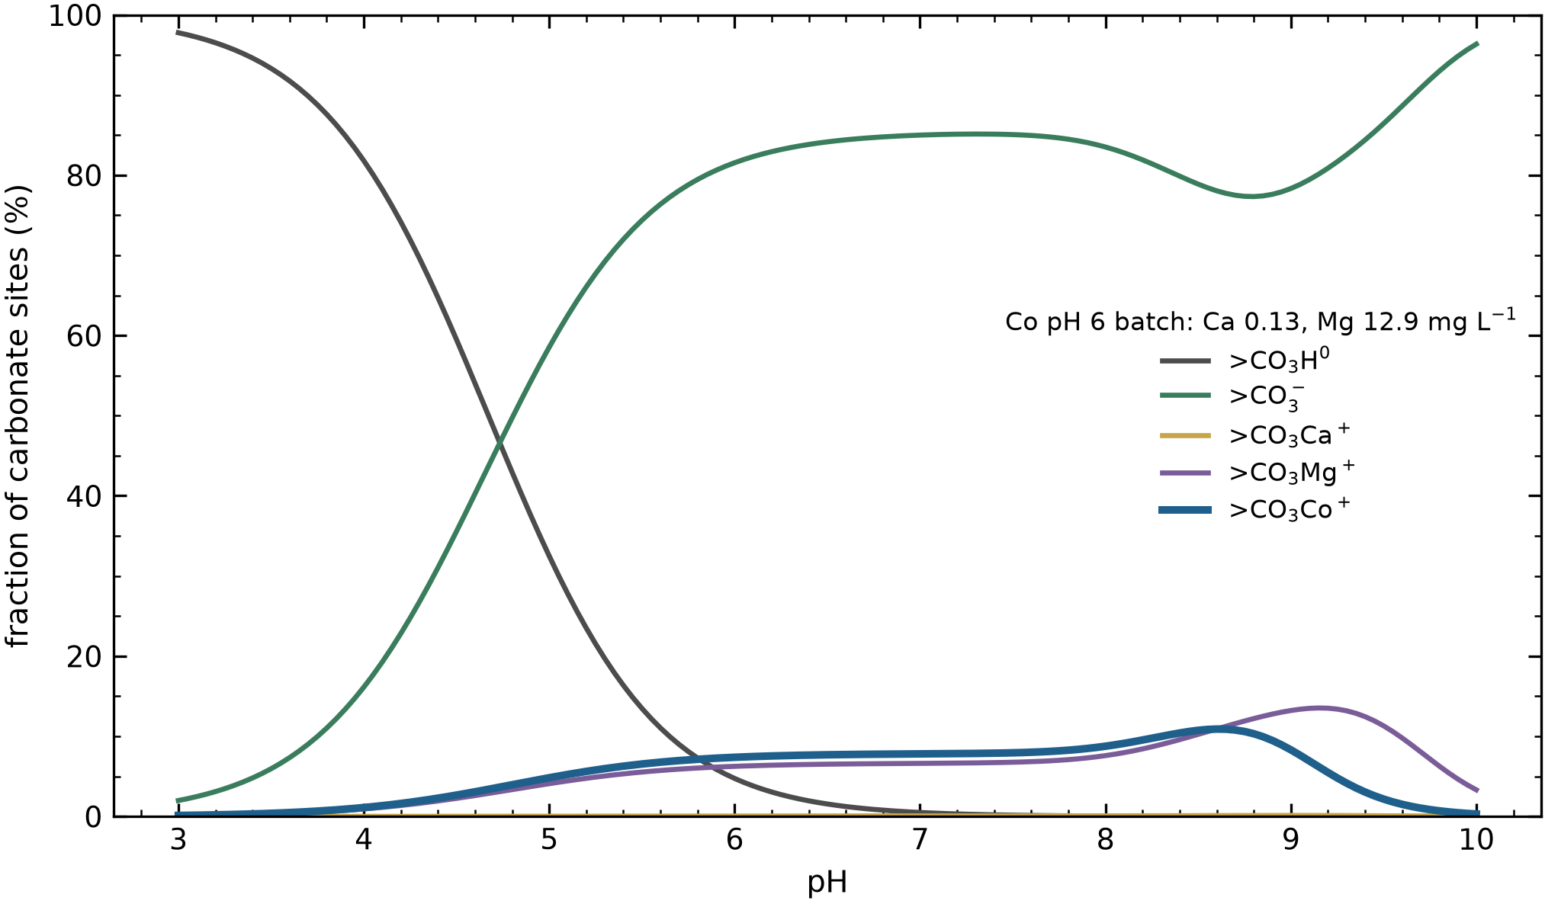
Figure S1. Fractional occupancy of the carbonate site against pH at the cobalt pH 6 batch chemistry, showing the >CO₃H⁰ to >CO₃⁻ transition, the >CO₃Mg⁺ competition and the >CO₃Co⁺ complex.

Data and code availability
The complete workflow, with every reaction, constant and datum embedded, is in `LogK_LiCo_dolomite_carbonate_site_STEPWISE.ipynb` (Python 3) in the project repository. A Wolfram Mathematica notebook implementing the same model is provided alongside.

References
Belova, D. A., Lakshtanov, L. Z., Carneiro, J. F., & Stipp, S. L. S. (2014). Nickel adsorption on chalk and calcite. Journal of Contaminant Hydrology, 170, 1–9. https://doi.org/10.1016/j.jconhyd.2014.09.007
Brady, P. V., Papenguth, H. W., & Kelly, J. W. (1999). Metal sorption to dolomite surfaces. Applied Geochemistry, 14(5), 569–579. https://doi.org/10.1016/S0883-2927(98)00085-7
Charlet, L., Wersin, P., & Stumm, W. (1990). Surface charge of MnCO₃ and FeCO₃. Geochimica et Cosmochimica Acta, 54(8), 2329–2336. https://doi.org/10.1016/0016-7037(90)90059-T
Davies, C. W. (1962). Ion association. Butterworths.
Dzombak, D. A., & Morel, F. M. M. (1990). Surface complexation modeling: Hydrous ferric oxide. Wiley.
Elshebli, M., Vilcáez, J., & Smay, J. (2025). Lithium and cobalt recovery from petroleum produced water using dolomite: Impact of pH, temperature, and surface area. Science of the Total Environment, 1003, 180743. https://doi.org/10.1016/j.scitotenv.2025.180743
Gustafsson, J. P. (2014). Visual MINTEQ 3.1 user guide. KTH Royal Institute of Technology.
Herbelin, A. L., & Westall, J. C. (1999). FITEQL 4.0: A computer program for determination of chemical equilibrium constants from experimental data (Report 99-01). Department of Chemistry, Oregon State University.
Parkhurst, D. L., & Appelo, C. A. J. (2013). Description of input and examples for PHREEQC version 3: A computer program for speciation, batch-reaction, one-dimensional transport, and inverse geochemical calculations (Techniques and Methods 6-A43). U.S. Geological Survey. https://doi.org/10.3133/tm6A43
Plummer, L. N., & Busenberg, E. (1982). The solubilities of calcite, aragonite and vaterite in CO₂-H₂O solutions between 0 and 90 °C, and an evaluation of the aqueous model for the system CaCO₃-CO₂-H₂O. Geochimica et Cosmochimica Acta, 46(6), 1011–1040. https://doi.org/10.1016/0016-7037(82)90056-4
Pokrovsky, O. S., & Schott, J. (2002). Surface chemistry and dissolution kinetics of divalent metal carbonates. Environmental Science & Technology, 36(3), 426–432. https://doi.org/10.1021/es010925u
Pokrovsky, O. S., Schott, J., & Thomas, F. (1999a). Dolomite surface speciation and reactivity in aquatic systems. Geochimica et Cosmochimica Acta, 63(19–20), 3133–3143. https://doi.org/10.1016/S0016-7037(99)00240-9
Pokrovsky, O. S., Schott, J., & Thomas, F. (1999b). Processes at the magnesium-bearing carbonates/solution interface. I. A surface speciation model for magnesite. Geochimica et Cosmochimica Acta, 63(6), 863–880. https://doi.org/10.1016/S0016-7037(99)00008-3
Schindler, P. W., & Stumm, W. (1987). The surface chemistry of oxides, hydroxides, and oxide minerals. In W. Stumm (Ed.), Aquatic surface chemistry (pp. 83–110). Wiley.
Smith, R. M., & Martell, A. E. (2004). NIST critically selected stability constants of metal complexes database (Version 8.0, NIST Standard Reference Database 46). National Institute of Standards and Technology.
Stumm, W., & Morgan, J. J. (1996). Aquatic chemistry: Chemical equilibria and rates in natural waters (3rd ed.). Wiley.
Turner, B. F., & Fein, J. B. (2006). Protofit: A program for determining surface protonation constants from titration data. Computers & Geosciences, 32(9), 1344–1356. https://doi.org/10.1016/j.cageo.2005.12.005
Van Cappellen, P., Charlet, L., Stumm, W., & Wersin, P. (1993). A surface complexation model of the carbonate mineral-aqueous solution interface. Geochimica et Cosmochimica Acta, 57(15), 3505–3518. https://doi.org/10.1016/0016-7037(93)90135-J
Westall, J. C. (1982). FITEQL: A computer program for determination of chemical equilibrium constants from experimental data (Report 82-01). Department of Chemistry, Oregon State University.
Wolery, T. J. (1992). EQ3/6, a software package for geochemical modeling of aqueous systems: Package overview and installation guide (UCRL-MA-110662 PT I). Lawrence Livermore National Laboratory.
Zachara, J. M., Cowan, C. E., & Resch, C. T. (1991). Sorption of divalent metals on calcite. Geochimica et Cosmochimica Acta, 55(6), 1549–1562. https://doi.org/10.1016/0016-7037(91)90126-Q

