Reinforcement Learning Project
(Lunar Lander)

Team Members

- Muhammed Alaa Ali
- Muhammed Mossad Ibrahim Qassim
- Muhammed Ibrahim Muhammed Desoky
- Marwa Emad Abdelfattah
- Shahd Muhammed Elaraby
- Shahd Essam Youssef
- Gehad Mohamed Abbas

Under Supervision:
Eng. Maryam Mahmoud

Introduction

This project implements a Deep Q-Network (DQN) reinforcement learning agent to solve the Lunar Lander environment from OpenAl Gym. The implementation includes advanced techniques like reward shaping and replay memory to improve learning efficiency and performance.
The Lunar Lander environment challenges an agent to safely land a spacecraft on a landing pad. The agent must control the main engine and side thrusters to navigate the lander to the target while managing fuel consumption and maintaining proper orientation.

2. Environment Description
The Lunar Lander is a classic control problem from OpenAl Gym. The spacecraft starts at the top of the screen with random initial velocity, and the agent's goal is to land it safely on the landing pad.
State Space (8 dimensions):
- Coordinates (x, y) of the lander.
- Linear velocities (x, y).
- Angle of the lander.
- Angular velocity.
- Left leg contact with ground.
- Right leg contact with ground.
Action Space (4 discrete actions):
- 0: Do nothing
- 1: Fire left thruster
- 2: Fire main engine
- 3: Fire right thruster
Reward Structure:
- Landing safely between the flags: +100 to +140 points
- Crashing: -100 points
- Using the main engine: -0.3 points per frame
- Successful landing: +100 points
- Each leg contact with ground: +10 points
- Moving away from landing site: Negative points
The environment is considered solved when the agent achieves an average score of 200 or more over 100 consecutive episodes.

3. Technical Implementation
The project implements standard DQN architecture with the following components:
Neural Network Structure:
- Input layer: 8 neurons (state dimensions).
- Hidden layer 1: 128 neurons with ReLU activation.
- Hidden layer 2: 128 neurons with ReLU activation.
- Output layer: 4 neurons (one for each action).

Key DQN Components:
- Experience Replay: Stores agent experiences in a memory buffer to break correlations between consecutive samples.
- Target Network: Separate network updated periodically to stabilize training.
- Epsilon-Greedy Policy: Balances exploration and exploitation, with decaying epsilon.

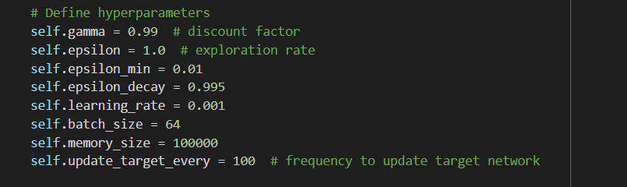
Hyperparameters:

Reward Shaping:
Reward shaping is implemented to provide denser feedback signals to the agent, helping it learn more efficiently. The shaped reward modifies the environment reward to encourage desired behaviors:
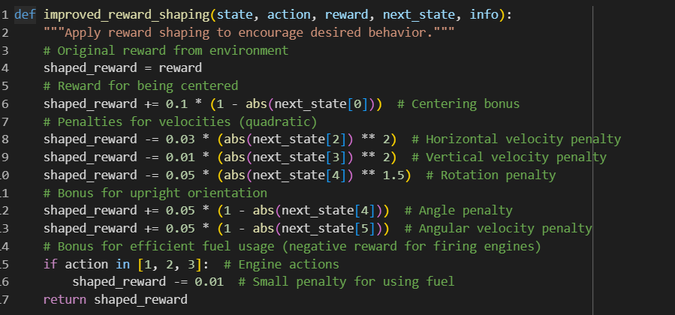
Reward Shaping Components:
- Centring Bonus: Encourages the lander to stay aligned with the landing pad.
- Velocity Penalties: Discourages high velocities, which can lead to crashes.
- Orientation Bonuses: Rewards keeping the lander upright.
- Fuel Efficiency: Small penalties for using engines to encourage efficient fuel management.

3. Training Process
- Environment Setup:
- Initialize the environment, obtaining the size of the observation and action spaces.

- Agent Creation:
- Instantiate a DQN agent with reward shaping, providing it with the necessary observation space size, action space size, and the reward shaping flag.

- Training Loop:
- For each episode, the environment is reset, and the agent begins in an initial state.
- The agent selects actions and interacts with the environment until the episode ends (or maximum steps are reached).
- Transitions (state, action, reward, next state, done flag) are stored, and the agent learns from them after each step.

- Progress Tracking:
- The agent’s performance is tracked through raw scores (direct rewards from the environment) and average scores over a window of recent episodes.
- Every 10 episodes, progress is printed. Every 100 episodes, the scores are visualized.
- Model Saving:
- Whenever the agent’s average score improves, the model is saved.
- If the environment is solved (average score reaches a target threshold), a final model is saved.
- Post-Training:
- After completing all episodes, the environment is closed, and the final training results (scores) are plotted.

4. Performance Evaluation
The agent's performance is evaluated using:
- Average Score: Mean reward over the last 100 episodes
- Learning Curve: Plot of episode scores over time
- Win Rate: Percentage of successful landings during evaluation
- Solving Time: Number of episodes required to consistently achieve the target score

Results and Discussion

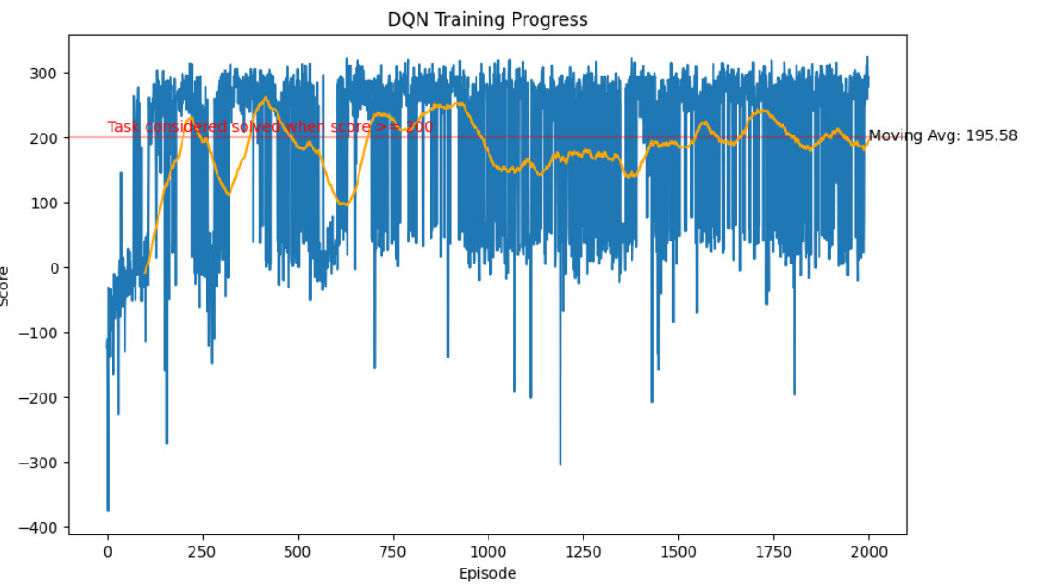
- PyTorch training results & Evaluation:
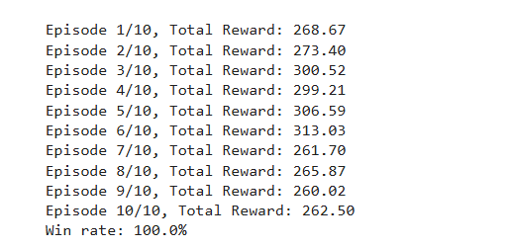

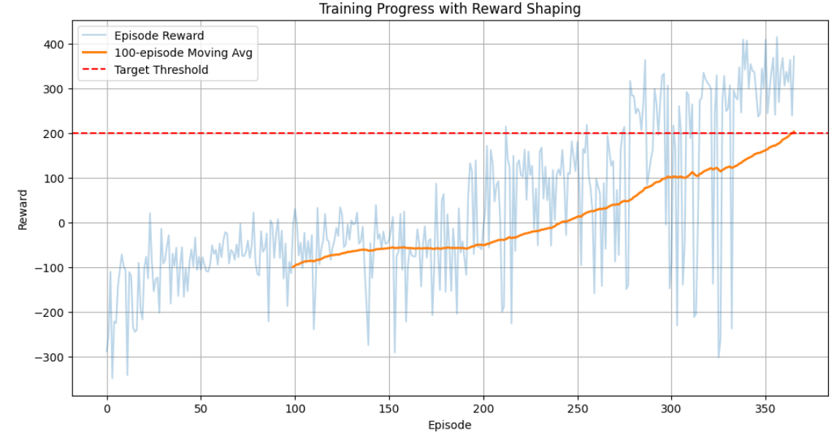
- TensorFlow training results & Evaluation :

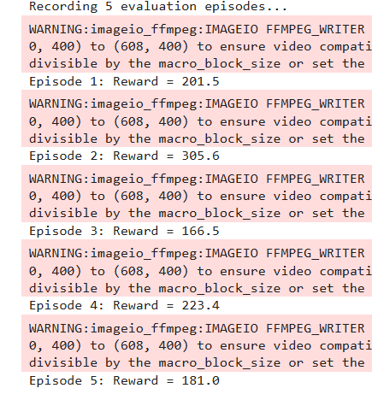

6. Conclusion
In conclusion, the DQN agent successfully learned to land the lunar module using reinforcement learning techniques. Reward shaping played a crucial role in guiding the agent's behavior, resulting in faster learning and better final performance.

The combination of DQN architecture, experience replay, target networks, and custom reward shaping proved effective for solving the Lunar Lander task. Future improvements could explore Dueling DQN, or Prioritized Experience Replay for further gains.

