Cairo University  
Faculty of Computers and Artificial Intelligent

**CS251**

**Software Engineering, I**

Parking Garage application

Software Design

* Marwa Ahmed Mohamed Mubarak
* Mariam Tarek Mohamed Amin
* Reham Rashad Ahmed Mohamed
* Mayar Ahmed Ibrahim Farag

6-2022

Contents

Instructions [To be removed] 3

Team 3

Document Purpose and Audience 3

System Models 3

I. Class diagrams 3

Important Algorithm 4

II. Sequence diagrams 5

Class - Sequence Usage Table 6

Ownership Report 6

Policy Regarding Plagiarism: 7

# Team

|  |  |  |  |
| --- | --- | --- | --- |
| **ID** | **Name** | **Email** | **Mobile** |
| 20200514 | Marwa Ahmed Mohamed Mubarak | marwamubarak6@gmail.com | 01112274338 |
| 20200524 | Mariam Tarek Mohamed Amin | mariam0155357@gmail.com | 01553573228 |
| 20200190 | Reham Rashad Ahmed Mohamed | rehamrashad2002@gmail.com | 01032390170 |
| 20200572 | Mayar Ahmed Ibrahim Farag | mayarahmed11211@gmail.com | 01270318645 |

# Document Purpose and Audience

What this document is?

This document talks about the system model like diagrams show the classes of the garage system and show the sequence of the garage system

This document talks about system for garage helps the garage owner to organize its garage and helps the driver to park in or park out from the garage and other functions shown below.

-The target audience to read this document:

1.The car drivers

2.Garage owners

# System Models

## I. Class diagrams

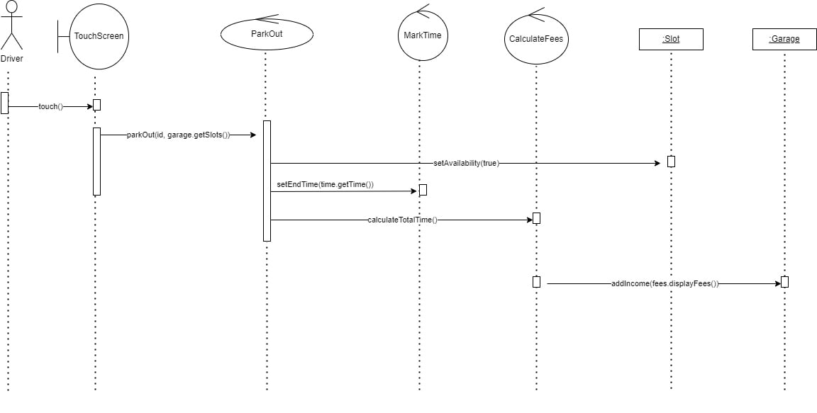

**List down your classes and describe them**

| **Class ID** | **Class Name** | **Description & Responsibility** |
| --- | --- | --- |
| 16 | CalculateTotalIncome | Calculate total income to grage owner |
| 15 | CalculateFees | Calculate fees the driver should pay |
| 14 | MarkTime | Set start and end time |
| 13 | GarageOwner | Choose configuration and set slots deimensions |
| 12 | ParkOut | Give veichel data to CalaculateFees Class |
| 11 | ParkIn | Get veichel data from The driver |
| 10 | BestSlot | Best slot option |
| 9 | FirstSlot | First slot option |
| 8 | Configuration  ” Interface” | All configuration the garage owner choose |
| 7 | ParkingOut | To press button to ask parking out from the driver |
| 6 | ParkingIn | To press button to ask parking in from the driver |
| 5 | TouchScreen  ” Interface” | Class to access data from the driver |
| 4 | Slot | Class has slots dimension and set and get it and set start time and end time |
| 3 | Vehicle | Class has vehicle data and change in it |
| 2 | Driver | Class has vehicle and get parking ID |
| 1 | Garage | Class to connect between touch screen and garage data |

### Important Algorithm

There is not.

## II. Sequence diagrams

# Ownership Report

| **Class Name** | **Sequence Diagrams** | **Overall used methods** |
| --- | --- | --- |
| CalculateTotalIncome | 3 | CalculateTotalIncome  addIncome  displayTotalIncome |
| CalculateFees | 3 | CalculateFees  CalculateTotalTime  displayFees |
| MarkTime | 1,3 | markTime  getTime |
| GarageOwner | 1 | getName  setName |
| ParkOut | 3 | parkOutSlot |
| ParkIn | 1,2 | parkInSlot |
| Configuration  ” Interface” | 1,2 | searchForSlot |
| ParkingOut | 1,2 | touch |
| ParkingIn | 1,2 | touch |
| TouchScreen  ” Interface” | 1,2,3 | touch |
| Slot | 1,3 | setWidth  setDepth  setParkingID  setStartTime  setEndTime  setAvailabilty  getWidth  getDepth  getParkindID  getAvailablity  getStartTime  getEndTime |
| Vehicle | 1,2 | getWidth  getDepth  setVeichelInfo  Veichle |
| Driver | 3 | setParkindID  Driver |
| Garage | 1,3 | getInstance  getSlot  setSize  getSlots  setAllSlots |