|  |  |
| --- | --- |
| Name | ID |
| Alaa Amer Mohamed | 20200090 |
| Sama Hussien AboElala | 20200232 |
| Marwa Shaaban Eid | 20200516 |

Garbage classification with CNN

*Abstract*—Garbage needs to be categorized in order to preserve the natural environment, which is essential to human survival, and to provide sustainable development for civilization. It is challenging for us to correctly comprehend the classification of each type of trash, nevertheless, because people are unfamiliar with the classification system. To assist people in appropriately classifying waste.so in this paper.we use (MobileNet , Xception) for feature extraction,and then use genatic algorithm and svm we obtain 97.4% ,95.9% respectively in traing data.

# **Introduction**

People have always placed a high priority on environmental issues, of which waste pollution is having an increasingly negative influence. [1].As the current global municipal solid trash generation rate is 2.01 billion tons per year, which seriously harms the environment. Under existing conditions, waste generation will rise by seventy percent [2].

Knowing that the global economic growth and rising living standards led to a rise in overall consumption, which in turn caused waste to grow quickly and put more strain on the environment[3,4]. As a result, managing trash requires the use of effective methods.For that reason Recycling is turning becoming a vital component of a sustainable community. But because of the materials' selection, categorization, and processing, recycling as a whole entails a significant hidden cost. When disposing of a wide range of materials, even while consumers are eager to sort their own waste in many nations these days, they may be unsure of how to identify which category the waste belongs in. In today's industrialized and information-driven culture, finding an automated recycling solution is crucial since it not only benefits the environment but also.

the economy.Right now we consider it as a challenge in developing countries. One of the most crucial steps in garbage management is garbage classification. It is the practice of grouping or separating waste materials that are comparable to one another.Manual waste separation is time-consuming, haphazard, and dangerous for human health. Consequently, this issue can be solved by utilizing technologies like (AI) . Waste types can be successfully classified thanks to AI's unique ability to classify images. A sustainable society requires waste to be used as efficiently as possible. The three Rs of waste management are reduce, reuse, and recycle [5]. Therefore, employing technology to minimize waste should be the main priority when it comes to waste management.

The appropriate classification of waste as biodegradable and non-biodegradable is the secondary concern of waste management. Our goal is to categorize a distinct category of waste and furnish details regarding its biodegradability or non-biodegradability[6]. Initially, using transfer learning techniques in CNN-based pre-trained models waste images were classified into seven types (cardboard, glass, metal, organic, paper, plastic, and trash). Then, as illustrated in figure 1.

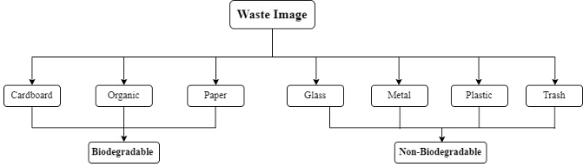

# 

Figure 1: Waste Classification Types

the classes of cardboard, organic, and paper are deemed biodegradable, while the remaining classes are deemed non-biodegradable.

The effective recycling of garbage is dependent on the sort of rubbish, and recycling is an important part of managing environmental degradation. Based on deep learning and transfer learning, a machine vision system is built to decrease cost of labor and improve trash categorization capability. With the help of this new technique, a better MobileNetV2 deep learning model for garbage detection and classification is recommended [7]. The first and last convolution layers of the MobileNetV2 model

now include an attention mechanism to increase recognition accuracy, and the transfer learning component uses a set of weight parameters that have already been trained to increase the model's capacity for generalization.We use CNN to capture the features of images putting in

consideration the nature of garbage image. So we aim to classify images to one of the garbage categories. The image of rubbish classified into seven categories (paper, garbage, glass, metal, plastic organic, cardboard, organic) applying transfer learning strategies with labeled dataset in CNN-based on pre-trained models like VGG19, MobileNet , ResNet50 , and DenseNet201.[8]

# **Related work**

In the last few decades, experts and scholars have been working to accurately classify the images into their respective groups photo arrangement was challenging by hand due to the requirement for computer power and limited photo databases.However, it is now possible to use PC vision methods efficiently because to the GPUs' continuously increasing handling intensity and the availability of large datasets.In image classification, Alex Net is a well-known and extremely talented CNN design; in 2012, it won the ImageNet Large Scale Visual Recognition Challenge (ILSVRC).It is evident that engineering is well-known for its effectiveness and is essentially simple and not very deep. Because Alex Net started a trend of CNN techniques becoming the best in class in image arrangement and becoming incredibly well-known in the ImageNet competition, it was fascinating.

In this paper[9], polythene detection, classify images into three classes: non-plastic (0), other types of plastic excluding polythene (1), and polythene (2).they use Original Loss Function( Categorical cross entropy) and Modify it for Polythene Misclassification to make the model more sensitive to this specific class. Polyth-Net, contain a 72-layered Xception model. This Model Architecture its Base Model is Xception with 72 layers. And Removed the original top layers of the Xception model. Then add 2 Fully Connected Dense layers with ReLU activation. And Each Dense layer is followed by a 0.25 Dropout for regularization. Then Use Softmax for classification with three classes. They use Adam optimizer while compiling.

in their data set they Preprocessed data by

Scaling and Normalization. they got

in Testing 88.84% accuracy This Document [10], This study suggests a solution that, without the need for human intervention, can identify and classify waste and separate it into recyclable, natural, and harmful waste receptacles. The system makes use of deep learning algorithms to identify and classify the losses into several groups. The sorted natural and repurposed wastes can be put to better use in the future. This process will assist the planet in becoming more ecologically protected and significant, as well as assist us in creating a rich, green biological system and a brighter, more promising future.

The image data used for training and testing will comprise multiple classes on various sorts of rubbish. Original frames from trash image will be used to create the training and testing data collection. There are a total of 2527 image in the data set utilized for deep learning architectures, divided into 6 classes. The training phase employed half of the image in the data set, while the testing procedure used the remaining portion. Additionally, shorter training sessions and more accurate test procedures were achieved through the use of transfer learning. Alexnet, VGG16, Googlenet, and Resnet structures were used as Transferred models. SoftMax and Support Vector Machines are two distinct classifiers that are used to measure the performance of classifiers. With GoogleNet+SVM, 6 different types of rubbish photos were accurately categorized with the greatest accuracy of 97.86%.

In paper [11] to convert the current InceptionV3 model recognition task on the Imagenet dataset to garbage identification, their study suggests a method of garbage classification and recognition based on transfer learning. First, use data augmentation to expand the data set. Next, using the source model as a foundation, construct a convolutional neural network and modify its parameters in light of the training outcome. According to the training data, the test accuracy is 93.2% and the training accuracy is 99.3%. Lastly, the model is used to identify objects in real-world photo collections. The recognition results validate the viability of this approach by demonstrating the model's good performance and high accuracy, ability to accurately recognize common rubbish in daily life, and reference significance for intelligent garbage classification.

The Paper [12]in the subject of picture classification is covered in this section, with a special emphasis on trash categorization. The authors draw attention to the lack of dedicated trash classification research, despite the fact that support vector machine and neural network-based image classification projects are widely used.The well-known CNN architecture AlexNet, which took first place in the 2012 ImageNet Large-Scale Visual Recognition Challenge, is presented by the creators. AlexNet is renowned for its ease of use, efficiency, and contribution to the spread of CNN techniques for image categorization.The 2016 TechCrunch Disrupt Hackathon's "Auto-Trash" concept is compared and critiqued. With the help of Google's TensorFlow, Auto-Trash is an autonomous trashcan that sorts waste based on its camera and Raspberry Pi module. It simplifies the classification work by having only two types and distinguishing between compost and recycling.An further initiative pertaining to waste is a smartphone application intended for the coarse segmentation of a picture containing a rubbish pile. Enabling neighbors to monitor and report trash in their areas is the aim. The application's authors employ a pre-trained AlexNet model to achieve a mean accuracy of 87.69%. The dataset was gathered from Bing Image Search.

Because there were no publicly available databases for waste classification, the authors manually gathered one. The first attempts, which used Google Images and the Flickr Material Database, were inadequate since they did not accurately depict the actual state of recycled goods. The authors used manual collecting in several areas to compile about 2,400 photos of recycled items from six classes. They used data augmentation methods, such as random transformations, to deal with the tiny dataset size, and they want to make the dataset available to the public.

[13]The goal of this work is to develop a faster R-CNN based predictive model for the automatic classification of ten distinct waste/litter object kinds. As backbone networks for feature extraction, two pre-trained networks—Inception-V2 and ResNet-101—are being studied. Additionally, the suggested model's performance is contrasted with two baselines: the SSD (single shot multibox detector) and the RFCN (region-based fully convolutional network).The Faster R-CNN coupled with Inception V2 is found to attain the greatest mean average precision (mAP) of 92%.

1. **Proposed Model**

In our Model we preparing dataset for Garbage classification , divided it into training and validation sets. And we use ImageDataGenerator for data augmentation to enhance our model's ability to generalize. Then we try different model as base model (MobileNet , Xception) for feature extraction, and we add a global average pooling layer to reduce the spatial dimensions. Features that we extracted from the pre-trained model for both training and testing datasets.

Then we perform feature selection using a genetic algorithm. We initialize a population of binary-encoded feature vectors, this feature vector representing the presence or absence of features. Our Fitness function is evaluated using a support vector machine (SVM) classifier on the selected features.

Then we select parents based on their fitness. We randomly select two indices for each member of the population, compare their fitness, and select the one with higher fitness as a parent, After that we perform a single-point crossover method between two parents that we selected to create two children. We randomly select a crossover point and combine the genetic information of the two parents before and after that point. And then apply mutation, and finally generate a new populations iteratively.

After Selecting best features that suit our data we apply SVM to get final results.

The following table illustrates the sequence of our model:

|  |
| --- |
| Feature Extraction  Base models  Xception  MobileNet |
| Feature Selection |
| Classification SVM |

Table 1: Model

4-Dataset

The Garbage Classification Dataset contains 6 classifications: cardboard ,glass, metal , paper, plastic and trash.

This garbage images dataset of Stanford that Thung and Young set up for TrashNet [14] dataset is used in the experiment [15].

We utilized photos from the Kaggle dataset that is devoted to the classification of garbage. There is only one piece of trash on a clean background in each of the 2527 images that make up this dataset. The lighting and positioning of objects in different pictures differs. All six of the aforementioned categories apply to each of these 384 x 512 pixel pictures. The table below lists the precise number of images for each class. All of the photos were taken with iPhones, and the originals had a resolution of 72 pixels per inch.

|  |  |
| --- | --- |
| Class type | total |
| Paper | 594 |
| Glass | 501 |
| Plastic | 482 |
| Metal | 410 |
| Cardboard | 403 |
| Trash | 137 |
| total | 2527 |

There’s some samples of the dataset we are using

Cardboard Metal

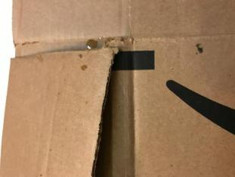 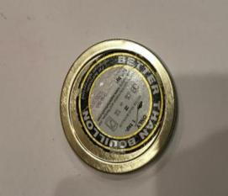

Glass Paper

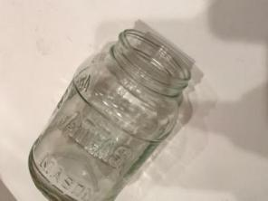 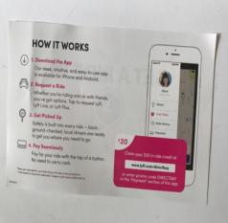

Plastic paper

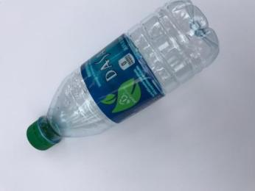

**5-Experimental result**

we split our data to train and test sets with 90% 10 % , we increased our training size to get more representative for learned features so in train set we have 2276 image and in test set we have 251 image.

In using of MobileNet as base Model we got the following classification report where our total accuracy in train data is 97.4% and in test data is 86%

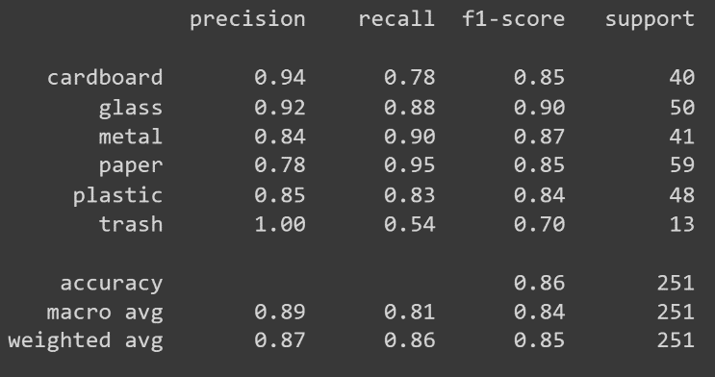

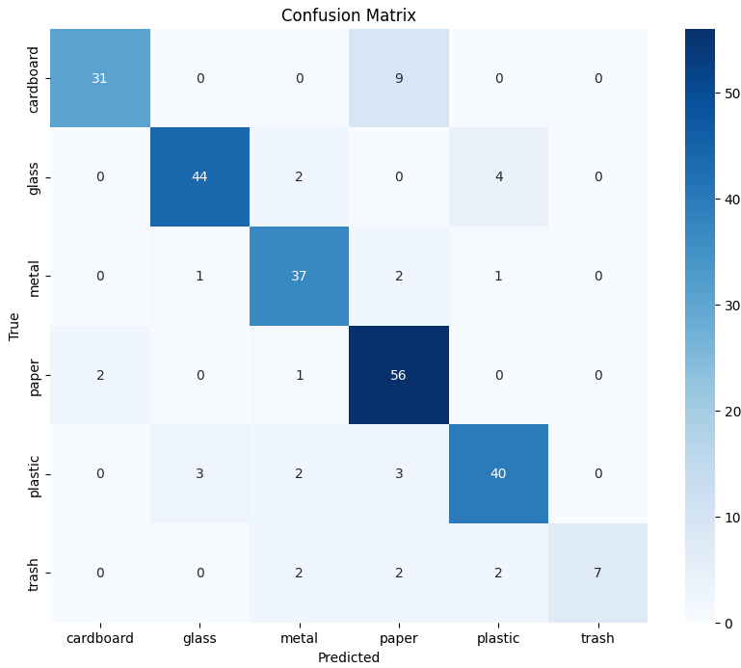

Fig. 1. Confusion matrix in Model with MobileNet

In using of Xception as base Model we got the following classification report where our total accuracy in train data is 95.9% and in test data is 88.4 %

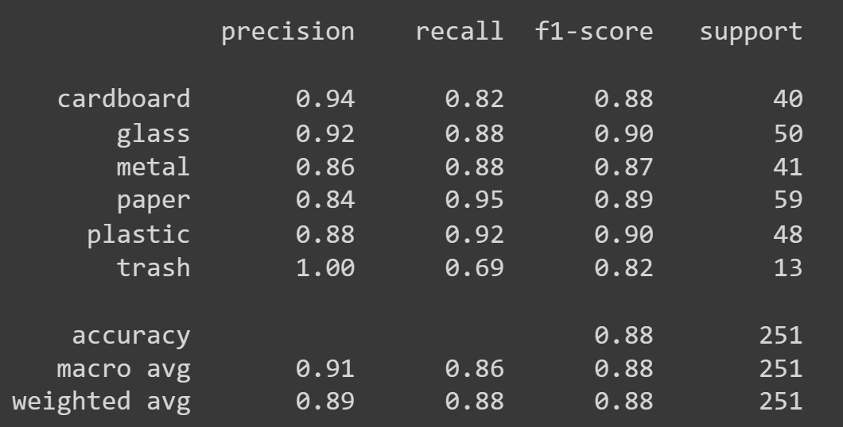

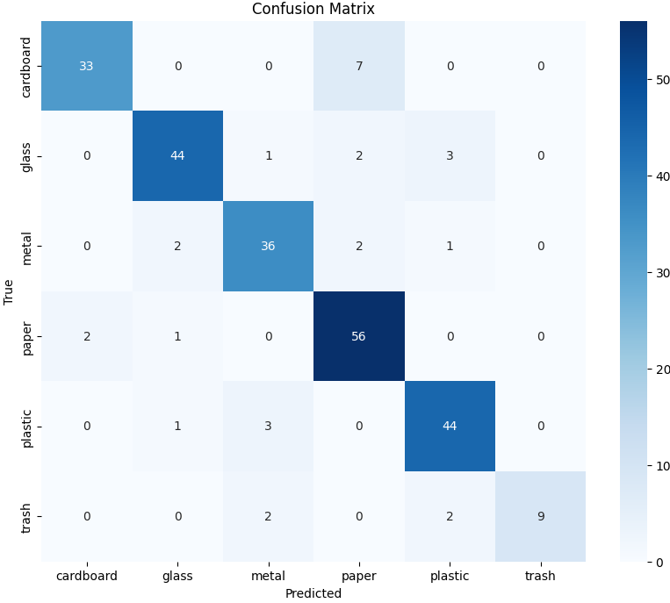

Fig. 2. Confusion matrix in Model with Xception

**6-Conclusion**

Garbage must be classified in order to conserve the natural environment, which is critical to human survival, and to ensure civilization's long-term progress. Nonetheless, because people are unfamiliar with the categorization system, it is difficult for us to fully understand the classification of each sort of rubbish. To aid people in properly sorting garbage. in this paper, we used (MobileNet, Xception) for feature extraction, and then apply genetic algorithm and SVM.

7. References

1. Zheng, J., Xu, M., et al.: Modeling group behavior to study innovation diffusion based on cognition and network: an analysis for garbage classification system in Shanghai, China. Int. J. Environ. Res. Public Health 16(18), 3349 (2019) [CrossRef](https://www.mdpi.com/1660-4601/16/18/3349) [GoogleScholar](https://scholar.google.com/scholar_lookup?&title=Modeling%20group%20behavior%20to%20study%20innovation%20diffusion%20based%20on%20cognition%20and%20network%3A%20an%20analysis%20for%20garbage%20classification%20system%20in%20Shanghai%2C%20China&journal=Int.)

2. S. Kaza, L. Yao, P. Bhada-Tata, and F. Van Woerden, What a Waste 2.0: A Global Snapshot of Solid Waste Management to 2050. The World Bank, 2018. [CrossRef](https://openknowledge.worldbank.org/entities/publication/d3f9d45e-115f-559b-b14f-28552410e90a)

3. Daskalopoulos, E., Badr, O., Probert, S.: Municipal solid waste: a prediction methodology for the generation rate and composition in the european union countries and the United States of America. Resour. Conserv. Recycl. 24(2), 155–166 (1998) [CrossRef](https://www.sciencedirect.com/science/article/abs/pii/S0921344998000329?via%3Dihub) [GoogleScholar](https://scholar.google.com/scholar_lookup?&title=Municipal%20solid%20waste%3A%20a%20prediction%20methodology%20for%20the%20generation%20rate%20and%20composition%20in%20the%20european%20union%20countries%20and%20the%20United%20States%20of%20America&journal=)

4. Stoeva, K., Alriksson, S.: Influence of recycling programmes on waste separation behaviour. Waste Manag. 68, 732–741 (2017) [CrossRef](https://www.sciencedirect.com/science/article/abs/pii/S0956053X17304440?via%3Dihub)  [GoogleScholar](https://scholar.google.com/scholar_lookup?&title=Influence%20of%20recycling%20programmes%20on%20waste%20separation%20behaviour&journal=Waste%20Manag.&volume=68&pages=732-741&publication_year=2017&author=Stoeva%2CK&author=Alriksson%2CS)

5. 2016. 3rs - reduce, Reuse and Recycle. Retrieved May 27, 2022[CrossRef](https://www.sustainablesanantonio.com/practices-technology/reduce-reuse-recycle)

6. Sunil Kumar 1 2, Rakesh Kumar 1, Ashok Pandey Current Developments in Biotechnology and Bioengineering Strategic Perspectives in Solid Waste and Wastewater Management 2021[CrossRef](https://www.sciencedirect.com/science/article/abs/pii/B978012821009300004X)

7. Yujin Chen , Anneng Luo , Mengmeng Cheng , Yaoguang Wu , Jihong Zhu , Yanmei Meng , Weilong Tan 15 August 2023 ,Classification and recycling of recyclable garbage based on deep learning [CrossRef](https://www.sciencedirect.com/science/article/abs/pii/S095965262301716X)

8. Xushan Peng, Xiaoming Zhang, Yongping Li, Bangquan Liu May 2020, 102705 Research on image feature extraction and retrieval algorithms based on convolutional neural network [CrossRef](https://ieeexplore.ieee.org/document/5540226)

9. Divyansh Singh, January 2021, Polyth-Net: Classification of Polythene Bags for Garbage Segregation Using Deep Learning [CrossRef](https://arxiv.org/ftp/arxiv/papers/2008/2008.07592.pdf)

10. Fine-Tuning Models Comparisons on Garbage Classification for Recyclability Umut Özkaya1* and Levent Seyfi 2 1Department of Electrical and Electronics Engineering/Konya Technical University, Konya, Turkey.

11. IEEE, 2020, Application of Convolutional Neural Network Based on Transfer Learning for Garbage Classification [CrossRef](https://ieeexplore.ieee.org/abstract/document/9141699)

12. Mindy Yang, Gary Thung, Classification of Trash for Recyclability Status [CrossRef](https://cs229.stanford.edu/proj2016/report/ThungYang-ClassificationOfTrashForRecyclabilityStatus-report.pdf)

13. IEEE , 2021, Garbage Detection and Classification using Faster-RCNN with Inception-V2 [CrossRef](https://ieeexplore.ieee.org/abstract/document/9691547)

14. G. Thung and M. Yang. "Dataset of images of trash; Torch-based CNN for garbage image classification". GitHub Repository, 2016, Accessed 23 May 2020. [CrossRef](https://github.com/garythung/trashnet)

15. Feyza Ozkefe. 2020. *Garbage CNN | Kaggle*. Retrieved May 27, 2022 [CrossRef](https://www.kaggle.com/code/rkuo2000/garbage-cnn/data)