**Analysis and Findings**

**The pie graph represents the count between female and male.**

**Which shows that the count of male is higher than the count of female.**

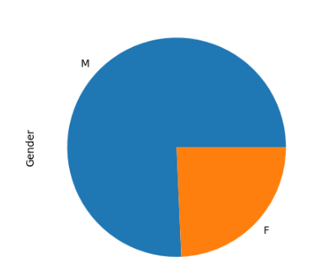

**The accompanying bar shows the precentage of the male and female**

**And the purchase.**

**Male precentage is more than female preccentage.**

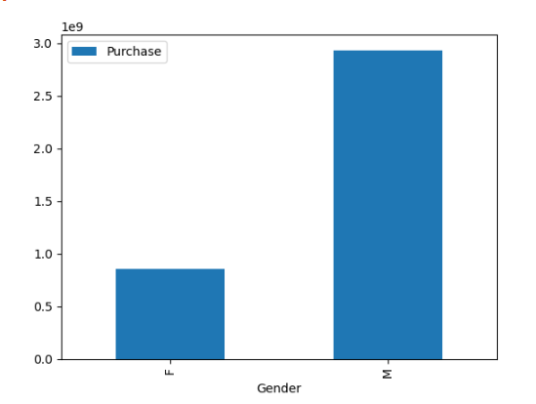

**The accompanying bar shows the count of age.**

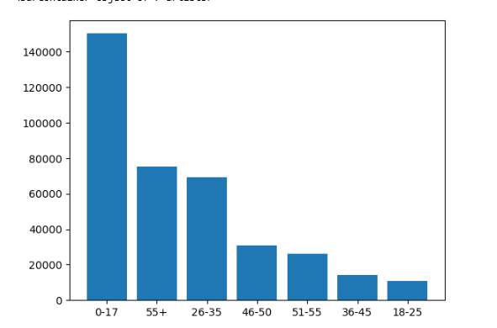

**The accompanying bar shows the precentage of the age and purchase which shows that from 26 to 35 is the highest**

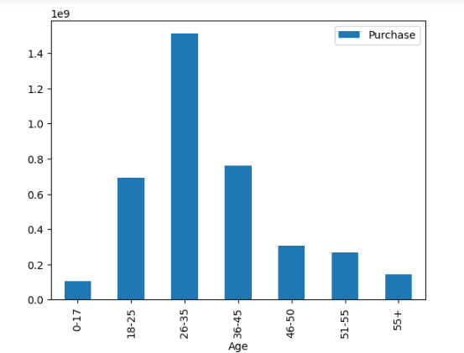

**The accompanying bar shows the count of city.**

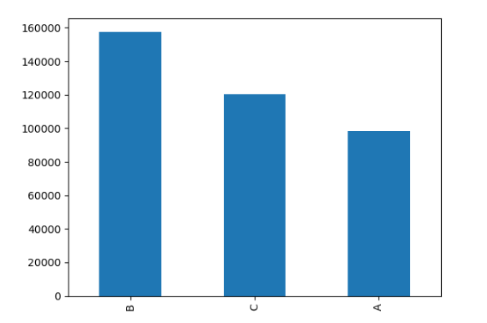

**The accompanying bar shows the precentage of the city and purchase which shows that city B is the highest**

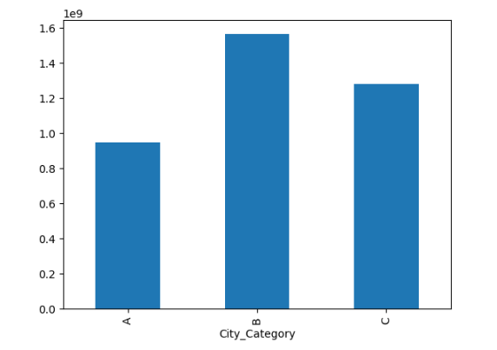

**The accompanying bar shows the precentage of the marital status**

**Married precentage is more than Not married preccentage.**

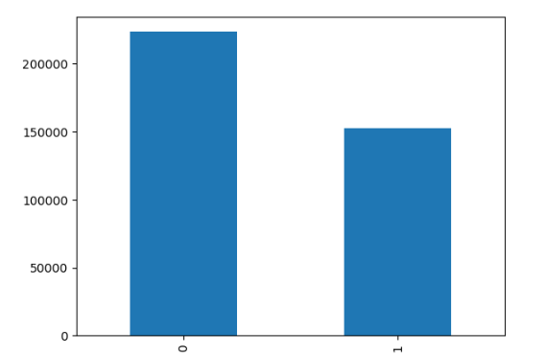

**The accompanying bar shows the precentage of the marital status and purchase**

**Married precentage is more than Not married preccentage.**

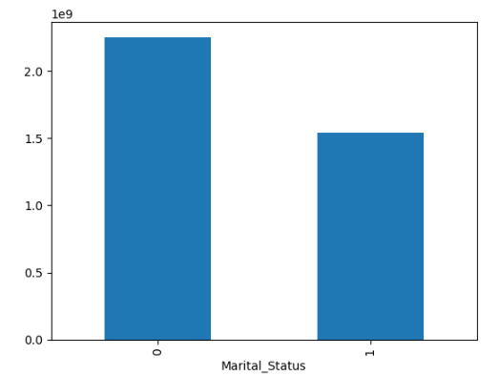

**Hypothesis**

1. **Males are more likely to buy in black Friday (unclear).**
2. **People’s age between 26 and 35 are more likely to buy in black Friday.**
3. **In city B people seem like they are more interested in black Friday sales.**
4. **Married people buy the most in black Friday sales.**