## CS 112 Programing II

## Lab Session 10: JavaFX Basics

The TicTacToe Class

NOTE: This class is similar to the ShowGridPane class that was discussed in Chapter 14.

TicTacToe class displays a 3x3 grid that can be filled with Xs and Os

Create the TicTacToe class by extending the Application class as follows:

* Override start(Stage)
* Use the GridPane class to create the grid
* Use the X and O classes to paint Xs and Os on that grid as shown in the picture
* Place the GridPane object in a Scene object
* Place the Scene object on the Stage object
* Show Stage object

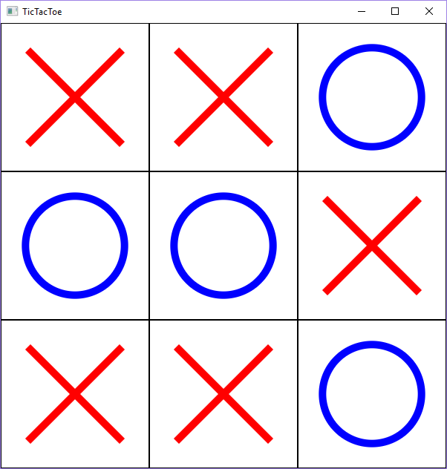

Pane

O

WIDTH: 200

HEIGHT: 200

O()

X

WIDTH: 200

HEIGHT: 200

X()

1. Create the UML class diagram showing TicTacToe, Pane, X, and O and their relationships.
2. Create the TicTacToe class. It should display the Xs and Os as shown in the picture.

import javafx.application.*;

import javafx.scene.*;

import javafx.scene.layout.*;

import javafx.scene.shape.*;

import javafx.stage.*;

public class TicTacToe extends Application {

// code for this class

}

class O extends Pane {

public O() {

setPrefSize(200,200); // preferred size of the pane

setStyle("-fx-border-color: black;"); // add black border to the pane

Circle circle = new Circle();

circle.centerXProperty().bind(widthProperty().divide(2));

circle.centerYProperty().bind(heightProperty().divide(2));

circle.radiusProperty().bind((heightProperty().add(widthProperty())).divide(6));

circle.setStyle("-fx-stroke: blue; -fx-fill: white; -fx-stroke-width: 10px;");

getChildren().add(circle);

}

}

class X extends Pane {

public X() {

setPrefSize(200,200); // preferred size of the pane

setStyle("-fx-border-color: black;"); // add black border to the pane

Line line1 = new Line(40, 40, 40, 40);

line1.endXProperty().bind(widthProperty().subtract(40));

line1.endYProperty().bind(heightProperty().subtract(40));

line1.setStyle("-fx-stroke: red; -fx-stroke-width: 10px;");

Line line2 = new Line(40, 40, 40, 40);

line2.startXProperty().bind(widthProperty().subtract(40));

line2.endYProperty().bind(heightProperty().subtract(40));

line2.setStyle("-fx-stroke: red; -fx-stroke-width: 10px;");

getChildren().addAll(line1, line2);

}

}