**Student name:** Mrwan Alhandi

**Student ID:** s3969393

**Vodcast URL:** [Submission.mp4](https://rmiteduau-my.sharepoint.com/:v:/g/personal/s3969393_student_rmit_edu_au/EXkszaQd2elFih1iKjRbw2YBs6y0cJHhNceyFsnRYJGuuw?e=d8dGtd)

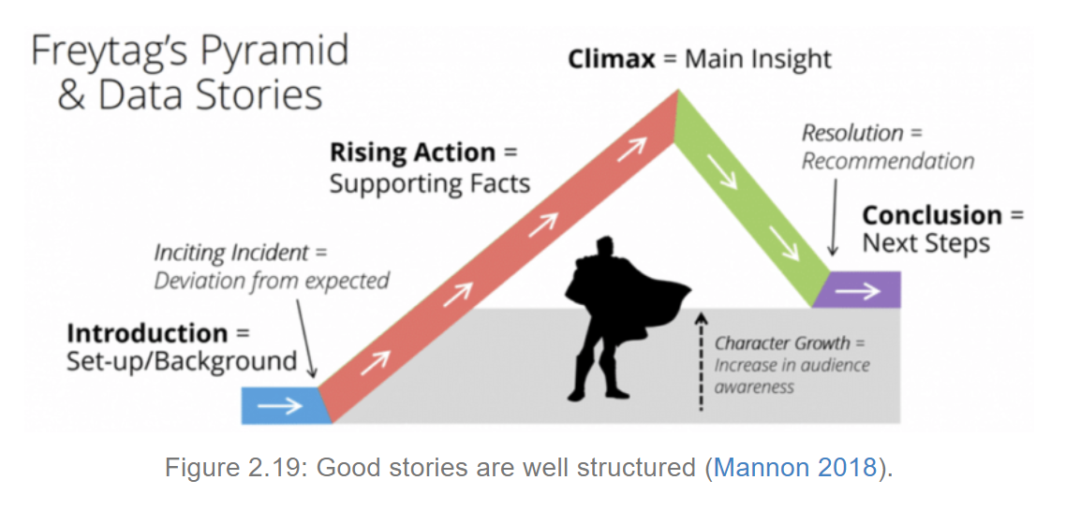

**Introduction (Hooking audience)**

**[SCENE 1]**

Tobacco is destroying our planet.

**[SCENE 2]**

Its poisoning our health

**Rising Action (Supporting facts)**

**[SCENE 3]**

Tobacco costs us more than 8 million lives every year.

**[SCENE 4]**

It also costs us 600 million trees.

**[SCENE 5]**

22 billion tonnes of water

**[SCENE 6]**

200000 Hectares of land

**[SCENE 7]**

84 million tonnes of CO2

**Climax (Main insights)**

**[SCENE 8]**

The data visualisation that will be shown is created by IHME. Global Burden of Disease in 2019 on the website our world in data

**[SCENE 9]**

In 1990, smoking was the third leading cause of deaths worldwide with a value of 5.87 million.

**[SCENE 10]**

In 1998, smoking became the second leading cause of deaths with a value of 6.54 million annually. An increase of about half a million.

**[SCENE 11]**

The data shows that smoking remained the second leading cause of deaths till 2019 with a value of 7.69 million. An increase of about a million.

**[SCENE 12]**

Despite all the facts, some people still smoke. We must acknowledge that smoking is addictive.

**[SCENE 13]**

Here we see that Across much of Asia, Eastern Europe, North America and Oceania, the average is around 20 to 25 cigarettes per day.

**[SCENE 14]**

Here we see that daily smoking is most common across Europe and Asia – more than 20% of adults in most countries in these regions smoke every day.

**Resolution (Recommendations)**

**[SCENE 15]**

So.. how to stop smoking?

According to Australia department of health, there are six steps to make an effective quitting plan:

The first is to understand why you want to quit, your motive and the health benefits.

The second is to learn what quitting will feel like

The third is to keep a quit diary to learn what makes you want to smoke

The fourth is to find out the tools and methods that are available to help you quit such as Nicotine replacement therapy

The fifth is to adjust your quitting plan to what suits you.

And finally, is to cope with quitting and understand what support is available to help you stay smoke-free

**[SCENE 16] Fuchsia**

Also, WHO have developed recently a new artificial intelligence system called Florence, Florence is digital health worker that can help someone who struggles with smoking addiction.

**Conclusion statement**

**[SCENE 17] Cyan**

In the end, health is one of the greatest blessings and we all must make better decisions to keep it.

**References**

Australia Government Department of Health and Aged Care. (2020). *How to quit smoking,* accessed 2 March 2023<https://www.health.gov.au/topics/smoking-and-tobacco/how-to-quit-smoking>

Our World in Data. (2013). *Smoking,* accessed 7 March 2023<https://ourworldindata.org/smoking#cigarette-consumption-per-smoker>

WHO. (2023). *Using AI to lead healthier lifestyle,* accessed 15 March 2023<https://ourworldindata.org/smoking#cigarette-consumption-per-smoker>

WHO. (2023). *Tobacco,* accessed 15 March 2023<https://ourworldindata.org/smoking#cigarette-consumption-per-smoker>