Flash App system |  | March 29  2020
This document describes the embedded software design of flash application. The target of this module is to have interface with flash fm25w32 with wear leveling concept. | System Design-ESW Part
Author : Ibrahem Mostafa | Version 1.0

Table of Contents
1. Introduction 3
1.1 Overview 3
1.2 Folders and files structure 3
1.3 Configuration file 3
1.4 References 3
1.5 Flash eeprom Emulation 4
2. Detailed Design 5
2.1 System flow 5
2.1.1 System through state machine 5
2.2Flash Blocks 5
2.3Records Design 7
2.3.1 How to choose the needed sectors number for record 7
2.3.2 Record sectors Sizes 7
2.3.3 Data structure in flash 9
3. Interfaces 10
3.1 Data structure 10
3.1.1 Flash_Record_ID_str 10
3.1.2 Flash_Image_Info_str 10
3.2 Global functions 10
3.2.1 Flash_app_init 10
3.2.2 Flash_app_Save_Record_ID 11
3.2.3 Flash_app_Get_Record_ID_from_flash 11
3.2.4 Flash_app_Save_Image_Info 11
3.2.5 Flash_app_Get_Image_Info 11
3.2.6 Flash_app_Set_Default_Record_ID 12
3.2.7 Flash_app_save_record 12
3.2.8 Flash_app_get_MAX_No_Records 12
3.2.9 Flash_app_get_index_record 13
3.2.10 Flash_app_clear_Record 13
3.2.11 Flash_app_get_num_record 13
3.2.12 Flash_app_get_record 14
3.2.13 Flash_app_get_mlti_rec 15
3.2.14 Flash_app_event 15
3.2.15 Flash_app_test 15
3.3 tested functions and function time 16

1. Introduction

1.1 Overview
Flash application is designed to use by file system to save records with wear leveling algorithm considering flash eeprom emulation concept and also to save images for new code, the current code and boot loader code if we need to make a bootstrap to start to run from.

1.2 Folders and files structure
flash application will be implemented inside \File_System\Flash directory. Flash_app.c will be source file and Flash_app.h will be header file. If other files required, it can be created inside Flash directory and this part of document must be updated. And it depended on calling the Flash driver in the same directory, so the static design of it as this figure:

1.3 Configuration file
This part will describe the defined features in Flash system and the dependency between them in the module. This part must be placed in config.h to select the required configuration for this module. Definitions will be as follow:
#define FLASH_FM25W32_ENABLE
And FLASH_APP_SAVING_IMAGES_FEATURE in flash_app.h.
And TEST_FLASH_APP in flash_app.c for testing function.

1.4 References
Some references describe the wear leveling and the flash eeprom emulation concept:

https://www.embedded-computing.com/guest-blogs/introduction-of-wear-leveling#
- Atmel AT4066: EEPROM Emulation Using Internal Flash (SAM4) pdf.
- AN4894-Application note-EEPROM emulation techniques and software forSTM32L4 and STM32L4+ Series microcontrollers’ pdf.
- AN798-silicon laps- EEPROM EMULATION WITHWEAR-LEVELING FOR8-BIT FLASH MCUS pdf.
- Flash driver datasheet: FM25W32 32M-BIT SERIAL FLASH MEMORY.

1.5 Flash eeprom Emulation
We use the term "EEPROM" for devices that are erasable on a per-byte or per "programming word" basis. Whereas we use the name "FLASH" for devices which only support erase capabilities in their entirety or on a sector base (mostly > 1k) here 4k.
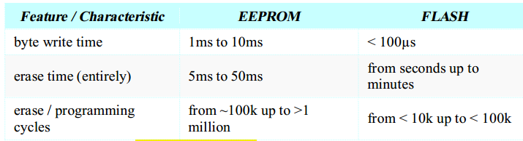
When using a data FLASH for the same scenario, two things fundamentally change rather than eeprom:
- It is not possible to overwrite data in a fixed address without erasing a big area of memory.
- The maximum number of programming cycles for a single cell decreases dramatically (approximately by factor 10).

A wear leveling algorithm allows monitoring and even distribution of Flash Write and Erase operations between Flash pages. When no wear-leveling algorithm is used, the pages are not used at the same rate. For instance, pages with long-lived data do not endure as many
Write and Erase cycles as pages that contain frequently updated data. The wear-leveling algorithm ensures that equal use is made of all the available write cycles for each Flash page.
By design, the EEPROM emulation algorithm distributes evenly the Flash write and Erase operations between Flash pages.

Wear Leveling is designed to allow NAND Flash to evenly spread throughout the use of blocks so that the P/E cycles of all blocks rise with the same data. This technology allows all blocks to be used thoroughly before the product reaches its life cycle, extending the life of the NAND Flash. Therefore, wear leveling technology can improve the reliability and durability of NAND Flash products.
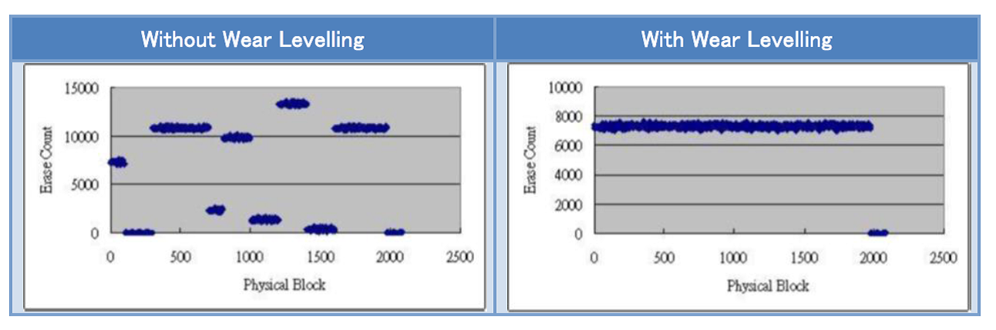

2. Detailed Design

2.1 System flow
There is main internal function to perform all operations which can be done by
- Initialize flash driver
- Get IDs for Records and Information for Images.
- Handle getting or saving records depending on events.
- Erase sector of Records ID and Image Information only when powered up or changed id to enable to save the changed IDs when power down event.

2.1.1 System through state machine

Flash Blocks
We use FM25W32 flash contains 32 Mbit separated as:
1024 sectors -> every sector has 4096 bytes arranged as 16 pages -> every page has 256 bytes.
So, 1024 sectors/flash * 16 pages/sector * 256 bytes/page = 4 Mbyte = 32 Mbit.
Which enabling us to make a high wear leveling using this huge size.

Sector | Block address | Description
0 | 0 | 256 bytes
 | 1 | 256 bytes
 | 2 | 256 bytes
 | 3 | 256 bytes
 | 4 | 256 bytes
 | 5 | 256 bytes
 | 6 | 256 bytes
 | 7 | 256 bytes
 | 8 | 256 bytes
 | 9 | 256 bytes
 | 10 | 256 bytes
 | 11 | 256 bytes
 | 12 | 256 bytes
 | 13 | 256 bytes
 | 14 | 256 bytes
 | 15 | 256 bytes
Till  …..  ..  … | The same sequence till reaching the end of flash …. ….. …  ..  …  ..
1023 | 0 | 256 bytes
 | 1 | 256 bytes
 | 2 | 256 bytes
 | 3 | 256 bytes
 | 4 | 256 bytes
 | 5 | 256 bytes
 | 6 | 256 bytes
 | 7 | 256 bytes
 | 8 | 256 bytes
 | 9 | 256 bytes
 | 10 | 256 bytes
 | 11 | 256 bytes
 | 12 | 256 bytes
 | 13 | 256 bytes
 | 14 | 256 bytes
 | 15 | 256 bytes

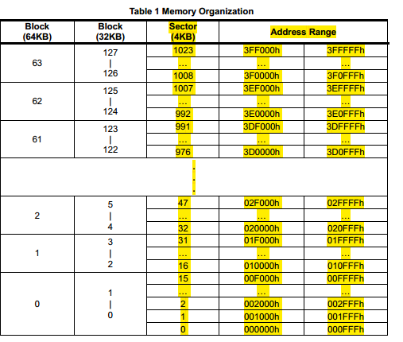

Records Design

2.3.1 How to choose the needed sectors number for record
We assumed the worst case to get the maximum number of records I need before making overlapping to save from the first address in the corresponding records space which forces us to erase one sector and lose some of data and increased the times for erasing and writing sectors with taking care about the limited number of erasing and writing sectors which is less than eeprom writing, so we should take care about this in flash as we can’t overwrite data without erasing, it will be corrupted if we write on an used sector which it’s byte != 0xff.
So, we put the worst case for every Record and add 1 sector for each record for saving more records when overlapping happened and erase sector happened and also for compensate the sector margin forces us to consider boundaries of sectors not to cut record data when erasing sector.
So Consider Sector Bounders means : if the record needs 20 bytes and now we reach near to the boundary of sector ,for ex: in page 15 in byte 240, if we write our record here we just write 15 byte of this record in this sector and the remaining 5 byte of the next sector, we will lose this record data when erasing any of these sectors, so the true behavior here is to leave 15 bytes in this sector and write the new record in the first address of the next sector.
We also consider not to put all records beside them, so we put at least one sector between the end of records sector and the start of the anther record type sector preventing any corruption in gates happened to all near sectors and to consider the need of increasing Record sector range.
So, when choosing the sector number needed for one record we considered:
- The maximum number of records we need to save it.
- Consider sector bounders.
- Overlapping times not to reach the maximum times of erasing/writing flash.
- Overlapping will force us to erase one sector and lose records in one sector.
- The frequency of saving record.

2.3.2 Record sectors Sizes
We assumed a huge space for records depending on the very worst scenario and considering wear leveling and consider we have a lot space till now used for records and images only, so it may be changed if we needed but till now we have a lot of free spaces.
All records takes: 292 sectors.
And images for current application code, new application code, current bootloader code and new bootloader code, take: 200 sectors. But it wasn’t implemented yet nor tested.
And one sector for ID for sectors and information data about image.
And one sector for general data saving in flash.
So the used space till now : 49% from all flash size.

2.3.2.1 Billing record
Billing record has 35 bytes.
Billing sector has: 4096 bytes/sector/35 bytes/billing record = 117.02 = 117 records/sector.
We made 3 sectors for billing record.
So the all number of sectors when no overlapping = 3 sectors * 117 records/sector = 351.
In normal use the billing records needed for 20 years = 12*20 = 240 records.

2.3.2.2 Event log record
Event record has 14 bytes.
One sector has: 4096 bytes/sector/14 bytes/record = 292.5 = 292 records/sector.
We made 8 sectors for Event log record.
So the all number of sectors when no overlapping = 8 sectors * 292 records/sector = 2336.
In worst cases the event log records needed for 20 years = 4000*20 = 80000 records which means 35 overlapping times only.

2.3.2.3 Money record
Money record has 17 bytes.
One sector has: 4096 bytes/sector/17 bytes/record = 240 records/sector.
We made 4 sectors for money record.
So the all number of sectors when no overlapping = 4 sectors * 240 records/sector = 960.
In worst cases the event log records needed for 20 years = 200*20 = 4000 records which means 5 overlapping times only.

2.3.2.4 Load Profile record
Load profile record has 22 bytes.
One sector has: 4096 bytes/sector/22 bytes/ record = 186 records/sector.
We made 272 sectors for Load profile record.
So the all number of sectors when no overlapping = 272 sectors * 186 records/sector = 50592.
In worst cases the Load profile records needed for 20 years = 103680*20 = 2073600 records which means 41 overlapping times only, assuming the load profile was taken every 5 minutes. And note we need to save 4 month events as log.

2.3.2.5 Configure meter record
Configure meter record has 10 bytes.
One sector has: 4096 bytes/sector/10 bytes/record = 409 records/sector.
We made 5 sectors for Configure meter record.
So the all number of sectors when no overlapping = 5 sectors * 409 records/sector = 2045.
In worst cases the Load profile records needed for 20 years = 356*20 = 7300 records which means 4 overlapping times only.

2.3.3 Data structure in flash
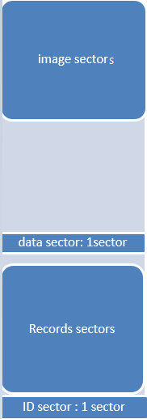
We have one Sector for ID to tell us the last place of every record and the record index and record numbers and how many overlapping happen.
This sector saved only when power down event.

3. Interfaces
This system has many interfaces that help other module to get required data and give the system the ability of working with different configurations.

3.1 Data structure

3.1.1 Flash_Record_ID_str
It is an array for all records types.
uint32_t Records_number; | Total saved records, when it reaches maximum, it will not increase any more.
uint32_t Record_index; | Record saved index, it may be overlapped and started counting from 0 when overlapping happened.
uint16_t last_Sector_Num; | The current sector number from 0 to 1023 which has the last saved record.
uint16_t Next_Sector_Num; | Next sector number from 0 to 1023 to save the new record in.
uint8_t Next_Byte_index; | Next byte index from 0 to 255 to save the new record in.
uint8_t Next_Page_index; | Next page index from 0 to 15 to save the new record in.
uint8_t OverLapping_times; | how many times records saved reached the last place in the last sector and erased the first sector to overlapping
Uint8_t Crc; | If when loading CRC was corrupted, raise flag corrupted data and set the default id.

3.1.2 Flash_Image_Info_str
It is an array for all image types.
uint32_t Image_Size_Bytes; | Image size by bytes.
uint8_t Version[10]; | Firmware version string.
uint8_t OverWrite_Times; | How many times overwrite to these sectors happened
Uint8_t Crc; | If when loading CRC was corrupted, raise flag corrupted data and set the default id.

3.2 Global functions

3.2.1 Flash_app_init
Format | uint8_t Flash_app_init()
Description | Initialize the flash driver and get the id for all records and the information about images.
Argument | None.
Return value | NO_ERROR if getting data is ok, else get one of Flash_errors_Enmt.

3.2.2 Flash_app_Save_Record_ID
Format | uint8_t Flash_app_Save_Record_ID(uint8_t recordType)
Description | Save Id of the required record to its appropriate place in flash.  NOTE:  We didn’t make wear leveling here as it will be saved a little time, only when power down, so we erased this sector before writing on it again.
Argument | recordType: type of file_sys_record_type_t.
Return value | NO_ERROR if ok, else get one of Flash_errors_Enmt.

3.2.3 Flash_app_Get_Record_ID_from_flash
Format | uint8_t Flash_app_Get_Record_ID_from_flash(uint8_t recordType, Flash_Record_ID_str* ID_data_ptr)
Description | Get ID of the required record to its appropriate place in flash.
Argument | ID_data_ptr: data pointer of the required record.  recordType: type of file_sys_record_type_t.
Return value | NO_ERROR if ok, else get one of Flash_errors_Enmt.

3.2.4 Flash_app_Save_Image_Info
Format | Flash_app_Save_Image_Info
Description | Save Image Information of the required record to its appropriate place in flash.
Argument | ImageType: type of ImageTypeEnum.  NOTE:  The address of images are fixed and didn’t need to be handled by wear leveling concept.
Return value | NO_ERROR if ok, else get one of Flash_errors_Enmt.

3.2.5 Flash_app_Get_Image_Info
Format | uint8_t Flash_app_Get_Image_Info(uint8_t ImageType, Flash_Image_Info_str* Info_data_ptr)
Description | Get Image Information of the required record to its appropriate place in flash.
Argument | ID_data_ptr: data pointer of the required image information.  ImageType: type of ImageTypeEnum.
Return value | NO_ERROR if ok, else get one of Flash_errors_Enmt.

3.2.6 Flash_app_Set_Default_Record_ID
Format | void Flash_app_Set_Default_Record_ID(uint8_t recordType)
Description | Set the default of Flash_Record_ID_arr.
Argument | recordType: type of file_sys_record_type_t.
Return value | None.

3.2.7 Flash_app_save_record

3.2.7.1 General description
Format | uint8_t Flash_app_save_record(uint8_t record_type, uint8_t *data_ptr)
Description | Save a record data in storage media of certain type like:  - Profile record  - Money transaction record  - Billing period history record  - Event record  - Configure meter records
Argument | record_type Type of records in file_sys_record_type_t  data_ptr: Address of buffer to get the data in
Return value | NO_ERROR if ok, else get one of Flash_errors_Enmt.

3.2.7.2 More description for saving record
We use the ID record structure to know the next place we need to save our record at. There are many probabilities:s
- If the next byte =0 and the next page = 0, we decide to erase this sector before writing in it avoiding if there are any data resulting from corruption or any unexpected behavior no to overwrite, and already we need erasing it when reaching the start of this sector if overlapping happened.
- Consider sector boundaries limit as described at section 2.3.1.
- When overlapping happen we need to erase the first sector then after completing it erase the second sector and so on till the last sector. This leads to decreasing the total record number from all records in sectors – the erased sector.
- So depending on number 3 when overlapping happened the records number will be = the number of records in one sector *(number of sectors - 1).but when reaching the last sector after overlapping happen, the record index will be > the number of records in one sector *(number of sectors - 1). So in this case (overlapping happened + reaching to the last sector) we decided to increase the record number to be equaled the record index. Then when reaching the last byte in the last sector the record number will be = the number of records in one sector *(number of sectors). Then after new overlapping again the record number will return to be = the number of records in one sector *(number of sectors - 1).

3.2.8 Flash_app_get_MAX_No_Records
Format | uint32_t Flash_app_get_MAX_No_Records (uint8_t record_type)
Description | Get the max number of records can be saved in all regared sector space.
Argument | record_type Type of records in #file_sys_record_type_t.
Return value | 32 bit: the max number of all records that can be used in this space either it is saved already or not.

3.2.9 Flash_app_get_index_record
Format | uint32_t flash_app_get_index_record(uint8_t record_type)
Description | Get the index of the wanted record of certain type.
Argument | Get the index of the wanted record of certain type like:  - Profile record  - Money transaction record  - Billing period history record  - Event record  - Configure meter records
Return value | 32 bit: the number of saved records.

3.2.10 Flash_app_clear_Record
Format | uint8_t Flash_app_clear_Record(uint8_t record_type)
Description | Clear records of certain type.
Argument | Clear all record saved in storage media of certain type like:  - Profile record  - Money transaction record  - Billing period history record  - Event record  - Configure meter records  NOTE:  Clearing storage media is not done by reset pages in storage media but, only by reset index and number of saved records to be overwritten by coming records.  As already when next byte =0 and next page =0, we will erase the sector before writing.
Return value | NO_ERROR if ok, else get one of Flash_errors_Enmt.

3.2.11 Flash_app_get_num_record
Format | uint32_t Flash_app_get_num_record(uint8_t record_type)
Description | Get number of saved records of certain type.
Argument | record_type Type of records in #file_sys_record_type_t
Return value | 32 bit: the number of saved records.

3.2.12 Flash_app_get_record

3.2.12.1 General description
Format | uint8_t Flash_app_get_record ( uint8_t recordType , uint32_t record_num , uint8_t *data_ptr , uint32_t WantedRecords_Num )
Description | Get a record data saved in storage media of certain type
Argument | record_type: Type of records in file_sys_record_type_t  record_num: Number of record to be read (0 -> max-1)  data_ptr: Address of buffer to get the data in.  WantedRecords_Num: number of wanted records from 1 to max record numbers.
Return value | NO_ERROR if ok, else get one of Flash_errors_Enmt.

3.2.12.1 More description for read algorithm
There are many steps:
- Check the argument and the record and the wanted records are< record numbers or not.
- If not overlapping, define the required sector, page index, byte index for the required record. Then get required records and consider sector boundaries in section 2.3.1.
- If overlapping, there are erased sector, so it will be a new start address for our record data. It depends on shifting records.
So the new start sector will = (last sector + 1).
And the new shift in this new start sector will = the number of records in the last sector.
Get example if overlapping happened to find the new start records address.

3.2.13 Flash_app_get_mlti_rec
Format | uint16_t Flash_app_get_mlti_rec(uint8_t record_type, uint16_t from, uint32_t num_rec, uint8_t *data_ptr)
Description | Get certain number of records saved in storage media of certain type
Argument | record_type: Type of records in file_sys_record_type_t  from First record number you want to read (0 -> max-1)  num_rec Number of record to be read (1 -> max)  data_ptr: Address of buffer to get the data in
Return value | NO_ERROR if ok, else get one of Flash_errors_Enmt.

3.2.14 Flash_app_event
Format | void Flash_app_event(uint8_t event_code)
Description | Tell flash module with a new event.  FLASH_APP_UP_SECONDS: when power is up flag after 10 seconds, we erased sector id if not erased yet to be enable to save ids direct when power down without need to wasting time at erase sector at this critical time.  FLASH_APP_PWR_DN: save IDs and image information when power down only if these ids changed or already get else don’t save as data wasn’t changed, and for safety check again if it changed and sector id need to erase, erase it.
Argument | event_code Code of event #file_sys_event_type_t
Return value | None.

3.2.15 Flash_app_test
Format | Void Flash_app_test()
Description | To test flash application function. Calling almost every important functions first then test save and get. There are two #define  - TEST_FLAFH_APP_SAVING_RECORDS to test saving record in billing history, write all space 5 times and reading after each record saving.  - TEST_FLAFH_APP_READING_ONLY to test read multi record function, read all records saved.
Argument | None.
Return value | None.

Tested functions and function time

All functions are tested and worked correctly and also tested when power down, before 10seconds and after it, to be ensured the time is enough.
I saved 10 records then erase sector id then save sector ids after power down and it worked correctly and go to power down.
Erase sector tasks ~= 50 mili-seconds.
Save one record with 35 bytes take ~= 5 mili-seconds.
Get all sector IDs take ~= 2 mili-seconds.
Erase all billing history and write and read 351 records takes ~= 3.5 seconds.

