CSE211 Web Programming, Fall Semester 24/25

Assignment #1: Websites conceptual Design and mock-up

Name: Marwan Mohamed Samy

Id :221100497

**2.3.1Part 1:resarch**

**1. Defining Characteristics from Web 2.0 to Web 4.0**

**Web 2.0: Often called the "Social Web," this era is centered on interactive, user-generated content and social networking. Prominent features include blogs, social media sites, and platforms for content sharing.**

**Web 3.0: Known as the "Semantic Web," Web 3.0 aims for a more personalized experience using AI and machine learning, allowing for contextual data interpretation. Its focus includes data integration and AI-powered insights.**

**Web 4.0: Termed the "Intelligent Web," this stage emphasizes enhanced interactions between humans and machines. This phase involves the Internet of Things (IoT), automation, and advanced AI, enabling highly personalized user experiences.**

**2. Web 2.0’s Key Features and How It Strengthens Networks**

**Key Features: User-created content, social networking, tagging, and collaboration within communities.**

**Impact: Web 2.0 transformed the internet into an interactive, two-way platform, encouraging individuals and businesses to engage, create, and build communities around shared interests.**

**3. Web 3.0’s Key Features and Its Role in Data and Knowledge Connection**

**Key Features: Semantic search, personalization, machine learning, and insights from data.**

**Impact: Web 3.0 enhances user-content interactions by interpreting data in a way that yields more relevant and meaningful results, thus strengthening the connection between knowledge and users.**

**4. Web 4.0’s Key Features and Its Impact on Intelligent Connections**

**Key Features: Advanced AI, IoT integration, automation, real-time communication, and virtual assistants.**

**Impact: Web 4.0 fosters an ecosystem where devices interact seamlessly, enabling quick responses and more tailored user experiences.**

**Significance of Collective Intelligence, Social Networking, Social Media, and Social Bookmarking**

**Collective Intelligence: Leveraging the knowledge of many users allows for more accurate insights and creative solutions.**

**Social Networking: Facilitates large-scale connections, collaboration, and community building.**

**Social Media: Provides platforms for global conversations and content sharing.**

**Social Bookmarking: Lets users save and organize content for easy access and sharing, contributing to a more interconnected and knowledge-rich web.**

**How These Technologies Empower Present and Future Business Strategies**

**Current Business: Web 2.0 to Web 4.0 technologies enable businesses to enhance customer engagement, offer personalized experiences, and make data-driven decisions.**

**Future Business: The advancement of automation and AI-driven insights will allow for even more innovative business models, improving efficiency and responsiveness to customer needs.**

**Intended Use of Emerging Technologies in Your Profession**

**Application: Describe how innovations like AI, IoT, or big data can be applied in your field. For instance, in marketing, Web 3.0 and Web 4.0 could enable personalized advertising and customer interaction in real-time, while in healthcare, these technologies could enhance patient care and data management through AI and IoT.**

**2.3.2.Part 2:website planning**

Define the Purpose of Your Intended Website:

The purpose of the "A.E.K" website is to highlight our family-owned restaurant, showcasing our menu, services, and story. It will serve as a platform for customers to explore our offerings, make reservations, and connect with our community.

What Would You Like the Website to Accomplish? The website aims to:

Promote our restaurant and unique culinary dishes.

Facilitate online reservations for dining or private events.

Share information on special events, promotions, and seasonal menus.

Convey our story and values to build a connection with our guests.

Who Is Your Intended Audience? The intended audience includes:

Local residents seeking quality dining experiences.

Event planners looking for catering or private dining options.

Families interested in custom menu options for celebrations.

Individuals looking for gluten-free, vegan, or other dietary options.

What Opportunities, Problems, or Issues Does Your Planned Website Address? Opportunities include:

Expanding our customer base by reaching people online.

Increasing bookings through online reservation and ordering options.

Building brand loyalty through storytelling and community engagement. Problems addressed:

Customers not knowing about our offerings or location.

Inconvenience for customers unable to visit the restaurant in person.

Difficulty in managing reservations and inquiries through phone calls.

What Kind of Content Could Be Incorporated on Your Website? The website could include:

A menu gallery showcasing our dishes (photos and descriptions).

An online reservation system for table bookings and private events.

A blog featuring cooking tips, recipes, and behind-the-scenes stories.

Customer testimonials and reviews.

Information on events, promotions, and catering services.

How Will the Site Serve the Client? The site will serve clients by:

Providing a user-friendly interface for browsing the menu and making reservations.

Offering easy access to information about our restaurant and its values.

Allowing customers to sign up for newsletters and promotions to stay informed.

What's the Best Method for the User to Do What's Wanted? The best method for users to engage with the site includes:

A clear navigation menu for easy access to different sections (menu, about us, contact).

Prominent call-to-action buttons for reservations and newsletter sign-ups.

A search function to quickly find specific dishes or information.

How Will Users Find the Function? Users will find functions through:

An intuitive layout that highlights key features (reservations, contact, events).

SEO-optimized content to improve visibility in search engine results.

Social media links and promotions to drive traffic to the website.

How Will the Results of the Function Be Received? The results of the functions on the website, such as reservation confirmations and inquiries, will be received through:

Email notifications sent to both the customer and the restaurant for each reservation made.

On-screen confirmation messages displayed after a reservation is successfully submitted, reassuring customers that their booking is confirmed.

Customer account dashboards (if applicable) that allow users to track their reservation history and status.

What Will the Receiver Do with the Received Entries? The receiver (restaurant staff) will:

Review reservations to ensure availability and prepare for service.

Respond to customer inquiries and feedback received through the contact form or email.

Maintain a database of customer orders for inventory management and future marketing efforts.

How Will the Receiver Deal with Results? The restaurant will deal with results by:

Organizing reservations into daily or weekly schedules for efficient table management.

Communicating with customers regarding reservation status, any issues, or event details.

Collecting and analyzing customer feedback to improve the dining experience.

What Follow-up Will Be Needed? Follow-up activities may include:

Sending follow-up emails to customers thanking them for their visit and inviting feedback.

Offering special promotions to previous customers to encourage repeat visits.

Conducting periodic surveys to assess customer satisfaction and gather insights for improvement.

List at Least Two Related or Similar Sites Found on the Web. Explain Why You Chose Them. Here are two similar sites I found:

Olive Garden

Reason for selection: Olive Garden's website effectively highlights its menu and special promotions, with an easy-to-use reservation system. It serves as a good reference for engaging customers with appealing visuals and convenient online booking.

The Cheesecake Factory

Reason for selection: The Cheesecake Factory’s website offers a clean, attractive design with a broad menu and a user-friendly reservation option. Its emphasis on quality and community involvement aligns well with "A.E.K's" values and customer engagement strategies.

Planning Analysis Sheet: a. Website Goal

The goal of the "A.E.K" website is to establish an online presence that showcases our restaurant's unique offerings, allows customers to make reservations easily, and builds a community around our family business through engagement and storytelling.

b. Working Title of Pages

About Us

Our Menu

Online Reservations

Special Offers

Events & Catering

Blog

Customer Testimonials

Contact Us

FAQs

Gallery

c. Description of Contents for Each Page

Homepage

Content: Brief introduction to the restaurant, featured dishes, and a promotional banner for current offers. Includes high-quality images of menu items, a short welcome video, and prominent call-to-action buttons for reservations and signing up for the newsletter.

About Us

Content: The restaurant's history, mission, and values. Paired with family photos and behind-the-scenes images, and a short video telling the story of the restaurant and its founders.

Our Menu

Content: Detailed listings of all menu items with descriptions, pricing, and high-quality images. Option to filter by category (e.g., appetizers, main courses, desserts). User inputs for selecting quantities.

Online Reservations

Content: An interactive form where customers can select dining times, specify seating preferences, and input special requests. Includes a summary of reservation details and confirmation options.

Special Offers

Content: Information on seasonal promotions, discounts, and loyalty programs. Text and visuals that highlight current deals, with an option for users to subscribe to get alerts on future offers.

Events & Catering

Content: Details about catering services and private events hosted at the restaurant. Images from past events, a downloadable catering menu, and a contact form for inquiries.

Blog

Content: Regularly updated posts featuring cooking tips, recipes, community stories, and restaurant news. Includes images and optional audio snippets for specific recipes.

Customer Testimonials

Content: A collection of quotes and reviews from satisfied customers, alongside their photos. A submission form for new testimonials to encourage user engagement.

Contact Us

Content: Contact form for inquiries, location map, restaurant hours, and social media links. Includes a FAQ section addressing common questions.

FAQs

Content: A list of frequently asked questions related to dining, reservations, and policies, with concise answers. Users can submit additional questions through a form.

Gallery

Content: A visually rich gallery showcasing product images, events, and community engagement. Users can upload their own photos featuring "A.E.K" dishes.

d. User Forms for Information Collection

Online Reservation Form: Users can select dining times, specify preferences, and enter special requests.

Newsletter Subscription Form: Collects email addresses for users to subscribe to updates and promotions.

Contact Form: Allows users to send inquiries or comments directly to the restaurant.

Customer Testimonial Submission: A form where customers can submit their own reviews or testimonials.

Event Inquiry Form: Collects information for catering requests or private event bookings.

**Customer Testimonial Submission**: A form where customers can submit their own

* e. Flow chart

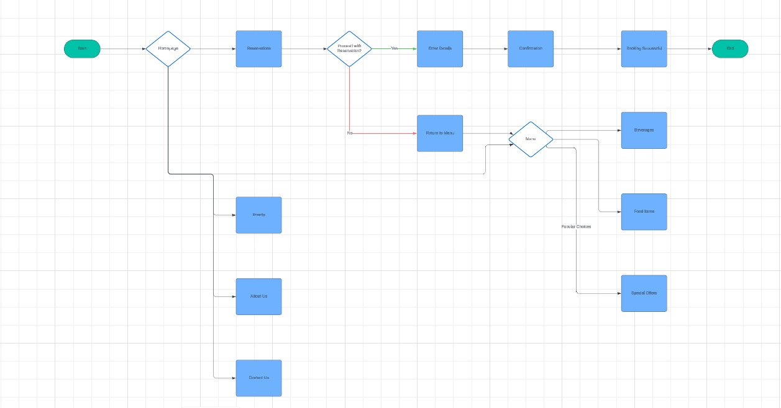

Wireframe

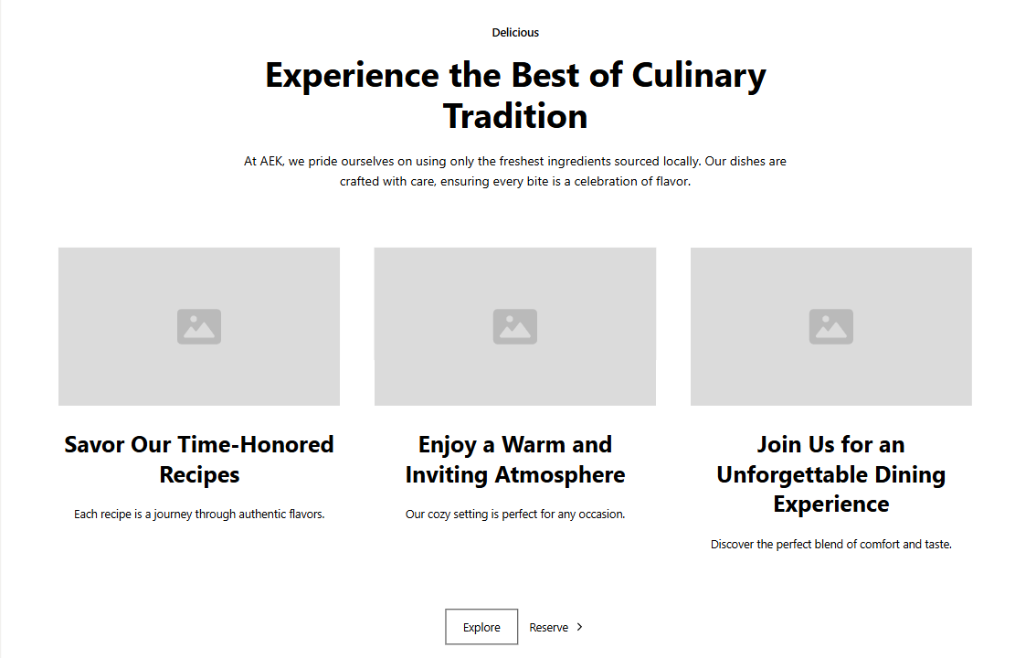

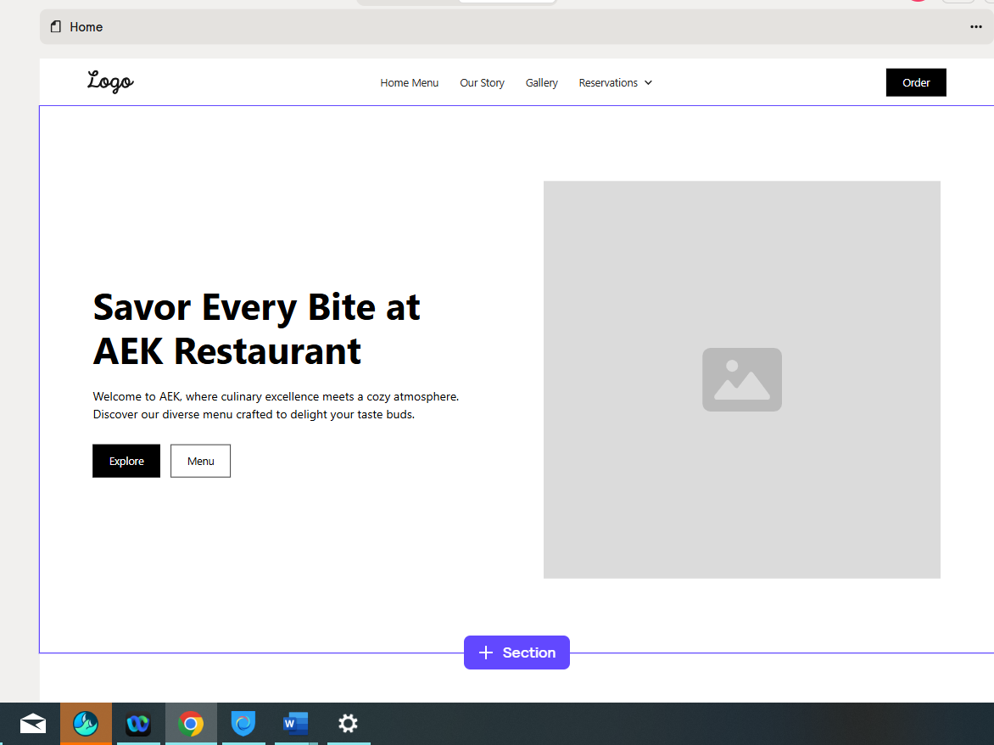

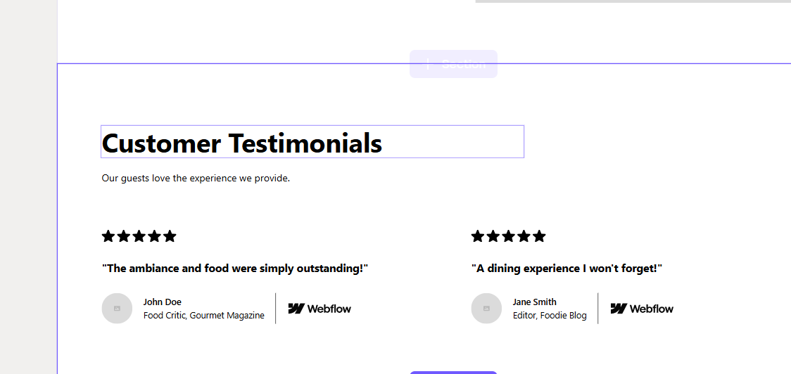

### - Gestalt Web Design Principles Implementation

1. Law of PRAGNANZ (Good Figure, Law of Simplicity)

* **Implementation:** Each page will have a clean, simple design with only essential elements to avoid clutter. The layout will focus on presenting information in a straightforward, minimalistic way, using large, clear images of baked goods and concise text.
* **Example:** On the **Our Products** page, each product will be displayed with a simple, high-quality image and brief description, helping customers quickly identify items without excessive details or distracting visuals.

2. Closure (Linking Individual Elements to Form a Pattern)

* **Implementation:** Elements such as product cards, testimonial quotes, and blog posts will be arranged in a grid format to give a sense of unity, even though they are individual items. Users will naturally perceive these individual items as part of a cohesive group.
* **Example:** On the **Gallery** page, images will be arranged in a grid with consistent spacing, encouraging users to view them as a collective showcase of bakery offerings, events, and customer photos.

3. Symmetry and Order (Effectively Communicate Information Quickly)

* **Implementation:** Each page will use balanced layouts and consistent navigation to communicate information in a structured manner, allowing users to quickly understand and engage with content.
* **Example:** On the **Homepage**, a balanced three-column layout will separate featured products, recent blog posts, and special offers, enabling users to identify main sections at a glance and navigate intuitively.

4. Figure/Ground (Relationship Between Positive Elements and Negative Space)

* **Implementation:** Ample white space will be used around images, text blocks, and buttons to distinguish key elements from the background and enhance readability. This separation between content and background makes it easy for users to focus on primary information.
* **Example:** On the **Contact Us** page, the form fields and contact information will be positioned with generous spacing around them, making the form fields stand out as the primary interactive area.

**5. Uniform Connectedness (Relationship Between Elements)**

* Implementation: Elements with similar purposes, such as buttons and links, will be styled uniformly across pages. This consistency reassures users and strengthens their understanding of how interactive elements function.
* Example: Across all pages, buttons like Order Now and Learn More will share the same color and style, indicating they serve a similar purpose of prompting user action. This will help users quickly identify clickable areas.

**6. Common Region (Connection Between Elements)**

* Implementation: Grouping related content within visual boundaries, such as boxes or shaded backgrounds, will help users recognize relationships between elements. This will make content easier to scan and interpret.
* Example: On the Online Ordering page, each product category will be visually grouped in sections with background color distinctions, helping users understand that products within each section are related.

**7. Proximity (Utilizing Empty Space to Create Relationships)**

* Implementation: Related elements on each page will be grouped close together with ample space separating unrelated sections. This use of white space will help guide the user’s eye and convey the relationships between different sections.
* Example: On the Our Products page, items in the same category (e.g., cakes, pastries) will be placed closely together, with space between categories, so users can easily understand which items belong together.

**8. Continuation (Continuous Perception of Shapes)**

* Implementation: The layout will use lines and flow to create a sense of continuity between sections. This encourages users to naturally follow the content as they scroll, ensuring a smooth user experience.
* Example: A continuous scrolling effect on the Homepage will guide users from the welcome message down through the featured products, blog highlights, and promotional offers, creating a fluid and engaging browsing experience.

**9. Common Fate (Synchrony: Items Moving or Changing Together are Perceived as Related)**

* Implementation: Elements that interact simultaneously will be grouped to enhance user experience. For instance, hovering effects on buttons or images will respond together to emphasize functionality.
* Example: On the Special Offers page, featured offers will zoom slightly or highlight when users hover over them. This creates a sense of interactivity and connects these elements visually, showing they can be clicked or interacted with.

**10. Parallelism (Parallel Elements are Seen as More Related)**

* Implementation: Parallel structures and aligned elements will be used to show connections between related items or sections, making it easier for users to understand the layout.
* Example: On the Events & Catering page, two columns will be used for event information and catering packages, with each section aligned horizontally. This structure shows that these offerings are parallel services provided by the bakery.

**11. Similarity (Elements with Similar Characteristics are More Related)**

* Implementation: Consistent design styles, such as colors, shapes, and fonts, will indicate related elements across pages. Repeating these styles will reinforce the brand identity and improve user navigation.
* Example: Buttons across the site (like Order Now, Subscribe, and Learn More) will share similar styling in color and shape, helping users quickly identify actionable items.

**12. Past Experience (Utilizing Observer’s Past Experience)**

* Implementation: Familiar elements, such as icons and common web patterns, will be used to match user expectations and make the site easier to navigate without a learning curve.
* Example: On the Contact Us page, using a familiar envelope icon for email or a phone icon for contact numbers will ensure that users instantly understand these functions. Similarly, a “cart” icon in the Online Ordering section will align with common e-commerce conventions.

**[B] Deployment of Other Design Concepts**

**1. Screen Resolution**

* Approach: The website will be designed to be responsive, meaning it adapts well to various screen resolutions and devices. The primary design focus will be on a mobile-first approach to ensure a seamless experience on mobile devices (e.g., 375x667) and tablets, then scaled up to fit larger screens (e.g., 1366x768, 1920x1080).
  1. **Color Palette**

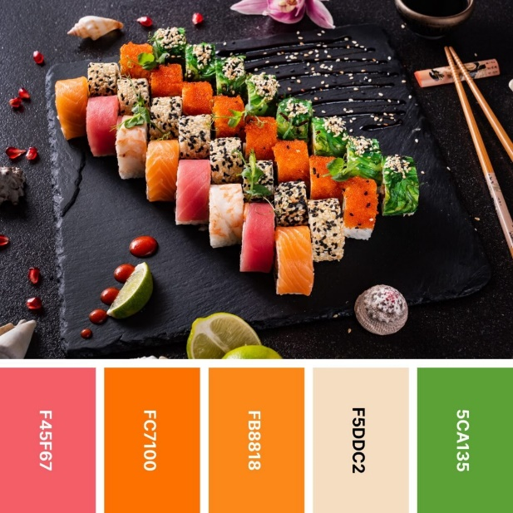

**3. Minimum Contrast for Accessibility**

* Implementation: To comply with Web Content Accessibility Guidelines (WCAG) standards, the site will maintain a minimum contrast ratio of 4.5:1 for text and background colors. This ensures that text remains legible for users with visual impairments. The color palette will be checked for contrast, especially for text on backgrounds, using tools like Contrast Checker.

**4. Front-End Development Technologies**

* Technologies: HTML5, CSS3, JavaScript, and React.js (or Vue.js) will be used to create an interactive, responsive, and accessible user interface.
* Frameworks and Libraries: Bootstrap (or Tailwind CSS) for responsive layout, and potentially React for building reusable UI components to enhance interactivity and manage data-driven elements such as the product listings and order form.

**5. Content Management Systems (CMS)**

* Choice: WordPress or Shopify (for eCommerce-focused needs) would be ideal CMS options, depending on the final site’s functionality.
* Rationale: WordPress offers flexibility and easy customization with plugins and themes, making it suitable for a small business. Shopify would be ideal if the bakery requires more advanced eCommerce capabilities, like inventory tracking and secure payment gateways.

**6. Back-End Development Technologies**

* Technologies: Node.js and Express for handling server-side requests, with a MongoDB or MySQL database for storing product information, customer orders, and contact form submissions.
* Security: Integration of secure practices such as HTTPS for secure connections and data encryption for user information in transit and at rest.

**7. Metrics for Measuring Website Performance**

* Key Metrics:
* Page Load Speed: Measured using Google PageSpeed Insights, as faster load times are critical for user experience and SEO.
* Bounce Rate: To understand user engagement and refine site navigation and content.
* Conversion Rate: Particularly for the Online Ordering page, to track the percentage of visitors who complete a purchase.
* User Behavior Flow: Tracking how users navigate between pages to identify drop-off points and optimize flow.
* Accessibility Score: Ensuring the site is accessible to users with disabilities, using tools like WAVE or Lighthouse.

8. **HTML5 Page Structure for Every Page**

**<!DOCTYPE html>**

**<html lang="en">**

**<head>**

**<meta charset="UTF-8">**

**<meta name="viewport" content="width=device-width, initial-scale=1.0">**

**<title>A.E.K - [Page Title]</title>**

**<link rel="stylesheet" href="styles.css">**

**</head>**

**<body>**

**<!-- Header Section -->**

**<header>**

**<nav>**

**<a href="index.html">Home</a>**

**<a href="about.html">About Us</a>**

**<a href="menu.html">Our Menu</a>**

**<a href="order.html">Order Online</a>**

**<a href="contact.html">Contact Us</a>**

**</nav>**

**</header>**

**<!-- Main Content Section -->**

**<main>**

**<section id="hero">**

**<!-- Hero content specific to the page -->**

**</section>**

**<section id="content">**

**<!-- Main content for each page, such as menu items, blog posts, etc. -->**

**</section>**

**</main>**

**<!-- Footer Section -->**

**<footer>**

**<p>© A.E.K Restaurant - All Rights Reserved</p>**

**<div>**

**<a href="privacy.html">Privacy Policy</a>**

**<a href="terms.html">Terms of Service</a>**

**</div>**

**</footer>**

**</body>**

**</html>**