|  |  |
| --- | --- |
| Knowledgebase project  COVID-19 TEST |  |
| **Supervisor: Dr. Osama Fathy**  **Supervisor: Eng. Abdulrahman Samy**  **By Marwan Khaled Diab 2016030082** |  |

|  |  |
| --- | --- |
| Basic definition What is covid-19 Test ? It is a system for diagnosing suspected cases with Corona disease through some questions whose answers are identified by the person being examined according to their answers. The system determines whether the person has symptoms of the virus or not and also uses the system to track cases by saving his personal data, address and phone number to communicate With him |  |

|  |  |  |  |
| --- | --- | --- | --- |
| Problem definition The major problem of the basic  :   * Confine the injured to a specific area. * Difficulty storing and tracking their data * Diagnosis of the patient with virus  Project objectives  * Corona virus disease diagnosis * Track patients * Store their data and examination results  Software Tools  * WPF With C# for (Code). * Exsys Developer for(Expert System). * Xaml and marital design for (Design).  Testing with screen shoot | | |  |
|  | |
|  |
|  |  |  |

Dsdsa

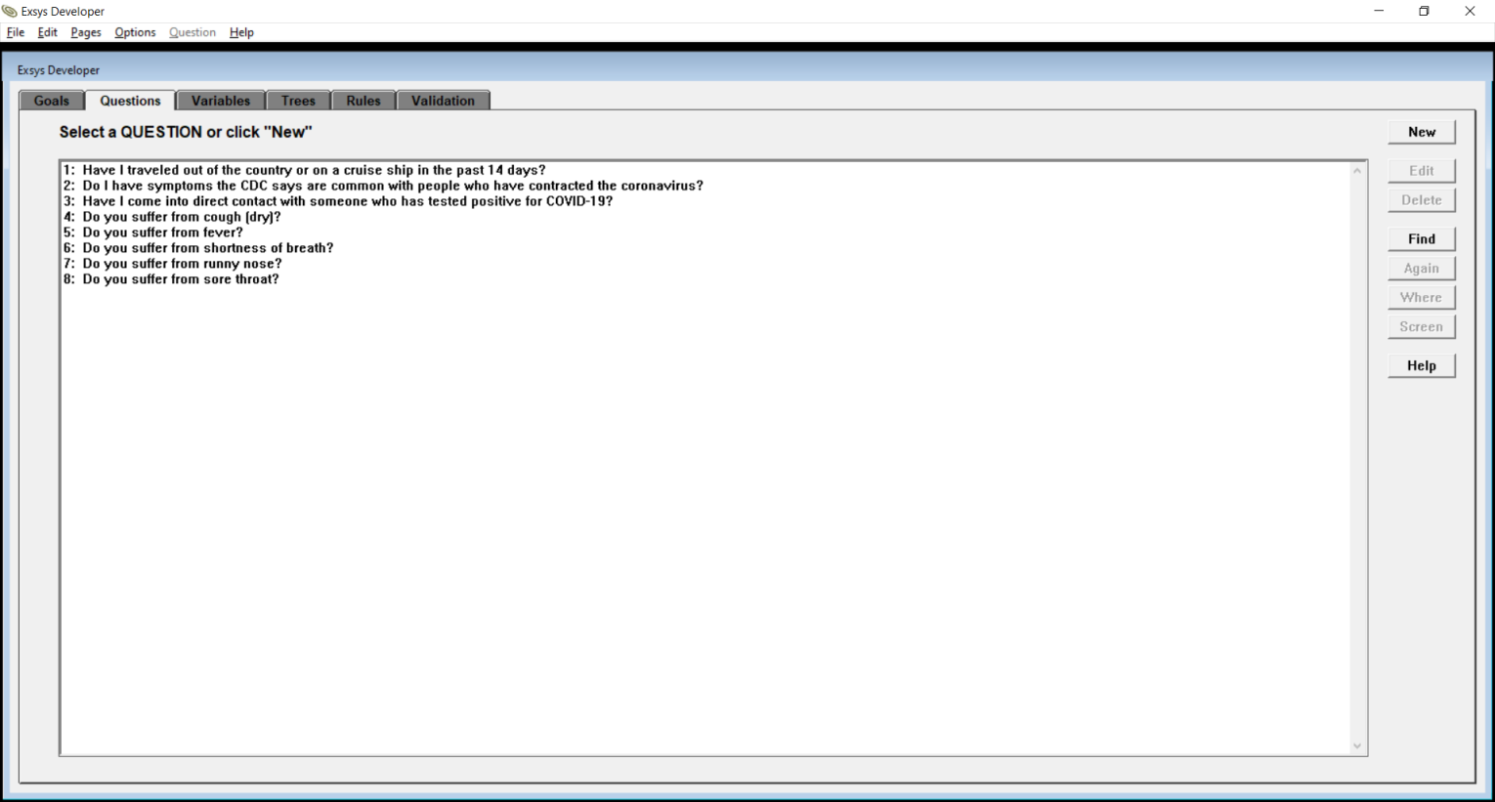

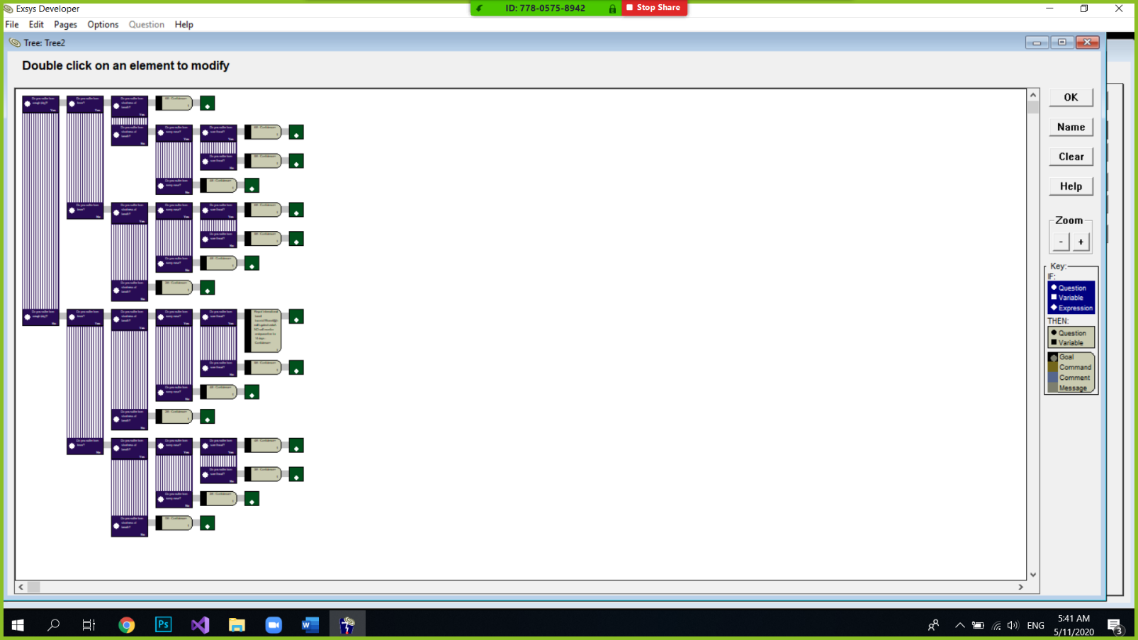

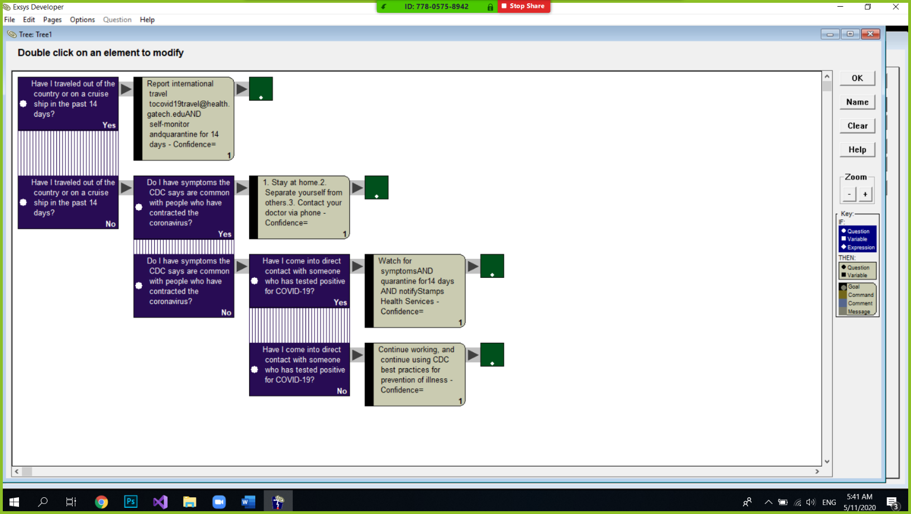

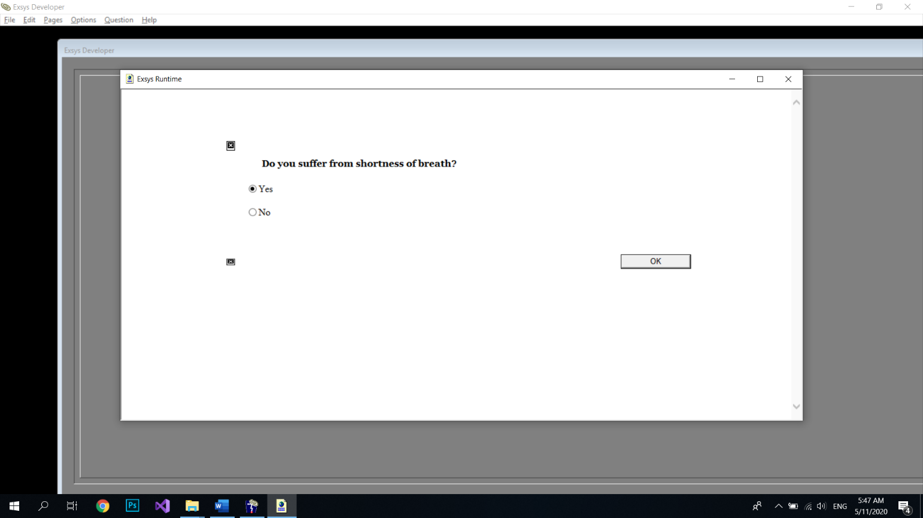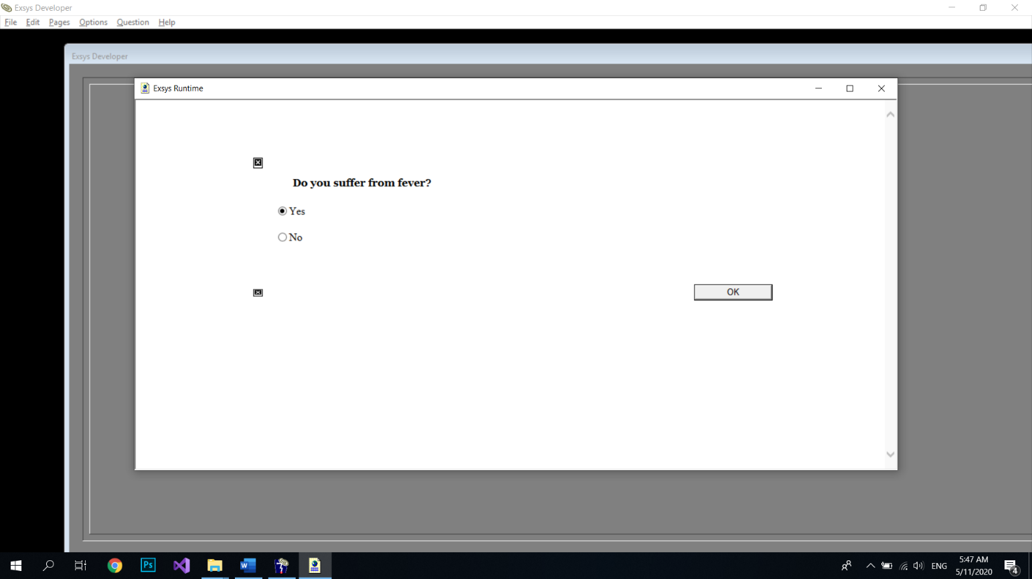

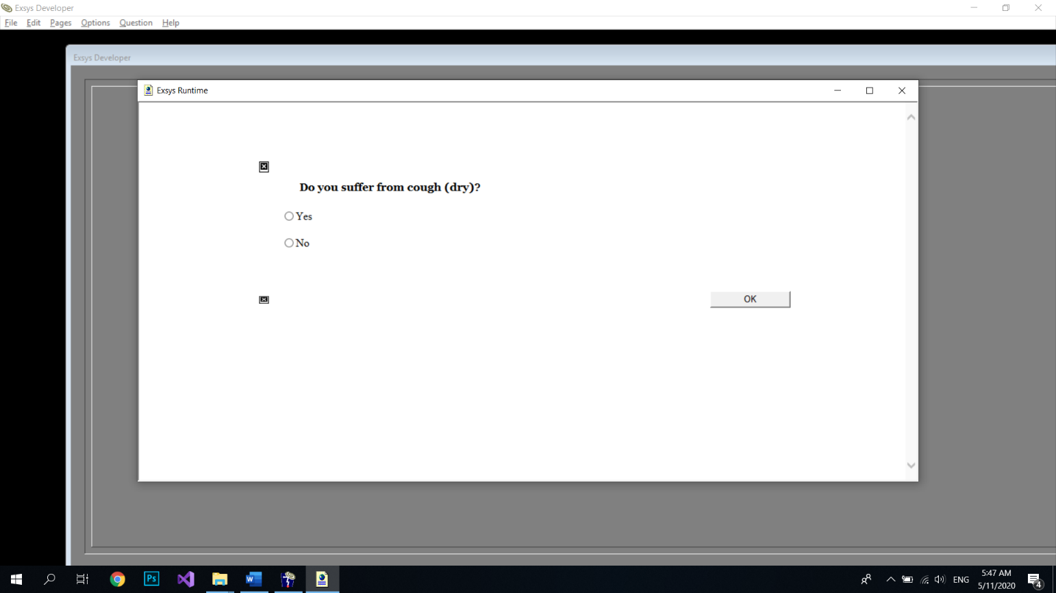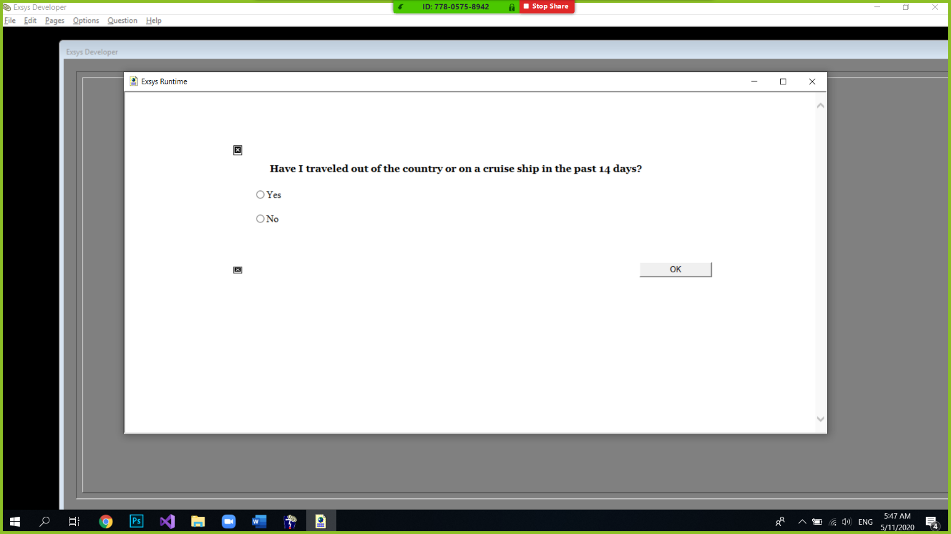

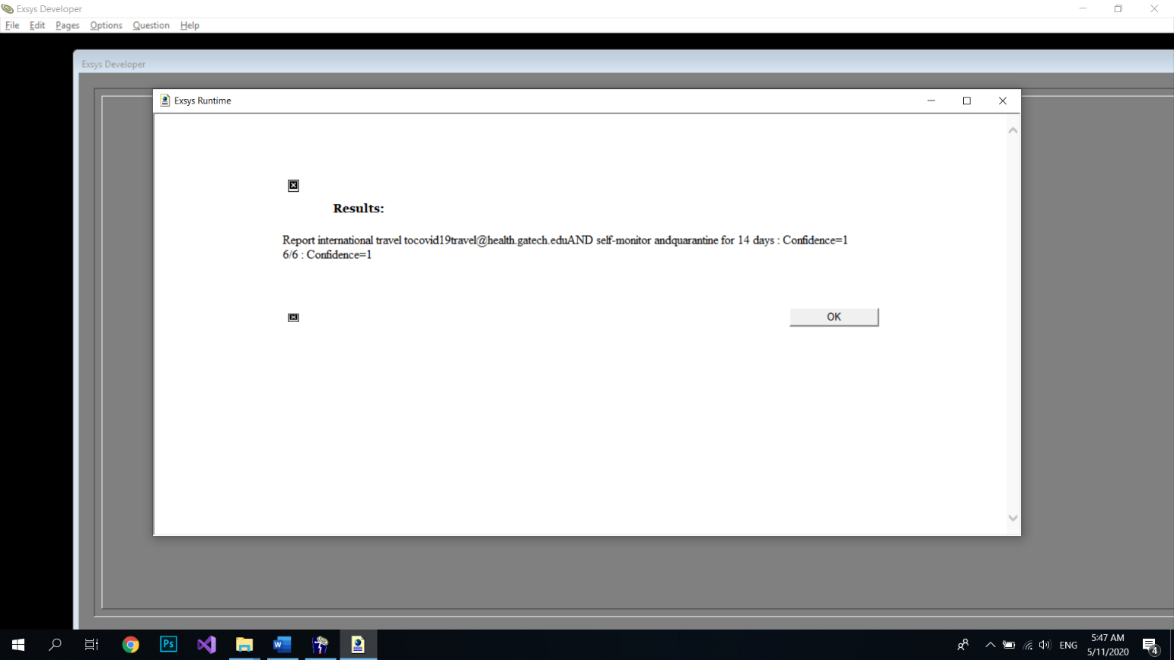

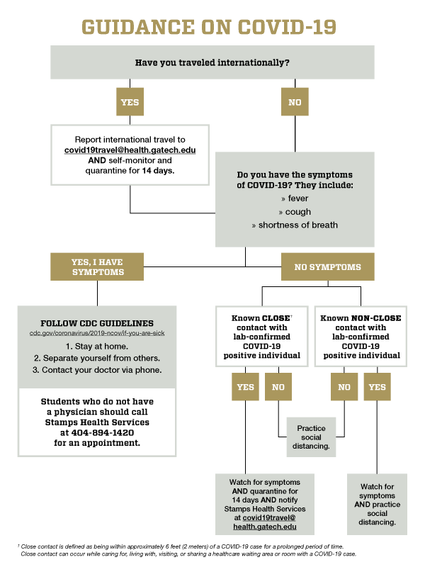

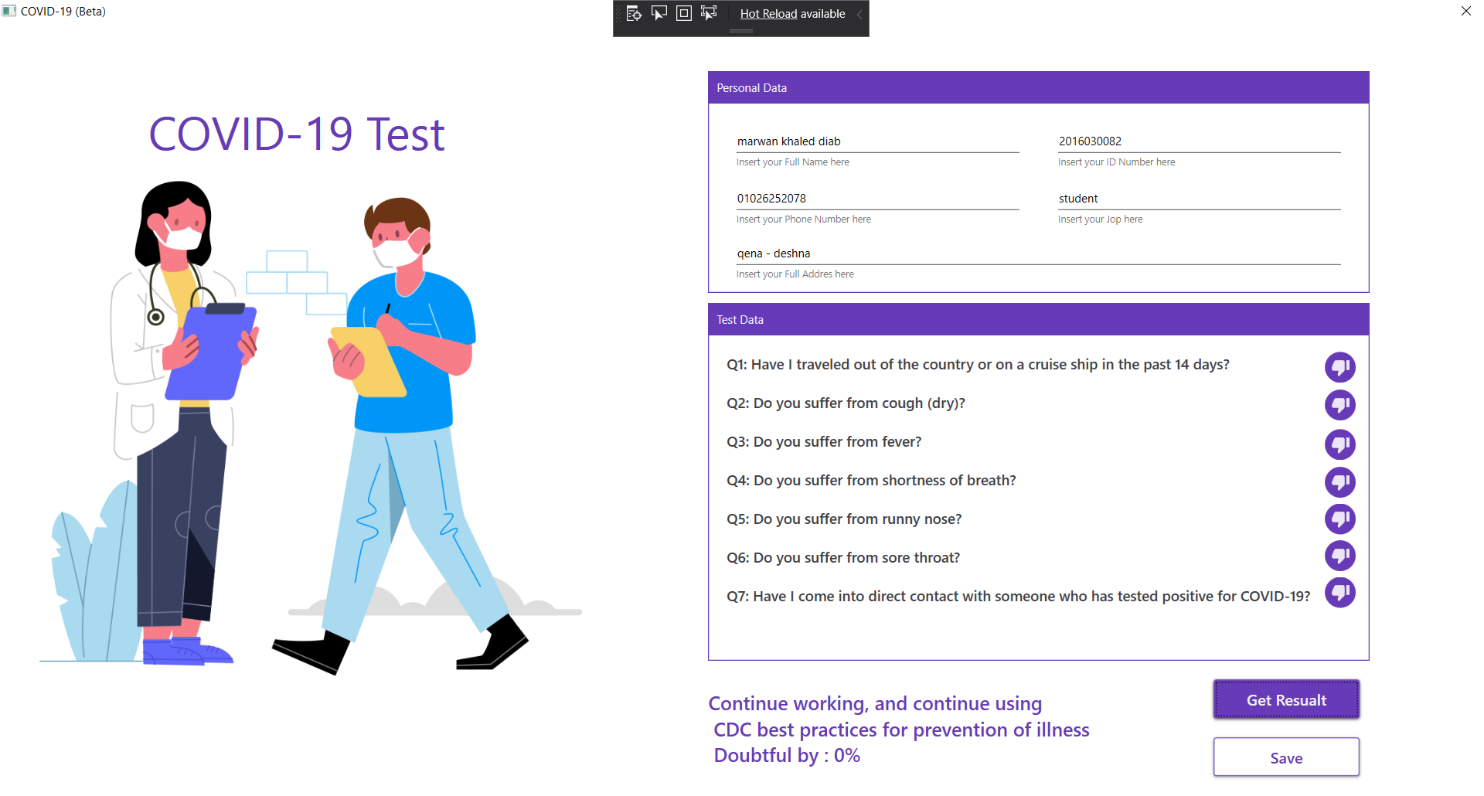

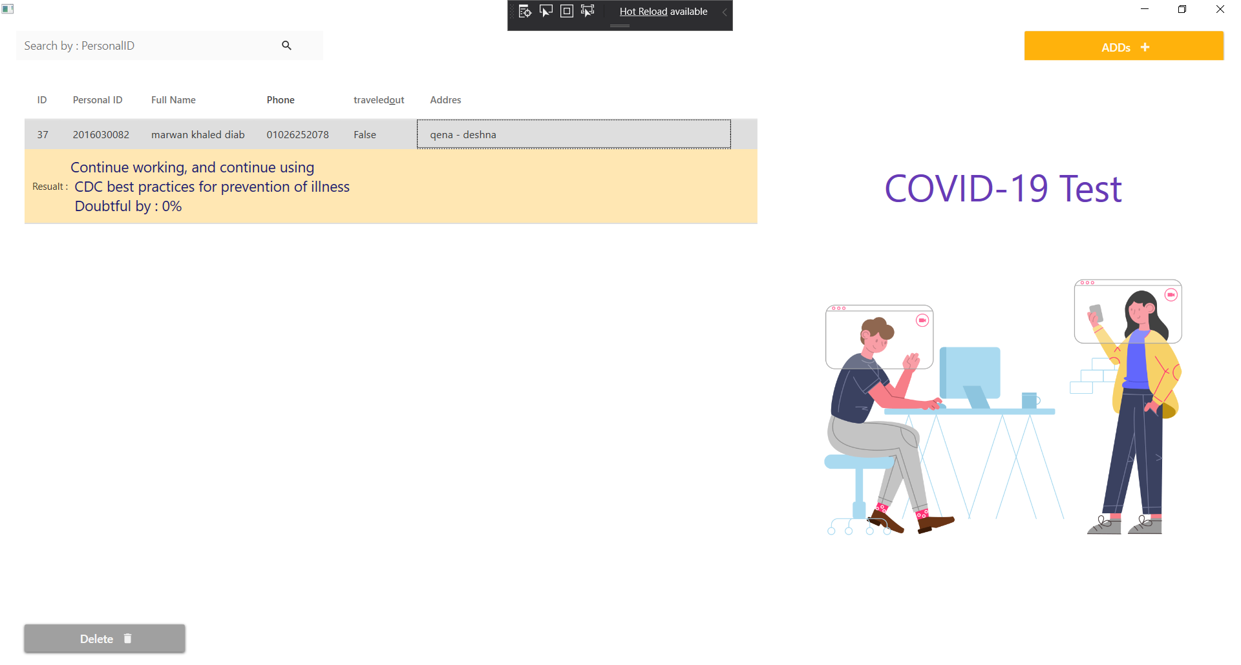

# Code form1

using System;

using System.Collections.Generic;

using System.Linq;

using System.Text;

using System.Threading.Tasks;

using System.Windows;

using System.Windows.Controls;

using System.Windows.Data;

using System.Windows.Documents;

using System.Windows.Input;

using System.Windows.Media;

using System.Windows.Media.Imaging;

using System.Windows.Navigation;

using System.Windows.Shapes;

using System.Data.SqlClient;

using System.Data.Sql;

namespace COVID_19

{

/// <summary>

/// Interaction logic for MainWindow.xaml

/// </summary>

public partial class MainWindow : Window

{

string conictionstring = "";

public MainWindow()

{

InitializeComponent();

conictionstring = @"Data Source=(LocalDB)\MSSQLLocalDB;AttachDbFilename=C:\Users\Marwan Diab\Source\Repos\COVID-19\COVID-19\Database.mdf;Integrated Security=True";

}

public string GetCOVID_19_Test(bool q1, bool q2, bool q3)

{

String Gool = "";

if (q1 == true)

{

Gool = "Report international travel tocovid19travel@health.gatech.eduAND\n self-monitor andquarantine for 14 days";

return Gool;

}

if (q1 == false && q2 == true)

{

Gool = "1.Stay at home.\n2. Separate yourself from others.\n3. Contact your doctor via phone";

return Gool;

}

if (q1 == false && q2 == false && q3 == true)

{

Gool = "Watch for symptomsAND quarantine\n for14 days AND notifyStamps Health Services";

return Gool;

}

if (q1 == false && q2 == false && q3 == false)

{

Gool = "Continue working, and continue using\n CDC best practices for prevention of illness";

return Gool;

}

return " ";

}

public int GetCOVID_19_SuppTest(bool q1, bool q2, bool q3, bool q4, bool q5)

{

int gread = 0;

if (q1 == true && q2 == true && q3 == true)

{

gread = 6;

return gread;

}

if (q1 == false && q2 == false && q3 == false)

{

gread = 0;

return gread;

}

if (q1 == true && q2 == true && q3 == false && q4 == true && q5 == true)

{

gread = 6;

return gread;

}

if (q1 == true && q2 == true && q3 == false && q4 == true && q5 == false)

{

gread = 5;

return gread;

}

if (q1 == true && q2 == true && q3 == false && q4 == false && q5 == false)

{

gread = 4;

return gread;

}

if (q1 == true && q2 == false && q3 == true && q4 == true && q5 == true)

{

gread = 6;

return gread;

}

if (q1 == true && q2 == false && q3 == true && q4 == false)

{

gread = 4;

return gread;

}

if (q1 == true && q2 == false && q3 == false && q4 == true && q5 == true)

{

gread = 4;

return gread;

}

if (q1 == true && q2 == false && q3 == false && q4 == true && q5 == true)

{

gread = 4;

return gread;

}

if (q1 == true && q2 == false && q3 == false && q4 == false)

{

gread = 2;

return gread;

}

if (q1 == false && q2 == true && q3 == true && q4 == true && q5 == true)

{

gread = 6;

return gread;

}

if (q1 == false && q2 == true && q3 == true && q4 == true && q5 == false)

{

gread = 5;

return gread;

}

if (q1 == false && q2 == true && q3 == true && q4 == false)

{

gread = 4;

return gread;

}

if (q1 == false && q2 == true && q3 == false && q4 == true && q5 == true)

{

gread = 4;

return gread;

}

if (q1 == false && q2 == true && q3 == false && q4 == false)

{

gread = 2;

return gread;

}

if (q1 == false && q2 == false && q3 == true)

{

gread = 2;

return gread;

}

return gread;

}

private void getruselt_Click(object sender, RoutedEventArgs e)

{

save.IsEnabled = true;

int x = GetCOVID_19_SuppTest(Q3.IsChecked.Value, Q4.IsChecked.Value, Q5.IsChecked.Value, Q6.IsChecked.Value, Q7.IsChecked.Value);

string test = "";

bool z= false;

if (x == 6)

{

test = "Doubtful by : 90% : 100%";

z = true;

}

else if (x == 5)

{

test = "Doubtful by : 70% : 80%";

z = true;

}

else if (x == 4)

{

test = "Doubtful by : 40% : 50%";

z = false;

}

else if (x == 3)

{

test = "Doubtful by : 30% : 40%";

z = false;

}

else if (x == 2)

{

test = "Doubtful by : 10% : 20%";

z = false;

}

else if (x < 2)

{

test = "Doubtful by : 0%";

z = false;

}

Resualt.Text = GetCOVID_19_Test(Q1.IsChecked.Value,z, Q8.IsChecked.Value) + " \n " + test.ToString();

}

private void save_Click(object sender, RoutedEventArgs e)

{

string istravel = "";

if (Q1.IsChecked.Value == true)

{ istravel = "True"; }

else { istravel = "False"; }

AddItem("insert into Users VALUES (N'" + Name.Text + "',N'" + ID.Text + "',N'" + Phone.Text + "',N'" + Addres.Text + "',N'" + istravel + "',N'" + Resualt.Text + "');");

}

public void AddItem(string qury)

{

try

{

using (SqlConnection con = new SqlConnection(conictionstring))

{

con.Open();

using (SqlCommand command = new SqlCommand(qury, con))

{

command.ExecuteNonQuery();

MessageBox.Show("Succseful Added");

this.Close();

}

con.Close();

}

}

catch (SystemException ex)

{

MessageBox.Show(string.Format("An error occurred: {0}", ex.Message));

}

}

}

}

# Code form2

using System;

using System.Collections.Generic;

using System.Data;

using System.Data.SqlClient;

using System.Linq;

using System.Text;

using System.Threading.Tasks;

using System.Windows;

using System.Windows.Controls;

using System.Windows.Data;

using System.Windows.Documents;

using System.Windows.Input;

using System.Windows.Media;

using System.Windows.Media.Imaging;

using System.Windows.Shapes;

using System.Windows.Threading;

namespace COVID_19

{

/// <summary>

/// Interaction logic for Window1.xaml

/// </summary>

public partial class Window1 : Window

{

private DataTable dataTable = new DataTable();

DispatcherTimer dispatcherTimer = new DispatcherTimer();

public Window1()

{

InitializeComponent();

dispatcherTimer.Tick += dispatcherTimer_Tick;

dispatcherTimer.Interval = new TimeSpan(0, 0, 1);

Fill();

}

private void dispatcherTimer_Tick(object sender, EventArgs e)

{

Fill();

// code goes here

}

private void ADD(object sender, RoutedEventArgs e)

{

dispatcherTimer.Start();

MainWindow m = new MainWindow();

m.Show();

}

public void Fill()

{

try

{

dataTable.Clear();

string connString = @"Data Source=(LocalDB)\MSSQLLocalDB;AttachDbFilename=C:\Users\Marwan Diab\Source\Repos\COVID-19\COVID-19\Database.mdf;Integrated Security=True";

string query = "select * from Users";

SqlConnection conn = new SqlConnection(connString);

SqlCommand cmd = new SqlCommand(query, conn);

try {

conn.Open();

}catch{ }

// create data adapter

SqlDataAdapter da = new SqlDataAdapter(cmd);

// this will query your database and return the result to your datatable

da.Fill(dataTable);

conn.Close();

da.Dispose();

grid.ItemsSource = dataTable.DefaultView;

grid.Items.Refresh();

}

catch { }

}

public void DeleteItem()

{

TextBlock x;

foreach (var item in this.grid.SelectedItems)

{

x = grid.Columns[0].GetCellContent(item) as TextBlock;

if (x != null)

{

try

{

using (SqlConnection con = new SqlConnection(@"Data Source=(LocalDB)\MSSQLLocalDB;AttachDbFilename=C:\Users\Marwan Diab\Source\Repos\COVID-19\COVID-19\Database.mdf;Integrated Security=True"))

{

con.Open();

using (SqlCommand command = new SqlCommand("DELETE FROM Users WHERE UserID = '" + x.Text + "'", con))

{

command.ExecuteNonQuery();

MessageBox.Show("Succseful Delete Client : " + x.Text);

}

con.Close();

}

}

catch (SystemException ex)

{

MessageBox.Show(string.Format("An error occurred: {0}", ex.Message));

}

}

}

}

public void Fill2(string x)

{

dataTable.Clear();

string connString = @"Data Source=(LocalDB)\MSSQLLocalDB;AttachDbFilename=C:\Users\Marwan Diab\Source\Repos\COVID-19\COVID-19\Database.mdf;Integrated Security=True";

string query = "select * from Users where ID LIKE '" + x + "%'";

SqlConnection conn = new SqlConnection(connString);

SqlCommand cmd = new SqlCommand(query, conn);

conn.Open();

// create data adapter

SqlDataAdapter da = new SqlDataAdapter(cmd);

// this will query your database and return the result to your datatable

da.Fill(dataTable);

conn.Close();

da.Dispose();

grid.ItemsSource = dataTable.DefaultView;

grid.Items.Refresh();

}

private void Button_Click(object sender, RoutedEventArgs e)

{

}

private void Button_Click_1(object sender, RoutedEventArgs e)

{

Fill2(CommentTextBox.Text);

dispatcherTimer.Stop();

}

private void grid_Loaded(object sender, RoutedEventArgs e)

{

dispatcherTimer.Start();

}

private void allowdelete_Click(object sender, RoutedEventArgs e)

{

DeleteItem();

Fill();

}

private void Border_TouchEnter(object sender, TouchEventArgs e)

{

dispatcherTimer.Stop();

}

private void grid_MouseDown(object sender, MouseButtonEventArgs e)

{

dispatcherTimer.Stop();

}

private void grid_MouseMove(object sender, MouseEventArgs e)

{

dispatcherTimer.Stop();

}

}

}