HAZMOVE MOBILE APPLICATION

1. Software Architecture (Clean Architecture)
The HazMove Mobile Application is built on Clean Architecture principles, ensuring a strict separation of concerns, testability, and scalability. The app code is divided into three distinct layers:
- Presentation Layer: Responsible for UI widgets, themes, localization, and state management. It uses BLoC/Cubit to manage the active state of the robot arm. The view consists of screens like HomeScreen, ManualControlScreen, AutoModeScreen, and SettingsScreen, coupled with custom UI structures like GlassContainer and AmbientBlob for visual effects.
- Domain Layer: The core business logic layer, written in pure Dart code independent of external packages or UI. It contains the Repository interfaces (e.g., RobotControlRepo) and Domain Models (e.g., RobotArmModel, ServoModel, LinearRailModel, and BaseRotationModel) which map the physical state of the robot.
- Data Layer: Implements domain repository interfaces and communicates with data sources. The RobotRemoteDataSourceApiImp class implements the remote source via WebSocket streams, while RobotLocalDataSource manages local SharedPreferences storage for connection URLs and user presets.

2. Data Flow & Connection Pipeline
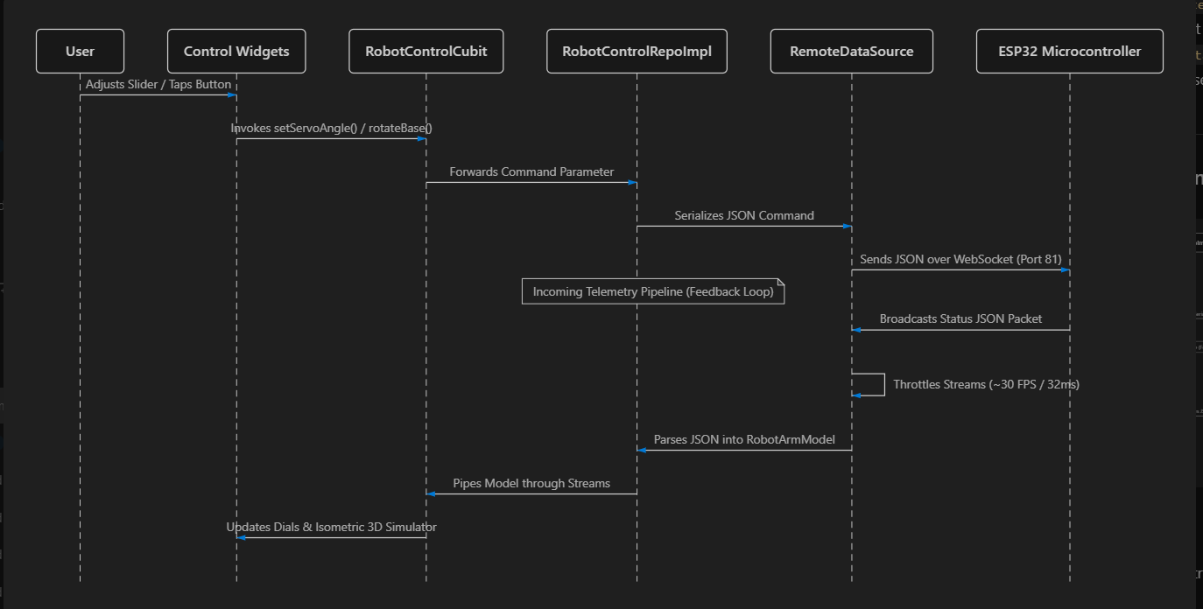
The mobile application operates on a bidirectional stream-based control pipeline. Below is the detailed sequence of how data moves from user interactions on the phone to the physical actuators of the robot, and how the feedback loop updates the visual user interface in real-time.
A. Outgoing Command Pipeline (Control)
1. Interaction: The user manipulates a control widget (such as moving a slider in Manual Control Screen).
2. State Notification: The slider widget invokes a Cubit method (e.g., setServoAngle).
3. Repository Call: The Cubit triggers the corresponding repository method inside RobotControlRepoImpl.
4. JSON Serialization: The repository formats the physical command parameters into a specific JSON layout (e.g., {"type": "servo", "servo_id": 2, "end": 90, "speed": 50}).
5. Transport: The RobotRemoteDataSource sends the serialized string asynchronously across the WebSocketChannel directly to port 81 of the ESP32's IP address (ws://<ESP32_IP>:81).
B. Incoming Telemetry Pipeline (Feedback & Simulator Sync)
1. Broadcast: The ESP32 collects actuator values and broadcasts a consolidated status JSON packet (including servo angles and stepper positions) back to the socket.
2. Throttling: To protect the UI threads and BLoC managers from high message rates, the data source applies a throttling mechanism restricted to 32 milliseconds (~30 Frames Per Second).
3. Parsing: Valid packets are decoded and converted into a RobotArmModel model instance.
4. Broadcast: The parsed model is piped through a broadcast stream to the Cubits.
5. UI Render: The Cubits emit states containing the updated models, causing the CustomPainter widget to re-render the 3D isometric simulation of the arm and update all telemetry dials.

3. Screen-by-Screen Documentation
This section details the layout, visual design, user flow, and technical specifications for each screen of the HazMove mobile application.
3.1 Home Screen (Main Dashboard)
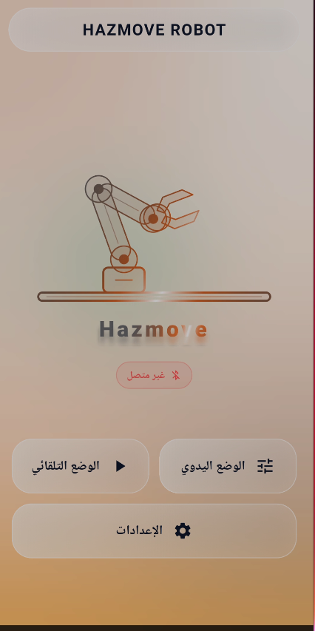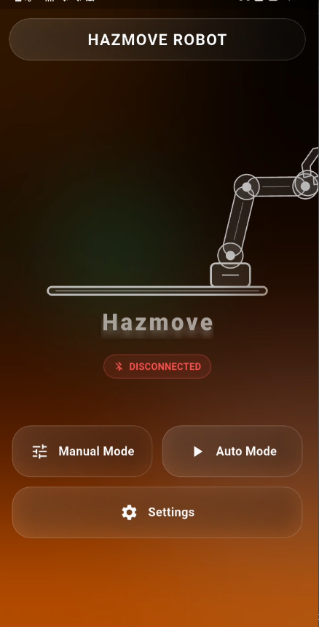

Description:
The Home Screen serves as the primary gateway to the application. It includes a brand title header "HAZMOVE ROBOT", an isometric vector illustration of the robotic arm, a connection status pill (showing red "غير متصل" / Disconnected or green "متصل" / Connected), and glassmorphic quick-action buttons for Mode selection (Manual, Automatic, and Settings).
User Flow:
* The user opens the app and is greeted with the Home Screen. If disconnected, any attempt to enter Manual or Automatic control is intercepted by the RouteGuard.
* The user clicks on 'Settings' (الإعدادات) to configure the connection URL.
* Once connected, the status pill glows green, unlocking manual and automatic operation modes.
Technical Stack & Architecture:
• State Management: Listens to the ConnectionStatus stream inside RobotControlCubit.
• Navigation Guarding: Implements RouteGuard.canNavigate() checks to prevent premature entry to control rooms.
• UI Theme: Extends dark gradients and AmbientBlob lighting in the background, utilizing BackdropFilter to deliver a premium Glassmorphism theme.

3.2 Automatic Mode Screen
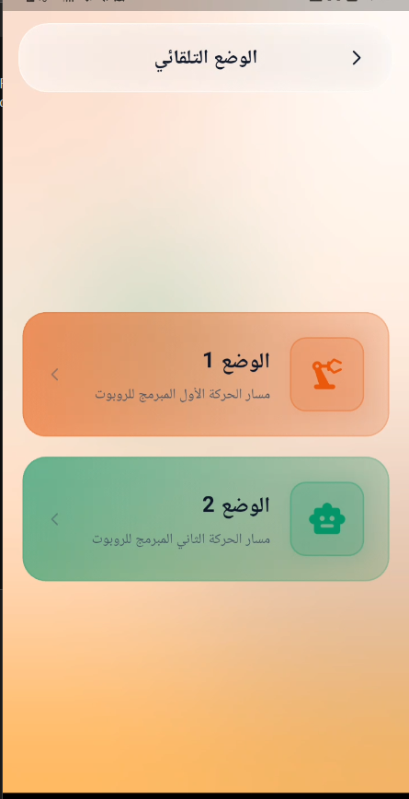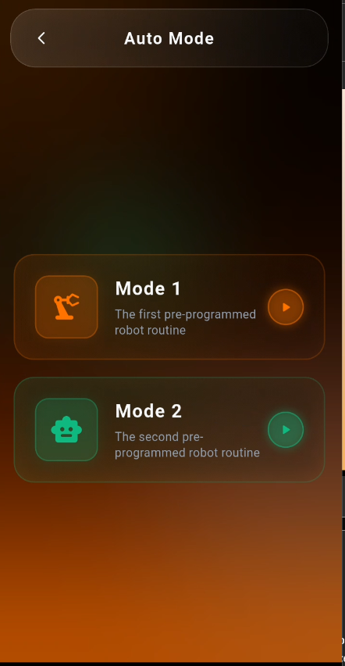
Description:
The Automatic Mode Screen hosts the controls for triggering pre-programmed automated paths. It presents two distinct mode cards: "الوضع 1" (Mode 1 - first preprogrammed sequence) and "الوضع 2" (Mode 2 - second sequence) styled with contrasting ambient color blocks. Tapping a card initiates the sequence execution on the robot.
User Flow:
* The user taps on an Automatic Mode card.
* The UI disables manual control sliders to prevent conflicting commands.
* The app displays the active execution status, prompting the user with an overlay stating manual input is locked.
Technical Stack & Architecture:
• State Machine: Monitors AutoModesCubit to manage the active automated routine.
• Interlock Safety: Prevents manual override by displaying a full-screen overlay during auto mode execution with an localized lock warning.
• Local Execution: Steps can also be executed client-side via Local Database Presets (stored in SharedPreferences), which sends commands sequentially with Future.delayed() intervals matching step delay properties.

3.3 Manual Control Screen
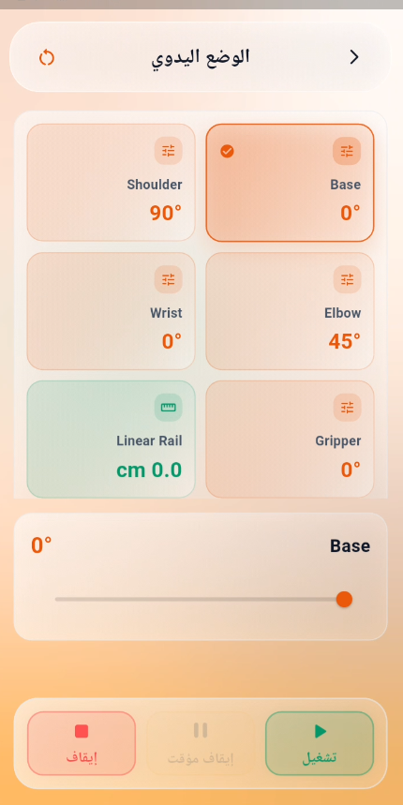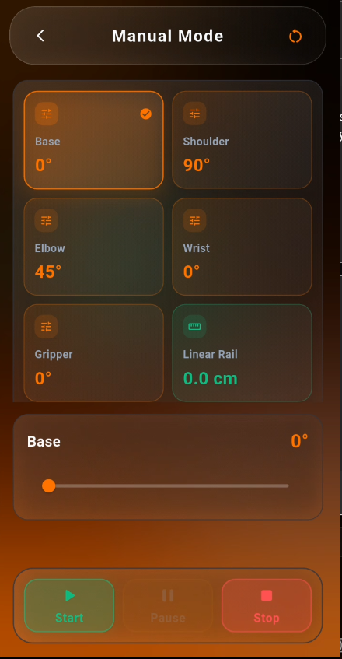
Description:
The Manual Control Screen contains a joint matrix configuration. It features a grid of 6 parameter cards: Shoulder angle, Base rotation, Wrist angle, Elbow angle, Linear Rail position (in cm), and Gripper angle. Selecting a card opens a dedicated control slider below the grid. At the bottom, three action buttons (Stop, Pause, and Reset) are fixed to the screen.
User Flow:
* The user taps on a joint card (e.g., Base). The card receives a checkmark indicator, and its slider is loaded.
* The user slides to change the angle or distance. Slider values trigger commands to the ESP32.
* In case of issues, the user clicks the red 'Stop' or 'Pause' buttons at the bottom to halt the robot immediately.
Technical Stack & Architecture:
• Interactive Binding: Selecting a joint card highlights the corresponding link in the 3D isometric simulation.
• Stepper & Servo Control: Base uses degrees (0°-360°), Linear Rail uses centimeters (0-100cm), while other joints are driven in degrees (0°-180°).
• Emergency Actions: The Stop button triggers a high-priority JSON payload (type: 'stop') which immediately aborts all active actuator loops on the microcontroller.

3.4 Settings Screen
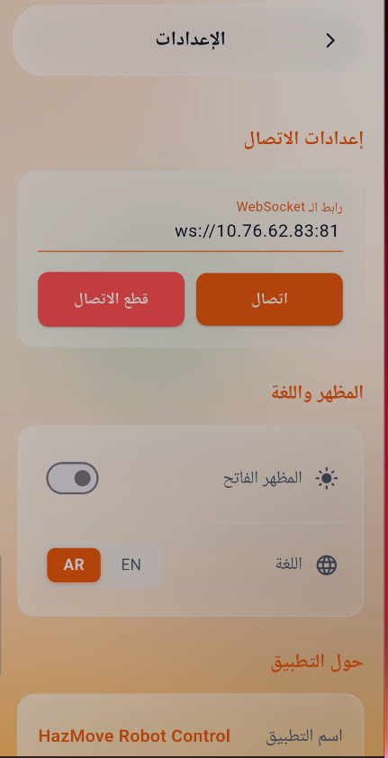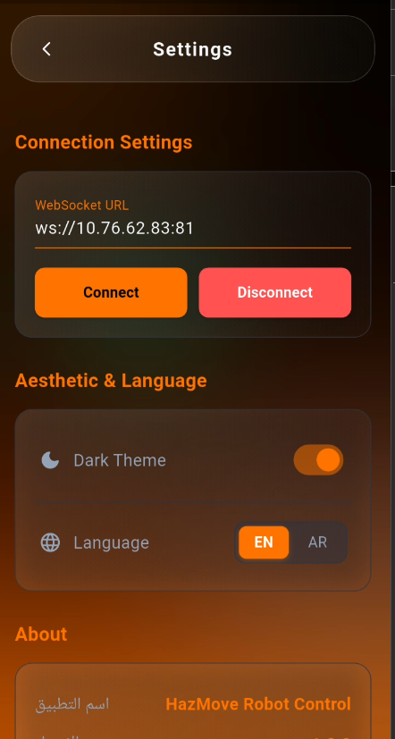
Description:
The Settings Screen is divided into three sections: Connection Settings (where the WebSocket URL is entered alongside Connect and Disconnect buttons), Appearance & Language (offering light/dark theme toggles and AR/EN language options), and the About section detailing the application name "HazMove Robot Control" and package build version.
User Flow:
* The user navigates to Settings.
* The user enters the ESP32 IP address (e.g., ws://192.168.4.1:81) and taps 'Connect' (اتصال).
* The user can also toggle between English and Arabic translations or change the visual theme.
Technical Stack & Architecture:
• Local Caching: Connection URLs are persisted to disk using SharedPreferences so the app re-establishes sessions automatically on boot.
• Multi-language: Integrated with the Easy Localization package, allowing language switching between AR and EN languages across all UI widgets.
• Network Diagnostics: Triggers ConnectionStatus updates that handle socket errors and show popup notifications when connection negotiations fail.

