Algorithms Project
Longest Balanced Substring
Non-Recursive & Recursive Algorithms

Problem Statement
A string is balanced if it consists of exactly two different characters and both appear exactly the same number of times. A substring is a sequence of consecutive characters. Goal: find the length of the longest balanced substring in string S.

Examples:
"aabbab" → balanced (a appears 3 times, b appears 3 times)
"aabba" → NOT balanced (a appears 3 times, b appears 2 times)
"aabbcc" → NOT balanced (contains 3 distinct characters)

Task: Given a string S, find the length of the longest balanced substring.

Test Cases:
S = "cabbacc" → 4 ("abba" is the longest balanced substring)
S = "abababa" → 6 ("ababab" and "bababa" are both longest)
S = "aaaaaaa" → 0 (no balanced substring exists)

First Algorithm — Non-Recursive

Non – Recursive Pseudo Code

1. Algorithm GetLongestBalancedSubstring(text)

2. // text is a string

3. {

4. n ← length(text); best ← 0;

5. for start ← 0 to n-1 do {

6. c1 ← NULL; c2 ← NULL; cnt1 ← 0; cnt2 ← 0;

7. for end ← start to n-1 do {

8. ch ← text[end];

9. if ch = c1 then cnt1 ← cnt1 + 1;

10. else if ch = c2 then cnt2 ← cnt2 + 1;

11. else if c1 = NULL then { c1 ← ch; cnt1 ← 1; }

12. else if c2 = NULL then { c2 ← ch; cnt2 ← 1; }

13. else break;

14. if (c1 ≠ NULL AND c2 ≠ NULL AND cnt1 = cnt2) then

15. best ← max(best, end - start + 1);

16. }

17. }

18. return best;

19. }

1.2 Non – Recursive Implementation (C++)

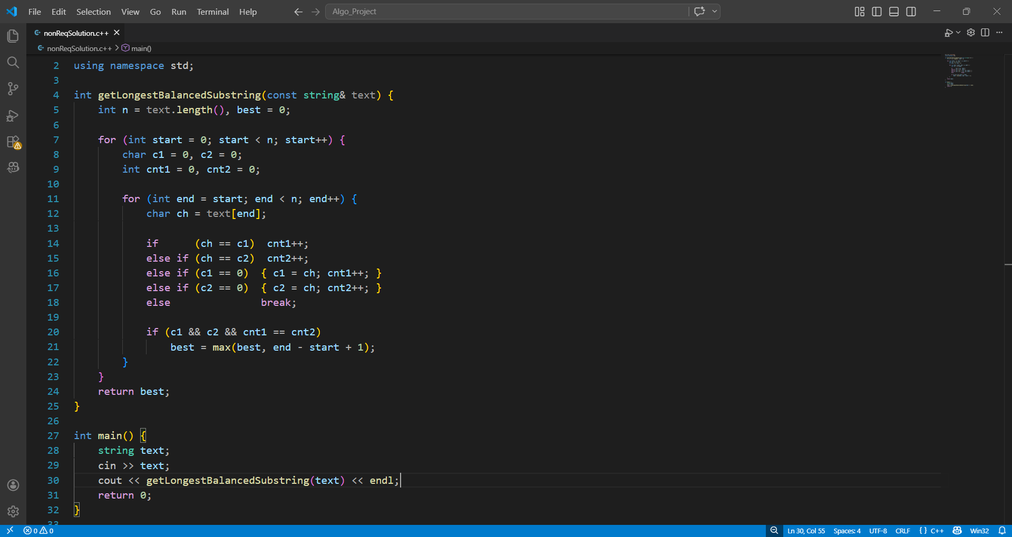

1.3 Non – Recursive Test

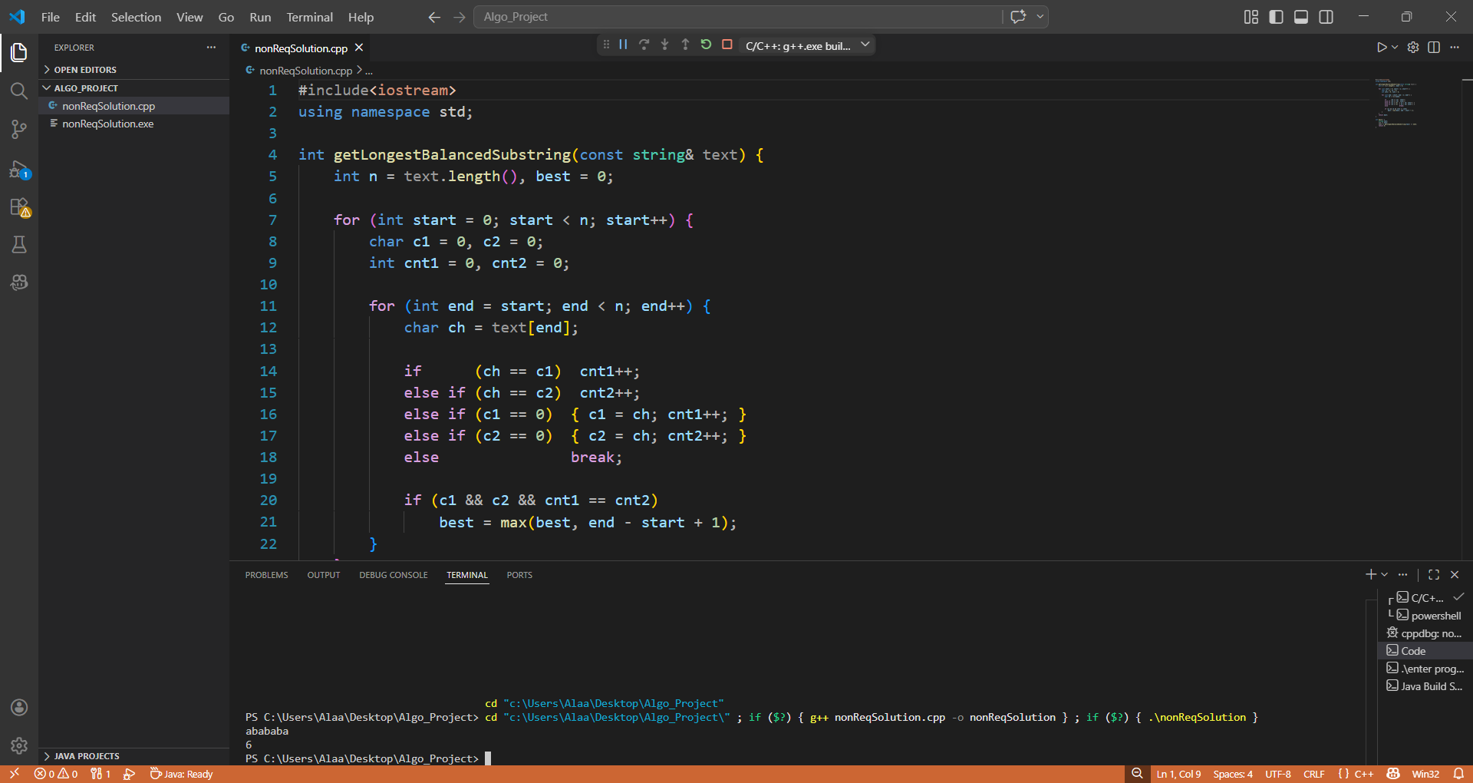

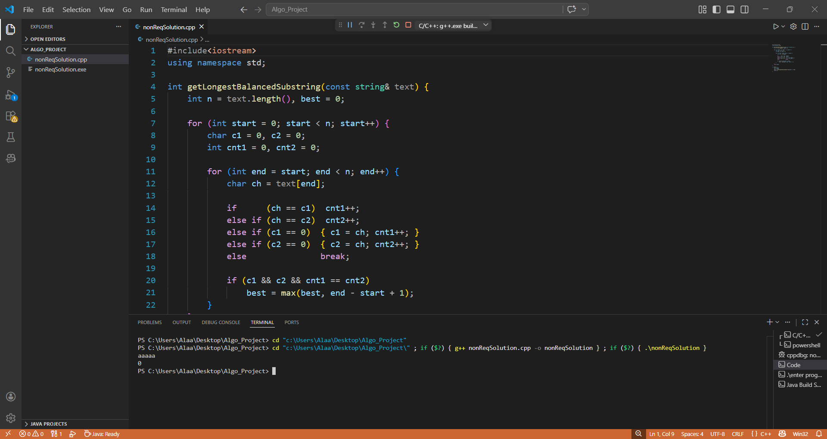

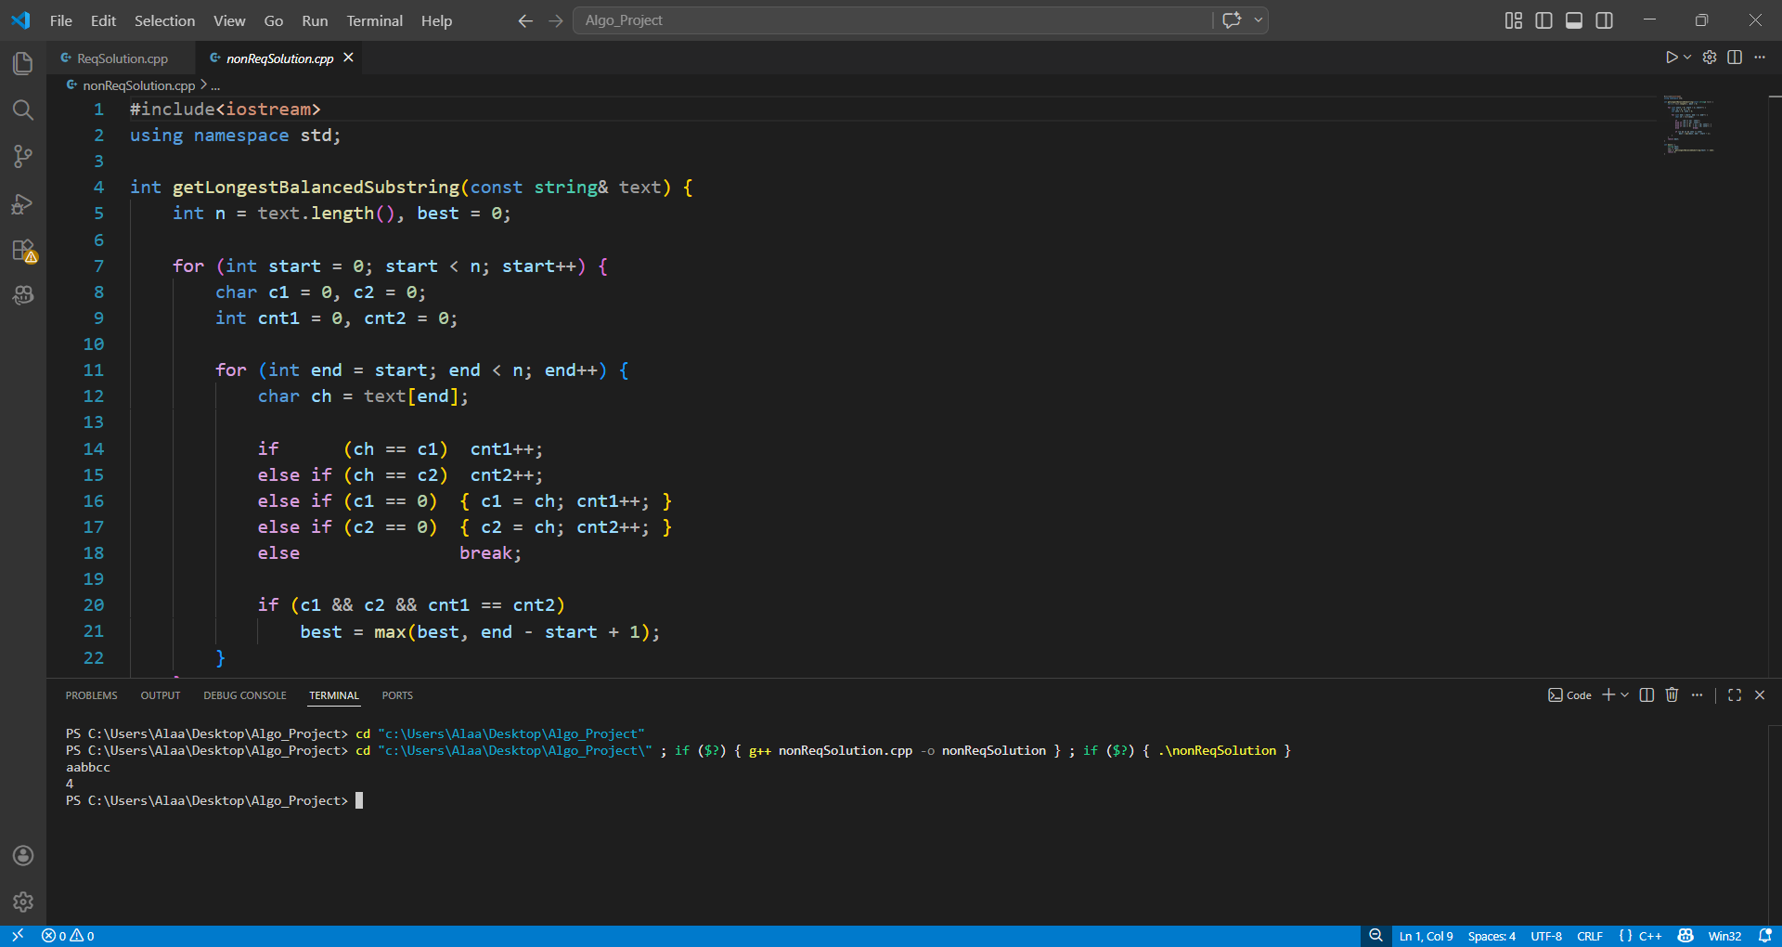

Analysis & Complexity (Steps)

T(n) =$\sum_{start=0}^{n-1}{\sum_{end=start}^{n-1}{1}}$

T(n) =$\sum_{end=start}^{n-1}{1=(n-start)}$

T(n) = ∑ n -∑start

T(n)$=\sum_{start=0}^{n-1}{n= }$ $n^{2}$ $\sum_{start=0}^{n-1}{start= }\frac{n\left(n-1\right)}{2}$

T(n) = $n^{2}$- $\frac{n\left(n-1\right)}{2}$ = $\frac{n^{2}+n}{2}$

T(n)= O($n^{2}$)

property | Value
Time Complexity | O(n²)
Space Complexity | O(1)
Best Case | O(n) — 3rd char appears immediately
Worst Case | O(n²) — all chars are same or two chars

Second Algorithm — Recursive

2.1 Pseudo Code

1. algorithm IsBalanced(s, l, r)

2. {

3. c1 := 0; c2 := 0; cnt1 := 0; cnt2 := 0;

4. for i := l to r do {

5. ch := s[i];

6. if ch = c1 then cnt1 := cnt1 + 1;

7. else if ch = c2 then cnt2 := cnt2 + 1;

8. else if c1 = 0 then { c1 := ch; cnt1 := 1; }

9. else if c2 = 0 then { c2 := ch; cnt2 := 1; }

10. else return FALSE;

11. }

12. return (c1 != 0 AND c2 != 0 AND cnt1 = cnt2);

13. }

14. algorithm Solve(s, start)

15. {

16. n := length(s);

17. if start = n then return 0;

18. best := 0;

19. for end := start to n - 1 do {

20. if IsBalanced(s, start, end) = TRUE then

21. if (end - start + 1) > best then best := end - start + 1;

22. }

23. return max(best, Solve(s, start + 1));

24. }

25. algorithm LongestBalanced(s)

26. {

27. return Solve(s, 0);

28. }

29. algorithm Main

30. {

31. read s;

32. write LongestBalanced(s);

33. }

2.2 Recursive Implementation (C++)

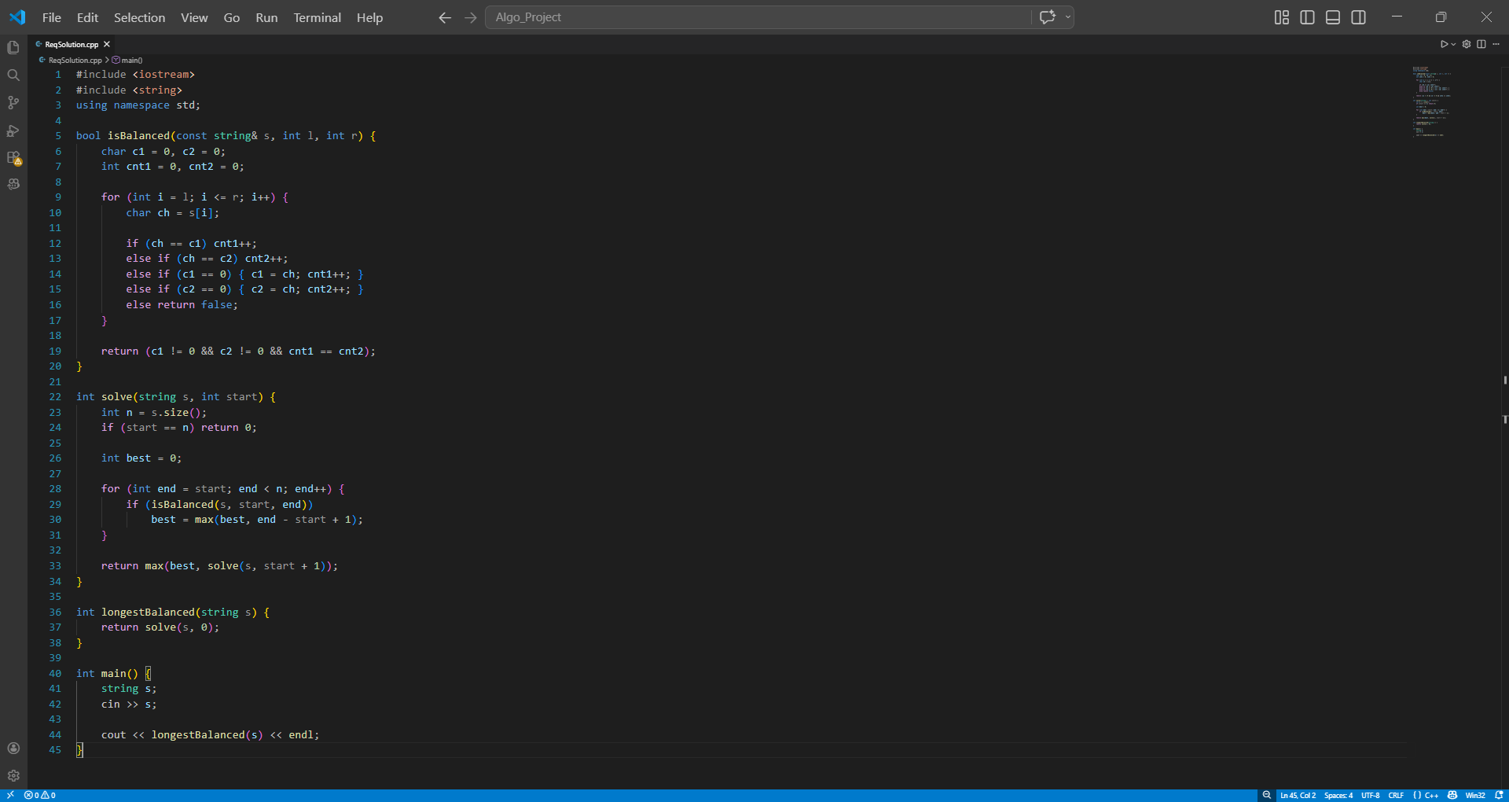

2.3 Recursive Test

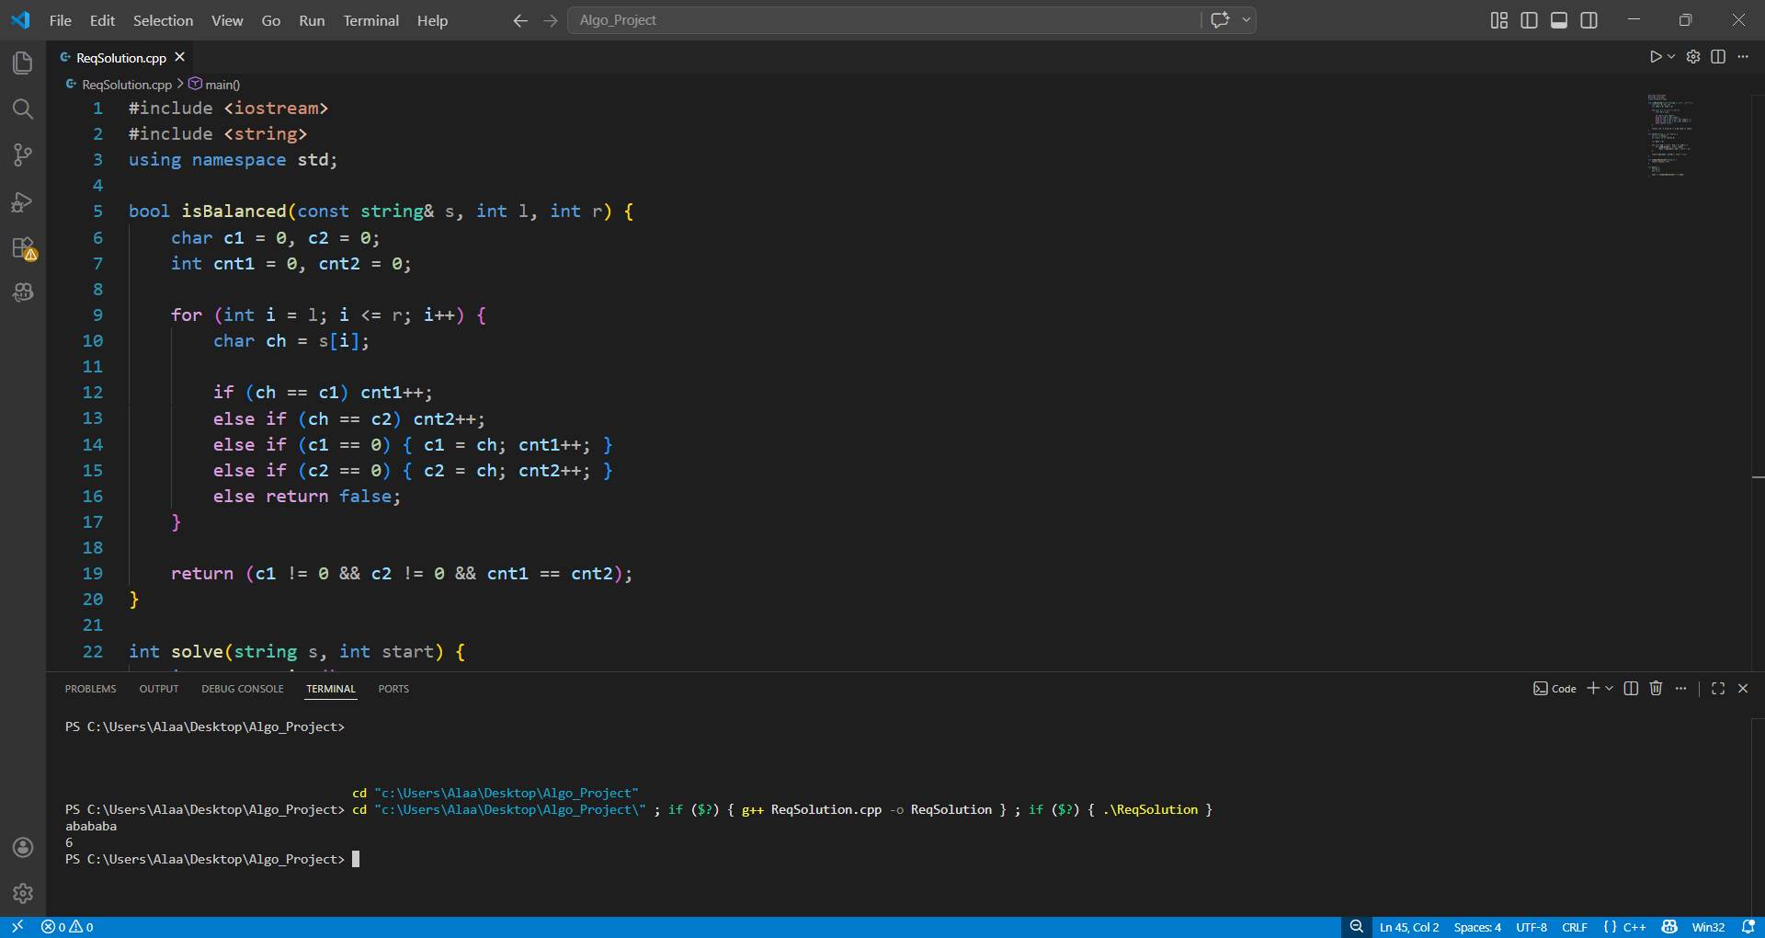

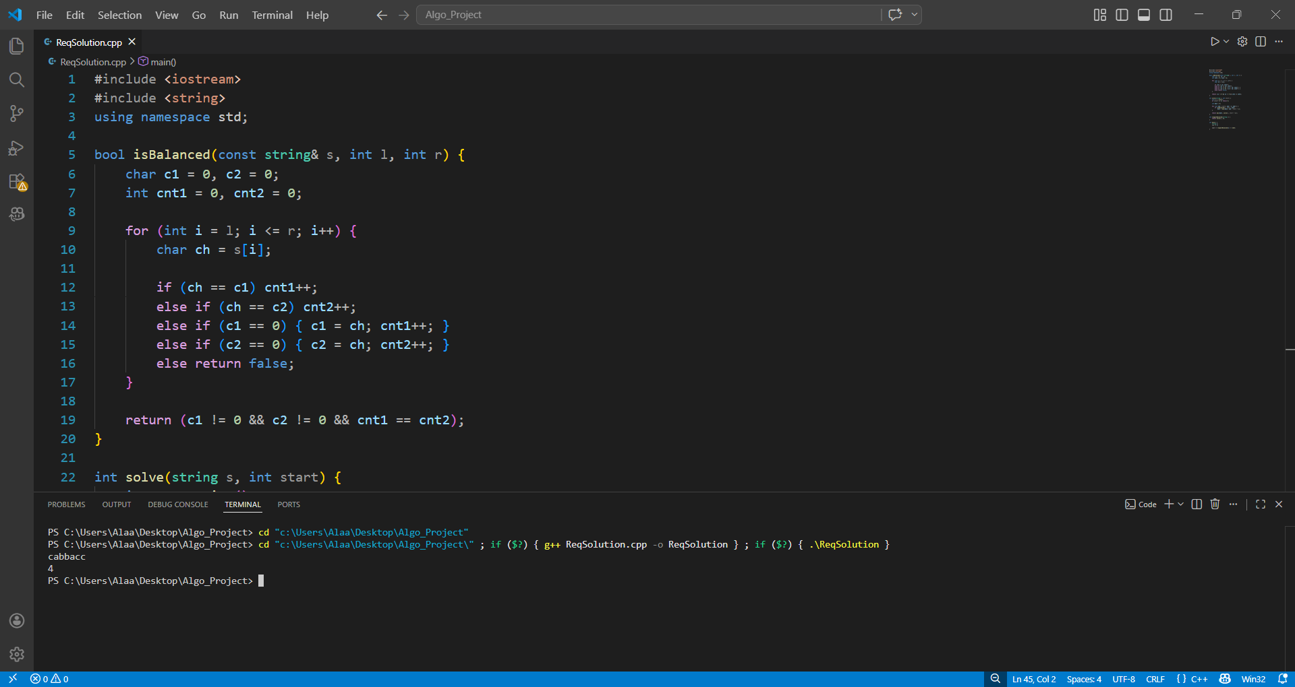

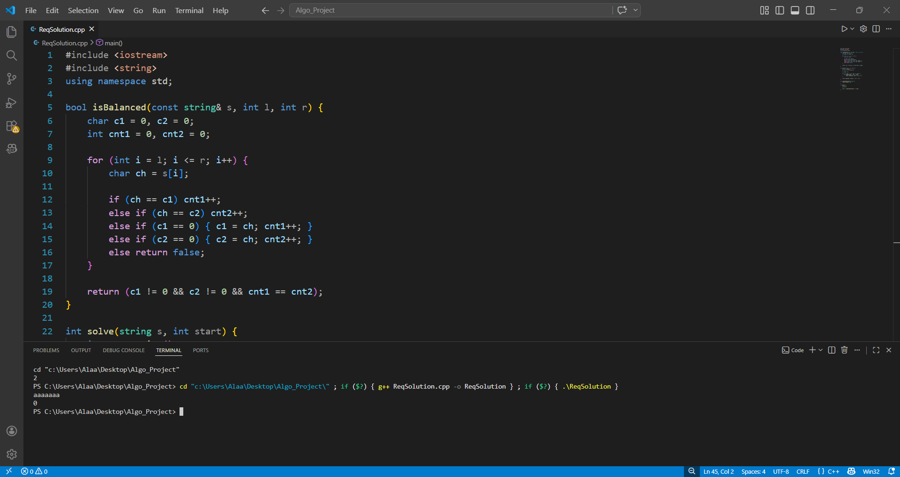

2.4 Analysis & Complexity (Steps)

Iteration method

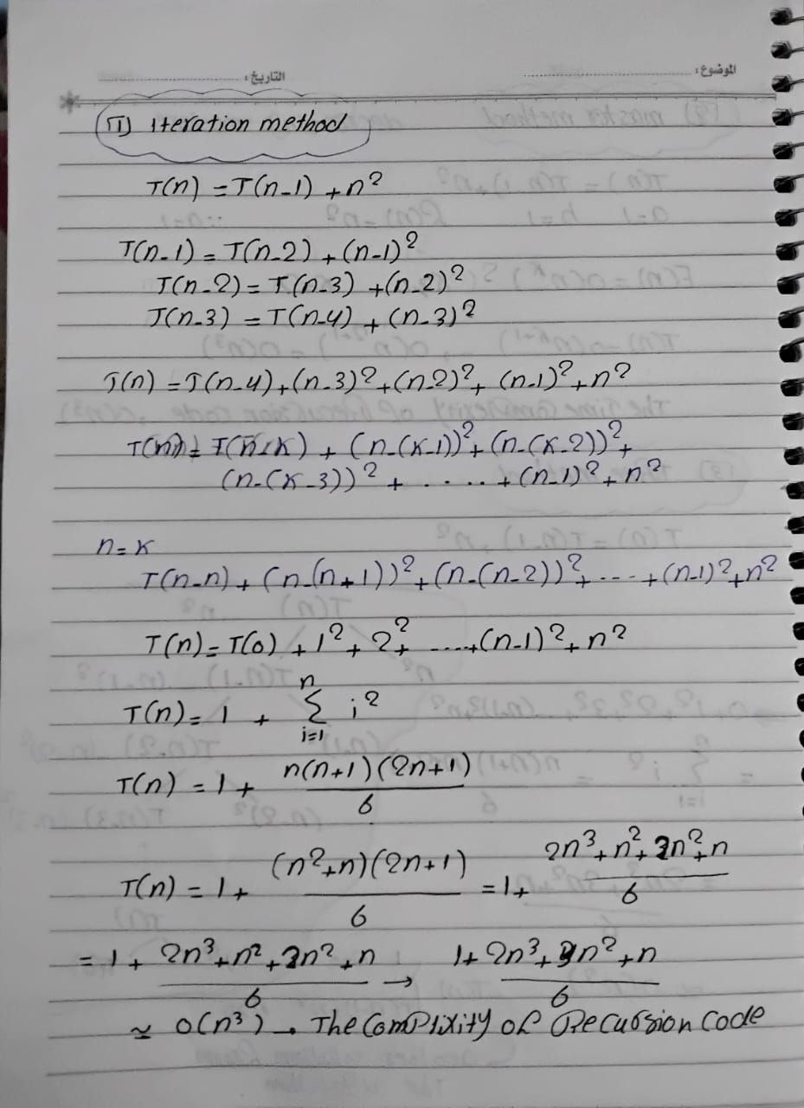

Master method & itertion tree
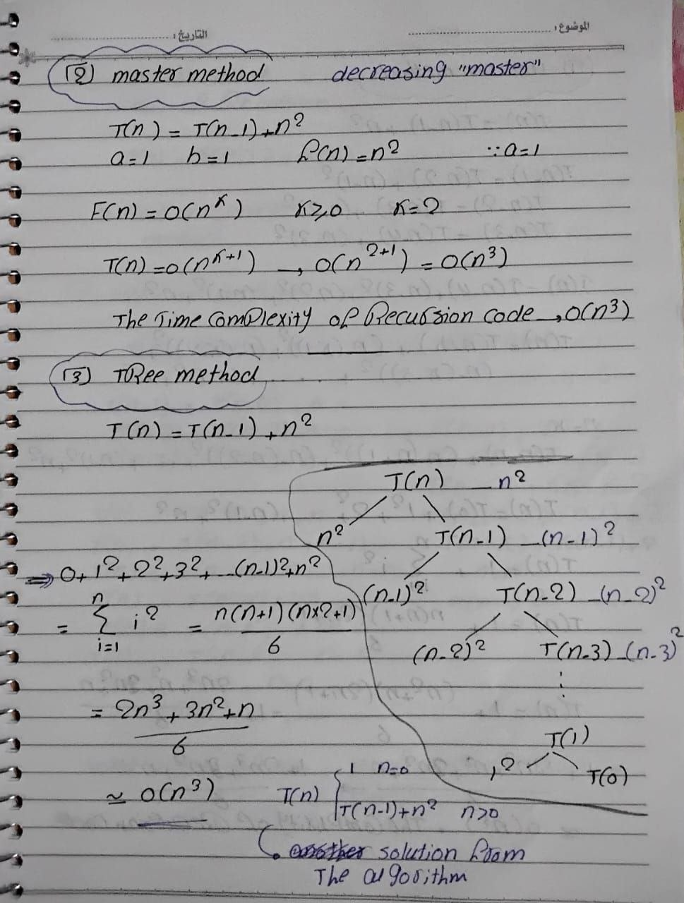

Property | Value
Recurrence | T(n) = T(n-1) + O(n²)
Time Complexity | O(n³)
Space Complexity | O(n) — call stack depth
Best Case | O(n²) — early breaks
Worst Case | O(n³) — no early breaks

Comparison — Iterative vs Recursive

Criterion | Iterative (Non-Recursive) | Recursive
Time Complexity | O(n²) | O(n³)
Space Complexity | O(1) | O(n) — call stack
Stack Overflow | No risk | Risk on large inputs
Readability | Clear & direct | Harder to trace
Redundant Work | None | Rescans every [start..end]
Performance | Faster | Slower
Best for | Production use | Conceptual understanding

Key Insight
Both algorithms solve the same problem correctly. The fundamental difference lies in how they re-use computed information:

Iterative: counts c1 and c2 incrementally as 'end' grows, never rescanning already-visited characters. This gives O(n²).

Recursive: at every call RecursiveSolve(text, start, end) it rescans the entire [start..end] range from scratch. This extra O(n) scan per call elevates the total to O(n³).

Conclusion: the Iterative algorithm is strictly superior in both time and space for this problem.

