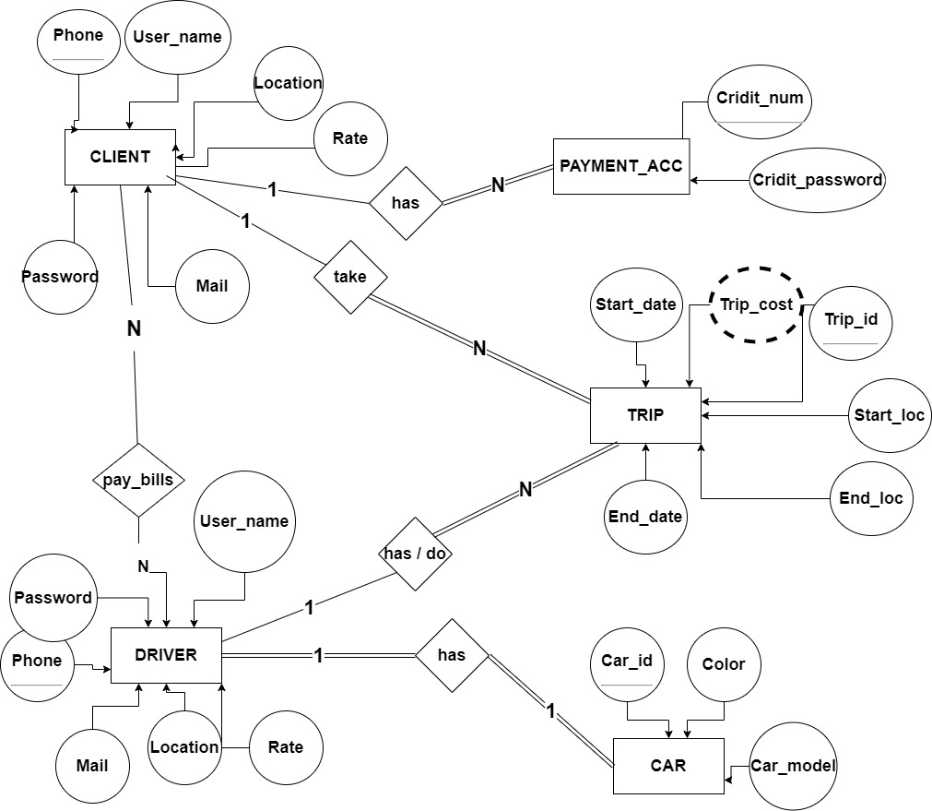

# Explanations

## Clint have a relation with The Trip Entity

### 1 to Many:

* Each Clint may have more than a trip
* Each trip cannot have more than one Clint

### The Relation has single line from Clint:

* Clint Can be existing without the trip entity

### The Relation has double line from Trip:

* Trip cannot be existing without the Clint Entity

## Client have a relation with Payment_acc Entity

### N to N:

* Each Client may have more than Payment Account
* Each Payment Account cannot have more than one Clint

### The Relation has single line from Client:

* Client Can be existing without the Payment_acc entity

### The Relation has double line from Trip:

* Payment_acc cannot be existing without the Client Entity

## Client have a relation with The Driver Entity

### Many to Many:

* Each Client can pay for more than Driver
* Each Driver can get money from more than one Client

### The Relation has single line from Client:

* Client Can be existing without the Driver entity

### The Relation has single line from Driver:

* Driver Can be existing without the Client entity

## Driver have a relation with The Trip Entity

### 1 to Many:

* Each Driver may have more than trip
* Each trip cannot have more than one Driver

### The Relation has single line from Driver:

* Driver Can be existing without the trip entity

### The Relation has double line from Trip:

* Trip cannot be existing without the Driver Entity

## Driver have a relation with The Car Entity

### 1 to 1:

* Each Driver must have one car
* Each Car cannot have more than one Driver

### The Relation has double line from Driver:

* Driver Cannot be existing without the Car entity

### The Relation has double line from Trip:

* Car cannot be existing without the Driver Entity