**Traffic volume and long-distance foraging movements to migratory prey shape roadkill patterns in Serengeti spotted hyenas**

Marwan Naciri1,2,3,*, Aimara Planillo1,Morgane Gicquel1,4, Marion L. East1, Heribert Hofer4,5,6, Sonja Metzger1, Sarah Benhaiem1

1 Department of Ecological Dynamics, Leibniz Institute for Zoo and Wildlife Research, Alfred-Kowalke-Strasse 17, D-10315 Berlin, Germany

2 Master de Biologie, Ecole Normale Supérieure de Lyon, Université Claude Bernard Lyon I, Université de Lyon, 69342 Lyon Cedex 07, France

3 CEFE, Univ Montpellier, CNRS, EPHE-PSL University, IRD, Montpellier, France

4 Department of Biology, Chemistry, Pharmacy, Freie Universität Berlin, Berlin, Germany

5 Leibniz Institute for Zoo and Wildlife Research, Alfred-Kowalke-Strasse 17, D-10315 Berlin, Germany

6 Department of Veterinary Medicine, Freie Universität Berlin, Berlin, Germany

* Corresponding author: marwan.naciri@ens-lyon.fr

**ABSTRACT**

Collisions with vehicles are a major cause of death for wild species worldwide. In Africa, over the last decades, traffic volume has substantially increased in many protected areas, exacerbating this issue. Yet, knowledge on wildlife killed by vehicles (roadkills) within protected areas is limited. Here we investigate the incidence and pattern of spotted hyena (*Crocuta crocuta*) roadkills inside the Serengeti National Park, Tanzania, between 1989 and 2022 (n = 96). We used a generalized linear model to study the spatial determinants of roadkill incidence. We also investigated potential temporal and spatiotemporal patterns in roadkill incidence, as well as the effect of age, sex and rank. Roadkills were more likely on main roads, where traffic was highest, and which served as ‘commuting’ routes for hyenas to both distant foraging areas and local anthropogenic food sources. The locations and number of roadkills varied according to seasonal changes in the locations of vast migratory ungulate herds, which are the main prey of hyenas. Adult females, who travel the most, suffered the highest levels of road mortality. Our results reveal how ‘commuting’ to distant prey largely shapes the roadkill patterns of hyenas and give insight into the threat posed by traffic to large carnivores in protected areas. Measures such as enforcement of existing speed limits, particularly on main roads, and more stringent restriction on night driving could mitigate this threat.

**KEYWORDS**

roadkill, road ecology; protected areas; human-wildlife conflicts; *Crocuta crocuta*; large carnivore; predator-prey relationships; carnivore ecology, wildlife conservation

**ARTICLE IMPACT STATEMENT**

Three decades of Serengeti spotted hyena roadkills show increased risk for high-ranking females, on main roads and close to migratory prey.

Spotted hyena roadkills are driven by traffic volume, prey location and individual characteristics

Three decades of Serengeti spotted hyena roadkills show risk is highest for high-ranking females, on main roads and is modulated by location of migratory prey.

# Introduction

**INTRODUCTION**

Large protected areas that limit human activities within their boundaries are considered a cornerstone of biodiversity conservation, particularly for large carnivores (Hofer & Mills 1998; Woodroffe & Ginsberg 1998). Although they have proven useful in this respect (Watson et al. 2014; Gray et al. 2016), protected areas are not free of anthropogenic pressure (Hofer et al. 1996; Geldmann et al. 2019) and wildlife populations are still declining in some of them due to human activities (Craigie et al. 2010; Laurance et al. 2012; Veldhuis et al. 2019). Among anthropogenic impacts, roadkills are one of the main sources of wildlife mortality in some protected areas (Garriga et al. 2012; Grilo et al. 2015; Hill et al. 2019, 2020). Roadkills can significantly hinder wildlife population growth and potentially cause population extirpation (Jones 2000; Roger et al. 2011; Grilo et al. 2015; Parchizadeh et al. 2018).

Within protected areas, vehicles are typically expected to give way to wildlife and vehicle speed is often regulated to reduce wildlife roadkills (Collinson et al. 2019). However, the human population, and therefore the traffic volume in regions surrounding most protected areas is increasing (Wittemyer et al. 2008) which poses a threat to conservation, and particularly to carnivore populations (Parks & Harcourt 2002; Cardillo et al. 2004). In addition, wildlife tourism has expanded in recent decades, contributing to the expansion of road networks and traffic volume and speed within protected areas (Drews 1995; Mkanda & Chansa 2011; Caro et al. 2014; Lyamuya et al. 2021). All these factors challenge conservation within protected areas (Wittemyer et al. 2008; Estes et al. 2012; Veldhuis et al. 2019). Knowledge of the spatiotemporal patterns of roadkills can help identify sections within road networks where a specific species is particularly vulnerable to vehicle collisions and where mitigation strategies should be implemented (Seiler 2005; Steiner et al. 2014; Rendall et al. 2021). Additionally, demographic information on roadkilled individuals can provide an assessment of the scale of loses and possible demographic consequences for a given species (Grilo et al. 2015; Gunson & Teixeira 2015; Garriga et al. 2017).

Large carnivores are particularly vulnerable to road accidents as they typically i) range over large distances and thus may cross roads more frequently (Grilo et al. 2015), ii) often travel along roads and tracks (Hill et al. 2021) and iii) may forage on prey or carcasses on roads (Planillo et al. 2018; Hill et al. 2021). Within a given carnivore species, sex or age specific differences in movement patterns may modulate the risk of being hit by a vehicle. For instance, adult male otters (*Lutra lutra*) (Philcox et al. 1999), adult male and female badgers (*Meles meles*) during the biannual peaks of female fertility (Davies et al. 1987) and dispersing adult male black bears (*Ursus americanus*) (Grilo et al. 2015) are particularly susceptible to being killed by vehicles.

Most studies on roadkills of large carnivores have been conducted in North America and Europe outside protected areas (e.g. (Planillo et al. 2018; Bencin et al. 2019)). By contrast, relatively little is known about large carnivores killed on roads in protected areas in Africa (Drews 1995; Mkanda & Chansa 2011; Njovu et al. 2019; Lyamuya et al. 2021), even though they often host a high diversity of large carnivores and most have experienced an increase in tourism in recent decades (Caro et al. 2014; Tablado & D’Amico 2017; Larsen et al. 2020).

Here we use long-term records from 1989 to 2022 to investigate the patterns of roadkills of a keystone predator, the spotted hyena (*Crocuta Crocuta*), in the Serengeti National Park (Serengeti NP), in northwestern Tanzania. The Serengeti NP and associated protected areas together form the Serengeti ecosystem which is one of the largest protected landscapes in Africa, and it contains one of the largest populations of this highly social carnivore (Hofer & Mills 1998).

In the Serengeti NP, the main prey of spotted hyenas are migratory wildebeest (*Connochaetes taurinus*), Thomson’s gazelles (*Eudorcas thomsoni*), and zebras (*Equus* *quagga*) (Hofer & East 1993a). At the start of the rain season around November, these migratory species leave their dry season refuges in the north and west of the park to move to the nutritious short-grass plains in the southeast (Fig. 1a, b). When the rains end around May, the migratory herds return to their dry season refuge (Pennycuick 1975; McNaughton 1979; Hopcraft et al. 2015). As a result, hyena clans experience major fluctuations in prey abundance in their clan territories throughout the year (Hofer & East 1993a). During periods when migratory prey are absent from the clan territory, subadult and adult hyenas regularly commute alone or in small groups between their territory and locations containing large migratory herds with round trips covering up to 150 km (Hofer & East 1993b). When commuting, hyenas typically travel on game trails, vehicle tracks and roads (Hofer & East 1993b) where they may encounter vehicles both within and outside their clan territory.

Our study aims at understanding the factors that determine hyena roadkill mortality within the protected area of the Serengeti NP. To this end, we study hyena roadkills in relation to landscape and environmental characteristics, seasonal shifts in prey distribution and hyena individual characteristics. We expected roadkill incidence to be higher: (i) on main roads than on tracks, because of the greater traffic volume and speed (Grilo et al. 2009, 2015; McCown et al. 2009; Bencin et al. 2019; Gunson et al. 2020), (ii) on roads close to human habitation (lodges, tented camps, campsites, staff housing) which may provide hyenas with anthropogenic food resources (Hofer & Mills 1998; Kolowski & Holekamp 2009; Belton et al. 2018), (iii) in areas close to water bodies, which may provide water to drink and provide resting sites (Kolowski & Holekamp 2009; Červinka et al. 2015; Pagany 2020), and (iv) in areas with dense woodland where hyenas may be more likely to walk along roads and (Abrahms et al. 2016; Hill et al. 2021) where the visibility of drivers may be reduced.

We expected the spatio-temporal pattern of roadkills to (i) reflect fluctuations in tourism, i.e., an increase in the number of roadkills during the peak in tourism in July-August and to a lesser extent during the Christmas-New Year period in December and January (Larsen et al. 2020), and (ii) reflect the migratory movements of the migratory herds, i.e. roadkills in the south-eastern area of the park between December and April, and roadkills in areas to the northwest between August and October, with a potential difference in the number of roadkill during each of these periods.

Finally, we expected differences in the incidence of roadkills between animals in different age, sex, and social status categories, as these are associated with the extent of their ranging behavior. This should affect road usage and thus the chance of encountering vehicles (Grilo et al. 2015). As cubs typically remain close to the clan communal den whereas subadult and adult hyenas range over a larger area (Mills & Gorman 1987; Hofer & East 1993a), we expected subadults and adults to experience a proportionally higher road mortality than cubs. Among adults, we expected the incidence of roadkills to be higher in: (i) females than males because they typically commute more often than males and hence should be more likely to encounter vehicles (Hofer & East 1993b, 1993c), (ii) low-ranking than high-ranking females because access to food resources within the clan territory is determined by social status, thus low-ranking females commute more frequently than high ranking females (Hofer & East 1993a; Gicquel et al. 2022).

# Methods

**METHODS**

**Study area**

The study was conducted within the Serengeti NP, in northwestern Tanzania (2.3° South, 34.8° East, Fig. 1a) between January1989 and April 2022. The Serengeti NP is an internationally famous tourist destination and since 1989, tourist lodges, tented camps and campsites have substantially increased, together with the number of vehicles used for viewing wildlife and those supplying lodges and tented camps (equipment, food and water).

We consider two categories of roads, which we term 1) main roads and 2) tracks (Fig. 1c). All main roads are graded ‘murram’ roads which are used throughout the year by trucks, national bus services and private cars in transit through the park, as well as vehicles associated with transporting tourists and supplies to tourist facilities within the park and beyond, vehicles used in park management and wildlife research. One main road (B144) passes from the south of the park northwards to link to towns in northern Tanzania such as Loliondo, the Kenyan border and the Maasai Mara National Reserve (MMR). From this main road, another main road branches north of Seronera westward through the Western Corridor of the Serengeti NP, providing access to towns in the Lake Victoria region, and another branch northwest towards the headquarters of the Serengeti NP at Fort Ikoma near the park boundary, and towns beyond. We term all other game viewing tracks and access roads to facilities ‘tracks’.

The network of tracks in the Serengeti NP has considerably expanded during the study, some tracks have been closed and the routes of others have changed. There is an official speed limit (50 km/hour) set for all roads and tracks within the Serengeti NP, and vehicles are mostly prohibited from driving at night, but these park rules are not always observed.

**Spotted hyena roadkills**

Data on hyena roadkills were collected by members of the Serengeti spotted hyena research project and included hyena roadkills they encountered and those provided by park staff, scientists, veterinarians, and tourists. For each hyena roadkill, the date on which the carcass was found or reported was recorded and this date was used in the analysis. For most carcasses this date was within approximately one or two days (maximum approximately 7 days) of death because scavengers ensure that carcasses typically only persist for a shorter period. The location of roadkills was either estimated using map grid references or, more recently, determined using GPS coordinates. The total number of carcasses was 96, of which 78 had GPS coordinates (acquired at the time of observation or determined using the location indications provided by the observer when sufficiently accurate (Fig. 1b-d).

**Individual characteristics**

Adult carcasses exhibiting clear evidence of lactation were sexed as females, otherwise sex was determined using the dimorphic glans morphology of the genitalia (Frank et al. 1990). Age at death was categorized as cub (< 1 year), subadult (1-2 years) or adult (> 2 years of age) based on body size, pelage characteristics and dentition (Kruuk 1972; Hofer & East 1993a). When age was not provided (n = 7, 7 %), individuals were considered adults by default, as a younger age category would most likely have been reported.

Based on unique spot patterns, other individually unique features and microsatellite profiling (East et al. 2009) 13 carcasses (15%) were identified as members of three hyena clans (Isiaka, Pool, Mamba) studied continuously since 1987, 1989 and 1990, respectively, as part of the ongoing Serengeti spotted hyena research project (for details see (Hofer & East 2003))*.* For these individuals, information about their social status on the death date was available. The social status of adult females in each clan was determined using submissive behaviors during dyadic interactions (Hofer & East 2003). Each adult female within a clan was assigned a standardized rank, equally spaced between -1 (lowest rank) and +1 (highest rank), with 0 as the median rank (see e.g. (Hofer & East 2003) or (Gicquel et al. 2022) for further details).

**Spatial data**

We downloaded the Tanzanian road network from the OpenStreetMap (OSM) dataset on the Geofabrik download server (Geofabrik GmbH 2020) and processed it for analysis using QGIS (QGIS Development Team 2020). This map included both the main roads and tracks in the Serengeti NP in 2020. We used the road network represented on a 2013 map of the Serengeti National Park (ISBN: 9781851374045) produced by Frankfurt Zoological Society (FZS) as a baseline. We removed from the OSM dataset tracks that do not appear on the FZS map. Conversely, we added the tracks that appear on the FZS map but were not present in the OSM dataset, using Google Earth satellite images. Tracks that were not distinguishable on the satellite images were not added (Fig. 1c).

We acquired the locations of amenities such as accommodation for tourists (lodges, tented camps and campsites) and housing for those working in the park (Fig. 1e), and the perennial and seasonal rivers and other water bodies (hereafter “water sources”, Fig. 1f) from OSM. We used the land cover map from (Reed et al. 2009) to characterize vegetation along roads and tracks (Fig. 1g).

**Commuting movements and roadkill risk**

To determine whether individuals from study clans were killed by vehicles when commuting, i.e. being outside their respective clan territories, we calculated the average territory for each clan as follows. Study clan territories are estimated to cover roughly 55 km2 (Hofer & East 1993c). We thus represented each territory by a circle with a radius of 4.2 km centered on the average position of the communal den (as in (Gicquel et al. 2022). Thus, when roadkill victims were found further than 4.2km from their clan communal den at the time of their death, we considered that they were outside their territory and thus killed during commuting.

**Data analysis**

To determine which variables affected the spatial distribution of hyena roadkills, we analyzed the determinants of the number of carcasses per unit length of road using a generalized linear model (GLM). We considered roads and tracks for which it was likely that we would receive reports of a carcass. We divided roads and tracks into 2.5km long segments (Fig. 1h). End segments shorter than 2km (representing 10.6% of the length of roads and tracks considered) were excluded. (Fig. 1b, c). The number of carcasses found per segment was used as the response variable for the GLM. In total there were 77 carcasses with GPS coordinates included in this analysis. To account for overdispersion, we fitted a negative binomial model. The variables used as predictors were i) the type of road (*RoadType*, main roads and tracks as previously defined), ii) the distance between the midpoint of each segment and the closest amenity (*DistanceAmenity*), iii) the distance between the midpoint of each segment and the closest riverine vegetation, which may indicate a seasonal river or a permanent water body (*DistanceWater*; and iv) the percentage of woodland cover in a 1km wide buffer (500m on each side) along the road (*Woodland*). We tested the significance of the predictors using the likelihood ratio test (test statistic abbreviated as G) to compare the full model with reduced models. Model assumptions were verified by inspecting model residuals.

To test for a potential temporal pattern in roadkills that may mirror fluctuations in tourism, we compared the number of carcasses found in each month (in total, n = 83) to the expected uniform distribution using a multinomial test, followed by a pair-wise comparison using exact binomial tests, with the fdr correction of p-values. For this test, we excluded the years 2020 and 2021 as the Covid pandemic interrupted the monitoring, and the year 2022 as records terminated in April. To test for a potential temporal pattern in relation to the movements of migratory herds, we defined two time-intervals. These corresponded to the period during which the migratory herds are located in the short-grass plains in the southeast (20th of December through 10th of May), and in their dry season refuge in the north and the MMR (1st of August through 31st of October) (Hopcraft et al. 2015). Although we defined these periods based on the location of the migratory herds, we sometime refer to them as ‘seasons’ for simplicity, as the periods during which the wildebeest are in the southeast or in the north broadly correspond to the wet and dry season respectively. We compared the number of carcasses of adults and subadults found during these two periods (n = 57) to the expected uniform distribution using a binomial test. For this comparison, as explained above, we excluded the years 2020-2022.

To determine whether there was a spatial shift in the roadkill locations during the year that reflected the location of the migratory herds (the spatiotemporal analysis), we tested for differences in median latitude and longitude of carcasses across the two periods described in the previous paragraph using a Wilcoxon test. The years 2020-2022 were included as this analysis was not affected by the interruptions and termination of records. We only included carcasses of adults or subadults found during the aforementioned seasons and located by GPS coordinates (n = 47).

To investigate risks associated with age, sex or social status, we compared the observed proportions of individuals of a given age class or sex among roadkills with the expected proportions given the age distribution and sex ratio in different age classes in the study population, using binomial tests. For this purpose, using the records of individuals in the three study clans, we calculated the proportion of cubs, subadults and adults, as well as females and males for each year, then calculated the averages across the study period. We compared the median standardized social status of roadkilled females belonging to the study clans to the expected median (0) if social status did not influence road mortality, using a one-sample Wilcoxon test.

Results are presented as means ± standard error of the mean (SE), and p values are reported for two-tailed tests. We used R v 4.1.2 (R Core Team 2021) and Rstudio v1.3.959 (RStudio Team 2021), along with the package MASS (Venables & Ripley 2002) for the analyses. We used the packages ggplot2 (Wickham et al. 2020) and tmap (Tennekes et al. 2020) for the figures.

# Results

**RESULTS**

In total, 96 hyena roadkills were recorded in the Serengeti NP between 1989 and 2022. Thirteen of the 96 carcasses were identified as members of the study clans. The mean roadkill rate was 0.75 (CI: 0.25-0.99) hyena/100 km/year on main roads and 0.08 (CI: 0.04-0.12) on tracks.

The number of roadkills per road segment was significantly higher on main roads than on tracks (β*RoadType:Track* = -2.74 ± 0.29, G = 73.32, df = 516, p < 0.001, Fig. 2a), closer to than further from amenities (β*DistanceAmenity* = -0.50 ± 0.15, G = 12.45, df = 516, p < 0.001, Fig. 2b), and closer to than further from riverine habitat/water sources (β*DistanceWater* = -0.40 ± 0.17, G = 6.47, df = 516, p = 0.01, Fig. 2c). Additionally, the number of roadkills per segments decreased with increasing percentage of woodland cover around the road (β*Woodland*= -1.11 ± 0.23, G = 27.89, df = 516, p < 0.001, Fig. 2d).

Roadkills were unevenly distributed over the months (multinomial test, n = 83 , p < 0.001), with a peak in March-April that is not concomitant with the peaks in tourism (Fig. 3a). However, pairwise comparisons only revealed a marginally significant excess of carcasses in March and deficit in November (p = 0.09 for both). When considering seasons, there was a significant excess in the observed number of roadkills of adults and subadults during the wet season (binomial test, n = 57, p < 0.01, Fig. 3b), which corresponds to the time period when migratory herds are on the short-grass plains.

The location of roadkills of adults and subadults changed with the location of migratory herbivores. When migratory herds were on the short-grass plains in the southeast, the median latitude and longitude of roadkills were 0.11° and 0.07° (or 12.2 km and 8.2 km) further south and east than when the herds were in their dry season refuge (two-sample Wilcoxon test, n = 47, W = 267, p < 0.01, and W = 49, p < 0.001, respectively, Fig. 3c).

Roadkills consisted of 65 adults, 16 subadults, 8 cubs and 7 individuals whose age was not reported and who were considered to be adults. Compared to the representation of each of these age classes in the study clans over the study period (66% adults, 13% subadults and 21% cubs, n = 2458 individuals), adults and subadults taken together were significantly over-represented (exact binomial test, n = 96, p < 0.001, Fig. 4a). This difference was still significant when only cases for which we knew the age with certainty were included (n = 89, p < 0.01). The proportion of males in roadkill cases of adults was 0.31, significantly lower than 0.45, the adult sex ratio in the study population (exact binomial test, n = 56, p < 0.01, Fig. 4b). This bias in the sex ratio was still significant when only cases for which we knew the age with certainty were included (n = 55, p < 0.01). Females were thus overrepresented among roadkill cases in adults.

Among the 13 carcasses of study clan members, nine were females (seven adults, one subadult, one cub), and four were (adult) males. Among adult and subadult females, high-ranking individuals were over-represented (one-sample Wilcoxon test, V = 34, p = 0.02, µ = 0, Fig. 4c). Among the 12 carcasses of adults and subadults, 9 died outside their clan territory, i.e. during commuting (Supporting Information).

# Discussion

**DISCUSSION**

Using three decades of roadkill data of spotted hyenas in the Serengeti NP, we showed that the main risk is posed by main roads in proximity to touristic amenities and water sources, and away from dense vegetation. Additionally, we found a seasonal pattern of roadkills parallel to the migration of the large herbivores, and that roadkill mortality disproportionally affect high-ranking adult females in the population.

In line with many studies on carnivore roadkills outside protected areas (Grilo et al. 2015; Bencin et al. 2019; Gunson et al. 2020; Dennehy et al. 2021), we found a higher incidence of hyena roadkills on main roads, where traffic volume and speed are typically higher, than on side tracks (Fig. 1b,c, Fig. 2a). Roadkill incidence was also higher close to amenities (Fig. 2b), possibly because hyenas are attracted to anthropogenic food associated with housing and tourist accommodation (Kolowski & Holekamp 2008; Yirga et al. 2012; Kalyahe et al. 2022) and typically access facilities using vehicle tracks which would increase their chance of encountering vehicles approaching and leaving these amenities. Moreover, traffic is particularly high close to amenities at dawn and dusk – when hyenas are active and highly mobile (Kruuk 1972) – as tourist cars and support vehicles typically leave early and arrive late, which likely exacerbates roadkill risk close to amenities. Roadkill incidence was also higher close to riverine habitat and potential water, probably because hyenas are directly attracted there (to drink and/or rest (Kolowski & Holekamp 2009)). Roadkill incidence was lower on woodland-surrounded roads and tracks, potentially because the density of hyenas is lower there (Hofer & East 1995).

As predicted, our results suggest that the long-distance commuting behavior of hyenas to and from areas containing large migratory herds contribute to the hyena roadkill patterns. First, the locations of hyena roadkills were linked to the location of migratory herds (Fig. 1b, 3c). The incidence of roadkills was higher during the wet season, when the migratory herds are clumped in the short-grass plains in the southeast (Fig. 3b). This is probably because the southeast to northwest main road serves as an important commuting route for hyenas belonging to clans in the north and west of the park that travel to and from the short-grass plains (Fig. 1c). Coupled with increased tourist traffic in areas containing large migratory herds (Larsen et al. 2020), this may contribute to the concentration of roadkills in the south of the Serengeti NP in the wet season. In the dry season, the migratory herds move to their wider dry season refuges in the northwest, where they are more sparsely distributed and where there are fewer roads. Second, most roadkills of adult and subadult clan members happened outside their clan territories, suggesting hyenas are particularly vulnerable when commuting (see supporting information for further details). Third, age and sex categories of hyenas that commute more often were more likely to be killed by vehicle, i.e. adults and subadults as opposed to cubs (Fig. 4a) and adult females as opposed to adult males (Fig. 4b). Our results are in line with other studies suggesting that that prey distribution can affect carnivore roadkill patterns (Barrientos & Bolonio 2009; Planillo et al. 2018) and that the risk of being killed by a vehicle increases with mobility, distance travelled or range size (Davies et al. 1987; Philcox et al. 1999; Grilo et al. 2015).

Even though low-ranking adult females commute more often than high-ranking females (Hofer & East 2003; Gicquel et al. 2022), they were less often found as roadkills. A potential explanation is that while high ranking females mostly commute between dawn and dusk, low ranking females may commute in daylight more often despite risks of overheating to (i) avoid confrontations with higher ranking females upon arrival at the communal den and (ii) reduce the time away from their maternal den to maximize provisioning rates to their cubs who are smaller and have lower survival than those of high-ranking females (Hofer & East 2003). By doing so, low-ranking female travel while visibility is higher which may incidentally reduce their risk of being killed by a vehicle. Alternatively, personality and individual experience may modulate roadkill risks in wild species (e.g. (Ascensão et al. 2014; Murray & St. Clair 2015)). It is possible that more frequent commuting might decrease road mortality risk to some extent through learning and experience. Alternatively, high-ranking females might suffer proportionately more roadkills because of a bolder and more risk-prone personality (Yoshida et al. 2016).

Our estimates of roadkill rates for hyenas on main roads (0.75 hyena/100 km/year, CI: 0.25-0.99) and tracks (0.08 hyena/100 km/year, CI: 0.04-0.12) are undoubtedly underestimates as carcasses may have gone undetected, unreported or been consumed by scavengers before detection (Santos et al. 2011; Teixeira et al. 2013). Even so, our results provide a conservative estimate of these rates, and as predicted the rate was substantially higher on main roads than tracks. This was probably due to the greater volume and speed of traffic on main roads. In line with this suggestion, a recent roadkill survey in the Serengeti NP reported that 69.4% of wildlife roadkills occurred on roads in a good condition and with a high volume of traffic (Lyamuya et al. 2021).

Although our study is based on incidences of hyenas killed by vehicles including those found by members of the project and those reported by people engaged in other activities in the Serengeti NP, we think that the seasonal pattern revealed by our analysis is likely to be robust. Notably, tourism and presence of researchers (other than hyena project members) is reduced during the wet season, meaning both traffic volume and detectability should be lower then. Yet we found an excess of roadkills during the wet season, when migratory herds are in the southeast of the park. Moreover, within the study area of the Serengeti spotted hyena project, research effort was essentially homogenous in time (Supporting Information, Fig. S1), owing to the long-term and ongoing nature of our project, with potential spatial biases most likely to have remained constant.

Hyena roadkills are likely to intensify as the human population continues to grows around the Serengeti NP (e.g. (Campbell & Hofer 1995; Estes et al. 2012)) and wildlife tourism in this area increases (Larsen et al. 2020), potentially threatening the long-term viability of the Serengeti hyena population. This perspective is all the more likely as roadkills can also entail the additional loss of fetuses in pregnant females and the death due to starvation of dependent cubs of lactating adult females, particularly as high-ranking ones who contribute most to the population growth rate (Benhaiem et al. 2018) are the most affected by both roadkills and snaring (Benhaiem et al. in revision.).

Based on our results, we suggest mitigation measures should be urgently imposed to reduce large carnivore roadkills, and they should prioritize main roads, such as the enforcement of existing regulations on night driving and speed limits. The enforcement of speed limits would effectively reduce roadkill incidence, particularly so during the evening when many tour cars and support vehicles often race to get to the campsites and other amenities before it gets completely dark. Restricting the opening hours of the Naabi gate in the southeast of the parc when the migratory herds are in the short-grass plains in the southeast may also reduce roadkill incidence. These measures would likely benefit other species that have been reported as roadkill cases, including threatened species (Lyamuya et al. 2021, 2022).

**Supporting Information**

Locations of the wind-energy facilities (Appendix S1),

estimated average carcasses/turbine (Appendix S2), and

notes on interpretation of raw data and hypotheses (Ap-

pendix S3) are available online

Locations of the wind-energy facilities (Appendix S1),

estimated average carcasses/turbine (Appendix S2), and

notes on interpretation of raw data and hypotheses (Ap-

pendix S3) are available online

Supplementary results (Appendix S1) are available online. The authors are solely responsible for the content and functionality of these materials. Queries (other than absence of the material) should be directed to the corresponding author.

**Acknowledgements**

We thank the Commission for Science and Technology of Tanzania (COSTECH) for permission to conduct research, and the Tanzania Wildlife Research Institute (TAWIRI) and Tanzania National Parks (TANAPA) for their support. We thank the Deutsche Forschungsgemeinschaft (grants EA 5/3-1, KR 4266/2-1, DFG-Grako 1121, DFG-Grako 2046), the Leibniz-Institute for Zoo and Wildlife Research, the Fritz-Thyssen-Stiftung, the Stifterverband der deutschen Wissenschaft and the Max-Planck-Gesellschaft for financial assistance. We thank Annie Francis, Thomas Shabani, Malvina Andris, Nelly Boyer, Robert Fyumagwa, Traudi Golla, Katja Goller, Nicole Gusset-Burgener, Richard Hoare, Karin Hönig, Mark Jago, Stephan Karl, Berit Kostka, Michelle Lindson, Melody Roelke-Parker, Dagmar Thierer, Agnes Türk, Harald Wiik and Kerstin Wilhelm for assistance.

# Literature

**Literature**

Abrahms B, Jordan NR, Golabek KA, McNutt JW, Wilson AM, Brashares JS. 2016. Lessons from integrating behaviour and resource selection: activity-specific responses of African wild dogs to roads. Animal Conservation **19**:247–255.

Ascensão F, Grilo C, LaPoint S, Tracey J, Clevenger AP, Santos-Reis M. 2014. Inter-Individual Variability of Stone Marten Behavioral Responses to a Highway. PLOS ONE **9**:e103544. Public Library of Science.

Barrientos R, Bolonio L. 2009. The presence of rabbits adjacent to roads increases polecat road mortality. Biodivers Conserv:14.

Belton LE, Cameron EZ, Dalerum F. 2018. Anthropogenic influences on spotted hyaena diet in the Kruger National Park, South Africa. Mammal Research **63**:315–323.

Bencin HL, Prange S, Rose C, Popescu VD. 2019. Roadkill and space use data predict vehicle-strike hotspots and mortality rates in a recovering bobcat ( Lynx rufus ) population. Scientific Reports **9**:15391. Nature Publishing Group.

Benhaiem S, Marescot L, East ML, Kramer-Schadt S, Gimenez O, Lebreton J-D, Hofer H. 2018. Slow recovery from a disease epidemic in the spotted hyena, a keystone social carnivore. Communications Biology **1**:1–12. Nature Publishing Group.

Campbell K, Hofer H. 1995. People and Wildlife: Spatial Dynamics and Zones of Interaction. Page in Sinclair ARE, Arcese P, editors. Serengeti II: Dynamics, Management, and Conservation of an Ecosystem. University of Chicago Press, Chicago, IL.

Cardillo M, Purvis A, Sechrest W, Gittleman JL, Bielby J, Mace GM. 2004. Human Population Density and Extinction Risk in the World’s Carnivores. PLOS Biology **2**:e197. Public Library of Science.

Caro T, Dobson A, Marshall AJ, Peres CA. 2014. Compromise solutions between conservation and road building in the tropics. Current Biology **24**:R722–R725.

Červinka J, Riegert J, Grill S, Šálek M. 2015. Large-scale evaluation of carnivore road mortality: the effect of landscape and local scale characteristics. Mammal Research **60**.

Collinson WJ, Marneweck C, Davies-Mostert HT. 2019. Protecting the protected: reducing wildlife roadkill in protected areas. Animal Conservation **22**:396–403.

Craigie ID, Baillie JEM, Balmford A, Carbone C, Collen B, Green RE, Hutton JM. 2010. Large mammal population declines in Africa’s protected areas. Biological Conservation **143**:2221–2228.

Davies JM, Roper TJ, Shepherdson DJ. 1987. Seasonal distribution of road kills in the European badger (Meles meles). Journal of Zoology **211**:525–529.

Dennehy E, Llaneza L, López-Bao JV. 2021. Contrasting wolf responses to different paved roads and traffic volume levels. Biodiversity and ConservationDOI: 10.1007/s10531-021-02239-y. Available from https://doi.org/10.1007/s10531-021-02239-y (accessed August 9, 2021).

Drews C. 1995. Road kills of animals by public traffic in Mikumi National Park, Tanzania, with notes on baboon mortality. African Journal of Ecology **33**:89–100.

East ML, Höner OP, Wachter B, Wilhelm K, Burke T, Hofer H. 2009. Maternal effects on offspring social status in spotted hyenas. Behavioral Ecology **20**:478–483.

Estes AB, Kuemmerle T, Kushnir H, Radeloff VC, Shugart HH. 2012. Land-cover change and human population trends in the greater Serengeti ecosystem from 1984–2003. Biological Conservation **147**:255–263.

Frank LG, Glickman SE, Powch I. 1990. Sexual dimorphism in the spotted hyaena (Crocuta crocuta). Journal of Zoology **221**:308–313.

Garriga N, Franch M, Santos X, Montori A, Llorente GA. 2017. Seasonal variation in vertebrate traffic casualties and its implications for mitigation measures. Landscape and Urban Planning **157**:36–44.

Garriga N, Santos X, Montori A, Richter-Boix A, Franch M, Llorente GA. 2012. Are protected areas truly protected? The impact of road traffic on vertebrate fauna. Biodiversity and Conservation **21**:2761–2774.

Geldmann J, Manica A, Burgess ND, Coad L, Balmford A. 2019. A global-level assessment of the effectiveness of protected areas at resisting anthropogenic pressures. Proceedings of the National Academy of Sciences **116**:23209–23215. Proceedings of the National Academy of Sciences.

Geofabrik GmbH. 2020. Geofabrik Download Server. Available from https://download.geofabrik.de/africa/tanzania.html (accessed January 28, 2020).

Gicquel M, East ML, Hofer H, Cubaynes S, Benhaiem S. 2022. Climate change does not decouple interactions between a central-place-foraging predator and its migratory prey. Ecosphere **13**:e4012.

Gray CL, Hill SLL, Newbold T, Hudson LN, Börger L, Contu S, Hoskins AJ, Ferrier S, Purvis A, Scharlemann JPW. 2016. Local biodiversity is higher inside than outside terrestrial protected areas worldwide. Nature Communications **7**. Available from https://www.ncbi.nlm.nih.gov/pmc/articles/PMC4974472/ (accessed October 14, 2019).

Grilo C, Bissonette JA, Santos-Reis M. 2009. Spatial–temporal patterns in Mediterranean carnivore road casualties: Consequences for mitigation. Biological Conservation **142**:301–313.

Grilo C, Smith DJ, Klar N. 2015. Carnivores: struggling for survival in roaded landsCapes. Pages 300–312 Handbook of Road Ecology. John Wiley & Sons, Ltd. Available from https://onlinelibrary.wiley.com/doi/abs/10.1002/9781118568170.ch35 (accessed May 18, 2020).

Gunson K, Teixeira FZ. 2015. Chap 13: Road–Wildlife Mitigation Planning can be Improved by Identifying the Patterns and Processes Associated with Wildlife-Vehicle Collisions. Pages 101–109 Handbook of Road Ecology. John Wiley & Sons, Ltd. Available from https://onlinelibrary.wiley.com/doi/abs/10.1002/9781118568170.ch13 (accessed January 16, 2020).

Gunson KE, Mountrakis G, Quackenbush LJ. 2020. Spatial wildlife-vehicle collision models: A review of current work and its application to transportation mitigation projects. Journal of Environmental Management **92**:1074–1082.

Hill JE, DeVault TL, Belant JL. 2019. Cause‐specific mortality of the world’s terrestrial vertebrates. Global Ecology and Biogeography **28**:680–689.

Hill JE, DeVault TL, Belant JL. 2021. A review of ecological factors promoting road use by mammals. Mammal Review **51**:214–227.

Hill JE, DeVault TL, Wang G, Belant JL. 2020. Anthropogenic mortality in mammals increases with the human footprint. Frontiers in Ecology and the Environment **18**:13–18.

Hofer H, Campbell KLI, East ML, Huish SA. 1996. The impact of game meat hunting on target and non-target species in the Serengeti. Pages 117–146 in Taylor VJ, Dunstone N, editors. The Exploitation of Mammal Populations. Springer Netherlands, Dordrecht. Available from https://doi.org/10.1007/978-94-009-1525-1_9 (accessed March 27, 2022).

Hofer H, East M. 1995. Population Dynamics, Population Size, and the Commuting System of Serengeti Spotted Hyenas. Page 665 Serengeti II: Dynamics, Management, and Conservation of an Ecosystem. University of Chicago Press.

Hofer H, East ML. 1993a. The commuting system of Serengeti spotted hyaenas: how a predator copes with migratory prey. III. Attendance and maternal care. Animal Behaviour **46**:575–589.

Hofer H, East ML. 1993b. The commuting system of Serengeti spotted hyaenas: how a predator copes with migratory prey. II. Intrusion pressure and commuters’ space use. Animal Behaviour **46**:559–574.

Hofer H, East ML. 1993c. The commuting system of Serengeti spotted hyaenas: how a predator copes with migratory prey. I. Social organization. Animal Behaviour **46**:547–557.

Hofer H, East ML. 2003. Behavioral processes and costs of co-existence in female spotted hyenas: a life history perspective. Evolutionary Ecology **17**:315–331.

Hofer H, Mills G. 1998. Hyaenas : status survey and conservation action plan. Available from https://portals.iucn.org/library/node/7402 (accessed January 19, 2021).

Hopcraft JGC, Holdo RM, Mwangomo E, Mduma S, Thirgood SJ, Borner M, Fryxell JM, Olff H, Sinclair ARE. 2015. Why are wildebeest the most abundant herbivore in the Serengeti? Page in Sinclair ARE, Metzger KL, Mduma SAR, Fryxell JM, editors. Serengeti IV: Sustaining Biodiversity in a Coupled Human-Natural System. University of Chicago Press, Chicago. Available from http://press.uchicago.edu/ucp/books/book/chicago/S/bo19085394.html (accessed October 23, 2020).

Jones ME. 2000. Road upgrade, road mortality and remedial measures: impacts on a population of eastern quolls and Tasmanian devils. Wildlife Research **27**:289–296. CSIRO PUBLISHING.

Kaidatzi S, Hofer H, East ML, Benhaiem S. in prep. Snare injuries reduce female reproductive success but not survival in Serengeti spotted hyenas.

Kalyahe MM, Hofer H, East ML. 2022. Do anthropogenic sources of food increase livestock predation in the area surrounding Ruaha National Park? Environmental Conservation:1–9. Cambridge University Press.

Kolowski JM, Holekamp KE. 2008. Effects of an open refuse pit on space use patterns of spotted hyenas. African Journal of Ecology **46**:341–349.

Kolowski JM, Holekamp KE. 2009. Ecological and anthropogenic influences on space use by spotted hyaenas. Journal of Zoology **277**:23–36.

Kruuk H (Hans). 1972. The spotted hyena; a study of predation and social behavior. Chicago, University of Chicago Press. Available from http://archive.org/details/spottedhyenastud0000kruu (accessed May 18, 2020).

Larsen F, Hopcraft JGC, Hanley N, Hongoa JR, Hynes S, Loibooki M, Mafuru G, Needham K, Shirima F, Morrison TA. 2020. Wildebeest migration drives tourism demand in the Serengeti. Biological Conservation **248**:108688.

Laurance WF et al. 2012. Averting biodiversity collapse in tropical forest protected areas. Nature **489**:290–294.

Lyamuya RD, Hariohay KM, Masenga EH, Bukombe JK, Mwakalebe GG, Mdaki ML, Nkwabi AK, Fyumagwa RD, Røskaft E. 2021. Magnitude, patterns and composition of wildlife roadkill in the Serengeti ecosystem, northern Tanzania. African Zoology **56**:173–180. Taylor & Francis.

Lyamuya RD, Munisi EJ, Hariohay KM, Masenga EH, Bukombe JK, Mwakalebe GG, Mdaki ML, Nkwabi AK, Fyumagwa RD. 2022. Patterns of mammalian roadkill in the Serengeti ecosystem, northern Tanzania. International Journal of Biodiversity and Conservation **14**:65–71. Academic Journals.

McCown JW, Kubilis P, Eason TH, Scheick BK. 2009. Effect of traffic volume on American black bears in central Florida, USA. Ursus **20**:39–46. International Association for Bear Research and Management.

McNaughton SJ. 1979. Grassland-herbivore dynamics. Pages 46–81 in Sinclair ARE, Norton-Griffiths M, editors. Serengeti: Dynamics of an Ecosystem. University of Chicago Press.

Mills MGL, Gorman ML. 1987. The scent-marking behaviour of the spotted hyaena Crocuta crocuta in the southern Kalahari. Journal of Zoology **212**:483–497.

Mkanda FX, Chansa W. 2011. Changes in Temporal and Spatial Pattern of Road Kills Along the Lusaka-Mongu (M9) Highway, Kafue National Park, Zambia. African Journal of Wildlife Research **41**:68–78. Southern African Wildlife Management Association.

Murray MH, St. Clair CC. 2015. Individual flexibility in nocturnal activity reduces risk of road mortality for an urban carnivore. Behavioral Ecology **26**:1520–1527.

Njovu HK, Kisingo AW, Hesselberg T, Eustace A. 2019. The spatial and temporal distribution of mammal roadkills in the Kwakuchinja Wildlife Corridor in Tanzania. African Journal of Ecology **57**:423–428.

Pagany R. 2020. Wildlife-vehicle collisions - Influencing factors, data collection and research methods. Biological Conservation **251**:108758.

Parchizadeh J, Shilling F, Gatta M, Bencini R, Qashqaei AT, Adibi MA, Williams ST. 2018. Roads threaten Asiatic cheetahs in Iran. Current Biology **28**:R1141–R1142.

Parks SA, Harcourt AH. 2002. Reserve Size, Local Human Density, and Mammalian Extinctions in U.S. Protected Areas. Conservation Biology **16**:800–808.

Pennycuick L. 1975. Movements of the migratory wildebeest population in the Serengeti area between 1960 and 1973. African Journal of Ecology **13**:65–87.

Philcox CK, Grogan AL, Macdonald DW. 1999. Patterns of otter Lutra lutra road mortality in Britain. Journal of Applied Ecology **36**:748–761.

Planillo A, Mata C, Manica A, Malo JE. 2018. Carnivore abundance near motorways related to prey and roadkills. The Journal of Wildlife Management **82**:319–327.

QGIS Development Team. 2020. QGIS Geographic Information System. Open Source Geospatial Foundation. Available from https://qgis.org/fr/site/.

R Core Team. 2021. R: A Language and Environment for Statistical Computing. R Foundation for Statistical Computing, Vienna, Austria. Available from https://www.R-project.org/.

Reed D, Anderson T, Dempewolf J, Metzger K, Serneels S. 2009. The spatial distribution of vegetation types in the Serengeti ecosystem: The influence of rainfall and topographic relief on vegetation patch characteristics. Journal of Biogeography **36**:770–782.

Rendall AR, Webb V, Sutherland DR, White JG, Renwick L, Cooke R. 2021. Where wildlife and traffic collide: Roadkill rates change through time in a wildlife-tourism hotspot. Global Ecology and Conservation **27**:e01530.

Roger E, Laffan SW, Ramp D. 2011. Road impacts a tipping point for wildlife populations in threatened landscapes. Population Ecology **53**:215–227.

RStudio Team. 2021. RStudio: Integrated Development Environment for R. RStudio, PBC, Boston, MA. Available from http://www.rstudio.com/.

Santos SM, Carvalho F, Mira A. 2011. How Long Do the Dead Survive on the Road? Carcass Persistence Probability and Implications for Road-Kill Monitoring Surveys. PLOS ONE **6**:e25383. Public Library of Science.

Seiler A. 2005. Predicting locations of moose–vehicle collisions in Sweden. Journal of Applied Ecology **42**:371–382.

Steiner W, Leisch F, Hackländer K. 2014. A review on the temporal pattern of deer–vehicle accidents: Impact of seasonal, diurnal and lunar effects in cervids. Accident Analysis & Prevention **66**:168–181.

Tablado Z, D’Amico M. 2017. Impacts of Terrestrial Animal Tourism. Pages 97–115 in Blumstein DT, Geffroy B, Samia DSM, Bessa E, editors. Ecotourism’s Promise and Peril: A Biological Evaluation. Springer International Publishing, Cham. Available from https://doi.org/10.1007/978-3-319-58331-0_7 (accessed October 21, 2019).

Teixeira FZ, Coelho AVP, Esperandio IB, Kindel A. 2013. Vertebrate road mortality estimates: Effects of sampling methods and carcass removal. Biological Conservation **157**:317–323.

Tennekes M, Nowosad J, Gombin J, Jeworutzki S, Russell K, Zijdeman R, Clouse J, Lovelace R, Muenchow J. 2020. tmap: Thematic Maps. Available from https://CRAN.R-project.org/package=tmap (accessed September 1, 2020).

Veldhuis MP et al. 2019. Cross-boundary human impacts compromise the Serengeti-Mara ecosystem. Science **363**:1424–1428.

Venables WN, Ripley BD. 2002. Modern Applied Statistics with S. Springer New York, New York, NY. Available from http://link.springer.com/10.1007/978-0-387-21706-2 (accessed March 26, 2022).

Watson JEM, Dudley N, Segan DB, Hockings M. 2014. The performance and potential of protected areas. Nature **515**:67–73. Nature Publishing Group.

Wickham H, Chang W, Henry L, Pedersen TL, Takahashi K, Wilke C, Woo K, Yutani H, Dunnington D, RStudio. 2020. ggplot2: Create Elegant Data Visualisations Using the Grammar of Graphics. Available from https://CRAN.R-project.org/package=ggplot2 (accessed September 1, 2020).

Wittemyer G, Elsen P, Bean WT, Burton ACO, Brashares JS. 2008. Accelerated Human Population Growth at Protected Area Edges. Science **321**:123–126. American Association for the Advancement of Science.

Woodroffe R, Ginsberg JR. 1998. Edge Effects and the Extinction of Populations Inside Protected Areas. Science **280**:2126–2128. American Association for the Advancement of Science.

Yirga G, Iongh HHD, Leirs H, Gebrihiwot K, Deckers J, Bauer H. 2012. Adaptability of large carnivores to changing anthropogenic food sources: diet change of spotted hyena (Crocuta crocuta) during Christian fasting period in northern Ethiopia. Journal of Animal Ecology **81**:1052–1055.

Yoshida KCS, Meter PEV, Holekamp KE. 2016. Variation among free-living spotted hyenas in three personality traits. Behaviour **153**:1665–1722. Brill.

# Figure legends

**Figure legends**

**Figure 1. Study area, spatial data, and hyena roadkill distribution. (a)** Location of the Serengeti ecosystem in Tanzania. **(b)** The Serengeti ecosystem, and the broad location of the migratory wildebeest herds between August and October (yellow) and between late December and early May (green). Serengeti NP: Serengeti National Park, NCA: Ngorongoro Conservation Area, MMR: Maasai Mara Reserve. **(c)** The road network of the Serengeti NP considered in our analysis and recorded roadkills with GPS coordinates. Thick lines represent the main ‘murram’ roads; thin lines represent the tracks used for ranger patrols, safari drives and access to lodges and campsites; yellow dots represent roadkills. **(d)** Adult male killed by a vehicle on a safari road. Photograph by Sonja Metzger. **(e-g)** Amenities (e), waterways and waterbodies (f), and land cover (g) in the study area. **(h)** The road network considered in our analysis segmented into 2.5km long segments for statistical analysis. Alternating colors (black and red) identify individual segments.

**Figure 2. Effect of environmental characteristics and road types on hyena roadkill incidence. (a)** Estimated mean number of carcasses per segment on the main road and on tracks. Error bars indicate 95% confidence intervals. **(b)** Estimated mean number of carcasses per segment as a function of the distance to the closest amenity, on main roads and tracks. Ribbons indicate 95% confidence intervals. **(c)** Estimated mean number of carcasses per segment as a function of the distance to the closest water source or riverine habitat, on main roads and tracks. **(d)** Estimated mean number of carcasses per segment as a function of the percentage of woodland cover in a 1km-wide buffer along the road. Numerical variables were set at their mean value.

**Figure 3. Temporal and spatiotemporal patterns of hyena roadkills. (a)** Number of hyena roadkill carcasses recorded between 1989 and 2019 by month. **(b)** Expected (transparent) and observed (solid colors) number of carcasses of adults and subadults recorded between 1989 and 2019 by season. **(c)** Spatial distribution of adult and subadult roadkills recorded between 1989 and 2022 by season. Violin plots show the distribution of roadkills by season along the latitudinal and longitudinal axes. Migratory herds are located in the southeast during the wet season (dark green) and in the north and Maasai Mara National Reserve (MMR) during the dry season (yellow) (Hopcraft et al. 2015).

**Figure 4. Effect of age, sex and social status on hyena roadkills. (a).** Expected and observed number of individuals of each age classes among roadkilled hyenas. **(b)** Expectedandobserved number of females and males among roadkilled adults. **(c)** Social status of the seven adult females and the subadult female belonging to the three study clans. -1, 0, and +1 are the lowest, the median and the highest rank, respectively.

# Figures

**Figure 1**

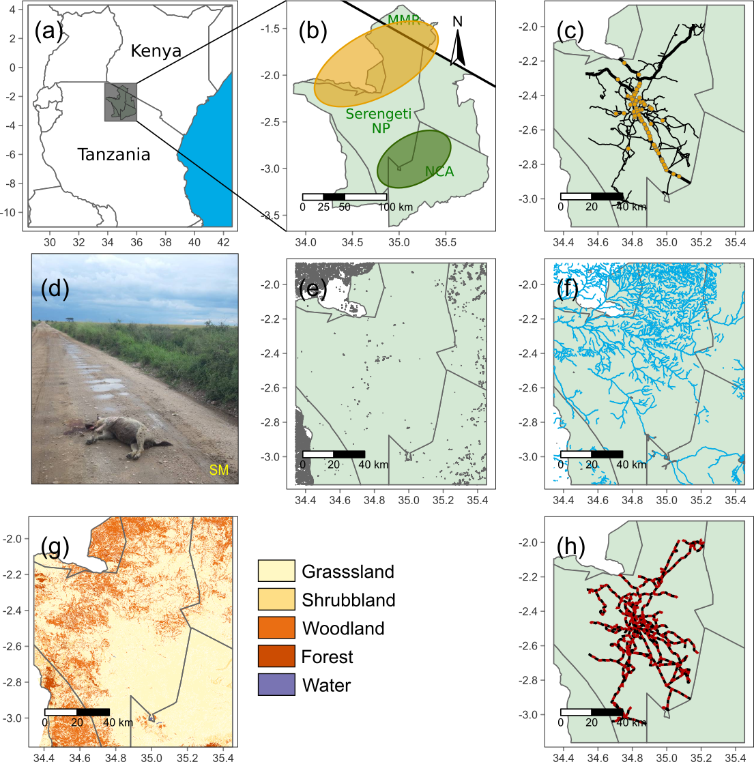

**Figure 2**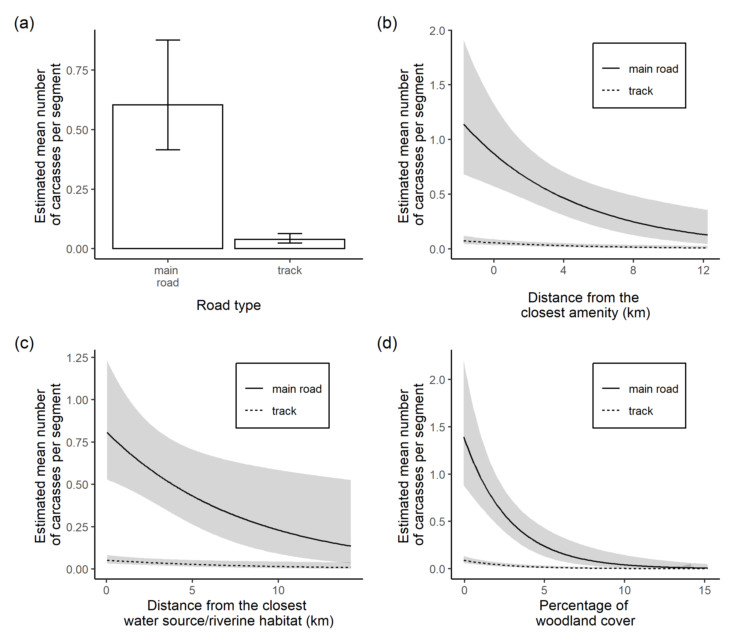

**Figure 3**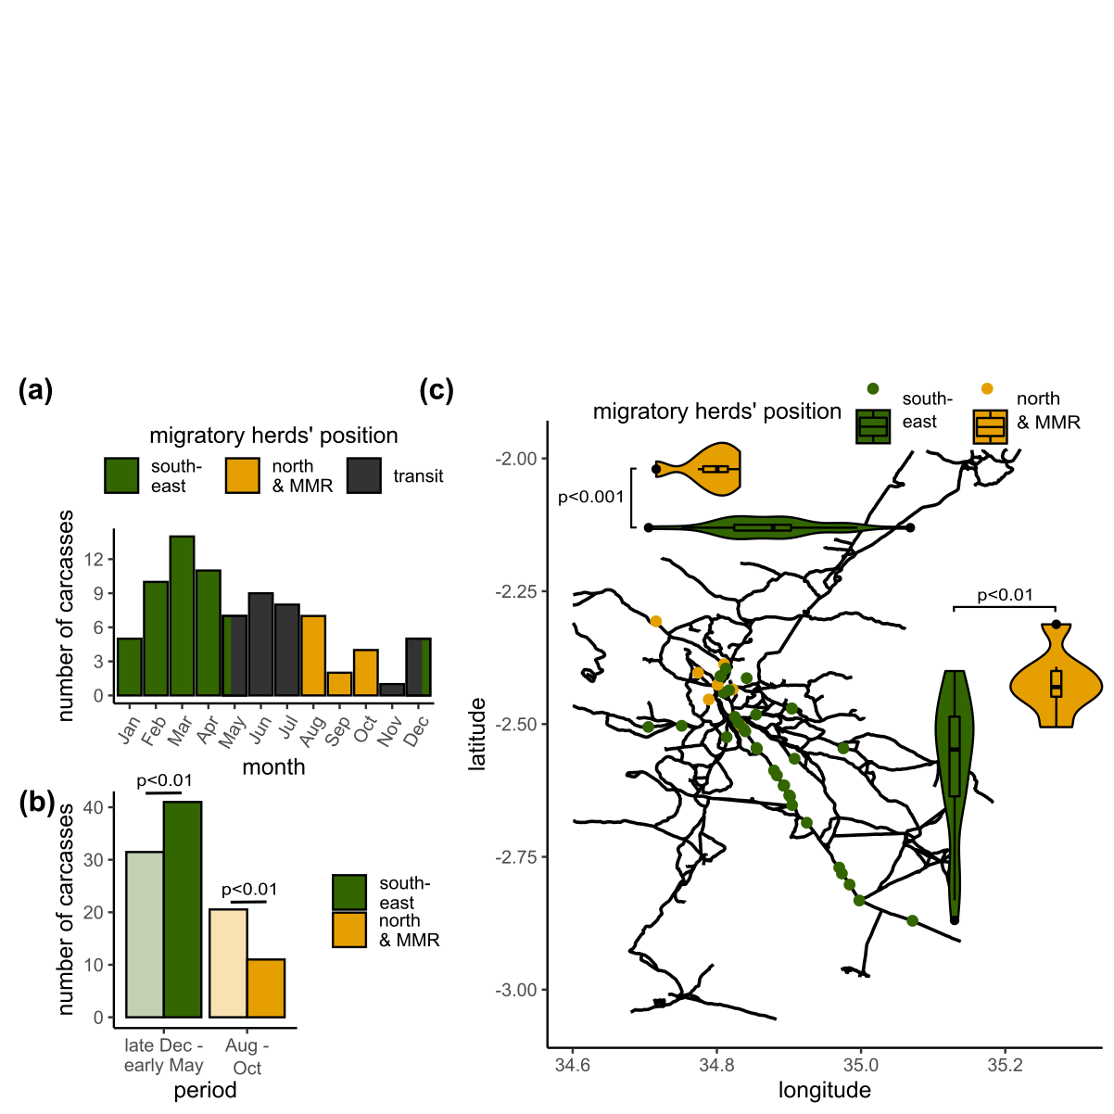

**Figure 4**