Activation Functions & Weight Initialization on CIFAR-10
Two-layer fully-connected network (Affine → Activation → Affine → Softmax) — Full-batch Gradient Descent
Generated: 2026-01-24 22:19 | Seed: 42 | Hidden size: 200 | Reg: 0.001 | LR: 0.05 with step decay

1. Executive Summary
We trained a two-layer neural network on CIFAR-10 and compared five activation functions (ReLU, Leaky ReLU, tanh, sigmoid, GELU) under two regimes: (A) activation-only controlled initialization (small init for all) and (B) best-practice initialization (He for ReLU-family/GELU and Xavier for tanh/sigmoid). Best-practice initialization improved final cross-validation (CV) accuracy for every activation, with the strongest overall performance achieved by GELU.

2. Experimental Setup
- Dataset: CIFAR-10 (train set split into Train and 10k CV)
- Model: 2-layer FC net, D=3072, H=200, C=10
- Optimization: Full-batch gradient descent (300 iterations)
- Learning rate: 0.05 with step decay (×0.9 at iters 100 and 200)
- Regularization: L2 with reg=0.001
- Logged metrics at iters [1, 50, 100, 150, 200, 250, 300]: loss and CV accuracy

3. Results Overview
Final CV accuracy after 300 iterations for both regimes:
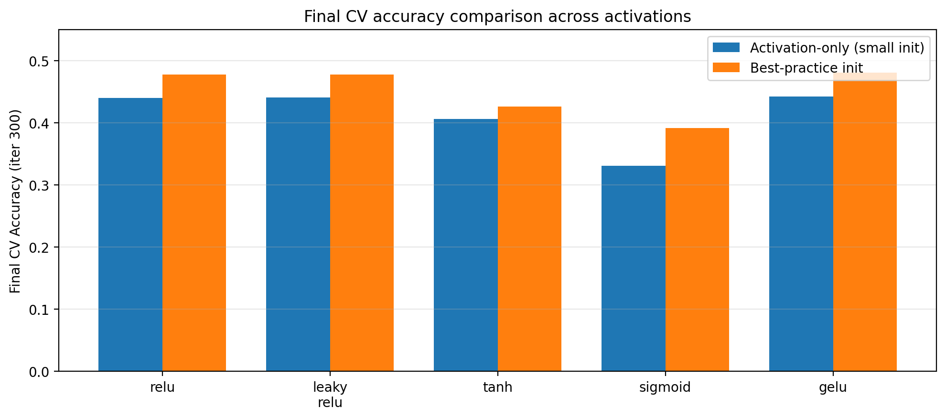
Activation | Mode A Final CV | Mode B Final CV | Δ (B−A)
relu | 0.4401 | 0.4774 | +0.0373
leaky_relu | 0.4405 | 0.4775 | +0.0370
tanh | 0.4058 | 0.4260 | +0.0202
sigmoid | 0.3304 | 0.3913 | +0.0609
gelu | 0.4422 | 0.4802 | +0.0380

4. Per-Activation Learning Curves
Each figure shows CV accuracy and loss versus iteration for activation-only vs best-practice initialization.

RELU
Mode A init: small; Final CV: 0.4401. Mode B init: he; Final CV: 0.4774. Improvement: +0.0373.
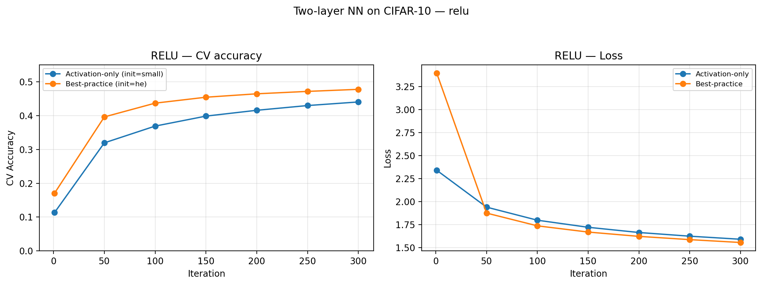

LEAKY_RELU
Mode A init: small; Final CV: 0.4405. Mode B init: he; Final CV: 0.4775. Improvement: +0.0370.
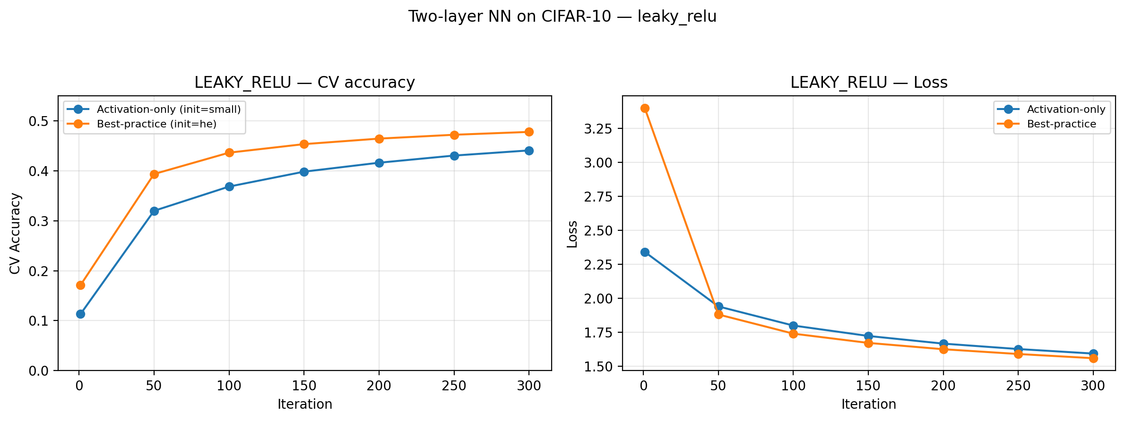

TANH
Mode A init: small; Final CV: 0.4058. Mode B init: xavier; Final CV: 0.4260. Improvement: +0.0202.
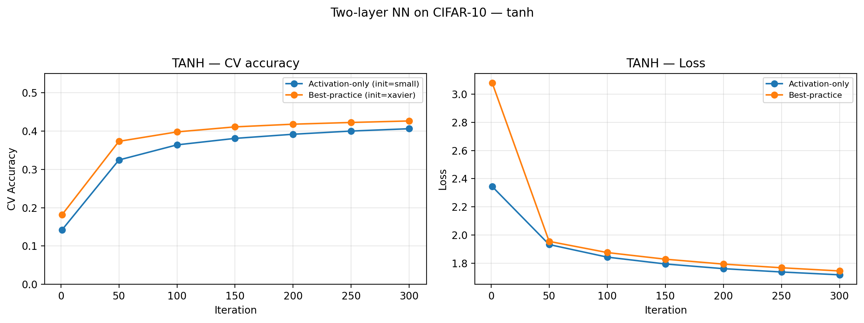

SIGMOID
Mode A init: small; Final CV: 0.3304. Mode B init: xavier; Final CV: 0.3913. Improvement: +0.0609.
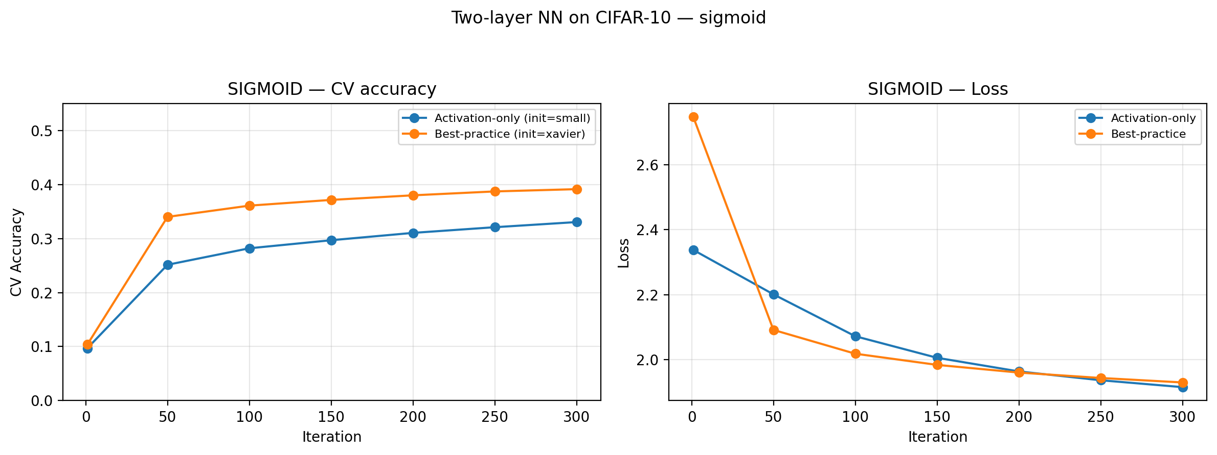

GELU
Mode A init: small; Final CV: 0.4422. Mode B init: he; Final CV: 0.4802. Improvement: +0.0380.
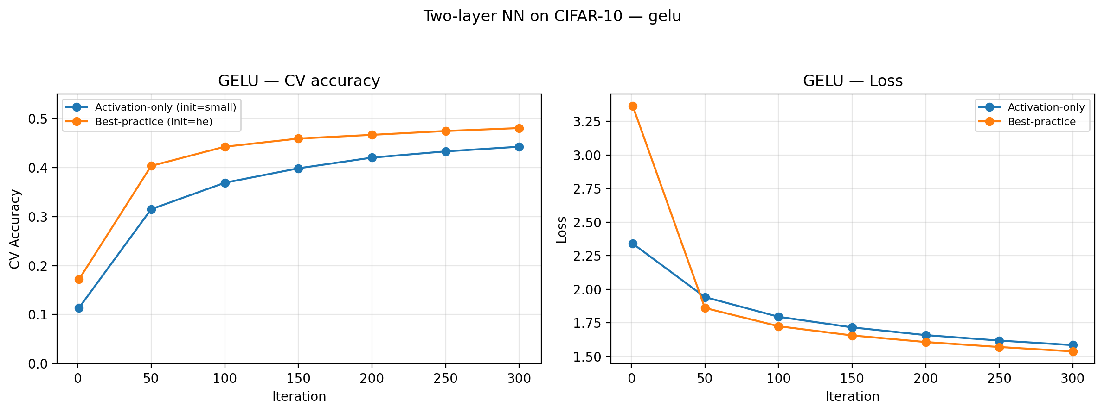

5. Key Findings & Interpretation
- Best-practice initialization improved final CV accuracy for every activation tested.
- ReLU-family activations (ReLU, Leaky ReLU) and GELU outperformed tanh and sigmoid in this 2-layer FC setting.
- GELU achieved the best final CV accuracy in both regimes, with a small but consistent advantage.
- Sigmoid benefited the most from best-practice initialization but remained the lowest-performing activation overall in this setup.

6. Why Best-Practice Initialization Depends on Activation
Initialization aims to keep activation magnitudes and gradient magnitudes in a healthy range. Different nonlinearities change the variance of signals passing through the network; He and Xavier initializations choose weight scales to approximately preserve signal variance (forward) and gradient variance (backward), improving optimization stability.

6.1 He initialization (ReLU / Leaky ReLU / GELU)
ReLU-like activations gate or attenuate negative inputs, reducing signal variance (e.g., ReLU sets many negative values to zero). He initialization uses a larger variance (≈2/fan_in) to compensate, helping maintain stable activations and gradients. Leaky ReLU and GELU behave similarly enough that He is a strong default.

6.2 Xavier initialization (tanh / sigmoid)
tanh and sigmoid can saturate when pre-activations are large, leading to small derivatives and vanishing gradients. Xavier initialization (≈2/(fan_in+fan_out)) aims to keep pre-activations closer to zero initially, where these activations are more linear and gradients are larger.

7. Reproducibility Notes
All runs used seed=42, hidden size H=200, reg=0.001, and the same learning-rate schedule. Mode A used the same small initialization for all activations. Mode B used He for ReLU-family/GELU and Xavier for tanh/sigmoid.

8. Artifacts (Saved Weights)
During training, checkpoints were saved every 100 iterations under models/checkpoints/<activation>_<mode>/, and final weights were saved under models/final/. Files are stored as NumPy .npz archives containing W1, b1, W2, b2 along with a JSON metadata file.

Appendix: Activation Function Shapes (f(x))
The following plots show the activation function shapes f(x) over x ∈ [-5, 5].

A.1 All activations (shape comparison)
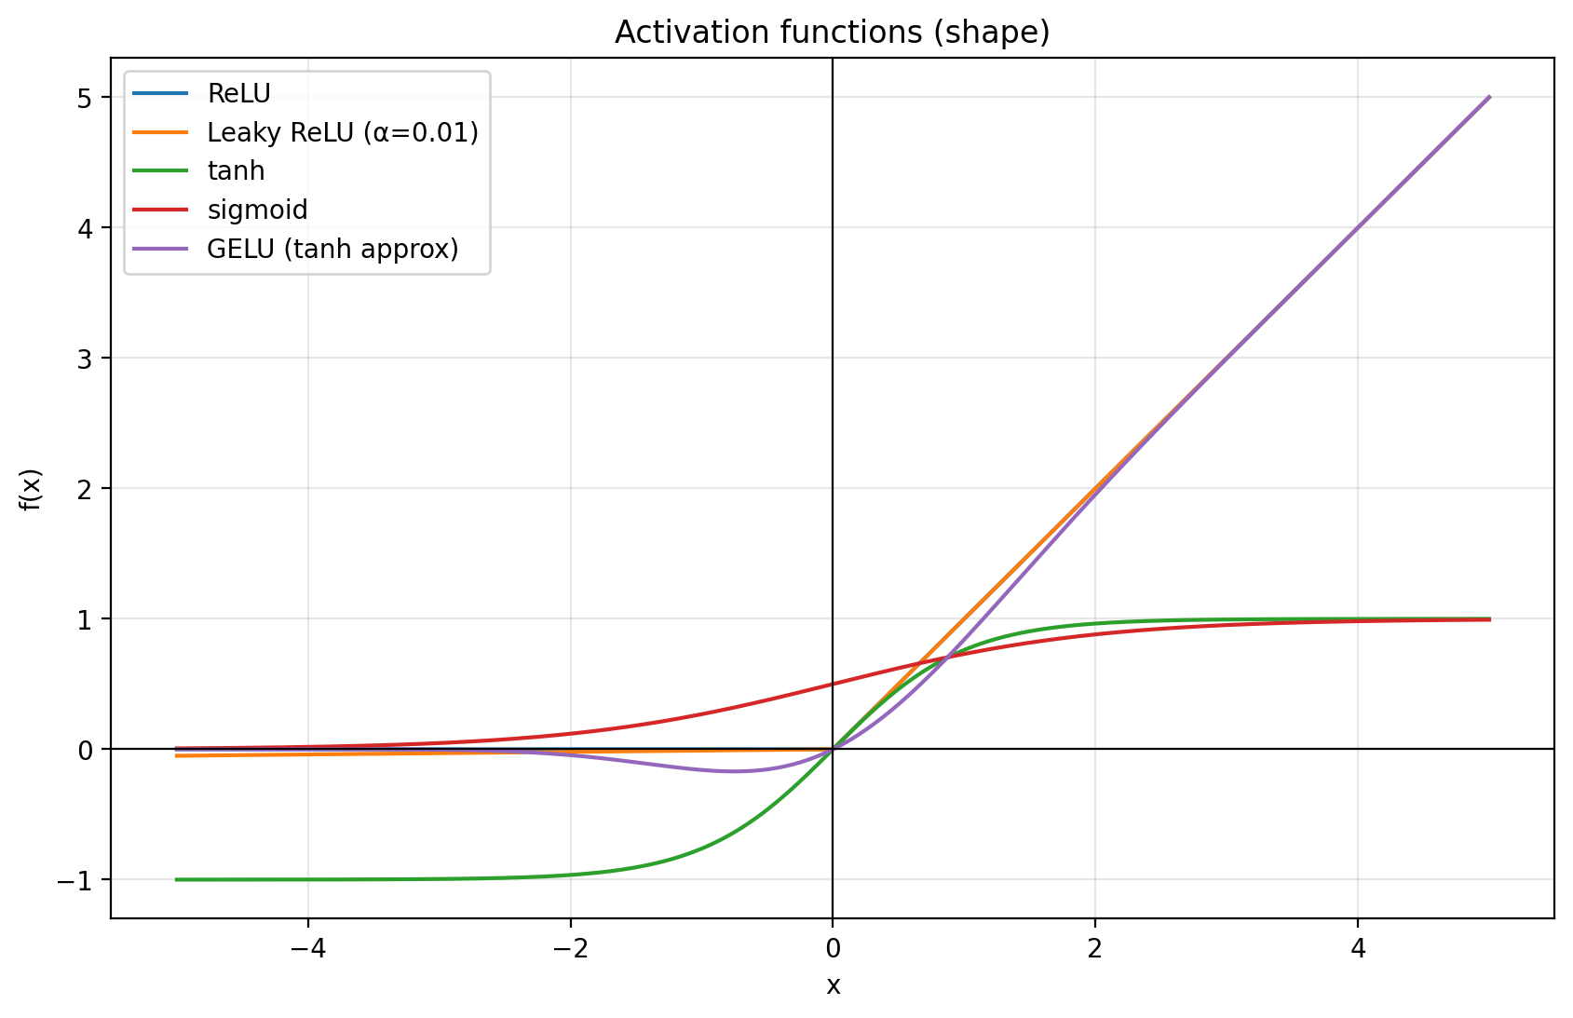

A.2 Individual activation shapes

ReLU
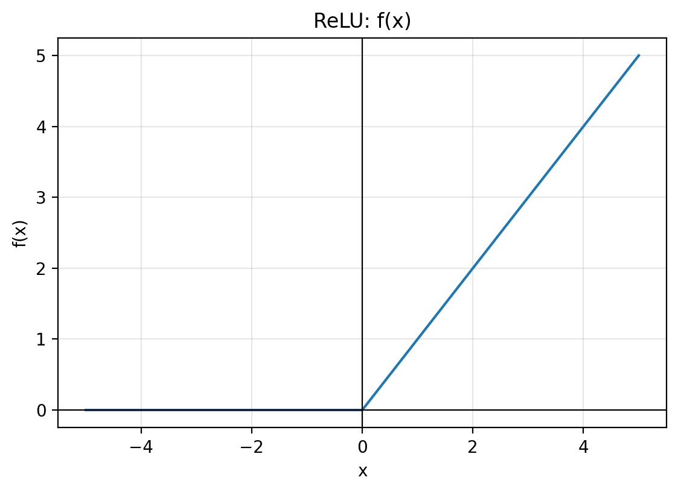

Leaky ReLU (α=0.01)
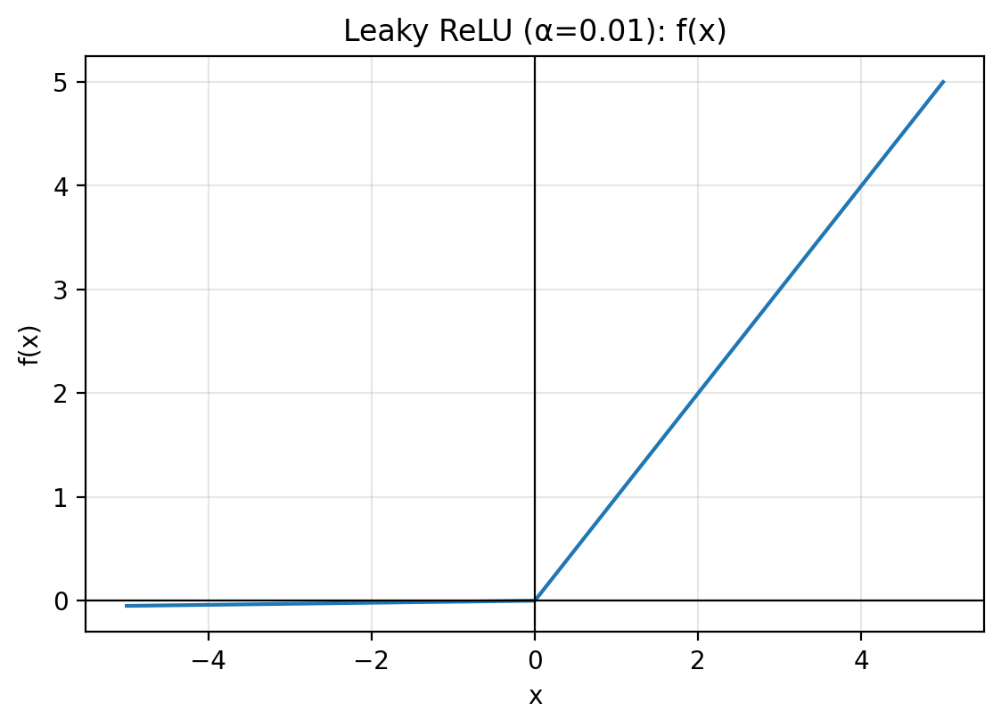

tanh
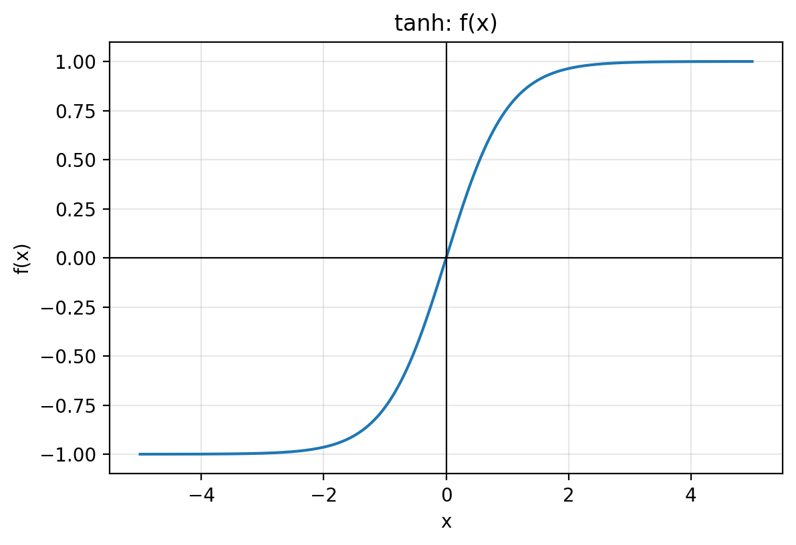

sigmoid
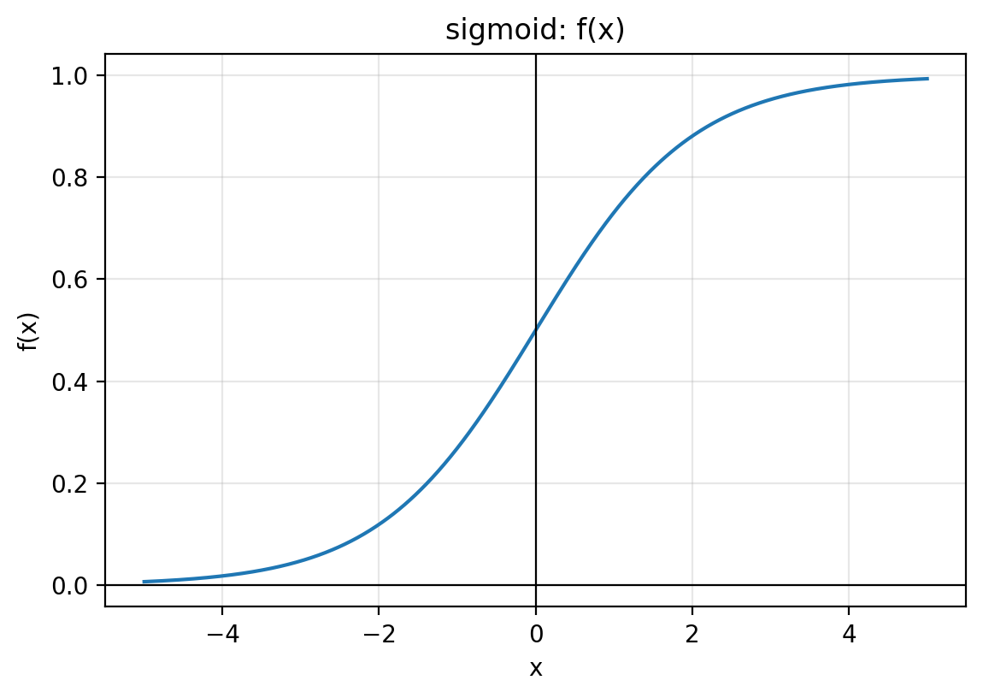

GELU (tanh approx)
