K-Nearest Neighbors and Linear Classification on CIFAR-10

k-Nearest Neighbors Classification on CIFAR-10

1. Dataset: CIFAR-10
The CIFAR-10 dataset consists of 60,000 color images, each with dimensions of 32×32 pixels. These images are categorized into 10 distinct classes: airplane, automobile, bird, cat, deer, dog, frog, horse, ship, and truck. The dataset is divided into a training set containing 50,000 images and a test set with 10,000 images. For feature representation, each image is flattened into a 3,072-dimensional vector, corresponding to the 32×32 pixels and three RGB channels.
- Classes: airplane, automobile, bird, cat, deer, dog, frog, horse, ship, truck
- Training set: 50,000 images
- Test set: 10,000 images
- Feature representation: Each image is flattened to 3,072 features (32×32×3 RGB channels)

2. Algorithm Implementation
k-Nearest Neighbors (k-NN):
- A lazy learning algorithm that stores all training data
- For each test image, finds k most similar training images
- Predicts the most common class among those k neighbors using majority voting

Distance Metrics Implemented
- L1 (Manhattan) distance: Computes the sum of absolute pixel differences
- Formula: (Sum of absolute differences between corresponding pixels)
•L2 (Euclidean) distance: Computes the square root of the sum of squared differences
- Formula: (Square root of sum of squared differences between corresponding pixels)

3. Experimental Setup
- k values tested: 1, 3, 5, 7, 9, 15, 20
- Test subset size: 100 images were used for faster experimentation
- Training data: Full set of 50,000 images

4. Results
k Value | L1 Accuracy | L2 Accuracy
1 | 0.18 | 0.29
3 | 0.25 | 0.24
5 | 0.25 | 0.21
7 | 0.26 | 0.21
9 | 0.26 | 0.23
15 | 0.25 | 0.2
20 | 0.26 | 0.2

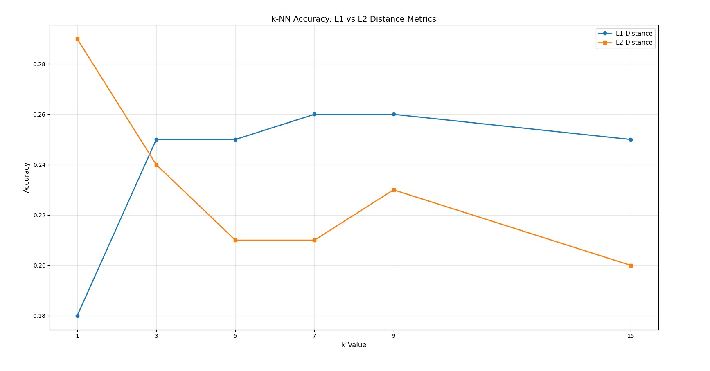

5. Analysis and Observations
- L2 excels at k='1' (29%), but its performance drops noticeably at higher k values, settling between 20-24%. L2 is optimal for identifying the single nearest neighbor due to its use of true Euclidean distance. However, squaring differences can amplify the impact of outlier pixels, making majority voting less consistent when considering more neighbors.
- L1 shows stable performance (25-26%) across all k values greater than 1. This metric is more robust to outlier pixels and treats all pixel differences equally, making it better suited for scenarios involving majority voting among multiple neighbors.
- Optimal k range: For the L1 distance metric, the best accuracy is achieved when k is between 7 and 9.
- Overall accuracy is modest (20-29%) for k-NN on raw CIFAR-10 images. As a comparison, random guessing would yield about 10% accuracy, given the ten classes. The use of raw pixel values does not effectively capture semantic features, and k-NN struggles with high-dimensional image data without additional feature engineering.

6. Conclusions
- L1 distance is more suitable for k-NN classification on CIFAR-10 when k is greater than 1.
- Performance results highlight the need for improved feature representations.
- Future work should include cross-validation to select the optimal k value more reliably.

Linear Classification

Implementing Linear Decision Boundaries via Ridge Regression
Linear classification was explored as an alternative to k-NN by implementing closed-form ridge regression to learn linear decision boundaries.

Data Preparation
- Original CIFAR-10 dataset: 50,000 training images and 10,000 test images
- Training set: 40,000 images used for learning model weights
- Cross-Validation set: 10,000 images reserved for hyperparameter tuning
- Test set: 10,000 images used for final evaluation

Preprocessing Pipeline
- Mean Subtraction: The mean is computed from the training data and subtracted from all datasets, shifting pixel values from [0, 255] to approximately [-140, 155] with a mean near zero. This step improves numerical stability and helps with model convergence.
- Bias Column: A column of ones is added to the feature matrix to allow the model to learn an intercept term; the final feature matrix shape is (N, 3073).
- One-Hot Encoding: Class labels are converted to one-hot vectors for use as training labels (e.g., class 5 becomes [0,0,0,0,0,1,0,0,0,0]).

Training Method: Ridge Regression (Closed-Form)
The model is trained using closed-form ridge regression, which minimizes the mean squared error loss with L2 regularization. The regularization term helps prevent overfitting by penalizing large weights, with the bias term excluded from regularization.
- Compute the feature correlation matrix X^{T}X (3073×3073)
- Create the regularization term λI, setting the last diagonal element to zero so the bias is not regularized
- Calculate feature-label correlations with X^{T}Y (3073×10)
- Solve the linear system for weights using a numerical solver
Loss Function: Mean Squared Error (MSE) with L2 regularization

Initial Results (λ = 0.1)
- CV Accuracy: 36%
- Test Accuracy: 36%
- Status: No overfitting detected (CV and Test accuracies are similar)

Issue: Lambda Tuning Not Working
Testing various values of λ (from 1e-4 to 10) resulted in identical model weights and cross-validation accuracy (36%). It was expected that different λ values would yield different weights and accuracies, but this was not observed.
- All tested lambda values produced identical weights and 36% CV accuracy
- Expected: Different lambda values should yield different weights and model performances

Root Cause: Unscaled Features
- Feature values remained large after mean subtraction (range: [-140, 155])
- The feature correlation matrix X^{T}X had very large magnitudes (~10⁶)
- The regularization term λI was negligible compared to the magnitude of X^{T}X
- Mathematically, adding a small λ to a large value results in no meaningful change

Solution: Feature Scaling (Standardization)
The solution was to standardize features by dividing by the training set standard deviation after mean subtraction, normalizing features to unit variance.
- Features were normalized to have unit variance
- Feature values were scaled to the [-1, 1] range, making them comparable to λ values
- Now, different λ values produced meaningfully different weights

Hyperparameter Tuning: Lambda Selection
Before feature scaling, lambda tuning yielded identical CV accuracy across all tested values. After standardization, the regularization term became meaningful, allowing for effective hyperparameter selection.
- Feature scaling allowed weights to change with different λ values
- Higher λ values produced smaller weights, indicating stronger regularization
- Optimal λ was found to be 10, providing the highest cross-validation accuracy
- Increasing λ improved model performance
Lambda | W[0,0] | CV Accuracy
0.0001 | 0.030095 | 35.97%
0.001 | 0.030085 | 35.97%
0.01 | 0.029983 | 35.97%
0.1 | 0.028983 | 35.99%
1 | 0.021298 | 36.24%
10 | 0.006626 | 37.03%✓

Final Model Performance
- Optimal λ = 10
- Features: Standardized pixel values (mean subtraction followed by variance scaling)
- Bias term: Not regularized and learned separately for each class

Comparison with k-NN
- Best k-NN accuracy: 29% (k='1,' L2 distance)
- Linear regression accuracy: 36.58%
- Linear regression outperformed k-NN by approximately 7.58 percentage points

Approaches to Linear Regression
For this project, two approaches to linear regression were implemented and compared: the closed-form solution and gradient descent.

Closed-Form Solution
- Formula: W = (X^{T}X + λI)⁻¹X^{T}Y
- Approach: Direct mathematical solution computed instantly using matrix algebra
- Advantages: Exact solution, guaranteed global optimum
- Disadvantages: Requires matrix inversion O(n³), memory-intensive for large datasets
- Results: CV Accuracy: 37.03%, Test Accuracy: 36.58%

Gradient Descent (Iterative)
- Formula: W(t+1) = W(t) − α∇L(W(t)) over 500 iterations
- Approach: Iteratively optimize by moving downhill along the gradient
- Advantages: Memory-efficient, works with non-linear models, GPU-accelerable
- Disadvantages: Requires tuning (learning rate, iterations), approximate solution
- Results: CV Accuracy: 38.01%, Test Accuracy: 38.49%
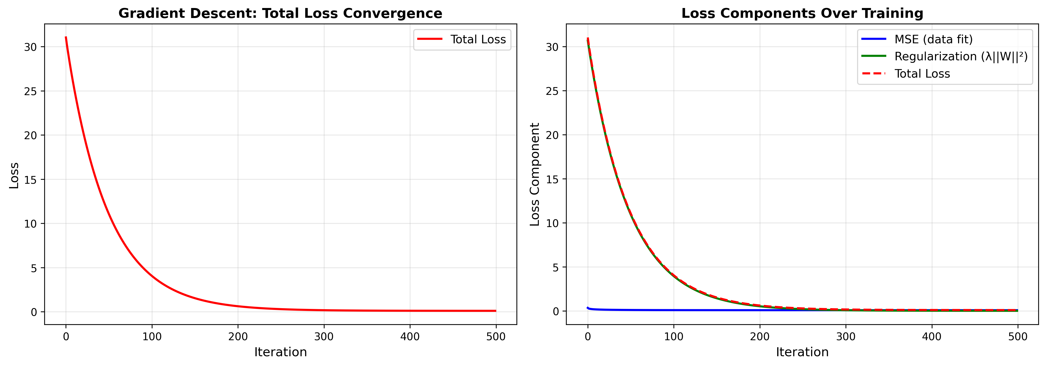

Performance Comparison
Method | CV Accuracy | Test Accuracy
Closed-Form | 37.03% | 36.58%
Gradient Descent | 38.01% | 38.49%

When to Use Each
- Closed-Form: Best for small to medium datasets (
- Gradient Descent: Preferred for large datasets, non-linear models, memory constraints, or streaming data

