Untitled

## Quarto

Quarto enables you to weave together content and executable code into a finished document. To learn more about Quarto see <https://quarto.org>.

|  |  |  |
| --- | --- | --- |
|  |  |  |

|  |  |  |
| --- | --- | --- |
|  |  |  |

|  |  |  |
| --- | --- | --- |
|  |  |  |

## Running Code

When you click the **Render** button a document will be generated that includes both content and the output of embedded code. You can embed code like this:

1 + 1

[1] 2

|  |  |  |  |
| --- | --- | --- | --- |
|  |  |  |  |

|  |  |  |  |
| --- | --- | --- | --- |
|  |  |  |  |

## Plotly

Here’s a plotly diagram

library(plotly)  
library(dplyr)  
library(forcats)  
  
# Небольшая предобработка: сделаем категориальную переменную явно категориальной  
mtcars <- mtcars |>  
 mutate(am = fct_recode(as.character(am), 'Automatic' = '0', 'Manual' = '1'))  
  
plot_ly(  
 mtcars,  
 x = ~wt,  
 y = ~hp,  
 z = ~qsec,  
 color = ~am,  
 colors = c('#BF382A', '#0C4B8E'),  
 width = 200, height = 140  
) |>  
 add_markers()

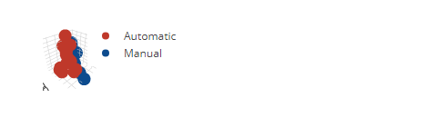

## Leaflet

Here’s a Leaflet map

library(leaflet)  
  
leaflet() |>  
 addTiles() |> # По умолчанию загружает карту OpenStreetMap, и норм   
 addMarkers(lng=37.560826, lat=55.722685, popup="Я разговариваю с вами отсюда")

