***Ufficio SEGRETERIA***

FIACOM PLATFORM

OBJECTIVE: to have a platform for the collection and distribution of monthly E.LAV. quotas between the agents (Responsabile Territoriale) and the labour consultants (Sportello Lavoro).

* Create the CRM for uploading, cataloguing and assigning companies uploaded
* Create an access port with data from INPS SERVIZI
* Create a commercial area to refer companies to Fiacom's contracted services

**STEP 1 - Create 3 levels of User and identify powers**

* **USER 1 -** **Super admin (FIACOM)**

1. sees all company master data entered by Users 1, 2 and 3
2. sees all commissions accumulated by Users 1, 2 and 3
3. Create the master data of Territorial Managers (User 2) and set the % commission
4. Create the master data of the Job Shops (User 3) and set the % commission

* **USER 2 -** **Responsabile Territoriale (Agende Commerciale)**

1. sees the company master data entered by him and the master data entered by the Consultants
2. he sees his commissions accumulate those of the workbenches associated with him

* **USER 3 -** **Sportello Lavoro (Consulente del Lavoro)**

1. only sees the records he has entered

sees only his accumulated commissions

* **USER 4 –** **Procacciatore**

The procacciatore is a simple collaborator of the Territorial Manager or the Labour Desk, he does not do real work but signals companies. He is basically User 3 with a 10% commission.

**NOTA 1 – Banca dati e Anagrafiche**

Each User will have its own database of companies and must be associated with the other Users

**EXAMPLE 1:** Fiacom appoints RGM SERVICE as territorial manager, RGM appoints 3M Consulting and SELE SRL as Sportello Lavoro.

**EXAMPLE 2:** Fiacom appoints RIZZO as territorial manager, Rizzo appoints MALARA and Gualtieri as Sportello Lavoro. We will have the following logical scheme:

* 3M Consultig can only see its own companies
* SELE SRL can only see its own companies
* RGM SERVICE can only see companies uploaded by 3M and SELE SRL
* RIZZO can only see companies uploaded by Malara and Gualtieri
* FIACOM sees all companies

**NOTE 2 - Specifications monthly ELAV fee and % commission**

The monthly ELAV fee is 10.42 per month, exceptions are those CCNLs where the monthly fee for the Bilateral Body is higher. In this case, the ELAV fee is capped at the fee specified in the CCNL itself.

ELAV 20% of EUR 10.42

TERRITORIAL RESPONSIBILITY % is inserted by FIACOM of 10.42

LABOUR OFFICE % la inserts FIACOM of 10.42

EMPLOYMENT OFFICER % la inserts FIACOM of 10.42

CASE 1 - Fiacom pays only the agent CASE 2 - Fiacom pays Agent and Consultant

**STEP 2 - Creating the 3 User Levels with Graphical Interfaces**

* **USER 1 -** **Super admin (FIACOM)**

The User Super Admin will be used exclusively by FIACOM.

The **Dashboard** shall contain the main information, quick access, forms and commercial material. In the navigation menu on the left-hand side, the 4 master data "Companies", "Agents", "Consultants", "Dealers" are visible and can be entered.

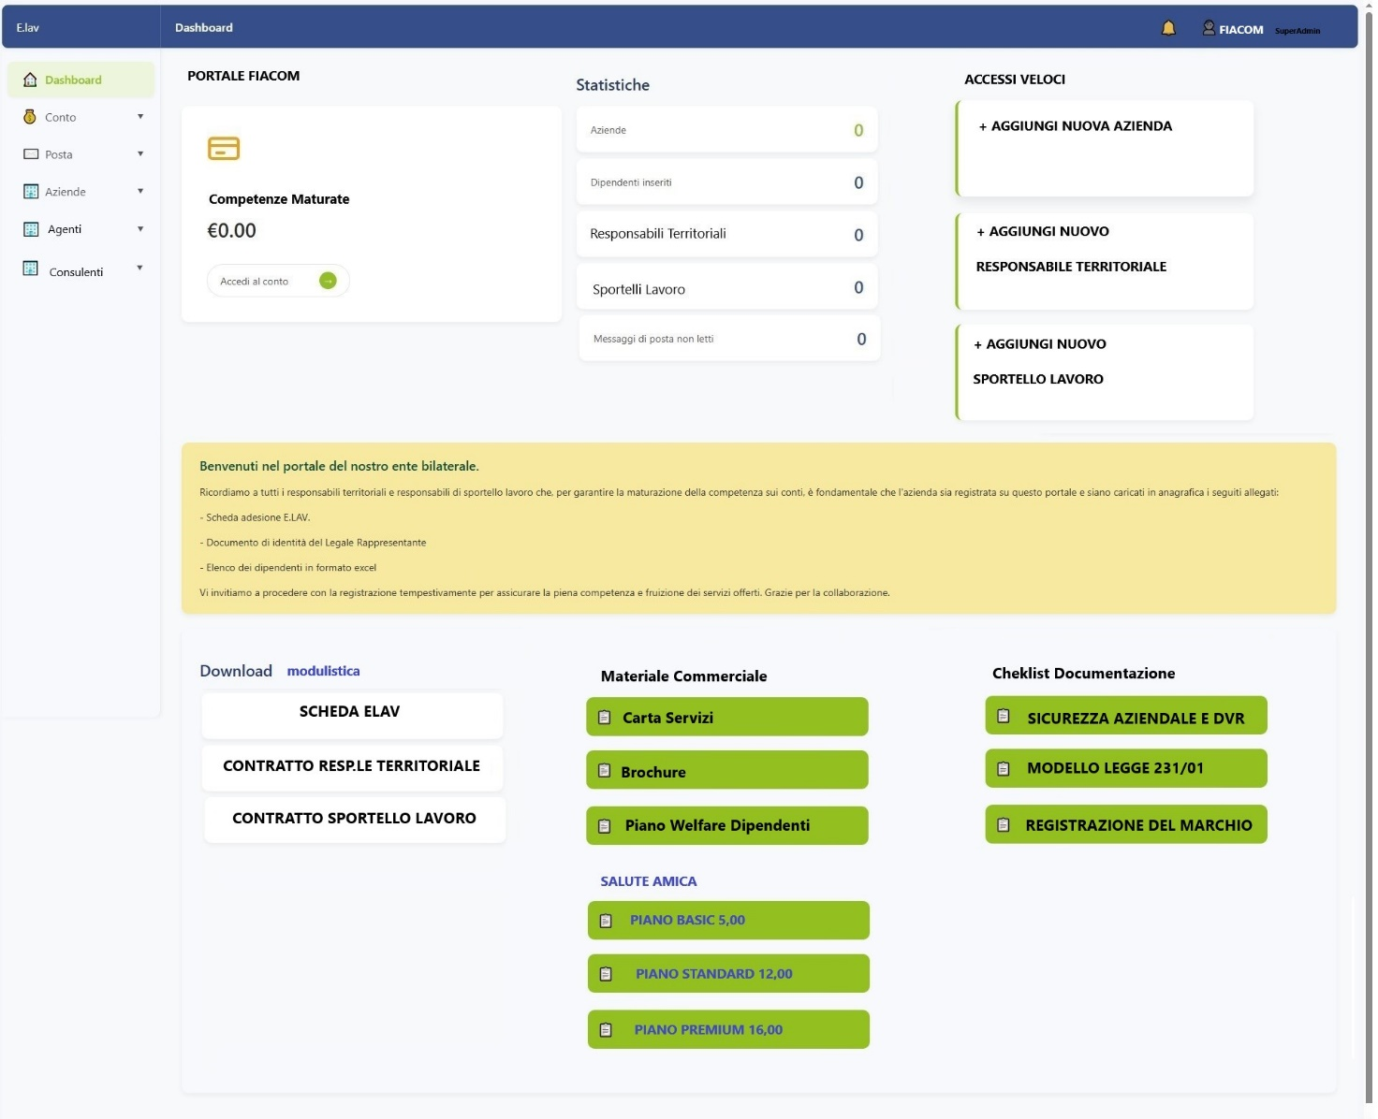

FIACOM must load the master data of companies, agents, labour consultants and brokers. It must have the power to associate the master data of commercial agents and labour consultants with the master data of the Territorial Manager. Below are the screens provided

ADD COMPANY DATA

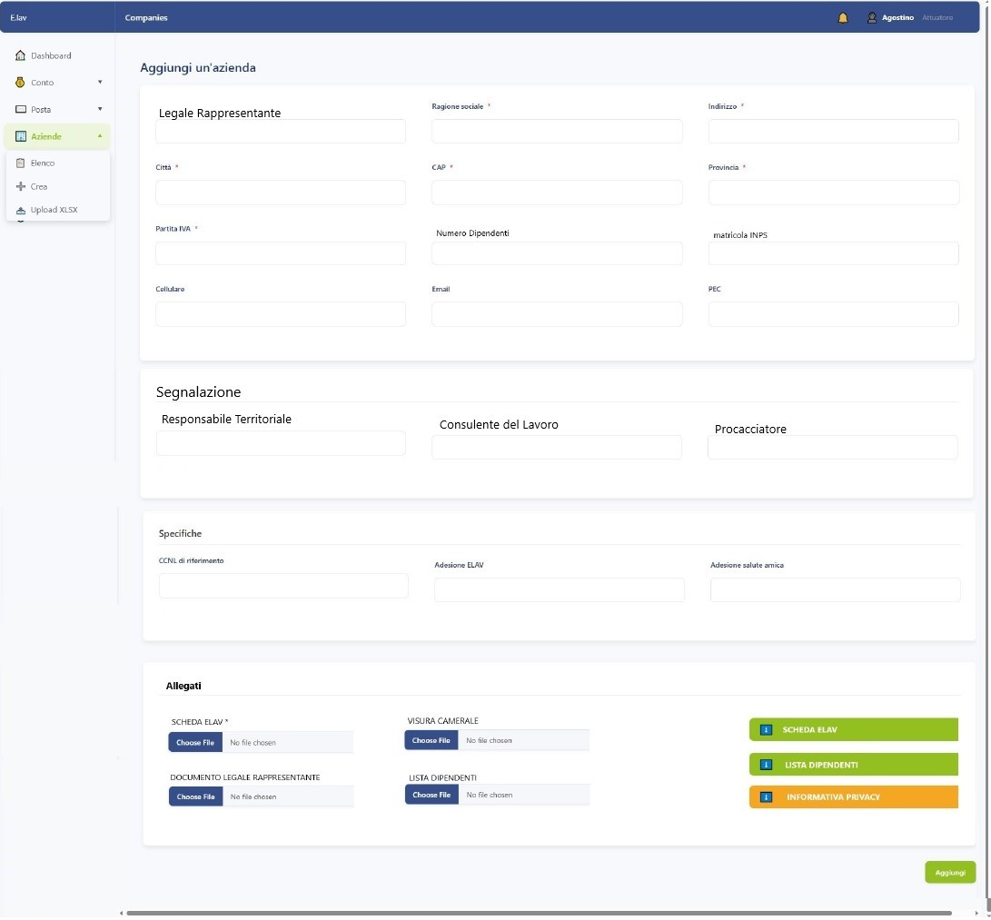

ADD AGENT MASTER DATA (Responsabile Territoriale)

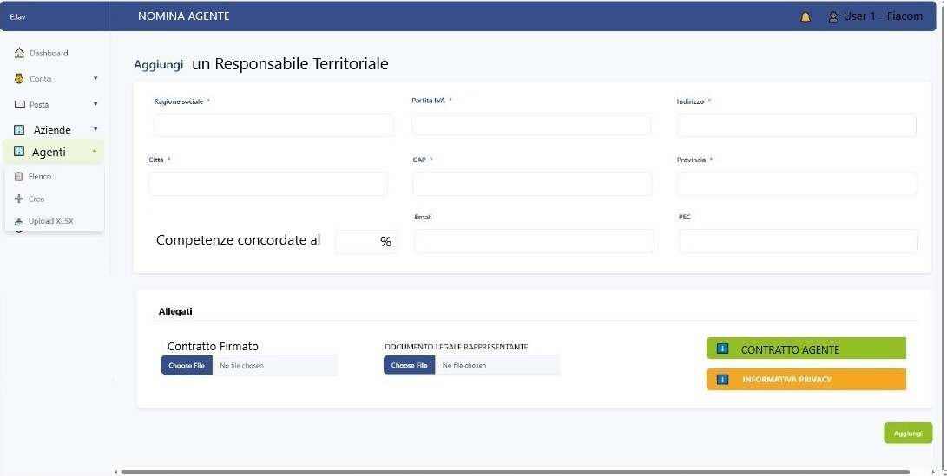

ADD LABOUR CONSULTANT (Sportello lavoro)

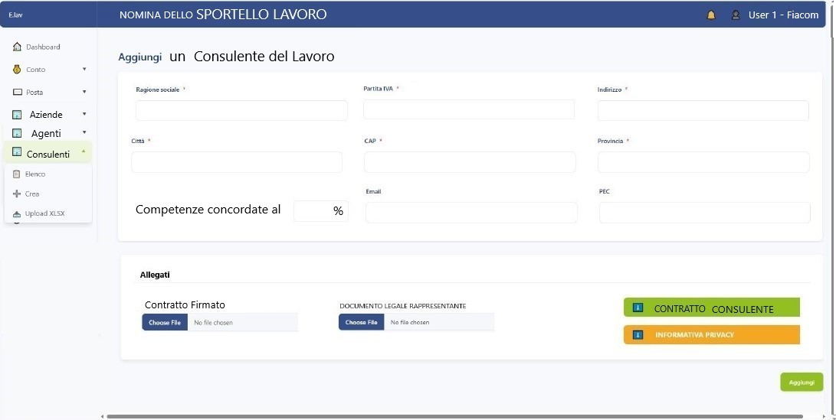

ADD PROCACCIATORE (User 4)

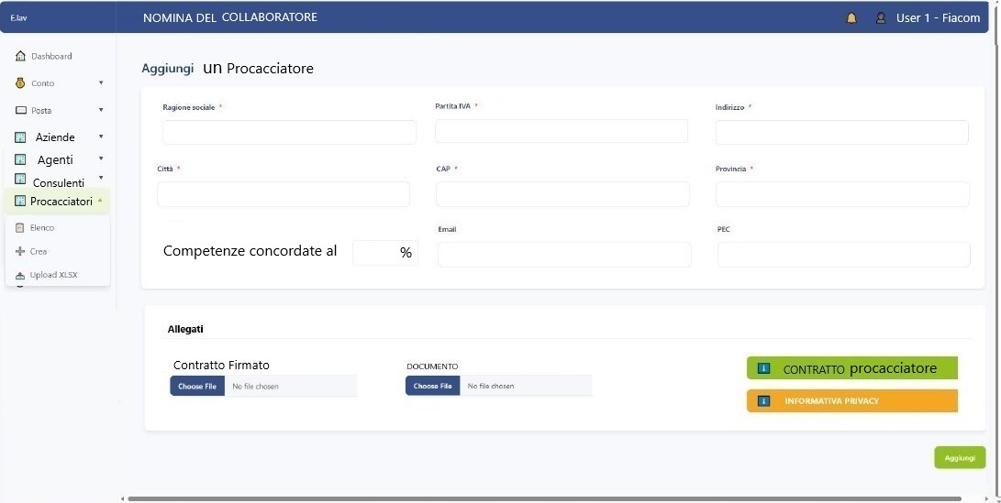

* **USER 2 –** **Responsabile Territoriale (Agente)**

The **Dashboard** and the remaining pages have the same structure

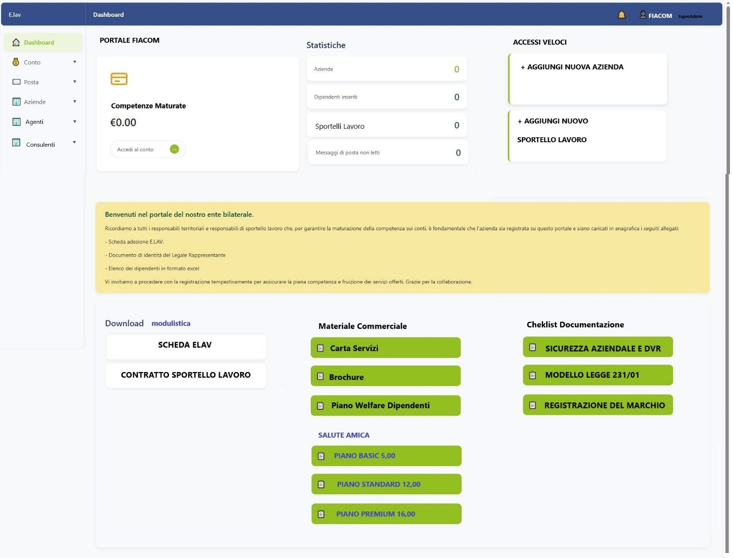

ADD COMPANY DATA

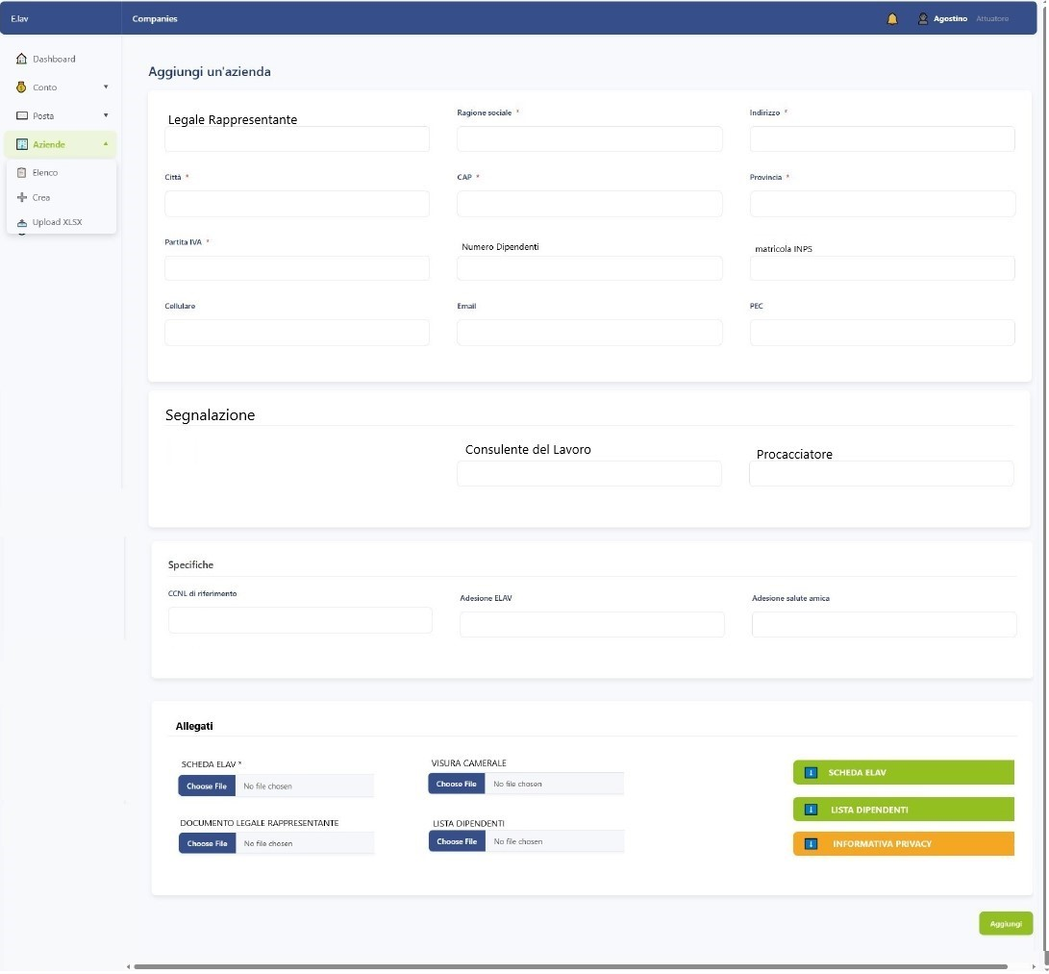

ADD CONSULENTE DEL LAVORO (Sportello lavoro)

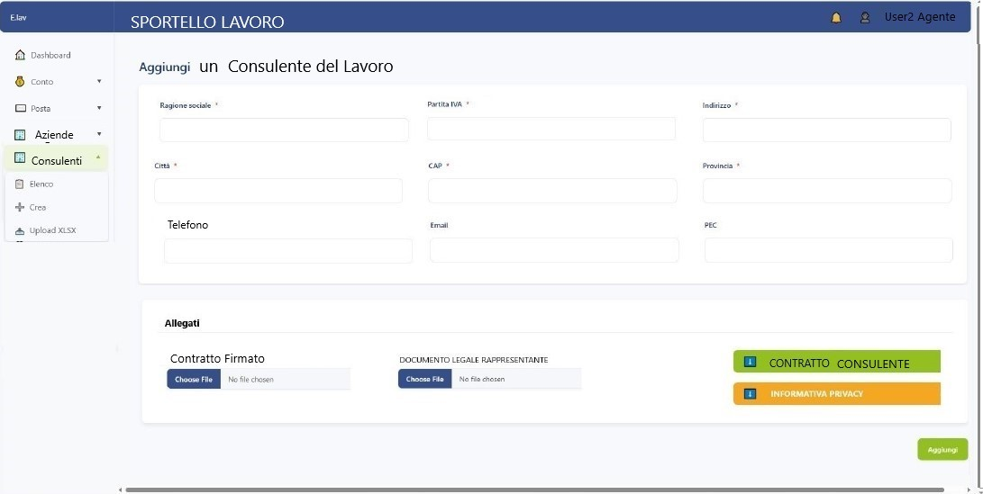

ADD PROCACCIATORE (User 4)

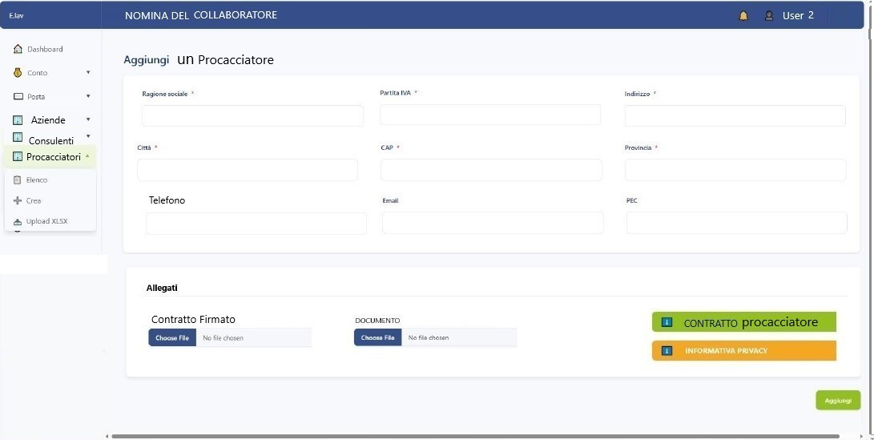

* **USER 3 –** **Sportello Lavoro (Consulente)**

**DASHBOARD**

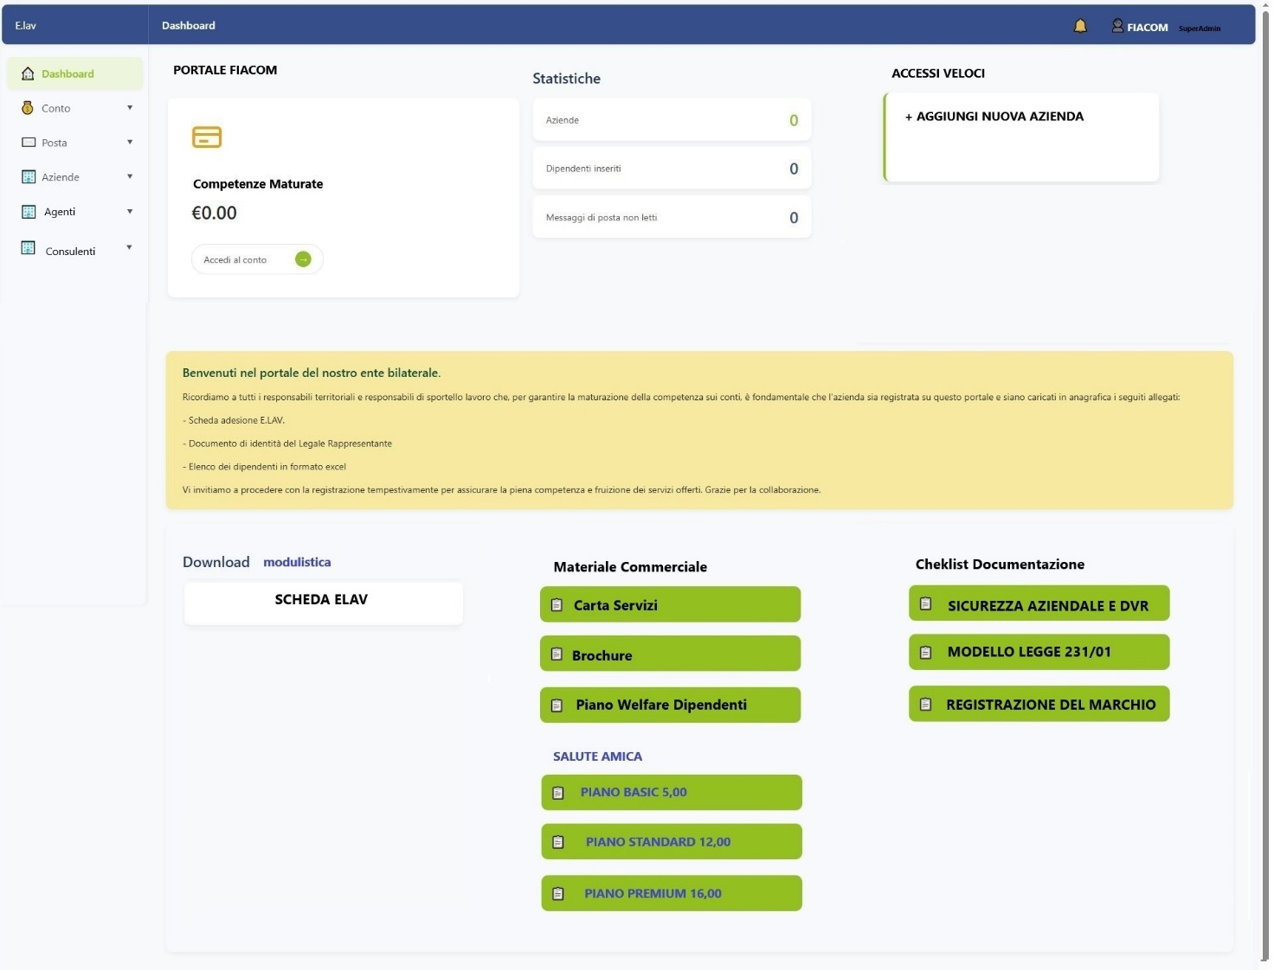

ADD COMPANY DATA

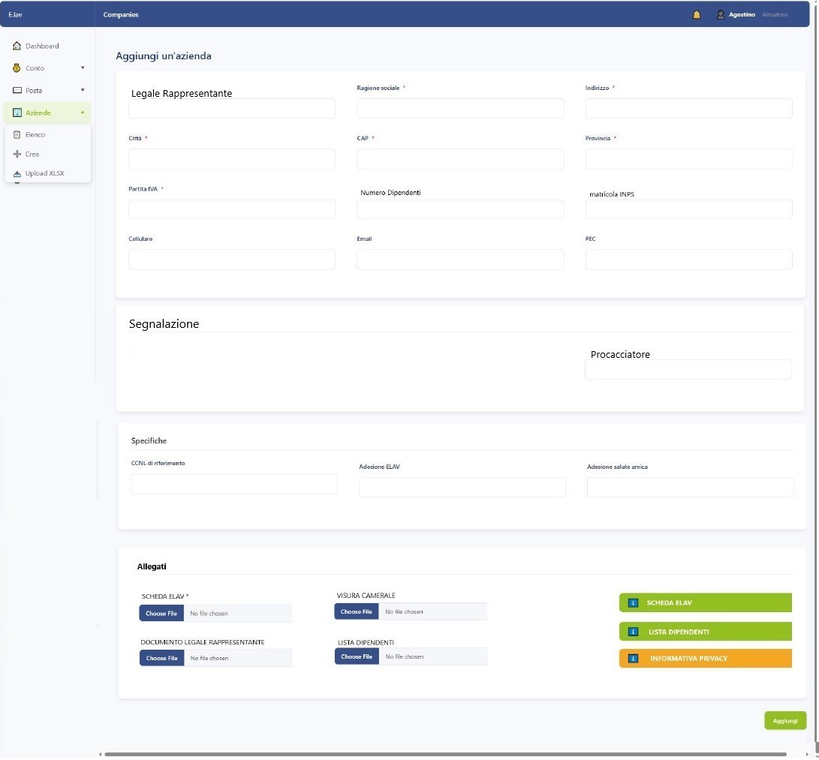

ADD PROCACCIATORE

