Query 1
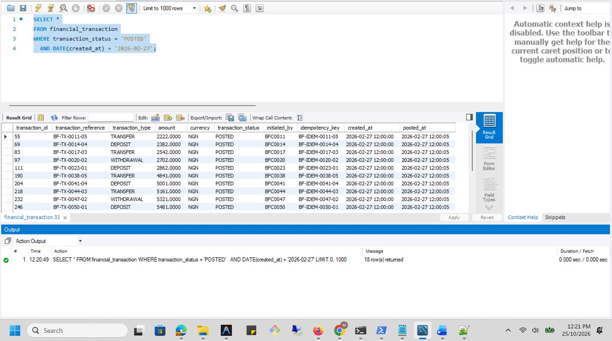
The query is functionally valid. The concern is that applying DATE() to created_at can prevent MySQL from using the created_at part of the existing index as a direct range condition.

Execution Plan
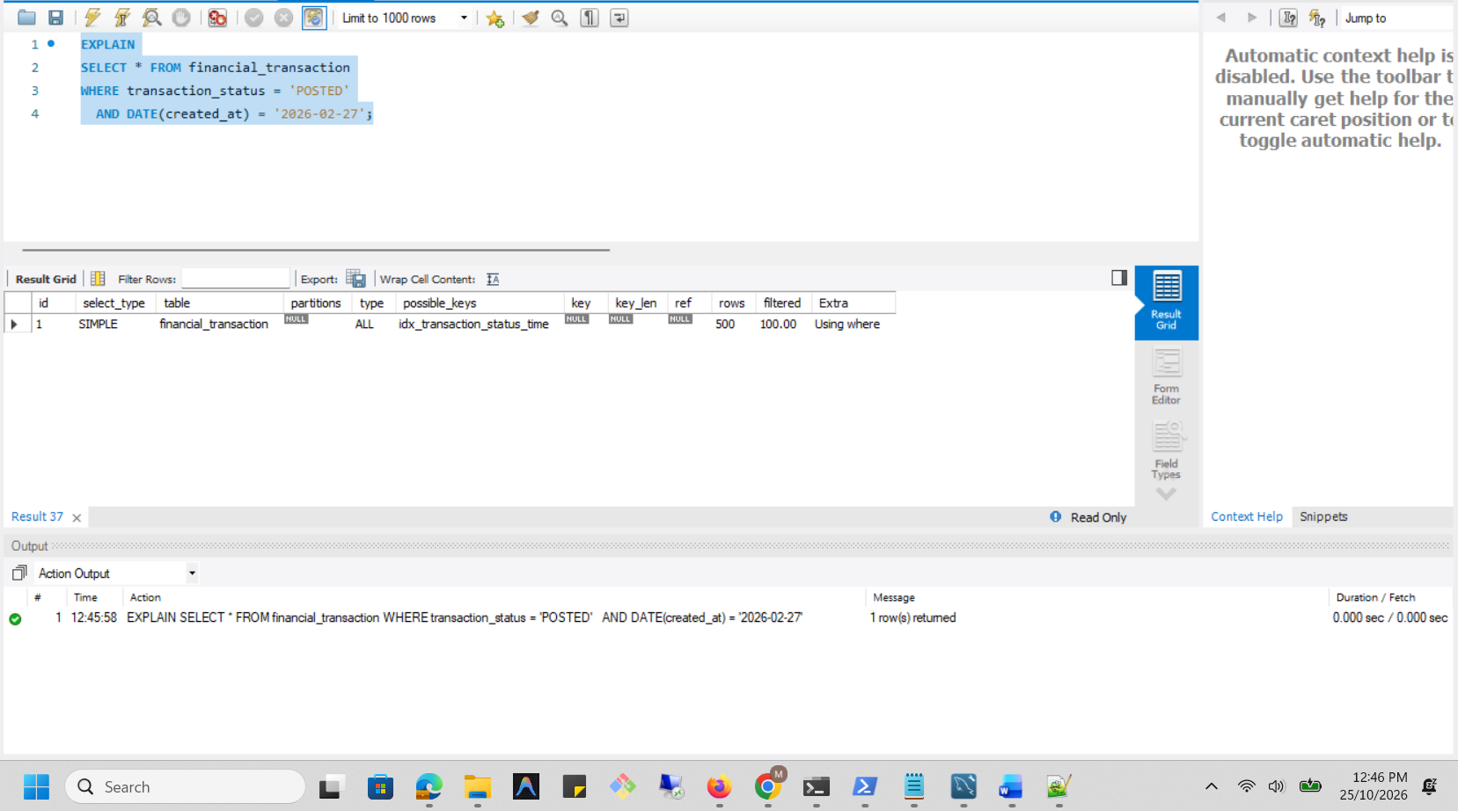
Optimisation option
Retain the existing index: KEY idx_transaction_status_time (transaction_status, created_at) but rewrite the date predicate to use a half-open range. This avoids wrapping created_at in a function and gives MySQL a direct range condition on the indexed column.
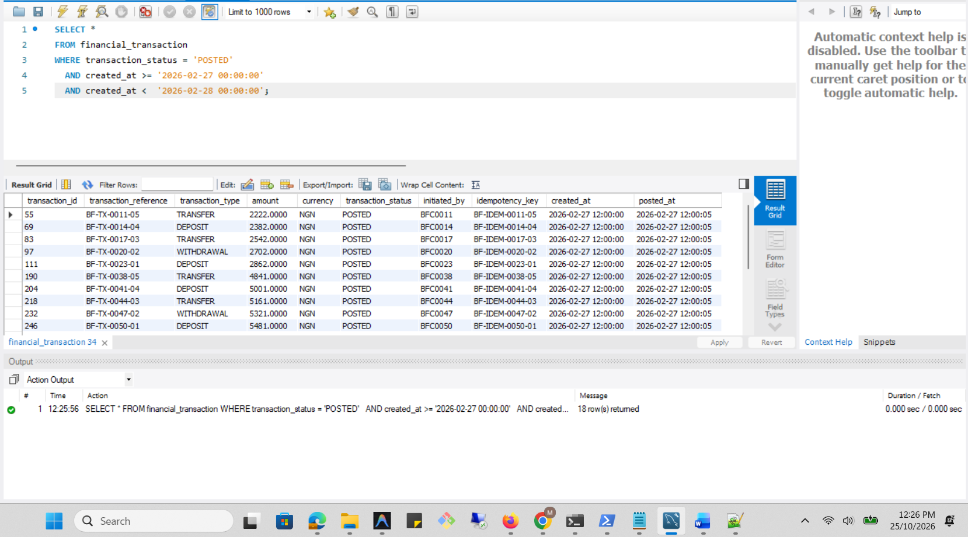

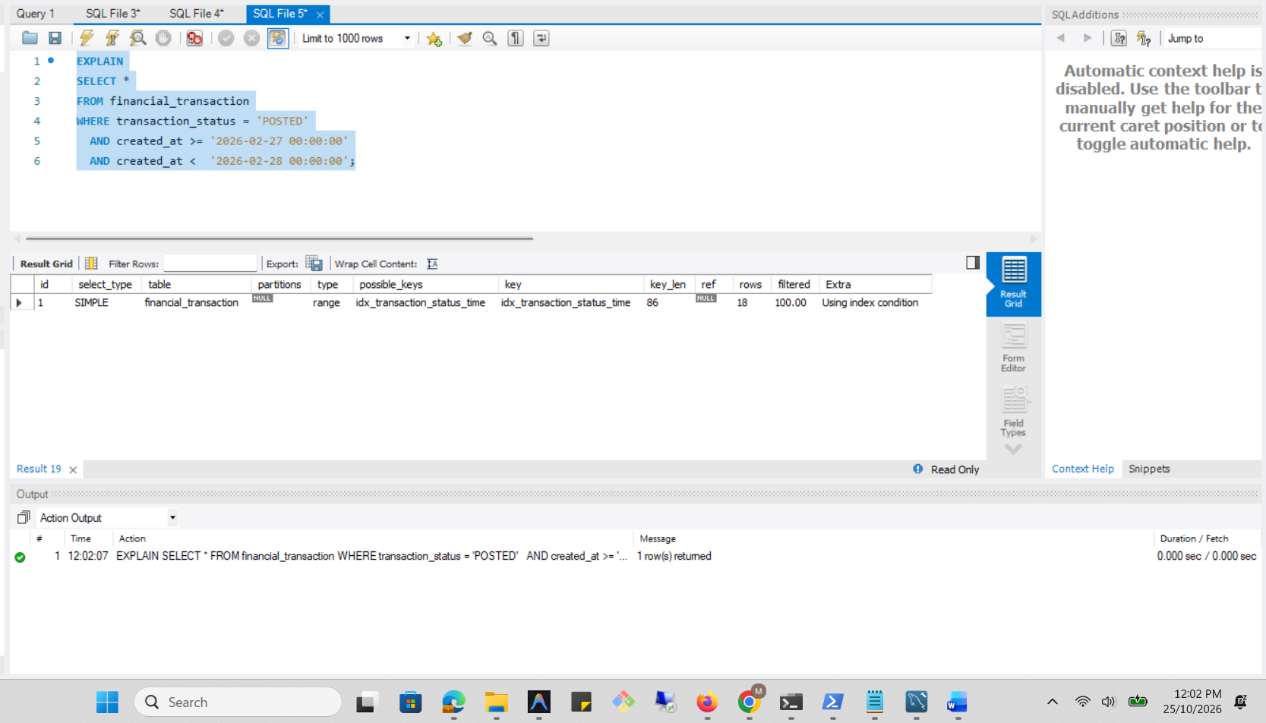
Indexing decision: no new index is required for this experiment because the existing composite index already supports the filter pattern.
Analysis Before
-> Filter: ((financial_transaction.transaction_status = 'POSTED') and (cast(financial_transaction.created_at as date) = '2026-02-27')) (cost=51.2 rows=500) (actual time=0.697..0.97 rows=18 loops=1)
-> Table scan on financial_transaction (cost=51.2 rows=500) (actual time=0.636..0.876 rows=500 loops=1)

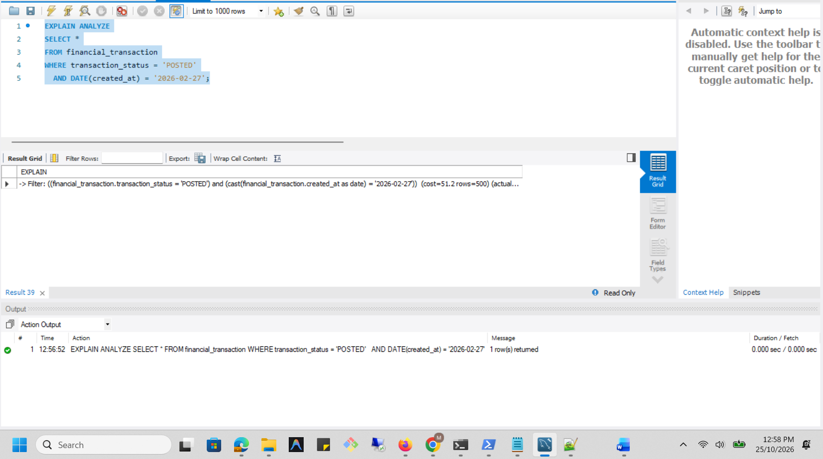

Analysis After
-> Index range scan on financial_transaction using idx_transaction_status_time over (transaction_status = 'POSTED' AND '2026-02-27 00:00:00' <= created_at < '2026-02-28 00:00:00'), with index condition: ((financial_transaction.transaction_status = 'POSTED') and (financial_transaction.created_at >= TIMESTAMP'2026-02-27 00:00:00') and (financial_transaction.created_at < TIMESTAMP'2026-02-28 00:00:00')) (cost=8.36 rows=18) (actual time=0.147..0.212 rows=18 loops=1)

