Query 2
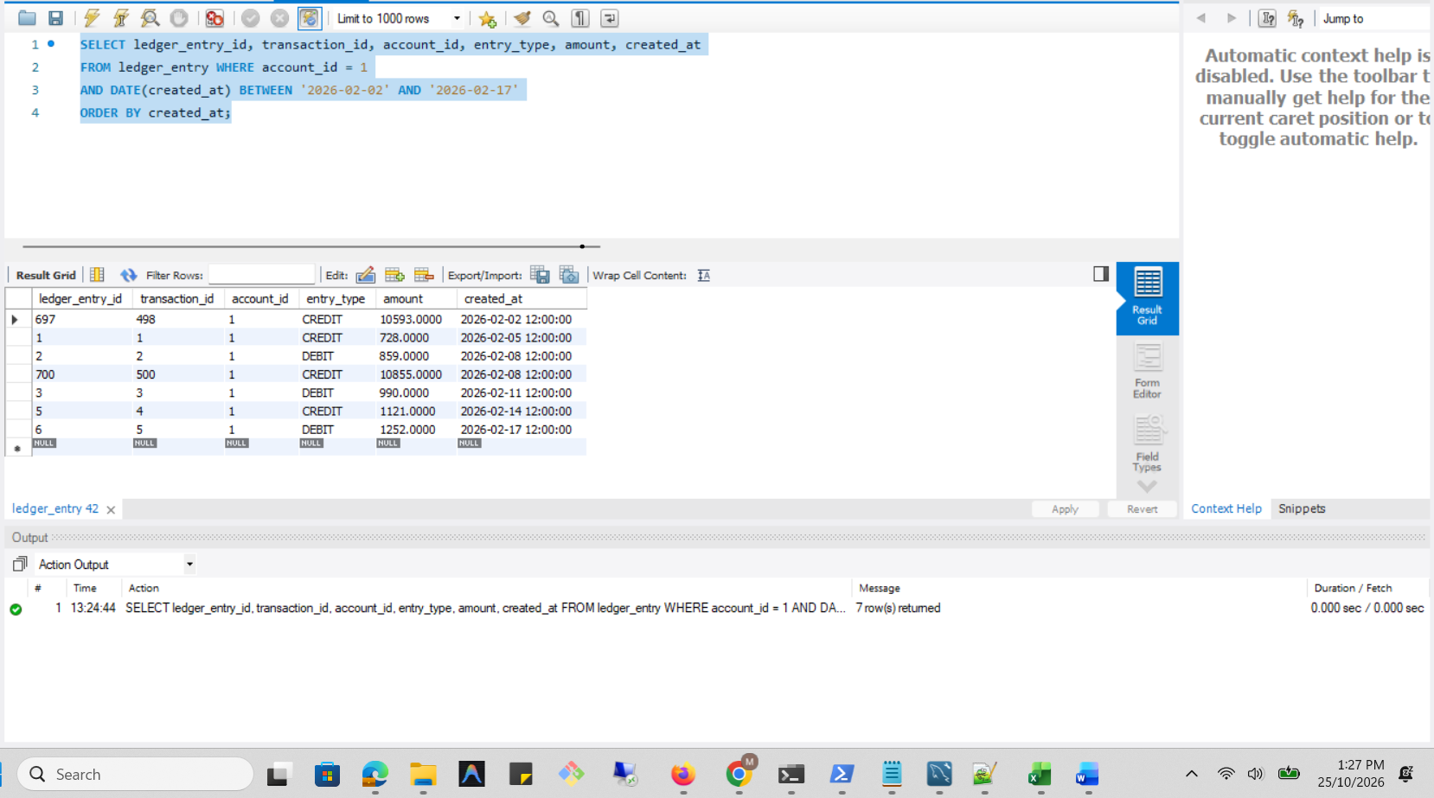

Execution Plan
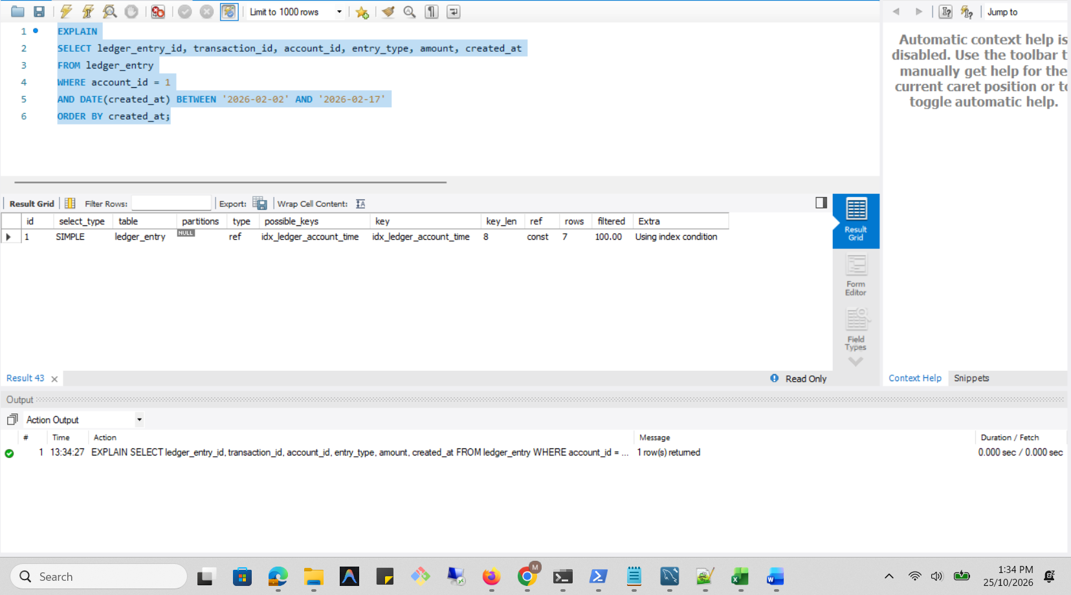

Analysis Before
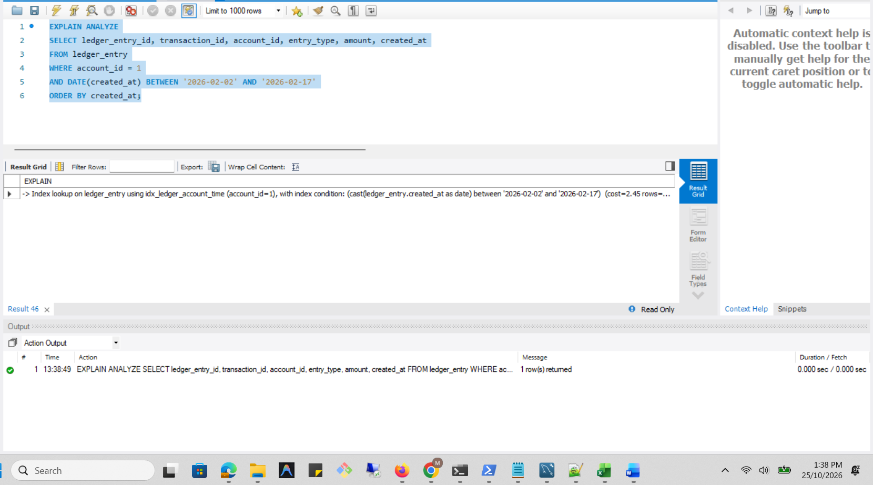

New Query
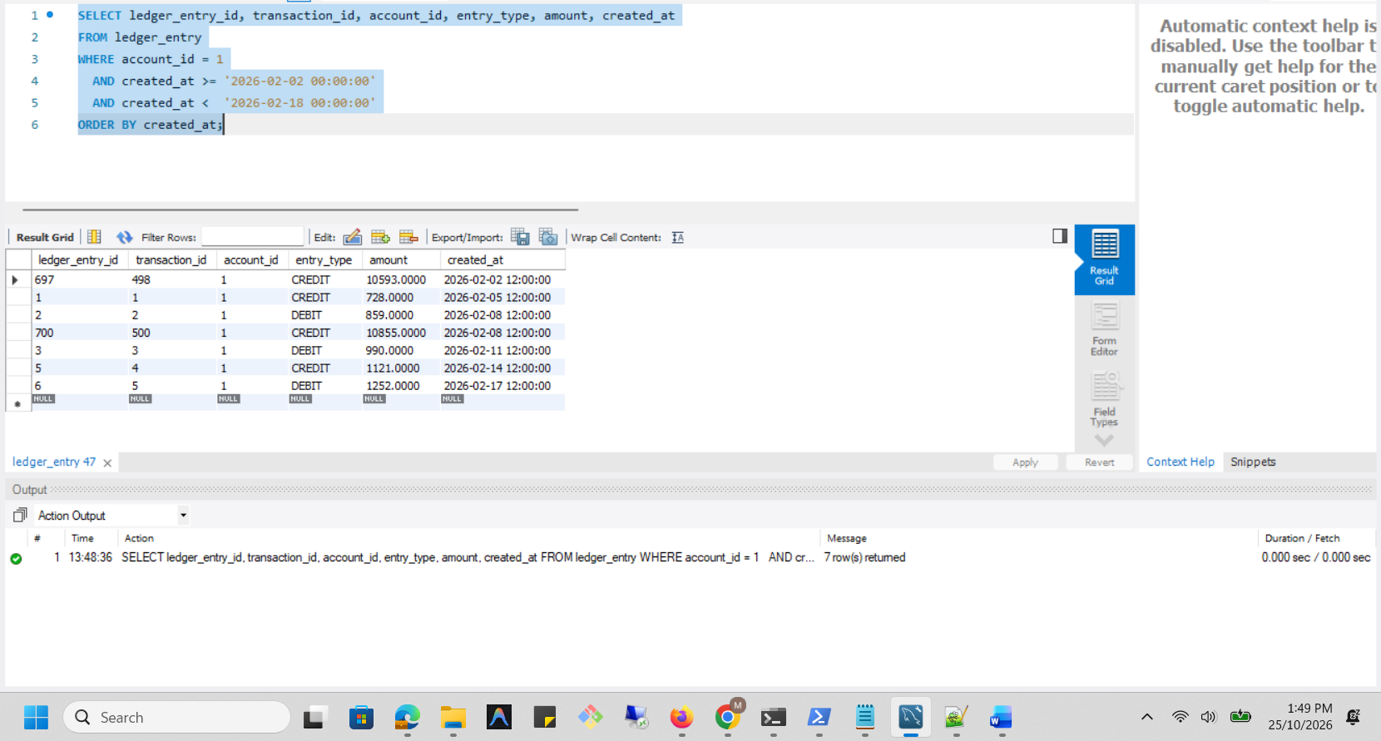

Optimized Execution Plan
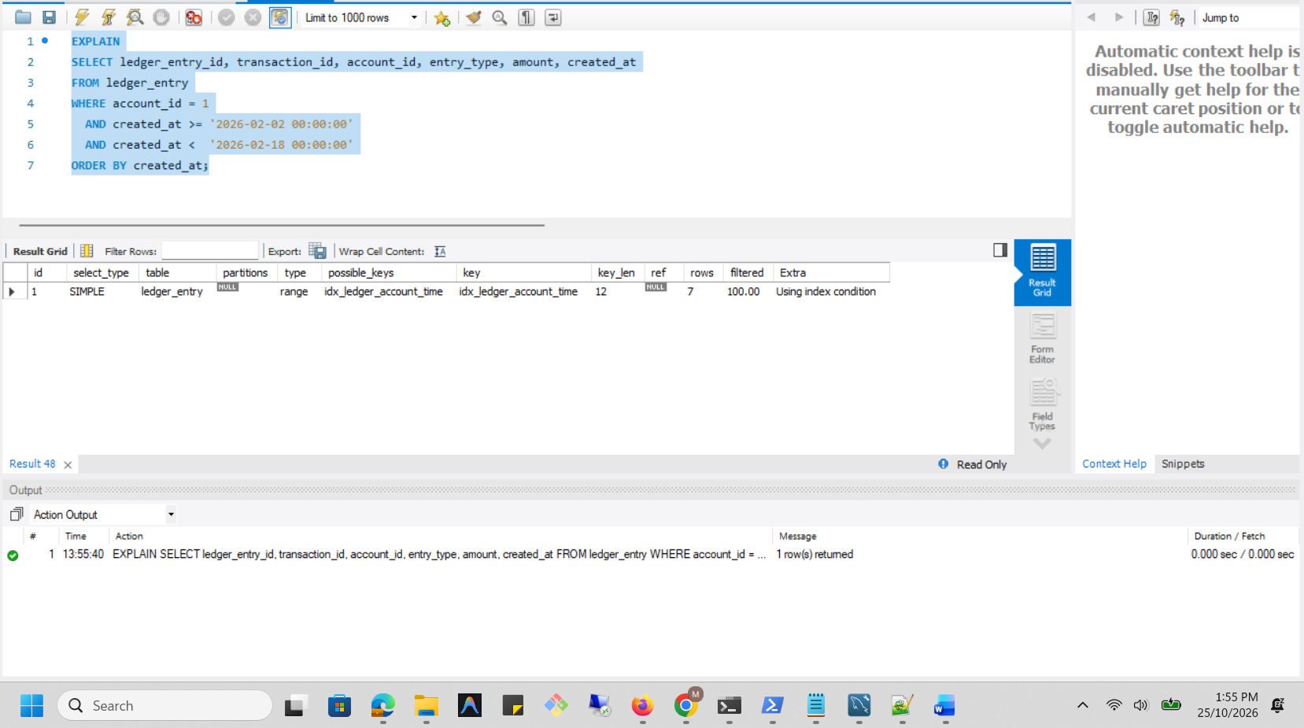

Analysis After
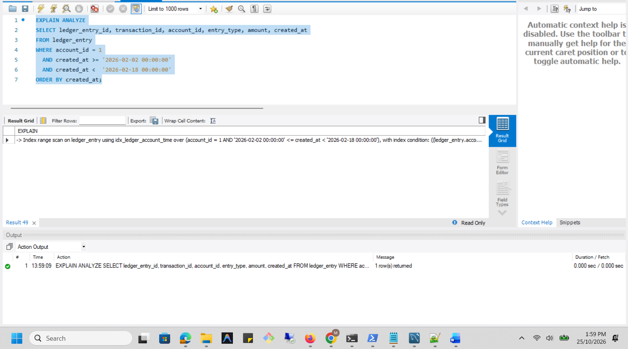

Execution plan comparison
Measure | Before Optimisation | After Optimisation
Date filter | DATE(created_at) BETWEEN '2026-02-02' AND '2026-02-17' | created_at >= '2026-02-02 00:00:00' AND created_at < '2026-02-18 00:00:00'
Access method | Index lookup (ref) | Index range scan
Index used | idx_ledger_account_time | idx_ledger_account_time
Rows returned | 7 | 7
Estimated optimizer cost | 2.45 | 3.41
Actual iterator time | 0.052–0.0551 ms | 0.076–0.0803 ms
Result equivalence | Baseline result | Same 7 rows
Performance observation | Existing index already supported account-based lookup | Recorded cost and execution time increased slightly
Conclusion | The original query was already using an index | The date-range rewrite did not demonstrate a performance improvement; no new index was required

