Query 3
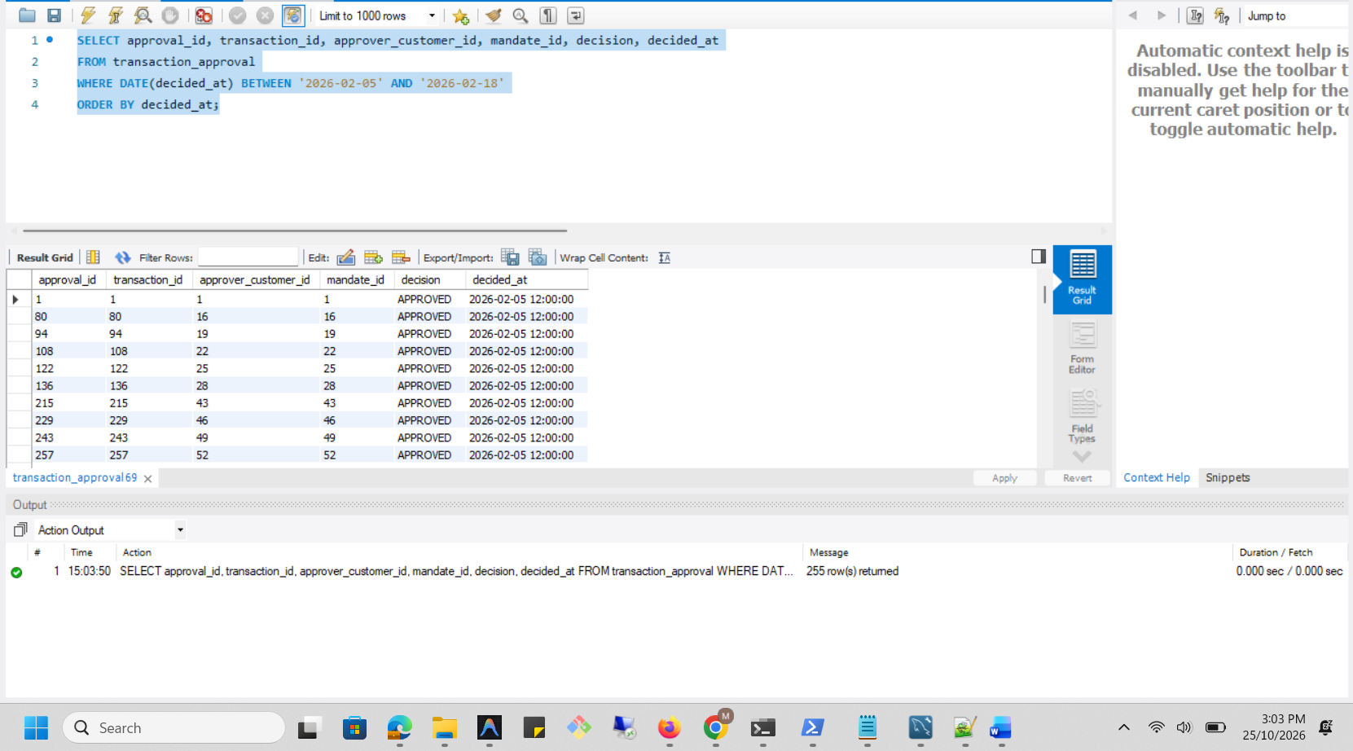

Execution Plan
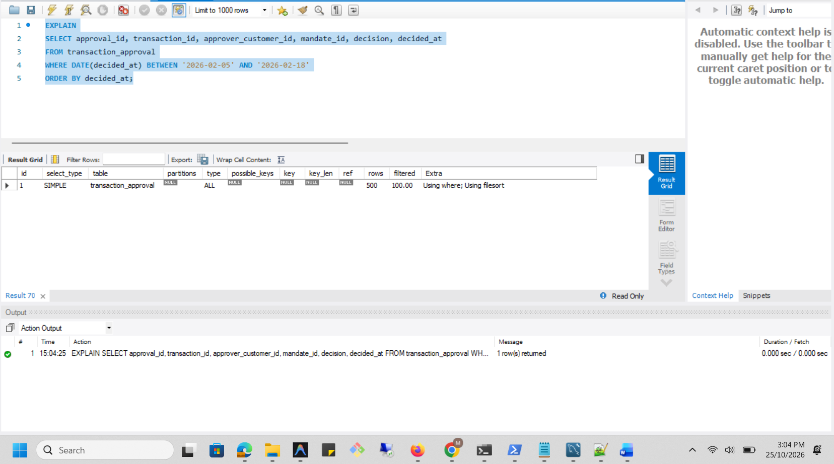

Analysis Before
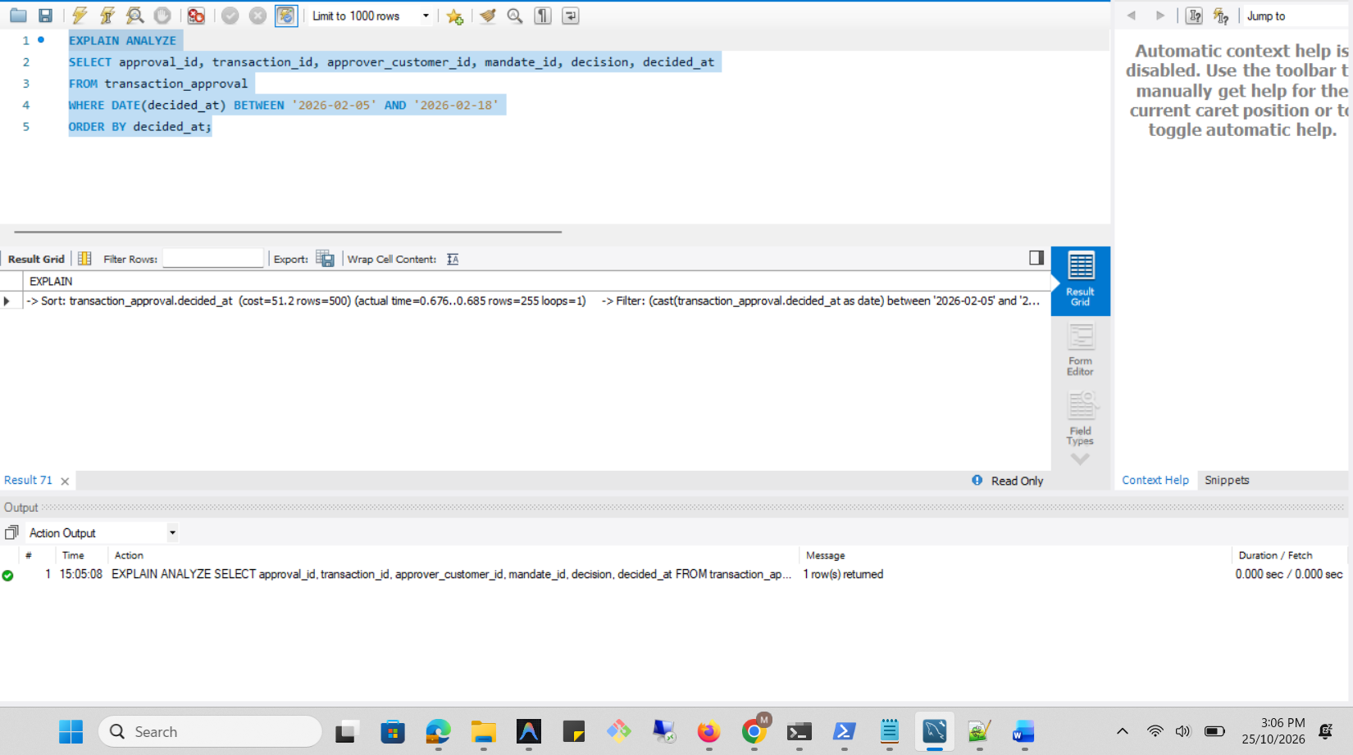

Optimization
CREATE INDEX idx_approval_decided_at ON transaction_approval (decided_at);
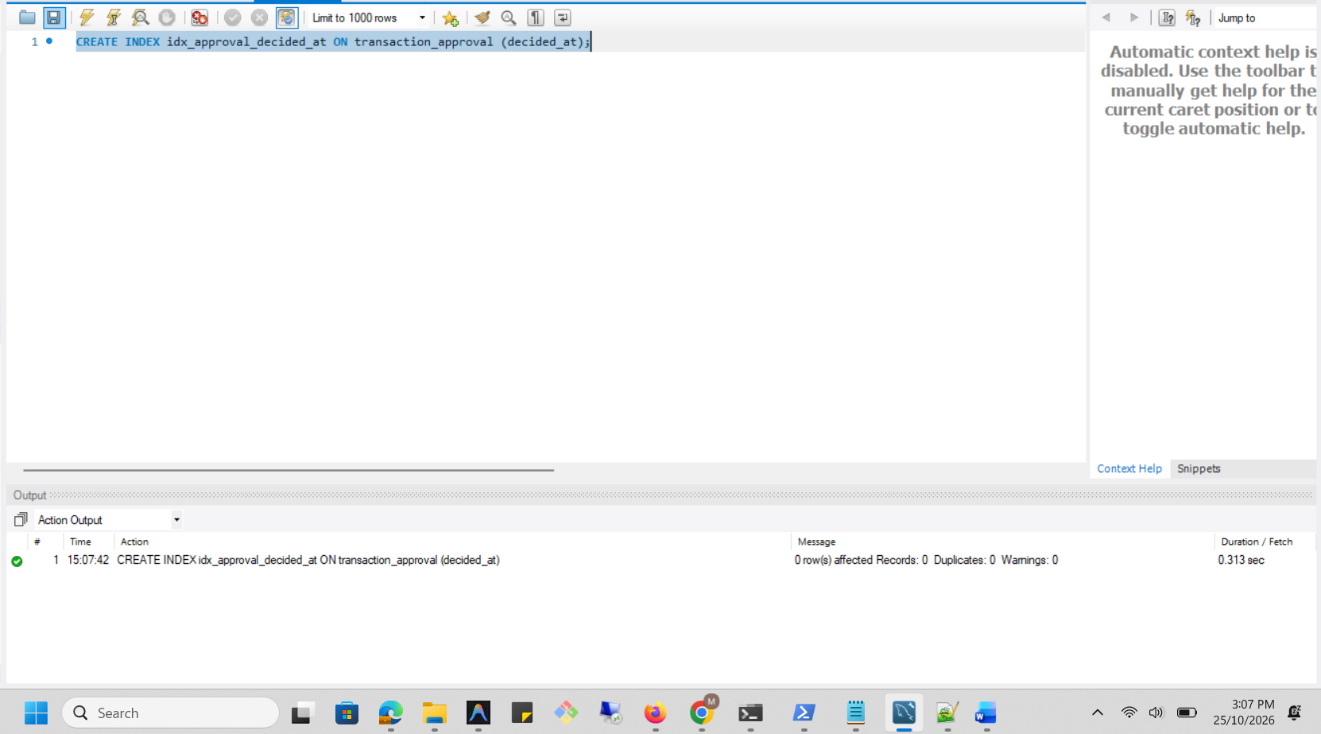
Optimized Execution Plan
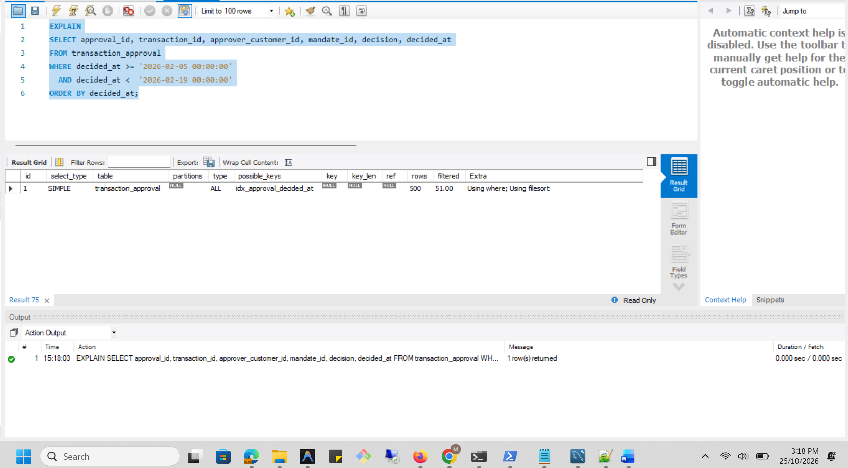

Analysis After
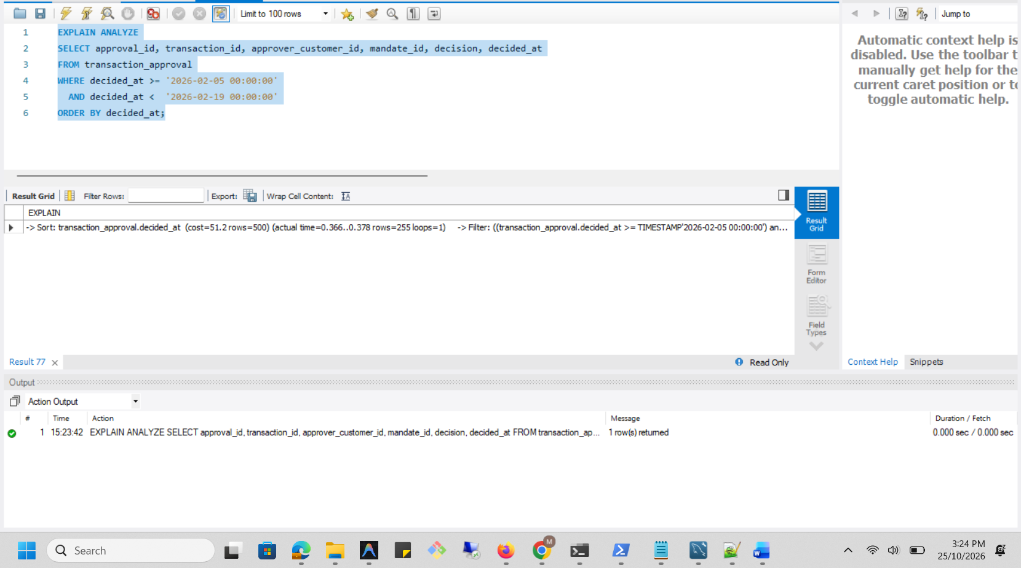

Dropping Created Index
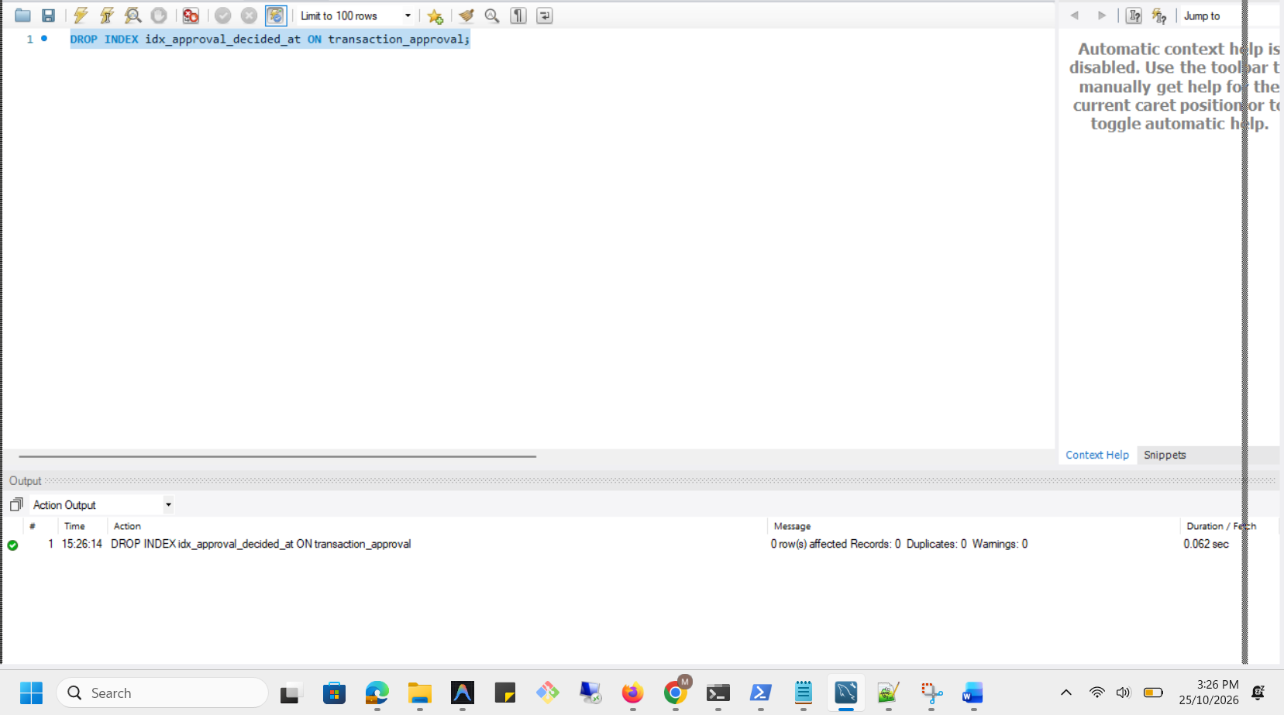

Execution plan comparison
Measure | Before index | After index
Date filter | DATE(decided_at) BETWEEN '2026-02-05' AND '2026-02-18' | decided_at >= '2026-02-05 00:00:00' AND decided_at < '2026-02-19 00:00:00'
Access method | Full table scan | Full table scan
Index used | None | Candidate index not selected
Rows examined | 500 | 500
Rows returned | 255 | 255
Estimated optimizer cost | 51.2 | 51.2
Actual execution time | 0.675–0.684 ms | 0.627–0.658 ms
Additional operation | Filesort | Filesort
Result equivalence | Baseline result | Same 255 rows
Conclusion | Full table scan required | Candidate index did not improve the access plan and was dropped

