Query 4
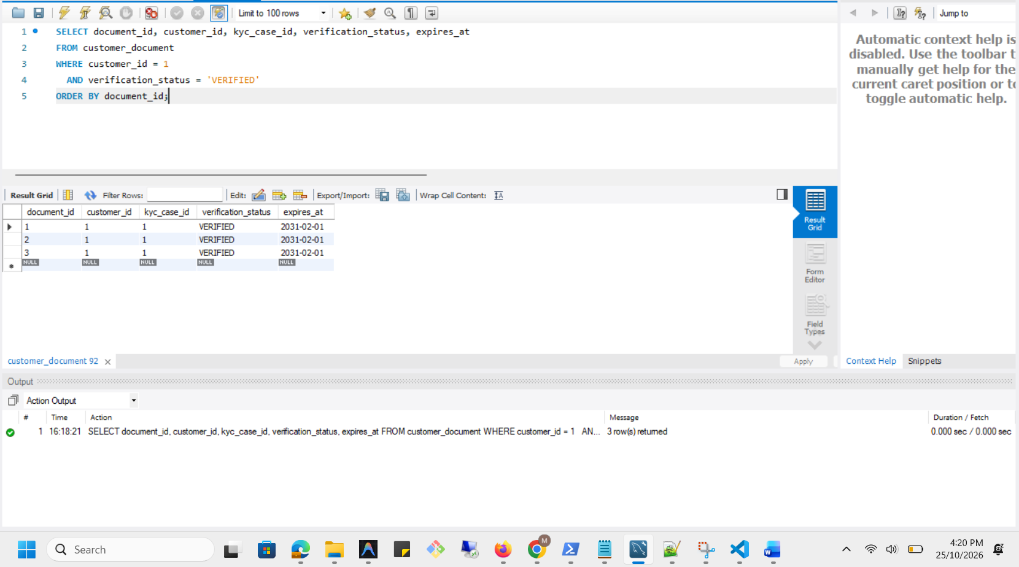

Execution Plan
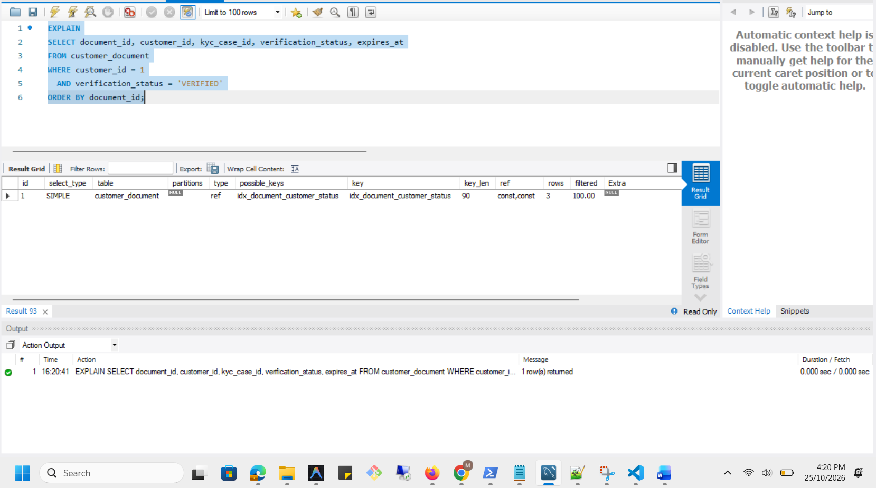

Analysis Before
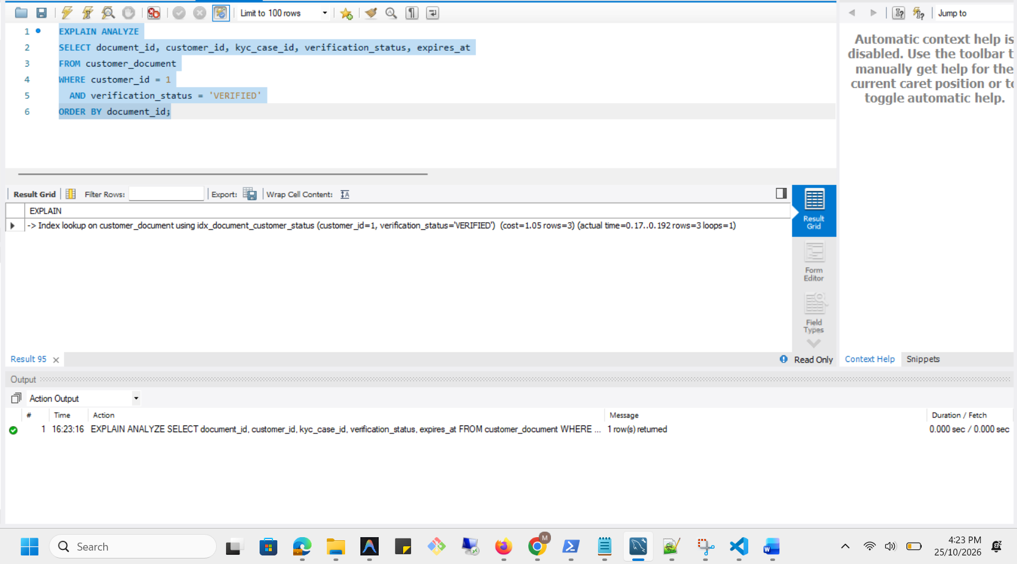

Optimization
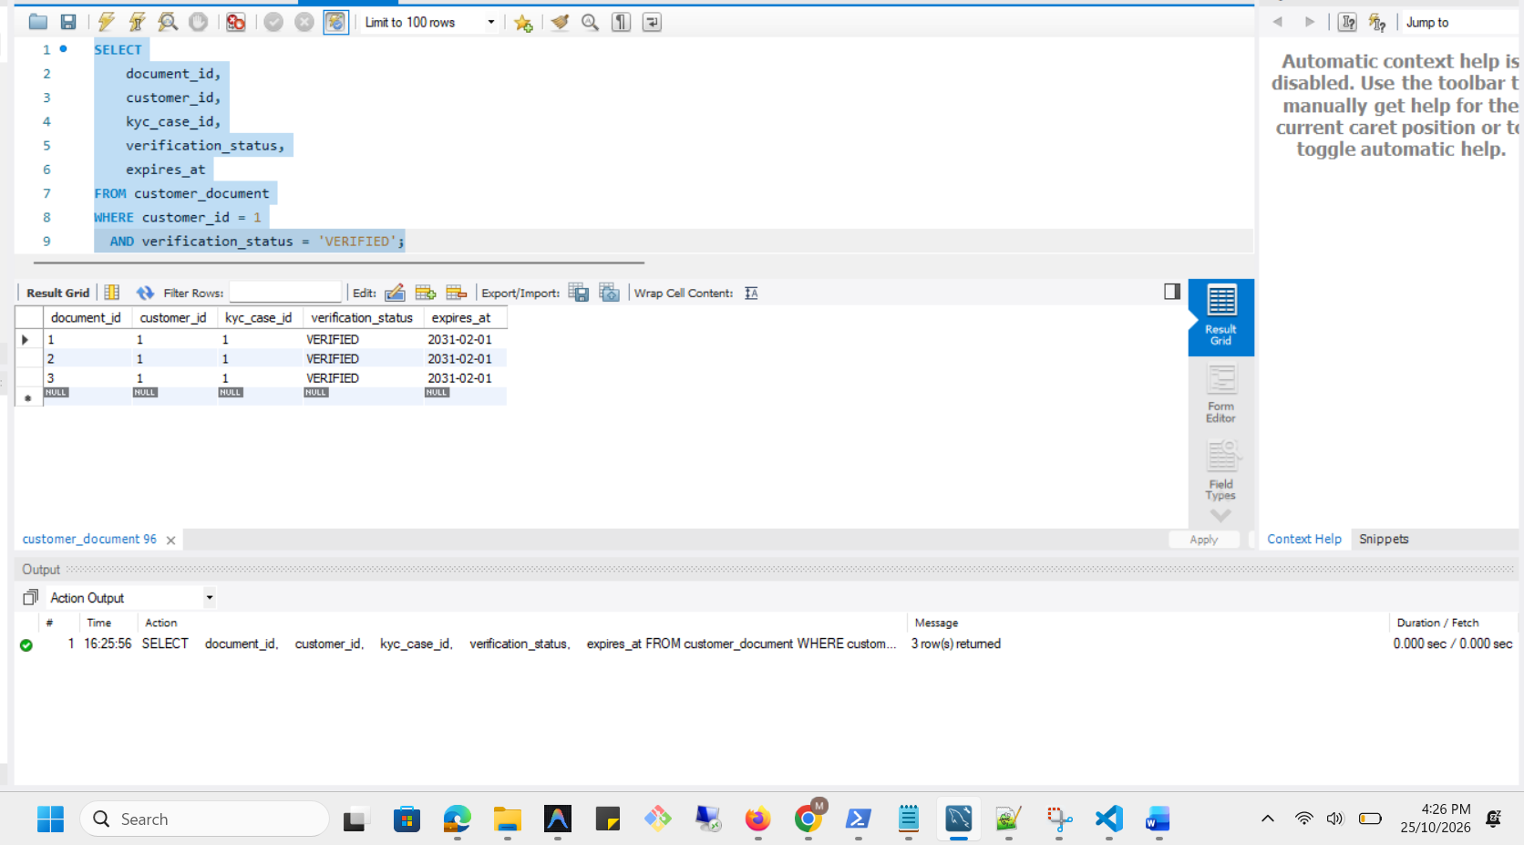

Optimized Execution Plan
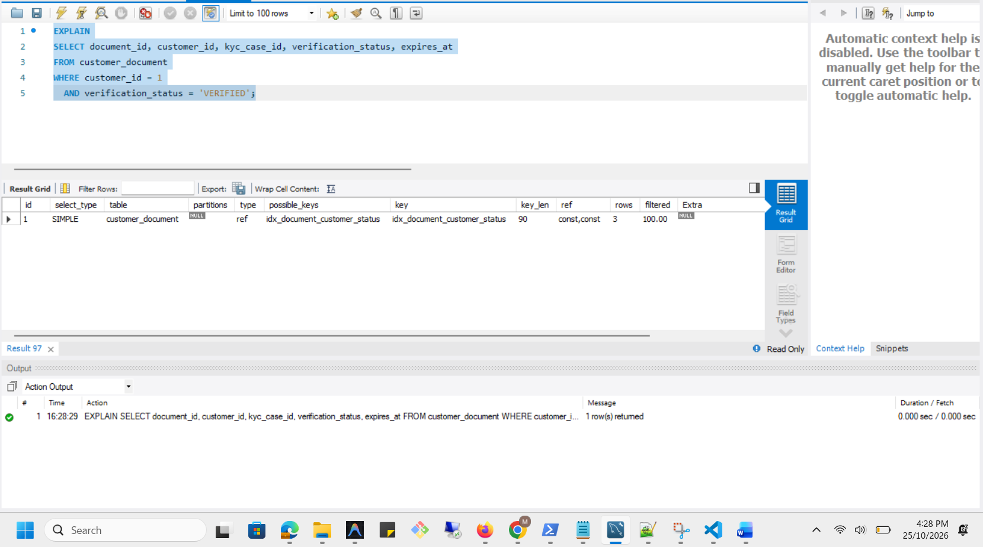

Analysis After
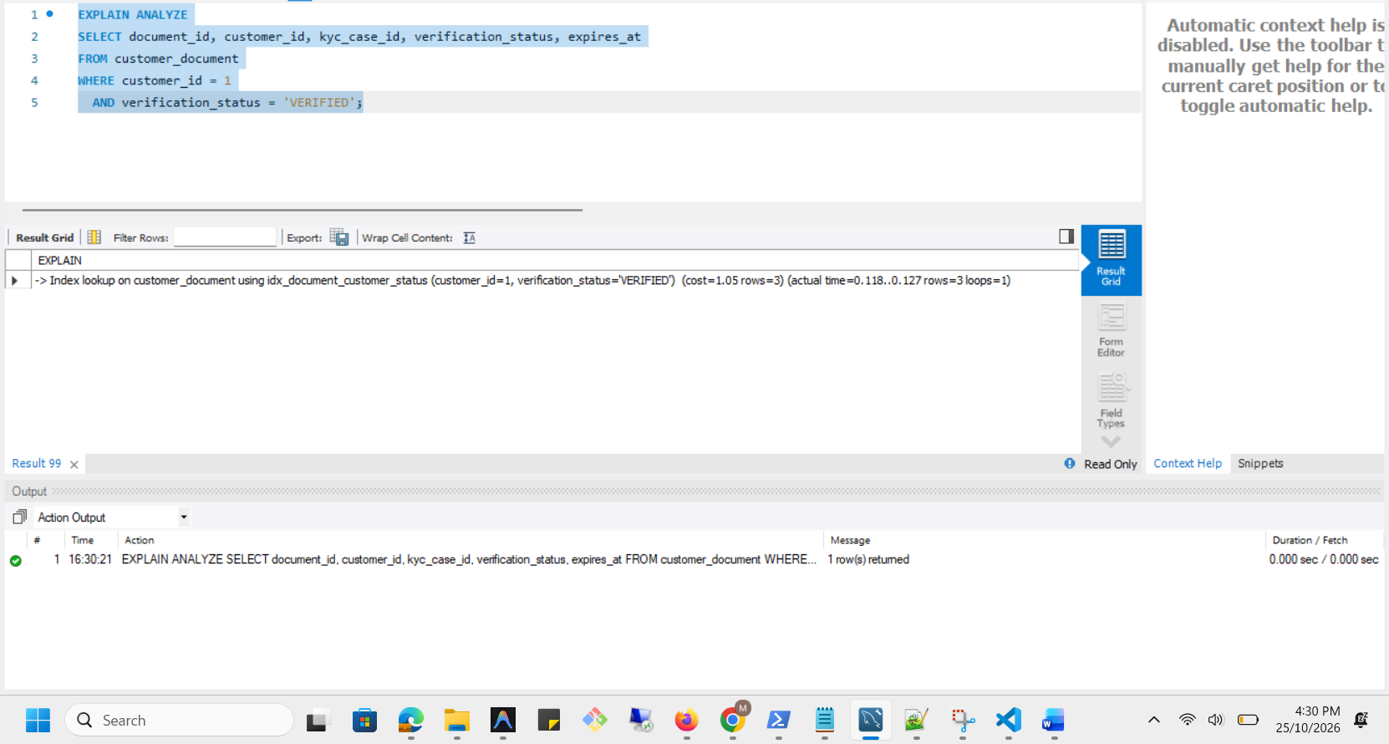

Execution plan comparison
Measure | Before index | After index
Query | Customer document lookup with ORDER BY document_id | Same lookup without ORDER BY document_id
Access method | Index lookup (ref) | Index lookup (ref)
Index used | idx_document_customer_status | idx_document_customer_status
Rows returned | 3 | 3
Estimated optimizer cost | 1.05 | 1.05
Estimated rows | 3 | 3
Actual execution time | 0.324–0.334 ms | 0.0992–0.107 ms
Result equivalence | Original result | Same three records
Ordering | Ordered by document_id | No guaranteed ordering
Conclusion | Existing composite index was effective | Lower time observed in one run, but the access plan remained unchanged

