Query 5
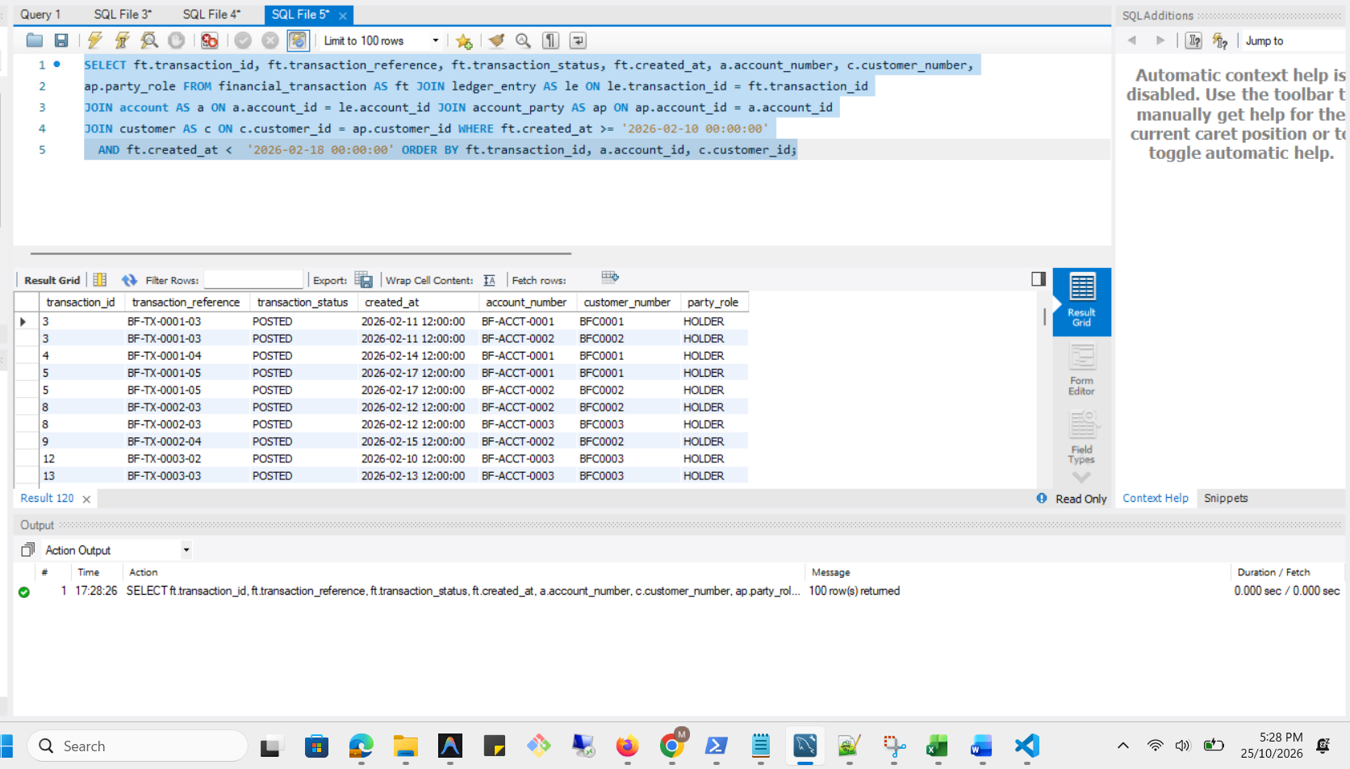

Execution Plan
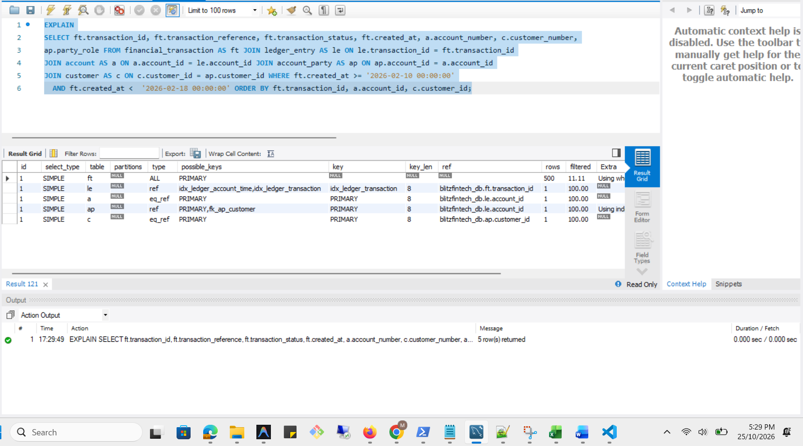

Analysis Before
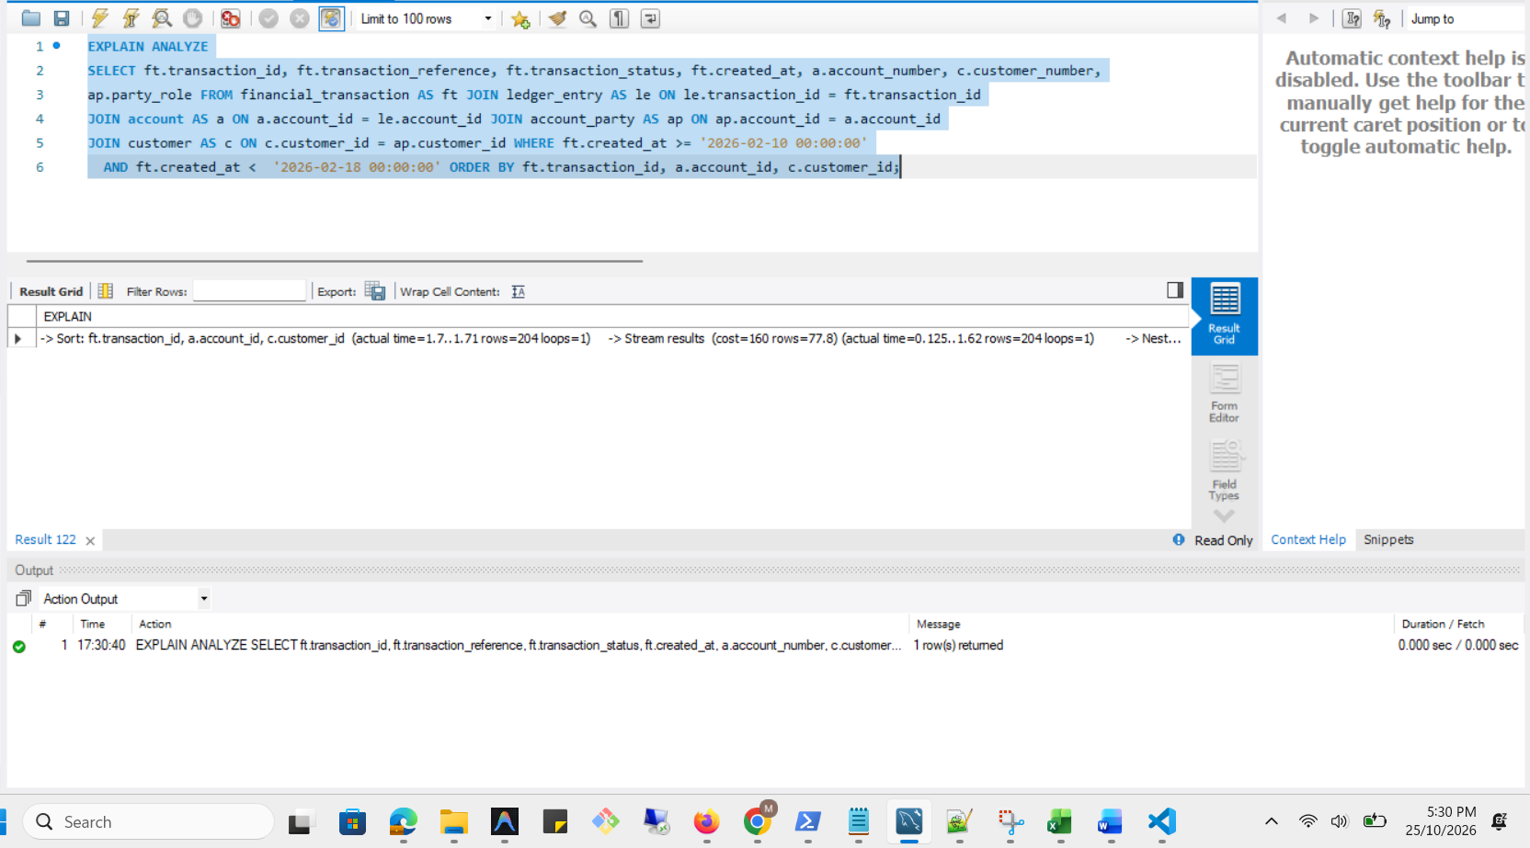

Optimization
CREATE INDEX idx_transaction_created_at ON financial_transaction (created_at);
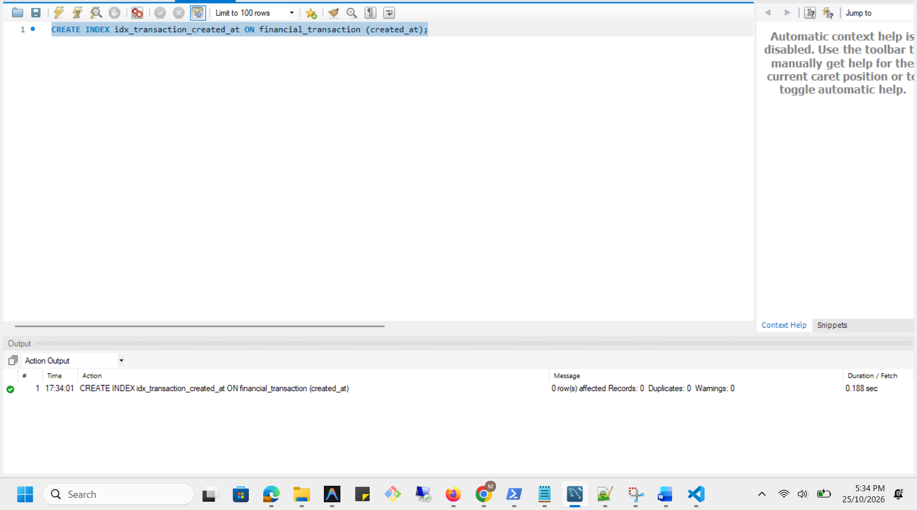
Optimized Execution Plan
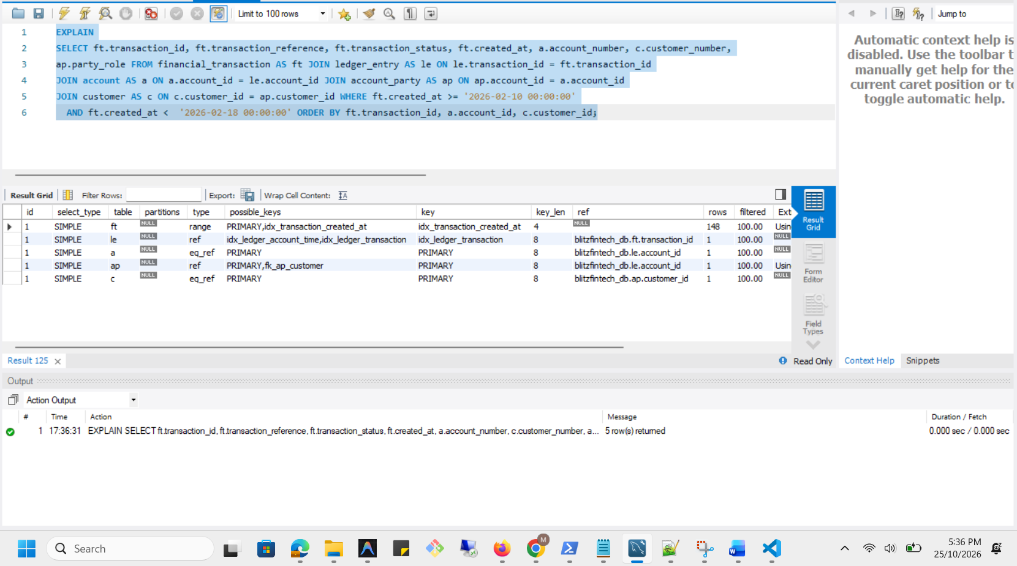

Analysis After
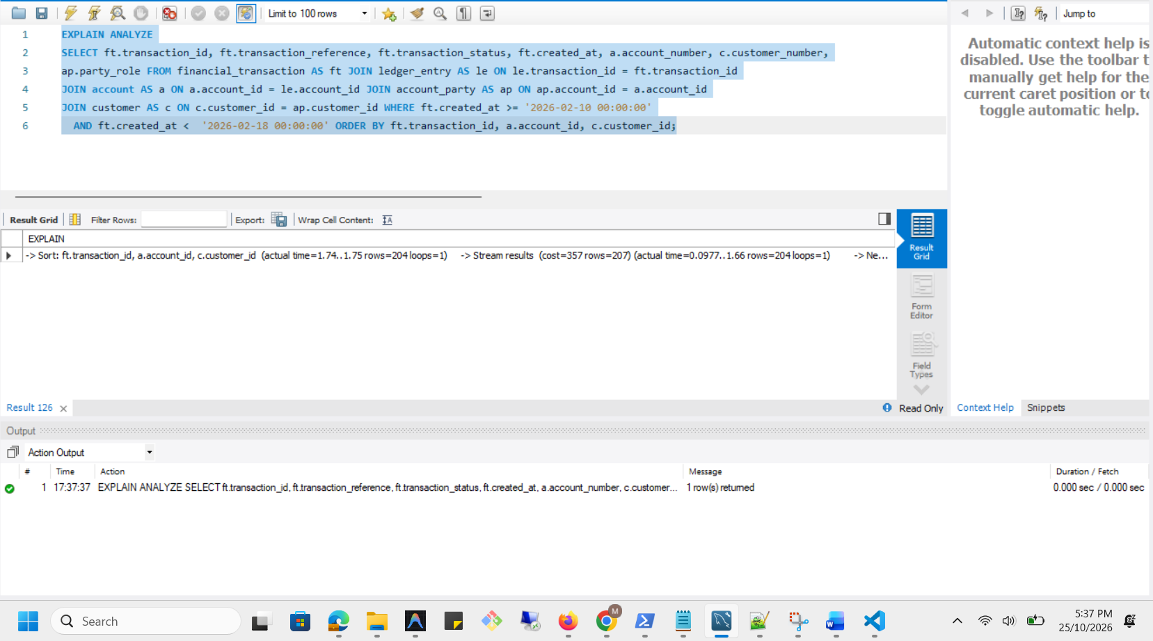

Execution plan comparison
Measure | Before index | After index
Access to financial_transaction | Full table scan | Index range scan
Transactions examined by that step | 500 | 148
Joined result rows | 204 | 204
Final sort | Required | Still required
Estimated join cost | 160 | 357
Final sort iterator time | 1.51–1.52 ms | 1.74–1.75 ms

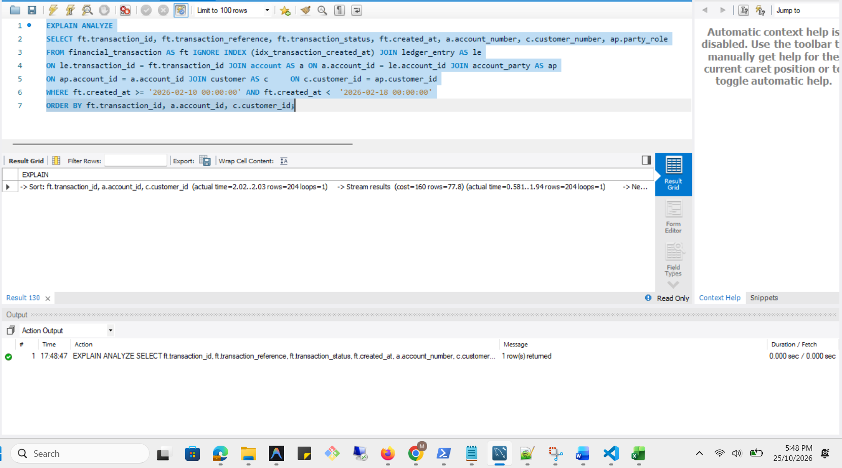
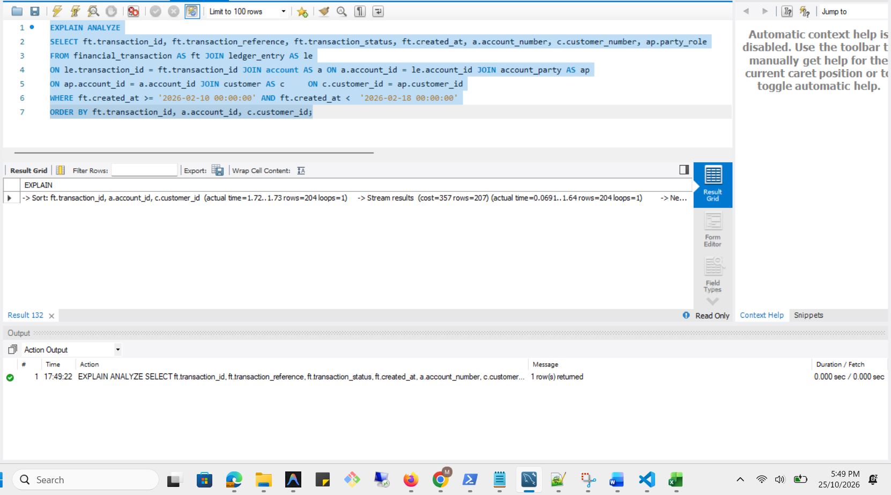

-> Sort: ft.transaction_id, a.account_id, c.customer_id (actual time=1.8..1.81 rows=204 loops=1)
-> Stream results (cost=160 rows=77.8) (actual time=0.174..1.7 rows=204 loops=1)
-> Nested loop inner join (cost=160 rows=77.8) (actual time=0.163..1.55 rows=204 loops=1)
-> Nested loop inner join (cost=133 rows=77.8) (actual time=0.153..1.39 rows=204 loops=1)
-> Nested loop inner join (cost=106 rows=77.8) (actual time=0.144..1.04 rows=204 loops=1)
-> Nested loop inner join (cost=78.5 rows=77.8) (actual time=0.137..0.893 rows=204 loops=1)
-> Filter: ((ft.created_at >= TIMESTAMP'2026-02-10 00:00:00') and (ft.created_at < TIMESTAMP'2026-02-18 00:00:00')) (cost=51.2 rows=55.5) (actual time=0.0992..0.376 rows=148 loops=1)
-> Table scan on ft (cost=51.2 rows=500) (actual time=0.0912..0.267 rows=500 loops=1)
-> Index lookup on le using idx_ledger_transaction (transaction_id=ft.transaction_id) (cost=0.353 rows=1.4) (actual time=0.00283..0.00338 rows=1.38 loops=148)
-> Single-row index lookup on a using PRIMARY (account_id=le.account_id) (cost=0.251 rows=1) (actual time=579e-6..595e-6 rows=1 loops=204)
-> Covering index lookup on ap using PRIMARY (account_id=le.account_id) (cost=0.251 rows=1) (actual time=0.00105..0.00161 rows=1 loops=204)
-> Single-row index lookup on c using PRIMARY (customer_id=ap.customer_id) (cost=0.251 rows=1) (actual time=640e-6..660e-6 rows=1 loops=204)

-> Sort: ft.transaction_id, a.account_id, c.customer_id (actual time=1.67..1.68 rows=204 loops=1)
-> Stream results (cost=357 rows=207) (actual time=0.0899..1.59 rows=204 loops=1)
-> Nested loop inner join (cost=357 rows=207) (actual time=0.0858..1.45 rows=204 loops=1)
-> Nested loop inner join (cost=284 rows=207) (actual time=0.0804..1.22 rows=204 loops=1)
-> Nested loop inner join (cost=212 rows=207) (actual time=0.0757..0.901 rows=204 loops=1)
-> Nested loop inner join (cost=139 rows=207) (actual time=0.0699..0.698 rows=204 loops=1)
-> Index range scan on ft using idx_transaction_created_at over ('2026-02-10 00:00:00' <= created_at < '2026-02-18 00:00:00'), with index condition: ((ft.created_at >= TIMESTAMP'2026-02-10 00:00:00') and (ft.created_at < TIMESTAMP'2026-02-18 00:00:00')) (cost=66.9 rows=148) (actual time=0.0582..0.242 rows=148 loops=1)
-> Index lookup on le using idx_ledger_transaction (transaction_id=ft.transaction_id) (cost=0.351 rows=1.4) (actual time=0.00247..0.00293 rows=1.38 loops=148)
-> Single-row index lookup on a using PRIMARY (account_id=le.account_id) (cost=0.25 rows=1) (actual time=848e-6..858e-6 rows=1 loops=204)
-> Covering index lookup on ap using PRIMARY (account_id=le.account_id) (cost=0.25 rows=1) (actual time=0.00101..0.00148 rows=1 loops=204)
-> Single-row index lookup on c using PRIMARY (customer_id=ap.customer_id) (cost=0.25 rows=1) (actual time=992e-6..0.001 rows=1 loops=204)

Updated execution plan comparison
Measure | Index ignored | Index used
Access to financial_transaction | Full table scan | Index range scan
Transactions examined by that step | 500 | 148
Transactions matching date filter | 148 | 148
Final joined result rows | 204 | 204
Estimated optimizer cost | 160 | 357
Final sort iterator time | 1.80–1.81 ms | 1.67–1.68 ms
Time for transaction access/filter step | 0.0992–0.376 ms | 0.0582–0.242 ms
Final sort required? | Yes | Yes
Result count consistent? | Yes | Yes

