Query 6
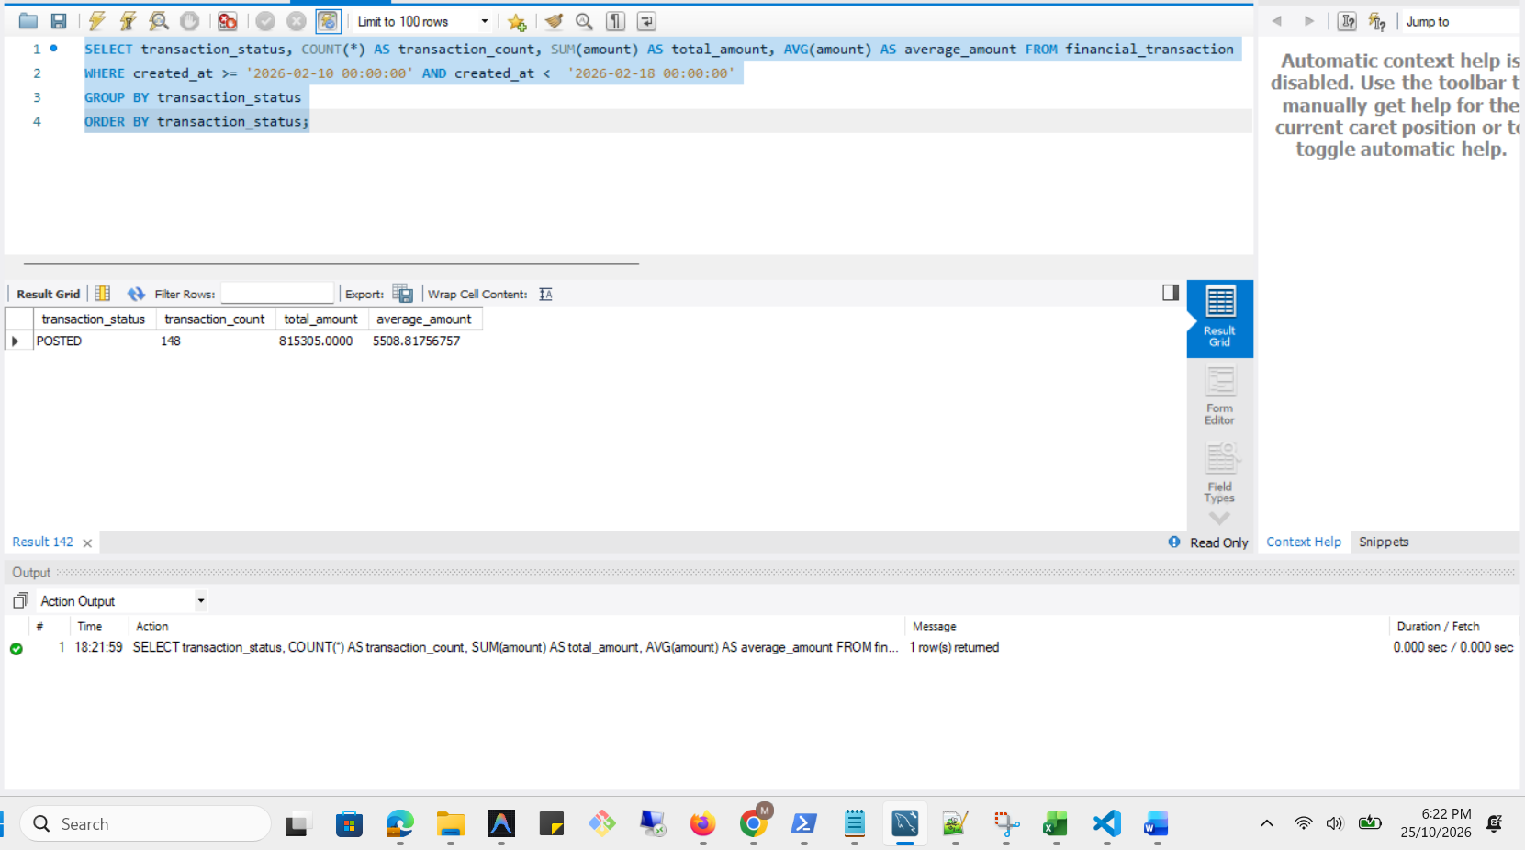

Execution Plan
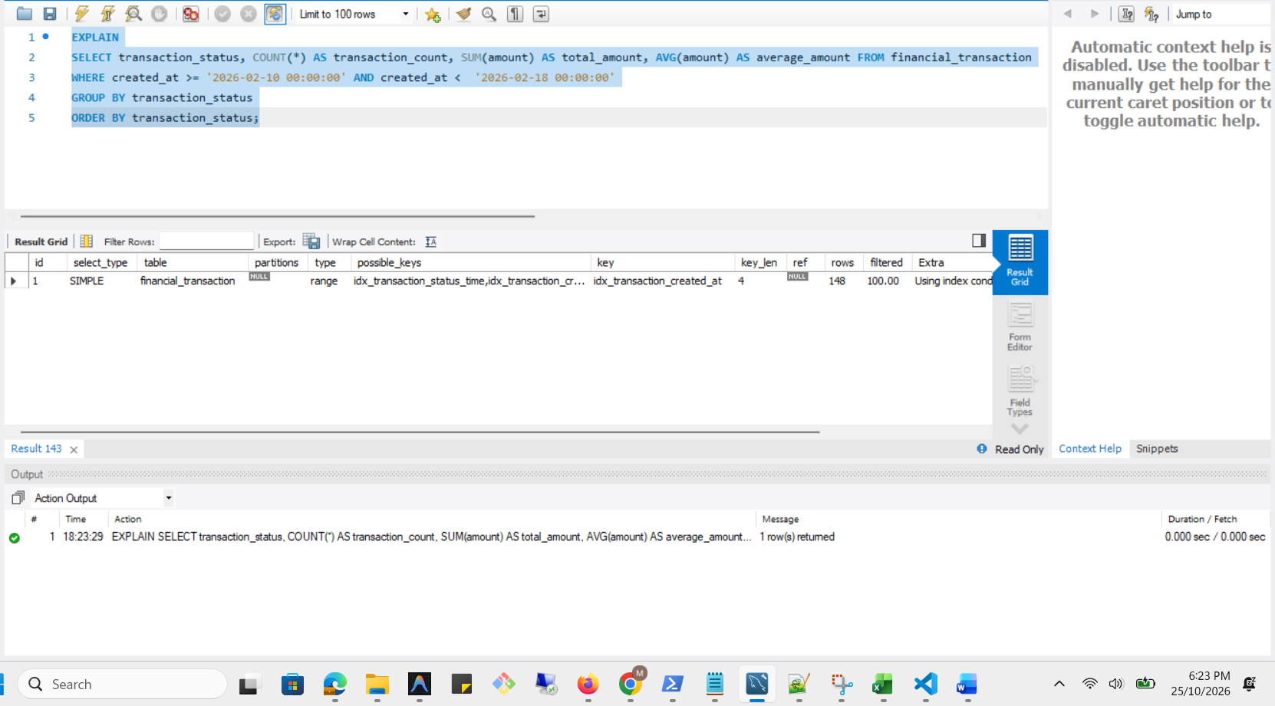

Analysis Before
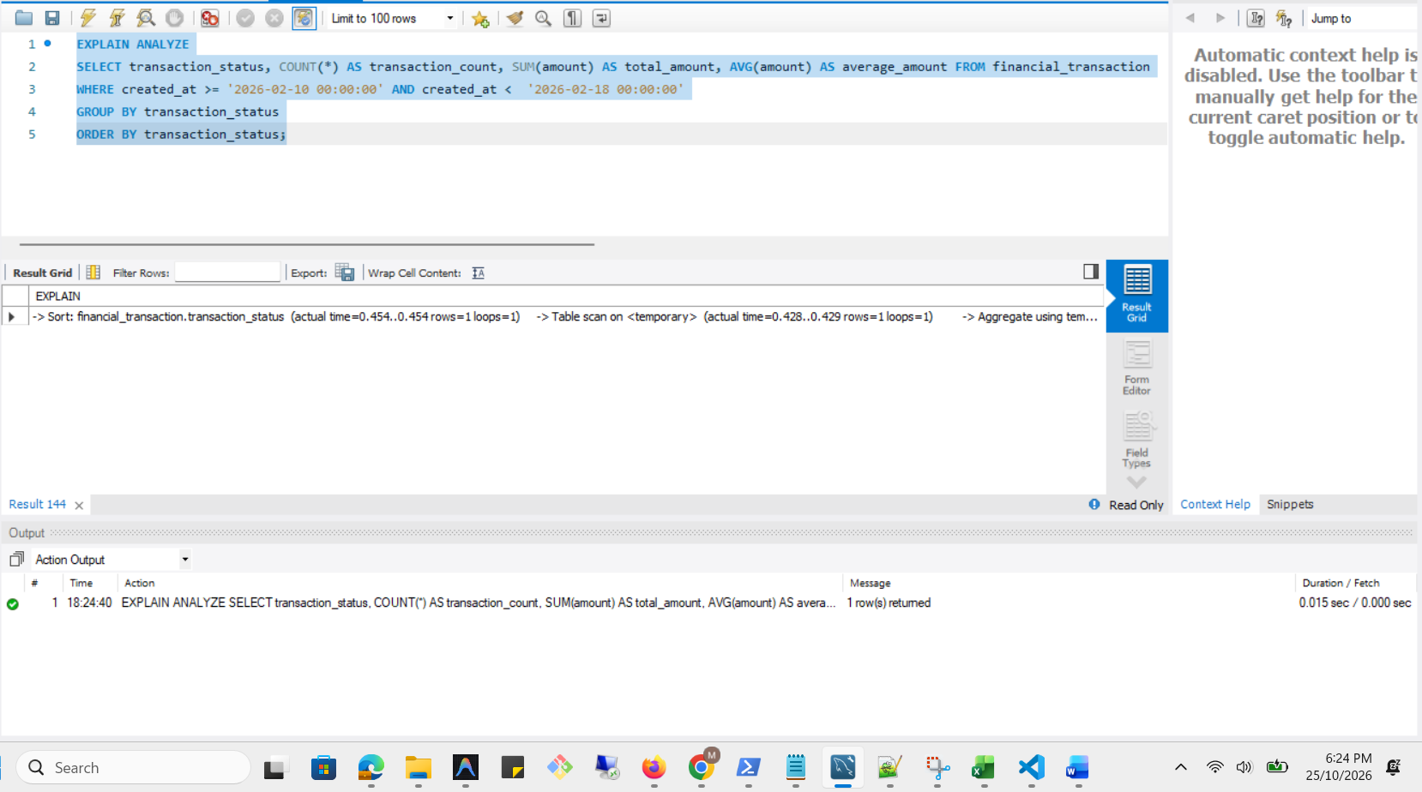

Optimization
CREATE INDEX idx_transaction_date_status_amount ON financial_transaction (created_at, transaction_status, amount);
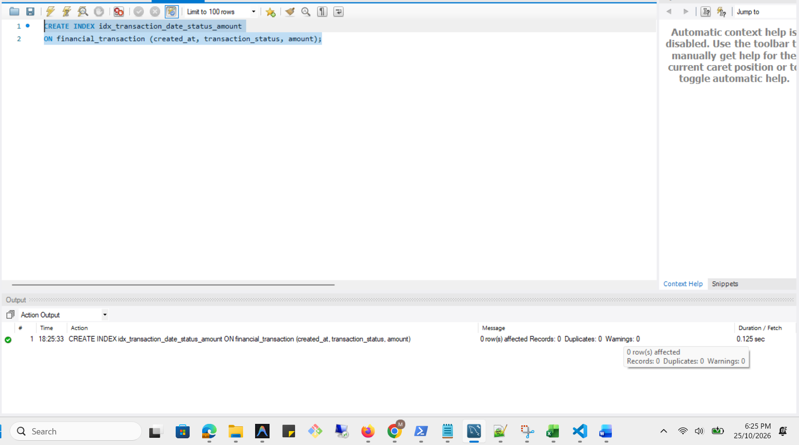
Optimized Execution Plan
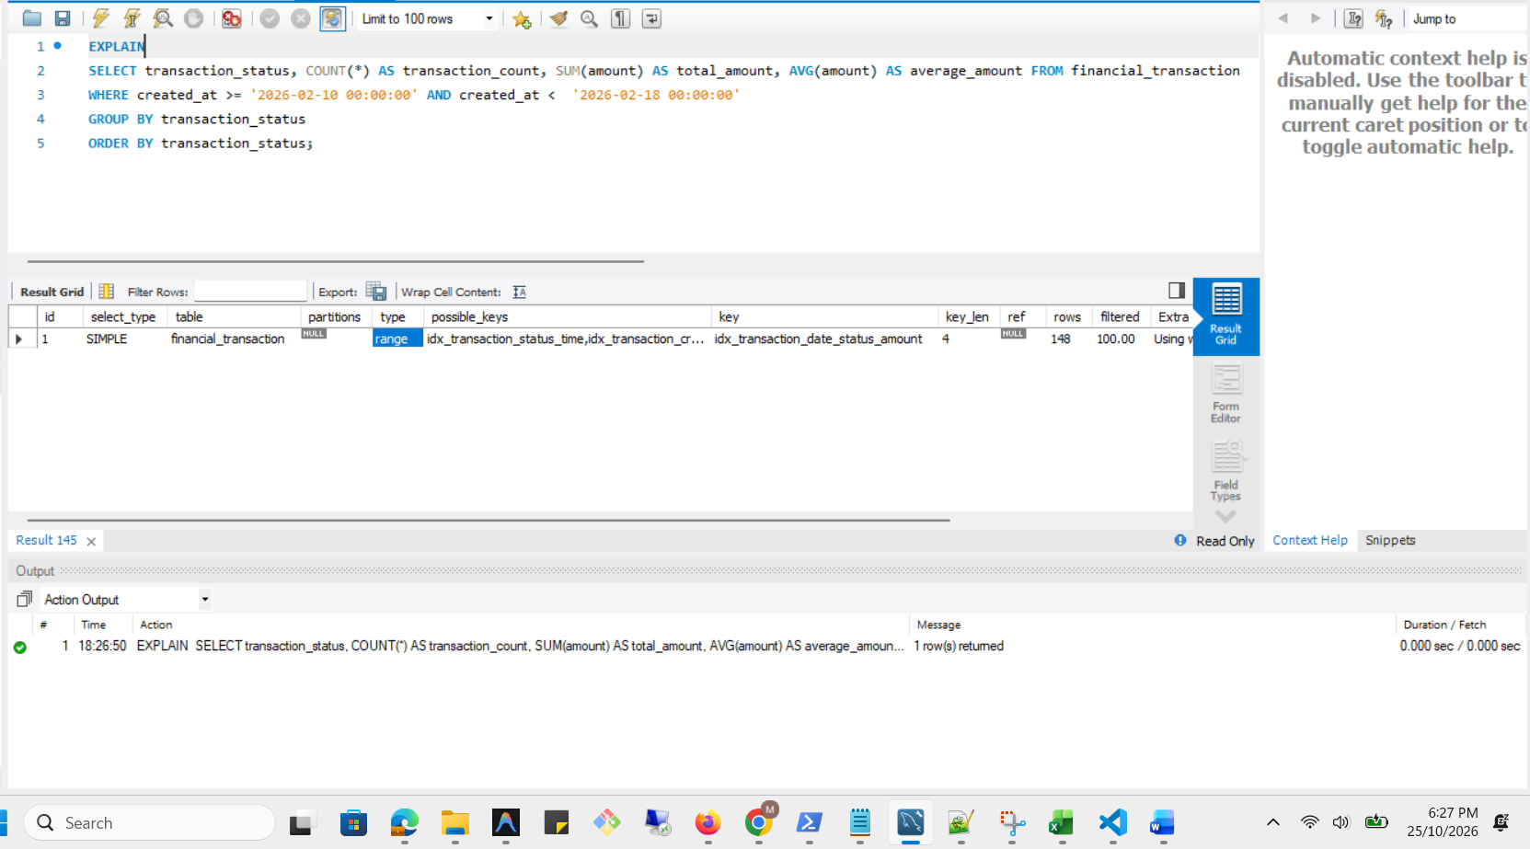

Analysis After
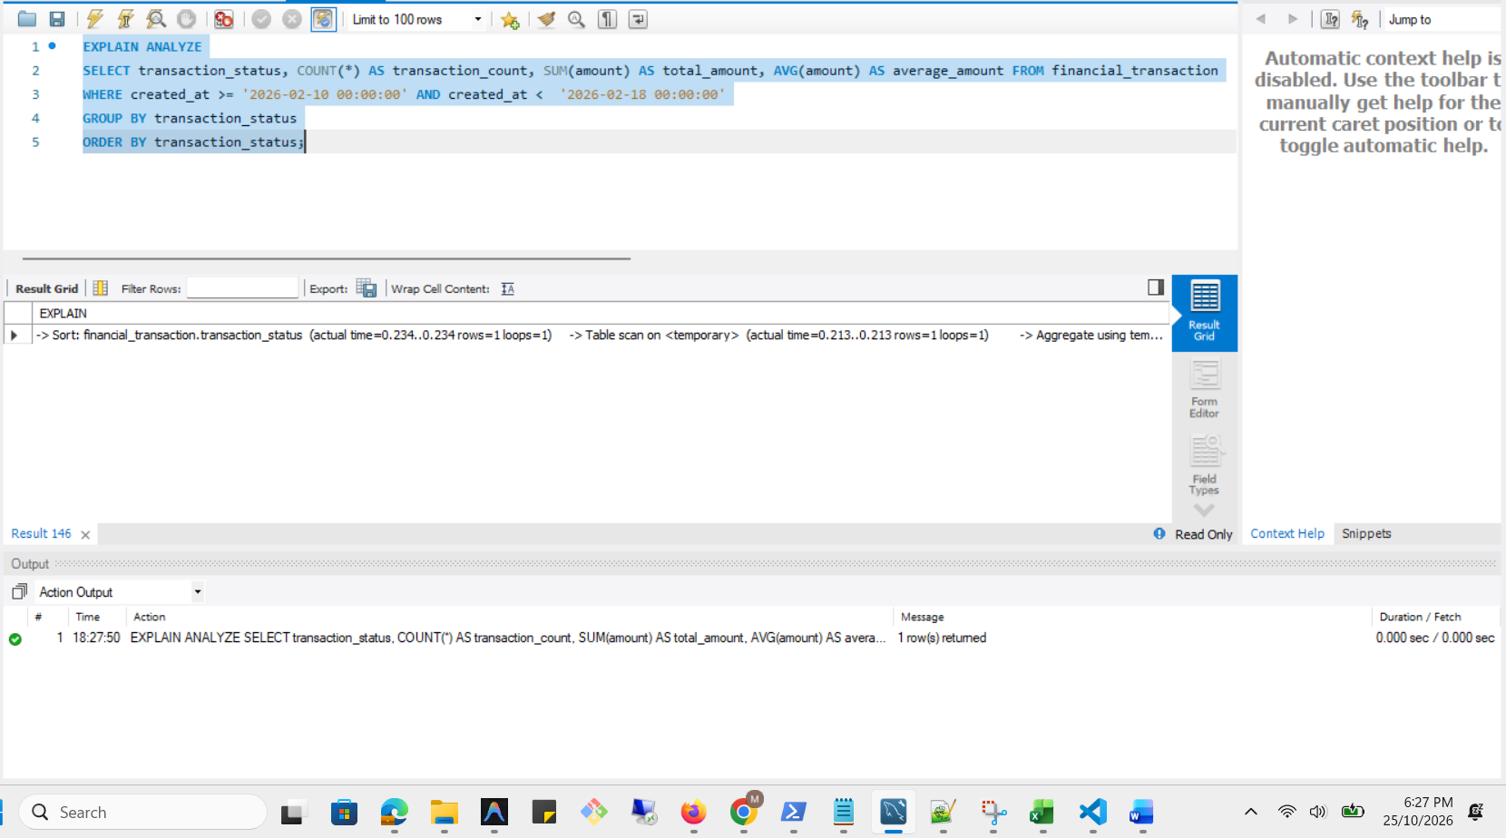

Execution plan comparison
Measure | Before covering index | With covering index
Access method | Index range scan | Covering index range scan
Index used | idx_transaction_created_at | idx_transaction_date_status_amount
Matching rows | 148 | 148
Estimated optimizer cost | 66.9 | 31.4
Index access time | 0.087–0.382 ms | 0.0241–0.0734 ms
Aggregation completion time | 1.66 ms | 0.212 ms
Temporary table used | Yes | Yes
Final sort required | Yes | Yes

