**SSD: draw the SSD for this given usecase description:**

Sample Use Case: Buy Ticket

A customer arrives at a ticket counter and wants to buy a ticket for a particular journey. The employee of the airline asks the customer for his wishes concerning • the destination airport, • the airport to start from, • the date and time of departure, • the class in which he wants to travel.

The employee enters these wishes into the flight information system which (hopefully) returns data about one or more possible flights matching the query.

Each flight ist described by • its number, • date of departure, • exact time of departure, • time of arrival, • price.

The customer chooses one of the possible connections found by the system and reserves this flight by getting a ticket for it. The ticket contains some further information such as the date of issue and whether the ticket is paid already or has to be paid at check-in time. After the customer has received one or more tickets, he has to pay for them. Our sample airline supports two different methods of payment - pay by credit card or by debit card. If you pay by credit card, the airline registers the number of the credit card and its expiration date. For payment by debit card the bank code and the number of your bank account are read from the card for an electronic debit note. Independent of the payment method the customer chooses, the airline always records the amount of money being paid, the date of the payment and the signature of the customer

**Sequence Diagram:**

i) Consider the following sequence diagram and write code in ja. Specify only what is conveyed in the diagram. [6]

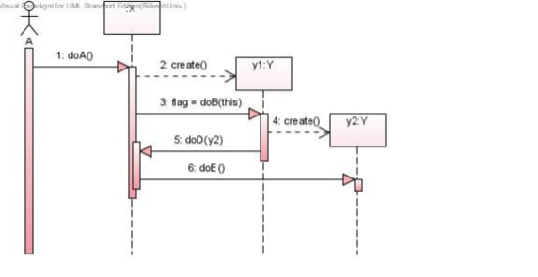

ii)Scenario: Task: Model the interactions between the customer and the equipment in the scenario with a UML Sequence diagram.

In a checkout system in a shop the customer can pay with a debit card, a credit card, or Swish1. If the customer pays with card, the card reader is invoked by the registration unit, who also sends the sum to pay to the card reader. The customer inserts the card, approves the sum, enters the code, gets an OK from the card reader, and removes the card. If the customer pays with Swish, the screen of the checkout terminal is invoked which displays a QR-code for the payment. The customer opens the Swish app in his/her mobile unit and scans the QR-code. The Swish app presents the sum and recipient. When user approves, the mobile BankID app is opened where the sum and recipient is shown again. To complete the transaction, the user enters the password, and gets an acknowledgement. Regardless of payment method, the customer gets a receipt.

**Class Diagram:**

1. Draw a UML class diagram to capture the following situation:

Every student is enrolled in a course. Each student may be enrolled in a set of units. Some units are core units for one or more courses and some units are elective units for one or more courses

1. Q4:In the UML Class diagram below there are two types of mistakes, one UML mistake and one domain modelling mistake. Describe what is wrong. The class-name Vehicle is written in italics. What does that mean? What would be the consequences if we wrote it in a regular font as in the other classes?

**Component Diagram:**

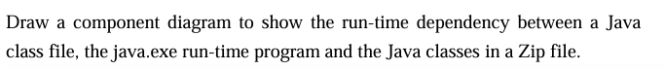

**Deployment Diagram:**

Draw a deployment diagram to show how a web browser and a web server located on different machines and Web server is interacting with a DB server. DB server is located on another different machine.

**Activity Diagram:**

Model the activity diagram associated with the use case:

