### 

**Project Deliverable-03**

In partial

fulfillment of the requirements

for the course of

### **FA2024-CS3004**

**Software Development**

**and Analysis**

### **By:**

### BSCS_C

Arrij Fawad i220755

Hamna Arshad i221098

Maryam Masood i221169

Use Case Diagram

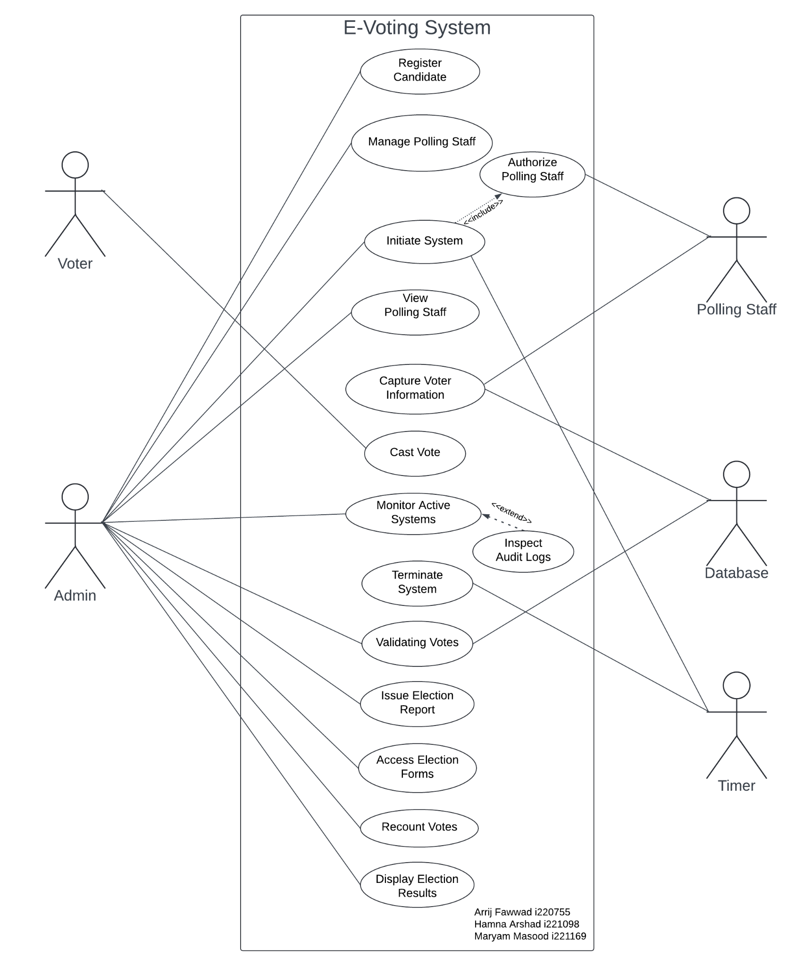

Extended Use Cases

# Use Case-01

Done by: Hamna Arshad (i221098)

| Use Case Name | Register Candidate | |
| --- | --- | --- |
| Scope | E-Voting System | |
| Level | User Goal | |
| Primary Actor | Administrator | |
| Stakeholders and Interests | **Administrator**: Ensures candidate eligibility.  **Election Commission**: Validates compliance with election laws.  **Candidate**: Wants to participate in the election. | |
| Preconditions | The candidate must adhere to all constitutional requirements and criterias. | |
| PostConditions | The candidate is successfully registered for the General Elections.  The system records the registration details. | |
| Main Success Scenario | **Actor Action:**  1. Admin logs into the system and registers a candidate.  2. Admin inputs the candidate's personal details and verifies that the candidate meets eligibility criteria.  3. Administrator submits the registration form. | **System Responsibility:**  4. System processes the registration and confirms the candidate registration.  5. The registration details are stored in the system's database. |
| Extensions | **2a.** Candidate is not eligible for elections.   * 2a1. Admin does not register the candidate.   **2b.** Incorrect candidate details.   * 2b1. Candidate details are entered again. | |

# Use Case-02

Done by: Hamna Arshad (i221098)

| Use Case Name | Manage electoral polling staff accounts | |
| --- | --- | --- |
| Scope | E-Voting System | |
| Level | User Goal | |
| Primary Actor | Administrator | |
| Stakeholders and Interests | **Administrator**: Needs to create, update, or deactivate staff accounts.  **Polling staff**: Requires access to perform their election duties.  **Election Commission**: Wants only authorized staff to manage election-related tasks. | |
| Preconditions | Administrator is logged into the system.  Polling staff roles and permissions are defined. | |
| PostConditions | Polling staff accounts are created, updated, or deactivated.  System records changes in polling staff account status. | |
| Main Success Scenario | **Actor Action:**  1. The administrator can perform different actions depending on the situation:  **Create**: Enter details for a new polling staff member.  **Edit**: Modify the details for the existing account.  **Deactivate**: Disable or remove an account. | **System Responsibility:**  2. The system takes the input provided by the administrator and performs the necessary action.  3. System confirms the successful update. |
| Extensions | **1a.** If account details are incomplete.   * 1a1. System prompts to complete fields.   **2a.** If a system error occurs.   * 2a1.The admin is asked to retry. | |

# 

# Use Case-03

Done by: Hamna Arshad (i221098)

| Use Case Name | Initiate system | |
| --- | --- | --- |
| Scope | E-Voting System | |
| Level | User Goal | |
| Primary Actor | Administrator | |
| Stakeholders and Interests | **Administrator**: Needs to initialize the system for election operations.  **Election Commission**: Wants the system to be properly set up to handle the election process.  **Voters**: Rely on a properly initiated system to cast their votes securely and efficiently. | |
| Preconditions | System is installed and available for initialization.  Administrator has the necessary credentials and permissions. | |
| PostConditions | System is successfully initiated and ready for election processes.  All components (e.g., voter database, candidate data) are properly initialized. | |
| Main Success Scenario | **Actor Action:**  1. Administrator configures settings by loading the candidate data, initializing the voter database etc.  3. Administrator confirms initialization. | **System Responsibility:**  2. System processes the configuration and initializes the necessary modules (voting, candidate management, etc.).  4. System verifies the settings and confirms successful initiation to the administrator. |
| Extensions | **1a.** If any configuration is incomplete:   * 1a1.The system prompts the administrator to complete the missing fields.   **2a.** If system errors occur during initialization:   * 2a1. The system logs the error and prompts the administrator to retry. | |

# Use Case-04

Done by: Hamna Arshad (i221098)

| Use Case Name | Authorize polling staff Entry | |
| --- | --- | --- |
| Scope | E-Voting System | |
| Level | User Goal | |
| Primary Actor | Polling staff | |
| Stakeholders and Interests | **Polling staff**: Needs secure access to manage the polling process.  **Administrator**: Ensures only authorized polling staff can access the system.  **Election Commission**: Ensures proper authorization and secure access to the e-voting system.  **Voters**: Rely on the system being managed by properly authorized personnel. | |
| Preconditions | The polling staff has valid login credentials.  Polling station setup is complete. | |
| PostConditions | Polling staff are successfully authorized to manage the polling station's operations within the e-voting system.  The system logs the officer's entry for future audits. | |
| Main Success Scenario | **Actor Action:**  1. The polling staff enters login credentials. | **System Responsibility:**  2. System verifies the credentials.  3. A polling staff is granted access to manage the polling station within the system.  4. System logs the successful authorization and allows access to polling management functions. |
| Extensions | **1a.** Incomplete fields:   * 1a1. Officer is requested to fill all the fields.   **2a.** Invalid credentials:   * 2a1. System denies access and prompts re-entry. * 2ab. System locks the account and notifies the Administrator for review. | |

# Use Case-05

Done by: Hamna Arshad (i221098)

| Use Case Name | View polling staff Assignments at Polling Station | |
| --- | --- | --- |
| Scope | E-Voting System | |
| Level | User Goal | |
| Primary Actor | Administrator | |
| Stakeholders and Interests | **Administrator**: Needs to view which polling staff members are assigned to specific polling stations.  **Polling Staff**: Requires clarity on their assignments.  **Election Commission**: Ensures proper staffing and operational readiness at all polling stations. | |
| Preconditions | Polling stations and polling staff assignments have been configured in the system.  Administrator is logged into the system. | |
| PostConditions | Administrator successfully views the assigned polling staff for a particular polling station.  The system generates a detailed list of polling staff members and their roles at the selected station. | |
| Main Success Scenario | **Actor Action:**  1. Administrator selects the option for viewing Polling Staff.  2. Administrator enters/selects a polling station.  5. Administrator views the list of assigned Polling staff and their roles. | **System Responsibility:**  3. System checks whether selected Polling staff or polling stations exist.  4. System retrieves and displays the Polling staff assignment data for the selected polling station. |
| Extensions | **3a.** Admin enters the wrong station.   * 3a1. System prompts to reselect/reenter.   **5a.** System error occurs   * 5a1. Admin retries. | |

# Use Case-06

Done by: Maryam Masood (i221169)

| Use Case Name | Capture Voter information | |
| --- | --- | --- |
| Scope | E-Voting System | |
| Level | User Goal | |
| Primary Actor | Polling staff | |
| Stakeholders and Interests | **Polling staff:** Needs to ensure voter’s information is captured correctly  **Voter:** Needs to have their information verified before voting.  **Election Commission**: Wants to have a record of the votes . | |
| Preconditions | Voter is present with valid identification at a polling station. | |
| PostConditions | Voter information is stored in the system. | |
| Main Success Scenario | **Actor Action:**  1.Polling staff initiates the process of capturing voter information.  3. Polling staff enters voter information.  5. Polling staff confirms data entry. | **System Responsibility:**  2. System requests the required voter data.  4. System verifies if the voter belongs to this polling station and records the information.  6. System saves the voter information. |
| Extensions | **3a.** If the voter information entered by the polling staff is incomplete or incorrect:   * 3a1. System displays a warning and asks the polling staff to correct the mistake.   **4a.** If the voter does not belong to the current polling station:   * 4a1. System alerts the polling staff and provides the voter’s registered polling station details, if available.   **5a.** If the polling staff accidentally confirms incorrect data:   * 5a1. System allows the polling staff to undo or revise the data entry before final submission. | |

# Use Case-07

Done by: Maryam Masood (i221169)

| Use Case Name | Cast Vote | |
| --- | --- | --- |
| Scope | E-Voting System | |
| Level | User Goal | |
| Primary Actor | Voter | |
| Stakeholders and Interests | **Voter:** Wants to ensure their vote is cast securely and correctly.  **Polling staff:** Assists voters in the voting process and ensures the system operates correctly.  **Election Commission**: Wants to ensure a fair, transparent, and efficient voting process. | |
| Preconditions | The voter has been successfully verified and is eligible to vote. | |
| PostConditions | The vote is successfully cast and recorded in the system. | |
| Main Success Scenario | **Actor Action:**  1. Voter approaches the system.  3. Voter selects their candidate and submits the vote.  5. Voter confirms their selection.  7. Voter receives a confirmation of their vote. | **System Responsibility:**  2. System displays the voting interface.  4. System verifies the selection and prepares to record the vote.  6. System records the vote and generates a paper trail.  8. System updates the total votes for the selected candidate. |
| Extensions | **3a.** If the voter attempts to cast a vote without confirming their selection:   * 3a1. System prompts the voter to confirm their choice before proceeding.   **5a.** If the vote cannot be recorded due to a system error:   * 5a1. System informs the voter of the issue and allows them to retry the vote.   **7a.** If the voter does not receive confirmation:   * 7a1. System provides an option for the voter to request the confirmation again. | |

# Use Case-08

Done by: Maryam Masood (i221169)

| Use Case Name | Monitor active systems | |
| --- | --- | --- |
| Scope | E-Voting System | |
| Level | User Goal | |
| Primary Actor | Admin | |
| Stakeholders and Interests | **Admin**: Needs to ensure all systems are functioning properly on polling day.  **Election Commission**: Wants to prevent electoral fraud. | |
| Preconditions | The admin is logged into the system.  Voting systems are operational and connected to the system. | |
| PostConditions | Admin has a real-time view of all active systems. | |
| Main Success Scenario | **Actor Action:**  1. Admin requests the status of active polling stations.  3. Admin reviews the status of each polling station.  5. Admin identifies any polling stations with issues.  7. Admin takes necessary actions based on the information provided. | **System Responsibility:**  2. System retrieves current status from all polling stations.  4. System displays the operational status, including any errors or alerts.  6. System allows the admin to escalate issues or contact responsible polling staff.  8. System logs the admin’s actions for future reference. |
| Extensions | **1a.** If the system is unable to retrieve the status from any polling station:   * 1a1. System notifies the admin of the connection issue and provides details for troubleshooting.   **3a.** If the admin finds a polling station with a malfunctioning system:   * 3a1. System allows the admin to initiate a support request to resolve the issue. | |

# Use Case-09

Done by: Maryam Masood (i221169)

| Use Case Name | Inspect Audit logs | |
| --- | --- | --- |
| Scope | E-Voting System | |
| Level | User Goal | |
| Primary Actor | Admin | |
| Stakeholders and Interests | **Admin**: Requires access to audit logs to monitor system activity and ensure transparency in the voting process.  **Election Commission:** Ensures the integrity and transparency of the electoral process. | |
| Preconditions | System logs votes and actions during polling.  The admin is logged into the system with sufficient privileges to access audit logs. | |
| PostConditions | Admin reviews audit logs successfully. | |
| Main Success Scenario | **Actor Action:**  1. Admin requests to view the audit logs.  3. Admin reviews the displayed audit logs.  5. Admin filters the logs based on date or event type. | **System Responsibility:**  2. System retrieves the relevant audit logs based on the specified criteria.  4. System highlights any anomalies or significant events recorded in the logs.  6. System updates the display to reflect the filtered logs. |
| Extensions | **1a.** If the system cannot retrieve the audit logs:   * 1a1. System notifies the admin of the issue and provides troubleshooting options.   **3a.** If the admin identifies a suspicious activity in the logs:   * 3a1. System allows the admin to initiate an investigation.   **5a.** If the filtering criteria yield no results:   * 5a1. System informs the admin that no logs match the specified criteria and prompts them to adjust their search. | |

# Use Case-10

Done by: Maryam Masood (i221169)

| Use Case Name | Terminate System | |
| --- | --- | --- |
| Scope | E-Voting System | |
| Level | User Goal | |
| Primary Actor | Timer | |
| Stakeholders and Interests | **Admin**: Needs to close polling securely.  **Polling staff:** Rely on the system to complete the voting process efficiently before shutdown.  **Election Commission:** Wants timely and secure termination of the voting system. | |
| Preconditions | Polling time has ended. | |
| PostConditions | Polling is closed, and no further votes are accepted. | |
| Main Success Scenario | **Actor Action:**  1. Timer signals the end of the voting period.  4. Timer confirms successful termination of the system. | **System Responsibility:**  2. System confirms that all voting activities are complete.  3. System initiates the termination process.  5. System logs the termination event for future reference.  6. System ensures all connections are safely closed. |
| Extensions | **1a.** If the timer signal is triggered but votes are still being processed:   * 1a1. System alerts the timer and postpones termination until all votes are finalized.   **3a.** If the system encounters an error during termination:   * 3a1. System notifies the admin of the issue and initiates troubleshooting steps.   **4a.** If the termination process fails:   * 4a1. System provides an option for the admin to retry termination or escalate the issue. | |

# Use Case-11

Done by: Arrij Fawwad (I220755)

| Use Case Name | Validating Votes | |
| --- | --- | --- |
| Scope | E-Voting System | |
| Level | User Goal | |
| Primary Actor | Administrator | |
| Stakeholders and Interests | **Administrator:** Requires vote verification for the final result.  Needs to ensure that all votes are valid.  **Voters:** Expect their votes to be counted accurately.  **NADRA:** Assists with the biometric verification of voter identities. | |
| Preconditions | The voting process is completed, all votes are recorded in the system, and the Administrator is authenticated into the system. | |
| PostConditions | The votes are verified, invalid votes are discarded, and the final count is displayed. A list of discarded votes is logged for auditing and review. | |
| Main Success Scenario | **Actor Action:**  1. The Administrator selects the option to verify votes in the system.  3. The Administrator requests the system to send the votes to Nadra.  8. The Administrator can view the total count and the list of all discarded votes. | **System Responsibility:**  2. The system retrieves all recorded votes.  4. The system initiates the send request by packaging the voter identification data and sending it to NADRA for biometric verification.  5. NADRA returns the biometric verification results, indicating valid and invalid voters.  6. The system discards invalid votes based on NADRA’s response and updates the vote tally.  7. The system generates a detailed report of all discarded votes, including reasons for rejection (e.g., failed biometric verification), and notifies the Administrator. |
| Extensions | 2a. **If the system is unable to retrieve votes**:   * 2a1. The system notifies the admin to retry.   4a. **If the system cannot communicate with NADRA’s API**:   * 4a1. The system logs the failure and notifies the Administrator of the communication issue. * 4a2. The Administrator is given the option to retry the connection or verify manually.   7a. **If the Administrator requests a list of all discarded votes**:   * 7a1. The system allows the Administrator to export the list of discarded votes in a detailed format. * 7a2. The list includes information such as voter IDs, polling stations, and reasons for vote rejection. | |

# 

# Use Case-12

Done by: Arrij Fawwad (I220755)

| Use Case Name | Recount Votes | |
| --- | --- | --- |
| Scope | E-Voting System | |
| Level | User Goal | |
| Primary Actor | Administrator | |
| Stakeholders and Interests | **Administrator:** Ensures transparency and accuracy in vote counting.  **Election Commission:** Upholds the integrity of the election by allowing for legitimate recount requests.  **Candidates and Voters:** Seek accurate, fair results and trust that any discrepancies will be handled correctly | |
| Preconditions | **1.** The election has concluded, and the initial vote count and verification are complete. **2.** A request or suspicion has been raised (by the administrator or another stakeholder) about the accuracy of the initial count. | |
| PostConditions | The votes are recounted, and results are either verified or updated. | |
| Main Success Scenario | **Actor Action:**  **1.** The administrator logs into the system and submits a request for a recount.  **3.** The administrator monitors the progress of the recount.  **5.** Once the recount is complete, the administrator reviews and verifies the new tally. | **System Responsibility:**  **2.** The system retrieves the stored vote data and begins recounting.  **4.** The system finalizes the recount, updates the vote tally if necessary, and generates a detailed report. |
| Extensions | **2a.** If a system error occurs during the recount, the system prompts the administrator to retry.  **4a.** If the recount produces different results, the system automatically updates the results. | |

# Use Case-13

Done by: Arrij Fawwad (I220755)

| Use Case Name | Issue election Report | |
| --- | --- | --- |
| Scope | E-Voting System | |
| Level | User Goal | |
| Primary Actor | Administrator | |
| Stakeholders and Interests | **Administrator:** Needs to generate and distribute a final election report.  **Election Commission:** Requires an accurate and comprehensive report to certify the election.  **Candidates and Voters:** Seek transparency and final confirmation of results. | |
| Preconditions | The system on all polling stations is terminated, the vote validation has been done and recounts (if any) have concluded. | |
| PostConditions | A detailed election report is generated, including vote counts, participation statistics, and any relevant observations. | |
| Main Success Scenario | **Actor Action:**  1. The administrator selects the option to generate the election report.  4. The administrator reviews and finalizes the report. | **System Responsibility:**  2. The system compiles the necessary data from the vote tally, voter turnout, and other related information.  3. The system generates and stores the election report for future reference. |
| Extensions | 3a. If the report fails to generate due to system errors, the administrator is prompted to retry | |

# Use Case-14

Done by: Arrij Fawwad (I220755)

| Use Case Name | Access Election Forms | |
| --- | --- | --- |
| Scope | E-Voting System | |
| Level | User Goal | |
| Primary Actor | Administrator | |
| Stakeholders and Interests | **Administrator:** Needs to review election forms for transparency and to ensure all results are properly documented.  **Candidates and Parties:** Rely on these forms for validating vote counts and official results. | |
| Preconditions | The system on all polling stations is terminated, the vote validation has been done and recounts (if any) have concluded. | |
| PostConditions | The administrator successfully accesses any requested form. | |
| Main Success Scenario | **Actor Action:**  **1.** The administrator selects the option to access election forms.  **3.** The administrator chooses the specific form to view.  **5**. The administrator reviews the contents of the selected form.  The administrator exports or prints the form if necessary. | **System Responsibility:**  **2.** The system displays the list of available forms.  **4**. Upon the administrator’s selection, the system retrieves and displays the chosen form with all relevant data. |
| Extensions | **2a.** No available forms:   * 2a1. The system informs the administrator that no forms are currently available for access. * 2a2. The system suggests checking back later after vote validation is completed.   **4a.** Form retrieval error:   * 4a1. The system encounters an error while retrieving the selected form (e.g., file corruption, server issue). * 4a2. The system displays an error message, explaining the issue to the administrator. | |

# Use Case-15

Done by: Arrij Fawwad (I220755)

| Use Case Name | Display Election Results | |
| --- | --- | --- |
| Scope | E-Voting System | |
| Level | User Goal | |
| Primary Actor | Administrator | |
| Stakeholders and Interests | **Administrator**: Needs to view the final election results (vote counts) after they are verified.  **Candidates and Voters**: Indirectly impacted as they expect a fair and accurate election outcome, but they do not access this internal view. | |
| Preconditions | The voting process and vote verification have been completed, and there is no recounting in progress. The final results have been consolidated. | |
| PostConditions | Election results are displayed to the **Administrator**.  The system logs the action for auditing purposes. | |
| Main Success Scenario | **Actor Action:**  1. The Administrator selects the option to display the final election results. | **System Responsibility:**  2. The system retrieves the final, verified results.  4. The system displays the election results on the public interface (e.g., website, announcement board).  5. The system logs the result display event for auditing purposes. |
| Extensions | **1a. If the results have not been verified or finalized:**  1a1. The system notifies the Administrator and prevents results from being displayed until the verification is complete.  **5a. If there is an issue with the display interface:**  5a1. The system alerts the Administrator and provides troubleshooting steps. | |